Alkynes
Alkynes: General Outline: —
Alkynes are the open chain, linear unsaturated acyclic hydrocarbons characterized by the presence of a carbon-carbon triple bond ($C≡C$). They form a homologous series having general formula $C_{n}H_{2n-2},where n=2, 3, 4, …$ . Since, alkenes contain four hydrogens fewer than the corresponding alkanes (saturated acyclic hydrocarbons); they are also known as unsaturated aliphatic hydrocarbons. Alkynes are also called acetylenes, since they are derived from acetylene, the simplest alkyne. Alkynes are not easily bent into a ring though a few (e.g. cyclooctyne and cyclononyne) which are not very stable, have been synthesized. Cycloalkynes are rare except when the ring is large.
Sources and Utility of Alkanes: —
The chemistry of carbon-carbon triple bond ($C≡C$) is similar to the carbon-carbon double bond. There are, however, some reactions that are specific to the triple bond of the alkynes. Acetylenic $-C≡C-$, is a reactive functional group. The unusual acidity of acetylenic $C-H$, together with other important reactions of acetylenic triple bond, has helped acetylene to emerge as a powerful tool in synthetic organic chemistry.
Alkynes are not common in nature as alkenes, but some natural products (e.g. $capillin$, $cicutoxin$, etc.), containing triple bond have been identified. Acetylenic bond is rare in drugs. However, a few drugs of interest $e.g.Pursalmide$(an analgesic),$ethynyl estradi$(a birth control pill), $Dynemicin$ (an antitumor agent) have been of interest as medicinal interest.
Nomenclature of Alkynes: —
In trivial (common) systems, alkynes are considered as derivatives of acetylene. In IUPAC system, the longest continuous chain containing triple bond is chosen and the carbon numbering is given from the end close to the triple bond. The suffixused for naming alkyne is $-yne$ instead of $-ane$ of the corresponding alkane. The substituents are named as usual as in alkanes and alkenes. For example,
$HC≡CH$ ${CH}_{3}C≡CH$ ${CH}_{3}{CH}_{2}C≡CH$ ${CH}_{3}-C≡C-{CH}_{3}$
IUPAC: Ethyne Propyne But-1-yne But-2-yne
Common: Acetylene Methyl acetylene Ethyl acetylene Dimethyl acetylene
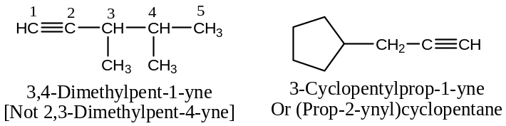
Acidity of Alkynes: —
Acetylene, (unlike ethyne and ethane), reacts with $Na$ to form the salt sodium acetylide and liberates hydrogen gas ($cf.$ The reaction of $Na$ with water, $HOH$).
$$2 HC≡C-⋮H +2Na ⟶ 2HC≡C:^{-}{Na}^{+} + H_{2}↑$$
$$(cf. 2 HO-⋮H +2Na ⟶ 2HO:^{-}{Na}^{+} + H_{2}↑)$$
This reaction shows the acidic character of hydrogen attached to triple bonded carbon in alkynes.
A weaker acid is known to be displaced from its salt by a stronger acid. While acetylene displaced ${NH}_{3}$ from its salt sodamide (${Na}^{+}{NH}_{2}^{-}$), water displaces acetylene from its salt, sodium acetylide.
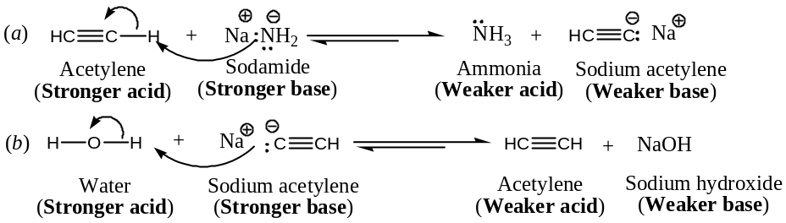
Therefore, acetylene is a stronger acid than ammonia, but weaker acid than water as apparent from their $p^{K_{a}}$ values.
$$H_{2}O > HC≡CH >{NH}_{3}$$
$$p^{K_{a}}= \sim 16 25 38$$
The relative acidities of ethane, ethylene and acetylene: The decreasing order of acidities of these hydrocarbons is:
$$HC≡CH >H_{2}C=CH_{2}>H_{3}C-CH_{3}$$
$$p^{K_{a}}= \sim 25 44 50$$
Conversely, the decreasing order of basic character of anions resulting from these hydrocarbons should be:
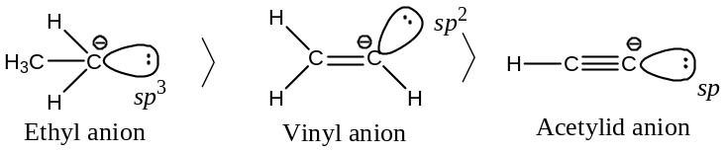
Explanation: The above sequence of acidities or basicity order can be well explained in two approaches —
[1]In ${CH}_{3}H_{2}{\ddot{C}}^{-}$, $H_{2}C={\ddot{C}}^{-}H$ and $HC={\ddot{C}}^{-}$ the unshared pair of electrons occupy an ${sp}^{3}$, ${sp}^{2}$ and $sp$ hybrid orbital respectively. When we proceed along the series${sp}^{3}$, ${sp}^{2}$ and $sp$, the $p$- character of the hybrid orbital decreases and the $s$- character increases. Electrons in $s$- orbitals are held closer to the nucleus than they are in $p$- orbitals. This means that $s$- electrons have lower energy and greater stability than $p$- electrons. In general, greater is the $s$- character in the hybrid containing a pair of electrons, the less basic is that pair of electron and higher is the acidity of its conjugate acid. Therefore, the acetylene should be the most acidic and ethane least in the above series.
[2]The $C-H$ bonds in acetylene, ethylene and ethane are $sp-s, {sp}^{2}-s \&{sp}^{3}-s$ respectively. In other words, the $sp$- hybridized carbon would attract the electron pair constituting the $C-H$ bond of acetylene morethan does the $sp^{2}$- hybridized carbon for the electron pair constituting the $C-H$ bond of ethylene. Similarly, the ${sp}^{2}$- hybridized carbon in ethylene compared to ${sp}^{3}$- hybridized carbon in ethane have greater attraction for electron pair constituting the $C-H$ bond in them. This means that $C-H$ bond in acetylene would be moreionic than ethylene and $C-H$ bond in ethylene would be more ionic than ethane. This implies that the hydrogen attached to a triply bonded carbon in acetylene have greater tendency to depart as proton ($H^{+}$) than the hydrogen attached to a doubly bonded carbon in ethylene. On similar ground ethylene tends to depart proton ($H^{+}$) to a greater extent than the hydrogen attached to a singly bonded carbon in ethane. Hence, acetylene is more acidic than ethylene, and ethylene should be more acidic than ethane.
The relative acidities of terminal and disubstituted alkynes:
Terminal alkynes, i.e. alkynes having at least one $≡C-H$ bond, show an acidic character, but disubstituted alkynes (e.g. dimethyl acetylene) do not show acidic character due to the lack of hydrogen attached to triple bonded carbon. It is reasonable in the light of what we have explained above.
General Methods of Preparation of Alkynes: —
Alkynes are best prepared from —
- From Alkyl halides ($RX$): It includes
  - Dehydrohalogenation of vicinal or geminal dihalides, and
  - Dehalogenation of tetrahalides.
- From Acetylene: — by alkylation of acetylene (conversion into higher alkynes).
These general synthetic methods of preparative interest are described below with their suitable mechanisms:
[1] Synthesis of Alkyne by the Dehydrohalogenation $vic./ gem.$ Halides: —
Vicinal as well as geminal dihalides on treatment with alcoholic potash ($alc. KOH$, usually ethanolic) followed by the reaction with sodamideundergoes dehydrohalogenation to form alkynes. For example,
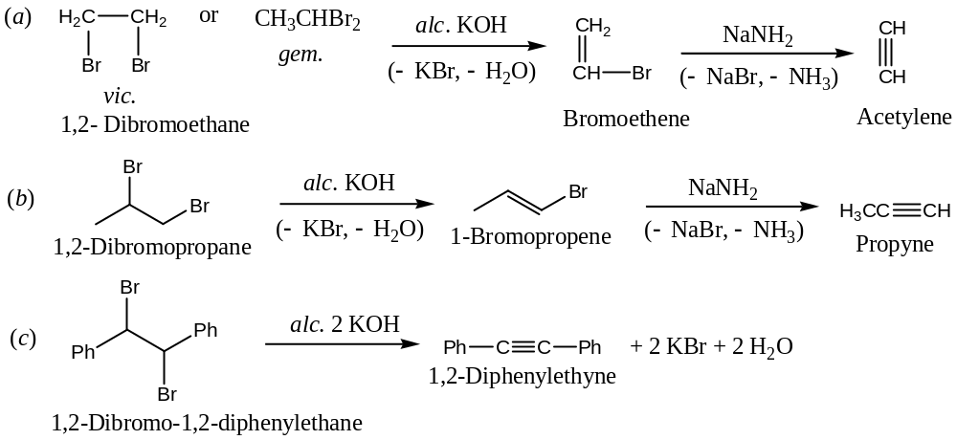
In this reaction, instead of using alcoholic $KOH$, use of sodamide in liquid ammonia fives better yield, due to the formation of minimum side products.
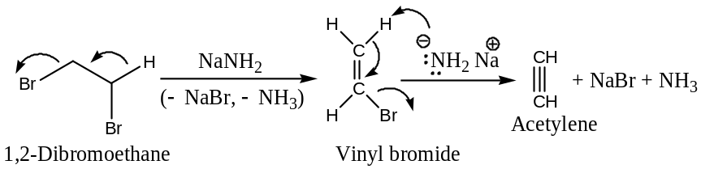
Application: Since vicinal dihalides are easily obtained from alkenes, it provides a route for the conversion of an alkene into an alkyne. For example, conversion of ethene to ethyne—
$$H_{2}C=CH_{2}\underset{→}{{ Br}_{2 }} BrCH_{2}-CH_{2}-Br \underset{→}{{ NaNH}_{2 }} HC≡CH+2{NH}_{3}+2NaBr$$
Ethene 1, 2- Dibromoethane Ethyne
[2] Synthesis of Alkyne by the Dehalogenation of Tetrahalides: —
When a tetrahalo alkane is heated with metallic zinc, all the halogens are taken away by the zinc to form alkanes to yield an alkyne. For example,
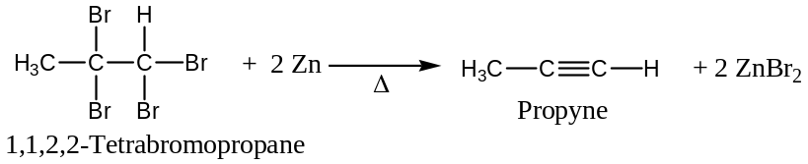
[Note: This reaction is more suitable for the purification and protection of a $C-C$triple bond, and not used as preparative method since the starting tetra halides are themselves obtained from alkynes.]
[3] Synthesis of Alkyne by the Alkylation of Acetylene: —
The method consists in treating an acetylene containing at least one $H$-atom on triply bonded $C$- atom with sodamide or better with sodium dissolved in liquid ${NH}_{3}$, followed by the action with a $1^{°}$- alkyl halide to form higher alkynes. For example,
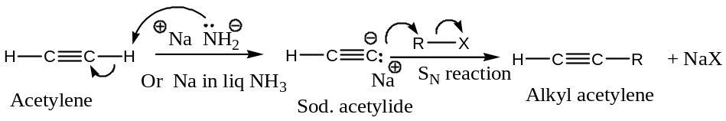
Alkylation alkynes using Grignard Reagent: Alternatively, the interaction of acetylenes with a Grignard reagent, $RMgX (X=usually Br \& I)$, followed by the action of alkyl halides yields higher alkynes (it is an example of nucleophilic substitution reaction). Thus—
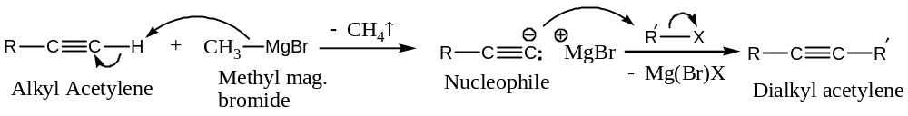
General Physical Properties of Alkynes: —
Important physical properties of alkynes are studied under the following headings —
- Physical appearance,
- Boiling point and melting point, and
- Solubility
Physical appearance of Alkynes:
First three members of alkene ($i.e. C_{2}-C_{4}$) are gases,
Next eightmembers of alkene ($i.e. C_{5}-C_{12}, dodecyne$) are liquids, and
Alkynes containing $13C$- atoms or more are solids at ordinary temperature.
Except acetylene all alkynes are colourless and odourless.
Boiling and Melting point trends of Alkynes:
The melting point, boiling point and densities of alkyne rise gradually with the increase in $C$- content (i.e. molecular weight).
Solubility and Dipole moments of Alkenes:
Alkynes are practically insoluble in water, but soluble in non-polar organic solvents like ether, carbon tetrachloride, benzene, petroleum ether, acetone, etc.
In general, the physical properties of alkynes are similar to alkenes and alkanes of similar molecular weights. //
General Chemical Properties (Reactions) of Alkynes: —
The most important reactions of alkynes are —
- Substitution of acetylenic hydrogen in terminal alkynes,
- Addition reactions,
- Reduction reactions,
- Oxidation reactions,
- Polymerization reactions,
- Rearrangement reactions, and
- Miscellaneous reaction.
Some of the representative reactions are discussed in detailed with appropriate mechanisms—
- Substitution Reactions of Alkynes involving Acetylenic Hydrogen in terminal Alkynes:
This includes —
- Formation of metal acetylides,
- Formation of heavy metal acetylides, and
- Substitution by halogens.
These are discussed with representative examples with appropriate mechanisms—
- Formation of Metal(alkali) Acetylides:
Acetylene and terminal alkynes, but not internal alkynes (dialkylacetylenes) react with alkali metals and Grignard reagents to form acetylides due to the acidic character of acetylenic hydrogen. For example,
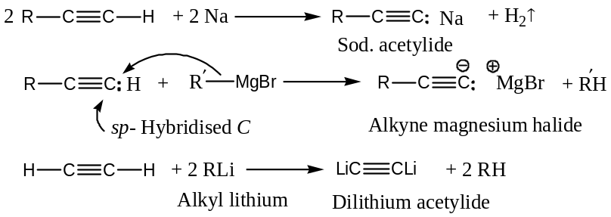
Acetylenes can be regenerated from the acetylides by the action of water. For example,
- Formation of Heavy Metal Acetylides:
Acetylene and terminal alkynes react with heavy metal ions like ${Cu}^{+}, {Ag}^{+}$ ($e.g. {Cu}_{2}{Cl}_{2}$ in ${NH}_{4}OH$ and ammonical ${AgNO}_{3}$) to form insoluble acetylides also known as heavy metal acetylides. Internal alkynes, which do not contain any acidic hydrogen, do not form these heavy metal acetylides. Acetylene also reacts with lithium (2 moles)to form dilithium acetylides as shown below:
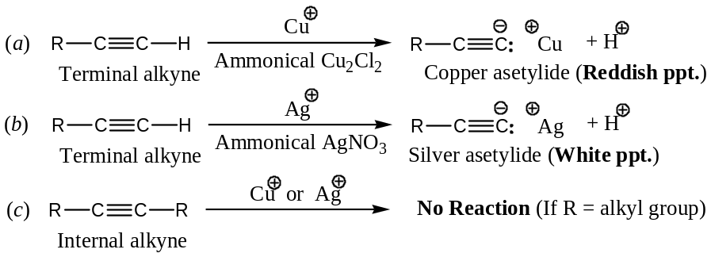
Analytical Application: The heavy metal acetylides are bonded more covalently than alkali metal acetylides. Hence, these are much less basic and less nucleophilic. Thus, we can distinguish between a terminal alkyne and an internal alkyne by simply adding silver or copper (I) reagents. Formation of white or reddish precipitate indicates a terminal alkyne.
Importance: The reaction of heavy metal ions provides the basis of —
- A diagnostic test for acetylene or terminal alkynes,
- The purification of acetylenes (the acetylenes are readily decomposed by dilute mineral acids to regenerate acetylenes),
- Separation of alkynes from alkenes and alkanes,and
- Acetylides, being typical nucleophile, react with alkyl halides to form higher alkynes. For example,
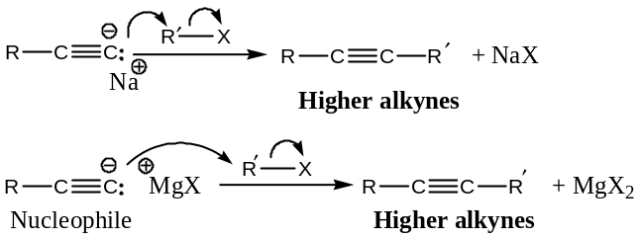
- Substitution of terminal acidic hydrogens of acetylenes by Halogens:
Acetylenic hydrogen can be replaced by halogen when treated with sodium hypohalides ($NaOX$), or with the reaction of iodine in ammonia. For example,
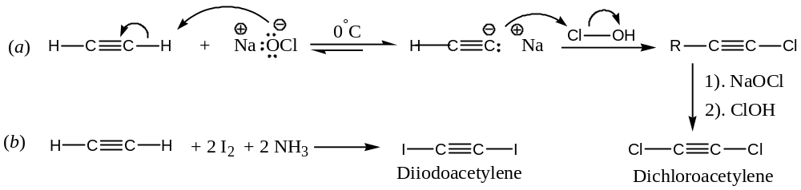
- Addition Reactions of Alkynes:
This includes both the Electrophilic and Nucleophilic addition reactions.
General Approach for Electrophilic Addition reactions in Alkynes:
Electrophilic addition reactions in alkynes are slower than alkenes. Many such additions require a catalyst like mercuric ion (${Hg}^{2+}$). Possibly, the bridged cation intermediate formed here a highlystrained system and hence less stable than the bridged cation intermediate formed in the case of alkenes.
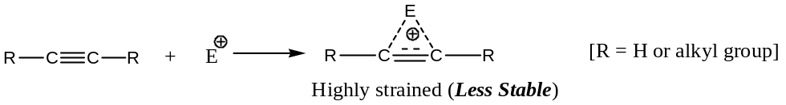
Another way to look at this lower reactivity of alkynes is that the triply bonded carbons are $sp$- hybridized and $π$- electrons are more tightly heldby such $C$- nuclei, hence are less available for combination with the electrophiles ($E^{+}$). These steric and electronic factors can explain the lower rate of electrophilic addition in alkynes than alkenes.
Some Important and representativeElectrophilic Addition reactions of alkynes are —
- Addition of Halogens,
- Addition of Hydrogen Halides ($HX$),
- Hydroboration-Oxidation, and
- Addition of hypohalous acid.
General Approach for Nucleophilic Addition reactions in Alkynes:
We know that $C-C$ triple bond has a reduced reactivity towards electrophiles. Therefore, it is logical to assume that such triple bond should also be susceptible to nucleophilic attack and this is actually so. These nucleophilic additions are generally catalysed by heavy metal ion(say${Hg}^{2+}$) which form a short of $π$- complex with alkynes and lowers the electron-density around the triple bond to facilitate the attack by nucleophiles.
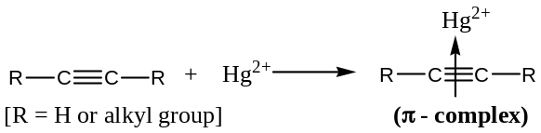
Important and representativeNucleophilic Addition reactions of alkynes are —
- Hydration (addition of water),
- Addition of Acetic acid (vinylation),
- Addition of Alcohols,and
- Addition of $HCN$.
All these Electrophilic & Nucleophilic Addition reactions of Alkynes are discussed with representative examples and appropriate mechanisms—
- Electrophilic addition of Halogens (${Br}_{2}$)to Alkynes:
Alkynes add to bromine to yield tetrabromo alkane, through dibromoalkene intermediate. Addition is stereoselective (Stereoselective reaction is one in which only one major stereospecific product is given by the reaction). The major product corresponds to $anti$- addition of $Br$- atoms.
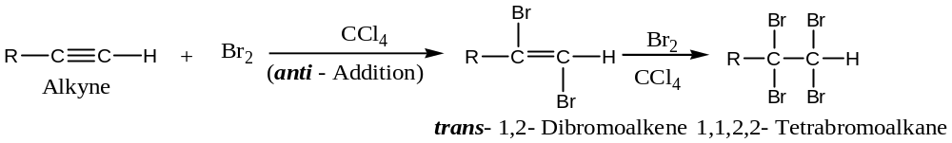
For example,
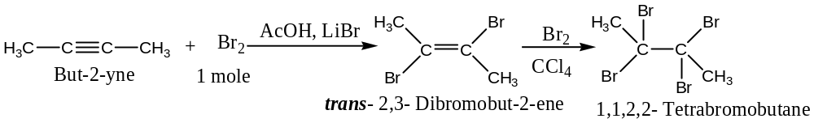
Mechanism: The reaction proceeds through the formation of cyclic bromonium ion involving three steps.
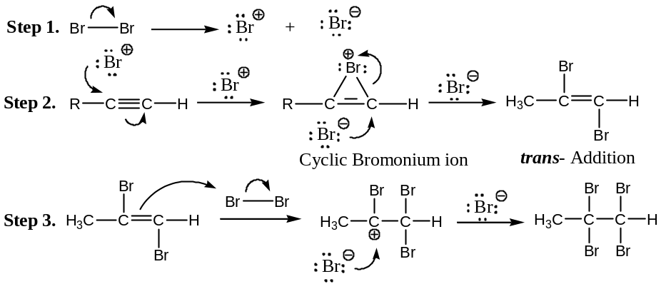
The fact that $1,2$- dibromoalkene formed in step (2) is $trans$- suggest that the cationic intermediate formed in step (2) has a cyclic structure.
- Electrophilic addition of Halogen halides ($HX$) to Alkynes:
Hydrogen halides add to alkynes to give dihaloalkanes via haloalkenes. The reaction is catalysed by light or mercury salts and the addition follow Markownikoff addition. Thus, the addition of $HX$ at both stages is regioselective with internal alkynes ($e.g. pent$-2-$yne$) a mixture of products results. The order of reactivity of haloacids is: $HI>HBr>HCl>HF$
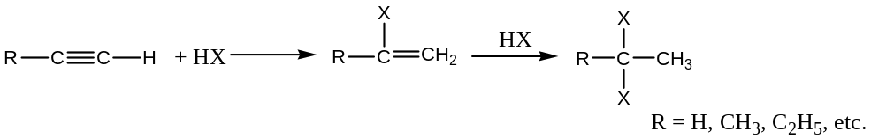
For example,
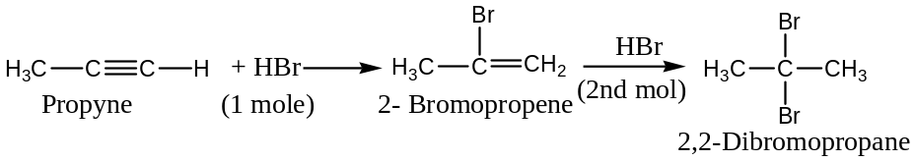
Mechanism: The reaction proceeds through cyclic intermediate with subsequent attack by $:X^{-}$ as shown below:
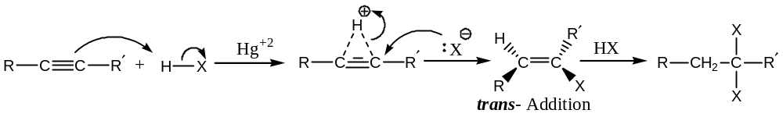
With $HBr$, alkynes also give $anti$- Markownikoff addition product in the presence of peroxides. For example,
$${CH}_{3}C≡CH+HBr \underset{→}{ Peroxide }{CH}_{3}CH=CHBr \underset{→}{ HBr }{CH}_{3}CH(Br)CH_{2}Br$$
Propyne $1$-Bromopropene $1,2$- Dibromopropane
Important Note: Addition of $1mol$ of $HCl$ to acetylene gives vinyl chloride, ${CH}_{2}=CHCl$, was of great industrial importance. Vinyl chloride is the monomer required for the familiar polymer PVC.
- Hydroboration-Oxidation (Electrophilic) reaction in Alkynes:
Monomer of diborane (${BH}_{3}$) adds to alkynes at $0℃$ in a $cis$- manner to form vinyl boranes which react with acetic acid to give $cis$- alkenes. The net effect of this hydroboration reaction is the reduction of an alkyne to $cis$- alkene (similar to the reduction of an alkyne with Lindlar’s catalyst). The reaction is stereoselective as only $cis$- product is formed in this reaction. For example,
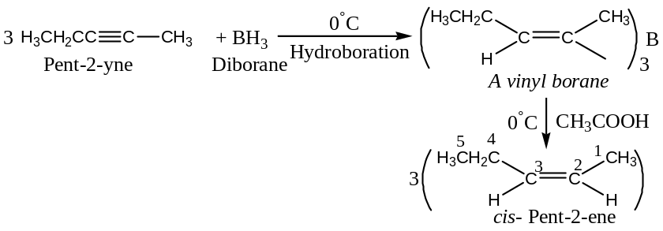
The $C-B$ bond can also be cleaved oxidatively by alkaline $H_{2}O_{2}$ to form alkenols that tautomerize to aldehydes or ketones. Terminal alkynes give aldehydes whereas internal alkynes will give ketones. For example,
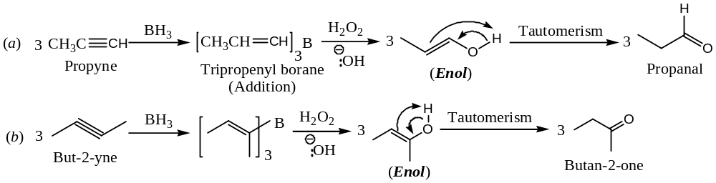
This method is valuable for the synthesis of aldehydes and ketones.
Important: In hydroboration-oxidation reaction of alkyne, enols have been shown to tautomerize to the more stable ketonic compounds. This transformation can be achieved by both acids and bases as outlined below:
Acid Catalyzed Tautomerization: It involves (a) removal of a hydroxyl proton by a base and (b) formation of a carbanion followed by the addition of a proton by the solvent as shown below:
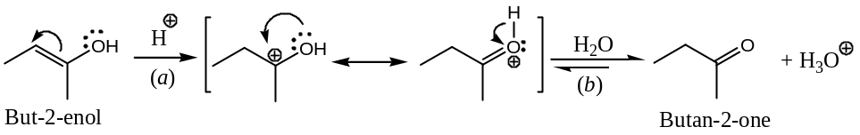
Base Catalyzed Tautomerization: It involves (a) addition of a proton and (b) elimination of hydroxyl proton, as shown below:
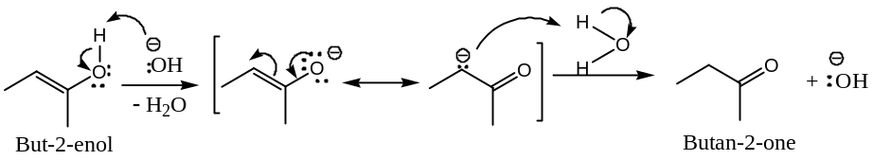
- ElectrophilicAddition of Hypohalous Acids ($H-OX$):
Addition of hypohalous to alkynes proceeds in two steps to form dichlorocarbonyl compounds, as shown below:
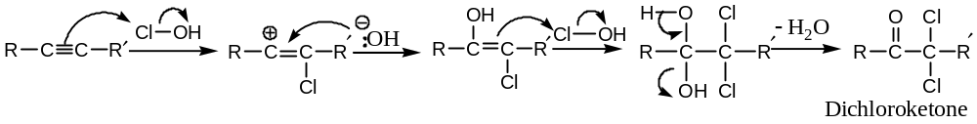
- Nucleophilic Addition of Water to Alkynes (Hydration):Use of ${Hg}^{2+}$ - salts
Alkynes add to water in presence of ${Hg}^{2+}$- salts as catalyst and the reaction follows Markownikoff rule. In this reaction, initially vinyl alcohol so formed undergoes rapid tautomerization to produce carbonyl compounds. Thus,
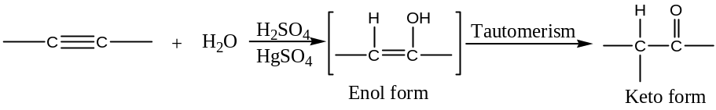
For example,
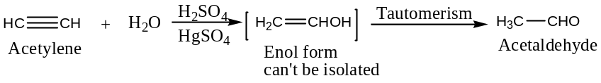
Similarly,
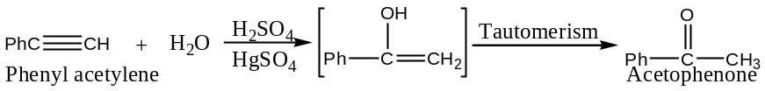
It is important to note that in this reaction acetylene (or any terminal alkyne) gives acetaldehyde, substituted acetylene yields acetone or other ketones.
Mechanism Hydration of an Alkyne by Hg²⁺ - salts:
Acceptable mechanism for the hydration of triple bond by of ${Hg}^{2+}$- salts involves a cyclic transition state involving of Hg²⁺ - ion, and can be written as:
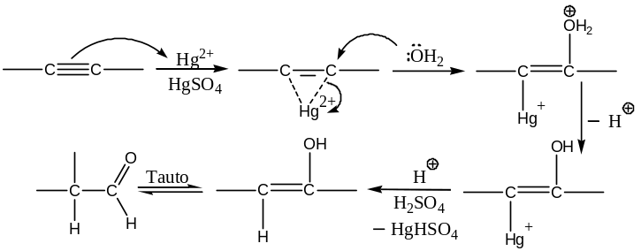
- Nucleophilic Addition of Acetic Acid to Alkynes (Vinylation): [$anti$- Addition]:
Reaction of acetic acid with alkynes are catalyzed by ${Hg}^{2+}$- salts leads to the introduction of vinyl group in acetic acid (vinylation) to form vinyl acetate and finally alkylidene acetate. This reaction is known as vinylation reaction (replaces H of acetic acid by a vinyl group). Thus,
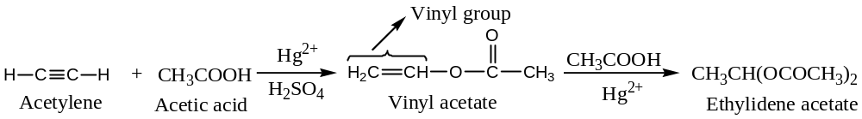
Important: Ethylidene acetate when heated to $300℃-400℃$ gives acetaldehyde and acetic anhydride. Further, vinyl acetate is the monomer for the polymer, polyvinyl acetate used as adhesive.
- Nucleophilic Addition of Alcohols to Alkynes (Vinylation):
Alcohols add to alkyne in the presence of potassium alkoxide to form vinyl ethers. This reaction may be viewed as replacement of alcoholic hydrogen by vinyl group. Thus,
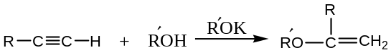
For example,
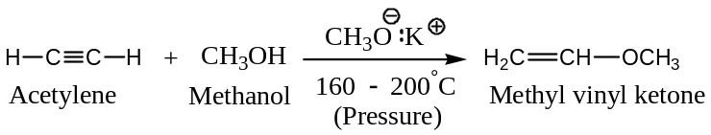
Important: This reaction is also known as vinylation of alcohol. (H of alcoholic group replaced by vinyl group)
Mechanism: Vinylation of alcohol is a nucleophilic addition reaction and involves the addition of nucleophile followed by protonation.
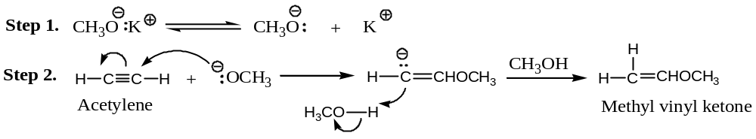
Important: The vinyl ethers are readily hydrolysed by dilute $H_{2}{SO}_{4}$ to give carbonyl compounds, presumably through the tautomerization of vinyl alcohols.
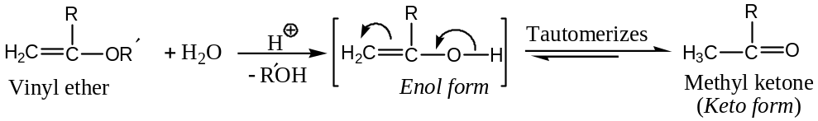
- Nucleophilic Addition of $HCN$with Alkynes:
Alkynes undergo nucleophilic addition with $HCN$ in the presence of $Ba(CN)_{2}$ to form vinyl cyanides. For example,
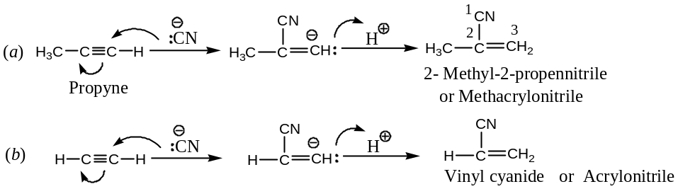
Important: Vinyl cyanide is used in the synthesis of synthetic rubber ($Buna N$).
Question: Discuss the comparative reactivity of alkenes and alkynes towards nucleophilic addition reactions.
Solution: The possible addition reaction pathway of alkynes and alkenes initiated by a nucleophile ${Nu:}^{-}$ can be represented as —
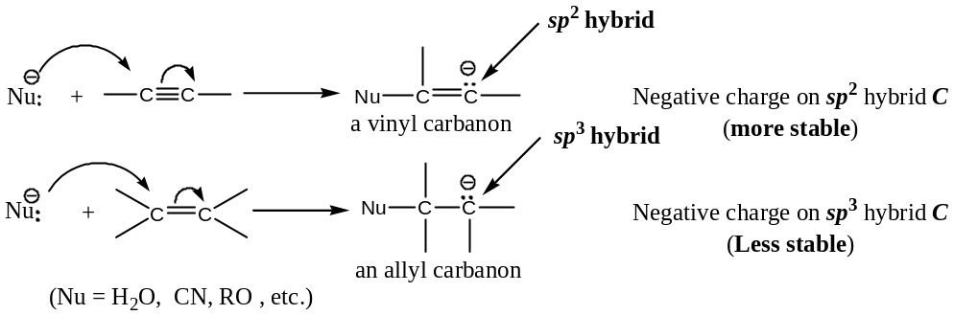
The $–ve$ charge on the vinylic $C$ is ${sp}^{2}$- hybridized whereas in allyl $C$ it is ${sp}^{3}$- hybridized. The electron pair on an ${sp}^{2}$- orbital having more $s$- character ($33.3\%$) would be held more tightly than ${sp}^{3}$- orbital ($25\%$). The $–ve$ charge stability would thus, be in the order ${sp}^{2}$- $C>{sp}^{3}$- $C$. In other words, the vinylic carbanion would be more stable (and hence more easily formed) than the alkyl carbanion. Assuming that the carbanion formation step, in the nucleophilic addition, to a multiple $C-C$ linkage is the rate-determining step. It is therefore, reasonable to expect that alkynes would be relatively more reactive towards nucleophilic reagents.
- Reduction Reactions of Alkynes:
Alkynes can be reduce either $(a)$catalyticallyor $(b)$chemically
- Catalytic Reduction of Alkynes: [$Syn$- Addition]
Alkynes can be hydrogenated catalytically first to alkenes and then to alkanes. Direct reduction can be achieved by $H_{2}$ in the presence of finely divided $Ni or Pd or Pt$. However, reduction to the alkene stage can be achieved by Lindlar’s catalystor nickel boride(${Ni}_{2}B$) catalyst (also known as $P$- $2$ catalyst). For example,
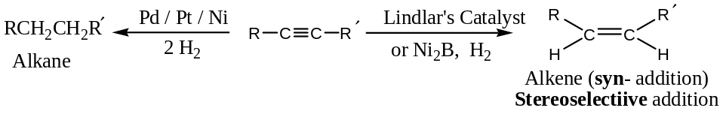
- Metal Reduction (Metal-Ammonia reduction)of Alkynes: [$Trans$- Addition]
Chemical or metal- ammonia reduction, involves the reduction of alkynes by $Na or Li$ in liquid ${NH}_{3}$. The reduction if fully stereoselective and gives exclusively $trans$- alkene. This reagent ($Na$ in liquid ${NH}_{3}$) is used by Birch for reduction and hence, known as Birch reduction. Thus,
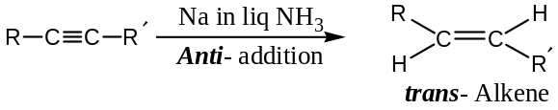
For example,
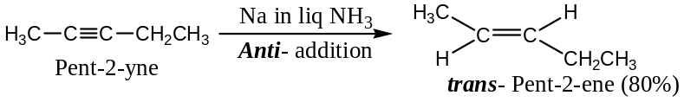
Mechanism: The sodium-ammonia reduction of an alkyne involves three steps —
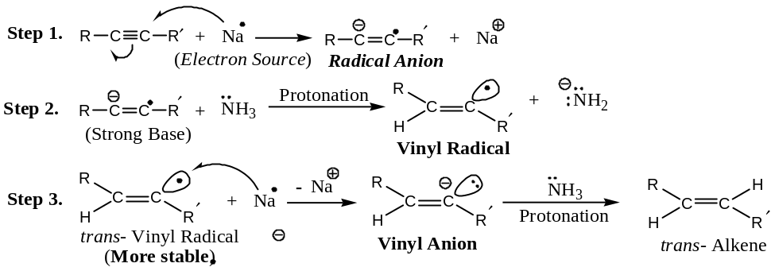
From the above mechanism, it is evident that the first electron from $Na$ goes into an anti-bonding $π$- orbital to form radical anion (strong base), in step (1). Ammonia acting as an acid, protonates the radical anion, gives vinyl radical in step (2). The vinyl radical so obtained takes another electron from $Na$ to form vinyl anion (strong base). Followed by protonation by ${NH}_{3}$ to give $trans$- alkene, $trans$- addition is favoured due to greater stability of $trans$- vinyl radical (formed in step 2) than $cis$- vinyl radical (alkyl groups in $trans$- configuration are farther apart).
- Oxidation Reactions of Alkynes:
This includes the following oxidation reactions —
- Ozonolysis, and
- Permanganate oxidation.
- Oxidation of Alkynes by Ozonolysis:
Ozone adds to alkynes to form ozonides, which can be hydrolysed to $1,2$- dicarbonyl compounds. Thus,
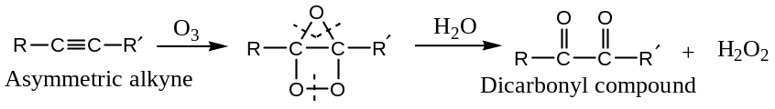
Mechanism: Formation of ozonide involves the following three steps:
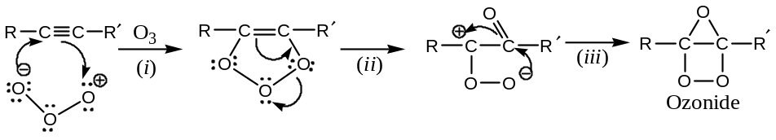
Important Note: Hydrogen peroxide formed during the course hydrolysis of ozonide, undergoes oxidative cleavage of $C-C$ bond of $1,2$- dicarbonyl compounds to form a mixture of carboxylic acids. Thus,
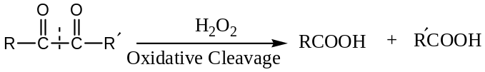
- Permanganate Oxidation of Alkynes:
When an alkyne is treated with ${KMnO}_{4}$ under almost neutral conditions, $1,2$- diketones results, as shown below:
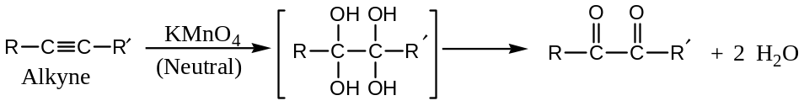
For example,
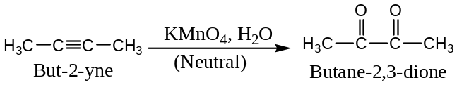
In the oxidation of alkyne by neutral ${KMnO}_{4}$, each of the two $π$- bonds of the alkyne gets hydroxylated (as in alkene) and the tetrahydroxylated intermediate then loses two molecules of water to give diketone. If the reaction mixture is warmed under basic conditions, the diketone intermediate undergoes oxidative cleavage to produce, free carboxylic acids on acidification. Thus,
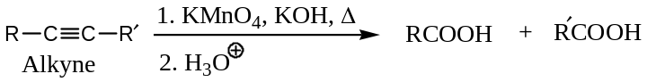
For example,
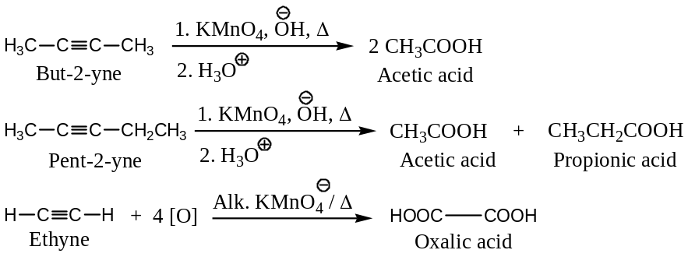
Terminal alkyne (e.g. propyne) would give carboxylic acid and ${CO}_{2}$.
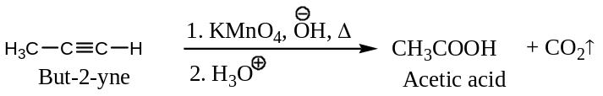
Analytical Importance: Both the oxidation reactions ($i.e. O_{3}\&{KMnO}_{4}{Ox}^{n}$) are of analytic importance. By identifying the carboxylic acids formed from an alkyne, we can locate the position of the $C-C$triple bond in the parent alkyne.
- Polymerization Reactions of Alkynes:
Under suitable conditions, alkynes add two or more molecules to form dimers, trimers or tetramers, as illustrated below:
$(a)$Dimerization of Alkynes: Acetylene when passed through a solution of cuprous chloride in ammonium chloride, acetylene dimerizes to form vinyl acetylene and divinyl acetylene.
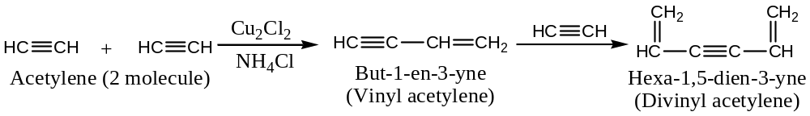
Divinyl acetyleneis the starting material for chloroprene, a raw material used in the synthesis of synthetic rubber (Neoprene).
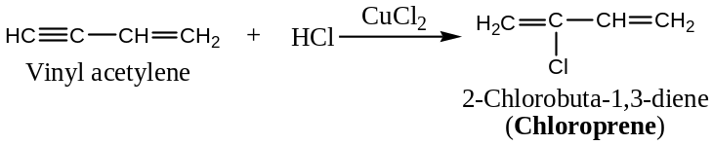
$(b)$Trimerization of Alkynes:Acetylene trimerizes in the presence of $dicarbonyl$-$di$- ($triphenylphosphino$)$nickel$, $[(CO)_{2}Ni(P{Ph}_{3})_{2}]$ to benzene.
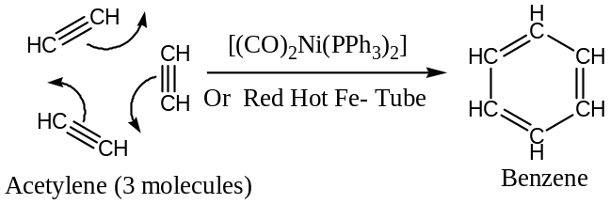
This trimerization also occurs when acetylene is passed through red hot iron tube. Similarly, propyne trimerizes to mesitylene.
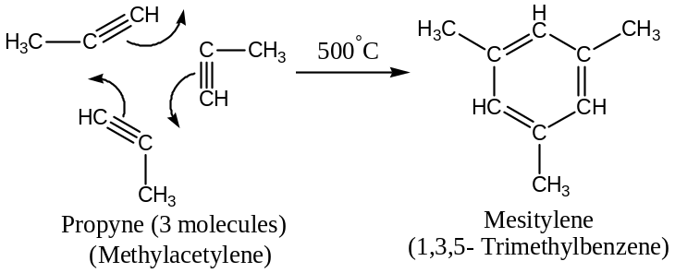
$(c)$Tetramerization of Alkynes:Under high pressure and in the presence of nickel cyanide (catalyst), acetylenetetramerizes to form cyclo-octatetraene.
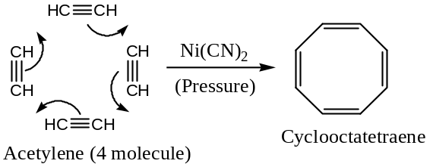
- Rearrangement Reactions of Alkynes:
Alkynes tend to rearrange on heating with alcoholic potash with the migration of the triple bond. For example,
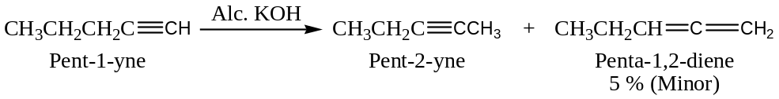
Mechanism of Rearrangement: Rearrangement of triple bonds in alkynes involves the following sequence of reactions, generating resonance stabilized intermediate carbanions.
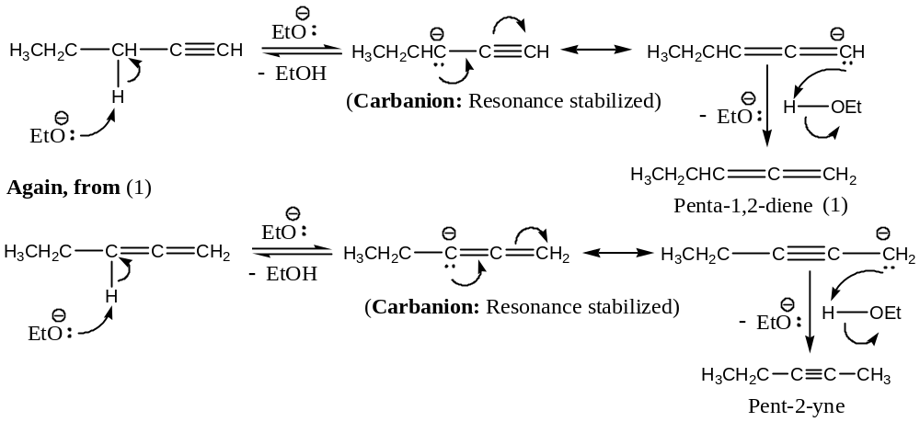
- Miscellaneous Reactions of Alkynes:
Following are the reactions of alkynes, not belonged to any one of the standard classified reactions of organic chemistry, and hence are termed as the miscellaneous reactions. These are —
- Combustion reactions,
- Addition of arsenic trichloride ($As{Cl}_{3}$), and
- Addition of terminal alkynes to carbonyl compounds ($Ethinylation$)
All these are discussed with representative examples and appropriate mechanisms—
($a$) Combustion of Alkynes: Alkynes get burnt in air or oxygen to form ${CO}_{2}\&H_{2}O$ with the evolution of large amount of heat. For example,
$$2C_{2}H_{2} + 5O_{2} ⟶ 4{CO}_{2} +2H_{2}O + 1305 kJ$$
Evolution of large amount of heat makes acetylene, useful in welding, cutting, etc. (oxy-acetylene flame).
($b$) Addition of Arsenic Trichloride with Alkynes:Arsenic trichloride adds to alkynes, in the presence of anhydrous ${AlCl}_{3}$, to form adducts, often used as poisonous gases in warfare. For example,
$$HC≡CH + As{Cl}_{3}\underset{→}{ Al{Cl}_{3}} ClCH=CHAs{Cl}_{2}$$
Acetylene $β$- Chlorovinyl dichloroarsine (Lewisite)
The adduct from acetylene is the well-known poisonous gas, $Lewisite$.
($c$) Addition of Terminal Alkynes to Carbonyl Compounds (Ethinylation):Ethyne or terminal alkynes containing ($≡CH$) group adds to carbonyl compounds under suitable conditions to form synthetic alcohols or other compounds. For example,
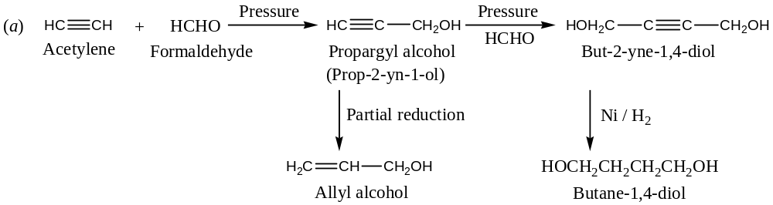
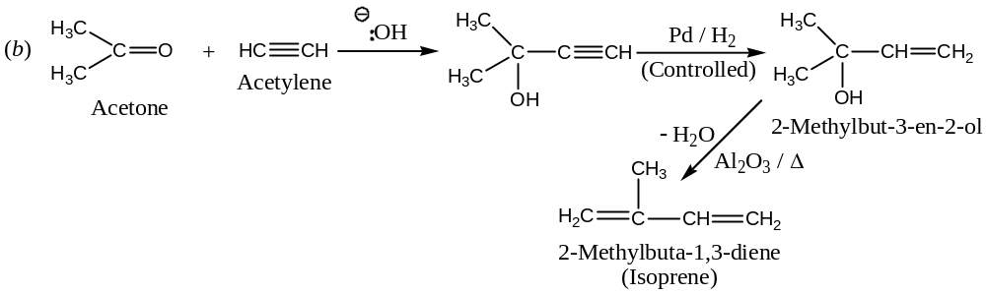
In the last additions, ethyne adds its active hydrogen ($≡C-H$) to carboxylic oxygen, and ethyne carbanion to carbonylic carbon of an aldehyde or a ketone. Therefore, this reaction is also known as ethinylation reaction, involving ethyne carbanion as nucleophile. It is evident from its mechanism.
Mechanism of ethinylation: Ethinylation is a nucleophilic addition of carbonyl compounds involving ethyne carbanion as nucleophile generated by methoxide ion (${CH}_{3}{O:}^{-}$).
$(1)$Generation of Carbanion:
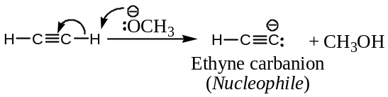
$(2)$Attack of Carbanion (Nucleophile) on the Carbonyl Carbon:
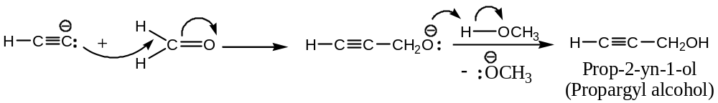
Commercial Importance of Acetylenes:
Alkynes like acetylene is extensively used
- As a fuel gas, say in oxyacetylene flame, for welding and cutting of metals, and
- As a key synthetic chemical.
Some important chemicals derived from acetylene are as follows —
- Acetaldehyde, acetic acid, acetone, butyl alcohol, ethyl alcohol.
- Tri and per- chloroethylenes, as the dry cleaning solvents, insecticides, etc.
- Vinyl acetate, used in paints, adhesives, plastics, etc.
- Vinyl chloride ($H_{2}C=CHCl$), widely used in plastics (PVC), etc.
- Acrylonitrile, used in the production of synthetic fibres (e.g. orlon, acrylon, etc.), synthetic rubbers and soil conditioners.
- Tetrahydrofuran (THF), a solvent and a versatile intermediate.
- Vinyl ethers, used in plastics, adhesives, rocket-fuels, etc.
- Acetylene black, used in dry batteries, compounding rubber and plastics, etc.
- Lewisite, the war gas.
It is, thus, evident from the above that acetylene can be extensively used to synthesise compounds of great applied interest. Acetylene is no longer a chemical curiosity as an illuminant. It is also a raw material of great synthetic importance in organic chemistry. //

