Proteins & Amino acids
[Amino acids, peptides and polypeptides: Primary, secondary, tertiary and quaternary structure of proteins]
Amino Acids:
The reactions —
Proteins:
The name protein was introduced by Mulder (1839) from the Greek word proteios (meaning first). Proteins are nitrogenous high molecular weight polypeptides containing only $α$- amino acids, which occurs in the protoplasm of all animal and plant cells [the composition varies with the source: $C=46-55\%;H=6-9\%;O=12-30\%;N=10-32\% \& S=0.2-0.3\%$, other elements may also be present, e.g. phosphorous (nucleoproteins), iron (haemoglobin)]. Proteins can be broken down into smaller and smaller fragments (by hydrolysis either with $6NHCl$ or $6N Ba(OH)_{2}$), until the final products are the amino acids, i.e. proteins on hydrolysis gives $α$- amino acids or mixture of $α$- amino acids. Thus —
$$Proteins⟶Polypeptides ⟶Peptides ⟶Amino acids$$
The distinction between protein and peptide or polypeptide is that — the proteins are those molecules whose molecular weight is above $\sim 10,000$ and peptides (polypeptides) are those molecules whose molecular weight is below$10,000$. But, in general, these are differing from both chemical and physical properties.
When an amino acid is combined with another amino acid, a peptide bond is formed as shown below —
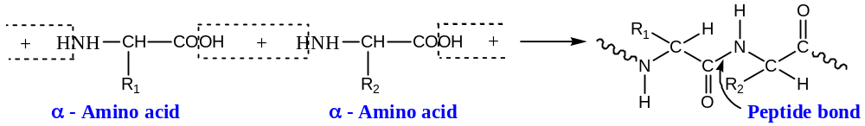
When several amino acids are combined a polypeptide is formed. Actually, proteins are the polypeptides whose molecular weight more than$10,000$.
The synthetic peptides of very high molecular weight are often referred as polypeptides, and their methods of preparation and their properties have provided a great deal of information about the structure and properties of proteins.
Properties of Proteins:
Isoelectric Point: Proteins are amphoteric, i.e. they can behave as an anion or a cation depending on the $p^{H}$ of the solution. At some definite $p^{H}$, characteristic for each protein, the $+ve$ and $–ve$ charges are exactly balanced, i.e. there is no net charge on the protein molecule, and the molecule will not migrate in an electric field. In this conditions, protein is said to be at its isoelectric point, and at this $p^{H}$, the protein has its least solubility i.e. it is most readily precipitated.
The physical properties like osmotic pressure, viscosity, etc. are also the minimum at the isoelectric point of protein. The amphoteric nature of the protein is due to the presence of large number of free acidic ($-COOH$) and basic ($-NH_{2}$) groups arising from the amino acid units in the molecule.
Denaturation of Protein: We know that all proteins are optically active, and may be coagulated and precipitated from aqueous solutions either by heating or by the addition of acids, alkalis, salts, organic solvents miscible with water, etc. Proteins in this precipitated state are said to be denatured, and the process of reaching this state is known as the denaturation, which occurs most readily near the isoelectric point.
Denaturation is now believed to be the result of change in configuration or unfolding of protein molecule ($2^{°}$- and $3^{°}$- structure of proteins accounts for the folding nature of the molecule, which is due to $H$- bonding). During denaturation, optical rotation is changes and usually the biological activities of protein are lost, e.g. enzymes (all are proteins) becomes inactive when denatured.
Renaturation or Refolding of Protein (Annealing): Denaturation is usually irreversible, but many examples are now known where the process has been reversed. The reversal of denaturation has been called renaturation or refolding. When denaturation is effected by heat, renaturation does not usually result on rapid cooling. If, however, cooling is carried out very slowly, renaturation often occurs. In this circumstance, the process of renaturation has been referred to as annealing.
Determination of Molecular mass of Protein:
The molecular weight of proteins are determined by many physical methods, such as ultra-centrifugal sedimentation, osmotic pressure, $X$- ray diffraction, light scattering effects, molecular sieves (gel-filtration) and by chemical methods.
Chemical methods are based on the estimation of a particular amino acid. Thus, suppose, the percentage composition of amino acid ($x$) in a protein has been estimated. From these values, it is possible to calculate the mole-proportions of each amino acid by dividing its percentage weight by its molecular weight ($w$). We now choose the amino acid present in the least molar amount and on the assumption that only one of these amino acid residues is present in the protein, the molecular weight ($M_{1}$) of the protein, is given by —
$$M_{1}=\frac{100}{x}×m, or x=\frac{m}{M_{1}}×100$$
If two molecules of the amino acid are present per molecule of the protein, the $\%$ weight is still ‘$x$’, but now, we have —
$$x=\frac{2m}{M_{2}}×100=\frac{2m}{2M_{1}}×100$$
That is, molecular weight $M_{2}$ is $2M_{1}$.
Hence, if $n$- molecules of amino acids are present, the molecular weight of the protein is $nM_{1}$. Therefore, $M_{1}$ is the minimum molecular weight of the protein and $nM_{1}$ is its true molecular weight.
For example, let us consider the protein bovine insulin. The amino acid that occurs in the smallest amount is threonine, $2\%, m=119$
$$∴ M_{1}=\frac{100}{2}×119=5950$$
Now, bovine insulin has been shown to contain one molecule of threonine and hence its true molecular weight is also $5950$. //
Classification of Proteins:
Proteins are classified into two different ways —
($A$) Based on the structure of the proteins and
($B$) Based on the composition of the protein molecules
($A$) Classification based on the structure of protein:
In this classification, proteins are classified into two groups name —
- Fibrous proteins and
- Globular proteins
Fibrous Proteins: These proteins have a large helical content and are essentially rigid molecules of rod-like shape. The rod-like shape i.e. straight chain is because of the presence of only one $–COOH \&-NH_{2}$ group in the protein. These types of proteins are insoluble in common solvents, but are soluble in concentrated acids & alkalis. Keratin of hair is an example of fibrous protein.
Globular Proteins: These consist of amino acids containing more than one acidic ($-COOH$) and basic ($-NH_{2}$) functional groups, and as a result they have branched chain or cyclic structure. Thus, globular proteins have a chain which consists partly of helical sections and folded about the random coil sections to give a ‘spherical’ shape. These are soluble in water and in dilute acids, alkalis & salts. Haemoglobin is an example of globular protein.
($B$) Classification based on the Composition of proteins:
This is the most common method for the classification of proteins. Here, the proteins are classified into three main groups —
- Simple proteins,
- Conjugate proteins, and
- Derived proteins
Again, each group are subdivided into a number of classes, and classes to sub-classes and are designated by general names.
Simple Proteins: These proteins on hydrolysis gives only amino acids (mainly $α$- amino acids) or their derivatives. For example — albumins (e.g. serum, egg albumin), globulins, insulin
Conjugate Proteins: These proteins on hydrolysis gives $α$- amino acids and a non-protein group (i.e. a compound not containing amino acid residue), which is attached to the protein part. The non-protein group is known as the prosthetic group, and it may be separated from the protein part by careful hydrolysis. For example —
- Nucleoproteins — here, the prosthetic group is a nucleic acid
- Chromoproteins — these are characterised by the presence of a coloured prosthetic group. For example, chlorophyll and haemoglobin
- Glycoproteins (these are also called Mucoproteins) — here, the prosthetic group is a carbohydrate molecule or its derivatives
- Phosphoproteins — here, the prosthetic group is the phosphoric acid
Derived Proteins: The derived proteins are the degradation products obtained by the action of acids, alkalis, or enzymes on the protein. For example —
$Proteins⟶Primary Protenoses ⟶Secondary Protenoses ⟶Peptones ⟶Polypeptide⟶Simple Peptide⟶Amino Acids$
Enzymes:
Enzymes are the biological catalyst, which brings about chemical reactions in living cells. These are either pure protein (if gives only amino acids on hydrolysis) or conjugated proteins and conjugated to — ($i$) metal (cofactor), ($ii$) organic molecules mainly vitamins — called coenzymes. When a non-proteinous group is simply attached to the protein molecule, then this part is called a prosthetic group.
Enzymes are produced by the living organisms and are usually present in only very small amounts in the various cells ($\sim 0.01\%$). They can also exhibit their biological activities even when they have been extracted from their source. All enzymes are globular proteins, many have been identified and a large number have been obtained in crystalline form.
Cofactors: In order to perform catalytic activities i.e. actions, it has been seen that many enzymes requires the presence of a non-protein compound along with the protein molecules. These non-proteinous compounds are collectively known as the cofactors or activators. Cofactors are of three types, i.e. fall into three main groups —
- Coenzymes,
- Prosthetic groups, and
- Metalloenzymes
Coenzymes are organic molecules, a non-proteinous compound present in the protein molecules, which may be separated from the enzyme e.g. by dialysis. These are not binds or bound to the enzyme.
There are some cofactors which are bound to the enzyme and then these are referred to as the prosthetic group of the enzyme. For example, nucleic acid is a prosthetic group present in the nucleoproteins.
Cofactors may be inorganic ions, especially metal ions. In some cases, the metal ion is tightly bound to the enzyme, which is then referred to as the metalloenzymes. In other cases, the enzymes are “metal-activated”. Metal activators are $uni$- or $bi$- valent metal cations, e.g. $Na^{+}, K^{+}$, $Mg^{2+}, {Ca}^{2+}, {Zn}^{2+}$.
Coenzymes and prosthetic groups generally act as carrier of specific functional groups or specific atoms. In order to act in this manner, these cofactors must be exist in two forms — one form being converted into the other during catalytic reaction, and the latter being reconverted into the former by a coupled reactions. These two reactions may or may not follow each other.
Holoenzyme and Apoenzyme:
Many enzymes require the presence of non-protein compound, called cofactors in order to perform their catalytic activity. The complex, enzyme-cofactor is known as the holoenzyme. Thus, the protein in combination with the cofactor or coenzyme is called holoenzyme.
When the cofactor has been removed from the enzyme-cofactor complex, the protein remains is known as an apoenzyme. Apoenzyme has no enzymic activity.
Zymogen: Some enzymes are synthesised in the organisms in an inactive form, this is known as the zymogen. Thus, e.g. the enzyme pepsin is synthesised as its zymogen, pepsinogen. This is reconverted into pepsin in presence of $HCl$.
Some Important Coenzymes:
Three important coenzymes, which are nucleotides in nature, are —
- $NAD^{+} or NADH$ [Nicotinamide-Adenine Dinucleotide],
- $NA{DP}^{+} or NADPH$ [Nicotinamide-Adenine Dinucleotide Phosphate], and
- $ATP$ [Adenosine Tri-phosphate]
$NAD^{+} or NADH$: This was formally known as diphospho-pyridine nucleotide ($DPN$) and has the following structure as shown below —
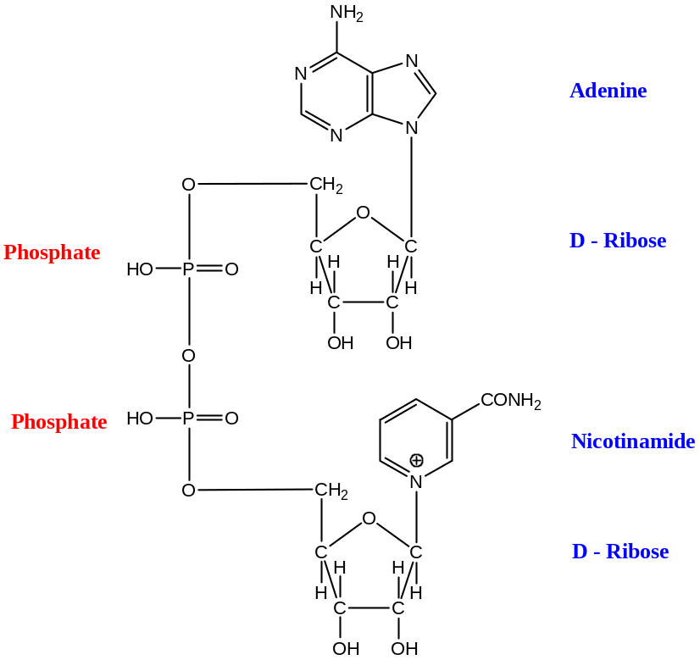
This coenzyme functions as an acceptor of $H$- atom and electrons (Note that one $N$- atom has $+ve$ charge in nicotinamide) in presence of dehydrogenases and is there by converted into the reduced form $NADH$. Since, only the nicotinamide moiety is involved in this transformation, the reaction may be written as shown (Note that — the hydride ion transfer from the substrate)—
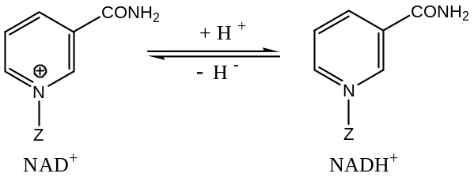
$NA{DP}^{+} or NADPH$: This was formerly known as triphospho-pyridine nucleotide ($TPN$) and has the following structure as shown below —
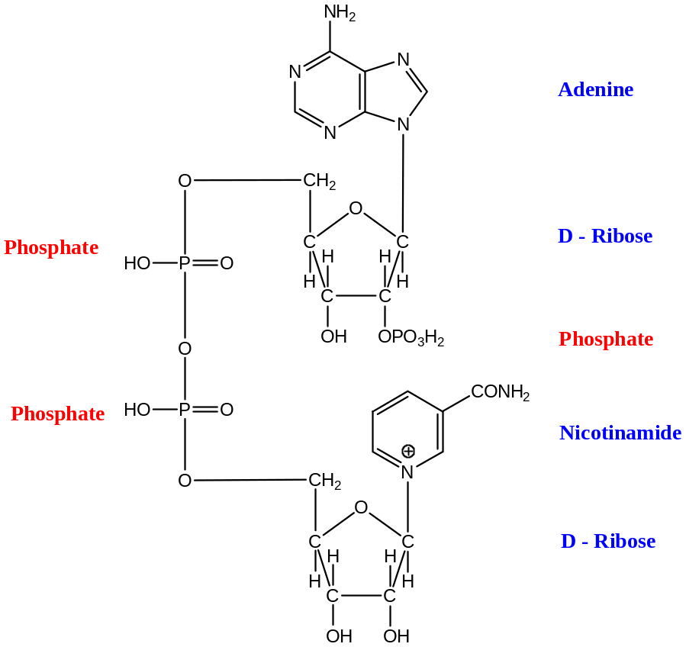
This also behaves as an acceptor of $H$- atoms and electrons, thereby being converted into the reduced form $NADPH$.
It has been seen that $NAD^{+} \& NADH$ are usually involved in the degradative processes, whereas $NA{DP}^{+} \& NADPH$ are usually involved in synthetic processes.
Since, only the nicotinamide moiety of $NA{DP}^{+} or NADPH$ is involved in this transformation of $H$- atoms or electrons, the reaction may be written as shown —
$ATP$: Adenosine Triphosphate
Adenosine triphosphate has the structure as shown below —
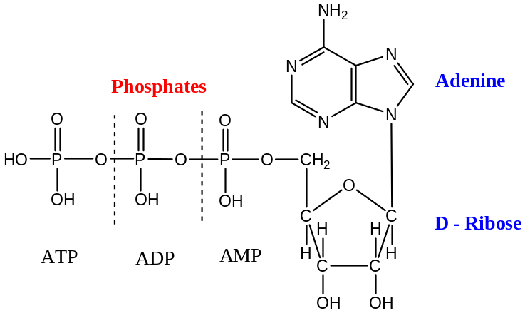
It involved in enzyme catalyzed trans-phosphorylation reactions, transferring one phosphate group to the substrate, itself being converted into adenosine diphosphate ($ADP$). Thus, in turn, can also transfer a phosphate group and is thereby converted into adenosine mono- phosphate ($AMP$).
As we know, to precede chemical reactions energy must be supplied to overcome the energy barriers. In biosynthetic processes, this energy is supplied by $ATP$, when it is involved in transphosphorylation reactions in presence of a suitable enzyme. For example, —
$$ROH+ATP ⟶R-OPO(OH)_{2}+ ADP$$
ADP also behaves as a transphosphorylating agent —
$$ROH+ADP ⟶R-OPO(OH)_{2}+ AMP$$
A less usual reaction of ATP is pyrophosphorylation —
$$ROH+ATP ⟶R-OPO\left(OH\right)-O-PO(OH)_{2}+ AMP$$
From the structural formula of ATP, it is seen that the phosphate group in $AMP$ is linked b a normal ester bond. On the other hand, the terminal phosphate groups in $ADP$ and $ATP$ is linked to a phosphate group by an acid anhydride bond. In hydrolytic reactions, the free energy change (heat of reaction) of an ester bond is $\sim -4.0 to-12.5 kJ{mol}^{-1}$, whereas that for acid anhydride bond is $\sim -29.5 to-210 kJ{mol}^{-1}$. It is the energy, which is used to ‘drive’ coupled reactions. The acid anhydride bonds have been referred to as ‘energy-rich’ bonds, and are sometimes represented by the symbol “$\sim$”, for example, $ATP$ has been written as —
$$Adenine-Ribose-O-PO\left(OH\right) \sim O-PO\left(OH\right) \sim O-PO(OH)_{2}$$
Active Sites: We know that most of the biochemical reactions are performed only in presence of one or some specific biocatalyst, collectively known as the enzymes. During biochemical reactions these enzyme combine with the substrate to form an “Enzyme-Substrate Complex”. The substrate “combines” with a particular region on the enzyme surface to form such a complex. These regions are the active sites, and the complex is known as the Michaelis complex.
An enzyme may have one or more than one active sites. When all these sites are occupied, the enzyme is saturated.
Nomenclature & Classification of Enzymes:
Following are the two most important aspects for the classification and nomenclature of the enzymes —
- Ideas of the active sites present in the enzyme molecule and
- The type of reactions catalyzed by the enzyme.
The gross structure of the enzymes is not so important for the nomenclature and classification, because there are many enzymes differing extensively in the gross structure may catalyze the same type of reactions.
Classical Nomenclature of Enzymes:
In the classical method of naming enzymes, the suffix “$ase$” is added to the name of the substrate, i.e. the substance being acted upon. Thus, —
$$Substrate+ase ⟶Enzyme^{'}s name$$
For example —
The enzyme esterase acts on esters
Amylase acts on starch ($amylum$)
Protease acts on proteins (by the enzyme protease the peptide bonds of the proteins are break down)
Urease acts on urea (urea converted to ammonia), etc.
Some enzymes, however, have retained their trivial names e.g. emulsin, pepsin, trypsin, etc.
Depending upon the nature of the reactions performed by the particular group of enzyme are also named by adding the suffix “$ase$” to the nature of reactions. For example, —
Reactions of addition of hydrogen — Hydrogenase
Elimination of hydrogen — Dehydrogenase
Addition of Oxygen — Oxygenase
Reactions where $-NH_{2}$ group is transferred — Amino transferase, and so on
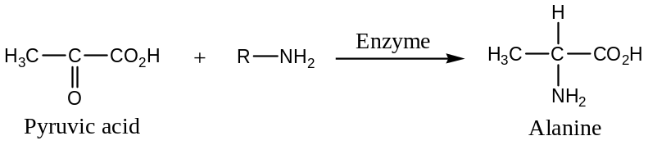
Similarly, —
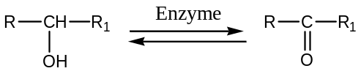
Here, the enzyme used is alcohol dehydrogenase.
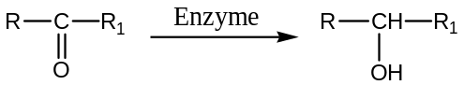
Here, the enzyme used is also called alcohol dehydrogenase as the reaction is reversible.
There are some enzymic reactions, in which the enzymes acted upon the protein are not the pure protein, for example —
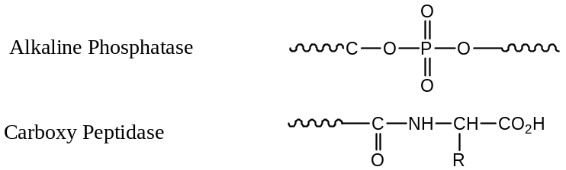
Here, the proteins where the enzyme acted are not pure proteins, these has either a cofactor or a coenzyme, such as ${Zn}^{2+}$, etc.
Some other Enzymes are —
- Phospho-hydrolase — Hydrolysis of phosphate bond
- Phospho-transferase — Involves the transfer of phosphate group from one molecule to another by the enzyme (here, the cofactor is ${Mg}^{2+}$)
Similarly in —
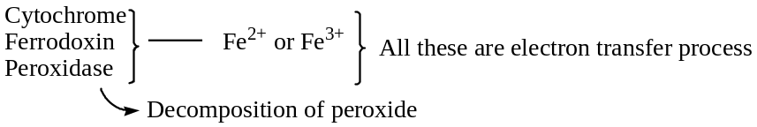
Examples of enzymes, which has essential coenzyme —
Hydrogen transfer enzymes —
- $NADH or NADPH$ (Nicotinamide Adenosine Dinucleotide; Nicotinamide Adenosine Diphosphate)
- $NAD^{+} or NADP^{+}$
- $FAD$ (Flavin Adenine Dinucleotide)
- Flavin Mononucleotide
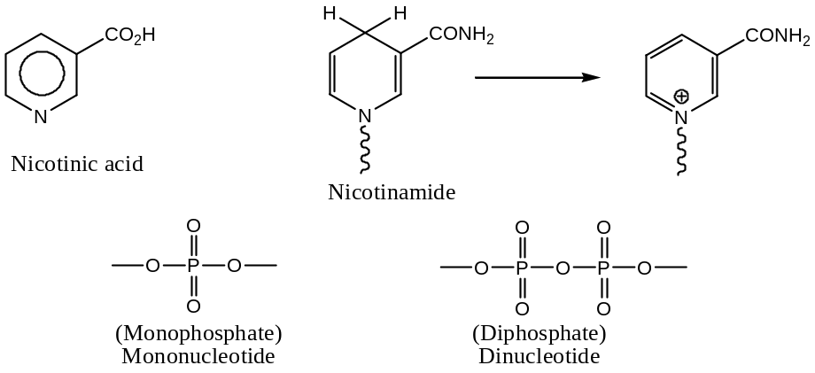
Enzyme Commission (EC) Nomenclature & Classification (1984 - 85):
International Union of Biochemistry (1972)
Classical nomenclatures for enzymes are still widely used, however, with the discovery of more and more enzymes it let to many difficulties. Because of this, the International Commission (EC) on Enzymes (1961) has recommended a systematic method of nomenclature and classification. According to this system, enzymes are divided into $6$- main groups (or class), according to the nature of the reaction that is catalyzed, and each main group is given a code number (e.g.$1,2,3,4,5 \& 6$).
Each of these main groups is divided into subgroups (or subclasses) which take the number of their main group followed by another number, which specifies the type of group in the substrate that undergoes reaction. The subgroups are also divided into sub-subgroups (or sub-subclasses). These are indicated by a 3rd figure, which gives more detailed information on the groups involved in the reaction. Finally, a 4th figure is used that indicates the serial number of the enzymes in the sub-subgroups. Thus, an enzyme is specified by four numbers (separated by dots), i.e.
$$Enzyme ⟶m.n.o.p$$
For example, $1.1.1.1$ is the oxidoreductase, which involved in $H$- transfer from an alcohol group ($-CH_{2}OH$) to $NAD^{+} or NADP^{+}$ as acceptor. The trivial name of this enzyme is alcohol dehydrogenase.
Thus, the first number or figure involved in the nomenclature of an enzyme according to $EC$- nomenclature is the class number or main group number according to the nature of the reaction that is catalyzed by the enzyme. Following are the $6$- main groups (or class) —
- Oxidoreductases: These enzymes catalyse oxidation-reduction reactions, and include oxidases (direct oxidation with molecular oxidation), dehydrogenases (removal of hydrogen from substrate), etc.
- Transferases: This group of enzymes catalyses the transfer of various functional groups, for example, transaminase
- Hydrolases: These catalyze hydrolytic reactions, e.g. proteases (protein), esterases (esters), etc.
- Lyases: These are two types lyases, one which catalyzes addition (of a group) to double bonds (to give saturated compound) and the other which catalyzes removal of a group (elimination) and leaves a double bond (unsaturated bonds).
- Isomerases: These catalyze various types of isomerisation, e.g. racemises, epimerases, etc.
- Ligases: These enzymes catalyse the formation of a bond (synthesis by joining two molecules, synthetase) between two molecules and is accompanied by breaking of a pyrophosphate bond (by hydrolysis) of $ATP to ADP$ or hydrolysis of similar triphosphate bonds.
Since, in $EC$ nomenclature by $4$- numbers and all this numbers will identify the enzyme and the first number is the number of the main group as shown above.
The 2nd number is for subclasses — generally depends on the nature of functional groups of the substrate that undergoes reactions.
The 3rd number is for sub-subgroups/ classes — gives more detailed information on the groups involved in the reaction. This number generally depends on the acceptor or donor (coenzyme).
The 4th number, i.e. the last number is for an accession number — depends on the sequence of the discovery of the enzyme.
Specific Examples:
$Class 1⟶$ Oxidoreductases: All has the first digit as $1$, thus —
$1.1⟶$ Those enzymes acts on $2^{0}$- alcohol ($RRCHOH or RR'CHOH$)
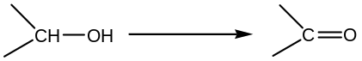
Here, the enzyme acting on a $RRCHOH or RR'CHOH$ i.e. $2^{0}$- alcohol group and thus, causes reduction.
$1.1.1⟶$ Reductase acting on $2^{0}$- alcohol group (involved on the $H$- atom) acceptor is hydrogen ($1$)
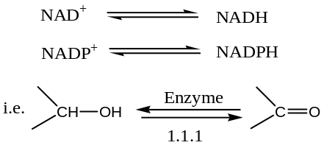
$1.1.1.1⟶$ Alcohol dehydrogenase
$1.1.2⟶$ Oxido-reductase acting on an alcohol acceptor is cytochrome ($2$)
$1.1.3⟶$ Oxido-reductase acting on an alcohol acceptor is molecular oxygen ($3$)
$1.2⟶$ Enzyme (oxido-reductase) acting on an aldehyde or keto group as donor
$1.2.1⟶$ Enzyme (oxido-reductase) acting on an aldehyde or keto group and the donor is $NADH or NADPH$
$1.2.1.1⟶$ Enzyme (oxido-reductase) acting on an aldehyde or keto group and the donor is $NADH or NADPH$ and it is the first enzyme of the series
$1.2.2⟶$ Oxido-reductase enzyme acting on an aldehyde or keto with cytochrome (electron donor) as coenzyme
$1.2.3⟶$ Oxido-reductase enzyme acting on an aldehyde or keto with molecular oxygen as donor
$Class 2⟶$ Transferase: All has the first digit as $2$
$2^{nd} No.⟶$ Sub- Class number depends on the general nature of the group transferred
$3^{rd} No.⟶$ Sub- subclass number depends on the exact nature of the group transferred (a specified group)
Following are the examples —
$2.1⟶$ Transferase which transfer carbon group ($1$)
$2.1.1⟶$ Transferase which transfer a methyl group ($-CH_{3}$)
$2.1.2⟶$ Transferase which transfer hydroxy methyl ($-CH_{2}OH$) or formyl group ($-OCH$)
$2.1.3⟶$ Transferase which transfer a carboxylate methyl ($-COO^{-}$)
$2.5⟶$ Transferase which transfer an aryl group ($-C_{6}H_{5}$) or alkyl group other than a methyl group ($-CH_{3}$)
$2.6⟶$ Transferase which transfer $N$- containing group ($e.g.-NH_{2}, -NO_{2}, -CONH_{2}, etc.$)
$Class 3⟶$ Hydrolases i.e. Hydrolytic Enzyme: Starting number is $3$
$2^{nd} No.⟶$ Sub- Class number depends on the general nature of the bond (i.e. functional group) that is hydrolyzed e.g. ester, ether, amide, etc. bond
$3^{rd} No.⟶$ Sub- subclass number depends on the characteristics of the molecules in which the bonds are hydrolyzed
Following are the examples —
$3.1⟶$ Enzymes which catalyzes the hydrolysis of ester group ($1$)
$3.1.1⟶$ Enzymes which catalyzes the hydrolysis of ester group ($1$) and the ester is a carboxylic acid ester ($1$) —
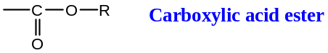
$3.1.2⟶$ Enzymes which catalyzes the hydrolysis of ester group ($1$) and the ester is the thio ester ($2$) —
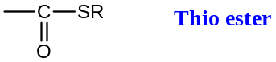
$3.1.3⟶$ Enzymes which catalyzes the hydrolysis of ester group ($1$) and the ester is the phosphoric mono-ester ($3$) —
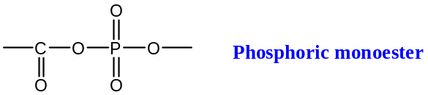
$3.1.4⟶$ Enzymes which catalyzes the hydrolysis of ester group ($1$) and the ester is the phosphoric di-ester ($4$) —
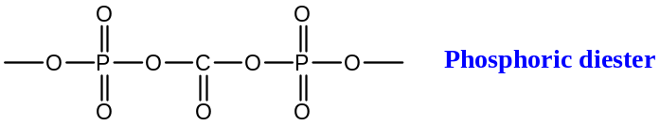
$Class 4⟶$ Lyases: All has the first digit as $4$, which indicates that the enzyme catalyzes the elimination in a reaction giving unsaturated bond. Again, —
$2^{nd} No.⟶$ Sub- Class number indicates the two atoms between which the unsaturated bond is formed.
$3^{rd} No.⟶$ Sub- subclass number depends on the group eliminated
Following are the examples —
$4.1⟶$ Enzymes which lyases (formation of unsaturation) $C-C$ bond
$4.1.1⟶$ Enzymes which lyases carboxy (elimination of $-COO^{-}$ or keto Gr. ($–CO-$)
$4.2⟶$ Enzymes which lyases carbon-oxygen bond i.e. formation of $C-O$ unsaturated bond
$Class 5⟶$ Isomerases: All has the first digit as $5$, and this indicates that the enzymes that catalyze various types of isomerisation. Again, —
$2^{nd} No.⟶$ Sub- Class number depends on the types of isomerisation
$3^{rd} No.⟶$ Sub- subclass number depends on the type of substrate or type of conversions
Following are the examples —
$5.1⟶$ The Enzymes is an epimerization or racemization enzyme
$5.1.1⟶$ The Enzymes is an epimerization or racemization enzyme and the enzymes is acting on amino acids or its derivatives
$5.1.2⟶$ The Enzymes is an epimerization or racemization enzyme and the enzymes is acting on hydroxy acids or its derivatives
$5.1.3⟶$ The Enzymes is an epimerization or racemization enzyme and the enzymes is acting on carbohydrates or its derivatives
$5.2⟶$ Cis- trans- isomerisation
$5.3⟶$ Intermolecular oxido-reductase
$5.3.1⟶$ Intermolecular conversion of an aldehyde to keto group
$5.3.2⟶$ Intermolecular conversion of a keto to enol group
$5.4⟶$ Intermolecular transferase
$5.4.1⟶$ Intermolecular transferring of acetyl groups
$5.4.2⟶$ Intermolecular transferring of phosphenyl groups
$Class 6⟶$ Ligases (Synthetase): All has the first digit as $1$, and —
$2^{nd} No.⟶$ Sub- Class number depends on the types of bond formed
$3^{rd} No.⟶$ Sub- subclass number depends on the type of substrate which are joined and on the nucleotide bond broken
$$[Note: -C-O-P-is a nucleotide bond,$$
$$it is highly energitic in biological systems and are found in DNA]$$
Following are the examples —
$6.1⟶$ Enzymes which catalyses the formation of $C-O$ bond
$6.2⟶$ Enzymes which catalyses the formation of $C-S$ bond
$6.3⟶$ Enzymes which catalyses the formation of $C-N$ bond
$6.2.1⟶$ Acid-Thio Ligases
$6.3.1⟶$ Acid-Ammonia (Amide Synthetase)
$6.3.2⟶$ Acid-Amino Acid (Peptide Synthetase) //
Systematic Nomenclature of Enzymes:
The systematic names of enzymes consist of two parts — 1st part specifying the substrate(s) and the 2nd part, which ends in “$ase$”, indicates the nature of the reaction that is catalyzed. Now, let us consider the systematic names of all the $6$- main groups of enzymes —
[$1$] Oxido-Reductase — here, the name of the enzyme depends on the nature of the substrate which is undergoing change.
Substrate — Dehydrogenase (most commonly used)
Substrate — Hydrogenase (very rarely used)
Substrate — Oxidases (not used at all except when molecular $O$- is the acceptor)
For Example, —
Here, the enzyme used is alcohol dehydrogenase, whose EC name is $1.1.1.1$
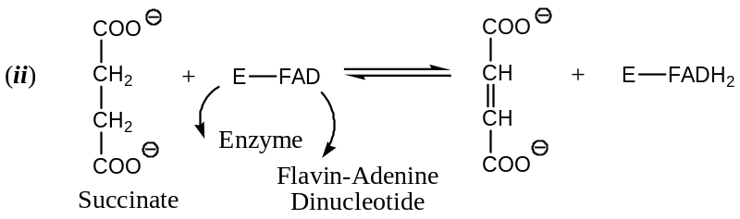
Here, the enzyme used is succinate dehydrogenase
[$2$] Transferases — Here, in the name of enzyme there are $3$- characteristics viz. donor, acceptor and the group transferred, and the enzyme is named as —
Donor: Acceptor – group transferred
For example, let us consider the following reaction —
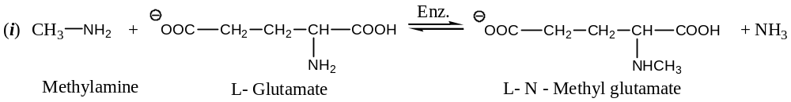
The name of the enzyme will be —
Methylamine: L- Glutamate – N- methyl transferase
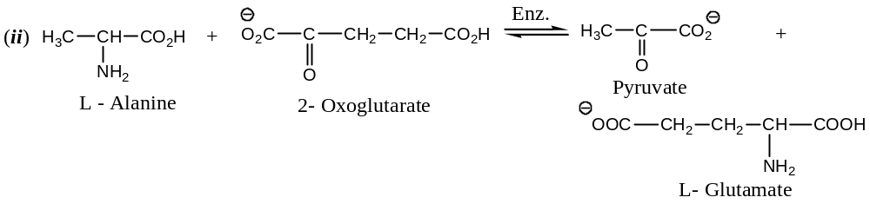
The name of the enzyme will be —
L - Alanine: 2- Oxoglutarate – amino transferase
(Enzyme commission (EC) number is $2.6.1.2$), etc.
[$3$] Hydrolases (Hydrolytic Enzymes) — Here, the substrate is hydrolyzed and the enzyme is substratease. For example, —
Acetyl choline esterase
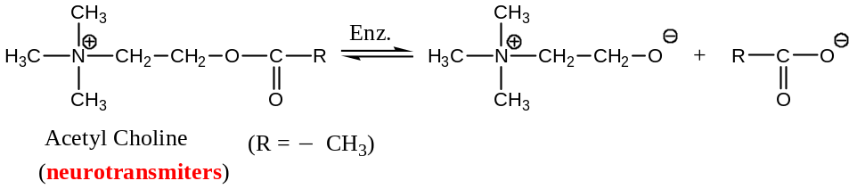
[Important: Acetyl choline is a quaternary ammonium salt, essential for neurotransmission.
The above reaction is better represented as —
$$(CH_{3})_{3}N^{+}CH_{2}CH_{2}O_{2}CCH_{3}+EnzymeOH⇌(CH_{3})_{3}N^{+}CH_{2}CH_{2}OH+$$
Acetyl choline Cholinesterase $EnzymeO_{2}CCH_{3}$
Acetylcholine esterase
In neurotransmission, the ester acetylcholine is released by a nerve impulse to trigger a muscle contraction. The enzyme cholinesterase hydrolyzes the ester to end the process. The hydrolysis is a transesterification, in which the acetyl group is transferred to a hydroxyl group of the enzyme.
Phosphorylation: Phosphoric esters accounts for over $3\%$ of the organic materials in most living tissues.
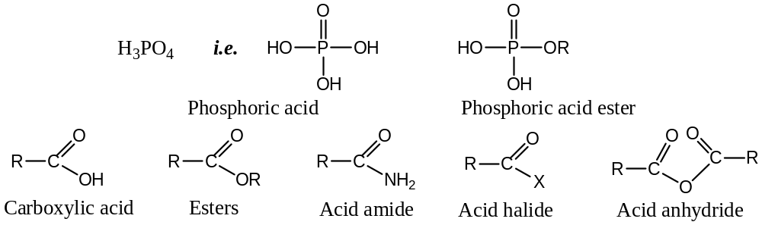
Phosphoric esters are involved in almost every aspect of cellular function. One of the important reactions of phosphoric ester is phosphorylation, the process whereby a phosphoryl group is transferred from one group to another. The sequence is nucleophilic substitution on phosphorous and is accomplishes the same type of structural change as do the acyl transfer reactions of carboxylic acid derivatives.
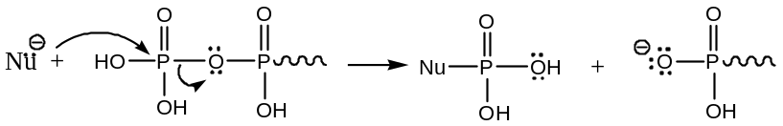
Adenosine triphosphate ($ATP$) is often referred to as a “high-energy” phosphate. In bio-chemical terms, this means that when $ATP$ transfers a phosphate group (phosphorylation) to a substrate acceptor (nucleophile), energy is released. The cleavage of phosphate bond is an important pathway for energy transfer in biological systems.
The amount of energy released depends on the nature of the nucleophile involved in phosphorylation. Using water as the standard hydrolysis of $ATP$ (phosphorylation of water) produces adenosine diphosphate ($ADP$) and release about $7 kcal{mol}^{-1} (30 kJ{mol}^{-1})$ of energy.
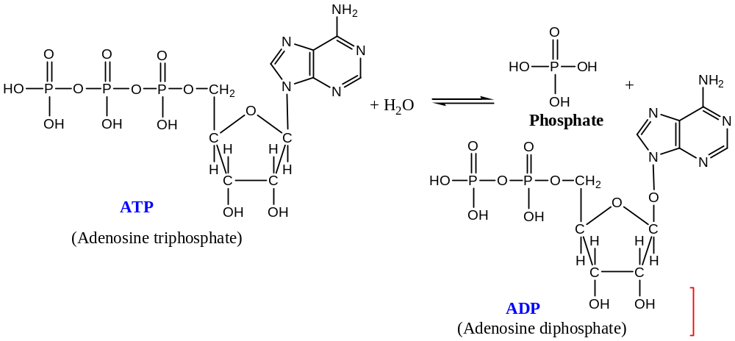
[$4$] Lyases — here, in the systematic name of enzyme is constructed by considering the substrate and the group which is eliminated in forming the double bond.
For example, let us consider the following reaction —
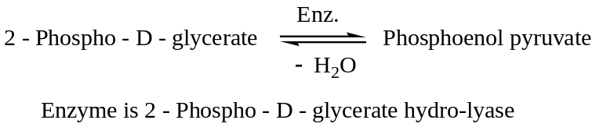
[$5$] Isomerases — here, in the name of the enzyme depend on the type of isomerisation which is catalysed.
For example, —
Epimerase — catalyze epimerization
Tautomerase — catalyze tautomerization
Mutase — catalyzes mutarotation, etc.
[$6$] Ligases — The Ligases are named systematically according to the molecules $X \& Y$, which are joined together the nucleotide that is formed in the process.
Name: $X:Y$ ligase ($ADP$ forming), for the enzyme which joins $X \& Y$ with the simultaneous hydrolysis of $ATP$ to $ADP$
For example, —
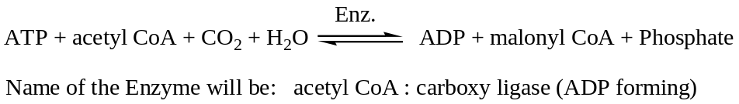
Acetyl CoA:
At present, it is believed that the fundamental units used in the cell in synthesis (i.e. biosynthesis) are water, carbon dioxide, formic acid (as ‘active formate’), and acetic acid (as ‘active acetate’). These ‘active’ compounds are acyl derivatives of coenzyme-$A$. This coenzyme is a complex thiol derivatives found in biological system as thioester, functions as an acylating agent and is usually written as $CoA$-$SH$, but $CoA$ is also in common uses. Thus, acetyl-coenzyme-$A$ may be represented as $CH_{3}CO-SCoA or CH_{3}CO-CoA$. This compound is energy rich.
The coenzyme-$A$ ($CoA or CoASH$) is a complex molecule, which terminates in a thio group.
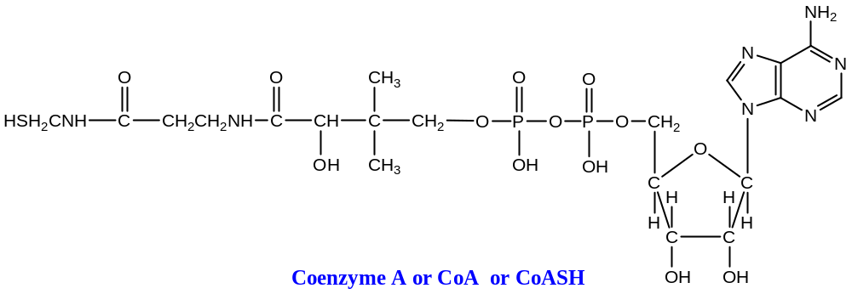
Coenzyme-$A$ functions as acetylating agent. For example, acetyl-coenzyme-$A$ ($AcSCoA$) can transfer an acetyl group to a phosphate ion (often called ‘inorganic phosphate’). This particular reaction is controlled by the enzyme phosphotransferase. It occurs in certain bacteria as one of the steps in the formation of adenosine triphosphate ($ATP$).
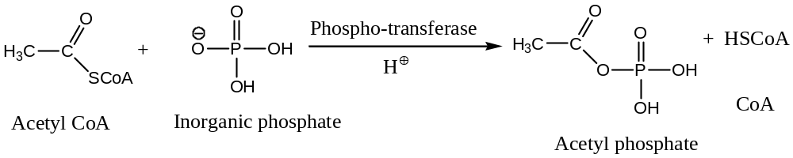//
Catalytic Activity of the Enzymes:
Most of the reactions in biosynthesis are catalyzed by different enzymes. It has been shown that the rate of the enzyme catalyzed reactions depends on the number of factors, i.e. the catalytic activity of the enzymes depends on various factors —
- Temperature — enzyme catalyzes reaction at $≈37℃$
- $p^{H}$ of the solution — enzyme catalyzes reactions properly (with high rate) at near to neutral $p^{H}≈7$
The rate of enzyme catalyzed reaction depends on the concentration of the substrate and that of the enzyme. If the substrate is in excess, the rate is directly proportional to the concentration of the enzyme. Following are the important points of catalysis reactions —
[$1$] Adsorption–Desorption: Since enzymes are characterized by the presence of ‘active site’, which is a part of the protein and forms a complex with the substrate (adsorption) during catalysis and the ‘active site’ is regenerated (desorption) after the reaction. This is true for enzymes which are of pure proteins. In case of the presence of coenzymes, the coenzyme part undergoes a change during catalysis. However, a reverse processing occurs to bring the coenzyme back to its original form (desorption).
[$2$] The rate of the catalytic reaction is enhanced by —
- Lower activation energy, and
- Causes the reactions to follow a different path
The activation energy of a non-catalyzed reaction is more than that of a catalyzed reaction, i.e. the enzyme catalyzed reaction has lower activation energy ($∆E$).

Catalyst causes the reaction to follow a different path. This theory was given by ML Benderi.
In ML Benderi’s view, the function of an enzyme is to provide a new reaction pathway in which the rate determining step (slowest step) has a lower energy of activation than the rate determining step of the uncatalyzed reaction.
[$3$] A catalyzed reaction never performs a reaction which is energetically or thermodynamically impossible [$-ve, ∆G⇒Spontaneous \left(exergonic\right), otherwise endergonic$]. For example, the first order biochemical synthesis of carboxylic acid is the conversion of acetyl coenzyme $A$ ($AcCoA$) to malonyl- $CoA$ in the following way —
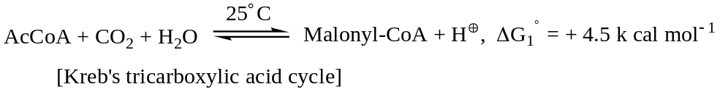
Hence, this reaction is thermodynamically non-spontaneous ($as ∆G is+ve$). This endergonic reaction is driven by an exergonic reaction, which is hydrolysis of $ATP (to ADP)$.
$$∴ ∆G^{0}=∆G_{1}^{0}+ ∆G_{2}^{0}=-4.4 kcal{mol}^{-1}$$
This reaction is catalyzed by an enzyme, which has Biotin as a coenzyme, $E$- Biotin.
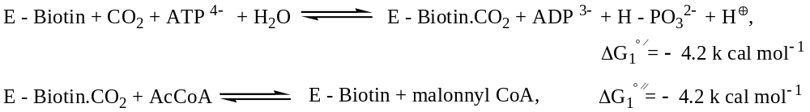
Thus, the overall reaction will be (by adding the above two) —
$$AcCoA+CO_{2}+ATP^{4-}+H_{2}O ⇌Malonyl CoA+ADP^{3-}+HPO_{3}^{2-}+H^{+}$$
$$and, ∆G^{0}=∆G^{0'}+ ∆G^{0''}=-4.4 kcal{mol}^{-1}$$
Using chemical structures, the above biological reactions can be represented as —
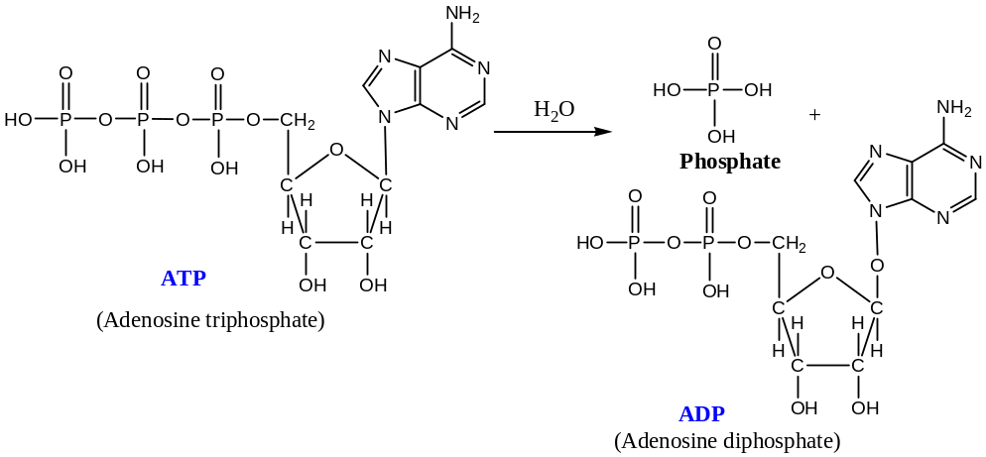
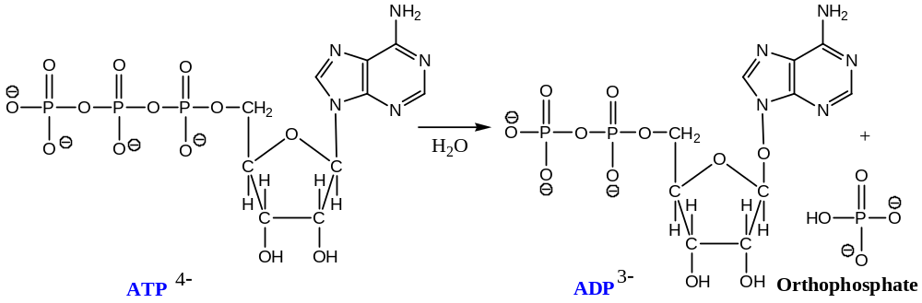
$$i.e. ATP^{4-} \underset{→}{{ H}_{2}O } ADP^{3-}+HPO_{4}^{2-}+H^{+}$$
Different phosphoric acids —
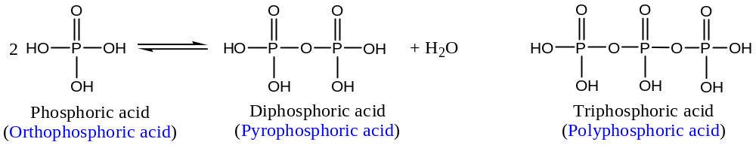
Glycolysis and Metabolic Energy:
Glycolysis is one of the important pathways by which organisms obtained energy that are stored in carbohydrates. A sequence of enzyme mediated steps converts glucose to pyruvate in an anaerobic (without air) process. The chemical reactions involved are closely related to those by which the glucose is produced during photosynthesis. The energy liberated in glycolysis reactions is used to reduce $NAD$ to $NADH$ as well as to produce $ATP$, the prime compound for energy transfer in metabolism.
The glycolysis pathway is outlined in the figure given below with showing common bio-chemical convention of using curved arrows at the reaction arrow to indicate the components which participate in specific reactions.
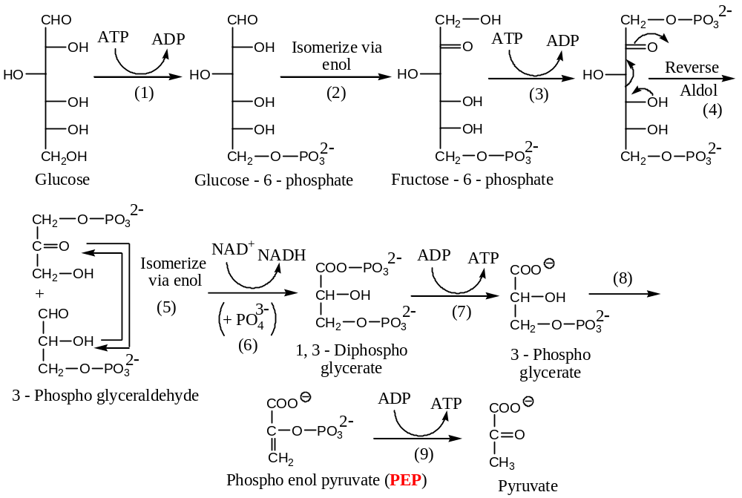
The central degradation in glycolysis is the reverse aldol cleavage (reaction 4) of a hexose to $2 moles$ of triose. Both triose fragments continue along the path to pyruvate by isomerisation (5), in which the carbonyl enolizes to an ene-diol and then reprotonates in the opposite direction. The same mechanism occurs in reaction- 2. Two hexose molecules utilize ATP to phosphorylate hydroxyl groups (1 & 3), and two triose regenerate ATP by phosphate removal (7 & 9). Since, there are twice as many triose molecules as there are hexose molecules, the result is a net gain of two ATP molecules to be stored for use as energy source elsewhere.
In the oxidation of an aldehyde to an acid derivative (reaction 6), $NAD^{+}$ is reduced and energy is thus made available. This energy allows the stable ‘inorganic’ phosphate ion ($PO_{4}^{3-}$) to be transformed into a phosphoric anhydride with sufficient reactivity to transfer a phosphate unit to ADP, so as to create ATP in step 7. The reaction is an oxidative phosphorylation. The enol phosphate, PEP, is also a fairly high-energy compound. It serves not only to generate more ATP but also in biosynthesis, as an active enol for $C-C$ bond formation via aldol and Michael addition.
In higher animals, glycolysis terminates in the conversion of pyruvate to lactate. Yeast and certain other organisms transform pyruvate to $EtOH$ and $CO_{2}$ in the process known as fermentation.
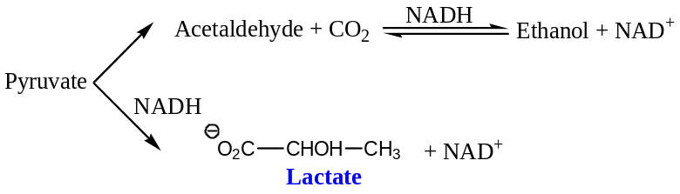
Glycolysis in most animals serves as a source of energy for short periods of time under anaerobic conditions. It accounts for only a small fraction of the potential energy of glucose.
$$Glucose+2ADP+2 Inorganic phosphate ⟶2 Lactate+2ATP+2H_{2}O,$$
$$∆G^{0}=-32.4 kcal{mol}^{-1}(-135 kJ{mol}^{-1})$$
Most of this energy is released during respiration, the process by which molecular oxygen converts acetyl units to water and carbon dioxide. //
Krebs Cycle or Tricarboxylic Acid Cycle or Citric Acid Cycle:
The Krebs cycle, also known as the tricarboxylic acid cycle or citric acid cycle is the central pathway of respiration. The cycle das a very important analogy to the Kelvin cycle of photosynthesis in that each provides a pathway for a chemical reaction which does not, in the total sequence, consume the chemical components of the cycle. The cycles represent rather complex catalytic systems.
Acetyl coenzyme A, the raw material for the Krebs cycle, originates from the pyruvate (or lactate) of glycolysis as well as from amino acid and fatty acid metabolism.
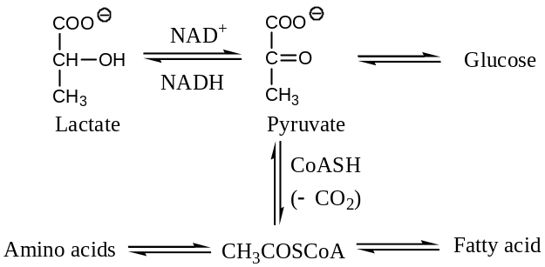
Acetyl coenzyme $A$ ($AcCoA$) enters the cycle through reaction with oxaloacetate. In a sequence of reactions which involves $10$- intermediates, $2 moles$ of $CO_{2}$ and $1 mole$ of $H_{2}O$ are released in addition to energy. Oxaloacetate is regenerated, and the cycle repeats. The steps of Krebs cycle are outlined below —
Some other enzymes are —
Theories of Enzyme Catalysis:
Some other enzymes are —
Theories of Enzyme Reaction Mechanism:
Some other enzymes are —
Induced-Fit Model for Enzyme-Substrate Interaction:
Some other enzymes are —
T C Buice Theory of Proximity Effect:
Some other enzymes are —
Enzyme Specificity i.e. Specificity of Enzyme Action:
Some other enzymes are —
Deactivation of Enzymes:
Some other enzymes are —
Enzyme Model:
Some other enzymes are —
Functionalized Polymers as Enzyme Models:
Some other enzymes are —
Coenzyme Model:
Some other enzymes are —
These generalizations are schematically shown below —

The End

