hormones_steroid hormones
(organic natural products)
[Definition, classification and functions of hormones]
Definition of Hormones:
Hormones are the most important ‘Biological Regulators’, which are the substances produced or secreted by the ductless glands (i.e. endocrine) and are carried to the site of action by the blood-stream. Structurally, hormones are quite different from one another and these are classified on the basis of their various physiological actions. Hormones are very specific in nature and are required in very small quantities to result in specific physiological function.
Hormones are basically of two types —
- Steroid hormones: — For example: Sex hormones (Testosterone — the male sex hormone and Estradiol — the female sex hormone) and Cortisone. Cortisone is produced by adrenal cortex. Its main function is to effect metabolism of carbohydrates, lipids, proteins and minerals
- Non-steroid hormones: — For example: Adrenaline, Thyroxin and Insulin
Basic unit of hormones is the cyclopentanophenanthrene a $C_{17}$- hydrocarbon —
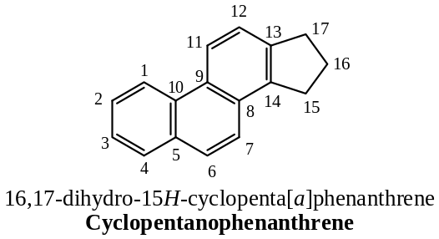
Question ($1$): Name the organ of secretion and one principal use of ($a$) adrenaline and ($b$) insulin.
Solution: ($a$) Hormone adrenaline is secreted by medulla part of the adrenal gland. This hormone is responsible to increase blood pressure and to stop haemorrhage.
($b$) Insulin is a non-steroid hormone secreted by pancreas. It controls blood sugar level (the deficiency of insulin causes diabetics).
Classification of Hormones:
Hormones are all structurally related compounds. They are mainly classified on the basis of their biological functions performed by them. These are broadly classified into the following six classes —
- Sterols (e.g. cholesterol),
- Sex hormones,
- Adrenocortical hormones,
- Bile acids,
- Phytosterol, and
- Vitamin- $D$
Sterols like cholesterol have received attention because of suspected correlation between cholesterol level in blood and heart diseases. Sex hormones regulate the sexual processes in animals. Bile acids are important in the assimilation of fatty materials in the intestinal tract of animals and hormones of the adrenal cortex, regulate a variety of physiological processes in animals are mostly steroidal. Plants also elaborate a verity of steroids, which are similar to animal steroids in structure but are not utilized by animals. Thus, steroids are organic compounds of great interest.
Physiological Activity & Functions of Cholesterol:
In the recent years, cholesterol has received much attention because of the suspected correlation between cholesterol level in blood and heart diseases. The deposition of excess cholesterol results to arteriosclerosis i.e. hardening of the arteries that produces degenerative heart diseases, stroke and other arterial diseases. When cholesterol precipitates out of the blood and accumulates in blood vessels and reduces blood flow. This leads to high blood pressure.
In common language “cholesterol” does not refer only to the pure compound that we call cholesterol but refer to mixtures of that contain cholesterol, other lipids and proteins. These combined forms are called chylomicrons, high density lipoproteins ($HDLs$) and low density lipoproteins ($LDLs$). These are similar to globular micelles and acts as the vehicles by which cholesterol is transported through the aqueous environment of the body. The HDL is called “good cholesterol” as it carries lipids containing cholesterol from the tissues to the liver for biosynthesis of other steroids, degradation and excretion. The LDL is referred to as “bad cholesterol” as it carries biosynthesised lipids containing cholesterol from the liver to the tissues. If too much cholesterol is being transported by $LDL$ and too little by $HDL$, the extra cholesterol deposited on the walls of arteries causing arteriosclerosis. Chylomicrons transport dietary lipids from the intestine to the tissues.
Besides, above said aspects cholesterol has several important physiological functions of the body, which are necessary for life. These are —
- It is one of the essential constituent of cells and helps in the permeability of the cells.
- It prevents the red blood cells from being easily haemolysed.
- In transportation of fat to the liver in the form of cholesterol esters for oxidation.
- It is used by the body in the biosynthesis of the bile acids and bile salts, $7$- dihydro cholesterol and vitamin $D_{3}$, corticosteroid hormones, androgens (male sex hormones), progesterone and estrogens (female sex hormones).
- Cholesterol helps in granulation of cell division and also an antagonist to phospholipids.
- Cholesterol is a poor conductor of electricity and is a good insulator against electric discharge. It is believed that it functions as insulator covering in nerves and spinal cord i.e. in impulse generating organs. Its abundances in these parts further prove this function. //
The structure of cholesterol is —
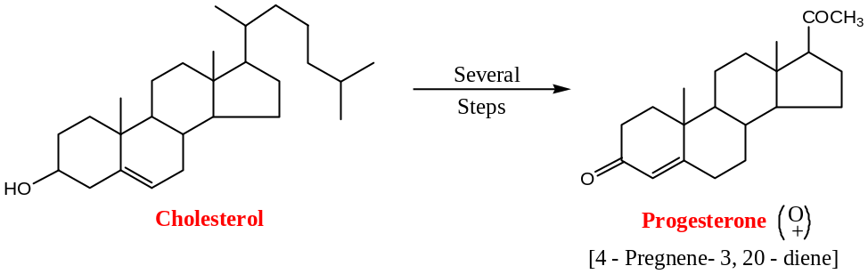
$$Cholesterol\underset{→}{Dehydrogenase}7-Dehydro cholesterol\underset{→}{UV Irradiation}Vitamin D_{3}$$
Steroid Hormones:
Hormones are the substances produced or secreted by the ductless glands (i.e. endocrine) and are carried to the site of action by the blood-stream. Structurally, hormones are quite different from one another and these are classified on the basis of their various physiological actions. Hormones are very specific in nature and are required in very small quantities to result in specific physiological function.
Steroid hormones are of two types —
- Sex hormones, and
- Adrenocortical hormones
Sex Hormones:
Sex hormones are produced in the gonads (testes in the males and ovaries in the females). They are responsible for sexual functions and secondary sexual characteristics which differentiates males from the females. The activity of sex-hormones appears to be controlled by the hormones (which are protein in nature) secreted by the anterior lobe of the pituitary gland, which are therefore, known as the primary sex-hormones. The steroid sex-hormones are therefore, therefore, known as the secondary sex-hormones.
The sex hormones are of three types —
- Estrogens (also written as oestrogens),
- Gestogens, and
- Androgens
While the first two (Estrogens & Gestogens) are responsible for reproductivity function in females (i.e. female sex hormones) and the last one (Androgens) is known as the male sex-hormones. In addition, androgens and estrogens are known to have significant effect on the anabolic system. These are used by athletes, weight-lifters, body-builders to enhance the muscle size and muscle strength. Such steroids are commonly known as the anabolic steroids.
Another type of steroid hormones is adrenocortical hormones. They are produced in the cortex protein of the adrenal gland and are involved in the metabolism of water, carbohydrates, etc. Their deficiency leads to the loss of fluids and excess results in the increase in the body blood pressure.
Classification of steroid hormones are presented below in flow-chart —
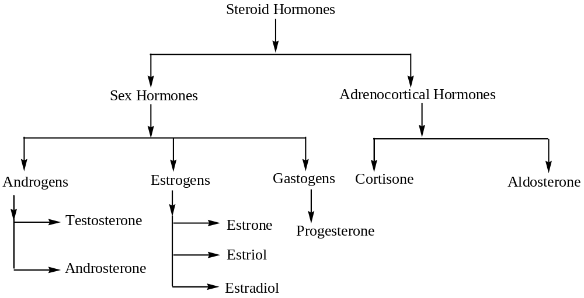
Androgens:
Androgens are the male sex hormones. Testosterone, which is produced in the testes, is the main the male sex hormone, other androgens like androsterone and dehydroepiandrosterone are the metabolites of testosterone. The testosterone is ten times more active than that of androsterone. Androsterone and dehydroepiandrosterone were first androgens isolated in the crystalline form. The structure of testosterone, androsterone and dehydroepiandrosterone are —
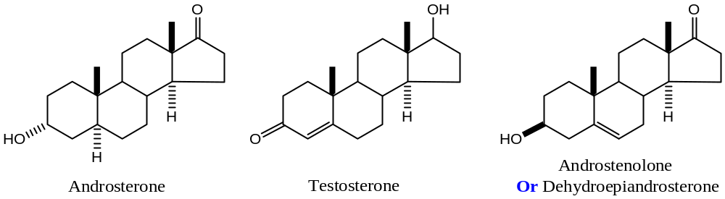
Estrogens:
All estrogens contains $18$- $C$- atoms and are characterized by the aromatic nature of ring $A$. All of them do not have the $C$-$10$ angular methyl group in their structure, $C$-$3$ position contains one $–OH$ group and $C$-$13$ position contains an $O$- atom containing functional group (e.g. keto, hydroxyl, etc.).
The most potent and the principal estrogen is the estradiol and the most abundant but less potent metabolites are estrone (oestrone) and estriol.
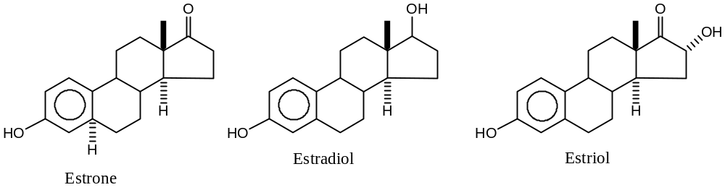
Important: Estrone was the first sex-hormone isolated in the crystalline form from the urine of the pregnant women. It is also isolated from palm-kern-oil.
Anabolic Steroids:
Androgens and certain other androgen derivatives are known as anabolic steroids. This is because androgen promotes protein anabolism, which stimulates the growth of skeletal muscles. Testosterone or similar androgens decreases the urinary loss of nitrogen without increasing the non-protein nitrogen of the blood and produce temporary increase in body weight. This suggests that hormone causes a true storage of nitrogen in the form of tissue protein. In the dog androgens have been reported to increase the synthesis of protein and decreases the rate of catabolism of animal acids. Androgens are often used by weight-lifters, football players and wrestlers to increase muscle mass and strength. Moreover, since, androgens increases the protein matrix of the bone, they have been used in the clinical treatment of certain skeletal defects.
Gestogens:
Gestogens are the female sex hormones, which are secreted in the corpora-lutea. Progesterone is the important member of this class.
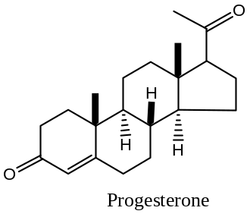
Adrenocortical Hormones: Adrenocorticoids
The adrenal glands (of mammals) are the small organs weighing about $6 g$, and are located in the upper portion of kidney. In the adrenal glands, there are two regions: the medulla which produces adrenaline, and cortex which produces steroid hormones known as the corticoids. The production of the corticoids is controlled by the hormones produced in the anterior lobe of the pituitary glands which are known as adreno-cortico-trophilic ($ACTH$). Around $50$- steroidal compounds are isolated from the cortex. Several of these compounds were found to be inactive, while only a few others turned out to already known sex-hormones. Several compounds have high physiological activity and they are collectively known as corticoids. It has been seen that eight of these substances are only highly physiological active, and these are —
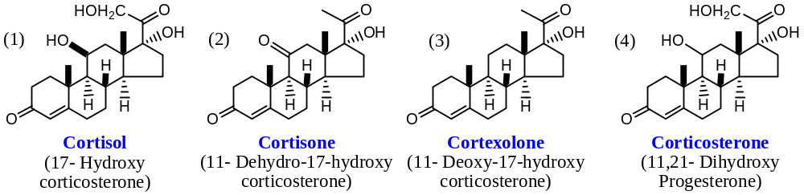
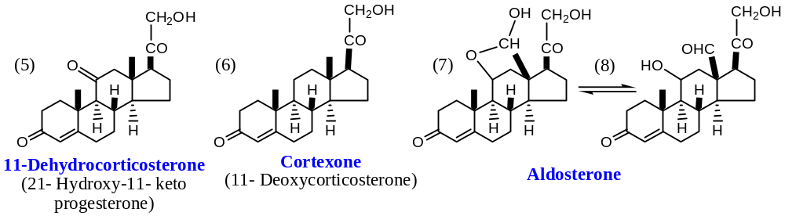
Functions of Corticoids:
Cortisone, corticosterone and $11$- dehydro corticosterone are gluco corticoids, since their chief action is on carbohydrate metabolism. They have also influence on protein metabolism, lipid metabolism and have effect on control of blood pressure. Mineralo corticoids of which aldosterone are the most prominent, have their greatest action on mineral and water metabolism. They help in the retention of $NaCl$ and water in the increased excretion of ‘$X$’.
Corticoids — the important Drugs:
Cortisone was applied successfully for the treatment of rheumatoid arthritis in the year 1949. This research affords to bring Novel Prize to Kendall, Hench and Reichstein. Moreover, the corticoid therapy had found extensive use in the treatment of various allergies like eczema, and asthma. Fatal allergic reactions to several drugs can be treated by corticoid injections. Thus, a person under penicillin shock can be cured in a matter of minutes with a corticoid injection. In rheumatoid arthritis not only the pains and stiffness, but also the more dangerous inflammation suffering of the endocardium, which is caused by streptococcal infections, are treated by corticoids. Corticoids along with antibiotics have proven useful to save the heart valves from deformations which could otherwise lead to fatal cardiac effects.
A healthy body defences itself against any foreign protein. In the process, therefore, the body not only destroys the implanted organ like heart or kidney but also itself in the extreme danger as a result of its excessive defence reactions. Corticoid therapy is helpful in such situation as well as by reducing these reactions to a measurable level so that heart and kidney transplants can function for several years in the host body. This dramatic application of corticoids makes them the most important drugs next only to the antibiotics.
Relationship between Structure & Biological Activity of Corticoids (Drugs):
After the structure elucidation of all the Corticoids, it was soon found that there was a definite relationship between the specific biological activities with the structure of the corticoids. It was found that the gradual addition of the $–OH$ groups at $C$-$11$ and $C$-$17$ changes the properties of the naturally occurring corticoids. Thus, cortexone, which has no hydroxyl groups has the maximum influence on the mineral metabolism and is, therefore, a minerallocorticoids. On the other hand, corticosterone which has one $–OH$ group at $C$-$11$ displays biological activities which is somewhere in between cortexone and cortisol. Again, cortisol with two $–OH$ groups at $C$-$11$ and $C$-$17$ is the excellent hormone of glucose metabolism and is the established gluco corticoids.
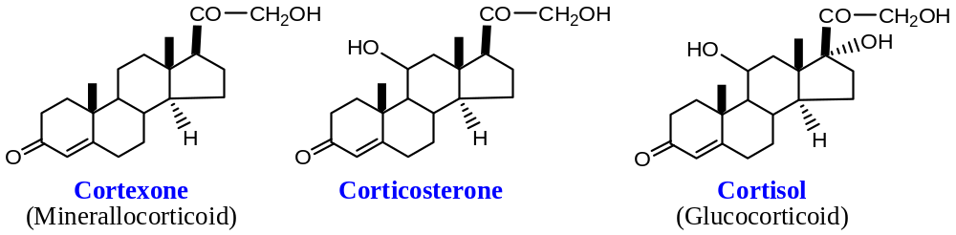
Therefore, cortexone and cortisol are drugs of choice for the relief of inflammatory conditions like rheumatoid arthritis and asthma. These compounds, however, suffer from disadvantage of suffering electrolyte balance, which causes excessive of water & nitrogen and depletion of potassium. Several synthetic analogues have therefore been made which would display an anti-inflammatory property and reduced minerallocorticoids activity.
Prednisone and its corresponding $11β$-$ol$, prednisolone are the two important members. Several of the synthetic corticoids which are in used today are the derivatives of these two compounds. It has been found that when a $F or Cl$ is substituted at $C$- $6$ or $C$- $9$, exceptionally potent corticoids for the treatment of skin diseases.
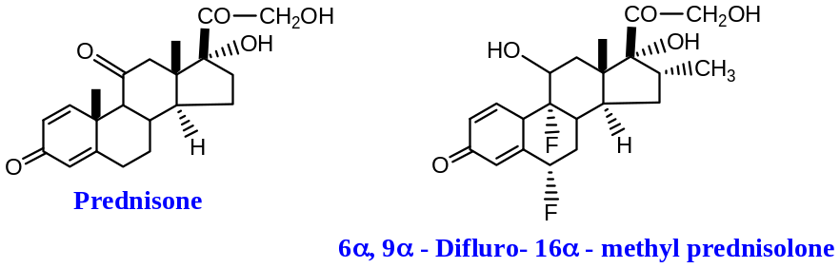
It is observed that one dehydro-derivative of cortisone and cortisol i.e. prednisone and prednisolone surpassed the parent hormones in anti-rheumatic anti-allergic activity, at the same time reducing minerallocorticoids quantities by $2-3$ times on methylation at $16α$- or $16β$- positions. Some of attachments to the basic nucleus which led to the improvement of a corticoid molecule are shown below —
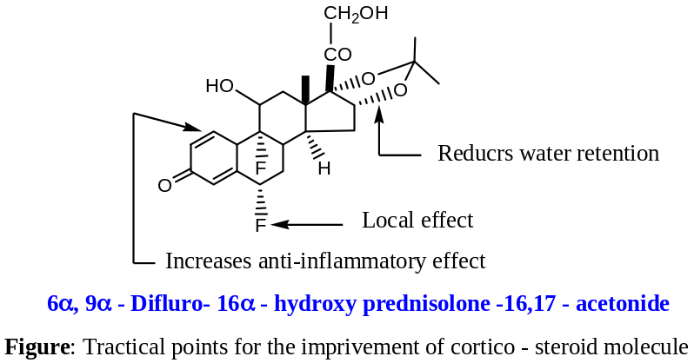
$1,2$- Dehydrogenation in the case of corticoids has been carried out with excellent results by microbiological dehydrogenation by Coryne- bacterium simplex, chemically this dehydrogenation has been brought about by $SeO_{2}$ distillation. //
Applications Adrenocortical Hormones:
Adrenal cortex, a part of adrenal glands present on the top of kidney secretes around $50$- steroidal compounds are isolated. Out of these the two important steroid hormones are cortisone and cortisol. Cortisol is the major hormone synthesised by the human adrenal cortex.
Adrenocortical steroids are important in regulating physiological processes of the body. These include carbohydrate, protein and lipid metabolism, water and electrolyte balance, reactions to allergic and inflammatory phenomenon. The usefulness of cortisone in the treatment of rheumatoid arthritis as an anti-inflammatory drug was recognized in 1949. About eleven oxygenated steroids now used in the treatment of a variety of disorders like skin-inflammations, asthma, and Addison’s disease.
Non Steroid Hormones:
Non-steroid hormones do not have any structural resemblance to steroids and hence the name. These are basically of two types —
- Thyroid gland hormones, and
- Adrenal gland hormones
Thyroid gland hormones: Thyroxine and related compounds —
It is secreted by thyroid gland situated in the neck. Thyroxine is closely associated with its precursor di- iodo-tyrosine and a protein called thyroglobulin. Thyroglobulin when hydrolyzed gives mainly —
- Thyroxine,
- Amino acids,
- $3$- Iodotyrosine,
- $3,5$- Di- iodotyrosine and
- Iodo derivatives of $L$- thyronines.
Three types of iodo-thyronines are known —
- $3,3'$- Di- iodo-thyronine,
- ${3,3}^{'},5'$- Tri- iodo-thyronine, and
- ${3,3}^{'},5$- Tri- iodo-thyronine
It has been shown that the ${3,3}^{'},5$- tri- iodo-thyronine is $5$- times more active than thyroxine and considered as true hormone with thyroxine as a precursor.
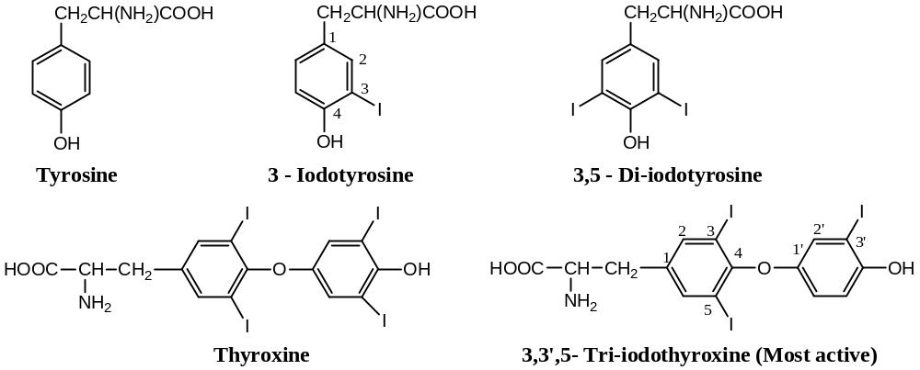
Functions of Thyroxine:
Thyroxine absorbs between $20 to 30 mg$ of iodine per $100 mL$ of tissue. Thyroxine is slowly released into the blood to maintain normal metabolic functions. Thyroxine deficiency causes disturbances in metabolism of carbohydrates, proteins, lipids, electrolytes, etc. Its deficiency in children causes juvenile myxedema. The excess of thyroxine causes rapid heart beating and nervous irritability.
Thyroxine causes an increase in the metabolism of carbohydrates, proteins and lipids. In general, it also increases the consumption of oxygen by tissues. It has been established that a low level of thyroxine (hypothyroidism) lead to lethargy and obesity; whereas a high level of thyroxine (hyperthyroidism) can cause reverse effect. Low thyroxine level can cause goitre, which can be cured by hormone supplements.
//
Adrenal gland hormones:
Adrenal glands are located above each kidney. These consists of two parts — medulla (central part) and cortex (outer part). The medulla secretes two hormones — adrenaline (epinephrine) and nor- adrenaline (nor- epinephrine) in $4:1$ ratio.
[Since, cortex hormones are already discussed in steroid hormones; hence, we will discuss briefly the medulla hormones here]
Adrenaline (epinephrine) and nor- Adrenaline (nor- epinephrine) Hormones:
Adrenaline is the first hormone, extracted from animal tissues. It is a derivative of phenyl-alanine and tyrosine. These have the following structures —
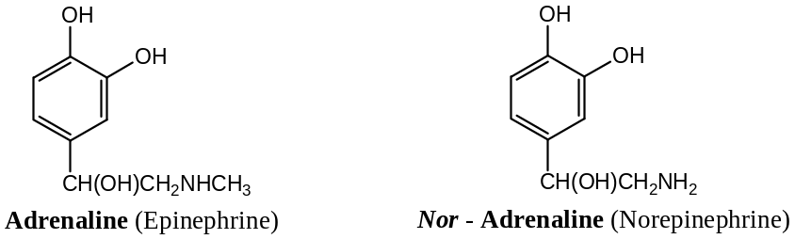
Nor- epinephrine is one-twentieth as active as epinephrine or as a hyperglycaemic agent but is a more active hypertensive agent.
Functions:
- These stimulate sympathetic nerves and therefore, necessary for the transmission of nerve impulses in sympathetic nervous system.
- It raises the level of glucose by splitting deposited glycogen of liver into glucose and increases metabolic rate.
- Injection of epinephrine increases blood pressure by the contraction of arteries, and
- These cause relaxation of bronchioles and increase salivation. //

Dr N Ahmed
JNC, Boko
06.08.2021

The End

