carbohydrates Glucose
(organic natural products)
General Introduction:
Carbohydrates like sugar, starch, cellulose, etc. provide us three basic needs of life —
- Food, in the form of starch containing grains,
- Clothing, in the form of cotton, linen and rayon are literally known as cellulose, and
- Shelter, wood used to make houses and furniture is almost cellulose.
Ribose and deoxyribose (aldopentoses) are the components of hereditary material nucleic acid ($RNA \& DNA$). Carbohydrates are also important to the economy many countries. Table sugar, for example, is one of the most important commercial commodities. In addition some commodities of daily use are paper, photographic films, plastics, lacquers, etc. derived from carbohydrate materials, as semisynthetic plastics.
Definition of Carbohydrates:
Carbohydrates were originally defined as the compounds of $C, H \& O$ with later two elements ($H \& O$) in the ratio $2:1$ (water composition), having empirical formula $C_{n}{\left(H_{2}O\right)}_{m}$, hence named as hydrates of carbon. For example, glucose and fructose, $C_{6}H_{12}O_{6}$ [i.e. $C_{6}{\left(H_{2}O\right)}_{6}$]; sucrose $C_{12}H_{22}O_{11}$ [i.e. $C_{12}{\left(H_{2}O\right)}_{11}$], etc. However, the word carbohydrate is a misnomer, as some members do not obey above definition (e.g. Rhamnose $C_{6}H_{12}O_{5}$, rhamnoheptose $C_{7}H_{14}O_{6}$, etc.), whereas some other compounds like formaldehyde ($CH_{2}O$), lactic acid ($C_{3}H_{6}O_{3}≡C_{3}{\left(H_{2}O\right)}_{3}$), etc. are not carbohydrates but obey empirical formula $C_{n}{\left(H_{2}O\right)}_{m}$.
Structurally, carbohydrates contain only two main functional groups —
- Carbonyl groups, and
- Hydroxyl groups
The carbonyl group, however, does not occur in free from but forms intramolecular hemiacetal or acetal linkages with $–OH$ group(s). Further, they contain more than one asymmetric $C$- atoms. Hence carbohydrates are defined as —
Carbohydrates are the polyhydroxy aldehydes or ketones or compounds which give these on hydrolysis and contain at least one asymmetric $C$- atom.
The name carbohydrate is still retained because of its simplicity and historical background. They are often called saccharides (Latin, saccharum meaning sugar) because of the sweet taste of simple members.
Classification of Carbohydrates:
Carbohydrates are broadly classified (divided) into three main classes —
- Monosaccharides,
- Oligosaccharides, and
- Polysaccharides
Monosaccharides: Monosaccharides are the simplest carbohydrates because they cannot be further hydrolyzed into simpler sugars. Depending upon whether the carbohydrates contain an aldehydes or a keto- group (free or potential), they may be —
- Aldoses or
- Ketoses
Depending upon the number of $C$- atoms present in the monosaccharides can be further subdivided into —
- Triose,
- Tetrose,
- Pentoses, or
- Hexoses
Some representative members of each type are given below —
Type | Molecular Formula | Structural Formula | Examples
Aldoses  Aldotriose  Aldotetrose  Aldopentose  Aldohexose  Ketoses  Ketotriose  Ketotetrose  Ketopentose  Ketohexose | $$C_{3}H_{6}O_{3}$$  $$C_{4}H_{8}O_{4}$$  $$C_{5}H_{10}O_{5}$$  $$C_{6}H_{12}O_{6}$$  $$C_{3}H_{6}O_{3}$$  $$C_{4}H_{8}O_{4}$$  $$C_{5}H_{10}O_{5}$$  $$C_{6}H_{12}O_{6}$$ | $$OHC-CHOH-CH_{2}OH$$  $$OHC{\left(CHOH\right)}_{2}CH_{2}OH$$  $$OHC{\left(CHOH\right)}_{3}CH_{2}OH$$  $$OHC{\left(CHOH\right)}_{4}CH_{2}OH$$  $$HOCH_{2}COCH_{2}OH$$  $$HOCH_{2}COCHOHCH_{2}OH$$  $$HOCH_{2}CO{\left(CHOH\right)}_{2}CH_{2}OH$$  $$HOCH_{2}CO{\left(CHOH\right)}_{3}CH_{2}OH$$ | Glyceraldehyde  Erythrose, Threose  Ribose, Xylose, Arabinose, etc.  Glucose, Mannose, Galactose, etc.  Dihydroxy acetone  Erythrulose  Ribulose, Xylulose  Fructose, Sorbose, etc.

Oligosaccharides (Greek, oligos meaning few): Carbohydrates, those on hydrolysis yields two to four monosaccharide units are termed as oligosaccharides. These are classified as $di$-, $tri$- or $tetra$- saccharides depending upon the number of monosaccharide units given on their hydrolysis. For example, —
Disaccharides : Sucrose, Maltose, Lactose, etc. ($C_{12}H_{22}O_{11}$)
Trisaccharides : Raffinose ($C_{18}H_{32}O_{16}$)
Tetrasaccharides : Stachyose ($C_{24}H_{42}O_{21}$)
Polysaccharides: Carbohydrates, those on hydrolysis yields more than four (in fact hundreds or even thousands) monosaccharide units are termed as polysaccharides. These are classified as $\underline{homo}polysaccharides or \underline{hetero}polysaccharides$, depending upon whether they give only one kind or more than one kind of monosaccharide units on hydrolysis. For example,
$\underline{Homo}polysaccharides$ : Starch and Cellulose — these on hydrolysis yields only one kind of monosaccharide (Glucose, $C_{6}H_{12}O_{6}$).
$${\left(C_{6}H_{10}O_{5}\right)}_{n}+ nH_{2}O ⟶n C_{6}H_{12}O_{6}$$
$\underline{Hetero}polysaccharides$ : $α$- Haparin and Hyaluronic acid — these on hydrolysis yields more than one kind of monosaccharide.
Sugars and Non-Sugars: All the $mono$- and $di$- saccharides are called sugars as they possesses sweet taste and soluble in water. In contrast, polysaccharides are non-sugars, amorphous in nature and insoluble in water.
Reducing and Non-Reducing Sugars or Carbohydrates:
The terms reducing and non-reducing carbohydrates/ sugars are commonly used in carbohydrate chemistry. Carbohydrates that can reduce Fehling solution or Tollen’s reagent are termed as reducing carbohydrates, while the others which do not reduce these reagents are called non-reducing carbohydrates. All monosaccharides and most of the disaccharides (except sucrose) are reducing carbohydrates.
Configuration of Aldotetrose and Aldopentoses:
Glyceraldehyde is the simplest aldotriose having an asymmetric $C$- atom and therefore, exist in two optically active forms. One form has a specific rotation of $+13.5°$ and for the other it is $-13.5°$. Emil Fischer gave the convention of projecting the formulae on $2$- dimensional plane in which the aldehyde group is written at the top followed by $H \& OH$ group written right and left on a vertical line. The formula of glyceraldehyde in which $–OH$ group is in the right to the asymmetric $C$- atom (marked with ‘$*$’) represents the dextrorotatory isomer and is assigned as $D$- configuration. The laevorotatory isomer in which the $–OH$ group is in the left to the asymmetric $C$- atom (marked with ‘$*$’) represents the levorotatory and is assigned as $L$- configuration.
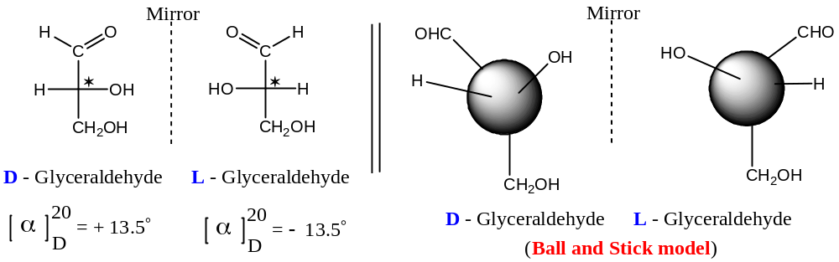
These forms of glyceraldehyde are very important in carbohydrate chemistry, as the more complex sugars may be considered to be originated from them. The sugars whose bottom structure terminate in the same configuration as $D$-glyceraldehyde are designated as $D$- sugars and those having terminal structure similar to $L$-glyceraldehyde (irrespective of optical rotation) are designated as $L$- sugars.
Its isomeric Ketotriose (dihydroxy acetone) is optically inactive due to the lack of asymmetric $C$- atom.
The Fischer convention can be illustrated by assigning configurations to the following six stereoisomeric aldopentoses out of the eight ($2^{3}=8$) optically form.
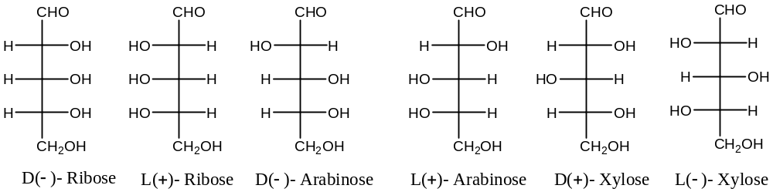
Important Note: The designation $D \& L$ has no concern (relation) with optical rotation as $D$- configuration may have ($+$) or ($-$) specific rotation and it is also true for $L$- forms. This is based only on the position (in relation to glyceraldehyde) of the lower $OH$ group attached to bottom asymmetric carbon atom.
Monosaccharides — Glucose:
Though monosaccharides contains $3 to 10 C$- atoms, only pentoses and hexoses are the important members containing $5 \& 6 C$- atoms respectively.
Monosaccharides are colourless, crystalline compounds soluble in water but insoluble in organic solvents. Unlike disaccharides, monosaccharides crystallize with difficulty. When heated, they char and give characteristic smell of sugars.
Chemically, monosaccharides exhibit the reactions of alcohols and aldehydes/ ketones. Glucose and fructose are the representative aldoses and ketoses respectively.
Glucose (dextrose, grape sugar, corn sugar, blood sugar), $C_{6}H_{12}O_{6}$:
($1$) Occurrence:
Glucose, the most important and abundant monosaccharides, occurs free in honey, ripe grapes (hence the name ‘grape sugar’), most sweet fruits, blood and urine of animals. In the combined form, it is present in many glycosides, disaccharides and polysaccharides.
($2$) Manufacture:
Glucose is manufactured from starch by hydrolysis with hot dilute mineral acids. The actual reaction is very complicated and involves the following three steps —
$$2{\left(C_{6}H_{10}O_{5}\right)}_{n} \underset{→}{ H_{2}O } 2{\left(C_{6}H_{10}O_{5}\right)}_{n}H_{2}O \underset{→}{ n H_{2}O } nC_{12}H_{22}O_{11} \underset{→}{ {n H_{2}O}/{H^{⊕}} } 2nC_{6}H_{12}O_{6}$$
Starch Dextrin Maltose Glucose
The common sources of starch are maize, rice and potatoes.
On complete hydrolysis, product is neutralized with chalk and the mixture is filtered. The filtrate is decolourized with animal charcoal and concentrated in vaccum pans. Glucose crystallizes out and can be purified from the crude product by recrystallization from alcohol.
($3$) Physical Properties of Glucose:
Important and representative physical properties of glucose are —
- Glucose forms colourless crystals, $mp=146℃$,
- It also forms monohydrate, $mp=118℃$,
- It is readily soluble in water, sparingly soluble in alcohol but insoluble in ether,
- It is optically active,
- Freshly prepared solution of glucose is dextrorotatory, ${\left[α\right]}_{D}^{20}=+112°$ (since, the optical rotation is $+ve$, hence the name dextrose), and
- It is about three-forth as sweet as cane-sugar (sucrose). //

($4$) Uses of Glucose:
Glucose has many potential uses, some of these are —
- As food for children and individuals,
- As reducing agent in silvering of mirrors,
- In the manufacture of confectionary, in syrups, candies, jams, wine, beer, etc.,
- As the starting material for the manufacture of ascorbic acid (Vitamin C), and
- For the treatment of tobacco. //
($5$) Structure/ Constitution of Glucose:
Two different structures were proposed for glucose —
- Open Chain structure and
- Ring structure
Both the structures were elucidated from the various established chemical analysis.
($A$) Open chain Structure for Glucose:
The open chain structure for glucose ($I$) was given by Baeyer form the following observations —
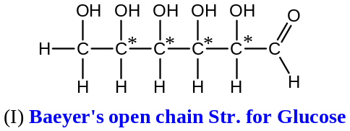
($a$) Molecular formula: On the basis of elemental analysis and molecular weight determination data, the molecular formula established for glucose is $C_{6}H_{12}O_{6}$
($b$) Presence of Straight Chain: Glucose on vigorous reduction with $P \& HI$ gives $n$- hexane, indicating that the $6C$- atoms of glucose are in a straight chain.
($c$) Presence of Aldehyde Group: Glucose reacts with —
- Hydroxylamine to form a mono-oxime, and
- Hydrogen cyanide ($HCN$) to form a cyanohydrine
These shows the presence of one carbonyl group in the glucose, so the partial structure for glucose is $C_{5}H_{12}O_{5}(C=O)$.
Mild oxidation of glucose with bromine water or sodium hypobromite gives a monobasic acid, gluconic acid, $C_{5}H_{11}O_{5}(COOH)$, containing the same number of $C$- atoms as in glucose. Therefore, the carbonyl group present in glucose must be an aldehyde group. The nature of the carbonyl group as an aldehyde also follows from the formation of heptanoic acid by the hydrolysis of the cyanohydrine of glucose followed by vigorous reduction with hydroiodic acid. Thus, the partial structure for glucose can be written as $C_{5}H_{12}O_{5}(CHO)$.
($d$) Presence of $5 OH$ Groups: Glucose forms penta-acetate [$C_{6}H_{7}O(OCOCH_{3})_{5}$], with acetic anhydride, indicating the presence of five $–OH$ groups in it. Thus, all $6 O$- atoms in glucose have been accounted for and it can be formulated as $C_{5}H_{6}{(OH)}_{5}(CHO)$.
This assignment is confirmed by the catalytic reduction of glucose to hexahydric alcohol, sorbitol ($C_{6}H_{14}O_{6}$), which gives hexa-acetate with acetic anhydride.
($e$) Presence of Terminal $-CH_{2}OH$ Group: Oxidation of gluconic acid with $HNO_{3}$ gives a dicarboxylic acid (glucaric acid or saccharic acid, $C_{6}H_{10}O_{8}$), containing the same number of $C$- atoms. As glucose contains only one $–CHO$ group, the 2nd carbonyl group must have originated from the oxidation of a primary alcoholic group ($-CH_{2}OH$). Hence, the formula of glucose becomes $C_{4}H_{4}{\left(OH\right)}_{4}(CH_{2}OH)(CHO)$
The arrangement of the $6 C$- atoms in glucose has been shown to be in a straight chain. The $–CHO$ group must be in the terminal position. One of the $5-OH$ groups is present as $-CH_{2}OH$ group, and this should be in a terminal position.
($f$) Open Chain Structure: The disposition of the remaining four $H$- atoms and four $–OH$ groups follows from the fact that the glucose does not dehydrate easily, to fulfil this criteria, glucose must not contain $C(OH)_{2}$ groups and a corresponding additional number of $-CH_{2}$ groups. On the basis of these observations, Baeyer in 1870 proposed the following open chain formula for glucose.
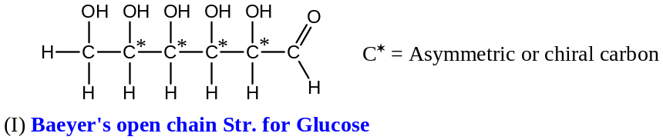
This open chain structure satisfactorily explains all the above reactions as shown below —
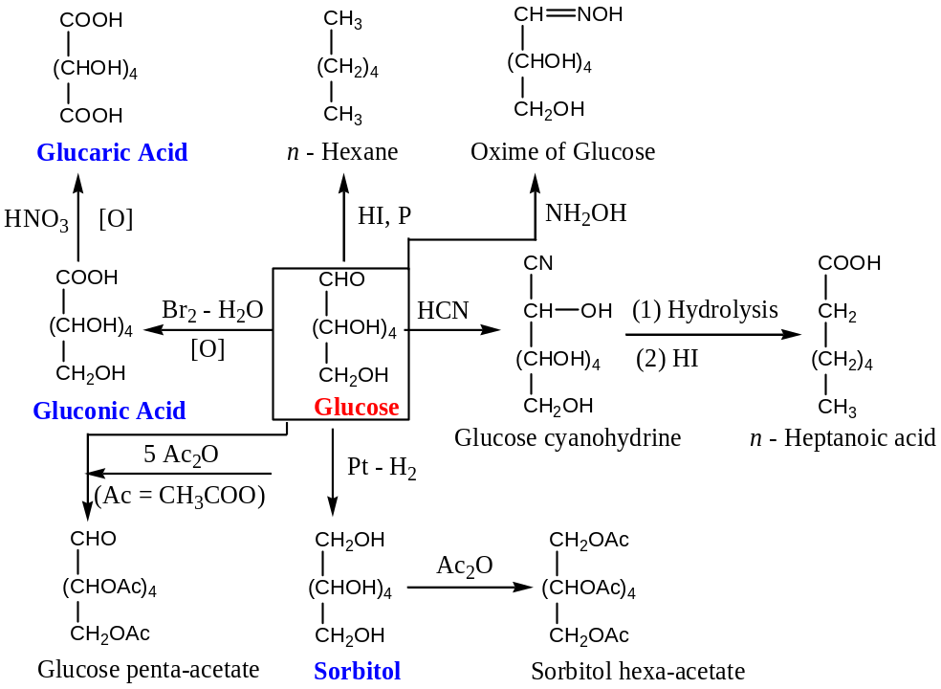
The open-chain structure of glucose as an aldohexose is further confirmed by the fact that glucose consumes $5 moles$ of periodic acid ($HIO_{4}$) to form $1 mole$ of formaldehyde and $5 moles$ of formic acid. Thus, —
$$C_{6}H_{12}O_{6} + 5HIO_{4} ⟶ HCH=O + 5HCOOH + HIO_{3}$$
Glucose Periodic acid Formaldehyde Iodic acid
This oxidative cleavage by $HIO_{4}$ for vicinal $–OH$ groups can explain the open chain structure for glucose as follows —
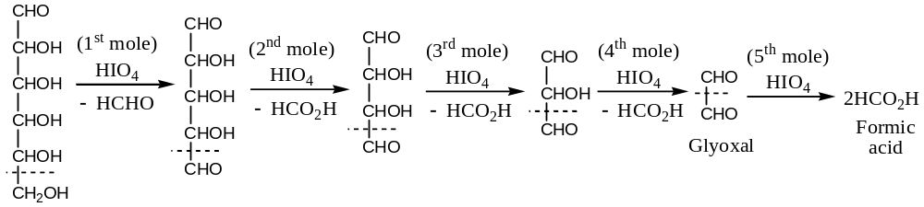
($g$) Stereochemistry: There are four different asymmetric $C$- atoms ($C^{*}$) in the open-chain structure ($I$) of glucose. Therefore, the possible stereoisomeric structures would be $2^{4}=16$, i.e. $8$- pairs of enantiomers. There would be no $meso$ compounds because two ends are dissimilar.
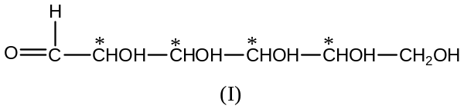
The naturally occurring dextrorotatory glucose, better represented as ($+$) - glucose, is only one of the $16$- stereoisomers. E. Fischer, assigned configuration ($II$), usually shown as $D$- glucose, or ($+$) – glucose, as the bottom structure (shown in screen box) resembles to $D$- configuration of glyceraldehyde.
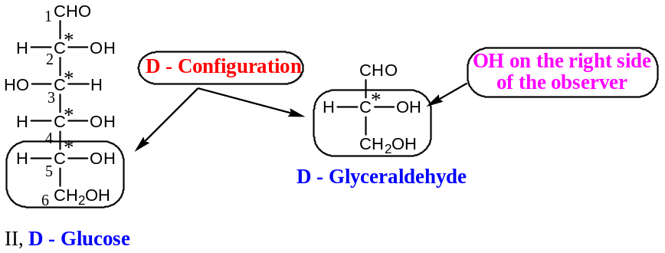
($h$) Limitations of Open chain Structure of Glucose: The open chain structure (II) for glucose can explain most of the reactions of glucose, but failed to explain the following properties —
($i$) Reaction of Aldehydic Group: It failed to give some reactions of aldehydes like formation of adduct with sodium bisulphite and does not give pink colour with Schiff’s reagent.
($ii$) Isomeric forms: Glucose exists in two stereoisomeric forms ($α$- and $β$-). The ordinary glucose ($α$- form) obtained by crystallization from alcohol water has $mp=146℃$ and $sp.rotation$ ${\left[α\right]}_{D}=+112°$ in fresh aqueous solution. On the other hand, when glucose is crystallized from pyridine solution a new form $β$- glucose is obtained which has $mp=150℃$ and $sp.rotation$ ${\left[α\right]}_{D}=+19°$
($iii$) Mutarotation: It has been observed that the specific rotation of an aqueous solution of $α$-$D(+)$- glucose gradually falls from$=+112° to+52.7°$, whereas in $β$-$D(+)$- glucose gradually increases from$=+19° to+52.7°$. Thus, $α$- and $β$- glucose gives an equilibrium mixture with a constant specific rotation. Such change in specific rotation to give equilibrium value is known as mutarotation.
$α$-$D(+)$- Glucose $⇌$ Equilibrium Mixture $⇌$ $β$-$D(+)$- Glucose
${\left[α\right]}_{D}=+112°$ ${\left[α\right]}_{D}=+52.7°$ ${\left[α\right]}_{D}=+19°$
($iv$) Formation of Glycosides (ethers): $α$-$D(+)$- Glucose when treated with equimolar amounts of methanol and anhydrous $HCl$ gives two forms of methyl glucosides viz. methyl-$α$-$D(+)$- glucoside ($mp=165℃$) and methyl-$β$-$D(+)$- glucoside ($mp=107℃$). The methyl glucosides behave as acetals (formed by the interaction of alcohol and aldehyde group). These glucosides do not reduce Fehling’s or Tollen’s reagent and do not undergo mutarotation.
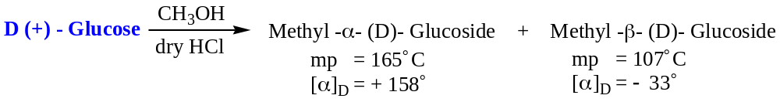
($B$) Ring Structure for Glucose ($D(+)$- Glucose):
From the above mentioned limitations of the open-chain structure for glucose [$D(+)$-], it is inferred that the aldehyde group is not free in glucose. Thus, a hemiacetal ring structure formed from open chain structure by the mutual intramolecular interaction of aldehyde group and $–OH$ group of position-$5$ was proposed. This cyclic hemiacetal structure ($A$) generates a new chiral centre at $C$-$1$. This can give two possible structures; one with $–OH$ at right is termed as $α$-$D(+)$- glucose ($A$) and other with $–OH$ at left ($B$) is $β$-$D(+)$- glucose. This pair of diastereomers which differ in configuration at $C$-$1$ only are known as anomers and the carbon $C$-$1$ is known as anomeric carbon.
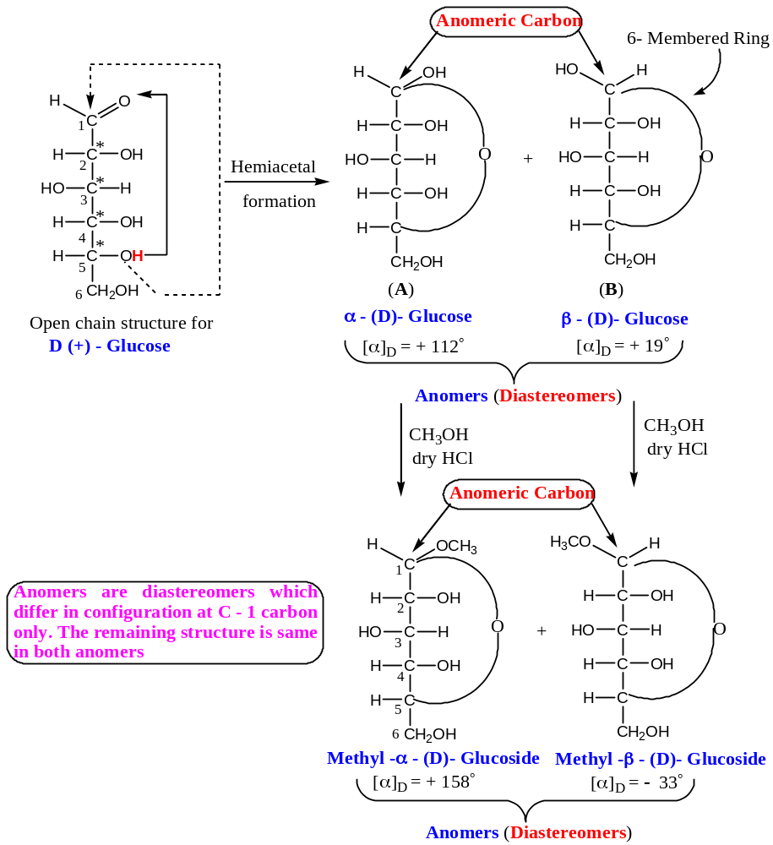
Structures $A \& B$ explain the formation of glycosides (cyclic ethers) and resistance to undergo addition reaction with sodium bisulphite. The phenomenon of mutarotation given by anomers ($α$- and $β$- forms) can also be explained, as each anomer is a hemiacetal (hemiacetal is formed by the reaction of $–OH$ group with $-CHO$) and readily hydrolyzed to give the open chain structure.
Thus, an equilibrium mixture contains both anomers ($A \& B$) and small amount of open chain structure. This phenomenon is known as Mutarotation.
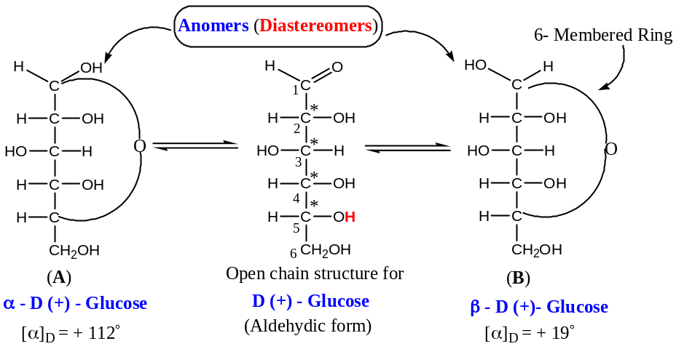
Mechanism of Mutarotation: Lowry in 1925 suggested that since water is an amphiprotic solvent (acts as an acid as well as a base), it helps in simultaneous addition and elimination of proton. The following concerted mechanism, showing 3rd order kinetics is believed to take place.
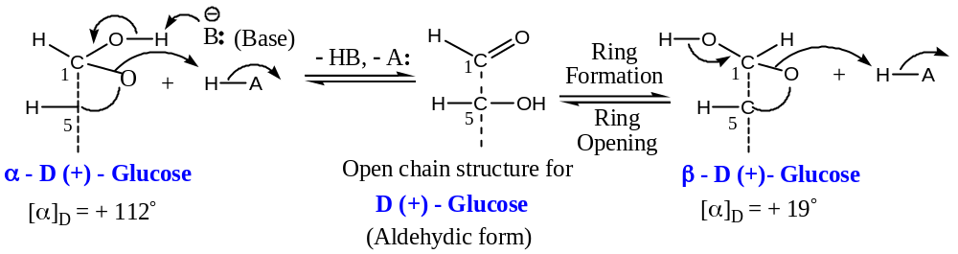
The presence of small amount of the open-chain aldehyde form in the equilibrium mixture of the two anomers can explain the reactions like osazone formation, reaction of Fehling’s solution and Tollen’s reagents. As the equilibrium is disturbed by conversion of the open-chain form into these derivatives, therefore, more of the open-chain forms in the equilibrium mixture will results to push the reactions. The aldehyde reactions like Schiff’s test, bisulphite addition, etc. are easily reversible and the concentration of the open-chain structure in the equilibrium mixture is too law (less than $0.5\%$) for satisfactory results. Therefore, it does not give Schiff’s test, bisulphite addition.
The two methyl $D$- glucosides are also anomers. These are stable in aqueous solution and do not undergo mutarotation. These are stable to alkali and do not hydrolyse to open chain form by the alkali present in Fehling’s or Tollen’s reagents. Hence, these are non-reducing.
($a$) Ring Size: We have assumed that the ring structures of $D(+)$- glucose is to be six – membered oxygen heterocycles pyran (hence, the name pyranose structure also) involving $C$- 1 and $C$- $5$ carbon atoms. The cyclization at $C$- 1 and $C$- $4$ carbon atoms gives a $5$- membered furanose ring structure, and it has to be considered, because it has the same order of stability as that of $6$- membered ring (pyranose) in accordance to Baeyer strain theory.
The following experimental facts have established the six – membered pyranose ring structure for $D(+)$- glucose rather than $5$- membered furanose ring structure for $D(+)$- glucose.
Six membered, methyl- $β$- $D$- glucoside, on methylation with methyl sulphate in the presence of an alkali followed by hydrolysis with dilute $HCl$ gave $β$- $2,3,4,6$- tetra- $O$- methyl- $D$- glucose. This was oxidised by $HNO_{3}$ to give a mixture of trimethoxy glutaric acid and dimethoxy succinic acid, which can be given only by the oxidative cleavage of the intermediate “Keto acid” on either side of $C$-$5$. The keto group in the intermediate keto acid must be situated at $C$-$5$. The free $–OH$ group in tetra- $O$- methyl- $D$- glucose would obviously be at $C$-$5$ that is the point of linkage of hemiacetal ring in $β$- $D$- glucoside. These sequence of reactions are shown below —
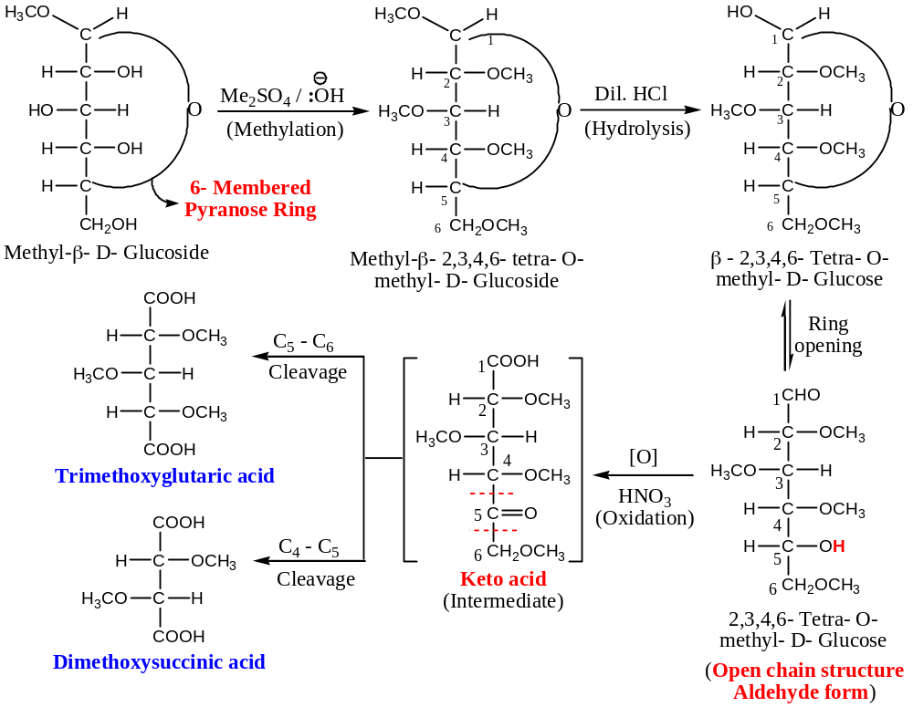
If $C$-$4$ hydroxy group is involved in the formation of hemiacetal ring of $β$- $D$- glucoside, then, we will have $5$- membered furanose ring structure, then trimethyl glutaric acid could not be formed which is actually been obtained in the experimental (as illustrated above). Further, $5$- membered ring is expected to give methoxymalonic acid, which is not found to be formed actually. Hence, $5$- membered furanose ring structure for glucose is ruled out.
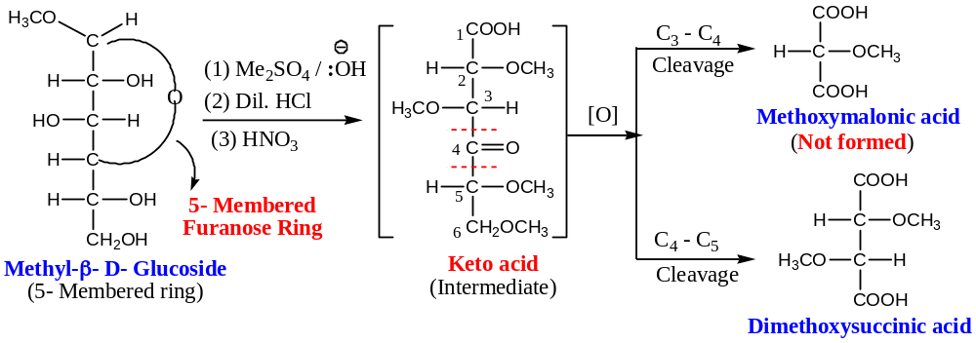
Hence, the $6$- membered pyranose ring structure is the common ring for $β$- $D$- glucoside and $β$- $D$- glucose which can account for the formation of both final products of oxidative cleavage.
($b$) Haworth Projection formulae to represent isomeric Glucose: OR
Representation of $α$- and $β$- $D(+)$- Glucose:
Instead of vertical presentation (Fischer Projection Formula) for two cyclic forms of glucose and their glucosides, these can be represented by the Haworth projection formula $A \& B$, in which hexagonal pyran ring is considered to be situated in the plane of the paper. In this structure next to oxygen is the chiral carbon $C$- $1$ followed by $C$- $2$, $C$- $3$, $C$- $4$ and $C$- $5$ arranged in a clockwise direction. The $–H \&-OH$ are situated at right angles to the plane of the ring. The lines projecting upwards are above the plane and lines projecting downwards are below the plane. Intersection of lines carries $C$- atom.
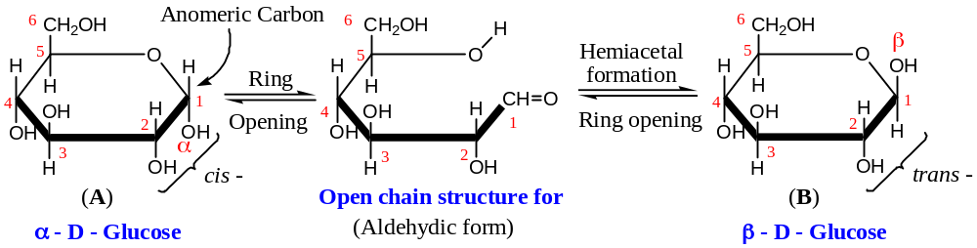
($c$) Chair Conformation of Glucose: Haworth planer projection formula for $α$- $D$- and $β$- $D$- glucose ($A \& B$) can be best represented by a strain free chair conformation ($C \& D$). This is believed to be most stable conformation as all the bulky substituents ($-CH_{2}OH \&-OH$) occupy the equatorial positions, except $–OH$ group at $C$- $1$ in $α$- $D$- glucose. It is obvious that $β$- anomer of $D(+)$- glucose is more stable as all the bulky substituents occupy equatorial position, and hence, it is [$β$- anomer of $D(+)$- glucose, i.e. $β$- $D$- glucose] more dominating anomer ($63\%$). These structures have been confirmed by $X$- ray analysis.
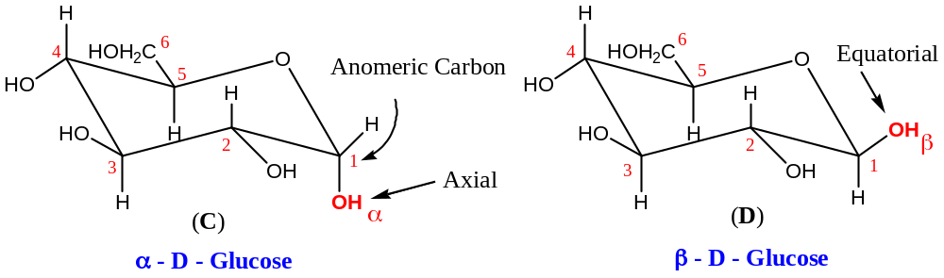
These two chair conformational structures have pyranose ring structures, and hence glucose is also known as glucopyranose. When the $H$- atom of $–OH$ group of $C$- $1$ is replaced by methyl group, it gives corresponding $α$- and $β$- methyl glucoside or methyl glucopyranoside.
($6$) Chemical Properties of Glucose: —
Glucose is an aldohexose, and it will exhibit the properties of glucose as well as an aldohexose i.e. reactions corresponding to an aldehyde group. Representative reactions are —
($a$) Reaction with Phenylhydrazine: With limited amounts of phenylhydrazine, glucose forms the corresponding phenylhydrazone. Thus, —
$$HOCH_{2}(CHOH)_{4}CHO \underset{→}{C_{6}H_{5}\ddot{N}H\ddot{N}H_{2}} HOCH_{2}(CHOH)_{4}CH=\ddot{N}\ddot{N}HC_{6}H_{5}$$
Glucose Glucose phenylhydrazone
With excess phenylhydrazine, the reaction is somewhat more complicated. Three moles of phenylhydrazine are consumed for each mole of the glucose to form glucosazone, a yellow crystalline solid containing two phenylhydrazine residues per molecule. For example, —
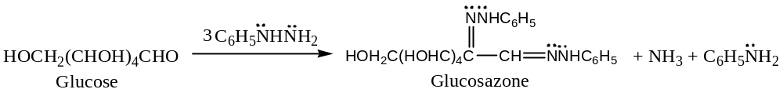
[Important —
Osazone Formation: Osazone formation is a general reaction given by all $α$- hydroxycarbonyl (aldehydes or ketone) compounds (which may not be a carbohydrate). Thus, —
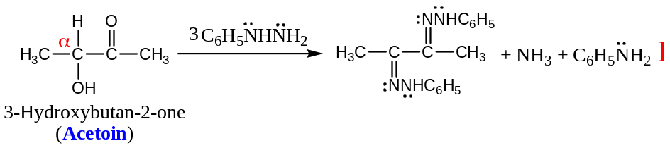
Mechanism of the reaction of Phenylhydrazone with Glucose:
It was suggested that the 2nd molecule of phenylhydrazine oxidise the $2°$- alcoholic group adjacent to the aldehyde to a keto group that reacts with the 3rd molecule of phenylhydrazine. It is not clear how phenylhydrazine (a strong reducing agent) acts as an oxidising agent. It is believed that that, this reaction involves rearrangement of phenylhydrazone to a $H$- bonded intermediate known as Amadori rearrangement. This intermediate loses a molecule of aniline to give an imino ketone which react further with phenylhydrazine to give the final product glucosazone.
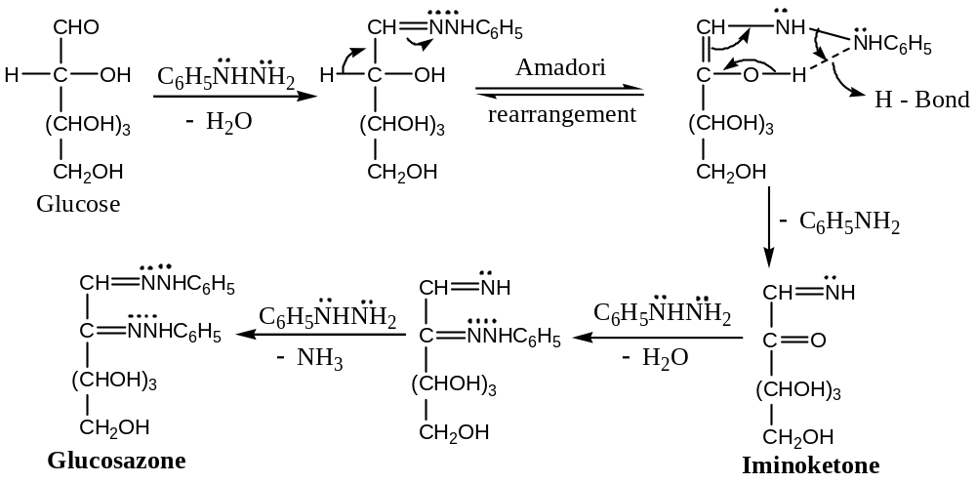
Epimer and Epimerisation: Conversion of Glucose to Mannose
During osazone formation, it has been observed that ($+$) - glucose has destroyed configuration only at one of the four asymmetric carbons, i.e. at $C$- $2$. Obviously, a diastereomeric aldohexose which differ from ($+$) - glucose only in configuration at $C$- $2$ should give the same glucosazone. Actually, ($+$) - mannose, a diastereomer of glucose gives the same osazone as ($+$) – glucose. Therefore, ($+$) – glucose and ($+$) – mannose should be a pair of diastereomeric aldohexoses, differ in the configuration at $C$- $2$ only. Such diastereomers which differ in configuration at one- asymmetric carbon atom are called epimers. The process used to change the configuration at one of the asymmetric carbon atoms (in compounds containing more than one- asymmetric carbon atoms) without altering any change in the remaining part is called epimerization.
For example, conversion of glucose into mannose is an example of epimerization. Hence, mannose is an epimer of glucose.
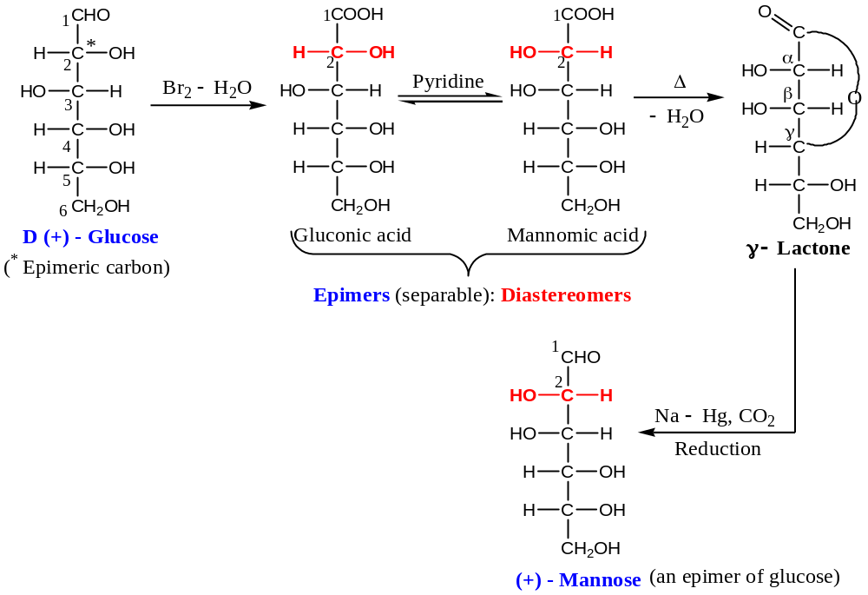
The Stereochemical significance of this reaction has been used in determining the stereochemistry of $D$- ($-$) - fructose.
($b$) Action of Alkalies (Lobry de Bruyn and Alberda Van Ekenstein Rearrangement):
Concentrated alkalis convert glucose into brown resins. Dilute alkalis, however, bring extensive isomerisation and even decomposition, presumably via monosaccharide with an enediol structure. Thus, —
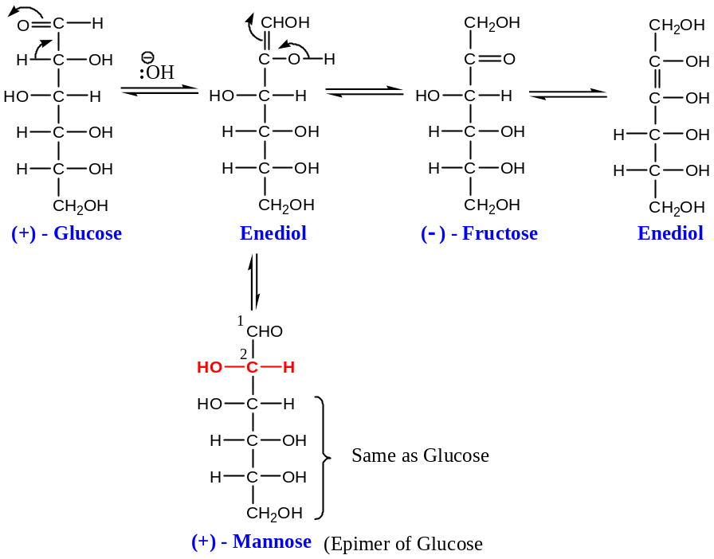
It is possibly due to this reversible isomerisation that ketoses (e.g. fructose) give positive tests with alkaline oxidising agents like Fehling, Benedict and Tollen’s reagents although they contain a keto group rather than an aldehyde group (simple ketones do not respond to these tests).
($c$) Action of Acids: Dilute acids have particularly no effect on glucose, but hot strong acids leads to complex reactions involving dihydro-cyclization, etc. $5$- Hydroxymethyl furfural, initially formed, transformed by hot acids into laevulinic acid and large amount of dark, insoluble condensation product known as humins is formed. Thus, —
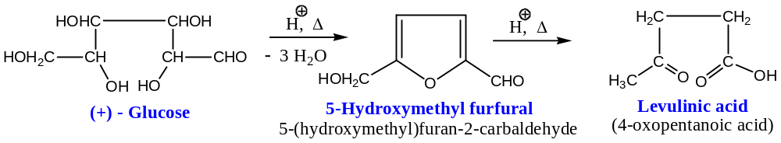
These furfurals give characteristic colour reactions with polyhydric phenols like resorcinol, phloroglucinol, etc. This reaction is used to distinguish hexoses from pentoses.
($d$) Action of Oxidising agents: Different oxidation products are obtained, depending on the nature of the oxidising agent the experimental conditions used. For example —
($i$) Fehling solution (${Cu}^{2+}$) and Tollen’s reagent (${Ag}^{+}$) are reduced (blue Fehling solution to red cuprous oxide and Tollen’s reagent to metallic silver) and the aldehyde group of glucose is oxidised to $–COOH$ group. The resulting acid formed is the gluconic acid.
($ii$) Bromine water (${Br}_{2}-H_{2}O$) oxidises glucose to gluconic acid.
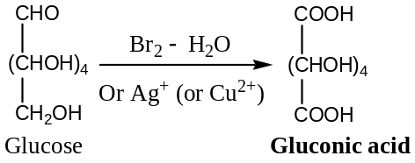
Mechanism of Oxidation: Monosaccharides (e.g. glucose) exist in the hemicyclic acetal form. The cyclic form is in equilibrium with the free aldehyde form, and therefore, susceptible to oxidation by above solutions. Hence, all monosaccharides are reducing sugars.
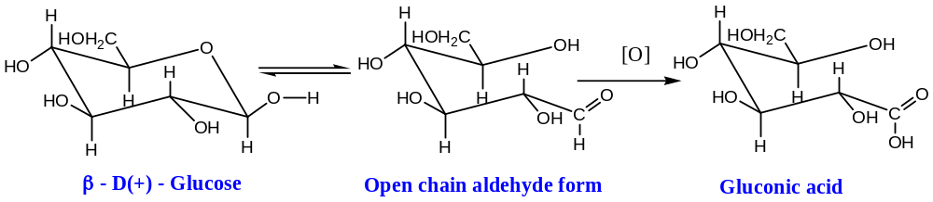
Important Note: Glycosides of monosaccharides are however non-reducing sugars, due to the hemiacetal ring which is unaffected by alkaline solution used to test reducing sugars. Glycoside rings do not open into free aldehyde form.
($iii$) Nitric acid ($HNO_{3}$), being a vigorous oxidising agent, oxidises both $–CHO \& CH_{2}OH$ groups glucose to $–COOH$ groups. The dicarboxylic acid so formed is called glucaric acid (or saccharic acid).
$$OHC(CHOH)_{4}CH_{2}OH \underset{→}{ {\left[O\right] }/{HNO_{3}} } HOOC(CHOH)_{4}COOH$$
Glucose Glucaric acid
($iv$) Oxidative Cleavage of Glucose: Glucose, being an $α$- hydroxy carbonyl compound (aldehyde) containing a number of $vic$- hydroxyl groups, it undergoes oxidative cleavage with specific oxidising agents like periodic acid (Malaprade reagent) and lead tetra-acetate. Thus, —
$$HOCH_{2}(CHOH)_{4}CHO +5HIO_{4} \underset{→}{Or Pb(OAc)_{4} } HCHO+ 5HCOOH+ 5HIO_{3}$$
Glucose Periodic acid Formaldehyde Formic acid Iodic acid
Application: This reaction has a great potential for structure determination of glycols and in carbohydrate research for structure determination of $vic. -OH$ groups present.
($e$) Reaction of Glucose with Hydroxy Compounds:
Glucose reacts with methyl alcohol in presence of anhydrous $HCl$ to form methyl glucoside which exists in two stereoisomeric forms viz. $α$- and $β$- [This reaction has already been discussed in the ring structure of glucose under the heading transformation of the hemiacetal form of glucose into an acetal].
The general reaction of aldohexoses in which methyl alcohol can be replaced by other alcohols or hydroxy compounds can be written as —
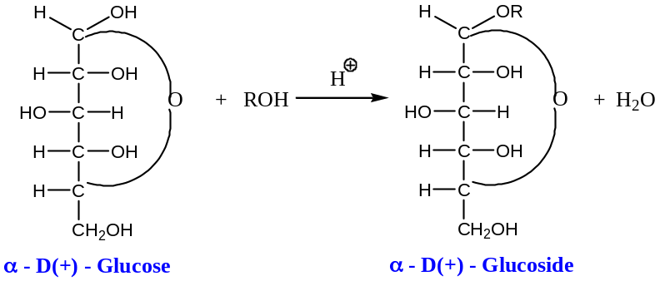
($f$) Fermentation of Glucose: Glucose, in the presence of the enzyme zymase (e.g. yeast) undergoes fermentation to form ethyl alcohol and release carbon dioxide. Thus, —
$$C_{6}H_{12}O_{6} \underset{→}{ Zymase } 2C_{2}H_{5}OH + CO_{2}↑$$
Glucose Ethyl alcohol
This reaction forms the basis of the manufacture of ethyl alcohol from molasses.
Structures of some important Aldopentoses and Aldohexoses: JS 990

The End

