The model of DNA Replication:
1.Theta model of DNA replication

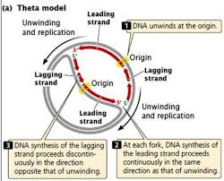

Theta model of DNA replication was studied in the circular DNA of bacteria E. coli .
-Replication begins with unwinding DNA double helix at the point of initiation which is called origin .
-An initiator protein binds to the origin .
-The initiator protein use ATP to unwinds double helix at the initiation point
and separate the two strand of DNA (produce two template DNA ).
-Two growing points are established and there is bidirectional DNA synthesis .
-A replication bubble form ,usually having a replication fork at each end .
-The fork proceed around the circle . The unwinding and replication move along the circle leading to the formation of two circle .
The circular DNA molecule does not break .It maintain its circular form throughout the replication process.
In the replication of circular DNA an intermediate theta structure is formed ,similar in shape to Greek letter θ . Hence it is called Theta model of DNA replication .

.

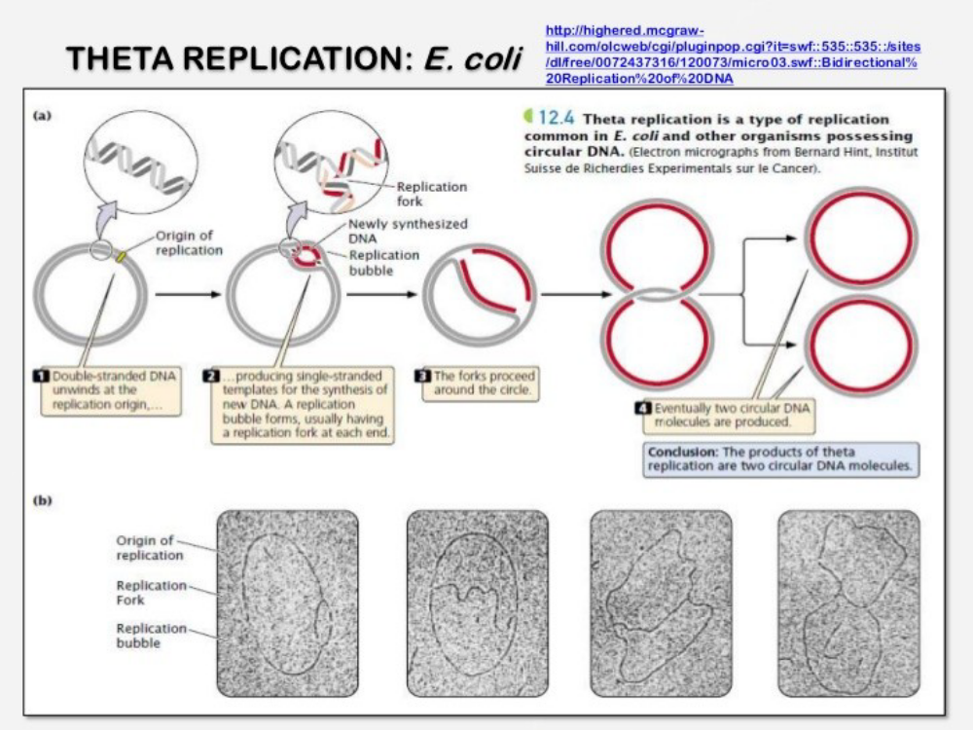

2.Rolling circular model:
Rolling circular model is explained the replication of single stranded DNAviruses e.g transfer of sex factor (plasmid) of E.coli .
-The chromosome first become double –stranded by the synthesis of negative strand .
-Nicking of one parental strand by endonuclease and created 3’end and 5’end .
-The 3’end serves as the primer for the synthesis of a new strand under the catalytic action of DNA polymerase .
-The unbroken strand use as the template and the complementary strand is synthesis .
-The 5’end of the broken strand is attached to the plasma membrane of the host bacterium .

-The unbroken strand (template)rolls and unwind as synthesis proceeds ,leaving a tail which is attached to the membrane .
-The tail region is synthizes discontinuous segments (Okazaki fragments) with the heip of RNA primer .

.

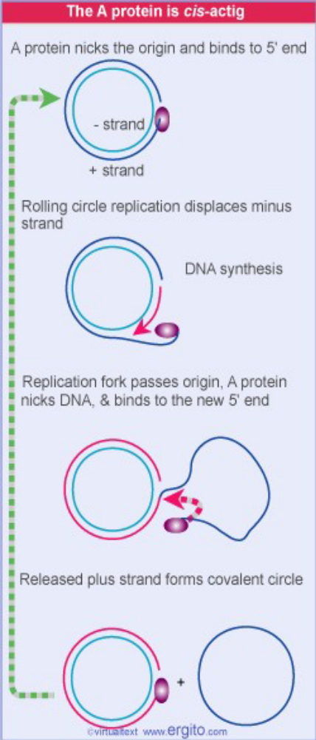
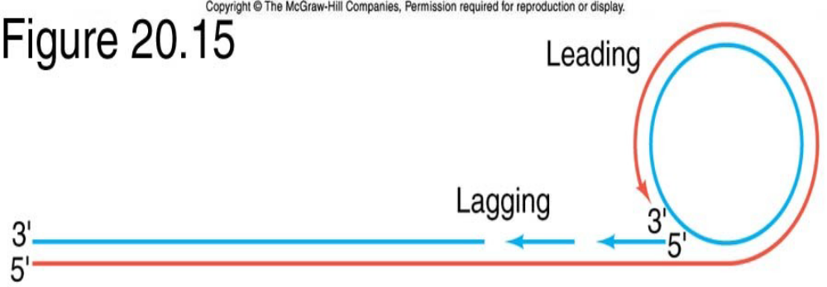
-The tail is cut by a specific endonuclease into unit length progeny rod .
-The progeny rod may undergo circularization to form a new circular molecule .
During the process the gap is closed by DNA ligase .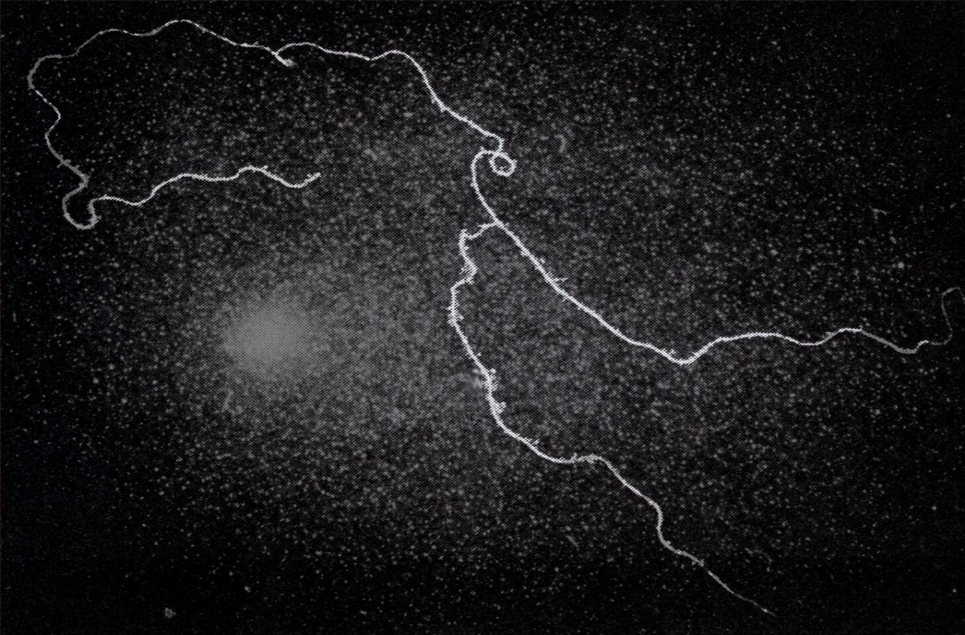
t

3 .Replication of linear dsDNA:
In the virus T4 the chromosome is a duplex rod of about 40,000base pairs .
-The parental strand separate at a point about 17% from one end .
-This site is called growing point .
-Bidirectional DNA synthesis takes place from this point .
-Separation of the two strand results the eye form .
-When the growing point of replication reaches the end of the DNA rod ,it result in the Y form .
-A second rounds of DNA synthesis may be initiated before the completion of the first round .
-This results in the formation of a secondary eye at a point 17%from the end of the arms of the Y .
