Alkenes
Alkenes: General Outline: —
Alkenes are the open chain unsaturated hydrocarbons characterized by the presence of a carbon-carbon double bond ($C=C$). They form a homologous series having general formula $C_{n}H_{2n},where n=2, 3, 4, …$ . Since, alkenes contain two hydrogens fewer than the corresponding alkanes (saturated acyclic hydrocarbons); they are also known as unsaturated aliphatic hydrocarbons. Alkenes are also called olefins ($Greek$oil-like) because some of the earliest products derived from alkenes were oily in nature. Being highly reactive, a carbon-carbon double bond ($C=C$) is generally considered as a functional group of alkenes and other unsaturated compounds.
Sources and Utility of Alkanes: —
The major commercial use of alkenes like ethylene and propylene is the production of polymers ($e.g.polyethylene$, $polypropylene$, $polyvinyl chloride$ ($PVC$), $teflon$, $etc.$)They are also most important starting materials or intermediates in the synthesis of many consumer chemicals used in a variety of consumer products. Usage of ethylene in ripening of fruits is familiar to us.
Alkenes have an important place in the biological world. Via terpenes a component of essential oils ($e.g.menthol$, $α$-$pinene$, $limonene$, $etc.$), alkenes have found a place in the world of perfumes, flavours and fragrances. Though sex pheromones, alkene have been given animals a “chemical way” to communicate with one another.
Thus, we find that the chemistry of carbon-carbon double bond (alkenes) is of great fundamental and applied interest.
Nomenclature of Alkenes: —
The trivial (common) as well as IUPAC names of the first few alkenes are —
Trivial name IUPAC Name Formula Structure
Ethylene Ethene $C_{2}H_{4}$ $H_{2}C=CH_{2}$
Propylene Propene $C_{3}H_{6}$ $CH_{3}CH=CH_{2}$
$α$- Butylene But- 1- ene $C_{4}H_{8}$ $H_{2}C=CHCH_{2}CH_{3}$
$β$- Butylene But- 2- ene $C_{4}H_{8}$ $CH_{3}CH=CHCH_{3}$
Isobutylene 2- Methylpropene $C_{4}H_{8}$ $CH_{3}C({CH}_{3})=CH_{2}$
— 3,3-Dimethylbut-1-ene $C_{6}H_{12}$ $({CH}_{3})_{3}CCH=CH_{2}$
Occasionally, Greek symbol ‘$∆$’ is used to denote a double bond (common system), the position of the double bond being shown by putting a suitable number at the top right hand corner of the symbol. Thus, $but$-2-$ene$is also named as $∆^{2}$- butene and $but$-1-$ene$ is $∆^{1}$- butene. In IUPAC systems, the number denoting the position of the double bond is put immediately before the suffix$-ene$. In substituted alkenes, double bond gets priority over the substituents. For example,
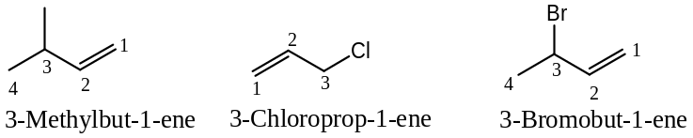
The alkenyl groups, derived by removing one $H$- atom from the corresponding alkene have the ending $enyl$ and the $C$- atom with free valency is numbered -1, when present in the side chain. However, alkenyl groups derived from ethene and propene are commonly called vinyl, allyl and isopropenyl groups. These names are more popular than the IUPAC names, and in fact these are approved by the IUPAC. For example,
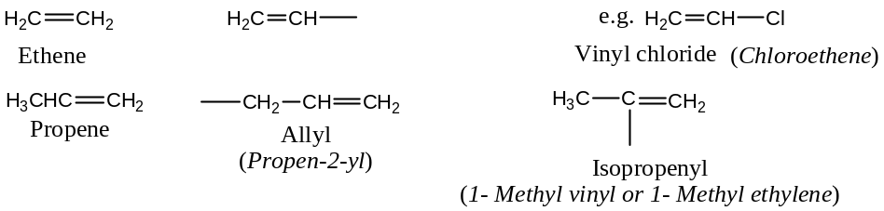
General Methods of Preparation of Alkanes: —
Alkenes are best prepared from —
- From Alkyl halides ($RX$):It includes
  - Dehydrohalogenation of alkyl halides, and
  - Dehydrohalogenation of vicinal dihalides.
- From Alcohols ($ROH$): — by dehydration in presence of a dehydrating agent, and
- From Alkynes ($-C≡C-$): — by controlled reduction.
These general synthetic methods of preparative interest are described below with their suitable mechanisms:
[1] Synthesis of Alkene by the Dehydrohalogenation of Alkyl Halides: —
Alkyl halides on treatment with alcoholic potash ($alc. KOH$, usually ethanolic) undergoes dehydrohalogenationto form alkenes. Thus,
$$R-CH_{2}-CH_{2}-X \underset{→}{alc. KOH} R-CH=CH_{2}$$
$Alkyl halide$ $Alkene$
For example,
$$C_{6}H_{5}-CH_{2}-CH_{2}-Br \underset{→}{alc. KOH}C_{6}H_{5}-CH=CH_{2}+KBr+H_{2}O$$
$1-Bromo-2-phenylethane$ $Styrene$
In general,
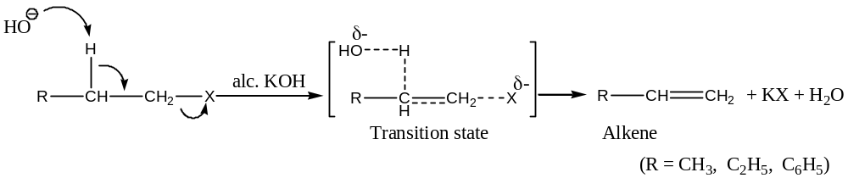
General Discussions:
The cleavage of $C-H$ and $C-X$ bonds requires energy and this comes from —
- The formation of bonds between abstracted proton ($H^{+}$) and hydroxide ion (${HO}^{-}$),
- Formation of the $π$- bond which supplies about $284 kJ{mol}^{-1}$ of energy, and
- The energy of solvation of the halide ions (i.e. energy of hydration).
Orientation/ Regioselectivity: Dehydrohalogenation generally proceeds in such a way that the more stable (the highly substituted) alkene is the dominant product (Saytzeff elimination). For example,
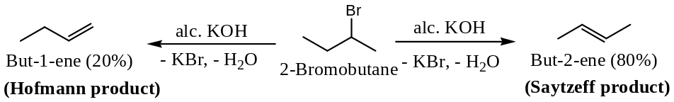
Relative Reactivities of Alkyl Halides:
The decreasing order of reactivity of alkyl halide is
$$R_{3}C-X>R_{2}CH-X>RCH_{2}-X$$
$$tert-Alkyl halides>sec-Alkyl halides>primary-Alkyl halides$$
The branching around carbon carrying the halogen increases as we move along the series from primary to tertiary halides. The greater the branching, the greater is the number of hydrogens which would be available for attract by the base, hence, the more favourable probability factor for elimination. The more branched alkyl halide (say, $tert$- halide) leads to the formation of a more highly branched (hence, more stable) alkene (Saytzeff product).
Again, among different halides, the decreasing order of reactivity due to halogen based on their polarity is —
$$Iodine>Bromine>Chlorine$$
[2] Synthesis of Alkene by the Dehydrohalogenation of Vicinal Dihalides: —
When a vicinal dihalide is treated with zinc, the halogens are taken away by the zinc to form alkenes. Thus—
For example,
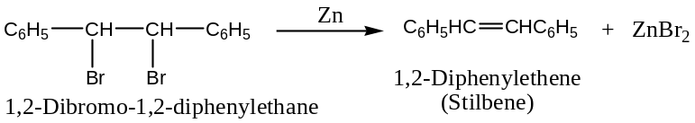
[Note: This reaction is more suitable for the purification of compounds containing $C-C$ double bond or for the protection of a $C-C$ double bond, and not used as preparative method.]
Mechanism of dehydrohalogenation: In the dehydrohalogenation reaction of vicinal dihalide by metallic zinc, zinc acts as a source of electron. The mechanism is believed to involve supply of electrons by zinc and elimination of halogen as shown below:
$$\left(1\right) Zn → {Zn}^{2+ } +2e^{-}$$
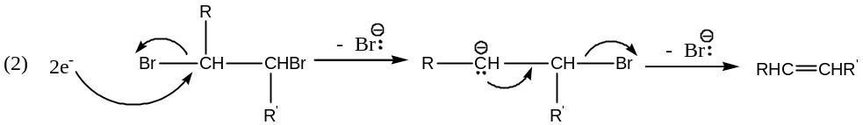
$$\left(3\right){Zn}^{2+} +2{Br:}^{-} → Zn{Br}_{2}$$
[3] Synthesis of Alkene by the Dehydration of Alcohols: —
Protonic acids (e.g. sulphuric acid) and Lewis acids (e.g. anhydrous zinc chloride, alumina, etc.) dehydrate alcohols to alkenes under suitable conditions. Thus,
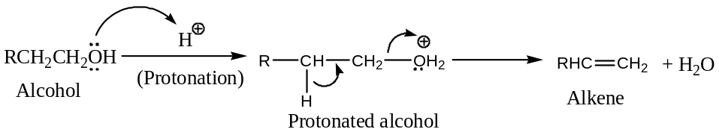
For example,
$$\left(a\right){CH}_{3}{CH}_{2}OH \underset{→}{Conc. H_{2}{SO}_{4}}H_{2}C=CH_{2} + H_{2}O$$
Ethanol Ethene
$$\left(b\right)C_{6}H_{5}{CH}_{2}{CH}_{2}OH \underset{→}{Conc. H_{2}{SO}_{4}}C_{6}H_{5}CH=CH_{2} + H_{2}O$$
2- Phenyl ethanol Styrene
$$\left(c\right)C_{6}H_{5}CH(OH){CH}_{2}C_{6}H_{5}\underset{→}{Conc. H_{2}{SO}_{4}}C_{6}H_{5}CH=CHC_{6}H_{5} + H_{2}O$$
1,2- Diphenyl ethanol Styrene
Important: Relative Reactivities of various Alcohols towards dehydration—
The ease of dehydration of alcohols is —
$$R_{3}C-OH>R_{2}CH-OH>RCH_{2}-OH$$
$$i.e. tert-(3^{°}) alcohols>sec-(2^{°}) alcohols>primary-(1^{°}) alcohols$$
Orientation/ Regioselectivity in Alcohol Dehydration (Saytzeff rule):
Dehydration of alcohol generally proceeds in such a way that the more stable (the highly substituted) alkene is the dominant product (Saytzeff elimination). Thus, when isomeric alkenes are possible during dehydration of alcohols, the more stable i.e. the highly substituted alkene (Saytzeff product) is the major product. This is known as the Saytzeff rule. For example,
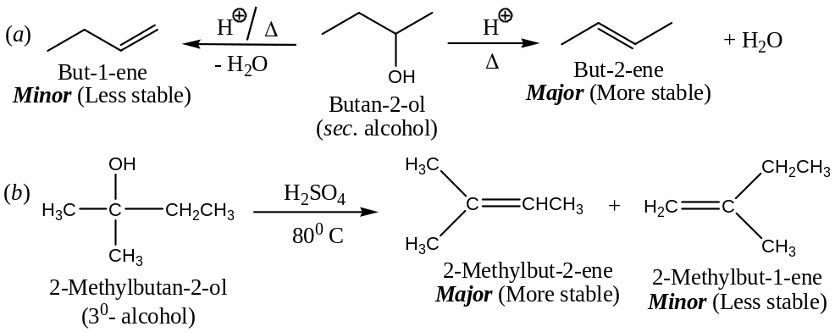
[4] Synthesis of Alkene by the Controlled Reduction of Alkynes: —
Alkynes on treatment with calculated amounts of hydrogen, in the presence of palladised charcoal partially deactivated with poisons like sulphur compounds or quinoline (Lindlar’s catalyst), reduced to $cis$- alkene. However, when alkynes are reduced with sodium in liquid ammonia $trans$- alkenes formed preferentially. [This is a stereoselective reduction reaction]. Thus, —
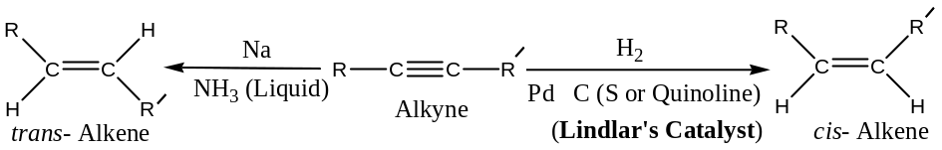
Important: Alkenes can also be prepared by—
- Hofmann Elimination reaction,
- Cope Elimination reaction,
- Wittig reaction,
- Pyrolysis of esters,
- Pyrolysis of Xanthate esters,
- Cracking of natural gas/ petroleum, etc.
We will discuss here briefly only Hofmann elimination reaction. This reaction is especially important for ascertaining the structure of unknown bases containing nitrogen (say, alkaloids occurring in nature). Let us illustrate this important reaction by taking a simple base, $n$- $butylamine$.
Hofmann elimination (Hofmann’s Exhaustive Methylation) reaction: This reaction can be applied to the amines in the following steps:
$\left(i\right) n$- Butylamine is methylated exhaustively by the interaction with methyl iodide to get the quaternary ammonium salt (trimethyl $n$- butylammonium iodide)
$${CH}_{3}({CH}_{2})_{3}{NH}_{2}+3{CH}_{3}I → [{CH}_{3}({CH}_{2})_{3}N^{⊕}({CH}_{3})_{3}]I^{⊝}$$
$n$- Butylamine Methyliodide trimethyl $n$- butylammonium iodide
$\left(ii\right)$ The quaternary ammonium salt obtained in step $(i)$is treated with $AgOH$, when $AgI$ precipitates out and a halogen free solid quaternary ammonium hydroxide forms.
$$[{CH}_{3}({CH}_{2})_{3}N^{⊕}({CH}_{3})_{3}]I^{⊝}+AgOH → [{CH}_{3}({CH}_{2})_{3}N^{⊕}\left({CH}_{3})_{3}\right]\ddot{O}H^{⊖}+AgI↓$$
Trimethyl-$n$- butylammonium iodide trimethyl-$n$- butylammonium hydroxide
$\left(iii\right)$ The quaternary ammonium hydroxide obtained in step $(ii)$is heated strongly, it decomposes to form tertiary amine,$({CH}_{3})_{3}\ddot{N}$, and an alkene (but-1-ene) along with water.
$$[{CH}_{3}({CH}_{2})_{3}N^{⊕}\left({CH}_{3})_{3}\right]\ddot{O}H^{⊖}\underset{→}{∆}{CH}_{3}{CH}_{2}CH={CH}_{2}+({CH}_{3})_{3}\ddot{N}+H_{2}O$$
Trimethyl-$n$- butylammonium iodide But-1-ene Trimethyl amine
The step ($iii$) is a typical nucleophilic $β$- elimination, as shown below:
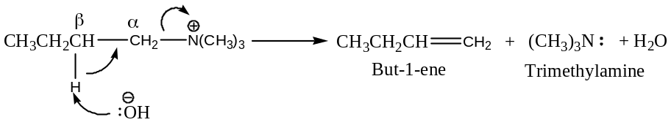
This elimination reaction is a general reaction applicable to all type of amines of varied structures. If the parent amine is an unknown nitrogenous base, we can identify the alkene formed in step ($iii$) and work backwards to deduce the structure of the parent amine.
[Hofmann Rule —
This rule is applicable for those substrate in which the $α$- $C$- atom is attached to a $+vely$ charged atom (usually$N or S$). According to this rule, in the elimination reaction of $+vely$ charged species, the major product will be the that alkene which is least substituted. Thus,
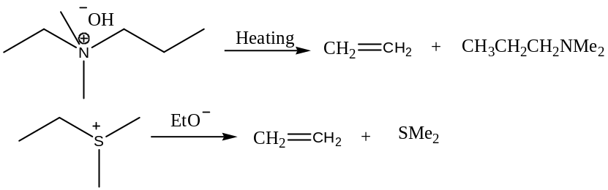
Hofmann rule can be understood by considering the mechanism of elimination reaction of quaternary ammonium hydroxide.
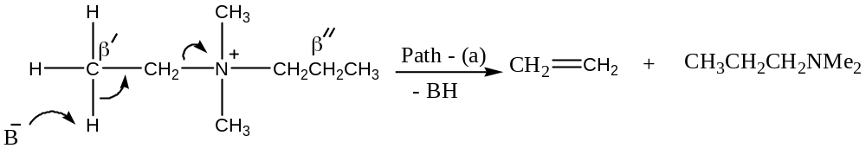
Another possibility is —
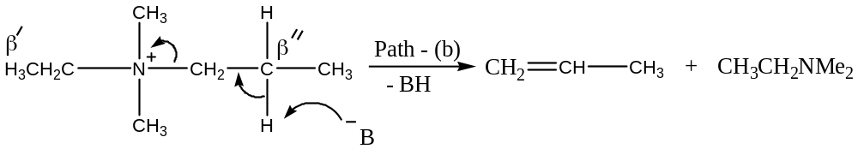
In the above reaction, the strong electron-withdrawing group makes the hydrogens of the $β$-carbons more acidic for facile abstraction by the base. In this compound, with alternate $β$- $H$- atoms (marked as $β^{'}\&β^{''})$, the $β^{''}$- $H's$ are less acidic due to$+I$effect of the adjacent methyl group. Hence, $β^{'}$- hydrogen is relatively more acidic and is removed to give the alkene (ethene) by path – (a).] //
General Physical Properties of Alkenes: —
Important physical properties of alkenes (similar to the corresponding alkanes) are studied under the following headings —
- Physical appearance,
- Boiling point,
- Melting point,
- Solubility, and
- Dipole moments ($μ$- values).
- These are discussed below with suitable examples.
Physical appearance of Alkenes:
First three members of alkene ($i.e. C_{2}-C_{4}$) are gases,
Next fourteen members of alkene ($i.e. C_{5}-C_{17}, heptadecane$) are liquids, and
Alkenes containing $18C$- atoms or more are solids at ordinary temperature.
***Boiling and Melting point trends of Alkenes:
The boiling point of alkene shows gradual rise with the increase in $C$- content (i.e. molecular weight). In general, the boiling point difference between two successive members of the homologous series (except for first few members) is about $20℃ to 30℃$. Among the isomeric alkanes, the straight chain isomer (i.e. normal compound) has higher boiling point than the branched chain isomer. The greater the branching of the chain, lower the boiling point is. For example, boiling points of but-1-ene, $cis$- and $trans$- but-2-ene and n- butane are all close to $0℃$. Like boiling points, the densities of alkene are also similar ($0.6-0.7 g{mL}^{-1}$).
Solubility and Dipole moments of Alkenes:
Alkenes are slightly more polar than alkanes due to weakly held electrons in the $π$- bonds are more polarisable (hence, instantaneous dipole moments). Thus, alkenes are insoluble in water but soluble in non-polar solvents like ${CCl}_{4}, C_{6}H_{6}$, petroleum ether, etc. i.e. follows the universal statement “Like dissolves like”. Since, alkyl groups are slightly electron donating ($+I$ effecting) and leads to the development of a small partial $+ve$ charge on the alkyl group and a small partial $-ve$charge on the double bond, hence possesses permanent dipole moment value. For example,
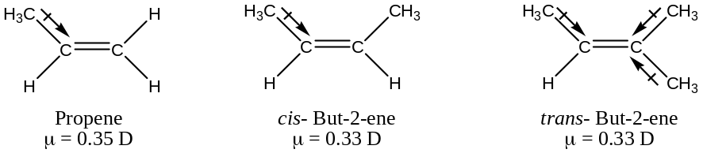
In trans- but-2-ene, unlike cis- but-2-ene, the two dipole moments tend to cancel out. Therefore, trans- but-2-ene in contrast to cis- but-2-ene has zero dipole moment. Because of the increased intramolecular attractions (dipole-dipole attractions besides van der Waals attractions), cis- but-2-ene have a higher boiling point than trans- but-2-ene ($4℃ against 1℃$). //
General Chemical Properties (Reactions) of Alkanes: —
The most important reactions of alkenes are—
- Electrophilic Addition, and
- Free-Radical Addition,
They also undergo—
- Free-Radical Substitution,
- Cleavage Reaction (Oxidation),
- Polymerization, etc.
Some of the representative reactions are discussed in detailed with appropriate mechanisms—
- Electrophilic Addition Reactions:
***[General outline of Electrophilic Addition Reactions:
In electrophilic addition reactions, electrophilic reagents become bonded to electron rich sites of the substrates. The most important substrates to which electrophilic reagents add possess $C-C$ multiple bonds i.e. alkenes and alkynes, because the $π$- electrons of these functional groups provide the required regions of high electron density. Thus,
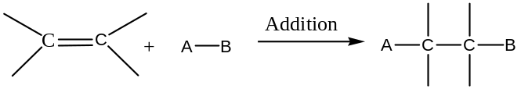
Electrophilic reagents i.e. electron seeking reagents are those possesses incomplete outer electron shells, so are also called Lewis acids. Electrophiles include ―
- Positively charged species i.e. Cations― Examples are: protons ($H^{+}$), carbocations ($R^{+}$), halonium ions ($X^{+}$), nitronium ions (${NO}_{2}^{+}$), etc.
- Non- charged/ Neutral molecules/ Electron deficient species―
- ${Br}_{2}$ (Because it can be polarized so that one end is $+ve$)
- Lewis acids: ${BH}_{3}, {BF}_{3}, {AlCl}_{3}, {SO}_{3}, carbene \left(-\ddot{C}-\right), etc.$
- Metal ions that contain vacant orbitals ― such as ${Ag}^{+}, {Hg}^{2+}, {Pt}^{2+}, etc.$
For example: Interesting examples are ―
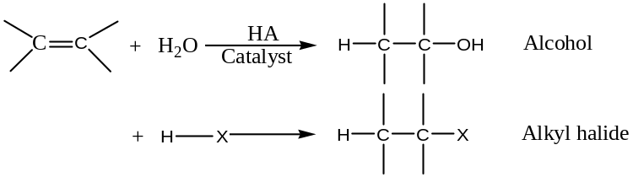
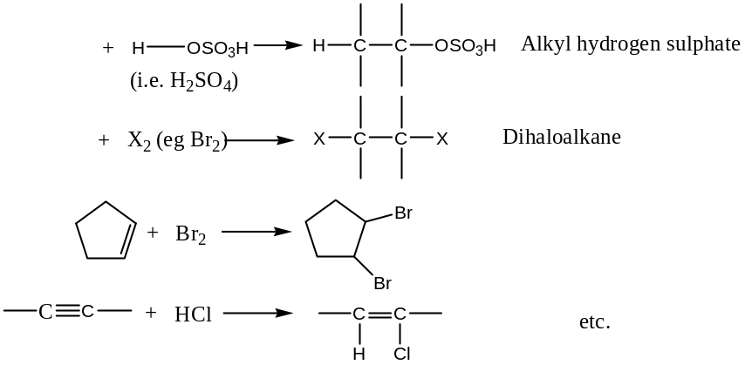
Electrophiles & Nucleophiles:
Electrophiles are Lewis acids as these molecules or ions can accept an electron pair. Nucleophiles are molecules or ions that can furnish an electron pair i.e. Lewis bases.
Any reaction of an electrophile also involves a nucleophile. For example, in the protonation of an alkene, the electrophile is the proton donated by an acid and the nucleophile is the alkene.
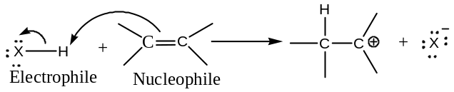
In the next step, the reaction of the carbocation with the halide ion, and here, the carbocation is the electrophile but the halide ion is the nucleophile.
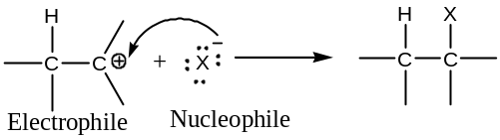
General Mechanism of Electrophilic Addition Reactions:
Electrophilic additions to multiple bonds involve conversion of a$π$- bond into two new$σ$- bond. In this mechanism, a$+vely$ charged species (electrophile) approaches to the double or triple bond and in the 1st step a$σ$- bond is formed by converting the$π$- electron pair into a$σ$- pair. In the 2nd step, the carbocation so formed reacts with an anion (nucleophile) in a faster rate to complete the reaction by forming another$σ$- bond. Thus,
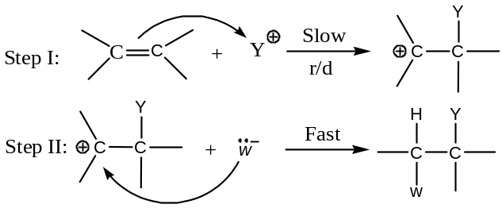
Thus, the electrophilic additions take place in two steps (normally) and follows 2nd order kinetics i.e.
$Rate=k\left[Substrate\right][Reagent]$
And these reactions are designated as ${Ad}_{E}2$ (Bimolecular Electrophilic Addition). The IUPAC designation for the mechanism is $A_{E}+A_{N} (or A_{H}+A_{N}ifY^{+}=H^{+})$.
All electrophilic addition reaction does not follow the above shown simplified mechanisms. For example,
- Bromination of alkene proceeds through the cyclic bromonium ion,
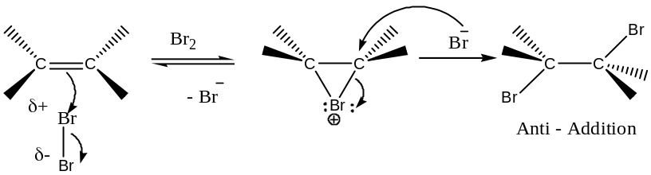
- ${OsO}_{4}$(Osmium tetroxide) or $KMnO_{4}$ (Potassium permanganate) adds to alkene through their corresponding cyclic ester intermediates, which on hydrolysis (catalysed by a base) yields diol, and the addition takes place in 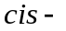fashion i.e. hydroxylation occurs to form diol. The sequence of the reactions is shown below:
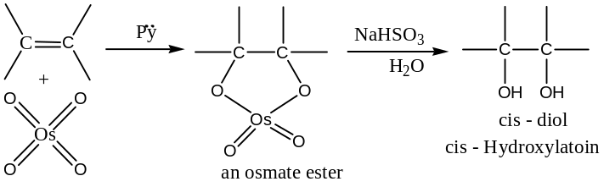
Similarly,
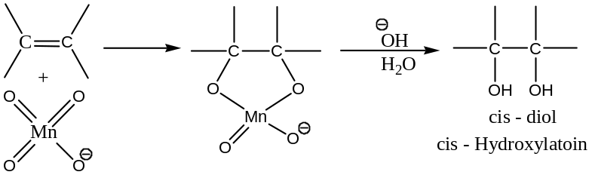
Some more examples of electrophilic addition reactions:
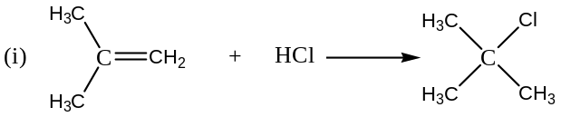
Mechanism:
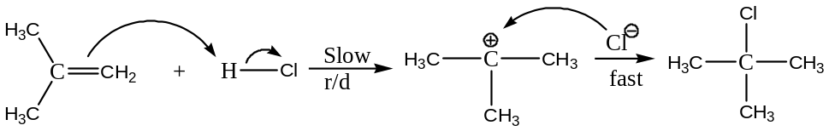
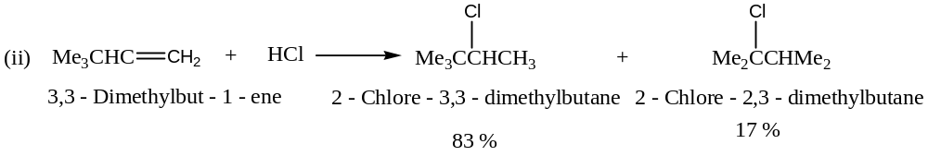Mechanism:
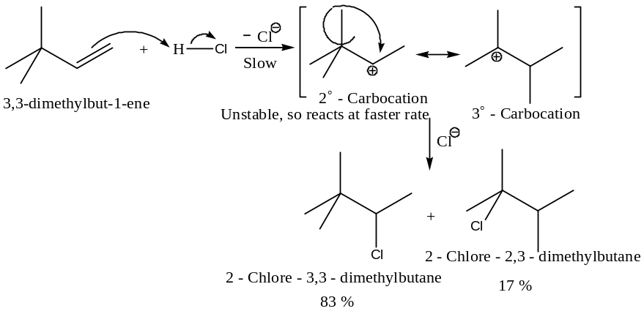
Which will react first? Electrophile or Nucleophile in${Ad}_{E}$
During electrophilic addition reactions, 1st step is always the addition of electrophile, because if nucleophile adds 1st it will generate a carbanion (reverse of $S_{N}2$ reaction: where nucleophile 1st adds to carbonyl group), which is less stable in comparison to carbocations.
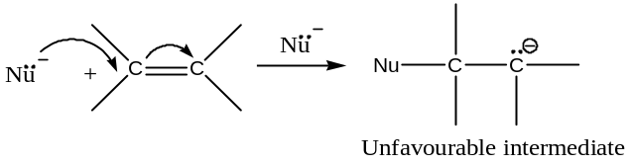
Structural Effects and Reactivity of ${Ad}_{E}2$ Mechanism:
The rate of an electrophilic addition reaction is greatly affected by the groups or atoms directly attached to the multiple bonds i.e. electrophilic sites i.e. nucleophile. Electron donating groups directly attached to the $C-C$ multiple bonds enhances the reactivity; whereas, electron withdrawing groups decreases the rate of ${Ad}_{E}2$ reactions. For example,
- Bromination of Alkene:
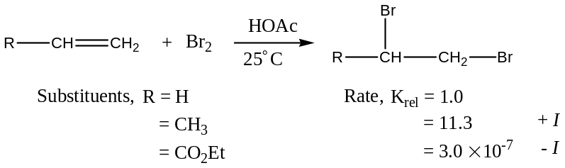
- Hydration of Alkene:
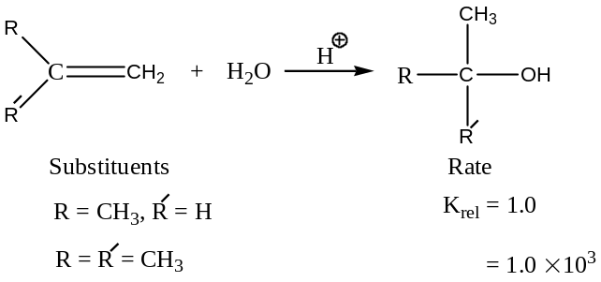
Alkynes are normally less reactive towards ${Ad}_{E}$ than similarly substituted alkenes. This is because of the fact that the addition of an electrophile to a double bond generates the $+ve$ charge on the substrate (i.e. a carbocation), whereas similar addition to a triple bond leads to a di-coordinated vinyl cation. Thus,
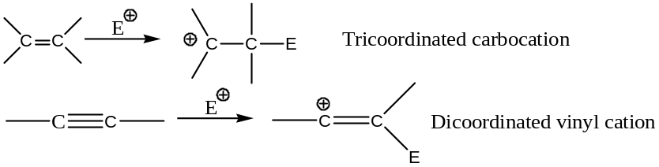
Since, the tri-coordinated carbocations easier to form, hence alkenes react at a faster rate than alkynes.]
Reactions involving electrophiles are called electrophilic reactions. For example,
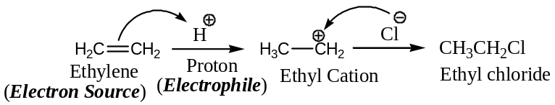
Some representative examples are—
- Addition of Hydrogen Halides($HX$):
Hydrogen halides ($HCl, HBr \& HI$) readily add to alkenes forming alkyl halides. The order of reactivity of the hydrogen halides in this reaction is: $HI>HBr>HCl$. For example,
$$H_{2}C=CH_{2}+HBr \underset{→}{Acetic acid}{CH}_{3}{CH}_{2}Br$$
Ethene Bromoethane
$$C_{6}H_{5}CH=CHC_{6}H_{5}+HBr →C_{6}H_{5}CH\left(Br\right)-CH_{2}C_{6}H_{5}$$
1, 2- Diphenyl ethene (Stilbene) 1- Bromo-1, 2- diphenylethane
Mechanism of $HX$ addition: It is an electrophilic addition reaction, initiated by the electrophile ($H^{+}$) released from $HX$. This reaction involves three steps:
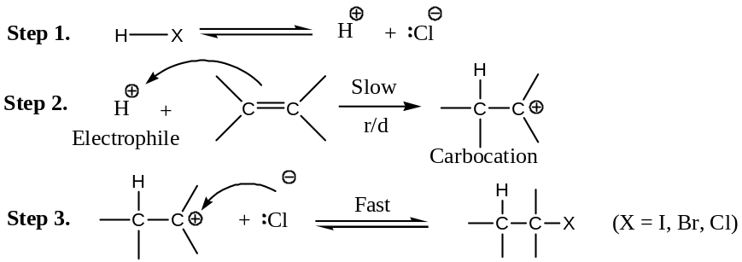
Markownikoff (or Markovnikov) Orientation —
The addition of $HX$ to an unsymmetrical alkene could conceivably occur in two ways (Regio-selective). In practice, however, one product mainly predominates. For example,
Addition of hydrogen bromide $(HBr$ to propene, can lead to $1$-bromopropane or $2$- bromopropane. The main product, however is $2$- bromopropane:
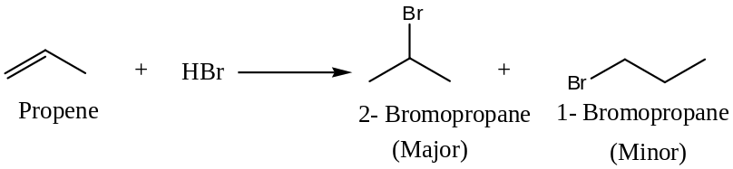
Similarly, when $2$- methyl propene reacts with $HBr$, the main product is $t$- butyl bromide, not isobutyl bromide:
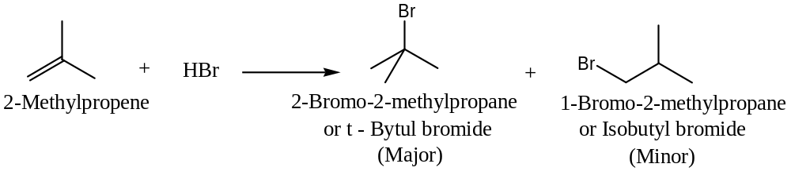
The regioselective addition of$HX$to an unsymmetrical alkene (asymmetric) was empirically given by Vladimir Markownikoff (1869), what is now known as Markownikoff rule. The rule states that in the addition of $HX$ to an alkene, the $H$- atom of $HX$ (or the $+ve$ part of the reagent) adds to that $C$- atom of the double bond of the unsymmetrical alkene that already has the greater number of $H$- atoms. (Mnemonics’ ― Rich becomes Richer).
In modern terminology, we can state Markownikoff rule in more general form: In the ionic addition of an unsymmetrical reagent to a double bond, the 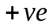 portion of the adding reagent attaches itself to an$C$- atom of the double bond so as to yield the more stable carbocation as an intermediate. Alternatively, the electrophilic addition to carbon-carbon double bond takes place in that direction that leads to the formation of the most stable carbocation intermediate. Thus, (mechanism)
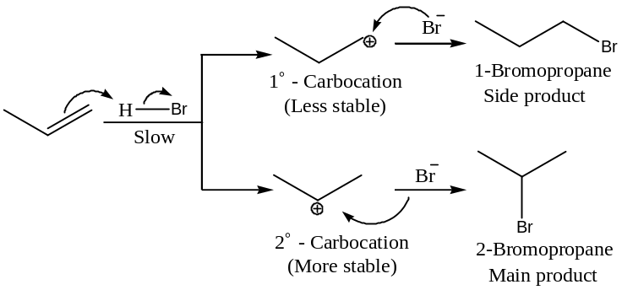
Similarly,
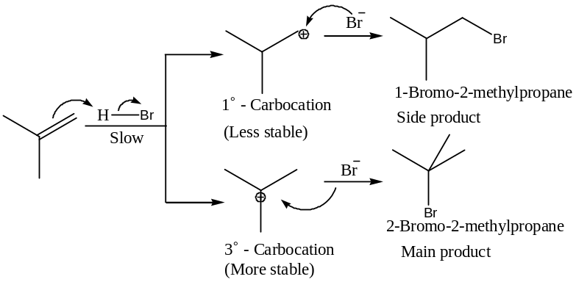
Some more examples of Markownikoff rule or addition:
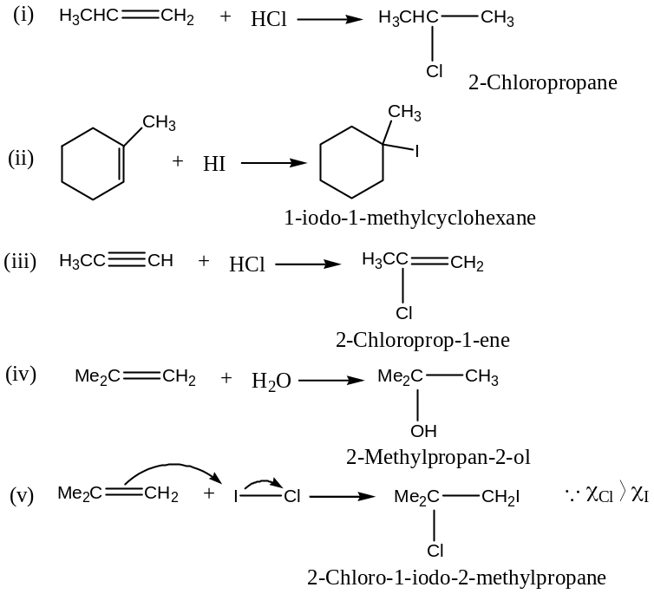
Evidences in support of new version of Markownikoff rule:
The following two somewhat difficult reactions find satisfactory explanation in terms of the above stated mechanism as well as the new version of Markownikoff rule.
$(i)$Addition of $HBr$ to 1- phenyl-1- propene: This asymmetric alkene has equal number of hydrogens attached to carbon-carbon double bond. There is thus a fair possibility that two expected addition product will be formed at almost equal amounts. Actually, only 1- bromo-1-phenyl propane (III) is formed as a major product, the result is really in accord with the normal mechanism as well as the new version of Markownikoff rule.
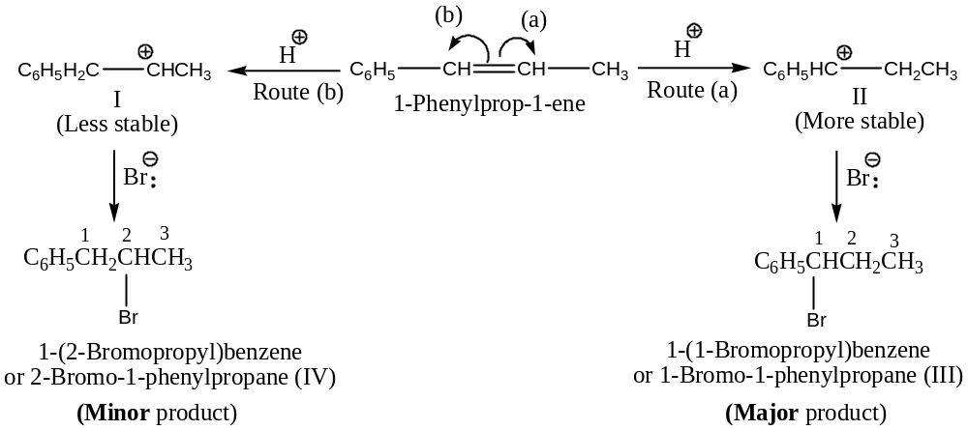
The carbocation intermediate (II) is more stable than (I), because (II) is resonance stabilized due to the presence of the adjacent phenyl group, as shown below:
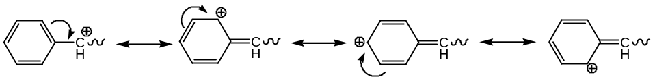
No such resonance stabilization is possible in the case of (I). Since (II) is more stable than (I), the adduct (III) should be formed as the major product. This supports new version of Markownikoff rule.
$(ii)$Addition of $HCl$ to 3, 3- dimethyl-1- butene: Unexpected addition product 2-chloro -2, 3- dimethylbutane formed as the major product in this reaction. This is conformity with the mechanism of the reaction as well as the modified Markownikoff rule. The actual isolation of such rearranged product in this reaction supports this mechanism as well as new version of Markownikoff rule.
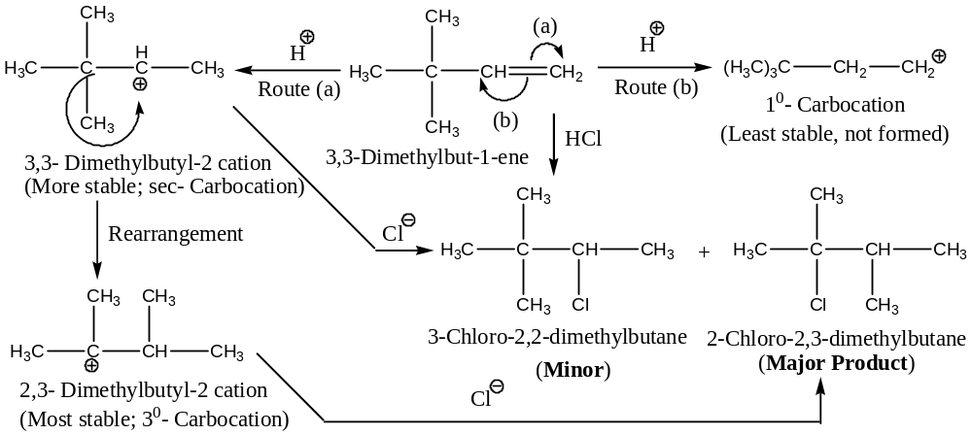
It can be mentioned in general that all reactions favour the formation of carbocation intermediates are susceptible to rearrangement, if it can lead to a more stable carbocation. For example,
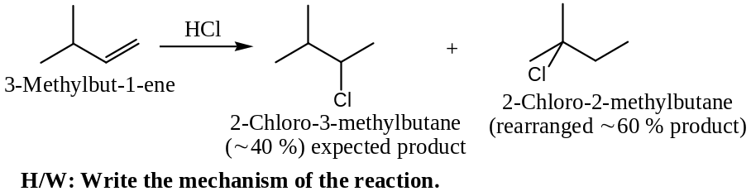
Important: In rearrangement step, $-{CH}_{3}$ group along with its bonding electron pair shifts from less stable carbocation to from more stable carbocation, usually $tert$- carbocation.
Relative reactivities of Alkenes: The decreasing order of reactivity of alkenes towards electrophilic addition reactions is based on the stability of alkenes. This is as follows—
$$R_{2}C=CR_{2}^{'}>R_{2}C=CHR^{'}>R_{2}C=CH_{2}, RCH=CHR^{'}>RCH=CH_{2}>CH_{2}=CH_{2}> CH_{2}=CHX$$
Explanation: This order of reactivity is consistent with the stabilization of the intermediate carbocations (and also of the incipient carbocations in the transition states) by electron releasing alkyl groups. The lowest reactivity of the double bond in vinyl halides ($CH_{2}=CHX$) in the above order is also in accordance with the fact that the halogens, being electron withdrawing, destabilizes the intermediate carbocations and transition state.
The peroxide effect or Anti – Markownikoff addition:
[1933 by MS Kharasch & FR Mayo of Chicago University, USA]
In presence of organic peroxides ($ROOR$) such as benzoyl peroxide, $C_{6}H_{5}{CO}_{2}.O.O_{2}CC_{6}H_{5}$the addition of $HBr$ (not and never $HCl, HF \& HI$) to an unsymmetrical alkene take place in the direction opposite to that predicted by Markownikoff rule. Thus,
$$RCH=CH_{2} + HBr \underset{→}{ROOR} RCH_{2}CH_{2}Br$$
For example,
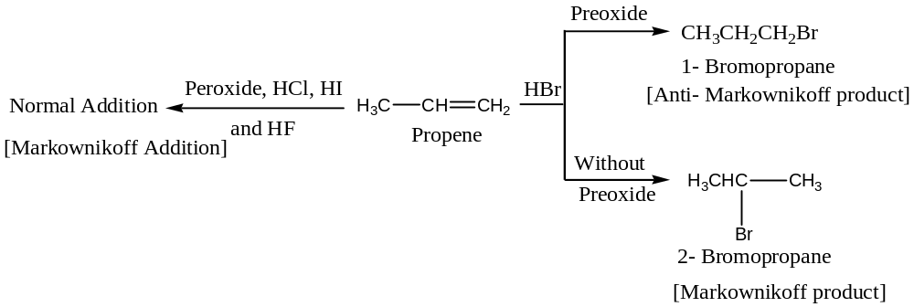
This effect of peroxides (organic) leading to abnormal addition (i.e. anti- Markownikoff addition) of $HBr$ to an unsymmetrical alkene is known as the peroxide effect. This is also known as Kharasch effect after the name of discoverer MS Kharasch.
Mechanism: Unlike the electrophilic addition, the peroxide initiated addition of $HBr$ to unsymmetrical alkenes is governed by a free radical addition, following chain mechanism―
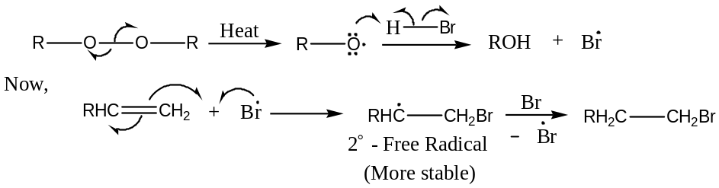
For example, considering benzoyl peroxide as the radical initiator —
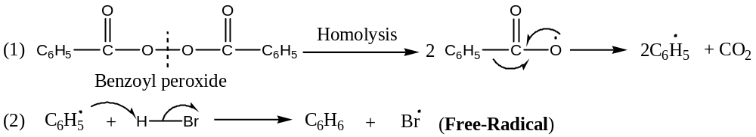
Bromine radical from step (2) can add to either of the two $C$- atoms of the double bond to produce a $1^{°}or a 2^{°}$ radical in step (3). The preferential formation of the free radical is in accordance with their stability $i.e. 3^{°}>2^{°}>1^{°}$.
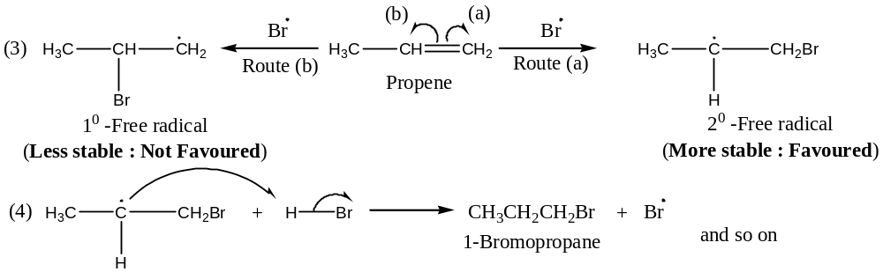
Since it is a free radical chain reaction, very few molecules of peroxide can alter the direction of addition of several molecules of $HBr$.
Important Note: Free radical addition reactions are also initiated by high temperature, oxygen or light.
Exceptional Behaviour of $HBr$ in Peroxide Effect:
Peroxide effect is not observed in addition of $HCl$ or $HI$. A possible explanation for this unique behaviour of $HBr$ is that the $H-Cl$ bond is stronger ($431 kJ{mol}^{-1}$) than $H-Br$ bond ($364 kJ{mol}^{-1}$), is not cleaved symmetrically by the free radical. The $H-I$ bond is, no doubt, weaker ($297 kJ{mol}^{-1}$), but iodine atom ($I^{.}$) tend to couple and form iodine molecules rather than to add at the double bond. Another explanation has been given for this exception is given below:
The reaction of an alkyl radical with $HCl$ is strongly endothermic,
Therefore, free radical chain reaction is not effective for the addition of $HCl$. Similarly, addition of iodine to alkene is also strongly endothermic. Therefore, the free radical addition of $HI$ is not observed.
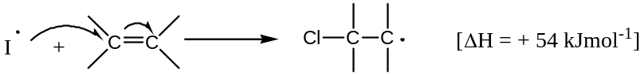
Thus, we see that only $HBr$ has just the right reactivity for each step of the free radical chain reaction to take place.
Stereochemistry of Markownikoff addition —
(Or For ionic addition to an alkene)
Considering the addition of hydrogen halide, $HX$ to but-1-ene, to generate 2- halobutane, which contains a stereogenic centre:
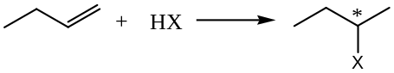
So, the product can exist as a pair of enantiomers. Since, the reaction proceed through the formation of an intermediate carbocation, which is trigonal planar in shape (${sp}^{2}$ hybridization) and achiral in nature. Hence, in the 2nd step, i.e. the reaction of halide ion is equally probable at the either face, leading to racemisation i.e. 50: 50 mixtures of two enantiomers.
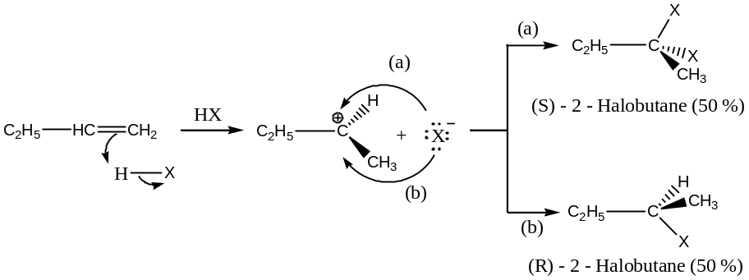
Stereochemistry of Electrophilic Addition Reactions: General Approach
In alkene two $C's$ of the double bond and the 4- atoms immediately attached to them are in the same plane. Again, the electron density associated with the $π$- bond of an alkene is the greatest above and below the plane of the double bond. Thus, there are three possibilities for the addition of electrophile and nucleophile ($Y-w or E-Nu$) to the double bond:
- Both the parts ($E^{+}\&{Nu}^{-}$) may enter from the same side of the plane i.e. addition is stereospecific synthesis.
- Both the parts ($E^{+}\&{Nu}^{-}$) may enter from the opposite sides for stereospecific anti addition.
- The reaction may be non-stereospecific.
Important: In order to determine which of these possibilities is occurring in a given reaction, the following type of experiment is often performed: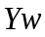 is added to the $cis$- &$trans$- isomers of an olefin of type $ABC=CAB$.
Considering the$cis$- isomer:
If the addition is $syn$- the product will be the $erythro dl$- pair because each $C$- has a 50% chance of being attract by “$Y$”
$Syn$- Addition:
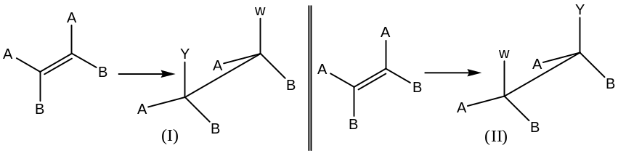
Thus, (I) & (II) constitutes an $erythro dl$- pair and since, these are the eclipsed forms, so can be translated directly to FPF.
On the other hand, if the addition is $anti$-, $threo dl$- pair will be the result
$Anti$- Addition:
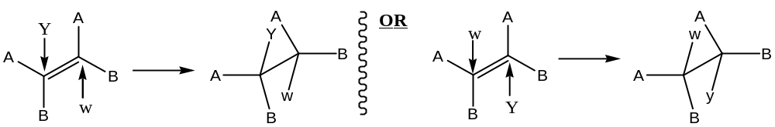
$Trans$- Isomers will give the opposite results, i.e.
$For syn$- Addition: $Threo dl$- pair and
$For anti$- Addition: $Erythro dl$- pair
Special case:
If$Y=w$, for example, addition of bromine (${Br}_{2}$) to an alkene, then
The$threo dl$- pair will be a$meso$- compound
In addition to the triple bond (i.e. alkynes), i.e. compound of the type$AC≡CA$
$Syn$- Addition results in a$cis$- olefin, but
$Anti$- Addition results in a$trans$- olefin.
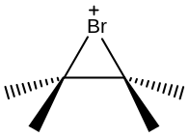 Addition to triple bond cannot be stereospecific, though it can be, and often is stereoselective.
There is a general tendency for electrophilic additions to favour$anti$- stereochemistry. This tells us that a reagent – substrate interaction can contribute in some way to configurational stability during the reaction. For example,
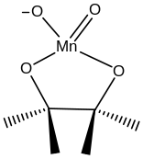 $Anti$- Stereochemistry of${Br}_{2}$- addition to alkene is because of the intermediate bromonium ion.
Similarly, the stereospecific$syn$- hydroxylation by permanganate probably involves a$cis$- cyclic intermediate.
Some General examples of Electrophilic Addition Reactions (${Ad}_{E}$):
[1] Addition of Hydrogen halides: Hydrohalogenation [Hydro-halo-addition]
See the Markownikoff rule
Stereochemistry of Hydrohalogenation:
Addition of$HBr$is stereoselective, and$anti$- addition predominates (as a trigonal planar carbocation is the intermediate) with simple monocyclic alkenes. However, both$syn$- and$anti$- additions take place on many conjugated double bonds. For example,
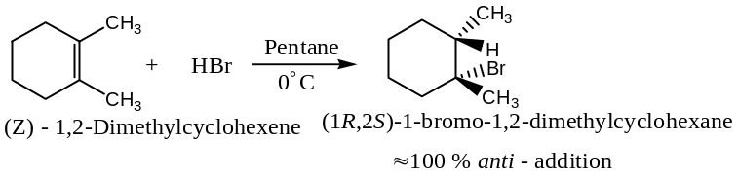
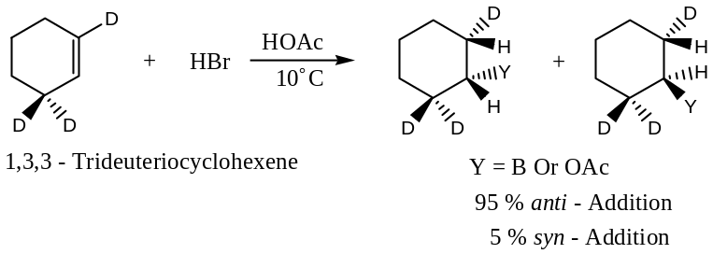
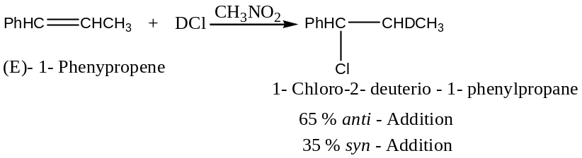
Addition of $HX$ to alkynes follows Markownikoff orientation and in many cases addition does not stop at the mono adduct but results a saturated compound.
Addition of$HCl$to$1,3$- butadiene gives both the$1,2$- &$1,4$- addition products:
[Solomon Page 606]
Electrophilic addition of$HCl or HBr$to$1,3$- butadiene (or any other conjugated diene) to give both 3-chlorobut-1-ene and 1-chlorobut-2-ene by 1, 2- and 1, 4- addition respectively.
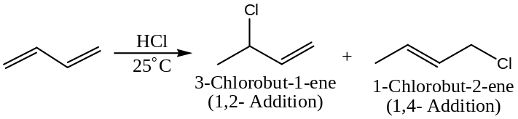
Formation of these two products can be explained through the formation of a resonance stabilized allylic cation.
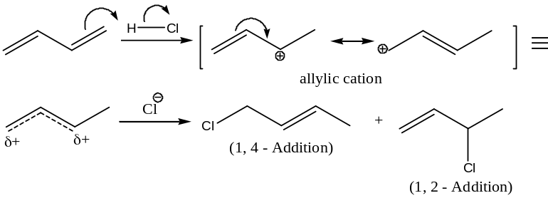
This reaction is temperature dependent as shown below:
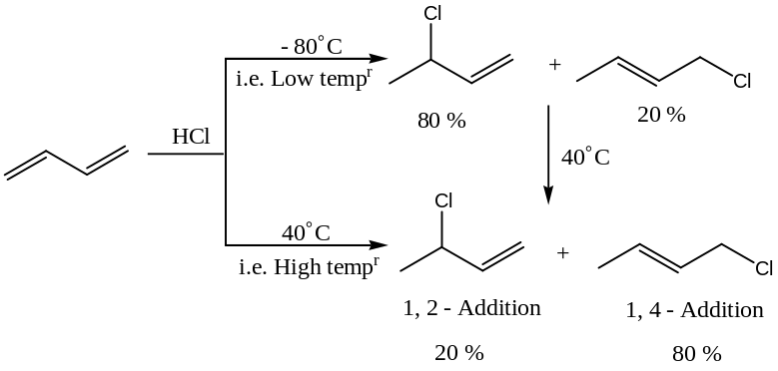
Thus, at low temperature,$1,2$- addition occurs exclusively but at high temperature,$1,4$- addition occurs exclusively. Again, when the mixture formed at low temperature ($40℃$) is brought to the high temperature, the relative amounts of the two products changes. The new reaction mixture eventually contains the same proportion of products given by the reaction carried out at high temperature ($80℃$).
It can also be shown that at higher temperature and in the presence of $HCl$, the $1,2$- addition product rearranges to the $1,4$- addition product and that equilibrium exists between them:
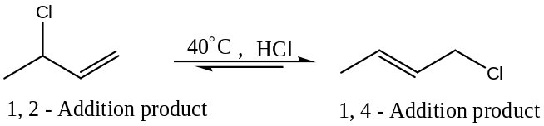
Because this equilibrium favours the $1,2$- addition product, that product must be more stable.
Thus, the reaction of$HCl$with $1,3$- addition butadiene provides an example, which can be explained by both relative rate of competing reaction and relative stabilities of the final product. At low temperature, the relative amount of the product formed is explained by the relative rates at which the two additions occurs; $1,2$- addition occurs faster, so it is the major product. At high temperature, the relative amounts of the products are determined by the position of equilibrium. The $1,4$- addition product is the more stable, so it is the major product.
Since, $1,2$- addition at low temperature is governed by the relative rates of the product formation is called the kinetic control or rate control reaction. On the other hand, $1,4$- addition at high temperature is governed by the position of equilibrium, so it is called equilibrium controlled or thermodynamically control reaction.
- Addition of Sulphuric Acid($H_{2}{SO}_{4}$)to Alkene: Sulphonation
Alkene reacts with cold concentrated $H_{2}{SO}_{4}$ to form alkyl hydrogen sulphate.
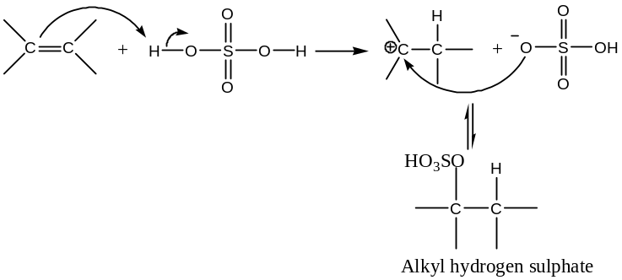
For example,
$$H_{2}C=CH_{2}+HO{SO}_{2}OH \left(H_{2}{SO}_{4}\right) → CH_{3}CH_{2}O{SO}_{2}OH$$
Ethene Sulphuric acid Ethyl hydrogen sulphate
Alkyl hydrogen sulphate so formed can be easily hydrolysed to alcohol just by heating with water. Thus,
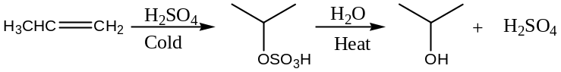
Thus, the overall result of addition of $H_{2}{SO}_{4}$ to an alkene followed by hydrolysis is the Markownikoff addition of $H \& OH$.
Stereochemistry of Sulphonation:
Addition of $H_{2}{SO}_{4}$ to an alkene in presence of an acid catalyst follows Markownikoff rule. For example, propene generates isopropyl hydrogen sulphate, not propyl hydrogen sulphate with $H_{2}{SO}_{4}$.
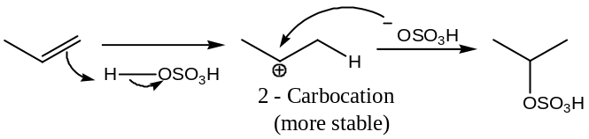
Mechanism of Halogenation of Alkane: Halogenation of alkane
- Addition of Water($H_{2}O$)to Alkene/ Double Bond: Hydration
Water adds to double bond in presence of an acid catalyst, usually dilute aqueous solution of $H_{2}{SO}_{4}andH_{3}{PO}_{4}$ to form alcohol (hence, reverse of hydration of alcohol). Thus,
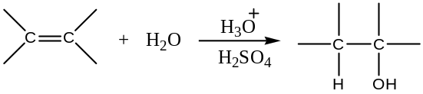
For example,
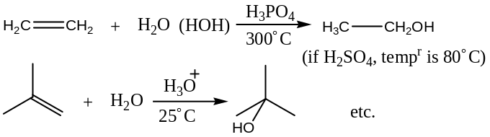
Further, the acid catalyst (as ordinarily water does not add directly to alkenes) hydration of alkenes takes place in accordance to Markownikoff rule to form alcohols.
Mechanism of Acid – Catalysed Hydration of an Alkene: Hydration of alkene in presence of an acid catalyst is an electrophilic addition reaction involving four steps:
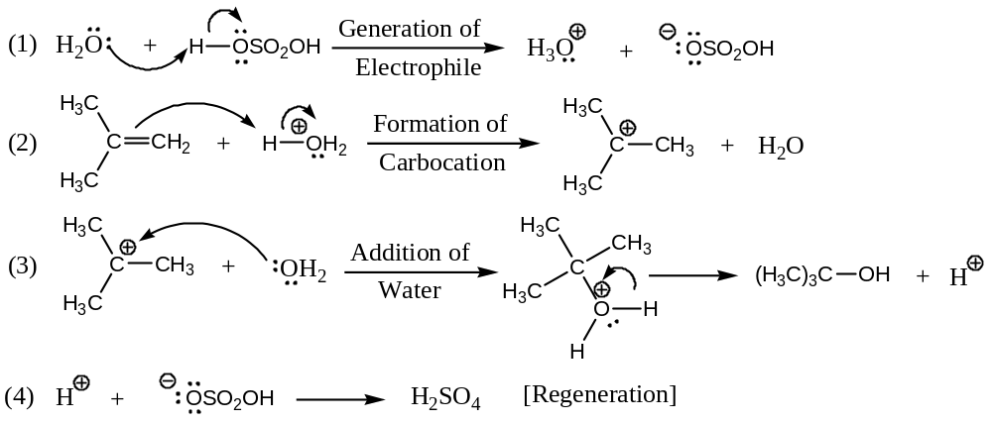
Briefly—
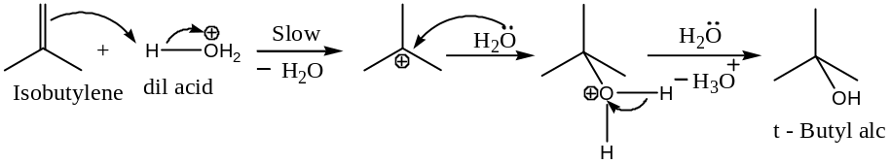
With suitable alkenes, rearrangement is also possible to generate more stable carbocation. For example,
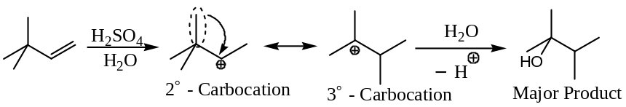
H/W: Formulate the acid catalysed hydration of 3- methyl-1- butene to 2- methyl-2- butanol and outline its mechanism. [Hints: 2⁰- carbocation rearranges to more stable 3⁰- carbocation by a hydride ($H^{-}$) ion transfer from 2⁰- carbocation.]
Stereochemistry of Hydration:
Hydration of alkenes is usually stereoselective, and follows Markownikoff rule. Though stereoselective, hydration tends to proceed by relatively random$anti$- and $syn$- stereochemical pathways:
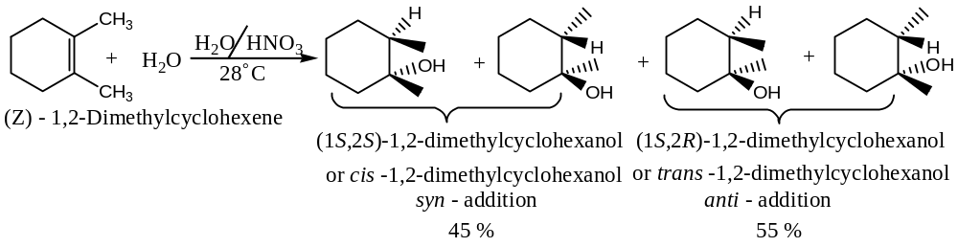
- Addition of Halogens($X_{2}, X=Cl \& Br only$):[$anti$- Addition]
Alkenes react rapidly with halogens (${Cl}_{2}\&{Br}_{2}$ only)at room temperature in nucleophilic solvents ($e.g.{CCl}_{4}$) to form vicinal dihalides. [Addition of fluorine is too fast to be controlled, and hence, not a useful laboratory procedure. Iodine generally fails to add as di-iodide product tends to decompose easily.] For example,
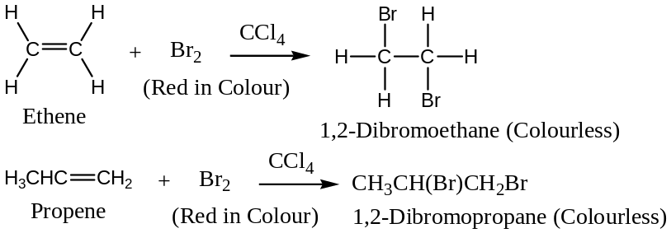
Some more examples are —
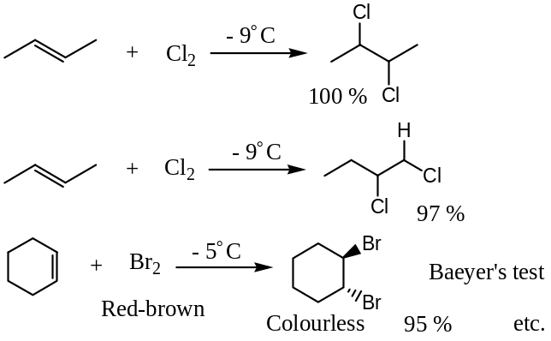
Analytical Importance: The reaction with bromine forms the basis of Bromine Test used in the laboratory to detect unsaturation ($C-C$ double or triple bond) in an unknown organic compound. Immediate decolourisation of bromine solution indicated unsaturation.
Mechanism of Halogenation of Alkene:
Halogenation (e.g. bromination) of alkene takes place in $trans$- manner. The ${Br}_{2}$- molecule is polarized by $C=C$ and $+ve$end attached to the double bond to form a cyclic three membered bromonium ion (cyclic halonium ion) intermediate. In the 2nd step, the bromide anion approaches from the opposite side to give the $trans$- product. Thus,
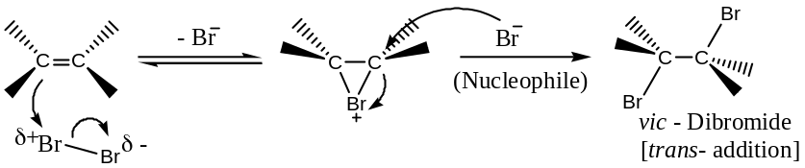
Evidences in support of the above Mechanism:
The above mechanism of halogenation of alkene is supported from the fact that by adding bromine to ethene in the presence of $NaCl$, the reaction product contained a mixture of 1,2 – dibromoethane and 1 – bromo-2- chloroethane but not $1,2$- dichloroethane. It is clear from the above mechanism that chloride anion competes with bromide anion only after the formation of cyclic bromonium ion.
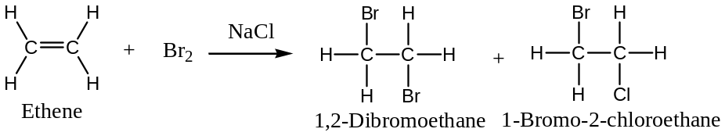
Stereochemistry of Halogenation of Alkene: OR
Stereochemistry of Halogenation of Alkene in terms of cyclic halonium ion mechanism:
Because of the formation of cyclic halonium ion as an intermediate,$anti$-addition occurs. For example, the $anti$- addition of bromine to $cis$- but-2-ene yields racemic-2, 3- dibromobutane as shown below —
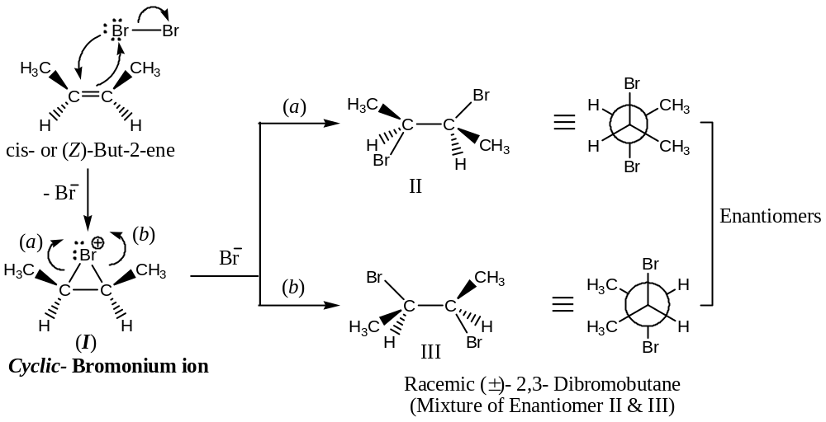
From the above mechanism, it is evident that the attack of the cyclic bromonium ion (I) by the bromide ion (${Br}^{-}$) from opposite sides ($a \& b$) is equally possible and enantiomers II & III will be formed in equal amounts. The cyclic structure of the bromonium ion (I) prevents rotation about the $C-C$ bond, and at the same time limits the ${Br}^{-}$ ion attack exclusively from the opposite side of the bromonium ion. It explains satisfactorily the formation of only racemic- $2,3$- dibromobutane and not meso-$2,3$- dibromobutane by the addition of ${Br}_{2}$ to $cis$-$but$-$2$-$ene$.
Similarly, $anti$- addition of bromine to $trans$- but-2-ene yields meso -2, 3- dibromobutane through the formation of cyclic bromonium ion as shown below —
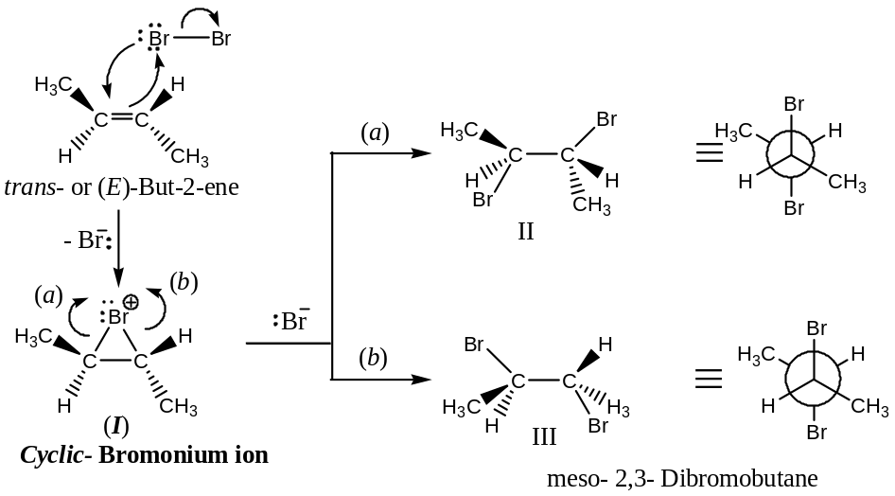
Similarly with cyclopentene —
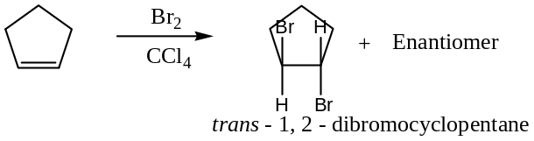
The$anti$- addition of bromine (${Br}_{2}$) to cyclopentene can be explained by a mechanism that involves the formation of a cyclic halonium ion in the 1st step. In the 2nd step, an${Br}^{-}$ion attacks an$C$- atom of the ring from the side opposite that of the${Br}^{-}$ ion (bromonium ion). The reaction is an$S_{N}2$- reaction. Nucleophilic attack by the${Br}^{-}$ ion causes inversion of configuration of the carbon being attracted, which leads to the formation of one$trans$- $1,2$- dibromo cyclopentane enantiomer. The other enantiomer results from attack of the ${Br}^{-}$ ion at the other $C$- atom of the${Br}^{-}$ ion:
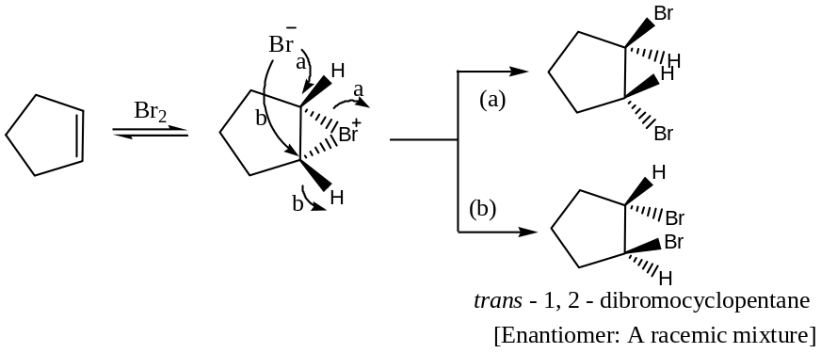
Finally, with cyclohexene,
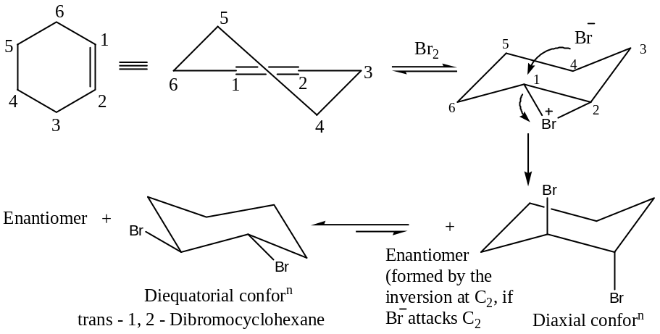
Note: Conformations and energies of dimethyl cyclohexanes are shown below:
Isomer | Conformation | No of gauche interactions | Interaction energy in 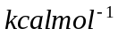
Cis – 1, 2  Trans – 1, 2 | 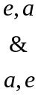  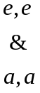 | 3  1  4 | 2.7  0.9  3.6
Cis – 1, 3  Trans – 1, 3 | 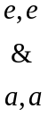  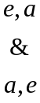 | 4  0  2 | 5.4  0  1.8
Cis – 1, 4  Trans – 1, 4 | 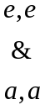 | 2  0  4 | 1.8  0  3.6

Halogenation of Alkene is $Stereospecificanti$- Addition:
That the halogenation of alkenes is stereospecific can be established from the following experimental observations. Bromination of$(Z)$- $orcis$-$but$-2-$ene$yields $racemic2,3$- $dibromobutane$but $(E)$- $ortrans$-$but$-2-$ene$ yields $meso2,3$- $dibromobutane$ respectively, indicating the stereospecific anti – addition of bromine to the double bond. Thus,
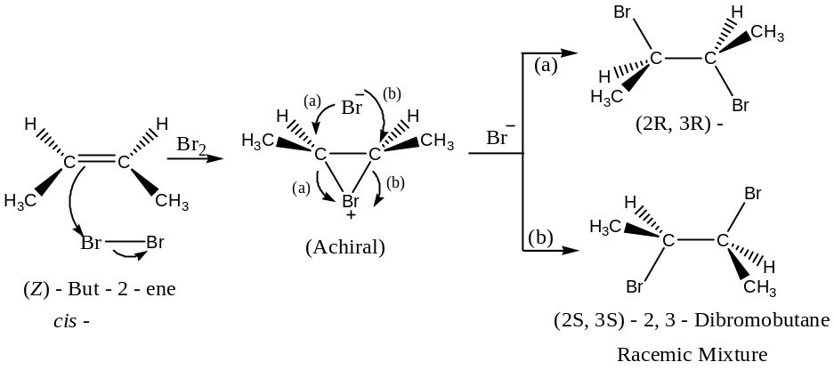
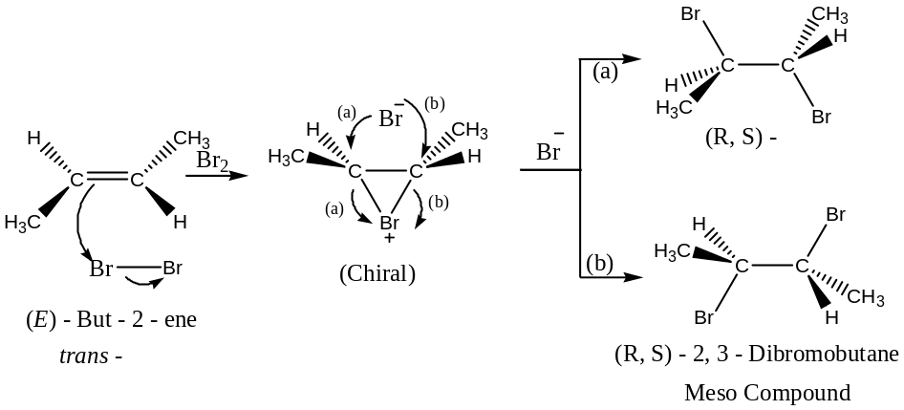
- Addition of Hypohalous Acid($HOX$): OR Addition of $X_{2}$ in aqueous medium to an Alkene: Halohydrin formation:[$anti$- Addition]
Reaction of an alkenes with halogens (${Cl}_{2} or {Br}_{2} only$) in aqueous medium produces halo-alcohol ($α$- halo alcohol) known as halohydrins and the reaction is known as halohydrin reaction. Thus,
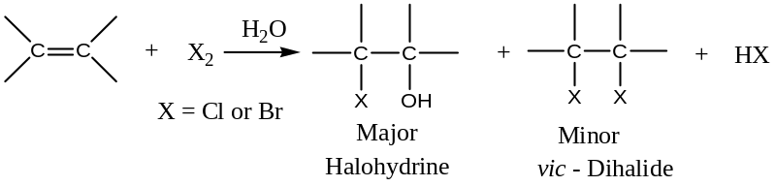
For example,
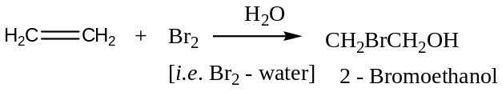
Mechanism:$Anti$- addition occurs through the intermediate halonium ion ―
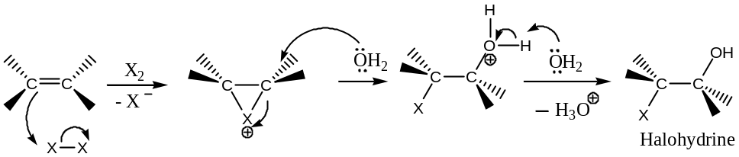
With unsymmetrical alkenes, halogen adds to the 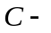atom that bears more number of 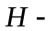atoms. Thus,
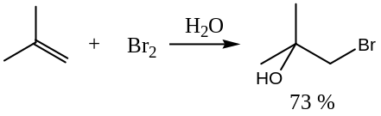
Thus, the addition of hypohalous acid ($HO-X$) to an unsymmetric alkene follows Markownikoff orientation/ rule.
- Addition of Nitrosyl Chloride($NOCl$):
Alkenes add to nitrosy chloride to give $chloronitrosoalkanes$ that $tautomerize$ to chlorinated oximes. For example,
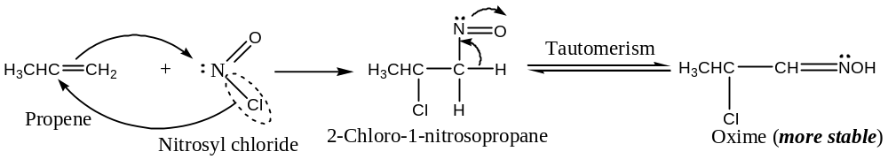
- Addition of Alkanes(Alkylation):
Alkanes add across the double bond of the alkene to form higher alkanes in presence of acidic catalyst. For example,
$$({CH}_{3})_{2}C={CH}_{2} + ({CH}_{3})_{3}CH \underset{→}{ HF } ({CH}_{3})_{2}CH{CH}_{2}C({CH}_{3})_{3}$$
2- Methylpropene 2- Methylpropane $2,2,4$- Trimethylpentane ($Iso$-octane)
Mechanism of Alkylation: The reaction is believed to proceed via carbocation involving the following three steps:
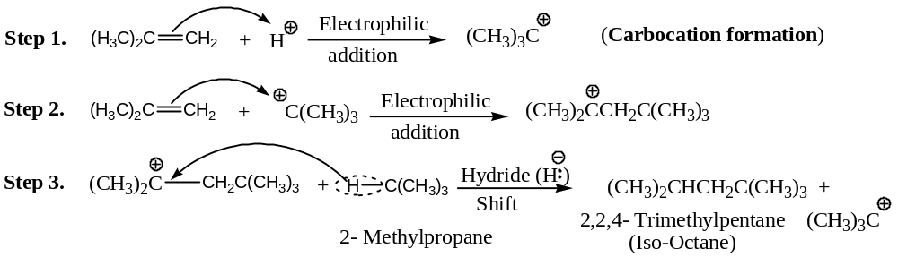
Step (2) and (3) are then repeated. It may be noted that the shift of methyl group in step (3) would have given less stable secondary carbocation.
- Addition of Alkenes:
In presence of dilute $H_{2}{SO}_{4}$ acid, an alkene adds to an alkene which may be identical or different to form dimer. For example,
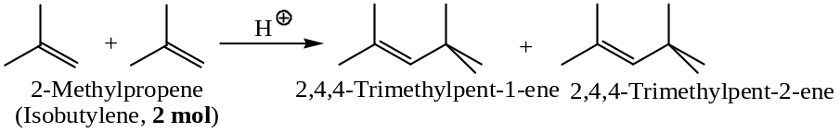
Mechanism: Acid catalysed dimerization of alkene proceed via the formation an intermediate carbocation, which on further reaction with another molecule of alkene to form a more stable carbocation. The stable carbocation so formed is stabilized by the release of proton in two ways to yield two different dimeric alkenes. Thus,
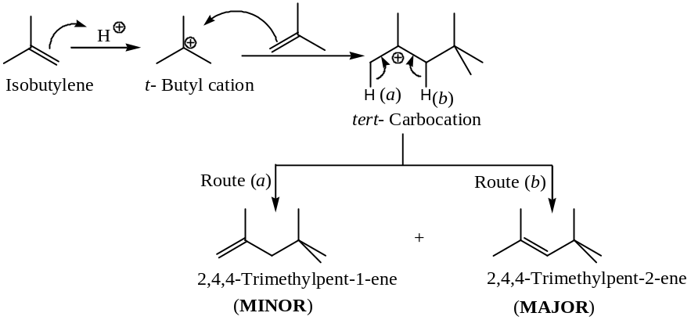
Important: Under suitable conditions, alkene can form trimers, tetramers and even polymers. These are discussed separately in polymerization.
- Hydration by Oxymercuration-Demercuration:$i.e.$
Reduction of Alkene to Alcohol by Oxymercuration – Demercuration:
Oxymercuration – Reduction/ Hydration of Double Bonds: [Hydro-Hydroxy-addition]
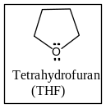Oxymercuration is the electrophilic addition of aqueous mercuric acetate,$Hg(OAc)_{2}$across a double bond. Reduction of the mercuric salt so formed by${NaBH}_{4}$(alkaline, by$NaOH$)leads to demercuration and produces an alcohol. Thus,
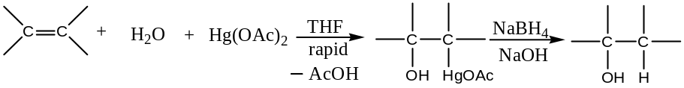
Some specific examples are:
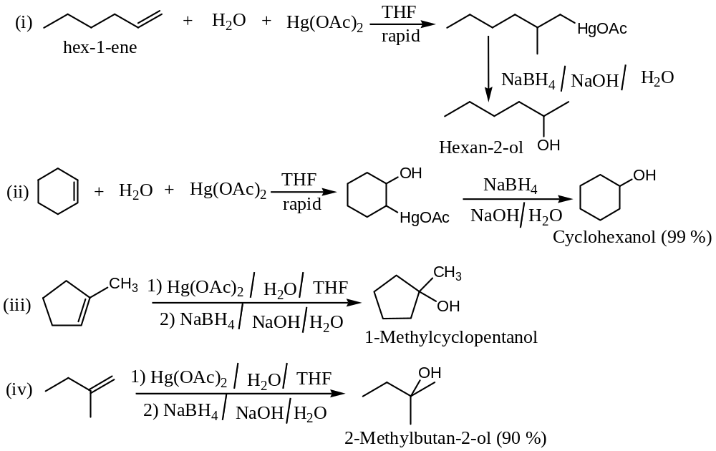
Mechanism Oxy Mercuration – Demercuration:
Acceptable mechanism for the reduction of alkene by mercuration-demercuration involves a cyclic transition state involving of${Hg}^{+}$- ion, and $NaBH_{4}$ can be written as:
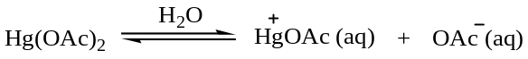
Now,
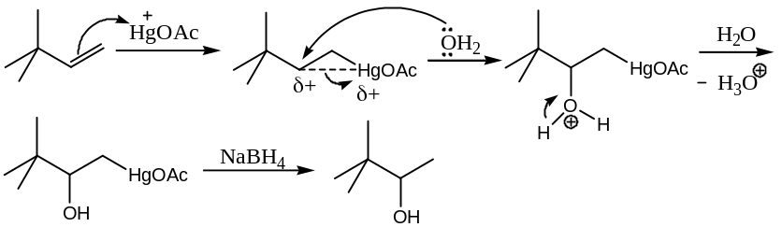
Stereochemistry of Oxy Mercuration – Demercuration:
Oxymercuration – reduction is highly regioselective. The net orientation of the addition of the elements of water,$H$- & -$OH$, is in accordance with Markownikoff rule. The$H$-becomes attached to the$C$- atom of the double bond bearing the greater number of$H$- atoms. Thus,
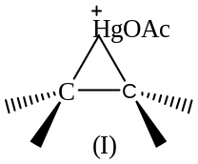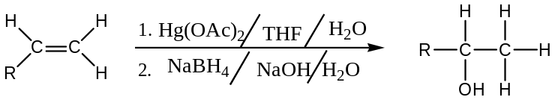
However, oxymercuration is regiospecific (Markownikoff orientation) and stereospecific ($anti$- addition). The stereospecificity is attributed due to the formation of intermediate mercurinium ion (I).
The bulk of the mercuric acetate group apparently plays an important role in controlling the direction in which the mercurinium ion (I) opens and thus, the addition regiochemistry. Water bonds to the more hindered$C$- atom from the back side of the molecule as the mercurinium ion opens towards the less hindered end of the original double bond.
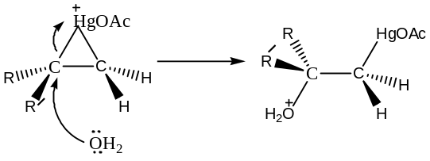
The reduction step follows a variable stereochemical pathway, so that the total reaction, oxymercuration – reduction is not necessarily stereospecific. Thus,
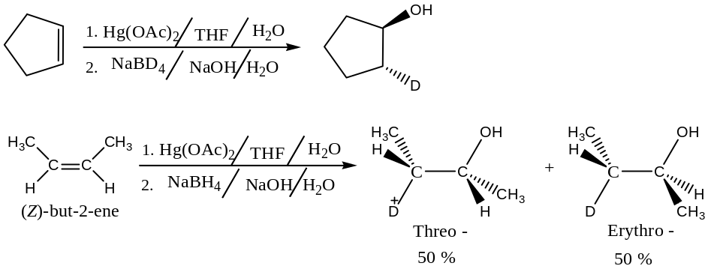
- Hydroboration-Oxidation of Alkene: [Alcohol from Alkene by Hydroboration – Oxidation][$Anti$- Markownikoff addition and follows $syn$- Hydration]
When olefins are treated with boranes in an inert solvent like THF or ether specially $diglyme$ (dimethoxy ether of diethylene glycol,${CH}_{3}O-{CH}_{2}{CH}_{2}-O-O{CH}_{3}$) solvent, borane adds across double bond to form alkylboranes, and the reaction is known as hydroboration. Thus,
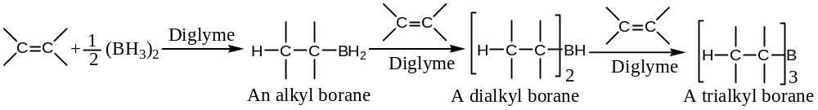
With unsymmetrical alkene, addition of borane follows $anti$-Markownikoff rule, i.e. the reaction is stereoselective and the$B$- atom usually bonds to the less substituted$C$- atom. For example,
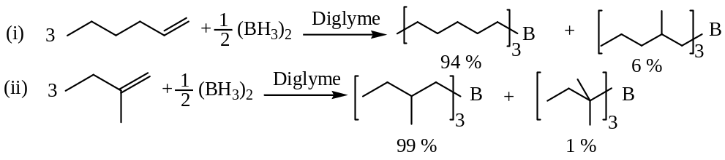
Oxidation and hydrolysis of alkylboranes (intermediate) by aqueous basic$H_{2}O_{2}$ ($H_{2}O_{2}/NaOH/H_{2}O$) produces alcohols and the overall reaction is known as hydroboration – oxidation. For example,
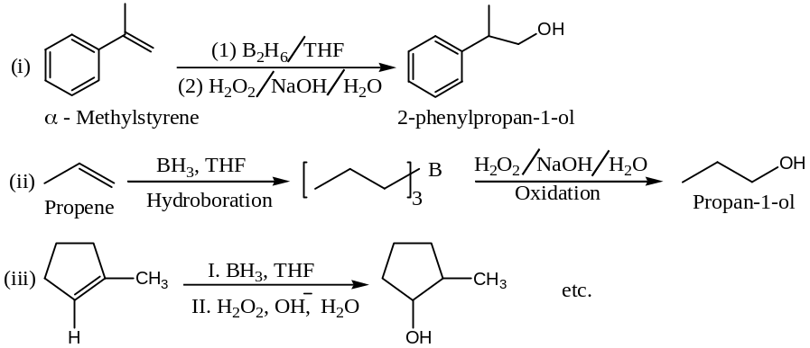
Mechanism of Hydroboration – Oxidation —
The hydroboration-oxidation reaction is supposed to proceed in a direct concerted mechanism involving a$π$- complex. The $anti$- Markownikoff regioselectivity is due to steric factor (bulky boron containing group). Thus,
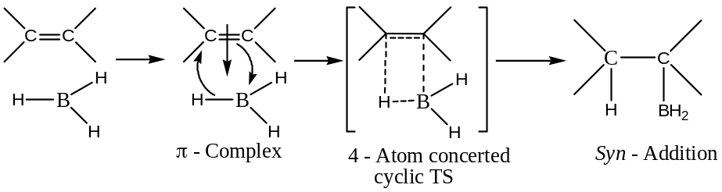
Thus, because of the cyclic transition state, $syn$- addition occurs.
Oxidation of Alkylboranes —
Trialkyl borane so formed by the hydroboration of alkene can be oxidised to an alcohol by alkaline hydrogen peroxide. Here the attacking reagent is the hydro-peroxide ion, initially generated from 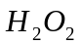by the base, which oxidized trialkyl borane into trialkyl borate ester. Thus,
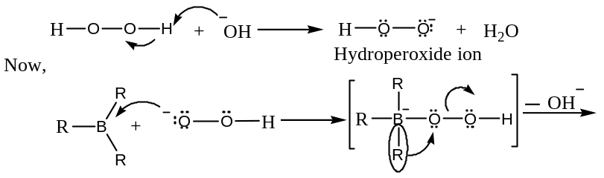
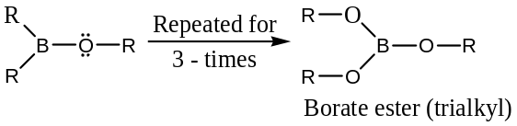
For the hydrolysis (alkaline) of trialkyl borate esters ―
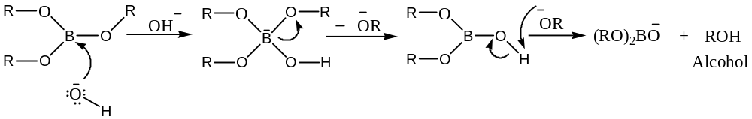
IMPORTANT:
- Hydroboration-oxidation is an important complementary process for the hydration of alkene. Both direct acid-catalyst hydration and oxymercuration-reduction produces alcohol following Markownikoff addition. But hydroboration-oxidation result in addition of components of water in an $anti$-Markownikoff orientation. Furthermore, the oxidation occurs with retention of configuration as hydroxy replaces the boron. Thus, the reaction is stereospecific$syn$- addition of$HOH$withanti – Markownikoff regiochemistry. For example, the acid catalysed hydrolysis/ hydration or oxymercuration-demercuration/ reduction of 1-hexene yields 2-hexanol.
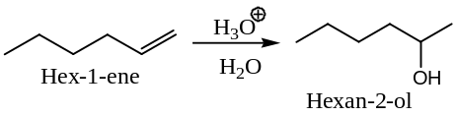
But hydroboration-oxidation of $1$-$hexene$ yields $1$-$hexanol$
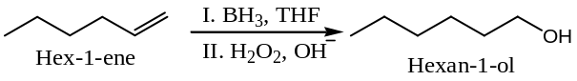
Similarly,
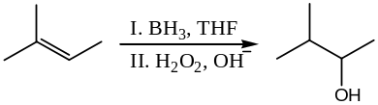
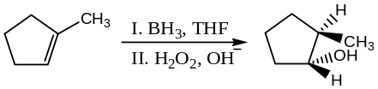
- Terminal alkynes also adds to boranes to form $1,1$-dibora compounds, which can be oxidised either to$1^{°}$- alcohols (with alkaline$H_{2}O_{2}$) or to carboxylic acids (with$m$-$ClC_{6}H_{4}{CO}_{3}H$). Thus,
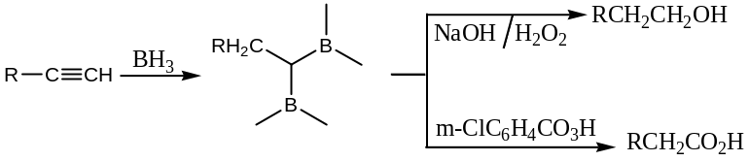
- Protonolysis of Alkylboranes: Alkylboranes on heating with acetic acid generates saturated hydrocarbon by cleaving$C-B$bond. Thus,
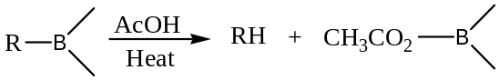
- Application of Hydroboration-oxidation: The hydroboration has immense utility as trialkyl boranes undergo a variety of useful transformation to yield $anti$- Markownikoff products. For example,
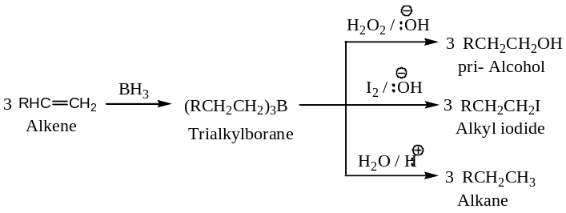
- Addition to Carbenes: Here two different reactions are exclusively studied —
$[1]$When an alkene is treated with diazomethane in presence of ultraviolet light, cyclo- propanes are formed by the addition of methylene across the double bond. For example,
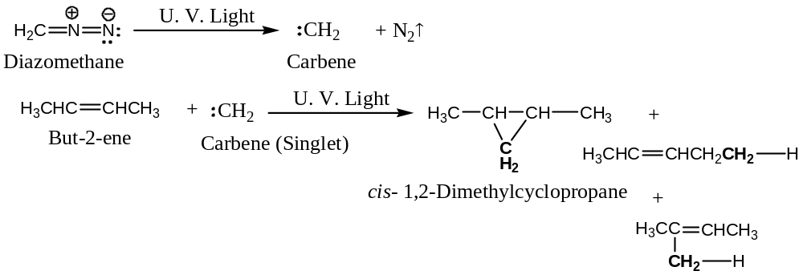
Methylene/ carbene generated from diazomethane is highly reaction. It inserts into $C-H$ bonds as well as $C=C$ bonds. [Note that the insertion of ${CH}_{2}$ in different bonds in the above reaction has been highlighted, by shading the ${CH}_{2}$ group. Further, diazomethane is being toxic and explosive; hence, we should be very careful while working with it.]
Mechanism: The reaction of diazomethane with an alkene is believed to involve the following steps:
Step I: Photolysis of diazomethane to generate the highly reactive methylene —
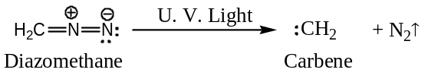
Methylene, may be singlet or triplet carbene depending on factors such as
- The wavelength of the light used,
- Reaction phase (gaseous or liquid),
- Presence or absence of inert gases like $N_{2}, {CO}_{2}, etc.$
Singlet carbene is usually formed in liquid phase photolysis, and triplet carbene is usually formed in gas phase photolysis.
Step II: Methylene undergoes cycloaddition at the $C-C$ double bond. The mode of addition depends on the type of carbene formed in step (I). The singlet methylene is believed to undergo the one-step addition whereas the triplet methylene (a diradical) undergoes the two-step free-radical like addition, as shown below to form both $cis$- and $trans$- product. Thus—
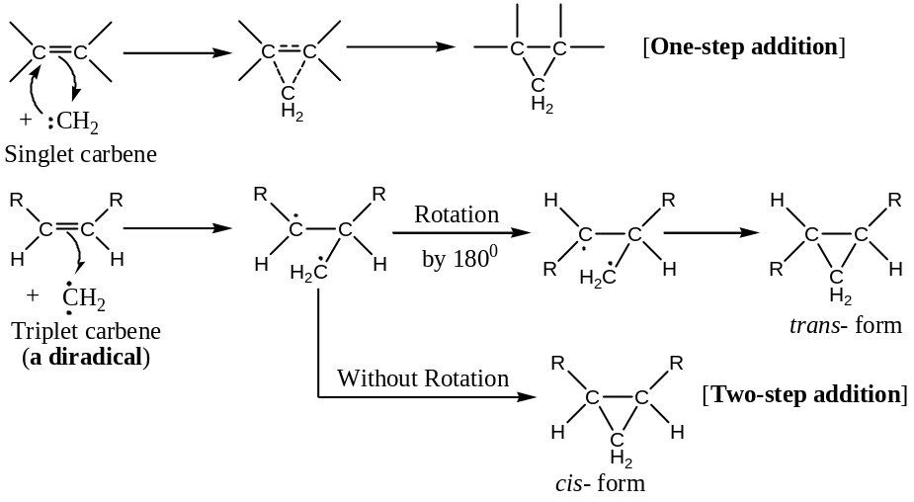
The one-step addition of singlet carbene would be stereospecific (where structure permits). The two-step addition of triplet methylene, which is essentially an addition-combination, would be non-stereospecific. This mechanism is supported by the following reactions:
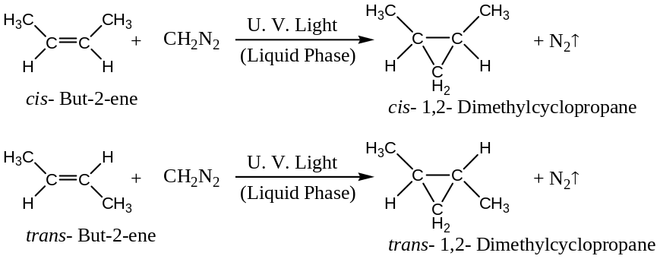
Reactions showing non-stereospecificity:
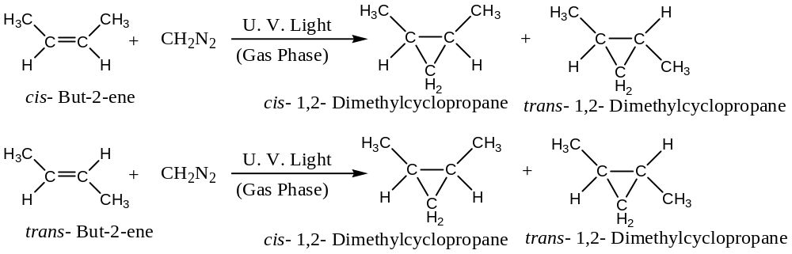
The two-step non-stereospecific addition of triplet carbene, being free-radical reaction, should be inhibited by oxygen and it is actually found to be so.
$[2]$ When an alkene is treated with diazomethane in presence of potassium $tert$- butoxide (strong base) dichloro substituted cyclopropanes are formed. Thus,
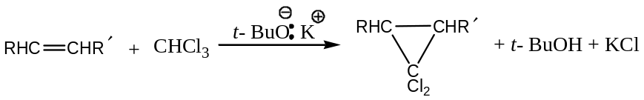
Mechanism: The reaction is believed to proceed in three steps —
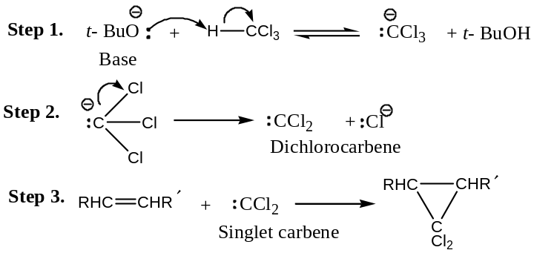
Step (2) and (3), which essentially, involve elimination of $HCl$ from chloroform, are understandable because $tert$- butoxide ion is a very strong base and chloroform is easy to be attached by the base due to the presence of three chlorine atoms in it.
This reaction is highly stereospecific. For example, $cis$- but-2-ene yields only $cis$- $1,1$-dichloro- $2,3$- dimethyl cyclopropane.
- 1, 3- Dipolar Addition:
Dipolar compounds containing $+ve \&-ve$ charges on atoms 1 and 3, readily add to double bond of alkenes to form five membered heterocyclic compounds. Such additions are called $1,3$- dipolar additions. For example,
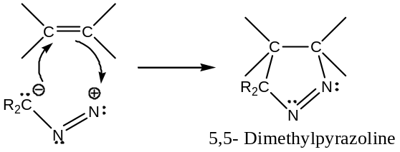
- The Simmons-Smith Reaction:
Conversion of alkenes to cyclopropanes using $iodomethyl zinc iodide$, the $Simmons$-$Smith$ reagent, $I{CH}_{2}ZnI$ (prepared by adding methylene iodide to Zinc-Copper couple) is known as the Simmons-Smith Reaction. Thus,
$${CH}_{2}I_{2} + Zn-Cu → I{CH}_{2}ZnI$$
Simmons-Smith reagent
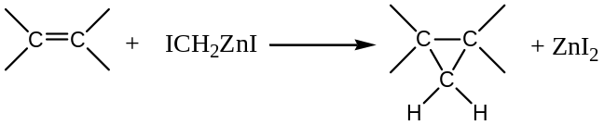
The Simmons-Smith reagent used in this reaction is called a $carbenoid$, because it behaves much like a carbene though it does not contain a divalent $C$- atom.
Merit of Simmons-Smith Reaction: This reaction gives better yield than the toxic diazomethane used in the preparation of cyclopropane rings via carbene intermediate. It is stereospecific and has less side-reaction.
- Free-Radical Addition Reactions of Alkene:
Addition of Carbon Tetrachloride:
Carbon tetrachloride adds to alkenes, in presence of organic peroxide to give tetrachloro-alkane. For example,
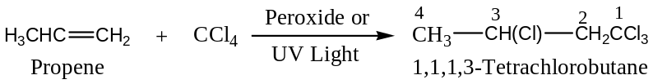
Mechanism: The reaction is governed by a free radical chain mechanism involving 4- steps:
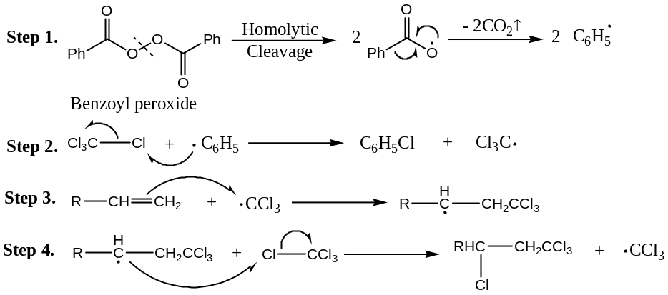
Step (3) and (4) are then repeated to complete the reaction.
Addition of $HBr$ to Olefins:
Free radical addition is the ‘abnormal’ addition of $HBr$ to olefins. It has been seen that (by Kharasch and Mayo) the reaction is proceeds by either an ionic or a radical mechanism. In the dark and in the absence of radical initiators, the reaction proceeds in an ionic fashion, however, in presence of light, or peroxide, a much faster radical addition occurs. For example,
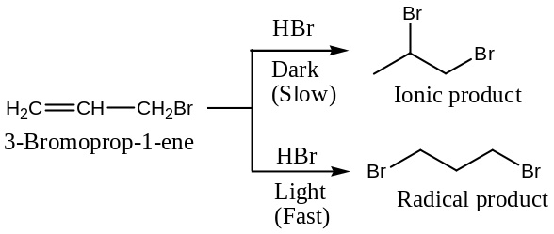
The difference in the nature of the products can be explained on the basis of the relative stabilities of the free radicals and carbonium ions, which follow the order $1^{°}<2^{°}<3^{°}$.
Initial addition of a proton produces a relatively stable carbonium ion in the ionic reaction, while an $Br$- atom adds first to generate the more stable $2^{°}$- free radical. Thus,
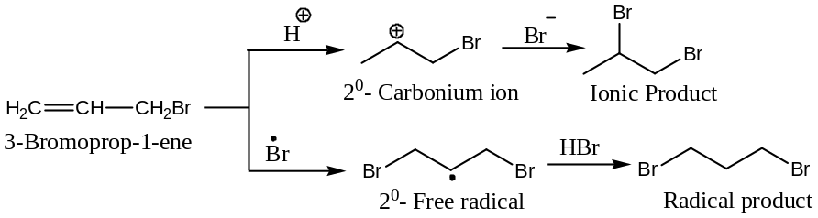
In presence of $O_{2}$, light or peroxides, $HBr$ dissociates to generate $\dot{Br}$,
$HBr+ O_{2} →H{\dot{O}}_{2}+ \dot{Br}$
$HBr \underset{→}{hν}\dot{H}+ \dot{Br}$
$RCOOH →R\dot{O}+ \dot{O}H+CO$
$R\dot{O}+HBr →ROH+ \dot{Br}$
Stereochemistry of free radical addition of HBr to Olefins:
Free radical addition is usually a stereospecific process, yielding a $trans$- product. Addition of deuterium bromide ($DBr$) to $cis$- (I) and $trans$-2- butene (II), for example, yields $threo$- (III) and $erythro$- 3 – deutero-2-bromobutanes (IV).
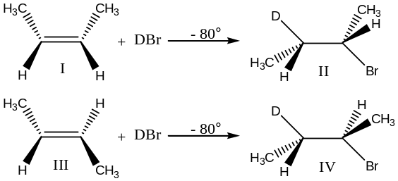
Note: Radical addition of $HI and HCl$ to olefins normally does not take place ― as here the 2nd step is endothermic.
- Oxidation or Cleavage Reactions of Alkene:
Important oxidation/ cleavage reactions of alkene includes —
- Ozonolysis and
- Hydroxylation
  - Involving dilute alkaline$KMnO_{4}→$ formation of glycols (vicinal diols of $i.e. cis$- diols) at low temperature
  - Involving dilute alkaline$KMnO_{4}→$ Oxidative cleavage or degradation to carbonyl compound and/ or acids at higher temperature
  - Involving $OsO_{4}→cis$- or $syn$- Hydroxylation through Osmate Ester
  - Epoxidation: Hydroxylation via epoxides $→$ formation of $trans$- diols
OZONOLYSIS: Ozonolysis of Alkene: [$Oxo$- uncoupling] —
Alkene reacts with ozone ($O_{3}$) first to form an unstable molozonide (also called initial ozonide), which rapidly rearrange to ozonide. Since, ozonides are explosive, hence are not normally isolated, but usually decomposed with $Zn/ AcOH$ ($H_{2}/$ catalyst or direct hydrolysis by $H_{2}O$are also can be used) or ${Me}_{2}S$ to yield $2$- moles of carbonyl compounds (i.e. oxidative cleavage). The overall reaction sequence is known as ozonolysis, which results in cleavage of the alkene at the double bond. Thus,
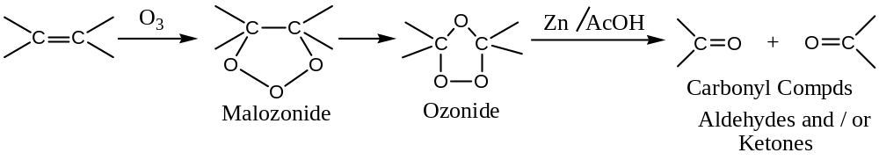
For example,
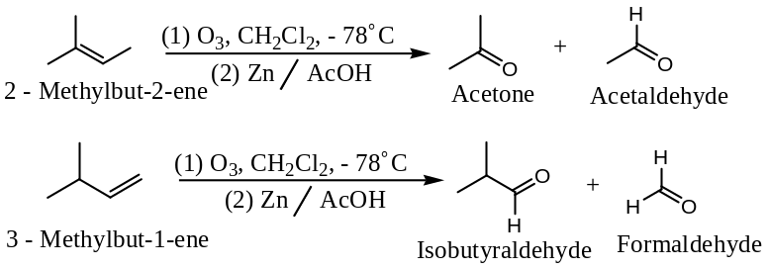
Mechanism of Ozonolysis —
The mechanism for the formation of an ozonide from an alkene can be written as:
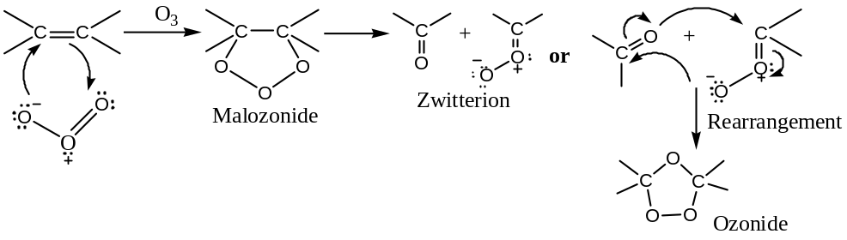
Important:
- Ozonides can also be oxidised by $O_{2}$, peracids, or$H_{2}O_{2}$to give ketones and/ or carboxylic acid.
- Finally, ozonides on reduction by${LiAlH}_{4}, {NaBH}_{4}, {BH}_{3},$or catalytic hydrogenation with excess of$H_{2}$to give $2$- moles of alcohols.
- The ozonolysis reaction is useful in locating a double bond in a compound. Identification of the ozonolysis products (carbonyl compounds) will give useful information about the structural environment of the carbon-carbon double bond. Working backwards from the structures of the carbonyl compounds, we can arrive at the structure of the parent alkene (if unknown).
Hydroxylation of Alkene (oxidation of alkene):
Hydroxylation of Alkene by Alkaline${KMnO}_{4}$ at Low (room) Temperature:
[$cis$- OR $syn$-Hydroxylation: Oxidation Alkene by${KMnO}_{4}$]
Alkene reacts with aqueous, neutral or alkaline${KMnO}_{4}$at room temperature (i.e. at low temperature) to yield$cis$- $1,2$- diols (also known as glycols). Thus,
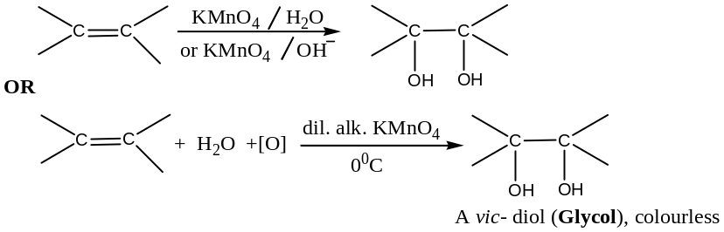
For example,
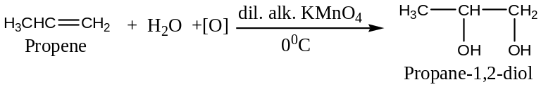
With neutral ${KMnO}_{4}$, purple colour of${KMnO}_{4}$ disappears and a brown precipitation of${MnO}_{2}$forms. But, with alkaline solution, colour changes from purple to green. Thus, this reaction can be used to detect$C-C$double bond and the test is called Baeyer’s test.
Mechanism of Hydroxylation: With neutral${KMnO}_{4}$ solution,
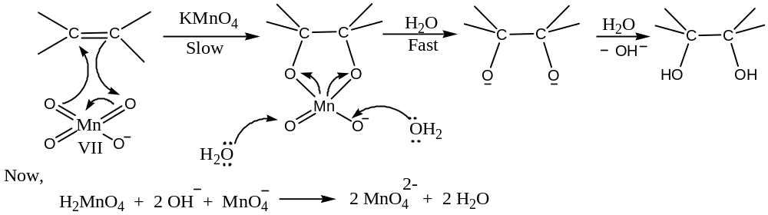
With alkaline${KMnO}_{4}$ solution, the reaction also involves the formation of intermediate manganese ester through electrophilic addition, as shown below:
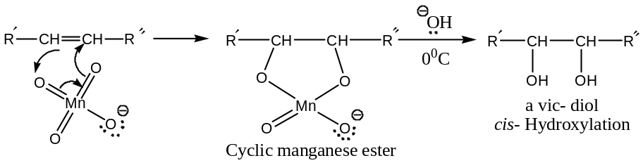
OR, briefly —
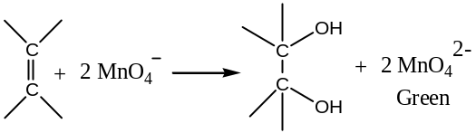
From the mechanism, it follows that where the structure permits (say, cycloalkenes), the resulting $1,2$- diol is a $cis$- diol (as shown below):
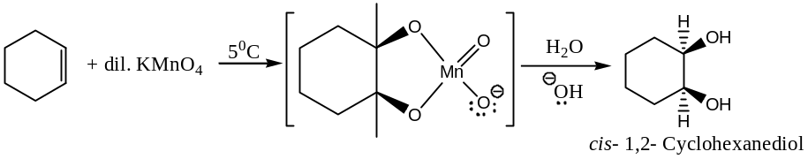
Stereochemistry of Hydroxylation:
The overall reaction involves the addition of two$OH-$groups to an alkene form the same side of the double bond, i.e. the addition is a stereoselective$cis$- or $syn$- addition. The reaction is also stereospecific. For example,
$cis$- But-2-ene forms$meso$-$2,3$- butanediol and$trans$- but-2-ene yields$dl$- pair $i.e.$ racemic mixture of$2,3$- butanediol:
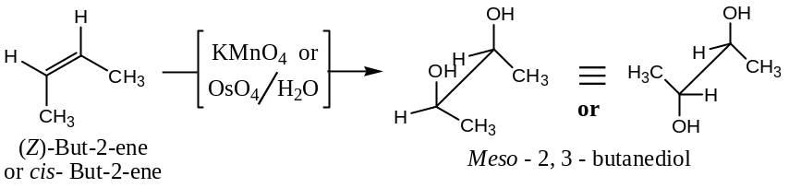
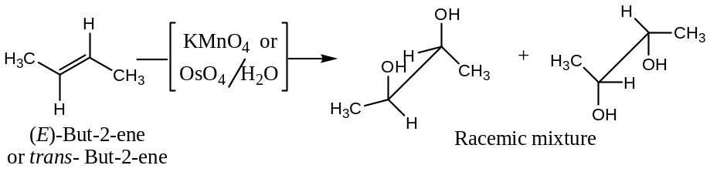
Question: Complete the following reactions with suitable mechanism:
$\left(i\right) (Z)$-${CH}_{3}CH=CH{CH}_{3}+Alkaline {KMnO}_{4} → ?$
$\left(ii\right) (E)$-${CH}_{3}CH=CH{CH}_{3}+ {OsO}_{4}\underset{→}{ P\ddot{y }} ? \underset{→}{ High Temperature} ?$
Hydroxylation of Alkene by Acidic or Alkaline ${KMnO}_{4}$ at High Temperature:
Alkene undergoes oxidative cleavage or degradation with acidic or alkaline ${KMnO}_{4}$ through glycol intermediate to form aldehydes, ketones and/ or carboxylic acids, depending upon the condition of the experiment, nature of the alkene and the oxidizing agent used. For example,
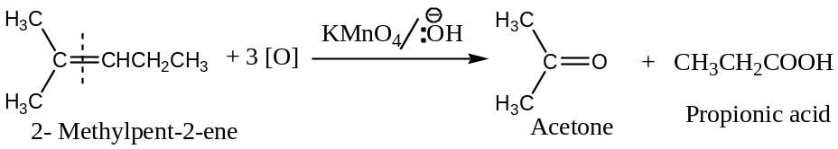
Important Note: This reaction is useful, though less reliable than ozonolysis, in locating a double bond in a compound.
Hydroxylation of Alkene by Osmium Tetroxide, ${OsO}_{4}$:
[$cis$- OR $syn$-Hydroxylation: Oxidation Alkene by${OsO}_{4}$
${OsO}_{4}$Reacts with alkene at room temperature to yield a$cis$- cyclic ester, known as the $OSMIC$ ester, which on hydrolysis by aqueous ethanolic$NaHSO_{3} (or {Na}_{2}{SO}_{4})$ solution yields$cis$- $1,2$- diols (also known as glycols), i.e. $cis$- or $syn$- hydroxylation products are formed. Thus,
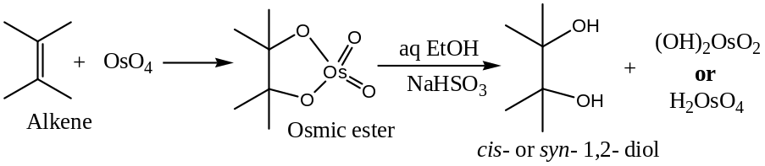
For example,
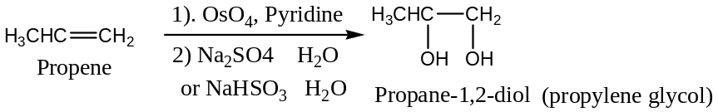
Mechanism of Hydroxylation:
Initially, a 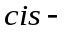cyclic ester, the OSMIC ester is formed, which on hydrolysis by aqueous ethanolic$NaHSO_{3} (or {Na}_{2}{SO}_{4})$ solution yields$cis$- 1, 2 – diols.
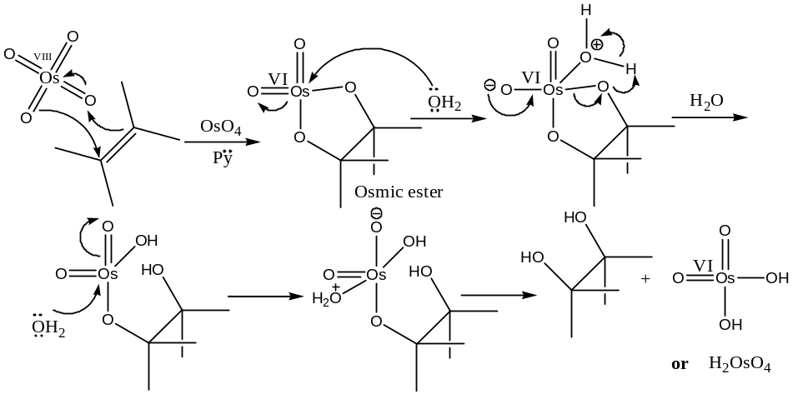
Stereochemistry of Hydroxylation:
Since, both the$OH$- groups form bond from the same side of the double bond, so$cis$- or$syn$- addition products are obtained and the reaction is stereospecific as well is stereoselective. For example,
$cis$- But-2-$ene$ gives$meso$-$2,3$-butanediol:
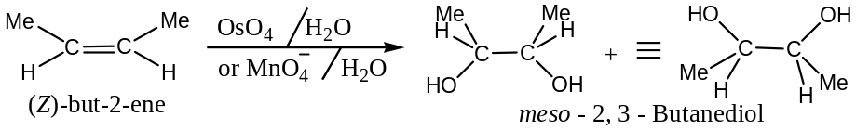
But,$trans$- But-2-ene gives $dl$- pair i.e. racemic mixture:
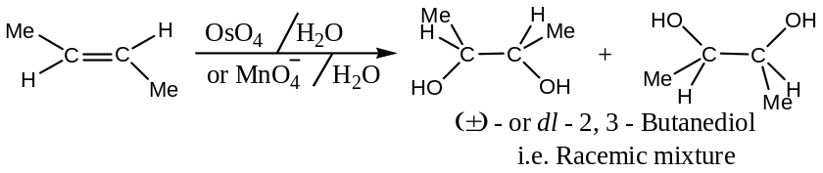
Application of Hydroxylation —
Since,${OsO}_{4}$ is expensive and toxic, so now-a-days for the position of double and for the preparation of carbonyl compounds, oxidative cleavage of$C-C$double bond is carried out by Lemieux reagent― aqueous solution of${NaIO}_{4}$and trace of${OsO}_{4}$ ($or {KMnO}_{4}$). Thus,
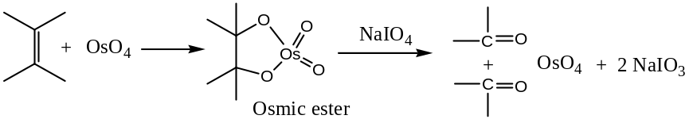
The position of double bond:
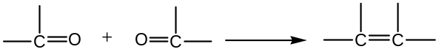
Hydroxylation of Alkene via Epoxides (Epoxidation) —
Epoxidation – Hydroxylation: Addition of per acids/ peroxyacids to an Alkene:
[$epi$- $oxy$- Addition:$anti$- Hydroxylation to Alkene]
Oxidation of$C-C$double bond with any member of peroxy acids i.e. per acids,${RCO}_{3}H$(most effective $per$ acid is$m$-$chloroperbenzoic acid$) or $H_{2}O_{2}$produces oxiranes, the three membered cyclic ethers commonly known as $epoxidation$. Thus,
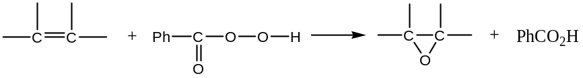
For example,
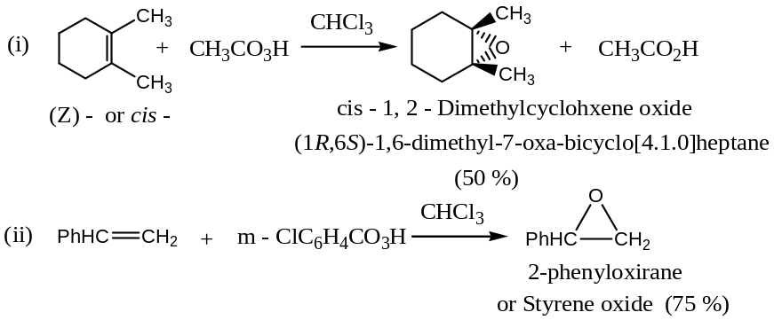
Mechanism & Stereochemistry of Epoxidation —
Epoxidation involves the$syn$- addition of an oxygen atom to the double bond. The stereo-specificity of the reaction indicates the ring formation is concerted i.e. completes in a single step without any free carbocation. Thus, with$trans$- alkene, we will have$trans$- epoxide:
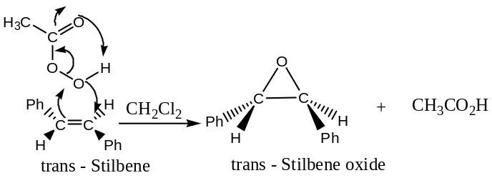
Similarly, with$cis$- alkene, we will have $cis$- epoxide:
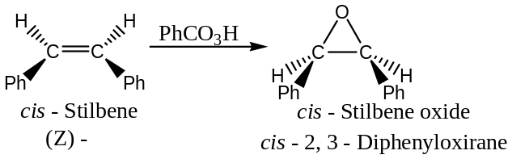
Important: Some other preparations of Epoxides are―
Epoxides, like other ethers, can also be prepared by a nucleophilic substitution reaction ― the Williamson ether synthesis. For example,
- First alkene is converted to halohydrin, then to the cyclic ether by a base promoted intermolecular substitution.
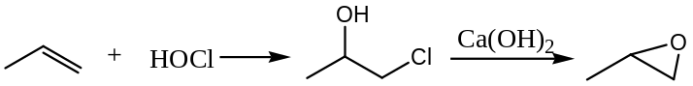
- The most important epoxide, the ethylene oxide is commercially prepared by the direct oxidation of ethylene over a silver catalyst.
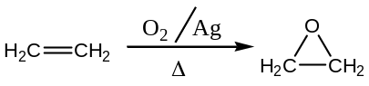
Hydrolysis of Epoxide:
Epoxides on hydrolysis yields $1,2$- diols (Glycols), and the reaction is catalyst either by acids or by bases. Thus,
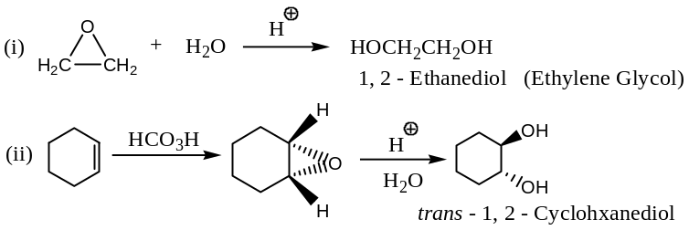
Thus, the peroxide oxidation of alkene is an$syn$- addition and the hydrolysis occur― when water attacks from the back side of the epoxide. The overall process results in an$anti$-hydroxylation to the original alkene.
Mechanism of Hydrolysis of Epoxide:
Since, epoxides are hydrolysed either by acids or by bases using as a catalyst to yield$1,2$- diols (Glycols), hence the reaction mechanism is proposed both by acids and by bases.
- Acid catalysed hydrolysis of epoxide:
― Acid catalysed hydrolysis of epoxide follows$S_{N}2$- pathways to form$anti$- diol
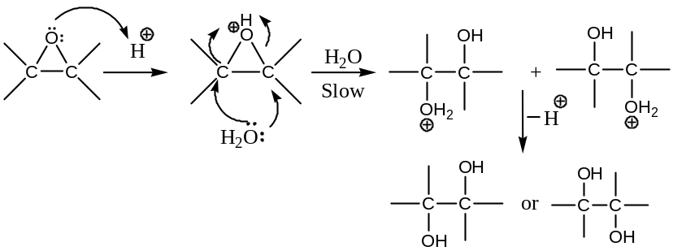
- Base catalysed hydrolysis of epoxide ―follows $S_{N}2$- pathways to form $anti$- diol
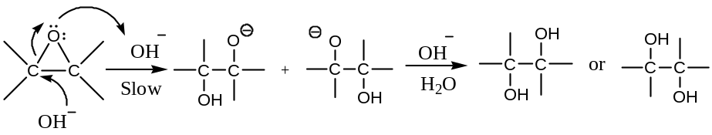
Stereochemistry of Hydrolysis via Epoxidation:
Since, the nucleophilic attack by$H_{2}O or {OH}^{-}$occurs from back side of the epoxide, so inversion of configuration occurs. Thus, the acid or base catalysed hydrolysis of epoxide is a$trans$-process. Again, hydroxylation via epoxidation is stereospecific. For example,
$trans$- Alkene gives$meso$- compounds:
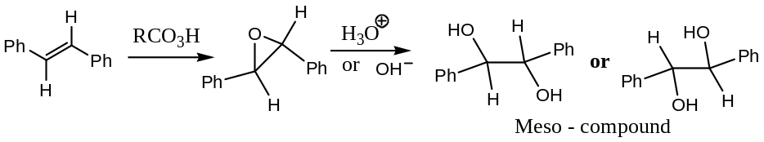
But,$cis$- Alkene yields$dl$- pair i.e. racemic mixture:
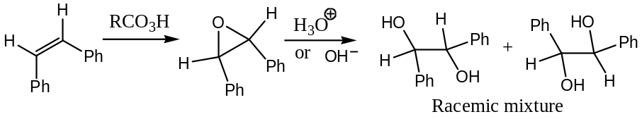
Question: Complete the following reactions with suitable mechanism:
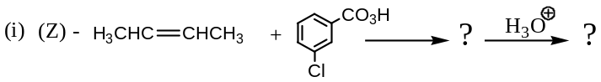
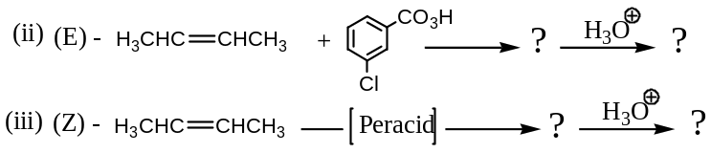
Problem: Explain the mechanism and stereochemistry of hydroxylation via epoxidation taking but-2-ene as an example.
Solution: Oxidation of $C-C$ double bond of alkenes with any member of peroxy acids i.e. per acids, ${RCO}_{3}H$, like $perbenzoic$ acid ($C_{6}H_{5}{CO}_{2}OH$), $peroxytrifluoroacetic$ acid(${CF}_{3}{CO}_{2}OH$),$m$-$chloroperbenzoic acid$(the most effective $per$ acid) or $H_{2}O_{2}$ followed by boiling with water leads to hydroxylation of the double bond to yield $trans$- diols through the intermediate oxiranes, (the three membered cyclic ethers) is commonly known as $epoxidation$. Thus,
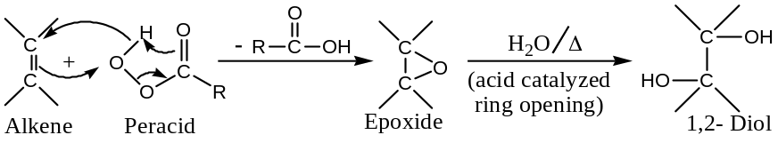
Stereochemistry: The stereochemical sequence of epoxidation is explained with but-2-ene. From the stereochemical sequence, it can be seen that $cis$- but-2-ene yields a racemic mixture, but $trans$- but-2-ene yields a $meso$- compound.
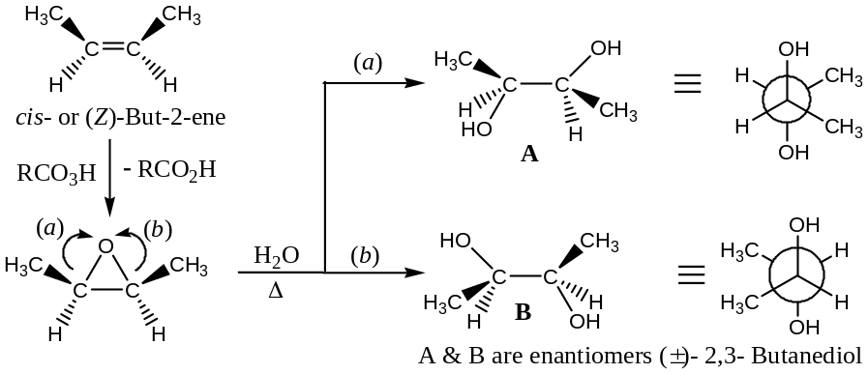
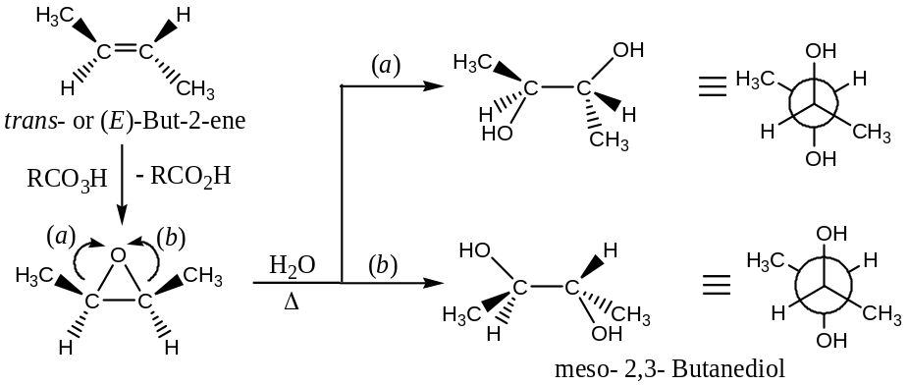
- Substitution Reactions of Alkene:
Alkene undergoes two types of substitution reactions —
- Free radical allylic substitution reactions and
- Allylic bromination by NBS.

Free-Radical Allylic Substitution reaction: The alkyl groups attached to doubly bonded $C$- atoms resemble alkanes in halogenation reactions when treated with halogens at high temperatures ($500℃ to 600℃$). Substitution occurs preferably at allylic position (a) with respect to the double bond. For example,
It is important to note that if the same reaction is carried out at low temperature in ${CCl}_{4}$, instead of allylic substitution, electrophilic addition occurs across the double bond. For example,
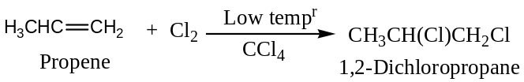
Mechanism: Allylic substitution, like halogenation of alkane, follows a free radical substitution chain mechanism, as shown below:
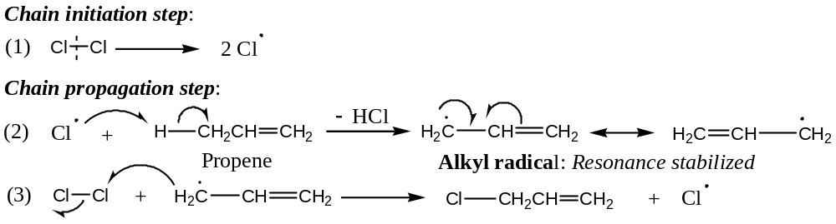
Important:
Stability of Allyl Radical: Allyl radical is a resonance stabilized species. The decreasing order of stability of different radicals is —
$$Allyl>Tertiary>Secondary>Primary>Vinyl radical$$
Allylic Bromination by $NBS$: Bromination by NBS (N – Bromosuccinimide):
NBS, N - bromosuccinimide is a very specific reagent for allylic and benzylic bromination. For example,
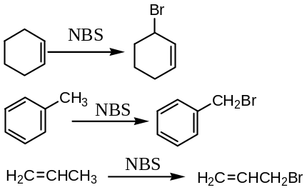
Mechanism:
The function of $NBS$ is merely to act as a bromine reservoir maintaining a low concentration of molecular bromine by reacting with$HBr$ that is initially formed in a side reaction.
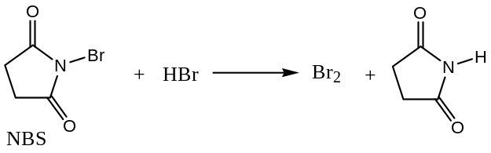
The${Br}_{2}$ molecule dissociates into$Br$- atom in presence of light or radical initiators. This explains why bromination by $NBS$ initiated by a peroxide (organic) or $UV$- light. Hydrogen abstraction by $Br$- atom generates an allylic radical, which then reacts with the molecular${Br}_{2}$ to yield the product.
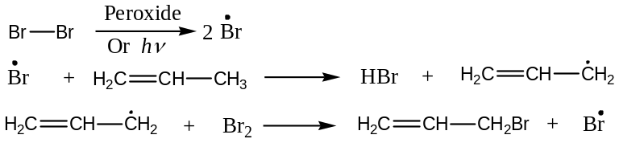
The chain is then continued with the production of$HBr \&\dot{Br}$. At lower concentration of${Br}_{2}$, favours allylic bromination over addition to the double bond, which is a reversible process.
$$\dot{Br}+ {CH}_{2}=CH-{CH}_{3} ⇆ HBr +Br{CH}_{2}-\dot{C}H-{CH}_{3}$$
$${Br}_{2} +Br{CH}_{2}-\dot{C}H-{CH}_{3} ⟶ \dot{Br} +Br{CH}_{2}-CHBr-{CH}_{3}$$
In the other words, the radical formed as a result of addition of${Br}_{2}$ will revert to the alkene if the concentration of${Br}_{2}$ is low, whereas an allylic radical is capable of waiting till it gets a${Br}_{2}$- molecule. Thus, a low concentration of ${Br}_{2}$ ($by NBS$) favours allylic bromination.
Question: Write the general mechanism of $allylic bromination$. What are the evidences that prove the mechanism? What will be the products of allylic bromination of?
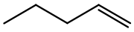
Solution: Substitution of a $H$- atom by a $Br$- atom in an olefin at its allylic position by using $NBS$ ($N$- $Bromosuccinimide$) in $C{Cl}_{4}$ ($a non-polar solvent$) in presence of peroxide or light is known as allylic bromination. Thus,
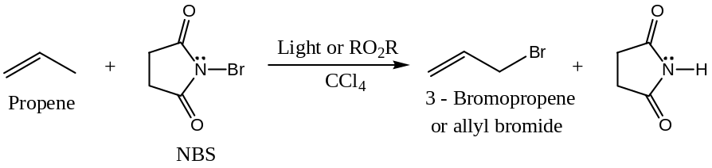
Similarly,
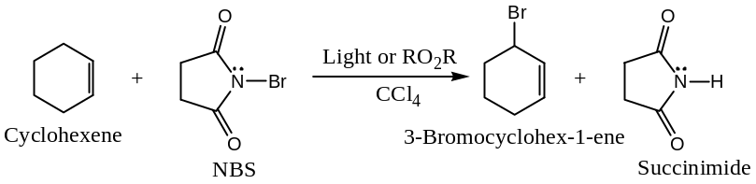
Generally,
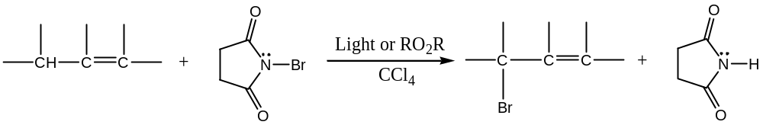
Mechanism:
Allylic bromination is a free-radical type reaction. The reaction is initiated by the formation of a small amount of 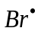 (possibly formed by the dissociation of N ― Br bond of the NBS). The main propagation steps for this reaction are as follows:
Chain – Initiation:
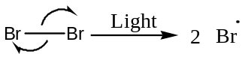
Chain – Propagation: This involves the following two steps ―
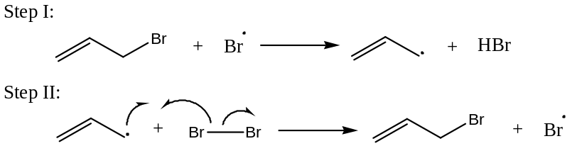
The source of the ${Br}_{2}$ in the reaction is the reaction between $NBS$, and the $HBr$
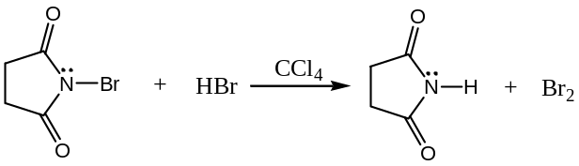
Since, $NBS$ is nearly insoluble in $C{Cl}_{4}$ (non-polar solvent), hence provides a constant, but very low conc. of ${Br}_{2}$ in the reaction mixture. The very little ${Br}_{2}$ instead of adding to double bond, reacts by substitution and replaces an allylic $H$- atom i.e. yields allylic bromination.
Evidences in support of allylic bromination:
The function of $NBS$ in allylic bromination is to provide a low and constant source of ${Br}_{2}$ conc. The main evidence for this mechanism is that NBS and Br₂ show similar reactivity and that the various $N$- bromoamides also show similar reactivity, which is consistent with the hypothesis that the same species is abstracting in each case.
If ${Br}_{2}$ is the reacting species, then it may be added to the double bond either by an ionic or a free-radical mechanism to give dibromo-alkane.
3rd Part:
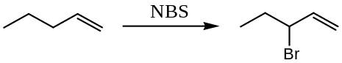
- Polymerization Reactions of Alkene:
The long-chained high molecular weight molecules in which certain structural units repeat themselves are called polymers (Greek Poly = many; meros = part). The simple molecules from which the structural units are derived are called monomers. The overall reaction leading to the formation of polymers from monomers is called polymerization.
An alkene can add to another alkene molecule to form a dimer. Under suitable conditions, however, several (100 or more) molecules of alkenes undergo mutual addition to a high molecular weight compounds (10, 000 and above).
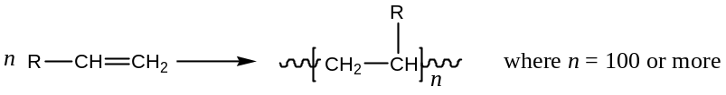
$R=H$or any suitable substituent (say, $-CN, -COOR$, etc.)
When a mixture of two or more different monomers is allowed to undergo polymerization, the resulting polymers are known as copolymers. These copolymers would have all the starting monomers repeat themselves in a regular fashion in the long-chain polymer. For example,
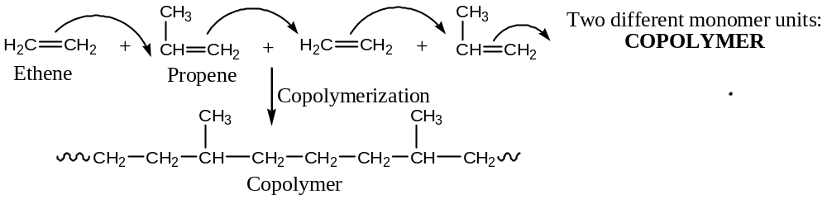
- Reduction [Addition of Hydrogen] Reactions of Alkene —
Addition of hydrogen across the double bond in an alkene to form corresponding alkane takes place only in the presence of finely divided metals (hence large surface area) $Pt or Pd or Ni$. The overall reaction is known as catalytic hydrogenation of alkene. For example,
Analytical Importance: Catalytic hydrogenation of alkenes is usually quantitative. The process is useful in determining the number of $C-C$ double or triple bonds in an organic compound (one mole per double bond or two moles per triple bond).
The catalyst mentioned above are heterogeneous, i.e. they used in a phase different from the reaction solution. Recently, homogeneous catalysts, such as Wilkinson’s catalyst consisting of rhodium or ruthenium phosphines, have been developed.

The End

