SOLUTIONS &Colligative Properties
Solution:
A solution is a homogenous mixture of two or more chemically non-reacting substances existing in one or more states in which each of them loses their individual identity.
In solutions the component present in relatively small amount is called the solute and that present in relatively large amount is called the solvent. Thus, we have ―
$$Solution=Solvent+Solute$$
In solution, solvent or solute may be solids, liquids or gases and depending upon the nature of solvent, three main types of solutions are possible ―
- Solid Solution: Here, solvent is solid, for example, brass, in which $1$ part $Zn$ (solute) and $4$ part $Cu$ (solvent),
- Liquid Solution: Here, solvent is liquid, for example, $NaCl$ solution in water solvent, and
- Gaseous Solution: Here, solvent is gas, for example, air is a gaseous solution of $O_{2}, CO_{2},$ etc. (solute) and $N_{2}$ (Solvent).
The following $9$- types of solutions are possible with above three types of solvent ―
Type | Solute in Solvent | Examples
Solid Solutions | Solid in solid  Liquid in solid  Gas in solid | Brass ($1 Zn+4 Cu$) alloy  $Hg in Na$ (Sodium amalgam); $H_{2}O$ in $CuSO_{4}.5 H_{2}O$ crystals  Hydrogen gas in spongy Palladium metal
Liquid Solutions | Solid in liquid  Liquid in liquid  Gas in liquid | Sugar in water  Ethanol in water  $CO_{2}$ gas in water (soda water: cold drinks)
Gaseous Solutions | Solid in gas  Liquid in gas  Gas in gas | Smoke ($C$- particles in air)  Moisture (water vapour in air)  Air ($O_{2}, CO_{2}$, etc. (solute) and $N_{2}$); not perfect solution

Different concentration units: Measures of Compositions ―
The concentration of a solution represents the quantity of solute in a given quantity of solvent or solution. The concentrations of solutions are expressed in different units. Generally following units are used ―
- Molarity ($M$): Moles of the solute per litre of the solution
- Normality ($N$): Equivalents of the solute per litre of the solution
- Molality ($m$): Moles of the solute per $kg$ of the solvent
Note: $Mass of solvent=(Volume of solution×Density) – Mass of solute$
- Mole Fraction ($χ$): It is the ratio of the number of moles of solute ($n_{2}$) or solvent ($n_{1}$) to the total number of moles ($n$) in the solution. Thus ―
$$Mole fraction of Solvent, χ_{1}=\frac{n_{1}}{n_{1}+n_{2}}=\frac{n_{1}}{n} \left[Mole, n=\frac{w (mass of the substance)}{M (Molar mass of the substance)}\right]$$
$$Mole fraction of Solute, χ_{2}=\frac{n_{2}}{n_{1}+n_{2}}=\frac{n_{2}}{n}$$
Such that ―
$$\boxed{χ_{1}+χ_{2}=1}$$
Some other units used to express concentrations are ―
[$1$] Formality ($F$): Gram formula mass of the solute per litre of the solution
For example: $1F NaCl$ solution $=1 g formula mass of NaCl/ L=58.5 g of NaCl/ L$
Generally, if ‘$a$’ gram of a solute of formula mass ‘$F$’ dissolved in ‘$b$’ mL of solution, then the solution so formed has the strength ―
$$Formality=\frac{a}{F}×\frac{1000}{b} (F)$$
$$or Formality=\frac{Mass of the Substance}{Formula Mass of the Substance}×\frac{1000}{Vol of Sol in cc (mL)} (F)$$
[$2$] Parts Per Million ($ppm$): It is the parts of the solute present per million parts of the solution, i.e. ―
$$ppm=\frac{Mass of the Solute}{Mass of the Solution}×{10}^{6}$$
[$3$] Percentage ($\%$): Mass or volume or both of solute present per $100$ parts so the solution. Percentage (%) concentration may be ―
$$a) Mass to Mass Percentage \left(M/m\right)=\frac{Mass of the Solute}{Mass of the Solution}×100$$
$$For example, 5\% \left(M/m\right) solution of NaCl=5g NaCl in 100 mL solution$$
$$b) Mass to Volume Percentage \left(M/V\right)=\frac{Mass of the Solute in g}{Mass of the Solution in mL}×100$$
$$For example, 5\% \left(M/V\right) solution of NaCl=5g NaCl in 95 g water (solvent)$$
$$c) Volume to Volume Percentage \left(V/V\right)=\frac{Volume of Solute in mL}{Volume of the Solution in mL}×100$$
$$d) Volume to Mass Percentage \left(V/M\right)=\frac{Volume of Solute in mL}{Mass of the Solution in g}×100$$
Solubility of Gases in Liquids:
Expressed by the term Solubility Coefficient ―
Solubility coefficient is defined as the volume of the gas dissolved by the unit volume of the liquid solvent. It is important to note that the volume of the dissolved is determined at the temperature and pressure at which the measurement of solubility is made.
Following are the factors that affect the Solubility of a gas in a Liquid ―
- Nature of the gas and solvent: Gases which can be liquefied ($e.g.CO_{2}, NH_{3}, HCl$, etc.) more easily are more soluble in common solvents, Again, chemical similarity between the gas and the solvent results greater solubility (like dissolves like).
- Effect of Temperature: At constant pressure, the solubility of a decrease with the rise in temperature (as exothermic process).
- Effect of Pressure: Pressure has a remarkable effect on the solubility of gases. The effect of pressure on the solubility of gases is well explained by Henry’s law.
HENRY’S Law ― the effect of Pressure on the solubility of a Gas:
Will be elaborately described after this section ― Page $06$
Problem ($1$): A solution of $20 \% EtOH$ by mass in water has a density of $0.966 kg {dm}^{-3}$ . Calculate ―
- Mole-fraction,
- 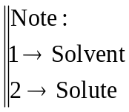Molality and
- Molarity of $EtOH$ in the solution.
Solution: $20 \% EtOH$ in water ($by mass$)
$⇒20 g$ Ethanol ($EtOH$) present in $100 g$ solution
Therefore, mass of water $=80 g$
$∴$Moles of water, $n_{1}= {80}/{18}=4.44 mol,$
And, moles of ethanol, $n_{2}= {20}/{46}=0.4348 mol,$
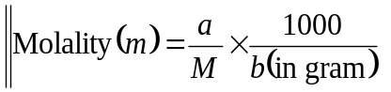Now, ($a$) Mole-fraction of ethanol ―
$$χ_{2}=\frac{n_{2}}{n_{1}+n_{2}}$$
$$=\frac{0.4348}{4.44+0.4348}=0.0897$$
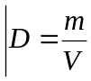[Therefore, mole-fraction of water, $χ_{2}=1-0.0897=0.9103]$
($b$) Molality of the $20 \% EtOH$ solution is ―
$$=\frac{20}{46}×\frac{1000}{80}=5.435 m (i.e.5.435 mol {kg}^{-1})$$
$$\left(c\right) Volume of the solution \left(b\right)=\frac{m}{D}=\frac{100×{10}^{-3}kg}{0.966 kg {dm}^{-3}}=\frac{100}{966}L \left[∵L=dm^{3}\right]$$
$$∴Molarity=\frac{a}{M}×\frac{1000}{b(in mL)}=\frac{a}{M}×Vol of solution in L^{-1}$$
$$=\frac{20}{46}×\frac{1000}{{100}/{966}}=4.2 M \left(i.e.4.2 mol L^{-1}\right) //$$
Problem ($2$): An aqueous $12 \% AgNO_{3}$ solution has a density of $1.1080 g {cm}^{-3} at 20℃$ and $1 atm$ pressure. Find the mole-fraction, the molar concentration and molality ($m$) of the solute. (Given relative atomic mass of $Ag=108$ )
Solution: $12 \% AgNO_{3}$ in water ($by mass$)
$⇒12 g$ Silver nitrate ($AgNO_{3}$) present in $100 g$ solution
Therefore, mass of water present $=88 g$
$∴$Moles of water, $n_{H_{2}O}= {88}/{18}=4.889 mol,$
And, moles of $AgNO_{3}$, $n_{AgNO_{3}}= {12}/{170}=0.0706 mol,$
Now, mole-fraction of $AgNO_{3}$ ―
$$χ_{AgNO_{3}}=\frac{n_{AgNO_{3}}}{n_{H_{2}O}+n_{AgNO_{3}}}$$
$$=\frac{0.0706}{4.889+0.0706}=0.0142$$
[Therefore, mole-fraction of water, $χ_{1}=1-0.0142=0.9858]$
Hence ―
Molar concentration, $c=mol L^{-1}$
$$=\frac{0.0706 mol}{{100g}/{1.1080 g {cm}^{-3}}}=7.822×{10}^{-4}mol {cm}^{-3}$$
$$=7.822×{10}^{2}mol m^{-3} \left[1 cm={10}^{-2}m;1m^{3}=1000 L\right.$$
$$=7.822×{10}^{-1}mol {dm}^{-3}$$
Finally ―
$$∴Molarity=\frac{a}{M}×\frac{1000}{b(in mL)}$$
$$=\frac{12}{170}×\frac{1000}{88}=0.8021 M \left(i.e.0.8021 mol L^{-1}\right) //$$
Dilute Solution:
Definition: A solution is said to a dilute solution if the number of solute present in the solution is relatively lower than the solvent present in the solution by volume. ($n_{1}≫n_{2}$)
Binary Solution: A solution having only two components viz. solvent and solute is called a binary solution.
Important: For binary solution we always mean a solution made by non-volatile solute in volatile solvent
Ideal Solution: An ideal solution is defined as the solution in which there is complete uniformity in cohesive forces i.e. the solute-solute; solvent-solvent and solute-solvent interactions are identical in an ideal solution. Thus, if there are two components $A \& B$, forming an ideal solution, then the intermolecular forces between $A-A, A-B \& B-B$ are essentially equal.
Characteristics of an Ideal Solution ―
An ideal solution possesses the following characteristics —
- There should not be any evolution or absorption of heat during mixing of two pure components, $i.e. ∆H_{mix}=0$,
- There should not be any change in volume during mixing of two pure components, $i.e. ∆V_{mix}=0$, and
- An ideal solution must obey Raoults & Henrys law over the whole range of concentration.
Examples of Ideal Solution ―
- $C_{2}H_{4}Br \& C_{2}H_{4}Cl$
- $C_{6}H_{14} \& C_{7}H_{16}$
- $C_{6}H_{6} \& C_{6}H_{5}CH_{3}$
- $C{Cl}_{4} \& Si{Cl}_{4}, etc.$
Ideally Dilute Solution: An ideally dilute solution is solution for which —
- Solvent obeys Raoults law and
- Solute obeys Henrys law over the whole range of concentration of the solution
Raoults Law:
[Ideal solution of non-volatile solute in volatile solvent and Raoults law]
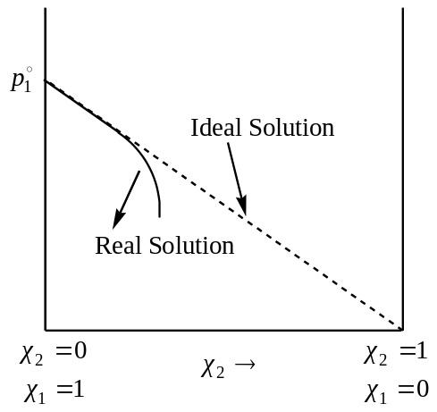We know that the vapour pressure of a pure solvent is always greater than that the vapour pressure of the solution ($p$), formed by mixing a non-volatile solute.
Thus, if $p_{1}^{0}=$ VP of the pure solvent and
$p=$ VP of the solution of non-volatile solute in volatile solvent, then —
$$p_{1}^{0}>p$$
Thus, the plot of $p_{1}^{0} vs χ_{2}$, the mole fraction of the solute in the solution will be a straight line for an ideal solution, as shown in the figure. And, the equation for the ideal solution will be —
$$p=p_{1}^{0}-p_{1}^{0}χ_{2} \left[y=mx+c\right]$$
$$=\left(1-χ_{2}\right)p_{1}^{0}=χ_{1}p_{1}^{0} \left[∵χ_{1}+χ_{2}=1\right]$$
$$Thus, p ∝ χ_{1}$$
Here, ‘$χ_{1}$’ is the mole-fraction of the solvent.
Thus, the vapour pressure of a solution of a non-volatile solute in a volatile solvent is equal to the product of the vapour pressure of the pure solvent and the mole fraction of the solvent in the solution. This is known as the Raoults law.
Actually, an ideal solution is the one, which obey Raoults law over the whole range of conc. A real solution behaves ideally when it obeys Raoults law at low concentration of the solution with $χ_{2}→0$.
Effect of Pressure on Solubility: Henrys law
With the increase in pressure, solubility of a gas in liquid also increases and the quantitative effect of pressure of a gas is found by Henrys law, which states that —
“The mass of a gas dissolved per unit volume of a liquid solvent is proportional to the pressure of the gas in equilibrium with the solution at constant temperature.”
Thus, if ‘$w$’ gram of a gas dissolved in ‘$M$’ gram of a liquid at pressure ‘$p$’, at constant temperature, then according to Henrys law —
$$\frac{w}{M} ∝p$$
$$or χ_{2} ∝ p$$
$$⇒χ_{2}=k_{H}^{'} p$$
$$χ_{2}=k_{H} p →(1)$$
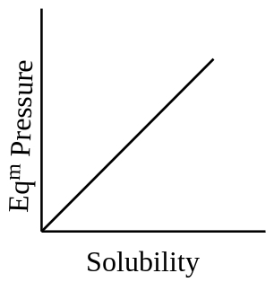Where: $k_{H}=1/{k_{H}^{'}}$ is called the Henrys law constant, whose magnitude depends on —
- The nature of the gas,
- Solvent and
- The unit of pressure.
Equation ($1$) is an equation of straight line passing through origin. Thus, a plot of the solubility of the gas versus the equilibrium pressure at a given temperature gives a straight line passing through origin as shown in the figure. This shows the validity of Henrys law.
Limitations of Henrys Law:
Henrys law is valid only for dilute solution and especially for ideal gases. For real gases, the law holds if—
- The pressure is low, at high pressure the law becomes less probable, and the proportionality constant shows a considerable variation,
- The temperature is not too low,
- The dissolved gas neither reacts with the solvent nor dissociates or associates in the solvent, and
- The solubility of the gas is low.

Relation between Raoults law and Henrys law:
Raoults law may be regarded as a special case of Henrys law. From Henrys law —
$$p_{2}=k_{H} χ_{2} →(1)$$
$p_{2}→$ Pressure of the gas, the solute dissolved
In the case when Henrys law is applicable over the whole range of concentration i.e. for an infinitely dilute solution ($χ_{2}→0,$ pure solvent) to the liquid solute ($χ_{2}→1,$ pure solvent) then $p_{2}$ would become the vapour pressure of the pure solvent, hence —
$$p_{2}^{0}=k_{H} →(2)$$
From equation ($1$) and ($2$) —
$$p_{2}=p_{2}^{0} χ_{2}$$
This expression is identical with the Raoults law, for a volatile solute. All systems, which obey Raoults law, must satisfy Henrys law, but the reverse will only true if Henrys law applies over the whole range of concentration.
Problem ($1$): $1 dm^{3}$ of water under a nitrogen pressure of $1 atm$ dissolves $2×{10}^{-5} kg$ of nitrogen at $293 K$. Calculate Henrys law constant.
Solution: From Henrys law —
$$p=k_{H} χ_{2}$$
Again —
$$χ_{2}=\frac{n_{2}}{n_{1}+n_{2}}$$
$$=\frac{{2×{10}^{-5}}/{28×{10}^{-3}}}{1/{18×{10}^{-3}}+{2×{10}^{-5}}/{28×{10}^{-3}}}=1.29×{10}^{-5}$$
Here, $p=1 atm$
$$∴ k_{H}=\frac{p}{χ_{2}}=\frac{1 atm}{1.29×{10}^{-5}}=7.7×{10}^{4} atm //$$
Problem ($2$): Calculate the amount of oxygen ($0.20 atm$) dissolved in $1 dm^{3}$ of water at $293 K$. The Henrys law constant for oxygen is $4.58×{10}^{4} atm at 293 K.$
Solution: From Henrys law —
$$χ_{2}=\frac{p}{k_{H}}$$
$$⇒χ_{2}=\frac{0.20 atm}{4.58×{10}^{4} atm}=4.37×{10}^{-6}$$
Now —
$$χ_{2}=\frac{n_{2}}{n_{1}+n_{2}}$$
$$⇒4.37×{10}^{-6}=\frac{n_{2}}{1/{\left(18×{10}^{-3}\right)}+n_{2}}$$
$$⇒n_{2}=2.43×{10}^{-4}$$
$∴$Amount of $O_{2}$ dissolved $=2.43×{10}^{-4}×32×{10}^{-3} kg$
$$=7.78×{10}^{-6} kg$$
Problem ($3$): The Henrys law constant for oxygen at $293 K is 3.37×{10}^{7} mm$. Find the solubility of oxygen in $1000 g$ of water at $293 K$ and a partial pressure of $190 mm of Hg$.
Solution: From Henrys law —
$$χ_{2}=\frac{p}{k_{H}}$$
$$⇒χ_{2}=\frac{190 mm}{3.37×{10}^{7}}=5.75×{10}^{-6}$$
Again —
$$χ_{2}=\frac{n_{2}}{n_{1}+n_{2}}$$
$$⇒5.75×{10}^{-6}=\frac{n_{2}}{{1000}/{18}+n_{2}}$$
$$⇒n_{2}=3.194×{10}^{-4} mol/1000 g of water$$
$∴$Amount of $O_{2}$ dissolved $=3.194×{10}^{-4}×32 kg$
$$=1.03×{10}^{-2} g/1000 g of water$$
$$∴Solubility of O_{2}=\frac{1.03×{10}^{-2}}{1000}×100$$
$$=1.03×{10}^{-3}\frac{g}{1000}g of water //$$
Chemical Potential of the Solvent in an Ideal Binary Solution:
As the solution of a non-volatile solute is in equilibrium with vapour, the chemical potential of the solvent have the same value as in the solution and in the vapour. Therefore, —
$$μ_{liq}=μ_{vap} →(1)$$
Here, $μ_{liq}=$ Chemical potential of the solvent in the solution and
$μ_{vap}=$ Chemical potential in the vapour state
Assuming that the vapour behaves ideally, we have —
$$μ_{vap}=μ_{vap}^{0}+RT \ln{p}$$
$$⇒μ_{liq}=μ_{vap}^{0}+RT \ln{p}, using eq^{n} \left(1\right)$$
Here, $p=$ The vapour pressure of the solvent in the solution, and
$μ_{vap}^{0}=$ The chemical potential of the vapour of the solution under standard condition
From Raoults law, we have —
$$p=χ_{1} p_{1}^{0}$$
Here, $p_{1}^{0}$ is the vapour pressure of the pure solvent and $χ_{1}$ is the mole-fraction of the solvent in the solution. Therefore —
$$μ_{liq}=μ_{vap}^{0}+RT \ln{χ_{1}}+RT \ln{p_{1}^{0}} →(2)$$
For the pure solvent in equilibrium with its vapour, having vapour pressure $p_{1}^{0}$, the equilibrium condition is —
$$μ_{liq}^{0}=μ_{vap}^{0}+RT \ln{p_{1}^{0}}$$
$$⇒μ_{vap}^{0}=μ_{liq}^{0}-RT \ln{p_{1}^{0}} →(3)$$
From equation ($2$) and ($3$), we have —
$$μ_{liq}=μ_{vap}^{0}+RT \ln{χ_{1}}$$
The above equation does not contain any term pertaining the vapour pressure. By omitting the subscript “liquid”, it can be written as —
$$μ_{1}=μ_{1}^{0}+RT \ln{χ_{1}} →(4)$$
Here, $μ_{1}$ is the chemical potential of the solvent in the solution and $μ_{1}^{0}$ is that for the pure solvent in liquid phase. The equation ($4$) is an expression for the chemical potential of the solvent in the solution. //
Chemical Potential of the Solute (non-volatile in volatile solvent) in an Ideal Binary Solution:
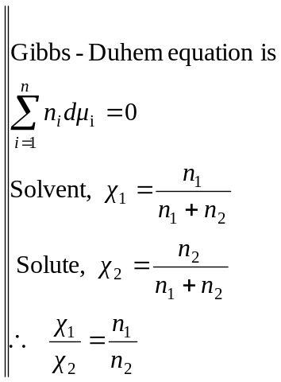The expression for the chemical potential of a non-ideal solute in an ideal binary solution can be derived by applying Gibbs-Duhem equation in the system —
$$n_{1}dμ_{1}+n_{2}dμ_{2}=0$$
$$⇒dμ_{2}=-\frac{n_{1}}{n_{2}}dμ_{1}$$
$$=-\frac{n_{1}}{χ_{2}}dμ_{1} →(1)$$
Again the chemical potential for a pure solvent in the solution is given by —
$$μ_{1}=μ_{1}^{0}+RT \ln{χ_{1}} →(2)$$
Here, $μ_{1}^{0}$ is the chemical potential of the pore solvent in liquid phase, which is a constant quantity for a given solvent.
Now differentiating equation ($2$) with respect to $χ_{1}$ at constant $T \& P$, we get —
$$dμ_{1}=0+RT \frac{dχ_{1}}{χ_{1}}$$
$$i.e. dμ_{1}=RT \frac{dχ_{1}}{χ_{1}} →(3)$$
Substituting equation ($3$) in equation ($1$), we have —
$$dμ_{2}=-RT \frac{dχ_{1}}{χ_{1}} →(4)$$
Since, for a binary solution —
$$χ_{1}+χ_{2}=1$$
$$⇒χ_{1}=1-χ_{2}$$
$$⇒dχ_{1}=-dχ_{2}$$
$$∴Equation (4)⇒dμ_{2}=RT \frac{dχ_{2}}{χ_{2}}$$
Integrating $μ_{2}=RT \ln{χ_{2}}+I (Integrating constant)$
When $χ_{2}=1$ i.e. for pure solvent, $I=μ_{2}^{0}$ the chemical potential of pure solvent and hence,
$$μ_{2}=μ_{2}^{0}+RT \ln{χ_{2}} →(5)$$
Equation ($5$) is the required expression for the chemical potential of a solute in an ideal binary solution. //
Colligative properties of dilute Solution:
Introduction: Since the chemical potential of the solvent in the solution is given by the expression —
$$μ_{1}=μ_{1}^{0}+RT \ln{χ_{1}}$$
Where, $μ_{1}^{0}=$ Chemical potential of the pure solvent, and
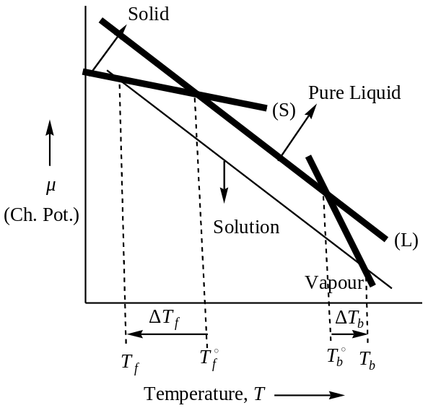 $χ_{1}=$ Mole-fraction of the solvent in the solution
Since, $χ_{1}<1$
$$⇒RT \ln{χ_{1}}=-ve quantity and hence, μ_{1}<μ_{1}^{0}$$
Thus, the chemical potential of the solvent in solution is always less than the chemical potential of the pure solvent by an amount $RT \ln{χ_{1}}$. Several related properties of the solution have their origin in this lower value of chemical potential. These properties are —
- Lowering of vapour pressure,
- Elevation of boiling point,
- Depression of freezing point, and
- Osmotic pressure.
Since, all these properties are bound together through their common origin, hence, are called colligative properties (Latin: co — together & ligore — to bind). All these properties have a common characteristic; they do not depend on the nature of the solute present but only depends on the number of solute molecules. Thus, colligative properties are those properties which depend on the number of solute particles present in the solution.
The plot of $μ vs T$ as shown in the figure given above, gives an idea about the colligative properties. In the figure dark-line represents the pure solvent and the thick-line refers to the solvent in the ideal solution. Since, the solute is non-volatile, it does not appear in the vapour phase, and so the curve for the vapour is that of the pure solvent. The solid also containing solvent and so the curve is for pure solid ($S$). The intersection points of solid and liquid curves are freezing point. From the figure, it is clear that $T_{f}<T_{f}^{0}$; where $T_{f}$ is the freezing point of solution and $T_{f}^{0}$ that for pure solvent. Similarly, $T_{b}^{0}>T_{b}$ i.e. elevation of boiling point. From the figure it is also evident that the magnitude of $∆T_{f}<∆T_{b}$.
The freezing point and boiling point of a solution depends on the equilibrium of the solvent in solution with pure solid solvent or pure solvent vapour. Another equilibrium is also possible to be established between solvent in solution and pure liquid solvent. This is done by increasing the pressure on the solution to rise the ‘$μ_{1}'$ of the solvent in solution to the value of $μ_{1}^{0}$ of the pure solvent. The additional pressure on the solution that is required to establish the equality of the $μ_{1}$ of the solvent both in the solution and in pure solvent is called the osmotic pressure of the solution.
Lowering of vapour pressure of solvent:
[Raoults law of relative lowering of vapour pressure]
Whenever a non-volatile substance is dissolved in a volatile solvent, the vapour pressure of the solvent is lowered. This lowering of vapour pressure can be explained from Raoults law of ideal solution.
Considering a solution obtained by dissolving a non-volatile solute in a volatile solvent. If $χ_{1} \& χ_{2}$ are the mole fractions of the solvent and solute and $p_{1}^{0} \& p$ be the vapour pressure of the pure solvent and solvent in solution respectively, than according to Raoults law —
$$p=p_{1}^{0} χ_{1}$$
Since, $χ_{1}<1, hence p<p_{1}^{0}$
Thus, the vapour pressure of the solution is less than the vapour pressure of the pure solvent. On the other hand, the addition of a non-volatile solute (electrolyte) to the solvent lead to lower the vapour pressure of the pure solvent. If $∆p$ is the lowering of vapour pressure, then —
$$∆p=p_{1}^{0}-p$$
$$or p_{1}^{0}-p=p_{1}^{0}-p_{1}^{0}χ_{1}$$
$$=p_{1}^{0}\left(1-χ_{1}\right)$$
$$=p_{1}^{0}χ_{2}$$
$$⇒\frac{p_{1}^{0}-p}{p_{1}^{0}}=χ_{2} →(1)$$
The quantity ${\left(p_{1}^{0}-p\right)}/{p_{1}^{0}}$ is known as the relative lowering of the vapour pressure and is independent of the nature of solute. The equation ($1$) is called the Raoults law of relative lowering of vapour pressure, and may be stated that in dilute solutions, the relative lowering of vapour pressure of the solute is equal to the mole-fraction of the solute ($χ_{2}$).
Again, equation ($1$) can also be written as —
$$\frac{p_{1}^{0}-p}{p_{1}^{0}}=χ_{2}=\frac{n_{2}}{n_{1}+n_{2}}$$
Here, $n_{1} \& n_{2}$ are the number of moles of solvent and solute respectively. For dilute solution, $n_{1}≫n_{2}$, hence —
$$\frac{p_{1}^{0}-p}{p_{1}^{0}}≈\frac{n_{2}}{n_{1}}$$
$$p_{1}^{0}-p=\frac{p_{1}^{0}}{n_{1}}. n_{2}$$
For a given amount of solvent, at a given temperature ${p_{1}^{0}}/{n_{1}}=Constant$
$$∴ \left(p_{1}^{0}-p\right) ∝ n_{2}$$
Which means that the lowering of vapour pressure of a solvent is directly proportional to the number of moles of the solute, i.e. the relative lowering of vapour pressure depends only on the number of moles ($g$-$mole$) of the solute in the solution. This indeed is a direct consequence from the Raoults law. The lowering of vapour pressure is thus a colligative property.
Application of Lowering of Vapour Pressure:
Determination of Molar Mass of the Solute from the Lowering of Vapour Pressure:
From the Raoults law of Lowering of Vapour Pressure, we have —
$$\frac{p_{1}^{0}-p}{p_{1}^{0}}=χ_{2}=\frac{n_{2}}{n_{1}+n_{2}} →(1)$$
Where, $p_{1}^{0}=$ vapour pressure of the pure solvent,
$p=$ Vapour pressure of the solvent in the solution,
And $n_{1} \& n_{2}$ are the number of moles of solvent & solute respectively.
If $w_{1} \& w_{2}$ be the masses of the solvent and solute having molar masses $M_{1} \& M_{2}$ respectively, then —
$$n_{1}=\frac{w_{1}}{M_{1}} and n_{2}=\frac{w_{2}}{M_{2}}$$
Hence, from equation (1), we have —
$$\frac{p_{1}^{0}-p}{p_{1}^{0}}=\frac{{w_{2}}/{M_{2}}}{{w_{1}}/{M_{1}}+{w_{2}}/{M_{2}}} →(2)$$
From equation ($2$), we can determine the molar mass of the solute ($M_{2}$) accurately.
The simplified form of equation ($2$) can be obtained as —
$$\frac{p_{1}^{0}-p}{p_{1}^{0}}=\frac{n_{2}}{n_{1}} ∵for dilute Sol^{n} n_{1}≫n_{2}⇒n_{1}+n_{2}≈n_{1}$$
$$⇒\frac{p_{1}^{0}-p}{p_{1}^{0}}=\frac{{w_{2}}/{M_{2}}}{{w_{1}}/{M_{1}}}=\frac{w_{2}M_{1}}{w_{1}M_{2}}$$
$$⇒M_{2}=\left(\frac{p_{1}^{0}}{p_{1}^{0}-p}\right)\frac{w_{2}}{w_{1}} M_{1} →(3)$$
Using equation ($3$), we can determine molar mass of the solute easily.
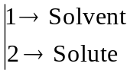Problem (1): The vapour pressure of water at $293 K is 17.540 mm Hg$ and the vapour pressure of a solution containing $0.10824 kg$ of a non-volatile solute in $1 kg$ of water at the same temperature is $17.354 mm Hg$. Calculate the molar mass of the solute.
Solution: Here —
Vapour pressure of pure solvent, water $p_{1}^{0}=17.540 mm Hg$
Vapour pressure of solution, $p=17.354 mm Hg$
Mass of the solute, $w_{2}=0.10824 kg$
Molar mass of the solute, $M_{2}= ?$
Mass of the solvent, $w_{1}=1 kg$
Molar mass of the solvent, $M_{1}=18×{10}^{-3}kg$
From the Raoults law of relative lowering of vapour pressure, we have —
$$\frac{p_{1}^{0}-p}{p_{1}^{0}}=χ_{2}=\frac{n_{2}}{n_{1}+n_{2}}=\frac{{w_{2}}/{M_{2}}}{{w_{1}}/{M_{1}}+{w_{2}}/{M_{2}}}$$
$$⇒M_{2}=0.1819 kg {mol}^{-1}=181.9 g {mol}^{-1}$$
This the accurate value of the molar mass of the solute. //
But, if we use the simplified equation —
$$\frac{p_{1}^{0}-p}{p_{1}^{0}}=\frac{n_{2}}{n_{1}}=\frac{{w_{2}}/{M_{2}}}{{w_{2}}/{M_{2}}}, assuming n_{1}≫n_{2}⇒n_{1}+n_{2}≈n_{1}$$
Then, $M_{2}=0.1838 kg {mol}^{-1}=183.8 g {mol}^{-1} //$
Thus, by using the simplified alternative equation, we have a difference in molar mass by $1.9 g {mol}^{-1}$. //
Problem ($2$): The vapour pressure of ethanol at $20℃ is 44.5 mm$, when $15 g$ of a non-volatile compound ‘$A$’ is dissolved in $500 g$ of ethanol the vapour pressure is $43.52 mm$ . Calculate the molecular weight of compound ‘$A$’.
Solution: Here —
Vapour pressure of pure solvent, water $p_{1}^{0}=44.5 mm$
Vapour pressure of solution, $p=43.52 mm$
Mass of the solute, $w_{2}=15 g$
Molar mass of the solute, $M_{2}= ?$
Mass of the solvent, $w_{1}=500 g$
Molar mass of the solvent, $M_{1}=46 g {mol}^{-1}$
From the Raoults law of relative lowering of vapour pressure, we have —
$$\frac{p_{1}^{0}-p}{p_{1}^{0}}=χ_{2}=\frac{n_{2}}{n_{1}+n_{2}}=\frac{{w_{2}}/{M_{2}}}{{w_{1}}/{M_{1}}+{w_{2}}/{M_{2}}}$$
$$⇒M_{2}=61.34 g {mol}^{-1} //$$
Problem ($3$): $15g$ of glucose is added to $250g$ of water at $20℃$. If the vapour pressure of water at $20℃$is$17.537mm$, calculate —
- Lowering in vapour pressure, and
- Relative lowering of vapour pressure at the same temperature.
Solution: From the Raoults law of relative lowering of vapour pressure, we have —
$$\frac{p_{1}^{0}-p}{p_{1}^{0}}=χ_{2}=\frac{n_{2}}{n_{1}+n_{2}}$$
Lowering of vapour pressure is, $∆p=p_{1}^{0}-p$
$∴$ Lowering of vapour pressure is, $∆p=p_{1}^{0}-p=p_{1}^{0} χ_{2}$
Here —
$$n_{1}=\frac{w_{1}}{M_{1}}=\frac{250 g}{18 g{mol}^{-1}}=13.889 mol$$
$$n_{2}=\frac{w_{2}}{M_{2}}=\frac{15 g}{180 g{mol}^{-1}}=0.083 mol$$
$$∴ χ_{2}=\frac{n_{2}}{n_{1}+n_{2}}=5.94×{10}^{-3}$$
Thus, the relative lowering of vapour pressure, ${p_{1}^{0}-p}/{p_{1}^{0}}=5.94×{10}^{-3}$
And, lowering of vapour pressure, $∆p=p_{1}^{0}-p=p_{1}^{0} χ_{2}$
$$=17.537 mm× 5.94×{10}^{-3}$$
$$=0.104 mm //$$
Problem ($4$): The vapour pressure of water at $25℃ is 23.76 mm$. Calculate — the vapour pressure of $20 \%$ glucose in water. Repeat the same calculation when $38 g$ of sucrose is dissolved in $100 g$ of water. Is the results in this case is different? If not, why? Finally, calculate the vapour pressure of water at the same temperature when $20 g$ of glucose is dissolved in $100 g$ of water.
Solution: $1^{st} part=23.19 mm;2^{nd} part=Same; 3^{rd} part=23.29 mm$
Problem ($5$): The vapour pressure of water at $20℃ is 17.54 mm$ and that for $10 \%$ urea is $16.93 mm$. Calculate its molecular weight.
Solution: $33.56 g{mol}^{-1}$
Problem ($6$): $126.28 g$ of compound ‘$A$’ was added in $1000 g$ of water. Calculate the relative lowering in vapour pressure of water at $20℃$.
Solution: $17.38 mm$
Elevation of Boiling Point by a Non-Volatile Solute:
[Raoults law of Elevation of Boiling Point]
Introduction: The boiling point of a liquid is the temperature at which its vapour pressure becomes equal to the atmospheric pressure ($760 mm of Hg$). Since, the vapour pressure of a solution is always lower than that of the pure solvent; it follows that the boiling point of a solution will always be higher than that of the pure solvent. This fact can be readily understood from the vapour pressure curves against temperature as shown in the figure given below —
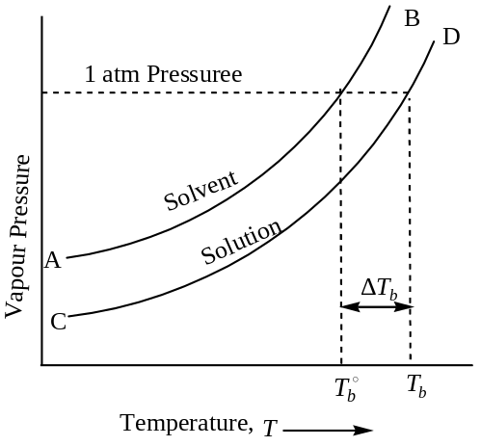
The upper curve ($AB$), represents the vapour pressure — temperature of the pure solvent and the lower curve ($CD$) represents the vapour pressure — temperature relationship of a dilute solution. It is evident that the vapour pressure of the solution ($p$) is lower than that of the pure solvent ($p_{1}^{0}$) at every temperature. The temperature $T_{1}^{0}$ gives the boiling point of the pure solvent and $T$ that for solution, because at these temperatures the vapour pressure becomes equal to the external atmospheric pressure, as shown in the figure. From the figure it is clear that —
$$T>T_{1}^{0}$$
$$and, ∆T_{b}=T-T_{1}^{0}$$
The term $∆T_{b}$ is known as the elevation of boiling point of a dilute solution of non- volatile solute in volatile solvent. //
Expression for Elevation of Boiling Point:
[From TD considerations i.e. Chemical Potential point of view]
Let us consider a dilute solution of non-volatile solute ($2$) is in equilibrium with the pure solvent ($1$). Hence, we have —
$$μ_{1}^{S}=μ_{1}^{v} →(1)$$
Where, $μ_{1}^{S}=$ Chemical potential of $1$, the pure solvent in solution, and
$μ_{1}^{v}=$ The chemical potential of $1$, in the vapour state i.e. at its boiling point
If the solution behaves ideally, then —
$$μ_{1}^{S}=μ_{1}^{0}\left(S\right)+RT \ln{χ_{1}} →(2)$$
Here, $μ_{1}^{0}\left(S\right)$ is the chemical potential of the pure solvent in the liquid state and $χ_{1}$is the mole fraction of $1$ in the solution.
From equation ($1$) & ($2$), we have —
$$μ_{1}^{v}=μ_{1}^{0}\left(S\right)+RT \ln{χ_{1}}$$
$$⇒\ln{χ_{1}}=\frac{μ_{1}^{v}-μ_{1}^{0}\left(S\right)}{RT}$$
$$or \ln{χ_{1}}=\frac{∆G_{vap}}{RT} →(3)$$
Where, $∆G_{vap}=μ_{1}^{v}-μ_{1}^{0}\left(S\right)=$ Change in free energy in the vapour state
Differentiating equation ($3$), with respect to $χ_{1}$ at constant pressure $p$ , we have —
$$\frac{1}{χ_{1}}=\frac{1}{R} \frac{d}{dχ_{1}}{\left[\frac{∆G_{vap}}{T}\right]}_{p}$$
$$=\frac{1}{R} {\left[\frac{∂\left({∆G_{vap}}/T\right)}{∂T}\right]}_{p}×{\left(\frac{∂T}{∂χ_{1}}\right)}_{p} →(4)$$
Again, from Gibbs-Helmholtz equation —
$${\left[\frac{∂\left({∆G_{vap}}/T\right)}{∂T}\right]}_{p}=-\frac{∆H_{vap}}{T^{2}} →(5)$$
Where, $∆H_{vap}=$ Enthalpy of vaporization per mole of the solvent
From equation ($4$) & ($5$), we have —
$$\frac{1}{χ_{1}}=-\frac{1}{R}.\frac{∆H_{vap}}{T^{2}}.{\left(\frac{∂T}{∂χ_{1}}\right)}_{p} →(6)$$
Integrating equation (6), between the proper limits as shown, we have —
$$\int_{1}^{χ_{1}}{\frac{dχ_{1}}{χ_{1}}}=-\frac{1}{R}\int_{T_{0}}^{T}{\frac{∆H_{vap}}{T^{2}}}dT →(7)$$
Where the lower limit $χ_{1}=1$, corresponds to the pure solvent having boiling point $T_{0}$; the upper limit $χ_{1}$ corresponds to a solution whose boiling point is $T$. Assuming that $∆H_{vap}$ is constant within the temperature range (Kirchoff’s equation), we have from equation ($7$) —
$$\ln{χ_{1}}=-\frac{∆H_{vap}}{R}{\left[-\frac{1}{T}\right]}_{T_{0}}^{T}$$
$$=-\frac{∆H_{vap}}{R}\left[\frac{1}{T_{0}}-\frac{1}{T}\right]$$
$$=-\frac{∆H_{vap}}{R}\left[\frac{T-T_{0}}{TT_{0}}\right]$$
$$or \ln{χ_{1}}=-\frac{∆H_{vap}}{R} \frac{∆T_{b}}{T_{0}^{2}} →(8)$$
Where, $T-T_{0}=∆T_{b}=$ elevation of boiling point and since for dilute solution $T_{0} \& T$ are not much different, so $TT_{0}=T_{0}^{2}$
Now, $\ln{χ_{1}}=\ln\left({1-χ}_{2}\right) ∵χ_{1}+χ_{2}=1$
$$⇒\ln{χ_{1}}=-χ_{2}+\frac{χ_{2}^{2}}{2}-\frac{χ_{2}^{3}}{3}+…$$
Since, $χ_{2}$ is the mole-fraction of the solute, which is very small in dilute solution (tends to zero). Therefore, —
$$\ln{χ_{1}}=-χ_{2} (neglecting higher powers of χ_{2})$$
Hence, from equation ($8$), we have —
$$\ln{χ_{1}}=-\frac{∆H_{vap}}{R} \frac{∆T_{b}}{T_{0}^{2}} →(8)$$
$$⇒-χ_{2}=-\frac{∆H_{vap}}{RT_{0}^{2}} ∆T_{b}$$
$$∴ \boxed{∆T_{b}=\frac{RT_{0}^{2}}{∆H_{vap}}χ_{2}} →(9)$$
Therefore, we have —
$$∆T_{b} ∝ χ_{2}$$
Thus, the elevation of boiling point of a solution ($∆T_{b}$) is directly proportional to the mole fraction of the solute ($χ_{2}$), hence, the elevation of boiling point is a colligative property.
Generally in the study of colligative properties, molality ($m$) is used rather than mole – fraction of the solute. Molality of the solute is defined as the number of moles of the solute per $kg$ ($1000 g$) of the solvent. If $n_{1} \& n_{2}$ are the number of moles of $1 \& 2$ (i.e. solvent and solute) in the solution, then —
$$χ_{2}=\frac{n_{2}}{n_{1}+n_{2}}≈\frac{n_{2}}{n_{1}} ∵for dilute solution n_{1}≫n_{2}$$
Molality of the solute in the solution is given by —
$$m_{2}=\frac{n_{2}}{n_{1}M_{1}} \left[⇒n_{2}=n_{1}M_{1}m_{2}\right]$$
Where, $M_{1}=$ Molar mass of the solvent in $kg {mol}^{-1}$
$$∴ χ_{2}=\frac{n_{2}}{n_{1}}=\frac{n_{1}M_{1}m_{2}}{n_{1}}=M_{1}m_{2}$$
Therefore, from equation ($9$), we have —
$$∆T_{b}=\frac{RT_{0}^{2}}{∆H_{vap}} M_{1}m_{2}$$
$$or \boxed{∆T_{b}=\left(\frac{RT_{0}^{2} M_{1}}{∆H_{vap}}\right) m_{2}} →(10)$$
For a given solvent, the term within the bracket in equation ($10$) is a constant; known as the elevation of boiling point or ebullioscopic constant, which is equal to the elevation of boiling point for $1 molal$ solution. It is represented by $K_{b}$ and always expressed in the unit of $Kkg{mol}^{-1}$.
$$∴ \boxed{∆T_{b}= K_{b}m_{2}}$$
$$⇒ ∆T_{b} ∝ m_{2}$$
Thus, the elevation of boiling point is directly proportional to the molality of the solute. This is known as the Raoults law of elevation of boiling point.
To find the unit of $K_{b}$, the ebullioscopic constant:
Since, —
$$∆T_{b}= K_{b}m_{2}$$
$$⇒K_{b}= \frac{∆T_{b}}{m_{2}}=\frac{K}{mol {kg}^{-1}}=Kkg{mol}^{-1}$$
Application of Elevation of Boiling Point:
Determination of Molecular Mass of the solute from Elevation of Boiling Point Measurement:
By measuring the elevation of boiling point of a solution of known concentration it is possible to calculate the molar mass of a non-volatile, non-electrolyte solute in the solution. Since, we have —
$$∆T_{b}= K_{b}m_{2}$$
Where, $∆T_{b}=$Elevation of boiling point, and $∆T_{b}=T-T_{0}$
$T_{0}=$ The boiling point of the pure solvent, and
$T=$ The boiling point of the solution
$m_{2}=$ The molality of the solute
$K_{b}=$ Molal elevation of boiling point, and
$$K_{b}=\frac{RT_{0}^{2} M_{1}}{∆H_{vap}} Kkg{mol}^{-1}$$
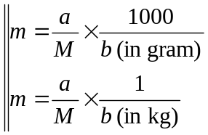If $w_{2} kg$ of the solute of molar mass $M_{2} kg {mol}^{-1}$is dissolved in $w_{1} kg$ of solvent, then —
$$m_{2}=\frac{w_{2}}{M_{2}}×\frac{1}{w_{1}}$$
Therefore —
$$∆T_{b}= K_{b}×\frac{w_{2}}{M_{2}}×\frac{1}{w_{1}}$$
$$⇒\boxed{M_{2}=\frac{K_{b}}{∆T_{b}}×\frac{w_{2}}{w_{1}}}$$
In the above expression all the quantities are known, hence the molar mass of the solute ($M_{2}$), can be easily calculated, and its unit will be $kg {mol}^{-1}$.
Problem ($1$): A sample of benzene that is contaminated with a non-volatile substance boils $3.1℃$ higher than that of the pure benzene ($bp=80.1℃$). What is the amount of impurity present in the sample? ($∆H_{vap}=30.76 kJ{mol}^{-1}$)
Solution: We have —
$$∆T_{b}= K_{b}m_{2}, and$$
$$K_{b}=\frac{RT_{0}^{2} M_{1}}{∆H_{vap}}$$
Here, $∆T_{b}=T-T_{0}=Elevation of bp=3.1℃=3.1 K$
$R=8.314 JK^{-1}{mol}^{-1}$
$T_{0}=80.1℃=80.1+273=353.1 K$
$M_{1}=molar mass of benzene=78 g {mol}^{-1}=0.078 kg {mol}^{-1}$
$∆H_{vap}=30.76 kJ{mol}^{-1}$
On substituting the various values, we will have —
$$K_{b}=2.63 Kkg {mol}^{-1}$$
Now, from —
$$∆T_{b}= K_{b}m_{2}$$
$$⇒m_{2}=\frac{∆T_{b}}{K_{b}}=\frac{3.1 K}{2.63 Kkg {mol}^{-1}}=1.18 mol {kg}^{-1}$$
Thus, the amount of impurity present $=1.18 mol {kg}^{-1}$ of benzene //
Problem ($2$): A solution containing $2.44 g$ of a solute dissolved in $75 g$ of water boils at $100.413℃$. Calculate the molar mass of the solute. ($K_{b} for water=0.52$)
Solution: We have —
$$M_{2}=\frac{K_{b}}{∆T_{b}}×\frac{w_{2}}{w_{1}}$$
Here, $∆T_{b}=T-T_{0}=373.413-372=0.413 K(=0.413℃)$
$w_{2}=2.44 g=0.00244 kg, w_{1}=75 g=0.075 kg$
$K_{b}=0.52 Kkg {mol}^{-1}$
Hence, the molar mass of the solute, $M_{2}=0.04096 kg{mol}^{-1}$
$$=40.96 g{mol}^{-1} //$$
Problem ($3$): The molar hear of vaporization of water at $100℃ is 40.585 kJ{mol}^{-1}$. At what temperature will a solution containing $5.60 g glucose per 1000 g$ of water boil?
Solution: We have —
$$∆T_{b}=T-T_{0}= K_{b}m_{2}, and$$
$$K_{b}=\frac{RT_{0}^{2} M_{1}}{∆H_{vap}}$$
$$=\frac{\left(8.314 JK^{-1}{mol}^{-}\right){\left(373 K\right)}^{2} \left(0.018 kg {mol}^{-1}\right)}{40585 J{mol}^{-1}}$$
$$∴K_{b}=0.513 Kkg {mol}^{-1}$$
Now, molality of solute (glucose, $M_{2}=180 g$) is given by —
$$m_{2}=\frac{w_{2}}{M_{2}}×\frac{1}{w_{1}}$$
$$=\frac{5.60 ×{10}^{-3}kg}{180×{10}^{-3}kg {mol}^{-1}}×\frac{1}{1 kg}=0.0311 mol {kg}^{-1}$$
$$∴∆T_{b}= K_{b}m_{2}=0.016 K$$
$$∴Boiling point of the solution, T=T_{0}+∆T_{b}$$
$$=373 K+0.016 K$$
$$=373.016 K=100.016℃$$
Problem ($4$): A solution containing $2.5 g$ of a non-volatile solute in $100 g$ of benzene ($K_{b}=2.67$) boiled at a temperature $0.42°$ higher than did the pure solvent. What is the molar mass of the solute?
Solution: $158.93 g {mol}^{-1}$
Problem ($5$): $5g$ of a non-volatile solute compound is dissolved in $250g$ of water. If the molar mass of the compound is$140g{mol}^{-1}$, calculate the elevation of boiling point. ($∆H_{vap}=40.66 kJ{mol}^{-1}$)
Solution: We have —
$$∆T_{b}= K_{b}m_{2}$$
$$where, K_{b}=\frac{RT_{0}^{2} M_{1}}{∆H_{vap}}=0.5121 Kkg{mol}^{-1}$$
And, molality of solute ($m_{2}$) is —
$$m_{2}=\frac{w_{2}}{M_{2}}×\frac{1}{w_{1}}=0.1429 mol {kg}^{-1}$$
$$∴∆T_{b}= K_{b}m_{2}=0.0732 K=0.0432℃$$
Problem ($6$): The boiling point of $C{Cl}_{4}$ was raised by $0.325K$ when $5.141×{10}^{-4}kg$ of anthracene ($C_{10}H_{10}$) was dissolved in $35×{10}^{-3}kg C{Cl}_{4}$. Calculate the molar mass of the solute ($M_{1}$). Given that for $C{Cl}_{4}, K_{b}=3.9 Kkg{mol}^{-1}$
Solution: $176.3 g {mol}^{-1}$
Problem ($7$): A solution containing $0.3g of camphor, C_{10}H_{16}O$ in $25.3g of chloroform$ boils at $334.3K$. Boiling point of chloroform is $334.0K$. Calculate the molar heat of vaporization and elevation of boiling point constant for chloroform.
Solution: Since —
$$∆T_{b}= K_{b}m_{2}$$
$$⇒K_{b}=\frac{∆T_{b}}{m_{2}}= \frac{∆T_{b}}{\frac{w_{2}}{M_{2}}×\frac{1}{w_{1}}}=3.8456 Kkg{mol}^{-1}$$
Again —
$$K_{b}=\frac{RT_{0}^{2} M_{1}}{∆H_{vap}}$$
$$⇒∆H_{vap}=\frac{RT_{0}^{2} M_{1}}{K_{b}}=28.82 kJ{mol}^{-1} //$$
Problem ($8$): Show that the elevation of $bp$ is a colligative property.
Solution: The elevation of boiling point, $∆T_{b}$ is given by —
$$∆T_{b}= K_{b}m_{2}=\frac{RT_{0}^{2} M_{1}}{∆H_{vap}} m_{2}$$
Again, the mole-fraction of the solute is given by —
$$χ_{2}=\frac{n_{2}}{n_{1}+n_{2}}≈\frac{n_{2}}{n_{1}}, for dilute solution n_{1}≫n_{2}$$
$$⇒∆T_{b}=\frac{K_{b}}{n_{1}}×n_{2}$$
$$=Constant×n_{2}$$
$$⇒∆T_{b} ∝ n_{2}$$
Thus, for a given amount of a particular solvent (i.e. $n_{1}$ is known) $∆T_{b}$, the elevation of boiling point is proportional to the number of moles of the solute present in the solution ($n_{2}$), and hence it is a colligative property. //
Depression of Freezing Point ($∆T_{f}$) of a Solution:
[By a non-volatile solute/ substance]
Depression of Freezing Point: Freezing point is the temperature at which solid and liquid states of a substance have the same $VP$ (vapour pressure). The $VP$ curves of the pure solvent and that of a dilute solution in the freezing point range are shown in the figure. The $VP$ curves of the solvent in the liquid and solid state are shown to meet at point $B$, corresponding to the temperature $T_{0}$, at which solid and liquid states have the same $VP$. Hence, $T_{0}$ corresponds to the freezing point of the pure solvent. As the $VP$ of the solution is less than that of the pure solvent, the $VP$ curves of the solution always lies between that of the pure solvent, as shown in the figure given below.
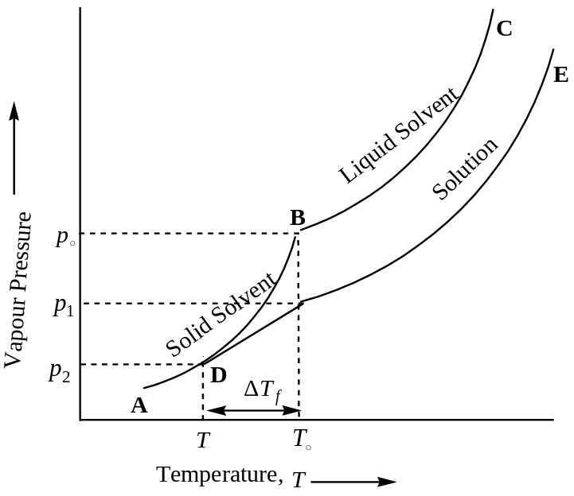
The $VP$ curve of the solution is seen to intersect that of the solid at $D$, i.e. at a lower temperature $T$. Therefore, $T$ gives the freezing point of the solution. Evidently, depression in freezing point $∆T_{f}$ is given by $T_{0}-T$. Thus —
$$∆T_{f}=T_{0}-T$$
Expression for Depression of Freezing Point from TD Considerations:
Let us consider a solution of a non-volatile solute ($2$) is in equilibrium with the vapour of the pure solvent ($1$). The equilibrium condition requires that —
$${\left(μ_{1}\right)}_{Solution}={\left(μ_{1}\right)}_{Solid}$$
Where, ${\left(μ_{1}\right)}_{Solution}=$ Chemical potential of $1$, the pure solvent in solution, and
${\left(μ_{1}\right)}_{Solid}=$ The chemical potential of the pure solvent in the solid state i.e. at its freezing point
If the solution behaves ideally, then —
$${\left(μ_{1}\right)}_{Solution}=μ_{1}^{0}+RT \ln{χ_{1}}$$
Here, $μ_{1}^{0}$ is the chemical potential of the pure solvent in the liquid state and $χ_{1}$ is the mole fraction of the solvent in the solution. Therefore —
$${\left(μ_{1}\right)}_{Solid}=μ_{1}^{0}+RT \ln{χ_{1}}$$
$$⇒\ln{χ_{1}}=-\frac{μ_{1}^{0}-{\left(μ_{1}\right)}_{Solid}}{RT}=-\frac{{\left(∆G\right)}_{Fusion}}{RT} →(1)$$
Where —
$${\left(∆G\right)}_{Fusion}=μ_{1}^{0}-{\left(μ_{1}\right)}_{Solid}$$
$=$Molar free energy of fusion of the solvent at equilibrium temperature $T$
Differentiating equation ($1$), with respect to $χ_{1}$ at constant pressure $p$, we have —
$$\frac{d}{dχ_{1}}\left(\ln{χ_{1}}\right)=-\frac{1}{R} \frac{d}{dχ_{1}}{\left[\frac{{\left(∆G\right)}_{Fus}}{T}\right]}_{p}$$
$$\frac{1}{χ_{1}}=-\frac{1}{R} {\left[\frac{∂\left\{{{\left(∆G\right)}_{Fus}}/T\right\}}{∂T}\right]}_{p}×{\left(\frac{∂T}{∂χ_{1}}\right)}_{p} →(2)$$
Again, from Gibbs-Helmholtz equation —
$${\left[\frac{∂\left({{∆G}_{Fus}}/T\right)}{∂T}\right]}_{p}=-\frac{∆H_{Fus}}{T^{2}} →(3)$$
Where: $∆H_{Fus}=$ The molar enthalpy of fusion of the solvent at temperature $T$
From equation ($2$) & ($3$), we have —
$$\frac{1}{χ_{1}}=\frac{1}{R} \frac{∆H_{Fus}}{T^{2}}.{\left(\frac{∂T}{∂χ_{1}}\right)}_{p}$$
$$or \frac{dχ_{1}}{χ_{1}}=\frac{1}{R} \frac{∆H_{Fus}}{T^{2}} dT$$
Integrating the above equation between the proper limits as shown, we have —
$$\int_{1}^{χ_{1}}{\frac{dχ_{1}}{χ_{1}}}=\int_{T_{0}}^{T}{\frac{∆H_{Fus}}{R}} \frac{dT}{T^{2}}$$
Where the lower limit $χ_{1}=1$, implies a pure solvent having freezing point $T_{0}$ and the upper limit $χ_{1}$ corresponds to a solution whose freezing point $T$. Assuming that $∆H_{Fus}$ is a constant over the temperature range $T_{0} \& T$, we have —
$$\ln{χ_{1}}=-\frac{∆H_{Fus}}{R} {\left[\frac{1}{T}\right]}_{T_{0}}^{T}$$
$$⇒\ln\left({1-χ}_{2}\right)=-\frac{∆H_{Fus}}{R} \left[\frac{1}{T}-\frac{1}{T_{0}}\right]$$
$$or -χ_{2}=-\frac{∆H_{Fus}}{R} \left[\frac{T_{0}-T}{TT_{0}}\right]$$
$$or -χ_{2}=-\frac{∆H_{Fus}}{RT_{0}^{2}} ∆T_{f}$$
Where, $T_{0}-T=∆T_{f}=$ Depression of freezing point of the solution
Since for dilute solution $T_{0} \& T$ are not much different, so $TT_{0}=T_{0}^{2}$
Further, $\ln{χ_{1}}=\ln\left({1-χ}_{2}\right) ∵ χ_{1}+χ_{2}=1$
$$⇒\ln{χ_{1}}=-χ_{2}+\frac{χ_{2}^{2}}{2}-\frac{χ_{2}^{3}}{3}+…$$
Since, $χ_{2}$ is the mole-fraction of the solute, which is very small in dilute solution i.e. $χ_{2}≪1$. Therefore, we can neglect the higher powers of $χ_{2}$, and hence, $\ln{χ_{1}}=-χ_{2}$. Thus —
$$∆T_{f}=\frac{RT_{0}^{2}}{∆H_{Fus}}. χ_{2} →(4)$$
Therefore, we have —
$$∆T_{f} ∝ χ_{2}$$
Thus, the depression of freezing point of a solution is directly proportional to the mole fraction of the solute ($χ_{2}$) in the solution i.e. it is a colligative property.
Generally in the study of colligative properties, molality ($m$) is used rather than mole-fraction of the solute. Molality of the solute is defined as the number of moles of the solute $per kg$ ($1000 g$) of the solvent. If $n_{1} \& n_{2}$ are the number of moles of $1 \& 2$ (i.e. solvent $\&$ solute) in the solution, then —
$$χ_{2}=\frac{n_{2}}{n_{1}+n_{2}}≈\frac{n_{2}}{n_{1}} \left[∵for dilute solution n_{1}≫n_{2}\right]$$
Molality of the solute in the solution is given by —
$$m_{2}=\frac{n_{2}}{n_{1}M_{1}}, ⇒n_{2}=n_{1}M_{1}m_{2}$$
Where, $M_{1}=$ Molar mass of the solvent in $kg {mol}^{-1}$
$$∴ χ_{2}=\frac{n_{2}}{n_{1}}=\frac{n_{1}M_{1}m_{2}}{n_{1}}=M_{1}m_{2}$$
Therefore, from equation ($4$), we have —
$$∆T_{f}=\frac{RT_{0}^{2}}{∆H_{Fus}}. M_{1}m_{2}$$
$$or ∆T_{f}=\left(\frac{RT_{0}^{2} M_{1}}{∆H_{Fus}}\right) m_{2} →(5)$$
For a given solvent, the term within the bracket in equation ($5$) is a constant; known as the molal depression of freezing point or Cryoscopic constant represented by the symbol $K_{f}$. It is defined as the depression of freezing point of $1$- molal solution. It is a constant for a given solvent and always expressed in the unit of $Kkg{mol}^{-1}$. Thus —
$$K_{f}=\frac{RT_{0}^{2} M_{1}}{∆H_{Fus}}$$
$$∴ ∆T_{f}=K_{f} m_{2} →(6)$$
$$i.e. ∆T_{f} ∝ m_{2}$$
Thus, the depression of freezing point is directly proportional to the molality of the solute. This is known as the Raoults law of depression of freezing point.
Application of Elevation of Boiling Point:
Determination of Molecular Mass of the solute from Freezing Point Measurement:
By measuring the freezing point depression of a solution of known concentration, it is possible to calculate the molar mass of a non-volatile, non-electrolyte solute in the solution. Since, we have —
$$∆T_{f}=K_{f} m_{2}$$
Where, $∆T_{f}=$Depression of freezing point, and $∆T_{f}=T_{0}-T$
$T_{0}=$ The freezing point of the pure solvent, and
$T=$ The freezing point of the solution
$m_{2}=$ The molality of the solute
$K_{f}=$ Molal depression of freezing point, and
$$K_{f}=\frac{RT_{0}^{2} M_{1}}{∆H_{fus}} Kkg{mol}^{-1}$$
If $w_{2} kg$ of the solute of molar mass $M_{2} kg {mol}^{-1}$is dissolved in $w_{1} kg$ of solvent, then —
$$m_{2}=\frac{w_{2}}{M_{2}}×\frac{1}{w_{1}}$$
Therefore —
$$∆T_{f}= K_{f}×\frac{w_{2}}{M_{2}}×\frac{1}{w_{1}}$$
$$⇒\boxed{M_{2}=\frac{K_{f}}{∆T_{f}}×\frac{w_{2}}{w_{1}}}$$
In the above expression all the quantities are known, hence the molar mass of the solute ($M_{2}$), can be easily calculated, and its unit will be $kg {mol}^{-1}$.
Problem ($1$): For benzene $T_{0}=278.6 K \& ∆H_{fus}=9.83 kJ{mol}^{-1}$, calculate the value of $K_{f}$.
Solution: We have —
$$K_{f}=\frac{RT_{0}^{2} M_{1}}{∆H_{fus}}$$
$$=\frac{\left(8.314 JK^{-1}{mol}^{-1}\right){\left(278.6 K\right)}^{2}\left(78×{10}^{-3}kg {mol}^{-1}\right)}{\left(9.83×{10}^{3} J{mol}^{-1}\right)}$$
$$=5.1205 Kkg{mol}^{-1} //$$
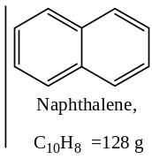Problem ($2$): A solution containing $2.423 g$ of sulphur in $100 g$ of naphthalene ($fp=80.1℃$) gave a freezing point depression of $0.64℃$. The latent heat of fusion of naphthalene is $35.7 cal g^{-1}$. What is the molecular formula of sulphur in solution?
Solution: Here —
$$w_{1}=100 g=0.1 kg$$
$$w_{2}=2.423 g=2.423×{10}^{-3} kg$$
$$M_{1}=128 g {mol}^{-1}=128×{10}^{-3} kg {mol}^{-1}$$
$$∆T_{f}=0.64℃=0.64 K$$
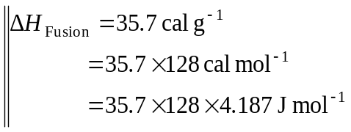$M_{2}= ?$
We have —
$$M_{2}=\frac{K_{f}}{∆T_{f}}×\frac{w_{2}}{w_{1}}$$
Here —
$$K_{f}=\frac{RT_{0}^{2} M_{1}}{∆H_{fus}}=6.9348 Kkg{mol}^{-1}$$
$$∴ M_{2}=\frac{K_{f}}{∆T_{f}}×\frac{w_{2}}{w_{1}}=0.2626 kg {mol}^{-1}=262.6 g {mol}^{-1}$$
Therefore, the atomicity of $S$- in solution will be —
$$=\frac{262.6 g {mol}^{-1}}{=32.0 g {mol}^{-1}}=8.2≈8$$
$∴$ Molecular formula of $S$- in solution $=S_{8}$ //
Problem ($3$): Calculate the molal depression constant of water. The heat of fusion of ice is $334.7 Jg^{-1}$.
Solution: Here —
$$∆H_{fus}\left(of ice\right)=334.7J g^{-1}$$
$$=334.7×18 J{mol}^{-1}=6024.6 J{mol}^{-1}$$
$$T_{0}=0℃$$
We have —
$$K_{f}=\frac{RT_{0}^{2} M_{1}}{∆H_{fus}}=1.85 Kkg{mol}^{-1} //$$
Problem ($4$): An aqueous solution containing $0.25 g$ of solute dissolved in $20 g$ of water froze at $-0.42℃$ . Calculate the molar mass of the solute. The molar heat of fusion of ice at $0℃$ is $334.7 Jg^{-1} \& R=8.314 JK^{-1}{mol}^{-1}$.
Solution: Here —
$$w_{1}=20 g=0.020 kg$$
$$w_{2}=0.25 g=0.025 kg$$
$$M_{1}=18 g {mol}^{-1}=18×{10}^{-3} kg {mol}^{-1}$$
$$∆T_{f}=0.42℃=0.42 K, T_{0}=0℃=273 K$$
$$M_{2}= ?, K_{f}= ?$$
Since —
$$K_{f}=\frac{RT_{0}^{2} M_{1}}{∆H_{fus}}$$
$$∴K_{f}=1.85 Kkg{mol}^{-1} //$$
Now —
$$∆T_{f}=K_{f} m_{2}=K_{f} \frac{w_{2}}{M_{2}}×\frac{1}{w_{1}}$$
$$⇒M_{2}=\frac{K_{f}}{∆T_{f}}×\frac{w_{2}}{w_{1}}=0.055059 kg {mol}^{-1}=55.059 g {mol}^{-1}$$
Problem ($5$): $4 g$ of a non-volatile solute is dissolved in $250 g$ of water. The depression in the freezing point of water observed is $0.087$. Calculate the molecular weight of the solute. Given that $K_{f}$ for water is $1.856 Kkg{mol}^{-1}$.
Solution: We have —
$$∆T_{f}=K_{f} m_{2}=K_{f} \frac{w_{2}}{M_{2}}×\frac{1}{w_{1}}$$
$$⇒M_{2}=\frac{K_{f}}{∆T_{f}}×\frac{w_{2}}{w_{1}}$$
$$=\frac{1.856 Kkg{mol}^{-1}}{0.087 K}×\frac{4×{10}^{-3}kg}{250×{10}^{-3}kg}$$
$$=0.3413 kg {mol}^{-1}=341.3 g {mol}^{-1} //$$
Problem ($6$): The lowering of freezing point of benzene was $2.33$ when $4.12 g$ of a solute of unknown molar mass dissolved in $9.31×{10}^{-3}kg$ of benzene. Calculate the molar mass of the solute. Molal depression constant for benzene is $5.1 Kkg{mol}^{-1}$.
Solution: $96.864 kg {mol}^{-1}$
Problem ($7$): A brass sample composed of $20 \% Zn \& 80 \% Cu by mass$ melts at $1268 K$. Pure copper melts at $1357K$. What is the molal freezing constant for copper? ($Cu=65 g{mol}^{-1}$)
Solution: We have —
$$∆T_{f}=K_{f} m_{2}$$
$$⇒K_{f}=\frac{∆T_{f}}{m_{2}}=\frac{∆T_{f}}{\frac{w_{2}}{M_{2}}×\frac{1}{w_{1}}}$$
$$i.e. K_{f}=∆T_{f}×\frac{w_{1}}{w_{2}}×M_{2}$$
$$=\left(89K\right)×\frac{80}{20}×\left(65×{10}^{-3}kg{mol}^{-1}\right)=23.14 Kkg{mol}^{-1}$$
Problem ($8$): $1g$ of urea when dissolved in $100g$ of a certain solvent decreases its freezing point by $0.2℃$. But, if $1.6g$ of unknown compound when dissolved in $80g$ of the same solvent depresses its freezing point by $0.36℃$. Calculate the molecular weight of the unknown compound.
Solution: $66.7 g{mol}^{-1}$
Problem (9): $0.4g$ of glucose was dissolved in $100g$ of water and the depression in freezing point is $-0.41℃$ . Calculate the heat of fusion of water.
Solution: $6045.2 J{mol}^{-1}$
Osmosis and osmotic pressure ($π$):
When a solution is separated from a pure solvent by a semi-permeable membrane ($SPM$), i.e. a membrane which allows free passage of the solvent molecules but not solute molecules, then a spontaneous flow of solvent to the solution has been occurred. This spontaneous flow of solvent into a solution through a SPM is known as osmosis. The flow of solvent through the $SPM$ will continue till equilibrium is reached, i.e. when the hydrostatic pressure of the liquid column is exactly balances the tendency of water (solvent) to pass inward through SPM. The hydrostatic pressure set up as a result of osmosis is the measure of osmotic pressure of the solution. For instance, if the liquid raises to a height of ‘$h$’, then —
Osmotic pressure, $π=h×ρ$
Here, $ρ$ is the density of the solution.
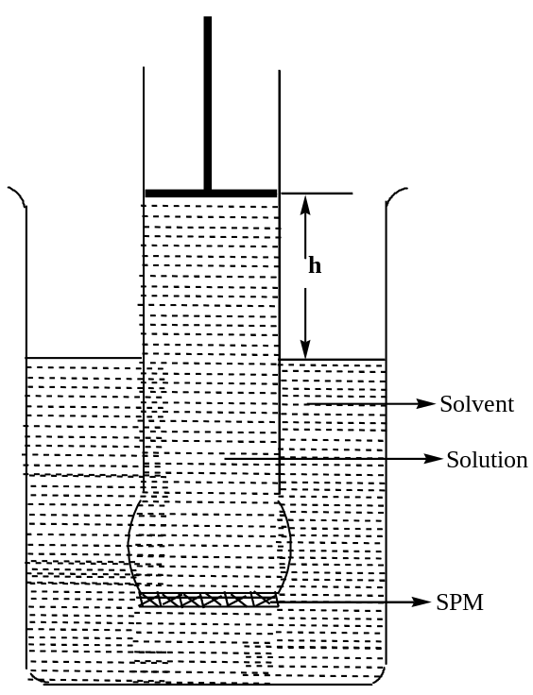
By applying a certain external pressure to the solution, osmosis can be prevented. The minimum external pressure required to stop osmosis, i.e. the spontaneous flow of solvent molecules to the solution through a SPM is called osmotic pressure ($π$).
Thus, in osmosis there is a spontaneous flow of liquid having lower concentration (dilute) to a liquid having higher concentration through a $SPM$. If the two solutions having same concentration were separated by a SPM, no osmosis will occur, and the solutions are said to be isotonic. Thus, solutions having same $molar conc.$ and osmotic pressure are called isotonic solutions.
diffusion versus osmosis:
The phenomenon of the movement of solute particles from a higher conc. solution to a lower conc. solution so as to bring about ultimately a uniform conc. throughout the bulk is known as diffusion.
Following are basic differences between the osmosis and diffusion —
Diffusion | Osmosis
[$1$] There is a flow of both the solvent and solute i.e. movement of solution as a whole and no SPM is required. | [$1$] There is a flow of solvent into the solution through a SPM.
[$2$] Solution flow from higher concentration to lower concentration until as equilibrium in concentration is achieved. | [$2$] Solvent flows from the solution of lower concentration to the solution of higher concentration.

Measurement of osmotic pressure: Berkeley and Hartley’s Method —
In Berkeley and Hartley’s technique, osmosis is prevented by applying an external pressure to the solution and the magnitude of this applied pressure corresponds to the osmotic pressure ($π$) of the solution. The apparatus used in this technique is as shown in the figure. The inner jacket of the concentric cylinder is fitted with $SPM$ (electrically deposited $Cu[Fe(CN)_{6}]$) and filled with the pure solvent. One of the ends of this inner tube is connected to a capillary indicator $C$, whereas the other ends to a reservoir through a stopcock $S$.This inner jacket is covered by a vessel (made up of Gun-metal) containing the solution, whose osmotic pressure is to be determined. Due to osmosis, the level of the solvent in the capillary indicator falls, a pressure is simultaneously applied to the solution by the piston $D$, such that the level of the solvent in the capillary indicator remains at its original position. The applied pressure in the piston is the osmotic pressure of the solution.
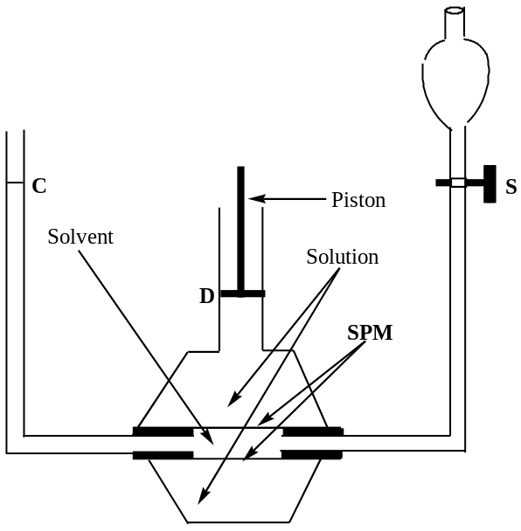
the laws of osmotic pressure:
Van’t Hoff and Pfeiffer’s law —
Van’t Hoff deduced the law of Osmotic Pressure from the results obtained from various investigations. These are —
[$1$] At constant temperature, the osmotic pressure ($π$) of a solution is inversely proportional to the volume ($V$), containing $1$- mole of the solute, i.e. —
$$π ∝ \frac{1}{V} [n,T→Constant]$$
$$i.e. π ∝ \frac{1}{c} [conc., c=\frac{n}{V}, here, n=1]$$
This law is also called Boyle’s-Van’t Hoff law of dilute solution.
[$2$] At constant volume, the osmotic pressure ($π$) of a solution is directly proportional to the temperature ($T$) of the solution, i.e. —
$$π ∝ T [V,n→Constant]$$
This law is also called Charles-Van’t Hoff law of dilute solution.
[$3$] At constant temperature and volume, the osmotic pressure ($π$) of a solution is directly proportional to the number of moles ($n$) of the solution, i.e. —
$$π ∝ n [V,T→Constant]$$
This law is also called Avogadro’s-Van’t Hoff law of dilute solution.
Combining these three laws, we have —
$$π ∝ \frac{nT}{V}$$
$$or π ∝ c T, c=\frac{n}{V}=Molar conc.$$
$$or π=S c T$$
Here, $S$ is a constant
For a known volume of solution at a given temperature and osmotic pressure, it has been found that the value of $S$ is to be $0.0821 LatmK^{-1}{mol}^{-1}$, which is similar to $R$, the universal gas constant. Hence —
$$π=cRT$$
$$or πV=nRT ∵c=\frac{n}{V}$$
The above equation is known as the Van’t-Hoff equation and holds strictly for dilute solutions, where the solute-solvent, interactions are negligible. For very-very dilute solution osmotic pressure ($π$) is equivalent to gas pressure ($p$), i.e. $π≈p$ //
osmotic pressure from thermodynamic considerations:
Derivation of Van’t Hoff equation for Osmotic Pressure of Dilute Solution —
Let us consider a pure solvent $A$ is separated from a solute $B$ by a semi-permeable membrane as shown in the figure given below. Solvent “$A$” flows from solvent site to solution site, resulting in the development of osmotic pressure, $π$. At equilibrium, chemical potential of the solvent $μ_{A}$ in solution is equal to the chemical potential of the pure solvent $μ_{A}^{*}$. Thus —
$$μ_{A}\left(at p+π\right)=μ_{A}^{*}\left(at p\right) →(1)$$
Here, $p$ is the external pressure and $π$ is the osmotic pressure of the solution.
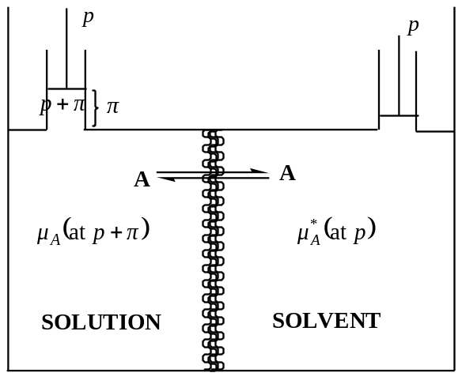
There are two opposing factors that cause the value of $μ_{A}$ in the solution to depart from that of pure $A$. Firstly, decrease in $μ_{A}$ is caused by the dilution of $A$ in the solution, it is given by —
$$∆μ_{A}=RT \ln{\frac{p_{A}}{p_{A}^{*}}}$$
Here, $p_{A}$ is the partial pressure of $A$ in the solution and $p_{A}^{*}$ is that of the pure solvent $A$.
Exactly counteracting this effect is the increase in $μ_{A}$, in the solution due to imposed osmotic pressure $π$, so that —
$$∆μ_{A}=πV_{A}$$
Here, $V_{A}$ is the partial volume of the solvent $A$ in the solution. At the equilibrium, both the effects are equal and opposite. Therefore —
$$πV_{A}=-RT \ln{\frac{p_{A}}{p_{A}^{*}}} →(2)$$
In ideal solution, partial molar volume of $A i.e.V_{A}$ is replaced by volume of the pure solvent $V_{A}^{*}$. Therefore —
$$πV_{A}^{*}=-RT \ln{\frac{p_{A}}{p_{A}^{*}}}=-RT \ln{χ_{A}} →(3)$$
Here, $χ_{A}$ is the mole-fraction of $A$ in the solution.
Hence, —
$$πV_{A}^{*}=-RT \ln\left(1-χ_{B}\right) ∵ χ_{A}+χ_{B}=1, ⇒χ_{A}=1-χ_{B}$$
Here, $χ_{B}$ is the mole-fraction of the solute in the solution.
But, for dilute solutions — $\ln\left(1-χ_{B}\right)≈-χ_{B}$
$$∴ πV_{A}^{*}=-RT χ_{B} →(4)$$
Now, —
$$χ_{B}=\frac{n_{B}}{n_{A}+n_{B}}≈\frac{n_{B}}{n_{A}}, for dilute solutions (n_{A}≫n_{B})$$
And, therefore from equation ($4$), we have —
$$π=RT \frac{n_{B}}{n_{A}V_{A}^{*}}=RT \frac{n_{B}}{V}$$
Where, $V=n_{A}V_{A}^{*}=Total volume of A$
Thus —
$$π=RT \frac{n_{B}}{n_{A}V_{A}^{*}}=c_{2}RT →(5)$$
Where, $c_{2}={n_{B}}/V\left(≡{n_{2}}/V\right)=Molar conc.of the solute in the solution$
Equation ($5$) is the van’t-Hoff equation of dilute solution for osmotic pressure. //
APPLICATIONS OF osmotic pressure:
[$1$] Determination of molar mass of polymer from Osmotic Pressure Measurement —
Osmotic pressure measurement is useful for the determination of molar mass of polymers up to the range of $5×{10}^{5}g {mol}^{-1}$, provided good enough semi-permeable membrane is available. From van’t-Hoff equation, osmotic pressure —
$$π=c_{2}RT=\frac{n_{2}}{V} RT$$
Where, $n_{2}=$ Numbers of moles of the solute,
$V=$ Total volume of the solvent,
$R=$ Universal gas constant, and
$T=$ Absolute temperature
If $w_{2}$ gram of solute of molar mass $M_{2}$ is dissolved in $V L$ of the solvent, then —
$$n_{2}=\frac{w_{2}}{M_{2}}$$
$$∴π=\frac{w_{2}}{M_{2}}× \frac{RT}{V}$$
$$⇒M_{2}=\left(\frac{w_{2}}{π}\right)× \frac{RT}{V} →(1)$$
From equation ($1$), we can determine the molar mass of the solute, i.e. a polymer. But for accurate determination of molar mass of polymer, we write equation ($1$) in the form —
$$\frac{π}{w_{2}}=\frac{RT}{M_{2} V} →(2)$$
Now, $π/{w_{2}}$ values for solutions of different concentration are plotted against $w_{2}$ and the line obtained is extrapolated to $w_{2}=0$.
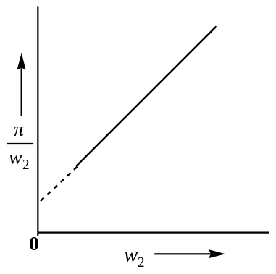
The limiting value of the ordinate ${\left(π/{w_{2}}\right)}_{0}$ is equal to ${RT}/{M_{2}V}$ . Therefore —
$$M_{2}={\frac{RT}{V}}/{{\left(\frac{π}{w_{2}}\right)}_{0}}$$
It must be emphasised that van’t-Hoff equation is applicable to non-electrolyte and macro molecules with no electric charge. Thus, protein will give correct molar mass at the $p^{H}$ value at which it possesses no electric charge, i.e. at iso-electric point (the $p^{H}$ value at which the macro molecule is neither $+vely nor-vely$ charged). //
[$2$] Reverse Osmosis:
Determination of Molecular Mass of the solute from Osmotic Pressure Measurement —
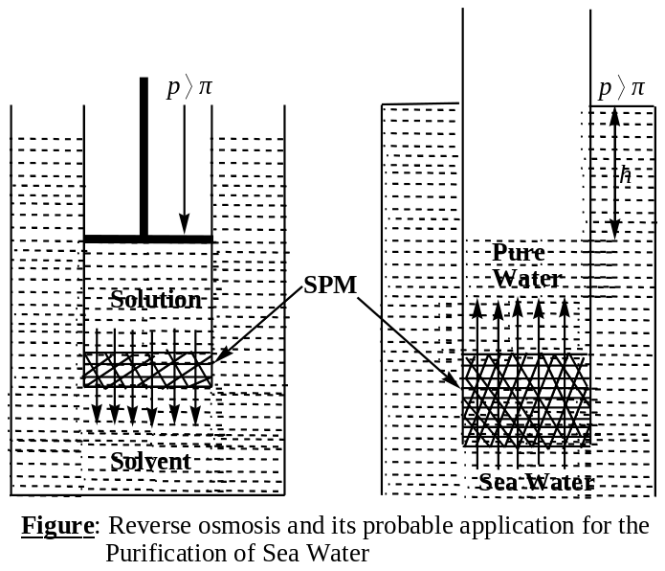If the pressure applied on the solution is more than that of the osmotic pressure of the solution, then the solvent starts flowing from the solution to the solvent side. This phenomenon is known as the reverse osmosis. This process has acquired great importance in the purification of sea water. A tube fixed with a semi-permeable membrane at its lower end is dipped in sea water below a height $h$. If the hydrostatic pressure due to the depth $h$ is higher than the osmotic pressure of sea water, pure water will start flowing inside the tube. Thus, the tube will act a fresh water reservoir. Generally, cellulose acetal membranes are used as the $SPM$ in this technique. Other uses of this process are —
- To control the pollution of industry waste,
- In the production and preservation of enzymes, and
- In the concentration of foodstuff, fruit juice, etc.
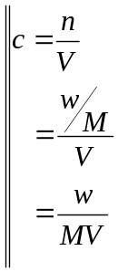Problem ($1$): Calculate the osmotic pressure of an aqueous solution containing $1g$ each of sucrose and glucose $per {dm}^{3} at 300K$. If this pressure were measured and if were not known that the solute was a mixture. What molar mass would be expected?
Solution: We know that —
$$π=cRT$$
Here, $c=c_{1}+c_{2}$
$$=\left(1/{342}+1/{180}\right)mol {dm}^{-3}$$
$$=0.0085 mol {dm}^{-3}$$
$$π=0.0085 RT mol {dm}^{-3}$$
Again, for the mixture of $2g$, if ‘$M$’ be the molecular weight, then from —
$$πV=nRT=\frac{w}{M}RT$$
$$⇒M=\frac{wRT}{πV}$$
$$=\frac{\left(2g\right)RT}{\left(0.0085 RT mol {dm}^{-3}\right)\left(1 {dm}^{3}\right)}=235.294 g {mol}^{-1}$$
Problem ($2$): A $5.13\%$ solution of cane sugar is isotonic with $0.9\%$ solution of an unknown solute. Calculate the molar mass of the solute.
Solution: For, cane sugar solution —
$$w=5.13 g M=342 g {mol}^{-1} V=100 mL=0.1 {dm}^{3}$$
Therefore, osmotic pressure —
$$π=\frac{wRT}{MV}=\frac{5.13 RT}{342 V}$$
For the unknown solute —
$$w=0.9 g M_{2}= ? V=100 mL=0.1 {dm}^{3}$$
Therefore, osmotic pressure —
$$π=\frac{wRT}{M_{2}V}=\frac{0.9 RT}{M_{2} V}$$
Since, the solutions are isotonic, hence —
$$\frac{0.9 RT}{M_{2} V}=\frac{5.13 RT}{342 V}$$
$$⇒M_{2}=\frac{0.9×342}{5.13}=60 g {mol}^{-1}$$
//
Problem ($3$): Calculate the molar mass of a substance if at $20℃$ its solution containing $6.0 g{dm}^{-3}$ has an osmotic pressure of $3 mm Hg$. Given $R=0.0821 {dm}^{3}atm K^{-1}{mol}^{-1}$
Solution: From Van’t Hoff equation, we have —
$$π=c_{2}RT=\frac{n_{2}}{V}RT=\frac{w_{2}}{M_{2}}×\frac{RT}{V}$$
$$⇒M_{2}=\frac{w_{2}}{π}×\frac{RT}{V}$$
Here, $π=3 mm Hg=3/{760} atm$
$w_{2}=6.0 g$
$V=1.0 {dm}^{3}$
$R=0.0821 {dm}^{3}atm K^{-1}{mol}^{-1}, and$
$T=27+273=300 K$
On putting these values, we will have, $M_{2}=3.74×{10}^{4} g {mol}^{-1}$ //
Problem ($4$): A solution containing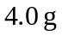of a non – volatile organic solute per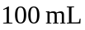was found to have an osmotic pressure equal to 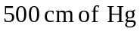at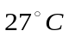. Calculate the molar mass of the solute.
Solution: From Van’t Hoff equation, we have —
$$π=c_{2}RT=\frac{n_{2}}{V}RT=\frac{w_{2}}{M_{2}}×\frac{RT}{V}$$
$$⇒M_{2}=\frac{w_{2}}{π}×\frac{RT}{V}$$
Here, $π=500 cm Hg={500}/{76} atm$
$w_{2}=4.0 g$
$V=100 mL=0.1 {dm}^{3}$
$R=0.0821 {dm}^{3}atm K^{-1}{mol}^{-1}, and$
$T=27+273=300 K$
$$∴M_{2}=\frac{4g}{{500}/{76} atm}×\frac{\left(0.0821 {dm}^{3}atm K^{-1}{mol}^{-1}\right)\left(300 K\right)}{0.1 {dm}^{3}}$$
$$=149.82 g {mol}^{-1} //$$
Problem ($5$): A solution containing $8.6 g per {dm}^{3} of urea$ ($mol wt.60$) was found to be isotonic with $5 \%$ solution of an organic compound. Calculate the molar mass of the latter.
Solution: For urea —
$$π=\frac{wRT}{MV}=\frac{8.6 RT}{60×1}$$
For the unknown solute —
$$π=\frac{wRT}{MV}=\frac{5 RT}{5×0.1}$$
Since the solutions are isotonic, hence —
$$\frac{5 RT}{5×0.1}=\frac{8.6 RT}{60×1}$$
$$⇒M=348.84 g {mol}^{-1} //$$
Problem ($6$): Show that Osmotic Pressure is a Colligative property.
Solution: From the Van’t-Hoff equation for dilute solution, viz. —
$$πV=nRT$$
We have —
$$π=\frac{n}{V}RT$$
This equation shows that osmotic pressure for a solution at any given temperature ($T$) depends only on the number of moles (and hence on the number of molecules) present per unit volume, quite independent of the nature of the solute. Thus, osmotic pressure is a colligative property.
Relation between Osmotic Pressure ($π$) and Lowering of Vapour Pressure of an Ideal Solution: [Thermodynamic Consideration/ Derivation]
By applying thermodynamics, we can derive a relationship between osmotic pressure and lowering of vapour pressure of an ideal solution. The transfer of solvent into a solution occurs, because at any constant temperature and atmospheric pressure, the chemical potential of the pure solvent ($μ^{0}$) is greater than that of the solution ($μ$). In order to bring about equilibrium between the solvent and solution, i.e. to prevent the flow of solvent into the solution, it is necessary to apply some additional pressure on the solution. The additional pressure applied should be equal to the osmotic pressure ($π$) of the solution. Thus, the total external pressure on the solution side of the $SPM$ has to be increased from $1 atm to \left(1+π\right)atm$, while the external pressure on the pure solvent side remain $1 atm$. The chemical potential of the solution side will also increase from $μ$ to say $μ+∆μ$. Since, the system is in osmotic equilibrium (i.e. there is no transference of liquid from one side to the other side of the membrane), hence —
$$μ^{0}=μ+∆μ$$
$$or μ^{0}-μ=∆μ$$
$$or μ-μ^{0}=-∆μ →(1)$$
The variation of chemical potential with temperature is given by —
$$μ=μ^{0}+RT \ln{a} →(2)$$
Here ‘$a$’ is the activity of the solvent in the solution.
Combining equation ($1$) and ($2$), we have —
$$-∆μ=RT \ln{a} →(3)$$
If the solution is ideal, we may take —
$$a=p/{p^{0}}$$
$$∴-∆μ=RT \ln{\frac{p}{p^{0}}} →(4)$$
Here ‘$p^{0}$’ is the vapour pressure of the pure solvent while ‘$p$’ is that for the solution at the same temperature.
From thermodynamics, at constant temperature, we know that —
$$dG=Vdp$$
For partial molar quantities, the above equation may be written as —
$$dμ=\overline{V}dp →(5)$$
Integrating equation ($5$) between the limits $μ$ of the solution at $1 atm$ pressure and $μ'$ of the solvent at $\left(1+π\right) atm$ pressure, we get —
$$\int_{μ}^{μ'}{d}μ=\int_{1}^{1+π}{\overline{V}}dp$$
Assuming $\overline{V}$ to be independent of pressure, we have —
$$μ^{'}-μ=\overline{V}\left(1+π-π\right)=\overline{V}π →(6)$$
Substituting equation ($6$) in equation ($4$), we get —
$$π\overline{V}=RT \ln{\frac{p^{0}}{p}} →(7)$$
This is the desired relation between osmotic pressure and the lowering of vapour pressure. If the solution is dilute $\overline{V}$ may be taken as $V_{0}$, the molar volume of the pure solvent. Equation ($7$) may, therefore be written as —
$$π=\frac{RT}{V_{0}} \ln{\frac{p^{0}}{p}} →\left(8\right) //$$
Problem ($1$): A solution of $54.1g manitol (C_{6}H_{10}O_{6}, M=182.2 g {mol}^{-1})$ per $1000g$ of water at $20℃$ has a vapour pressure of $2.326 kPa$. Whereas that of pure water is $2.338 kPa$, calculate the osmotic pressure of the solution.
Solution: We can calculate the osmotic pressure from —
$$π=\frac{RT}{V_{0}} \ln{\frac{p^{0}}{p}}=0.0821 atm //$$
Van’t-Hoff Equation for Osmotic Pressure ($π$) of Dilute Solution from Raoults Law:
According to Raoults law, for an ideal solution —
$$\frac{p}{p^{0}}=χ_{1}=1-χ_{2}$$
Here $χ_{1}$ is the mole-fraction of the solvent and $χ_{2}$ is that for solute in the given solution.
Since —
$$πV_{0}=RT \ln{\frac{p^{0}}{p}}$$
$$=-RT \ln{\frac{p}{p^{0}}}$$
$$=-RT \ln\left(1-χ_{2}\right)$$
Since, for dilute solution $χ_{2}≪1$, and hence, $\ln\left(1-χ_{2}\right)≈-χ_{2}$
Hence, $πV_{0}=RTχ_{2}$
Again —
$$χ_{2}=\frac{n_{2}}{n_{1}+n_{2}}≅\frac{n_{2}}{n_{1}} [for dil sol, n_{1}≫n_{2}]$$
Here, $n_{1}$ is the number of moles of the solvent containing $n_{2}$ moles of the solute.
Therefore, we have —
$$πV_{0}=\frac{n_{2}}{n_{1}}RT$$
$$⇒\boxed{π=c_{2}RT} →(1)$$
Here, $n_{1}V_{0}=V=$ Total volume of the solvent containing $n_{2}$ moles of the solute and,
$c_{2}={n_{2}}/V=$ Molar concentration of the solution
Equation ($1$) is the well known van’t-Hoff equation for dilute solution. //
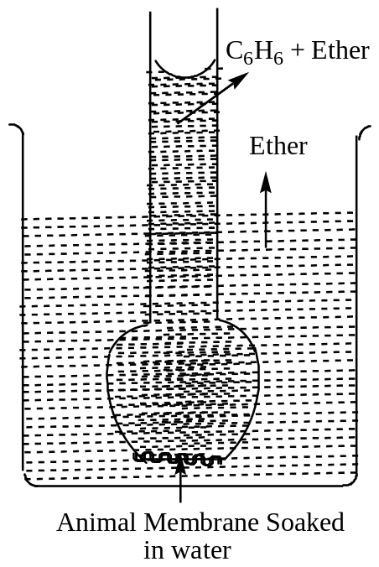Theories of Semi-permeability/ Action of SPM/ the Solubility Theory:
The solubility theory explains semi-permeability by supposing that the solvent is soluble in the membrane, whereas the solute does not. The theory may be explained by reference to the following experiment:
An inverted thistle funnel, the lower end of which is closed by an animal membrane thoroughly soaked in water, is filled by a mixture of ether and benzene as shown in the figure. The thistle funnel is then immersed in a beaker containing moist ether. The liquid is seen to rise in the tube. Thus, the animal membrane when wetted with water behaves as a SPM, as it permits the passage of ether molecules through it into the tube but not that of benzene in the opposite direction. This may be explained on the basis of solubility of ether in water, with which the membrane was thoroughly wetted easier. Benzene is almost insoluble in water and, therefore, its passage is prevented.
Abnormal Colligative Property/ Abnormal Behaviour of Solutions and Van’t-Hoff Factor ($i$):
Colligative properties are often used for the calculation of molar masses of the solute dissolved in a particular solvent. In certain cases, it has been found that these observed values are highly different from the normal value. This is due to the following two factors —
[$1$] The solutions are often not ideal, especially at higher concentration
The non-ideality leads to abnormal results. This is explained as — since the laws of dilute solutions basically derived from Raoults law viz. $p_{i}=χ_{i}p_{i}^{0}$. Raoults law is valid for dilute solution only, and
[$2$] The association or dissociation of solute molecules in solution also leads to departure from theoretical expectations.
Van’t Hoff, in order to account for all abnormal cases, introduced a factor, “$i$” known as van’t-Hoff factor, which is defined as —
$$i=\frac{Observed value of Colligative Property}{Normal value of Colligative Property}$$
$$Thus, i=\frac{{\left(Δp\right)}_{Obs}}{{\left(Δp\right)}_{Nor}}=\frac{{\left(ΔT_{b}\right)}_{Obs}}{{\left(ΔT_{b}\right)}_{Nor}}=\frac{{\left(ΔT_{f}\right)}_{Obs}}{{\left(ΔT_{f}\right)}_{Nor}}=\frac{{\left(M\right)}_{Nor}}{{\left(M\right)}_{Obs}}$$
Where, “$M$” is the molar mass of the solute (since all the colligative properties are inversely varies as the molar masses of the solutes). //
Van’t-Hoff Factor ($i$) and Dissociation of Solute in Solution:
Inorganic acids, bases and salts in aqueous solutions undergo dissociation, i.e. the molecule break into $+vely \&-vely$ charged ions. For example, $NaCl$ in aqueous solution exist almost entirely as ${Na}^{+} \& {Cl}^{-}$ ions. In such cases, the number of effective particles increases, and, therefore, osmotic pressure, elevation of boiling point and depression of freezing point are much higher than those of calculated on the basis of un-dissociated single molecules (hence lower $M$ values).
Degree of Dissociation:
By degree of dissociation, we mean the fraction of the total number of molecules which dissociate i.e. break into simpler molecules or ions.
Considering an electrolyte, $A_{x}B_{y}$ is dissolved in a given volume of a solvent and ‘$α$’ be its degree of dissociation. Then —
$$A_{x}B_{y} ⇌ xA^{y+} + yB^{x-}$$
Initial concentration $c moles$ $0$ $0$
Equilibrium concentration $c-cα$ $xcα$ $ycα$
$∴$ Total number of moles at equilibrium after dissociation $=c-cα+xcα+ycα$
$$=c[1+α\left(x+y-1\right)]$$
Had there been no dissociation in the solution, number of moles of solute in the solution would have been $c mole$
Hence, van’t-Hoff factor —
$$i=\frac{c[1+α\left(x+y-1\right)]}{c}$$
$$or α=\frac{i-1}{\left(x+y\right)-1}$$
(Colligative proportional are proportional to the concentration of the solute)
If the dissociation is completed, then $α=1$
Therefore, $i=x+y$
Thus, the value of the colligative property would be $\left(x+y\right)$ times of the calculated value, i.e. increases abnormally.
If no dissociation occurs, then $i=1$
Therefore, the observed value of the colligative property would be equal to the calculated value of the colligative property. //
Association of the Solute in Solution:
There are many organic solutes which in non-aqueous solution undergo association, i.e. two or more molecules of the solute associated to form a bigger molecule. Thus, the number of effective molecules or particles decreases and consequently the values of the colligative properties is less than that of the calculated value on the basis of single molecules. For example, acetic acid in benzene and chloro acetic acid in naphthalene undergoes dimerization. The molar masses of the solute in such a case will be higher than the true molar mass of acetic acid, as indicated by their molecular formula.
Degree of Association:
By degree of association, we mean the fraction of the total number of molecules which combine to form a bigger molecule.
Let, us consider $c mole$ of a solute dissolved in a given volume of a solvent. Suppose, ‘$n$’ simple molecules of a solute $A$, combined to form an associated molecule ${\left(A\right)}_{n}$ and ‘$α$’ be its degree of dissociation. Thus —
$$nA ⟶ {\left(A\right)}_{n}$$
Now —
$$nA ⇌ {\left(A\right)}_{n}$$
Initial concentration $c moles$ $0$
Equilibrium concentration $c-cα$ ${cα}/n$
$∴$ Total number of moles at equilibrium after association $=c-cα+{cα}/n$
$$=c\left[1+α\left(\frac{1}{n}-1\right)\right]$$
Had there been no association in the solution, number of moles of solute in the solution would have been $c mole$
Hence, van’t-Hoff factor —
$$i=\frac{c\left[1+α\left(\frac{1}{n}-1\right)\right]}{c}$$
$$or α=\frac{i-1}{\frac{1}{n}-1}$$
(Colligative proportional are proportional to the concentration of the solute)
If the association is completed, then $α=1$
Therefore, $i=1/n$
Thus, the value of the colligative property would be $1/n$ times of the calculated value, i.e. decreases abnormally.
If no dissociation occurs, then $α=0, ⇒i=1$
Therefore, the observed value of the colligative property would be equal to the calculated value of the colligative property. //
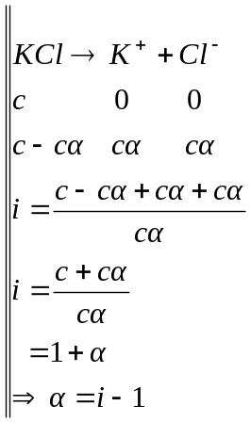Problem ($1$): An $0.5\%$ aqueous solution of $KCl$ was found to freeze at $272.76 K$. Calculate van’t Hoff factor ‘$i$’, and degree of dissociation of $KCl$ at this temperature. [$K_{f}=1.86 Kkg{mol}^{-1}$]
Solution: Here —
$$∆T_{f}=273-272.76=0.24 K$$
$$w_{2}=0.5×{10}^{-3}Kg,$$
$$w_{1}=100×{10}^{-3}Kg$$
$$K_{f}=1.86 Kkg{mol}^{-1}$$
$$∴M_{2}=\frac{K_{f}}{∆T_{f}}×\frac{w_{2}}{w_{1}}$$
$$=\frac{1.86 Kkg{mol}^{-1}}{0.24 K}×\frac{0.5×{10}^{-3}Kg}{100×{10}^{-3}Kg}$$
$$=38.8 g{mol}^{-1}$$
But, the normal molar mass of $KCl, M_{Nor}=39.1+35.5=74.6 g{mol}^{-1}$
$$∴Van^{'}t Hoff factor, i=\frac{M_{Nor}}{M_{Obs}}=\frac{74.6}{38.8}=1.9227$$
Degree of dissociation is given by —
$$α=\frac{i-1}{\left(x+y\right)-1}$$
Here, $x+y=1+1=2 (no.of ions)$
$$∴ α=i-1$$
$$⇒α=1.9227-1=0.9227=92.27 \%$$
Thus, $92.27 \% of KCl$ is dissociated at the given temperature in aqueous medium. //
Problem ($2$): Acetic acid associates in benzene to form double molecules. When $1.65g$ of acetic acid dissolved in $100g$ of benzene raised the boiling point by $0.36℃$ . Calculate the van’t Hoff factor and degree of association of acetic acid in benzene. [$K_{b} for benzene=2.57 Kkg{mol}^{-1}$]
Solution: Here —
$$∆T_{b}=0.36 K$$
$$w_{2}=1.65×{10}^{-3}Kg,$$
$$w_{1}=100×{10}^{-3}Kg$$
$$K_{b}=2.57 Kkg{mol}^{-1}$$
$$∴M_{2}=\frac{K_{b}}{∆T_{b}}×\frac{w_{2}}{w_{1}}$$
$$=\frac{2.57 Kkg{mol}^{-1}}{0.36 K}×\frac{1.65×{10}^{-3}Kg}{100×{10}^{-3}Kg}$$
$$=0.1178 kg{mol}^{-1}=117.8 g{mol}^{-1}$$
Thus, the observes molar mass of acetic acid, $M_{Obs}=117.8 g{mol}^{-1}$
But, the normal molar mass of acetic acid, $M_{Nor}=60 g{mol}^{-1}$
$$∴Van^{'}t Hoff factor, i=\frac{M_{Nor}}{M_{Obs}}=\frac{60}{117.8}=0.509$$
Since, the observed molar mass of acetic acid is nearly double of the normal value, hence most of the acetic acid dimerise in benzene, i.e.
$$n=2$$
Now, degree of association is given by —
$$α=\frac{i-1}{\frac{1}{n}-1}$$
$$∴α=\frac{0.509-1}{\frac{1}{2}-1}=0.982=98.2 \%$$
Thus, $98.2 \%$ of acetic acid associates in benzene //
Problem ($3$): A solution of $1×{10}^{-2}kg NaCl in 1kg of water$ freezes at $-0.604℃$. Calculate the degree of dissociation of $NaCl$ . [$K_{f} for water=1.86 Kkg{mol}^{-1}$]
Solution: Here —
$$∆T_{f}=-0.604℃=0.604 K (as depression of temp, so-ve)$$
$$w_{2}=1×{10}^{-2}Kg,$$
$$w_{1}=1Kg$$
$$K_{f}=1.86 Kkg{mol}^{-1}$$
$$∴M_{2}=\frac{K_{f}}{∆T_{f}}×\frac{w_{2}}{w_{1}}$$
$$=\frac{1.86 Kkg{mol}^{-1}}{0.604 K}×\frac{1×{10}^{-2}Kg}{1Kg}$$
$$=0.03079 kg{mol}^{-1}=30.79 g{mol}^{-1}$$
Thus, the observes molar mass of $NaCl$, $M_{Obs}=30.79 g{mol}^{-1}$
But, the normal molar mass of $NaCl, M_{Nor}=23+35.5=58.5 g{mol}^{-1}$
$$∴Van^{'}t Hoff factor, i=\frac{M_{Nor}}{M_{Obs}}=\frac{58.5}{30.79}=1.9$$
Degree of dissociation is given by —
$$α=\frac{i-1}{\left(x+y\right)-1}$$
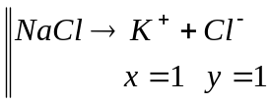Here, $x+y=1+1=2 (no.of ions)$
$$∴ α=i-1$$
$$⇒α=1.9-1=0.9=90 \%$$
Thus, $90 \% of NaCl$ is dissociated at the given temperature in aqueous medium. //
Problem ($4$): The freezing point depression of $1/{200}m$ solution of $Na_{2}SO_{4}$ in water was found to be $0.0265℃$. Calculate the degree of dissociation of the salt at this concentration. ($K_{f}=1.86$)
Solution: Here —
The normal molar mass of the solute $Na_{2}SO_{4}, M_{Nor}=142 g {mol}^{-1}$
Concentration of the solution is —
$$=\frac{1}{200}m=\frac{142}{200}=0.71g per 1000 g of water, thus$$
$$w_{2}=0.71×{10}^{-3}Kg and w_{1}=1Kg$$
$$∆T_{f}=0.0265℃=0.0265 K, and K_{f}=1.86 Kkg{mol}^{-1}$$

$$∴M_{2}=\frac{K_{f}}{∆T_{f}}×\frac{w_{2}}{w_{1}}$$
$$=\frac{1.86 Kkg{mol}^{-1}}{0.0265 K}×\frac{0.71×{10}^{-3}Kg}{1Kg}$$
$$=0.04983 kg{mol}^{-1}=49.83 g{mol}^{-1}$$
Thus, the observes molar mass of $Na_{2}SO_{4}$, $M_{Obs}=49.83 g{mol}^{-1}$
$$∴Van^{'}t Hoff factor, i=\frac{M_{Nor}}{M_{Obs}}=\frac{142}{49.83}=2.85$$
Degree of dissociation is given by —
$$α=\frac{i-1}{\left(x+y\right)-1}$$
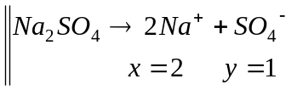Here, $x=2, and y=1 (no.of ions)$
$$∴ α=\frac{2.85-1}{3-1}=0.925=92.5 \%$$
Thus, $92.5 \% of Na_{2}SO_{4}$ is dissociated at the given temperature in aqueous medium. //
Problem ($5$): A solution containing $0.2956g$ of benzoic acid in $20.27g$ of benzene freezes at $0.317K$ below the freezing point of benzene. The freezing point of benzene is $278.5K$ and its latent heat of fusion is $126 Jg^{-1}$. Calculate —
- Apparent molar mass of benzoic acid in benzene, and
- Degree of dissociation of benzoic acid, assuming that it dimerise in benzene.
Solution: Here —
$$∆T_{f}=0.317 K$$
$$w_{2}=0.2956×{10}^{-3}kg, w_{1}=20.27×{10}^{-3}kg$$
$$∆H_{fus}=126 Jg^{-1}=126×78 J{mol}^{-1}$$
$$T_{0}=278.5 K$$
$$∴K_{f}=\frac{RT_{0}^{2}M_{1}}{∆H_{fus}}=5.1179 Kkg{mol}^{-1}$$
Now, ($a$) apparent molar mass (i.e. observed) of benzoic acid is—
$$M_{Obs}=\frac{K_{f}}{∆T_{f}}×\frac{w_{2}}{w_{1}}$$
$$=0.2354 kg{mol}^{-1}=235.5 g{mol}^{-1}$$
However, the normal molar mass of benzoic acid $M_{Nor}=122 g{mol}^{-1}$
($a$) For benzoic acid, the Van’t Hoff factor ($i$) is —
$$i=\frac{M_{Nor}}{M_{Obs}}=\frac{122}{235.5}=0.5183$$
Therefore, the Degree of dissociation of benzoic is given by —
$$α=\frac{i-1}{1/n-1}$$
Here, $n=2 \left(as dimerised\right), and i=0.5183$
$$∴ α=0.9634=96.34 \%$$
Thus, $96.34 \%$ of benzoic acid is associated (or dimerised) in benzene. //

XXXXX#XXXXXX

The End —
Dr N Ahmed @JNC
09.07.2021
Books consulted
- Peter, A. & Paula, J. de. Physical Chemistry 9th Ed., Oxford University Press (2011).
- Castellan, G. W. Physical Chemistry 4th Ed., Narosa (2004).
- Levine, I .N. Physical Chemistry 6th Ed., Tata McGraw Hill (2010).
- Metz, C.R. 2000 solved problems in chemistry, Schaum Series (2006)
- Dogra S. K. and Dogra S., Physical Chemistry Through Problems, Wiley Eastern Limited; Forth Reprint (1993)
- Puri, B. R.; Sharma, L. R.; Pathania, M. S. Principles of Physical Chemistry, Vishal Publishing Co.; 47th Ed. (2017)
- Kapoor, K. L. A Textbook of Physical Chemistry (Volume 2) McGraw Hill Education; Sixth edition (2019)
- Negi A S & Anand S C, A Textbook of Physical Chemistry, New Age International Publishers; Second edition (2020)

