Alkanes
Alkanes: General Outline: —
Alkanes are the binary compounds of $C \& H$ only (hence the name hydrocarbon) and have no reactive functional group. They constitute the homologous series of hydrocarbon having general formula $C_{n}H_{2n+2}, where n=1, 2, 3, …, i.e. an integer$. Alkanes are relatively inert towards most of the reagents and hence are also called paraffins ($Greek$ Less or little affinity). They are also called saturated acyclic hydrocarbons because —
- They are acyclic (i.e. open-chain) hydrocarbons and
- They are saturated, i.e. bears only $C-C$ single bonds ($σ$- bonds).
Alkanes are also known as aliphatic hydrocarbons, because the higher members of this class resemble in physical properties to the long chain $C$- molecules present in animal fats and plant oils ($Greek:aleiphar, fat or oil$).
Sources and Utility of Alkanes: —
The main sources of alkanes are —
- Natural gas,
- Petroleum, and
- Coal, collectively known as fossil fuels.
Fossil fuels played important role in our daily life as sources for —
- Our energy requirements, and
- Most of the organic raw materials for the synthesis and manufacture of synthetic fibres, plastics, detergents, drugs, etc.
The familiar LPG (liquefied petroleum gas) contains essentially propane and butane. Though alkanes are least reactive, but they undergo commercially important reactions such as cracking and combustion at high temperatures. Alkanes have also been detected as waxy constituents of certain plants. For example, $n$-$Nonacosane (C_{29}H_{60})$ has been isolated from cabbage leaves.
General Methods of Preparation of Alkanes: —
Alkanes can be obtained by the fractional distillation of petroleum and natural gas. Synthetic methods are, however, more practical for the preparation of desired pure alkane. Some general synthetic methods of preparative interest are described below with their mechanism:
- From alkenes & alkynes— Catalytic hydrogenation at high temperature & pressure — Sabatier-Senderen’s reaction.
- From alkyl halides ($RX$): It includes —
  - Direct reduction of $RX$,
  - Indirect reduction of $RX$— via the formation of Grignard reagent,
  - Wurtz reaction, and
  - Corey-House reaction
- From the sodium salts of carboxylic acids ($RCO_{2}Na$): It includes —
  - Decarboxylation (removal of ${CO}_{2}$), and
  - Kolbe’s electrolytic method.
[1] Prep of Alkane by the catalytic hydrogenation of Alkenes & Alkynes: —
Hydrogenation of alkenes and alkynes using finely divided $Pt, Pd \& Ni$ as catalyst yields alkanes. For example,
$${CH}_{3}-CH=CH-{CH}_{3}+ H_{2}\underset{→}{Pd/Pt/Ni}{CH}_{3}-CH_{2}-CH_{2}-{CH}_{3}$$
$But-2-ene$ $Butane$
$$R-C≡C-R^{'}+ 2H_{2}\underset{→}{Pd/Pt/Ni} R-CH_{2}-CH_{2}-R^{'}$$
$Alkyne$ $Alkane$
[$R \&R^{'} may be hydrogen or alkyl group$]
Ordinary temperatures and pressures are adequate with $Pt \& Pd$ catalysts, but relatively higher temperature and pressure required with $Ni$ catalysts. The modification using nickel catalyst in this reaction is called Sabatier-Senderen’s reaction. Thus,
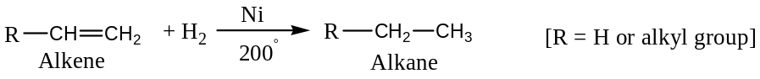
[Catalytic hydrogenation is an important eco-friendly reaction and proceeds smoothly as well as quantitatively. Further, the catalyst used can be recovered after the reaction.]
Mechanism of catalytic hydrogenation: Alkene and hydrogen are simultaneously adsorbed on the surface of the catalyst with weakening of $H-H and C=C (π bond)$ to form a 4- centred transition state, which is then converted to an alkane and vacate the surface of the catalyst for further addition of alkene and hydrogen molecules.
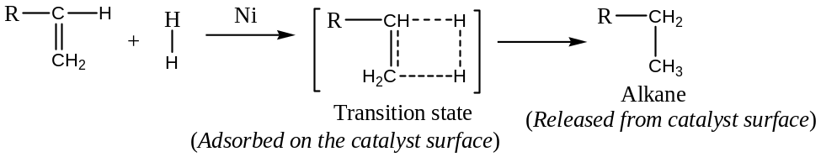
Limitation: Methane cannot be prepared by this method, as methene ($={CH}_{2}$) has no existence.
[2] Prep of Alkane from Alkyl halides, $RX$: —
Following four methods are commonly employed for the preparation of alkanes from alkyl halides —
- Direct reduction of $RX$,
- Indirect reduction of $RX$— via the formation of Grignard reagent,
- Wurtz reaction, and
- Corey-House reaction
- Alkane by the direct reduction of alkyl halides: Direct reduction of alkyl halide using chemical reducing agents such as$Zn \&acetic acid or HCl$; $Zn-Cu$ couple & alcohol; magnesium amalgam ($Mg/Hg$) and water, etc. gives good yields of alkanes. Thus,
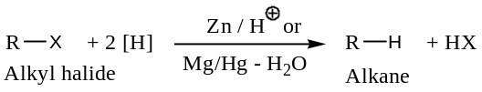
For example,
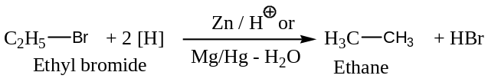
Mechanism: Mechanism for the direct reduction of alkyl halides using normal chemical reducing agents is believed to involve electron transfer from the metal ($Zn or Mg$) to alkyl carbon to form a carbanion that can take up a proton from the acid or solvent to form alkane. Thus,
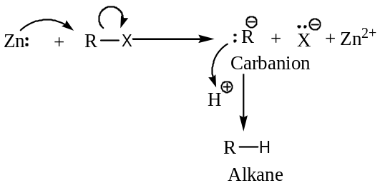
Important: Alkyl halides can also be reduced catalytically by $palladised charcoal$ ($Pd+C$) and hydrogen.
$$R-X+H_{2}\underset{→}{Pd/C} R-H+HX$$
This reaction is an example of $hydrogenolysis$, since it brings cleavage ($lysis$) of carbon-halogen bond by hydrogen.
- Alkane by the indirect reduction of alkyl halides: In this method, alkyl halides are first converted to the corresponding Grignard reagent ($RMgX$) by the reaction with $Mg$ in dry ether. The Grignard reagent so formed is decomposed by water to form alkanes. Thus,
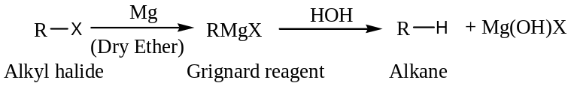
Mechanism: The alkyl magnesium halides (Grignard reagent) can be regarded as magnesium salts of extremely weak acids ($RH$). Thus, this is the displacement of the weaker acid ($RH$) by stronger acid ($HOH i.e. H_{2}O$), as shown below:
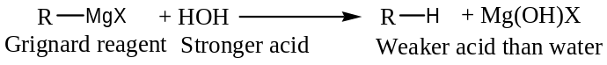
- Alkane by the Wurtz Reaction:The reaction of two molecules of alkyl halides (except$RF$) with metallic sodium in dry ether to form an alkane is called Wurtz reaction [C A Wurtz (1817 – 1884), A French Chemist, well known for the preparation of alkane by this method and discovery of ethylene glycol]. Thus,
$$R-X+2Na+X-R \underset{→}{Dry Ether} R-R+2NaX$$
For example,
$${CH}_{3}{CH}_{2}Br+2Na+Br{CH}_{2}{CH}_{3}\underset{→}{Dry Ether}{CH}_{3}{CH}_{2}{CH}_{2}{CH}_{3}+2NaBr$$
Ethyl bromide Ethyl bromide Butane ($n$- Butane)
When a mixture of two different alkyl halides is used, a mixture of three alkanes is formed:
$${CH}_{3}-Br+2Na+Br-{CH}_{2}{CH}_{3}\underset{→}{Dry Ether}{CH}_{3}{CH}_{2}{CH}_{3}+2NaBr$$
Propane
$${CH}_{3}-Br+2Na+Br-{CH}_{3}\underset{→}{Dry Ether}{CH}_{3}{CH}_{3}+2NaBr$$
Ethane
$${CH}_{3}{CH}_{2}-Br+2Na+Br-{CH}_{2}{CH}_{3}\underset{→}{Dry Ether}{CH}_{3}{CH}_{2}{CH}_{2}{CH}_{3}+2NaBr$$
Butane
The separation of such mixture into individual alkanes may not always be easy.
Limitations of Wurtz reaction: Following are the limitations of Wurtz reaction —
- It is suitable only for the preparation of alkanes containing even number of $C$- atoms,
- Halogen compounds containing other reactive functional groups like $-OH \&-CO_{2}H$ groups cannot be used,
- It fails with $tert$- alkyl halides, due to steric effects, and
- Methane cannot be prepared by this method.
Application of Wurtz reaction: Wurtz reaction is useful in ascending the series of organic compounds, because it leads to the formation of a new $C-C$ bond. For example, conversion of methane to ethane—
$${CH}_{4}+ {Cl}_{2} → {CH}_{3}Cl+HCl$$
$${CH}_{3}Cl+2 Na+ ClCH_{3} → {CH}_{3}CH_{3}+2NaCl$$
Mechanism of Wurtz reaction: There are two possible mechanisms for Wurtz reaction
- Ionic mechanism: Ionic mechanism involves the formation of intermediate $organo$-$sodium$ compound. The ogano-sodium compound provides the nucleophilic alkyl carbanion to replace the halide ion from another molecule of alkyl halide, to give the higher alkane by the formation of new $C-C$ bond. Thus,
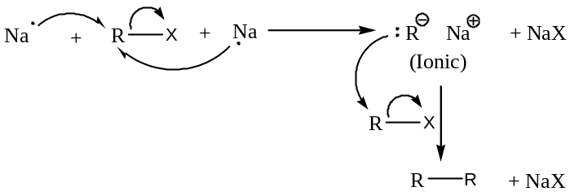
- Free radical mechanism: In free radical mechanism, first alkyl free radicals ($\dot{R}$)are formed as reactive intermediate, which couple together to from the alkane. Thus,
$$R-X+Na → \dot{R}+NaX$$
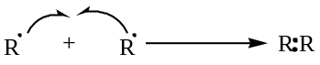
Evidence in support of free radical mechanism: Reaction between ethyl bromide and sodium produced minor amount of ethane and ethene, besides butane as the major products supports the free radical mechanism for Wurtz reaction. Disproportionation of ethyl radical can explain this experimental fact.
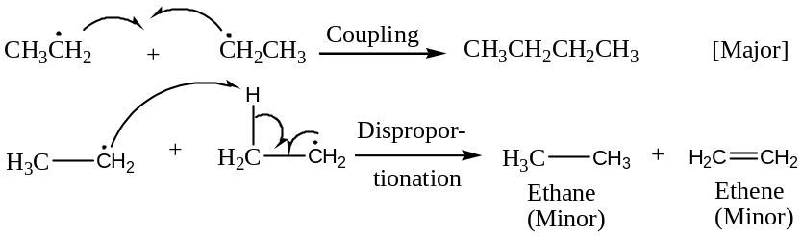
- Alkane by the Corey-House Reaction: Reaction of an alkyl halide ($RX$) with a $lithiumdialkyl copper$ ($R_{2}^{'}CuLi$), the $Gilman reagent$ (this is prepared during the course of reaction by the interaction of alkyl lithium and cuprous halide) gives an alkane and the reaction is known as the $Corey$-$House$ reaction. Thus,
$$2R^{'}-X +Li \underset{→}{N_{2}-Atmosphere} 2R^{'}-Li \underset{→}{CuX}R_{2}^{'}CuLi +LiX$$
Alkyl halide Alkyl lithium $Lithium dialkyl copper$
(Gilman reagent)
Now,
$$R-X + R_{2}^{'}CuLi → R-R^{'} + R^{'}Cu +LiX$$
Alkyl halide Gilman reagent Alkane
For example,
$$\left(1\right) (C_{2}H_{5})_{2}CuLi + n-C_{7}H_{15}I → n-C_{9}H_{20} + C_{2}H_{5}Cu + LiI$$
Lithium diethyl copper $n$- Heptyl iodide $n$- Nonane
$\left(2\right) [{CH}_{3}CH\left({CH}_{3}\right)]_{2}CuLi+{CH}_{3}CH_{2}{CH}_{2}Br→{CH}_{3}CH({CH}_{3})CH_{2}{CH}_{2}{CH}_{3}+i$-$PrCu+LiBr$
Lithium di-isopropyl copper $n$- Propyl bromide $Isohexane$ (2-methylpentane)
Application of Corey-House Reaction: Important utility of the reaction are —
- Unlike Wurtz reaction, Corey-House reaction can be used in the preparation of unsymmetrical alkanes containing an odd number of carbon atoms, and
- The reaction is useful for the synthesis of higher alkanes.
Mechanism of Corey-House reaction:
In this reaction, the organometallic compound, the lithium dialkyl copper generates an alkyl carbanion (nucleophile) that attacks the alkyl halide with the displacement of halide ion (nucleophilic substitution) to give the alkane. Thus,
$$Step I: R_{2}^{'}CuLi ⇌ R_{2}^{'}{Cu}^{⊖} + {Li}^{⨁}$$
$$Step II: R_{2}^{'}{Cu}^{⊖} ⇌ 2 {R^{'}}^{⊖} + {Cu}^{⨁}$$
$Step III:$
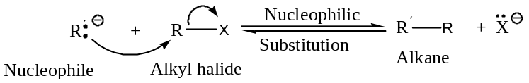
[3] Prep of Alkane from the Sodium Salts of Carboxylic acids, $RCO_{2}Na$: —
Following two methods are commonly employed for the preparation of alkanes from the sodium salts of carboxylic acids —
- Decarboxylation of monocarboxylic acids, and
- Kolbe’s electrolytic method.
- Alkane by the Decarboxylation of monocarboxylic acids ($RCOONa$): Sodium salts of monocarboxylic acid (alkanoic acid) on heating with soda lime ($NaOH+CaO$) undergoes decarboxylation to give the corresponding alkane. Thus,
$$RCOONa + NaOH \underset{→}{{CaO}/∆} R-H + {Na}_{2}{CO}_{3}$$
Sod alkanoate Alkane
For example,
$${C_{2}H}_{5}COONa + NaOH \underset{→}{{CaO}/∆}{C_{2}H}_{6} + {Na}_{2}{CO}_{3}$$
Sod propionate Ethane
$${CH}_{3}COONa + NaOH \underset{→}{{CaO}/∆}{CH}_{4} + {Na}_{2}{CO}_{3}$$
Sod acetate Methane
Important: Sodium hydroxide can replace soda lime, but soda lime is preferred because it permits the reaction to be carried out at relatively higher temperature.
Mechanism of Decarboxylation: Decarboxylation mechanism can be written as —
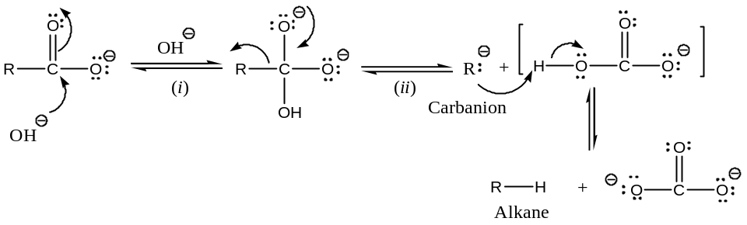
Application: Decarboxylation reactions are used to step-down(but, Wurtz &Corey-House reaction for step-up a series) in a series (Hofmann degradation reaction is also used for the same purpose). A simple flow chart is given below for common aliphatic interconversion.
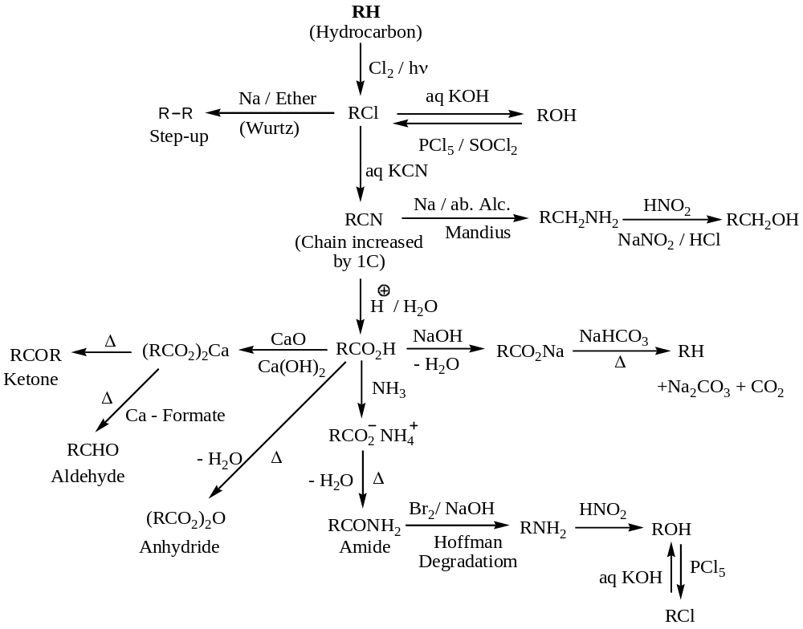
- Alkane by the Electrolysis of $aq.$ Solution of salts of monocarboxylic acids (Kolbe’s Electrolysis): Electrolysis of a concentrated aqueous solution of the sodium or potassiumsalts of carboxylic acid (alkanoic acid) to give alkanes at anode is known as Kolbe’s electrolysis. Thus,
$$2 RCOONa +2 H_{2}O \underset{⇔}{Electrolysis}\underset{At anode}{\underbrace{R-R+2 {CO}_{2}↑ }}+\underset{At cathode}{\underbrace{2 NaOH+ H_{2}}}$$
For example,
$$2 CH_{3}COONa +2 H_{2}O \underset{⇔}{Electrolysis}\underset{Ethane (At anode)}{\underbrace{CH_{3}-CH_{3}+2 {CO}_{2}↑ }}+\underset{At cathode}{\underbrace{2 NaOH+ H_{2}}}$$
$$Sodium acetate$$
Mechanism of Kolbe’s Electrolysis reaction: Kolbe’s electrolysis involves both the ionic and free radical mechanism as shown below:
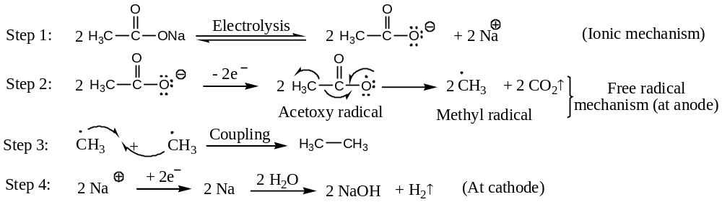
Evidence in support of free radical mechanism: Generation of by-products like alkenes, esters, etc. due to disproportionation supports above mechanism. //
GeneralPhysical Properties of Alkanes: —
Important physical properties of alkanes are studied under the following headings —
- Physical appearance,
- Boiling point,
- Melting point,
- Solubility, and
- Densities.
- These are discussed below with suitable examples.
Physical appearance of Alkanes:
First four members of alkane ($i.e. C_{1}-C_{4}$) are colourless gases,
Next thirteenmembers of alkane ($i.e. C_{5}-C_{17}, heptadecane$) are colourless liquids, and
Alkanes containing $18C$- atoms or more are solids at ordinary temperature.
***Boiling point trends of Alkanes:
The boiling point of alkane shows gradual rise with the increase in $C$- content (i.e. molecular weight). In general, the boiling point difference between two successive members of the homologous series (except for first few members) is about $20℃ to 30℃$. Among the isomeric alkanes, the straight chain isomer(i.e. normal compound) has higher boiling point than the branched chain isomer. The greater the branching of the chain, lower the boiling point is. For example,
$$Alkane$$ | $n$-$Butane$: ${CH}_{3}{CH}_{2}{CH}_{2}{CH}_{3}$ | $n$-$Pentane$: ${CH}_{3}({CH}_{2})_{3}{CH}_{3}$ | $n$-$Hexane$: ${CH}_{3}({CH}_{2})_{4}{CH}_{3}$
$$bp in ℃$$ | $$0$$ | $$36$$ | $$69$$
$$Alkane$$ | $n$-$Isobutane$: $({CH}_{3})_{2}CH{CH}_{3}$ | $n$-$Isopentane$: $({CH}_{3})_{2}CH{CH}_{2}{CH}_{3}$ | $Neopentane$: $({CH}_{3})_{4}C$
$$bp in ℃$$ | $$-11.5$$ | $$28$$ | $$9.5$$

In fact, the lowering of boiling point with the branching of the $C$- chain is a general feature of all the classes of organic compounds. This abnormal behaviour of boiling point for isomeric alkanes is due to van der Waals interactions(weak force).
Explanation: The van der Waals forces which hold non-polar molecules are weak and have a very short range. Therefore, within a family of compounds (isomeric compounds) the strength of intermolecular forces would be directly proportional to the size (or the surface area) of the molecule. The process of boiling requires overcoming of these intermolecular forces of a liquid and a solid. As the molecules become larger, the intermolecular forces increases and the boiling points should rise with increase in the number of $C$- atoms.
As the branching increases in a molecule, its shape approaches that of a sphere and there is a reduction in surface area. This renders the intermolecular forces weaker and they overcome at relatively lower temperature. Therefore, a branched-chain isomer should boil at lower temperature than a straight-chain isomer, and this is actually so.
***Melting point trends of Alkanes:
The melting points of alkane shows gradual rise with the increase in $C$- atoms (i.e. molecular weight), but the trend is not regular as in the case of boiling point. For example,
$$n-Alkane$$ | $${C_{4}H}_{10}$$ | $${C_{5}H}_{12}$$ | $${C_{6}H}_{14}$$ | $${C_{7}H}_{16}$$ | $${C_{8}H}_{18}$$
$$mp in ℃$$ | $$-135$$ | $$-130$$ | $$-95$$ | $$-90$$ | $$-57$$

It is, however, significant that as we move from an alkane having anodd number of$C$- atoms to a higher alkane, the rise in melting point is much higher than when we move up from an alkane with an even number of$C$- atoms to odd number of$C$- atoms.
Explanation: The intermolecular forcesin a crystal depend not only on the size of the molecules, but also, on how they are packed into a crystal. During melting, these intermolecular forces have to be overcome. Since ‘breaking of crystal structure’ is a more complicated process, it is understandable that the rise in melting point with increasing molecular weight is not regular as in the case of boiling points. The structure or geometry of the alkane is also of crucial importance.
Solubility trends of Alkanes:
Alkanes are made up of $C \& H$ atoms only. Since these two elements have almost similarelectronegativities, alkanes are non-polar. “Like dissolves like”. Therefore, non-polar alkanes are soluble in non-polar solvents like ${CCl}_{4}, C_{6}H_{6}$, etc., but insoluble in polar solvents, like water, alcohol, etc.
Densities of Alkanes:
The densities of alkanes show a definite rise with increasing molecular weight, but they reach a limiting constant value of about $0.8$ with $n$-$hexadecane (C_{16}H_{34})$. Thus, alkanes are always lighter than water. //
General Chemical Properties (Reactions) of Alkanes: —
Alkanes are inert to acids, bases, oxidising and reducing agents, and this is understandable from their structure (i.e. saturated). However, they do undergo the following reactions (substitution)
- Halogenation,
- Nitration,
- Sulphonation,
- Pyrolysis,
- Isomerization,
- Aromatization,
- Combustion,
- Controlled oxidation reaction, and
- Inclusion or insertion of Carbene.
All these reactions are discussed in detailed with appropriate mechanisms—
- Halogenation:
Alkanes undergo substitution on reaction with halogens (chlorine and bromine only as fluorine reacts too explosively involving rupture of $C-C$ bonds, but iodine reacts too slowly and reversibly to be of any practical importance), in presence of ultraviolet light or at high temperature ($250℃ to 400℃$). For example,
$${CH}_{4} + {Cl}_{2}\underset{→}{Light, 250℃}{CH}_{3}Cl + HCl, [∆H=-88 kJ{mol}^{-1}]$$
Methane Chloromethane
$${CH}_{3}{CH}_{3} + {Cl}_{2}\underset{→}{Light}{CH}_{3}{CH}_{2}Cl + HCl$$
Ethane Chloroethane
The mono-halogenated alkanes undergo further halogenation, and in due course all available hydrogens in an alkane can be successively replaced by halogen. For example,
$${CH}_{3}Cl + {Cl}_{2} → {CH}_{2}{Cl}_{2} + HCl$$
Dichloromethane
$${CH}_{2}{Cl}_{2} + {Cl}_{2} → CH{Cl}_{3} + HCl$$
Trichloromethane or Chloroform
$$CH{Cl}_{3} + {Cl}_{2}→ C{Cl}_{4} + HCl$$
Tetrachloromethane or Carbon tetrachloride
Mechanism of Halogenation of Alkane: Halogenation of alkane is a free radical substitution chain reaction, involving —
- Chain initiation,
- Chain propagation, and
- Chain termination steps.
Chain initiation: In this step, homolytic cleavage of halogen molecule ($X_{2}, X=Cl or Br$) by the heat energy or ultraviolet light to generate highly reactive halogen atoms or free radicals ($\dot{X}$). Thus,
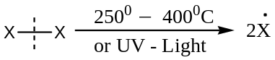
Chain propagation: In this step, the free radicals so formed in the initiation step react with the alkane molecule ($R-H$) to form alkyl free radical ($\dot{R}$) by abstracting hydrogen from the alkane.
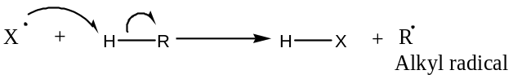
The alkyl free radical so formed reacts with another molecule of the halogen to form alkyl halide and generate another reactive halogen atom i.e. free radical (so the name propagation) for further reaction. Thus,
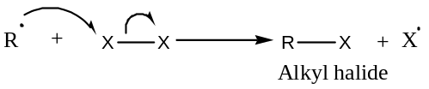
- This step is more difficult and hence, controls the rate of over-all reaction.
The halogen atom or free radical ($\dot{X}$) so formed repeats reaction, and hence, setting up a chain reaction. Since the process repeated several times, so the quantum yield of this reaction is quite high.
The halogen atom ($\dot{X}$), so generated can also abstract a hydrogen atom (if available) from the alkyl halide ($RX$) to form a new substituted alkyl radical, which in turn react with another molecule of halogen to form a dihalogenated alkane and a halogen atom. The process continued until all the $H$- atoms are substituted by the halogen atoms successively. Thus,
$$\dot{X}+H-{CH}_{2}X \underset{→}{-HX}{\dot{C}H}_{2}X \underset{→}{X_{2}}{CH}_{2}X_{2} + \dot{X}$$
$$\dot{X}+H-{CHX}_{2}\underset{→}{-HX}{\dot{C}HX}_{2}\underset{→}{X_{2}} CHX_{3} + \dot{X}$$
$$\dot{X}+H-{CX}_{3}\underset{→}{-HX}{\dot{C}X}_{3}\underset{→}{X_{2}} CX_{4} + \dot{X}$$
Chain termination: In chain termination step, the chain carriers i.e. the free radicals are exhausted (i.e. completely used or finished) by the following possible reactions and thereby the chain terminates.
$\dot{X}+ \dot{X} → X-X$
$\dot{R}+ \dot{R} → R-R$
$\dot{R}+ \dot{X} → R-X$
Evidences in support of free radical chain mechanism for halogenation of alkane:
The following facts support free radical chain mechanism for halogenation of alkane —
- The reaction does not take place in dark or at room temperature. This observed fact established that the homolytic cleavage of halogen bond is endothermic and requires considerable energy in the form of light or heat.
- The reaction has a high quantum yield, implies that it is a chain reaction.
- The reaction is inhibited by oxygen. Even a small amount of oxygen is enough to slow down the reaction considerably. The combination of oxygen with alkyl radical gives another radical (peroxy radical,$R-O-\dot{O}$) which is less reactive than the alkyl radical, and thereby the chain is broken.
- Ordinarily, halogenation of methane requires a temperature of $250℃$ but when halogenation was done in presence of a little tetramethyl lead, the reaction was successful even at$150℃$.
Explanation: Tetramethyl lead yields methyl radical, when heated to just $150℃$.
$$({CH}_{3})_{4}Pb \underset{→}{150 ℃} 4{\dot{C}H}_{3}+Pb$$
This methyl radical can then react with the halogen molecule to form halogen atom ($\dot{X}$) which can then react with the alkane to form alkyl radicals and thus, propagate the chains of the mechanism for halogenation even when temperature of the reaction ($150℃$) is not adequate to cleave halogen molecules.
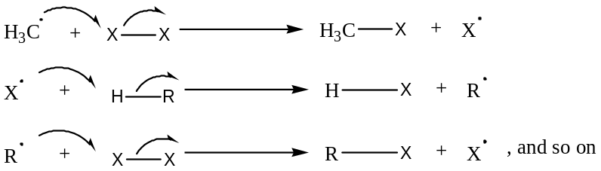
Relative reactivities of halogens in halogenation of alkanes: The decreasing order of reactivity of halogens in the halogenation of alkanes is —
$$F_{2}>>>{Cl}_{2}>>{Br}_{2}>>>>I_{2}$$
Explanation: The mechanism of halogenation of alkanes (say, methane) involves three steps (initiation, and two main propagation step). Knowing the bond dissociation energies involved in each of the three steps and of the overall reaction, we can calculate the values of $∆H$ (the change in heat content) for them. The relevant data is summarized as follows:
$$∆H (kJ)$$
Mechanistic step $X=F Cl Br I$
$\left(1\right)X_{2} →2\dot{X}$ $+151 +242 +188 +150$
$\left(2\right)\dot{X}+{CH}_{4} →HX+\dot{C}H_{3}$ $-133 0 +63 +130$
$\left(3\right)\dot{C}H_{3}+X_{2}→{CH}_{3}X+\dot{X}$ $-297 -88 -97 -62$
Overall reaction
$CH_{4}+X_{2}→{CH}_{3}X+HX$ $-430 -88 -34 +68$
If we examine the $∆H$ values of the overall reaction, we find that fluorination, chlorination and bromination are exothermic, but iodination is highly endothermic. Iodination, therefore, would have a rather high value of energy of activation ($E_{act}is at least 68 kJ$). Consequently, iodination of methane is very difficult. However,$E_{act}$ for fluorination, chlorination and bromination would be very small, and they are expected the following decreasing order:
$$Bromination> Chlorination> Fluorination$$
Consequently, their reaction rates would show the following decreasing order:
$$Fluorination> Chlorination> bromination$$
This is an over simplified explanation for the relative reactivities of halogens in halogenation of alkanes. A better way to rationalize the relative reactivities of halogens would be to evaluate the $∆H$ values of each step of the overall reaction, and this is illustrated below:
Step (1) is a simple dissociation reaction so that $∆H=E_{act}$. Chlorine with the highest $E_{act}$ ($242 kJ$) should, therefore, dissociate most slowly. In contrast, iodine with the smallest $E_{act}$ ($150 kJ$) should dissociate most rapidly. This order of activity is, however, against the actual experimental facts. Therefore, this step cannot be the rate determining step in halogenation of methane.
Step (3) is exothermic in each case, $E_{act}$ in such reactions expected to be very small. Further, $∆H$ is fairly similar for chlorine, bromine and iodine. This step too cannot account for the observed order of activity. In fact, if this were the rate determining step, halogenation would have taken place with similar ease in all the cases.
Step (2) is partly exothermic and partly endothermic. In endothermic reaction, $E_{act}$has to be at least as large as its$∆H$, but in an exothermic reaction, $E_{act}$ can be very small. $E_{act}$of step (2) in the endothermic bromination of methane is $75 kJ$and it is $17 kJ$ in the case of chlorination of methane.$E_{act}$of the highly exothermic step in fluorination is less than $4 kJ$. The highly endothermic step in iodination would have rather high (at least$130 kJ$)$E_{act}$. Thus, the decreasing order of$E_{act}$ of step (2) in the four cases is:
$$Iodination >Bromination> Chlorination> Fluorination$$
Consequently, the number of effective collisions in step (2) should decrease in the following order at a given temperature as smaller the$E_{act}$ greater will be the rate of halogenation.
$$Fluorination> Chlorination> bromination>Iodination$$
Relative reactivities of different classes of Hydrogens in alkanes:
Since the rate determining step in the halogenation of alkanes is the step involving abstraction of hydrogen atom of the alkane by a halogen atom.
$$R-H+ \dot{X} → \dot{R}+H-X$$
The case with which $H$- atom can be abstracted, varies with the class to which the $H$- atom belongs, namely $tertiary, secondary or primary$ hydrogen. This will naturally regulate the overall process of halogenation of an alkane.
$E_{act}$of a process, is the crucial step in determining the reactivity of the process. The lower is the $E_{act}$, the greater the ease with which the removal of hydrogen takes place. It is found thatthe$E_{act}$ for reactions involving abstraction of different classes of hydrogen are in the following decreasing order:
$$Methane H>Primary H>Secondary H>Tertiary H$$
In the chlorination of different alkanes, for example, the $E_{act}$ of step:
$$R-H+ \dot{Cl} → \dot{R}+H-Cl$$
It has been found to be 17, 4, 2 and 1 $kJ$ respectively for a methane hydrogen, a primary hydrogen, a secondary hydrogen and a tertiary hydrogen. It follows from above that the ease of abstraction of different classes of hydrogens should be in the following decreasing order:
$$Tertiary H>Secondary H>Primary H>Methane H$$
This is actually found to be so.
Orientation inHalogenation of alkanes:
Considering the data given in following reactions —
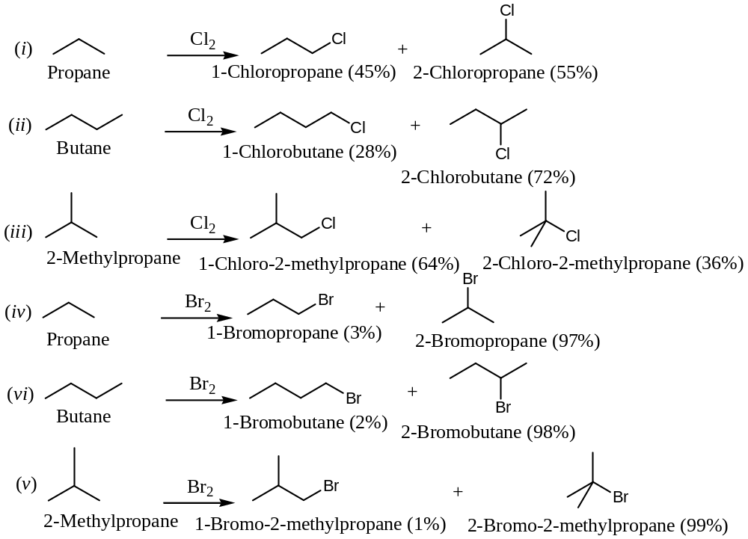
From the percentage composition, we find that —
- There is a wide variation in the relative yields of the different isomeric products in the above reactions.
- For $bromination$, in contrast to $chlorination$, leads to almost an exclusive formation of only one of the possible isomeric products.
Explanation: Considering the chlorination of butane as an example,
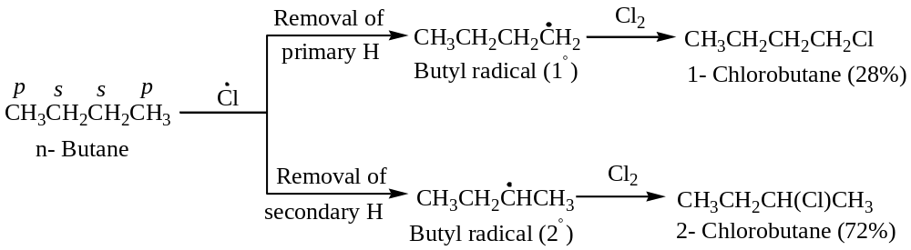
The relative amounts of 1- chlorobutane and 2- chlorobutane would depend on the rates at which the intermediate radicals formed. Butane has $six 1^{°}$ and$four 2^{°} H's$. Therefore, the probability factor would favour the removal of $1^{°}\&2^{°} H's$ by the ratio of $6:4 or 3:2$. In other words, chlorination of butane would be expected to yield, (on the basis of probability factor alone) 1- chlorobutane and 2- chlorobutane in the ratio of $3:2$. However, 1- chlorobutane and 2- chlorobutane are actually formed in the ratio of about $1:2.5 i.e.$ the proportion of 2- chlorobutane is more than three times as expected on the basis of probability factor. This means that about three times as many collisions with $2^{°} H's$ are effective as with $1^{°} H's$. This implies that $2^{°}$- butyl radicals formed more easily than the $1^{°}$- butyl radical. Now, $2^{°}$- butyl radical, being $2^{°}$- radical, is more stable than the $1^{°}$- butyl radical, and hence, should be formed more easily.
Thus, the orientation in chlorination of butane is determined largely by the energy factor, i.e. the $E_{act}$ for abstraction or removal of $1^{°}\&2^{°} H's$ in butane.
Important: It has been found that at room temperature, the relative rates for removal of $3^{°}, 2^{°}\&1^{°} H's$ are $5 , 3.8 and 1$ respectively. With the help of these values, it is possible to predict fairly well the ratio of isomeric chlorination products obtained from a given alkane. For example,
The expected ratio of 1- chloro and 2- chlorobutane in the above reaction can be calculated as follows:
$$\frac{Yield of 1-chlorobutane}{Yield of 2-chlorobutane}=\frac{No. of 1^{°}H }{No. of 2^{°}H}×\frac{Reactivity of 1^{°}H }{Reactivity of 2^{°}H}=\frac{6}{4}×\frac{1}{3.8}=\frac{3}{7.6}$$
$$or Yield of 2-chlorobutane=2.5×Yield of 1-chlorobutane$$
The expected ratio of 1- chlorobutane and 2- chlorobutane in the above can be calculated as follows:
$$\left(i\right)The relative amount of 1-chlorobutane=No. of 1^{°}H's×reactivity$$
$=6×1=6$
$$\left(ii\right)The relative amount of 2-chlorobutane=No. of 2^{°}H's×reactivity$$
$=4×3.8=15.2$
$$The sum of relative amount of both the products=6+15.2=21.2$$
$$\% Yield=\frac{Relative amount ×100}{Sum of relative amount}$$
$$∴\% of 1-chlorobutane=\frac{6 ×100}{21.2}=28\%$$
$$\% of 2-chlorobutane=\frac{15.2 ×100}{21.2}=72\%$$
These values are close to experimental values.
Similarly, the observed relative yields of isomeric products in the chlorination of propane and isobutane (2- methylpropane) can also be rationalized, by considering the reactivity of primary, secondary and tertiary hydrogen as $1, 3.8 \& 5$ respectively.
In bromination of alkanes, the sequence of reactivity is same, $i.e. 3^{°}>2^{°}>1^{°}$, but reactivity rates are larger. The relative rates per hydrogen atom at $127℃$ are $1600:82:1$for $3^{°}$, $2^{°}$ and $1^{°}H$ respectively. With the help of these values, it is possible to predict fairly well the ration of isomeric bromination products obtained from a given alkane by using the above calculation. //

- Nitration:
Alkanes undergo nitration, when treated with fuming nitric acid in the vapour state, at high temperature for several hours to give nitroalkane. For example,
$$C_{6}H_{14}+HONO_{2}\left(HNO_{3}\right)\underset{→}{450-500℃ for 40 hrs}C_{6}H_{13}NO_{2}+ H_{2}O$$
Hexane Nitrohexane
Actually, in this reaction, mixtures of nitroalkanes are formed including those with smaller carbon chains than parent alkane. For example,
$${CH}_{3}{CH}_{2}{CH}_{3}\underset{→}{{HNO_{3}}/{450℃}}{CH}_{3}{CH}_{2}{CH}_{2}NO_{2}+{CH}_{3}CH(NO_{2}){CH}_{3}+{CH}_{3}{CH}_{2}NO_{2}+{CH}_{3}NO_{2}$$
Propane 1- Nitropropane 2- Nitropropane Nitroethane Nitromethane
Mechanism of Nitration: Nitration of alkane is a free radical substitution reaction involving initiation, propagation and termination steps as shown below:
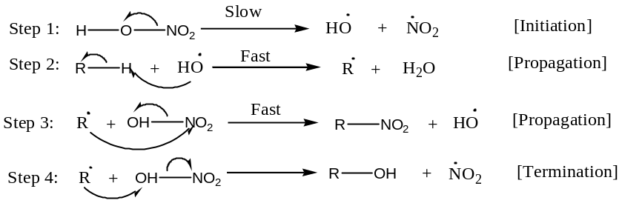
- Sulphonation:
Alkanes undergo sulphonation, when treated with fuming sulphuric acid (sulphuric containing ${SO}_{3}$ at high pressure) at high temperatureto give alkanesulphonic acid. For example,
$$C_{6}H_{14}+HOSO_{2}OH\left(H_{2}SO_{4}\right)\underset{→}{∆}C_{6}H_{13}NO_{2}+ H_{2}O$$
Hexane Hexanesulphonic acid
Mechanism of Sulphonation: Sulphonation of alkane is also a free radical substitution reaction like nitration. The ease of sulphonation is $3^{°}>2^{°}>1^{°}$.
- Pyrolysis:
When an alkane is heated to high temperatures, it decomposes into smaller units including lower alkanes, alkenes, etc. Such a decomposition of alkane (or any compound) into smaller units by the application of heat is called pyrolysis. For example,
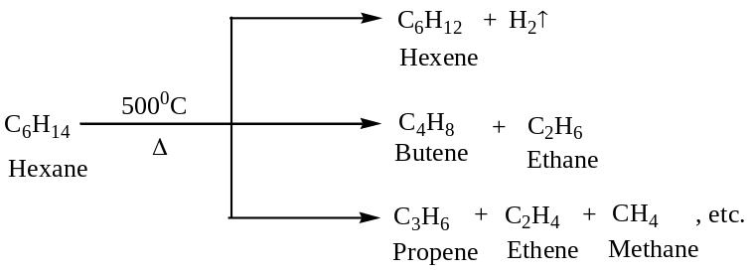
This pyrolytic elimination is known as creaking in petroleum industry.
[Important: The preparation of laboratory oil gas from kerosene oil (mixture of higher alkanes) involves similar pyrolytic reactions. These pyrolytic reactions involving petroleum or petroleum fractions (for example kerosene oil) are known as creaking.]
Mechanism of Pyrolysis: Pyrolysis of an alkane at high temperature is believed to be a free radical reaction, and preceded by the following mechanistic pathway —
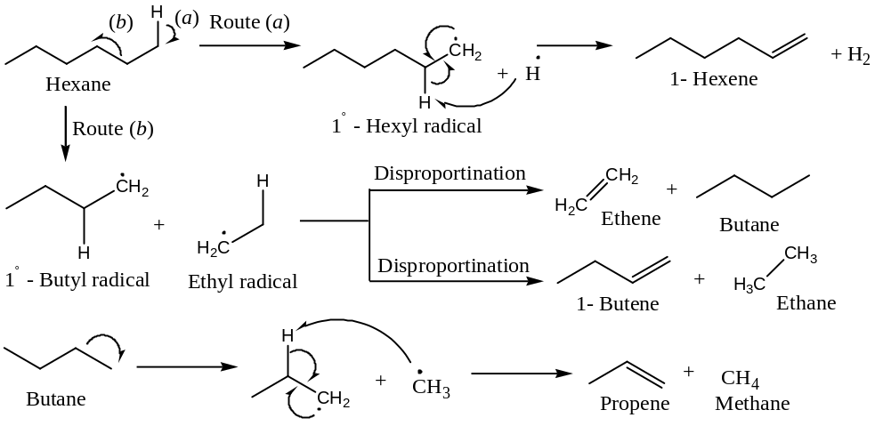
- Isomerization:
When$n$-alkanesare heated in presence of anhydrous $Al{Cl}_{3}$ and $HCl$ they isomerise to the branched chain alkanes and the reaction is known as isomerization reaction. For example,
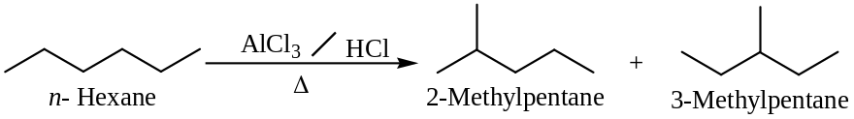
- Aromatization:
When alkanes containing six or more carbon atoms are heated to high temperature (about $500℃$) under high pressure (10 to 20 atmospheres) in presence of special catalyst (e.g. oxides of $r, V \& Mo$ supported on alumina) they are converted into aromatic hydrocarbons. This process is called aromatization and it involves cyclization and dehydrogenation to give aromatic hydrocarbon, as given below:
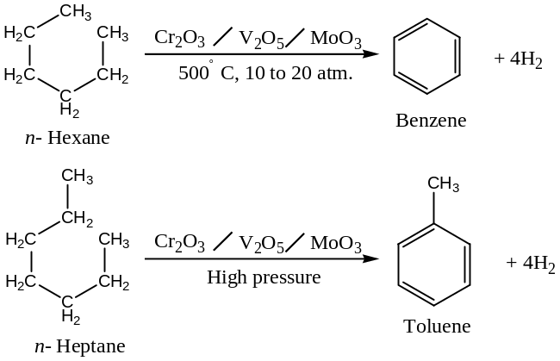
[Important: This reaction is also called catalytic reforming(this increases the octane number of the fuel in petroleum industry)in petroleum technology. This renders petroleum an important source of aromatic compound.]
- Combustion:
When alkanes burnt in air or oxygen, they are completely oxidized to ${CO}_{2}\&H_{2}O$ with the liberation of large quantities of heat. For example,
$${CH}_{4}+2O_{2}\underset{→}{∆}{CO}_{2}+2H_{2}O, ∆H=-804 kJ{mol}^{-1}$$
Methane
The value of $∆H$ calculated on the basis of bond energies of different bonds comes out to be $-810 kJ{mol}^{-1}$ and this value is quite close to the experimental value ($-804 kJ{mol}^{-1}$).
[Important: Following points are found to be crucial in combustion techniques —
- Despite being highly exothermic, these reactions require too high temperature of a flame to start them, because these reactions have a rather high energy of activation.
- The large quantities of heat evolved in these reactions can be a source of extensive power (hence, the use of petrol, diesel, etc. as fuels in internal combustion engines).
- Incomplete combustion of alkanes (say methane) leads to the formation of carbon black which is used in the manufacture of Indian ink, printer’s ink, black pigments and as fillers in the rubber compounding.]
- Controlled oxidation reaction:
Controlled oxidation of alkanes are carried out in the following two ways —
- Catalytic Oxidation: When alkanes are treated in a regulated supply of air or oxygen at high pressure and in the presence of a suitable metallic catalyst, they are oxidised to alcohols, aldehydes or fatty acids. For example,
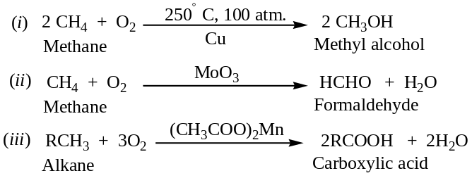
- Oxidation by Oxidizing agents: Ordinarily, alkanes resist the action of oxidizing agents like $KMnO_{4}$, etc. but alkanes containing $tertiary hydrogens$ can be oxidized by such reagents to give $tret$ -alcohols. For example,
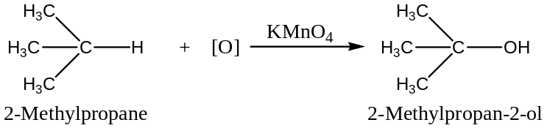
- Inclusion or insertion of Carbene:
A highly reactive intermediate like carbene (generated by the irradiation of ketene), can be inserted into a $C-H$ ($σ$- bond) of an alkane. In this reaction, usually mixtures of isomeric higher homologue of the parent alkane are formed.
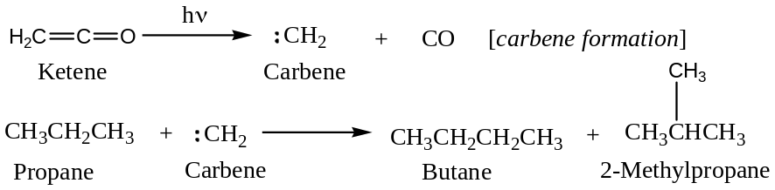

The End

