Stereochemistry
Compounds which have the same molecular formula and the same sequence of covalently bonded atoms, but different spatial orientations of those atoms, are known as stereoisomers and their existence is called stereoisomerism.
Mainly stereoisomers are divided into 2 – classes viz.
- Conformational and
- Configurational stereoisomers
Stereoisomers that interconvert easily at room temperatures through rotations about single bonds are known as conformational stereoisomers. Thus these are non – separable.
On the other hand, the stereoisomers which interconvert only with difficulty under normal conditions (i.e. not inter-convertible under ordinary conditions) and thus can be separated are known as configurational stereoisomers. Interconversion of configurational stereoisomers involves a bond breaking process.
Representation of 3D’al Molecules: 2 – ways —
- Molecular Models: it is important to represent 3D’al molecules for visual inspection in 2D’s, so chemist have devised various molecular models as well as a set of conventions for perspective pictorial representation. The models are of two kinds —
  - Those which show only the framework (bonds & nuclei) and
  - Those which show the full bulk of each atom, so called space filling models.
Ball-and-stick models are a combination of framework and space-filling types.
- Two dimensional representations: This is the best way of representing 3D’al molecules in 2 – dimensions and can be done by —
  - Wedge formula,
  - Sawhorse formula,
  - Newman projection formula, and
  - 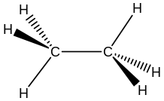Fischer projection formula.
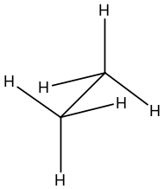Wedge Formula: The most common representation of 3D’al molecule is the wedge formula. Here a solid wedge represents a bond projecting above the plane of the paper and a broken wedge a bond below the plane. Solid lines are bonds in the plane. For example, ethane ($C_{2}H_{6}$) is —
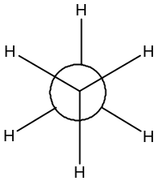Sawhorse Formula: It is also a common method of representing of 3D’al molecule. Here, the molecule is viewed from slightly above and to the side of one $C—C$ bond (i.e. obliquely). All bonds are drawn as straight lines, so that the angular representation provides a graphic three – dimensional perspective picture. For example, ethane ($C_{2}H_{6}$) is —
Newman Projection Formula: Here, the molecule is viewed directly down a $C—C$ bond axis. The front $C$- atom is represented by a central point from which the bonds emerge. The rear $C$- atom is depicted as a circle, from which the bonds connected to the carbon emerge. When drawing a Newman projection, it is important to clearly terminate bond lines of the rear $C$- atom at the perimeter of the circle. For example, ethane ($C_{2}H_{6}$) is —
Fischer Projection Formula: In this representation, the molecule is so oriented that the asymmetric carbon is in the plane of the projection; the groups at the top and bottom are inclined equally below the plane of projection, and the groups on the left and right are similarly inclined equally above the plane of projection. The molecule is then projected in the shape of a cross. The projection formula, being 2D’al, may never be lifted out of the projection plane and turned over. And, since the vertical bonds are in reality below ($Cf tetrahedron, Eliel page 17$) the projection plane whereas the horizontal bonds are above this plane, it is not permissible to rotate the projection formula within the plane of the paper by either a 90⁰ or a 270⁰ angle, although it is all right to rotate it by a 180⁰ angle. For example, (–) $Lactic$ acid,
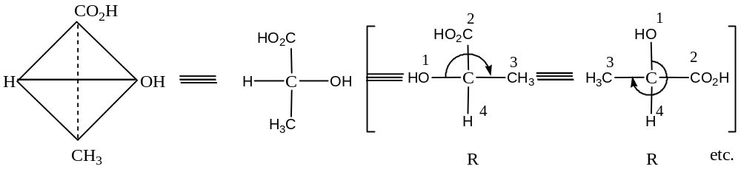
Problem: Draw a Wedge, a Sawhorse, a Newman and a Fischer projection formula for one stereoisomer of —
- $3–Bromo –2–butanol$,
- $2,3–Dichlorobutane$ and
- $Butane$
Solution: (a) $3–Bromo –2–butanol$
Fischer projection formula (FPF) of $3–bromo –2–butanol$ for both erythro (diastereomers in which two like or similar groups are on the same side of the FPF) and threo (diastereomers in which two like or similar groups are on the opposite side of the FPF) form are as shown below —
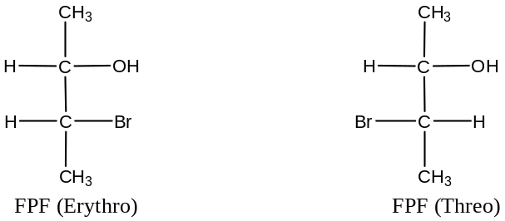
The corresponding sawhorse projection formula of $3–bromo –2–butanol$ for both erythro and threo form are as shown below —
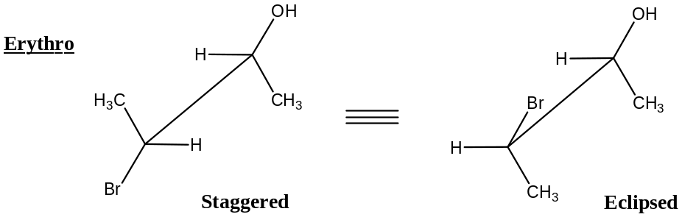
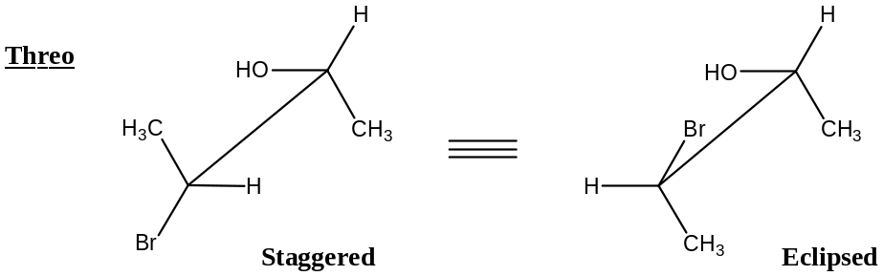
The corresponding Newman projection formula of $3–bromo –2–butanol$ for both erythro and threo form are as shown below —
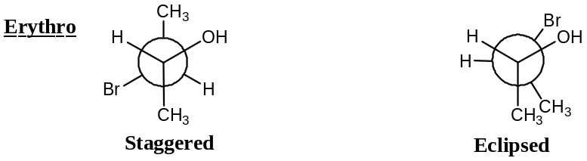
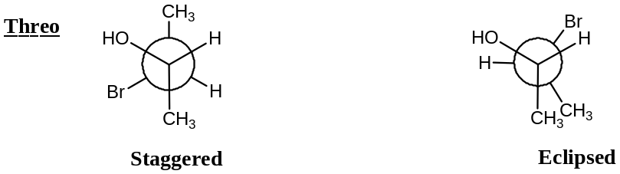
The corresponding Wedge projection formula of $3–bromo –2–butanol$ for both erythro and threo form are as shown below —
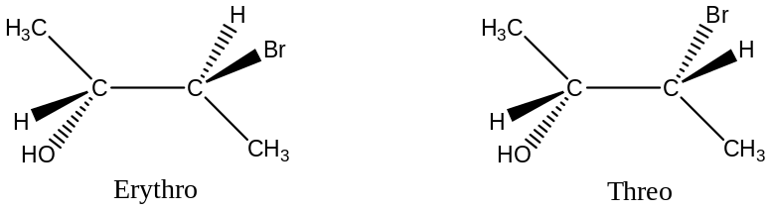
Similarly for the compound (b) and (c)
Conformation in open chain compounds:
For any open chain single bond connecting two ${sp}^{3}$- hybridized $C$- atoms, there are an infinite number of conformations possible, each of which has a certain energy associated with it. For example,
In ethane, $C_{2}H_{6}$ — there are two extremes, $viz$.
- A conformation of highest energy and
- A conformation of lowest energy
These are depicted in figure (a) and (b) by sawhorse projection formula and in figure (c) and (d) by Newman projection formula.
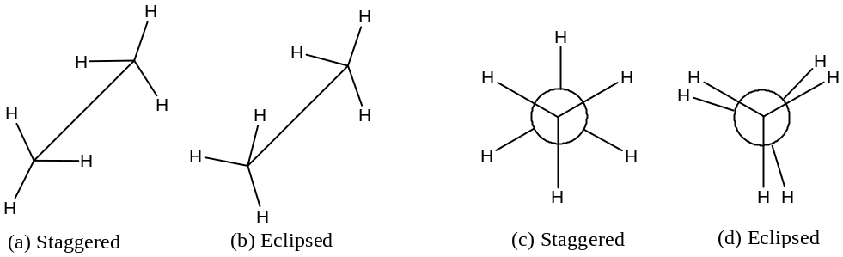
The staggered conformations ($a or c$) is the conformation of lowest potential energy ($PE$) for ethane. As the bond rotates, the energy increases gradually until the eclipsed conformation (b or d) is reached, where the energy is maximum. Further rotation decreases the energy again. For ethane, the difference in energy is, $ΔE ≈ 2.9 kcal{mol}^{-1}$, and called energy barrier. Molecular orbital calculations show that the barrier is caused by repulsion between overlapping filled molecular orbitals, i.e. ethane molecule has its lowest energy in conformation ($a$) or ($c$) because in these conformations the $C—H$ bond orbitals have the least amount of overlap with the $C—H$ orbitals of the adjacent carbon.
In order to construct the energy level diagram for the conformations of ethane, let us construct rotomers, i.e. conformational isomers obtained by rotating one $CH_{3}$ group about $C—C$ bond keeping other fixed by an angle (dihedral angle) $60^{°}$ at each time to reach the original conformation, as shown below by Newman projection formula.
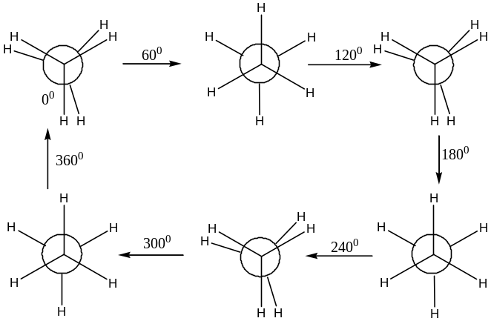
Thus ethane has only two conformational structures viz. eclipsed and staggered. The energy level diagram will be:
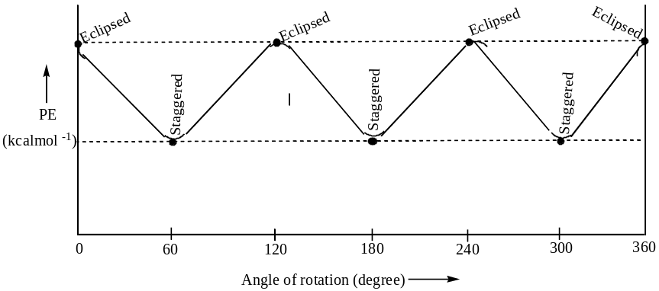
Conformational Analysis of 1, 2 – Disubstituted Ethane:
There are two forms of 1, 2 – disubstituted ethane viz. —
- $Y—CH_{2}—CH_{2} — Y$, For example, $n–butane, CH_{3}CH_{2}CH_{2}CH_{3}$
$$1,2–dichloroethane, ClCH_{2}CH_{2}Cl$$
$1,2–difluoroethane, FCH_{2}CH_{2}F, etc.$
- $Y—CH_{2}—CH_{2} — X$, For example, $1–chloropropane, CH_{3}CH_{2}CH_{2}Cl, etc.$
Conformational Analysis of n – Butane:
Conformational analysis of $n–butane$ is slightly complicated than ethane, for which there are four extremes:
- A fully staggered conformation, also called anti or anti-peri-planar,
- A partially staggered conformation, also called gauche or synclinal,
- A fully eclipsed conformation, also called syn-peri-planar, and
- A partially eclipsed conformation, also called eclipsed or anticlinal.
The Sawhorse and Newman projection formula for the above conformations of $n–butane$ are shown below —
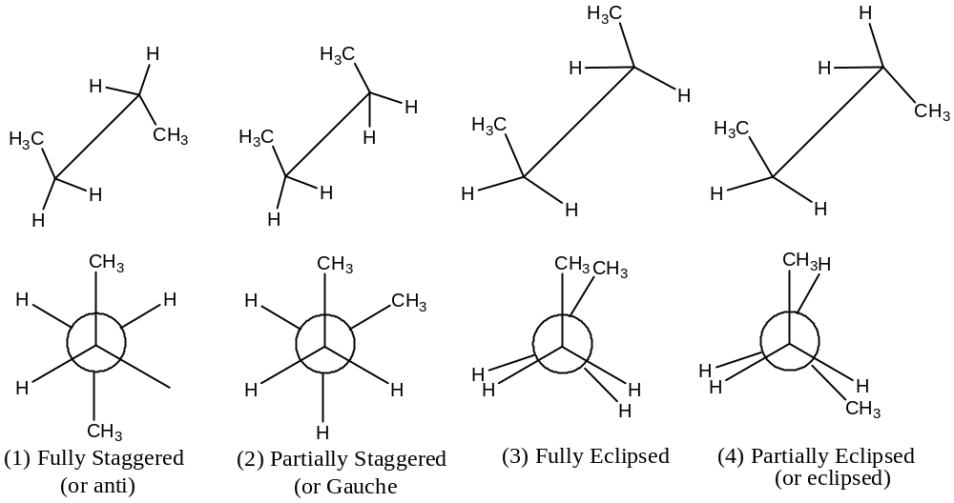
These four conformations are associated with different amount of energy, and the order of increasing energy is —
$Fully staggered<Gauche<Eclipsed<Fully eclipsed$
[This energy order was confirmed from the percentage composition of the various conformations concluded from the consideration of dipole moment and polarizability measurement in $C{Cl}_{4}$ at $25^{°}$ C for —
Fully staggered Gauche Eclipsed Fully eclipsed
- $n–Butane$ 70 % 29 % 0.9 % 0.1 %
- $1,2–Dichloroethane$ 70 % 30 % 0 % 0 %
- $1,2–Dibromoethane$ 89 % 11 % 0 % 0 % ]
In order to construct energy level diagram for the various conformations of n – butane, let us rotate (i.e. rotomers) the half of the molecule by an angle of 60⁰ about the central bond —
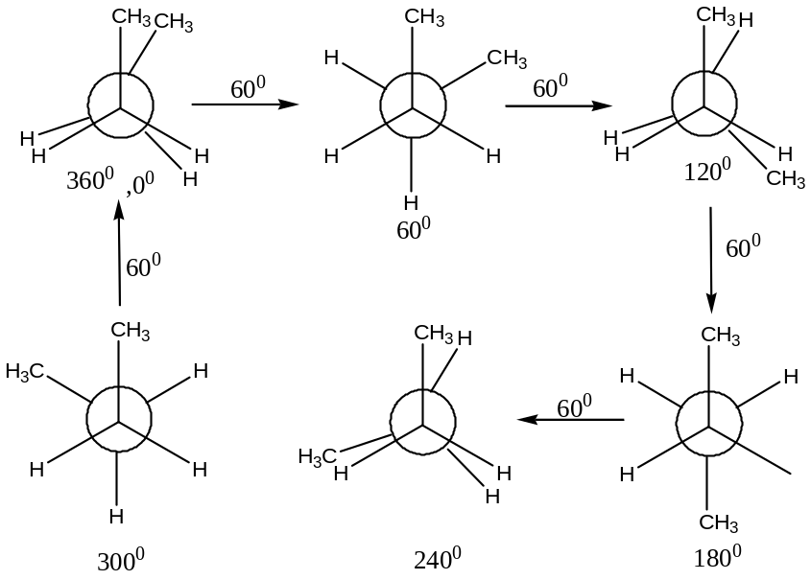
So the approximate energy level diagram will be —
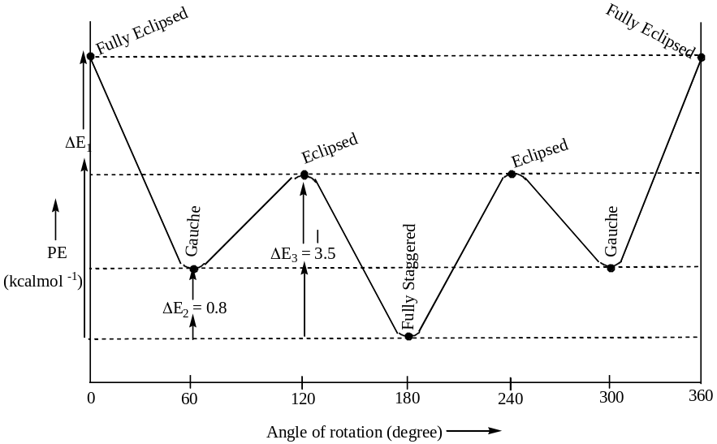
Conformational Analysis of $1,2–dichloroethane$:
Various rotomers are —
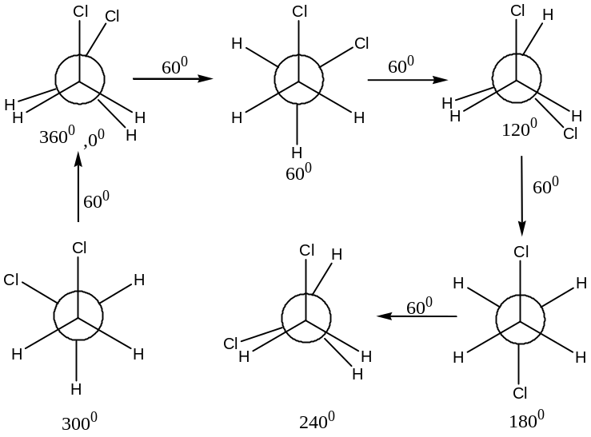
Here, $ΔE_{1}=4.5 – 6.3, ΔE_{2}=0.7, ΔE_{3}=3.6 kcal{mol}^{-1}$
Classification of Stereoisomers:
In the classical stereochemistry, stereoisomers were divided into three classes —
- Optical isomers,
- Diastereomers and
- Geometrical (or cis – , trans – i.e. Z – , E –) isomers
Now -a -days classification of stereoisomers is bases on two factors —
- Classification based on symmetry criteria and
- Classification bases on energy criteria
Classification of stereoisomers based on symmetry criteria is simple and straightforward. Only two types are recognised viz.
- Enantiomers and
- Diastereomers
Enantiomers: If two isomers are related to each other as object and mirror image which are not super imposable, they are called enantiomers and said to exhibit enantiomeric relationship. Such molecules are necessarily chiral and belong to the point groups $C_{1}, C_{n} and D_{n}$only. Since enantiomers are optically active, i.e. they turn the plane of polarised light towards the opposite direction but in equal degree, they are also called optical isomers or optical antipodes.
Thus, chiral molecules which are non-super imposable mirror images of each other are called enantiomers and the phenomenon of their existence in a single structural formula but in opposite configuration are called enantiomerism.
Compounds containing two or more (say ‘$n$’) dissimilar asymmetric $C$- atoms ($i.e.$ chiral centres) in which there is no plane ($σ$- plane) or centre of symmetry ($i$- centre), then $2^{n}$ optical isomers ($i.e.$ enantiomers) are possible. Thus, compounds with —
Only one asymmetric C – atom will have only $2^{1}=2$, enantiomers. For example,
Lactic acid, ${CH}_{3}C^{*}H\left(OH\right)CO_{2}H$
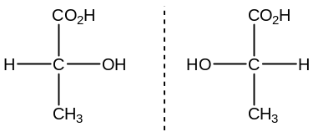
Glyceraldehyde, ${CH}_{2}OHC^{*}H\left(OH\right)CHO$
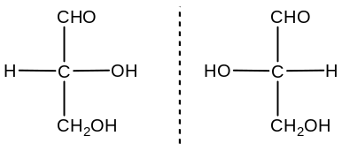
Alanine, ${CH}_{3}C^{*}H\left(NH_{2}\right)CO_{2}H$
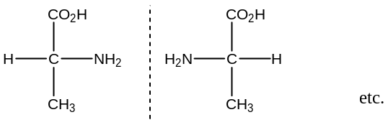
Similarly, compounds with $2$- asymmetric $C$- atom, has $2^{2}=4$ enantiomers. For example,
$Cinnamic acid dibromide$, ${C_{6}H}_{5}C^{*}HBrC^{*}HBrCO_{2}H$
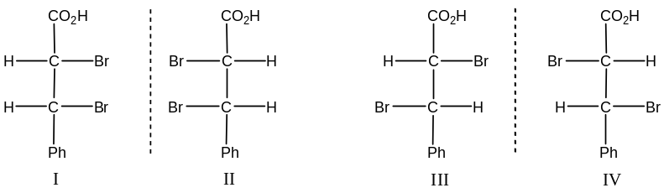
I, II, III & IV are enantiomers, as they are one is the mirror image of the other and non-super imposable.
Similarly, $aldotetrose$, ${CH}_{2}OHC^{*}H\left(OH\right)C^{*}H\left(OH\right)CHO$ have $2–pairs$ of enantiomers —
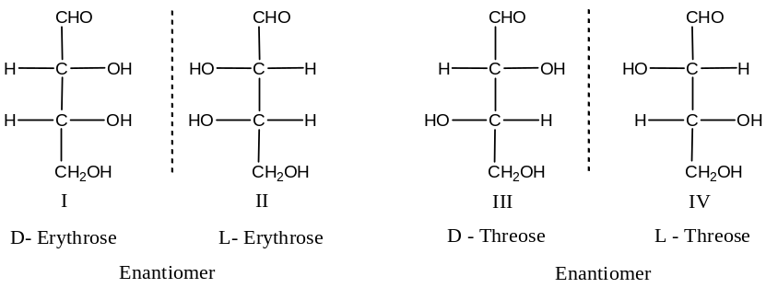
Compounds containing different chiral centres (for example, as in aldotetrose) are called constitutionally unsymmetric as it has no centre or plane of symmetry.
But compounds containing two or more similar asymmetric $C$- atom are called constitutionally asymmetric (as here centre or plane of symmetry is present) has $2^{n}-1$ isomers and out of them only $2^{n-1}$ are optically active. For example,
Considering tartaric acid, ${HO}_{2}CC^{*}H\left(OH\right)C^{*}H\left(OH\right)CO_{2}H$
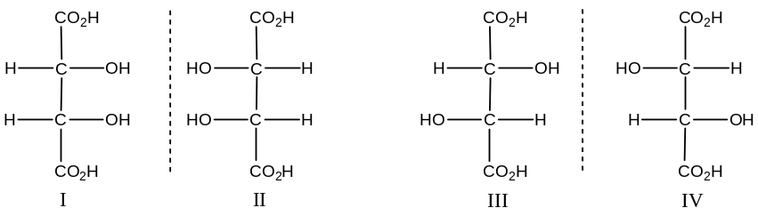
Here, I & II are mirror image but super imposable (as rotation by 180⁰ is permissible), hence are not optically active, and called $meso$ compounds. So I & II are the same compounds. Thus, we have only three structures (I or II, III & IV) out of these only III & IV are optically active.
Meso Compounds:
An organic molecule, with two stereo-genic centres does not always have possible stereoisomers (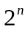). This happens because some molecules are achiral even though they contain stereo-genic carbons. For example,
Considering tartaric acid, 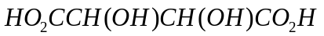
The formula of one stereoisomer and its mirror image:
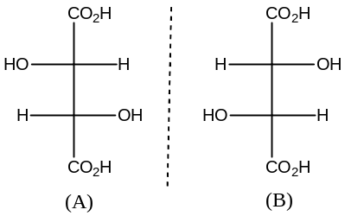
Structure (A) & (B) are non-superimposable mirror images and thus, represents a pair of enantiomers.
When we write structure (C) as shown below and its mirror image (D), the situation is different. The two structures are superimposable. This means that (C) & (D) do not represent a pair of enantiomers. Actually, formula (C) & (D) represents two different orientations of the same compound.
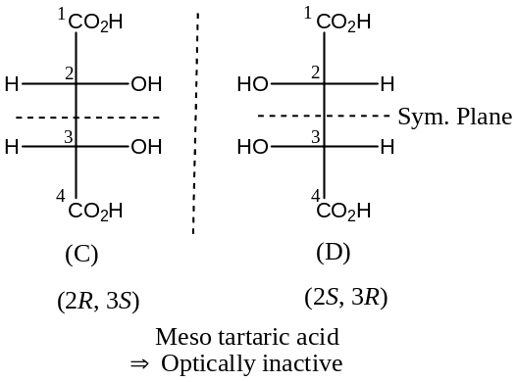
The molecule represented by the structure (C) (or D) is not chiral (as it contains a plane of symmetry), even though it contains tetrahedral arrangement with 4 – different groups or atoms. Such molecules are called meso compounds. Meso compounds, because they are achiral, are optically inactive.
Thus, an optically inactive compound whose molecules are superimposable on their mirror images despite the presence of chiral carbon atoms is known as a meso compound. Meso compounds are optically inactive, because the rotation caused by one half of the molecule is cancelled by the equal and opposite rotation of the other half of the molecule – the mirror image of the first half. In other words, optical inactivity in a meso compound is due to compensation within the molecule (also called internal compensation).
Meso structure has a plane of symmetry and this plane divides the molecule into two halves, one is the mirror image of the other.
Tartaric acid exists in three stereo-isomeric forms, a pair of optically active enantiomers and an optically inactive meso form. It can be shown by similar reasoning that all compounds with two similar chiral carbon atoms (for example, 2, 3 - $dichlorobutane$) can, exist in three stereo-isomeric forms, a pair of optically active enantiomers and an optically inactive meso form.
Prochirality (Or Topicity of Ligands):
If a molecule is not chiral (so optically inactive), i.e. possesses either a plane of symmetry or axis of symmetry (low order), but by replacing just one group or atom i.e. ligand, we can make it chiral (optically active) is called $prochiral$ centre. Thus, molecules that are achiral, but can become chiral through one simple replacement are called prochiral, and the phenomenon is called $prochirality$. For example,
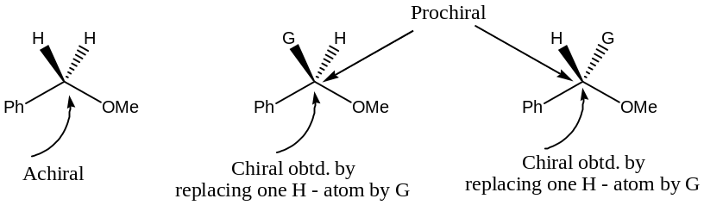
Enantiotopic Ligands or Groups:
An enantiotopic ligand is the ligand that on its replacement creates an enantiomer. It can be labelled as $Pro-R or Pro-S$ligand if their replacement produces an enantiomer with stereochemical configuration $R- or S-$ respectively.
An $H$- atom in a molecule is said to be enantiotopic, if its replacement by another atom or group, $say G$, result a structure which can form non-superimposable mirror image with original. Thus, the two identical $H's$, where replacement or modification of one of the $H's$ gives an enantiomer, is called enantiotopic $H's$. Thus,
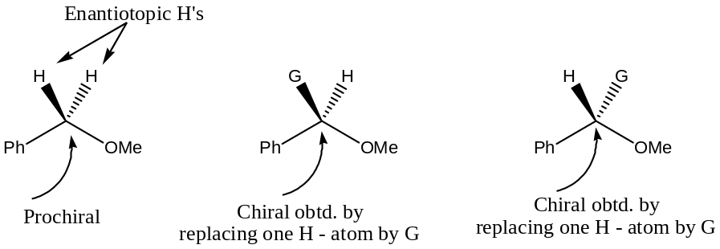
Enantiotopic $H's$ are labelled as $Pro-R or Pro-S$, if their replacement produces an enantiomer with stereochemical configuration $R- or S-$ respectively. For example, in ethanol, two hydrogens are enantiotopic hydrogens.
Diastereotopic Ligands or Groups:
Again, if the two $H$- atoms being replaced are stereo-chemically non-equivalent, such pairs are said to be diastereotopic: Replacement of one or the other of them gives one or other of a pair of diastereomers. Thus, an $H$- atom in a molecule is said to be diastereotopic $H's$ if its replacement by another atom or group,$say G$, results diastereomers (no mirror image relationship). Thus,
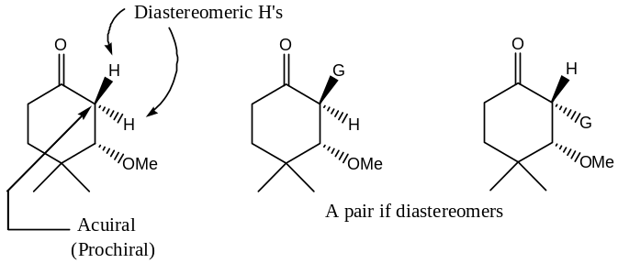
It is important to note that, by applying the replacement test, we find that a set of diastereotopic ligands are sometimes attached to different $C's$ within a molecule, and are sometimes attached to the same doubly bonded $C$- geometrical isomers, after all, are one kind of diastereomer. For example,
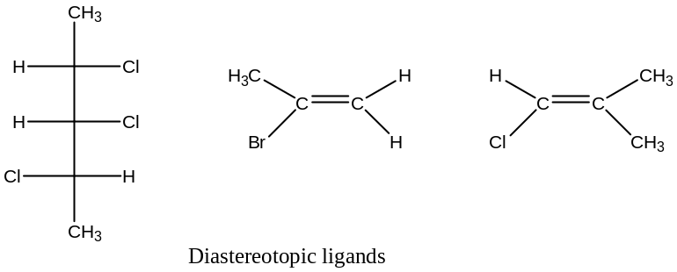
Question: Draw the Fischer’s projection of ($+$), ($–$) and meso-tartaric acid and identify the homotopic, enantiotopic and diastereotopic hydrogens in all the three structures. Explain how the topocity of hydrogens could be ascertained.
Solution: Fischer’s projection of ($+$), ($–$) and meso-tartaric acid are drawn below:
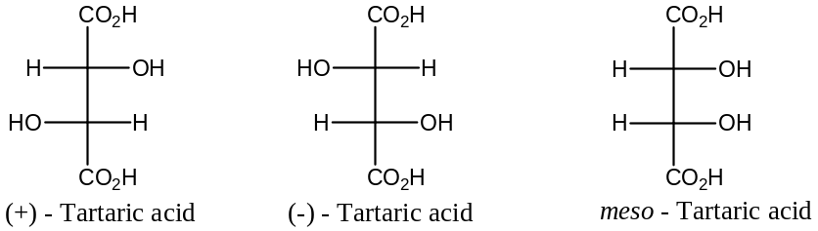
Homotopic hydrogens (or ligands): [$D Nasi Puri$ – Page_108]
Two hydrogens in a molecule are said to be homotopic, if substitution i.e. replacement of 1st one and then the other by an atom or group which is not already attached to the ligating centre gives identical product. Thus, the two methine $H’s$ in $(+)$- tartaric acid (I) [as also in the $(–)$- tartaric acid] are homotopic, since, their replacement by deuterium ($D$) leads to identical product (II).
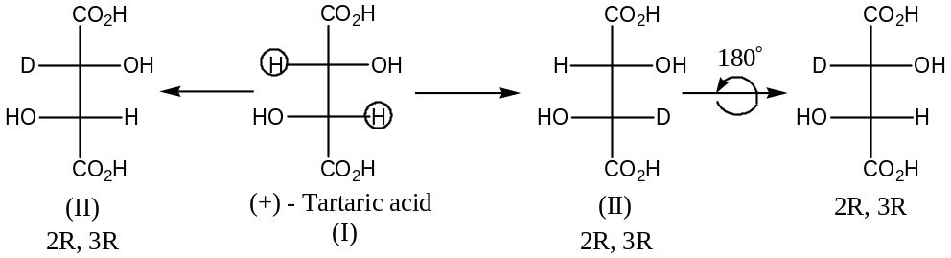
Enantiotopic hydrogens (or ligands): [$D Nasi Puri$ – Page_110]
Two hydrogens in a molecule are said to be homotopic, if substitution i.e. replacement of 1st one and then the other by a different achiral ligand (atom or molecule) gives rise to two enantiomers (which constitutes a pair of non-superimposable mirror images). Thus, the two methine H’s viz. H_{A} & H_{B} in meso – tartaric acid are enantiotopic, as their replacement by deuterium (D) generates to enantiomers (A & B).
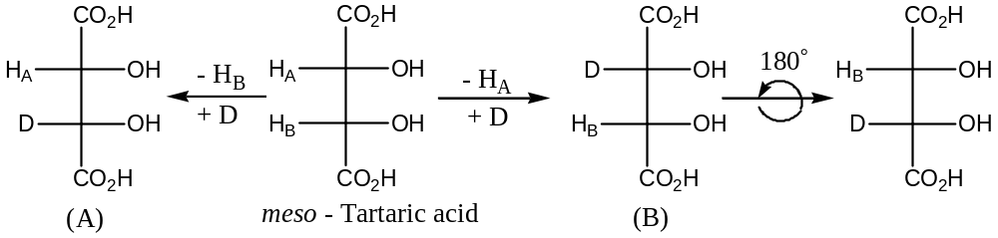
Similarly, two H’s of $CO_{2}H and OH$ groups are also enantiotopic as mono-esterification of $CO_{2}H$ groups mono-acetylation of $OH$ groups leads to enantiomeric products.
Diastereotopic hydrogens (or ligands): [$D Nasi Puri$ – Page_114]
Two hydrogens in a molecule are said to be diastereotopic, if substitution i.e. replacement of 1st one and then the other by a different ligand give rise to two diastereomers. By this definition, no H’s in tartaric acid is diastereotopic.
Determination of topicity of hydrogens (or ligands) in a molecule:
Topicity of H’s in a molecule is determined by spectroscopic methods especially NMR – spectroscopy. //
Stereogenicity & Chirotopicity: [$D Nasi Puri$ 66_Page]
Stereogenicity & Chirotopicity are two distinct characters of an asymmetric atom and are most closely associated to organic stereochemistry. However,
- Stereogenicity is dependent on disposition of bonds, but Chirotopicity is quite independent of it (i.e. disposition of bonds) and is determined only by local symmetry.
- A chirotopic atom is one which resides in a chiral environment. Thus, all the five atoms in $CHFClBr$ are chirotopic, although only the $C$- atom is a stereogen.
Similarly, considering the two isomers (I & II) of $2,3,4$- trihydroxy glutaric acid, here $C_{3}$ is chirotopic, but it is non-stereogenic, i.e. in this case, the two properties of a regular asymmetric tetrahedral centre is delinked.
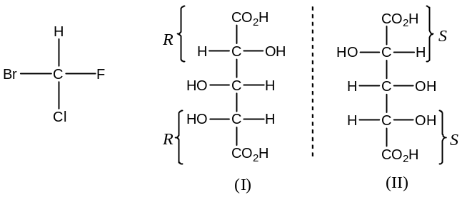
$Stereogenicity$ &$Chirotopicity$: [$D Nasi Puri$ 66_Page]
Stereogenicity & Chirotopicity are two distinct characters of an asymmetric atom and are most closely associated to organic stereochemistry. However,
- Stereogenicity is dependent on disposition of bonds, but Chirotopicity is quite independent of it (i.e. disposition of bonds) and is determined only by local symmetry.
- A chirotopic atom is one which resides in a chiral environment. Thus, all the five atoms in $CHFClBr$ are chirotopic, although only the $C$- atom is a stereogen.
Similarly, considering the two isomers (I & II) of $2,3,4$-$trihydroxy$ $glutaric$ acid, here $C_{3}$ is chirotopic, but it is $non$-$stereogenic$, $i.e.$ in this case, the two properties of a regular asymmetric tetrahedral centre is delinked.
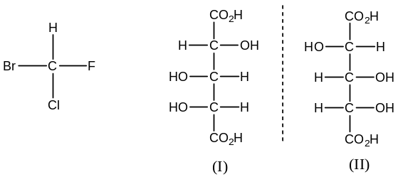
Diastereomers:
Stereoisomers which are not related to each other as object and mirror image, i.e. which are not enantiomers are called diastereomers and said to exhibit $diastereomeric$ relationship. A broad range of organic molecules falls under this category.
In Fischer projection formula, which two similar groups attached to different chiral centre are in the same side, then the conformation that obtained are diastereomers and when on opposite side give rise to enantiomers. For example, in tartaric acid, ${HO}_{2}CC^{*}H\left(OH\right)C^{*}H\left(OH\right)CO_{2}H$
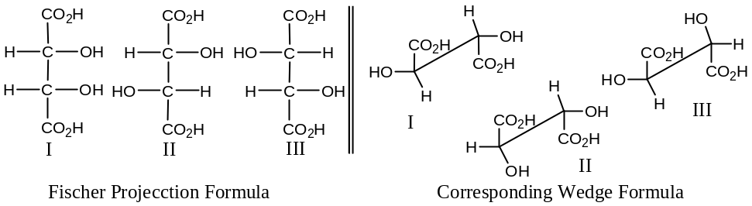
In the above figure (I), (II); (I), (III) are two pairs of diastereomers.
Similarly, with $1,3– and 1,4–dimethyl cyclohexane$ —
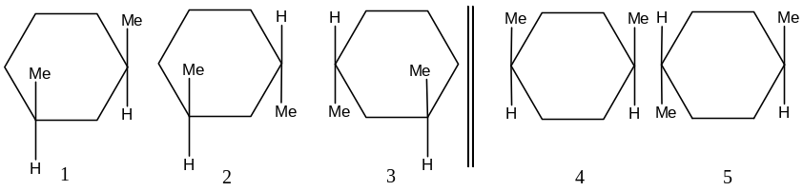
(1, 2); (1, 3); (4, 5) → Diastereomers
How to think whether a molecule is Enantiomer or Diastereomer:
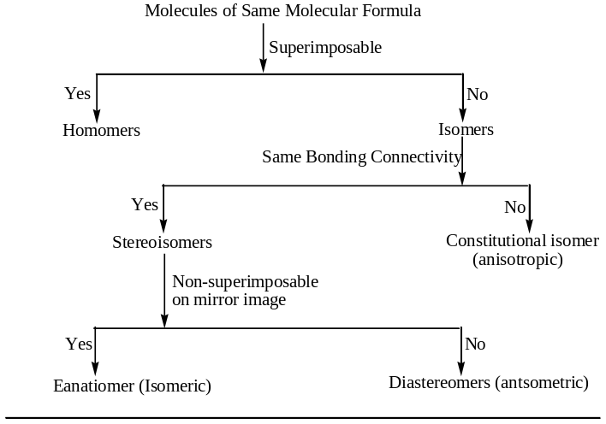
$π$- Diastereomers & the Method of their Nomenclature: [$D Nasi Puri$Page_57]
Diastereomers (not related as object & mirror image) that are due to the presence of $π$-bonds are called $π$- diastereomers. For example,
$2$- $Butene$ can exist in two diastereomeric forms, due to the restricted rotation around the $π$- bond, and these are:
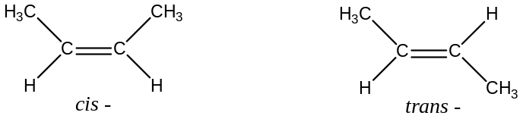
In IUPAC system $π$- diastereomers are named as $Z$- (derived from the word $Zusammen$ means together) if groups or atoms of higher priority are on the same side of the double bond ($π$-bond) or $E$- (derived from the word $Entgegen$ means across i.e. opposite) if groups or atoms of higher priority are on the opposite side of the double bond ($π$- bond). For example,
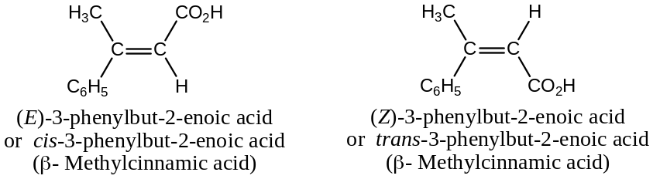
Similarly, with oximes ―
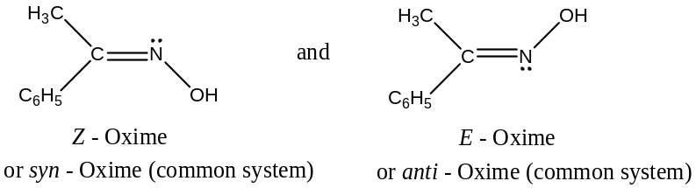
$E \& Z$ - Nomenclature of geometrical isomers:
Because of the restricted rotation about a $π$- bond, olefinic compounds exists in two distinct forms i.e. exhibits geometrical isomerism.
Geometric isomers are named by using the symbol “$E$” (from Gr. Entgegen, means across) and “$Z$” (from Gr. Zusammen, means together) which are equivalent to $trans$- and $cis$- respectively.
In CIP – sequence (Chan – Ingold - Prelog), if the groups or atoms of higher priority (Groups or atoms having higher atomic number or mass number have the higher priority) are on the same side of the double bond, the configuration is $Z$- ($i.e. cis$-), but if they (groups or atoms of higher priority) are on the opposite side, the configuration is $E$- ($i.e. trans$-).
For example, $but–2–ene$ may be ―
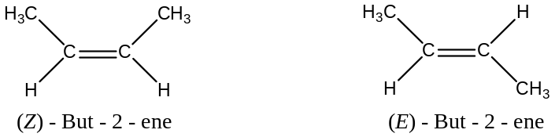
Similarly, with $β-methyl cinnamic acid$,
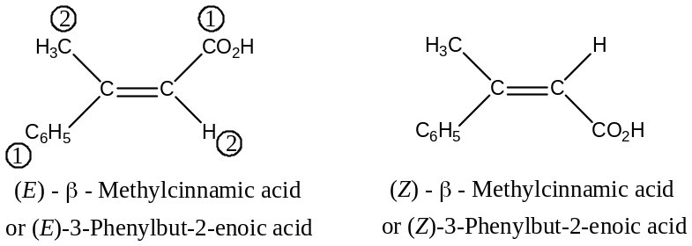
Question: Why are geometrical isomers known as $π$-diastereomers? Assign $E \& Z$ nomenclature to the following:
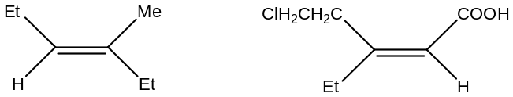
Solution: Since, geometric isomers are due to the restricted rotation about a $C―C$ double bond, and the two forms so obtained are not related as object & mirror image, hence are called diastereomers i.e. diastereomeric forms due to the presence of $π$- bonds hence, are called $π$- diastereomers. For example,
$2–Butene$ can exist in two diastereomeric forms, due to the restricted rotation around the $π$- bond, and these are:
2nd Part:
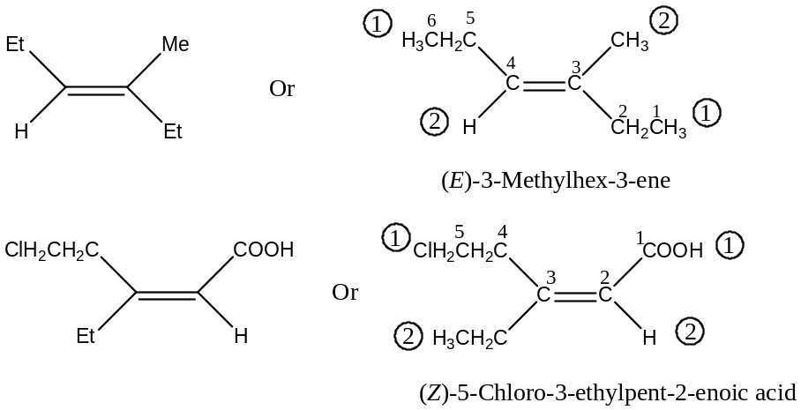
Erythro and Threo Nomenclature:
The diastereomers are separated as erythro and threo in analogy with $erythrose$ and $threose$, the two isomers of aldotetrose.
The diastereomers in which two like (or similar) groups are on the same side of the Fischer projection formula (as two $-OH$groups in erythrose) is called erythro form, whereas the diastereomers in which two like (or similar) groups are on the opposite side of the Fischer projection formula (as two $-OH$groups in threose) is called threo form.
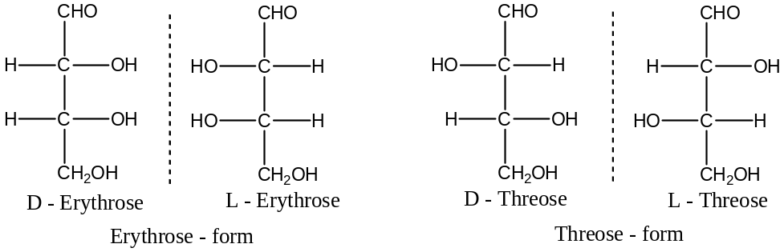
More Examples: The two diastereomeric $3–bromo–2–butanols$ (str. 1 & 3) are thus erythro and threo isomers respectively:
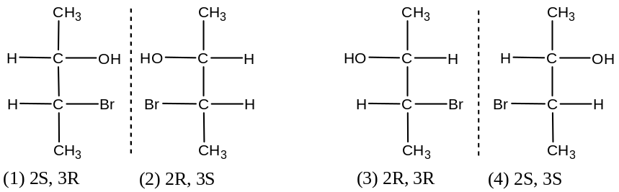
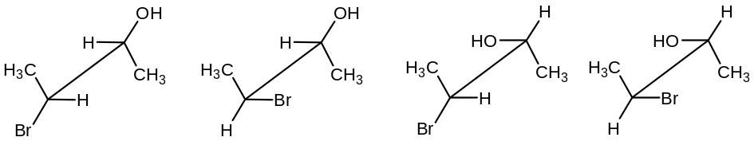
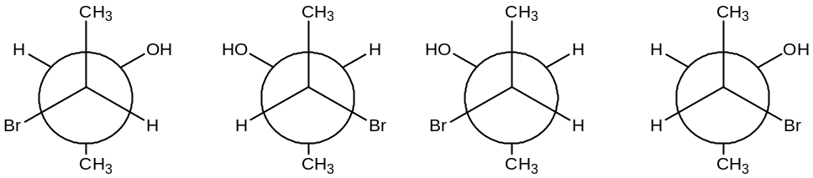
Since such molecules are very often represented by Sawhorse or Newman formula, the definition may be modified to conform to such structures.
The erythro form is the one in which the two terminal groups (in FPF) and the two like groups (or similar) groups, have the same relative stereochemistry (anti or gauche); the threo form is the one in which the two pairs of groups have different relative stereochemistry (anti or gauche or vice – versa). This is evident in the Sawhorse formula (each of the form stereoisomers exists in the three distinct conformations, only the one with the terminal methyl groups anti are shown) shown in the figure given above.
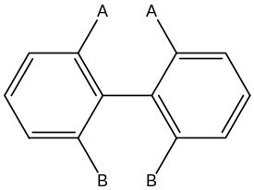Asymmetry & Dissymmetry: – (Optical activity)
Asymmetry → Structure has no element of symmetry at all
Dissymmetry → It does not means completely devoid of symmetry, but possesses so few element of symmetry (centre or plane), it devoid of only those elements of symmetry which effect the non-super- imposability of the mirror images of the two forms.
Note:
- Thus every asymmetric structure is also dissymmetric but not vice – versa
- Asymmetry is the necessary condition for optical isomerism but dissymmetry is the necessary and sufficient condition for optical isomerism. For example, the molecule biphenyl is not asymmetric but optically active because of the presence of molecular dissymmetry (plane of symmetry).
Optical activity of molecules having $S_{1} \& S_{2}$ axis of symmetry: [$D Nasi Puri$ 26 Page]
We know that,
$S_{2}=i$ the inversion centre and
$S_{1}=σ$- plane
Now, molecules which are not superimposable with their mirror images are called chiral and those which are superimposable are called achiral. Further, only chiral molecules are optically active and they exhibit a type of stereoisomerism known as enantiomerism and belong to the point groups $C_{1}, C_{n} \& D_{n}$; they can be recognized by the absence of an $S_{n}$- axis of any order. Thus, a molecule containing a plane of symmetry ($S_{1}$) and an inversion centre ($S_{2}=i$) is achiral i.e. optically inactive. For example, considering lactic acid,
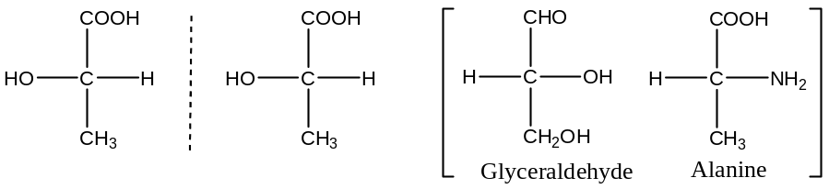
― Shows that non-superimposable mirror-image relationship of lactic acid, $i.e.$ chiral molecules, therefore, are optically active.
Further, it has no $S_{2}=i and σ=S_{1}$.
But, benzene is optically inactive (achiral), and it has both $i \& σ (S_{2} \& S_{1})$.
Conformations in Cyclic Systems: –
Classification of monocyclic system — depending upon the number of $C$- atoms in the ring, these are of following types —
- Small rings $→ 3–4 C- atoms$
- Common rings $→ 5 – 7 C – atoms$
- Medium rings $→ 8 – 11 C – atoms$ and
- Large rings $→ 12 – onwards C –$ atoms
cyclohexane: –
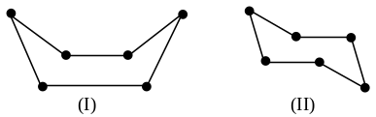On the basis of tetrahedral theory Sachse proposed two distinct non – planar forms for cyclohexane —
- Boat conformation and
- Chair conformation

The chair form is ‘rigid’ as it resists distortion and when it is transformed into the boat form some angular deformation is necessary. The energy barrier in this process has been determined from $NMR$ spectral data and is about $37.7 – 46.0 kcal{mol}^{-1}$. This value is large enough for each conformation to retain its identity, but is not large enough to prevent their Interconversion at room temperature. Thus, it is not possible to isolate each conformation.
Stability of the two forms of Cyclohexane:
Both the boat and chair forms of cyclohexane are free from angle strain (according to Hassel there is a small amount of angle strain, the ring angle being $̴ 111.5^{°}$, not the normal angle $109.5^{°}$) but because of difference in steric strain and bond opposition strain, the two forms differ in energy content.
The figure (a) and (b) represent the chair and boat conformations and the direction of $C—H$ bonds. In the chair conformation, all the adjacent $C—H$ bonds of carbon are in the skew position (figure c). On the other hand, in the boat conformation, there are only four skew interactions (1, 2; 3, 4; 4, 5 and 6, 1) and two eclipsed (2, 3 and 5, 6). At the same time, there will be some bond opposition strain for these two pairs of eclipsed bonds, and also steric repulsion between the two flag – pole ($fp$) hydrogen (at 1, 4), which are $1.83 Å$ (considerably closer than the sum of their van-der-Waal’s radii, 2.5 Å). Hence the total strain in the boat conformation is larger than that in the chair conformation (as only two $diaxial$ interactions 1, 3 – and 1, 5 –) and consequently the boat form is less stable than the chair form of cyclohexane.
The boat form is however, flexible and can easily be distorted into many shapes, and in these the H – eclipsing and flag – pole interactions are reduced (figure d). Experimentally (Hendrickson) it has been found that the twist boat contains $6.7 kJ{mol}^{-1}$less energy than the classical boat form ($28.9 kJ{mol}^{-1}$). From the measurement of heat of combustion and other measurable quantities, it has been calculated that the energy difference between the flexible (boat) and the chair form of cyclohexane is $22.2 kJ{mol}^{-1}$ (at $25℃$, vapour phase). Thermodynamic calculations have shown that the population of the flexible boat form of cyclohexane is about 1 to 2 in a thousand at $25℃$. Again, from electron diffraction studies at room temperature, it is found that cyclohexane molecules are mainly in the chair conformation, $X$- ray analysis also agrees with this phenomenon. However, the boat conformation has been found in certain molecules, but their number is relatively small.
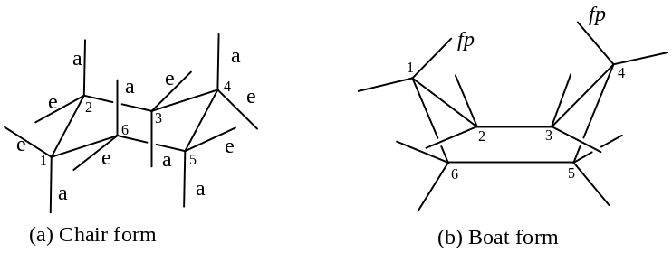
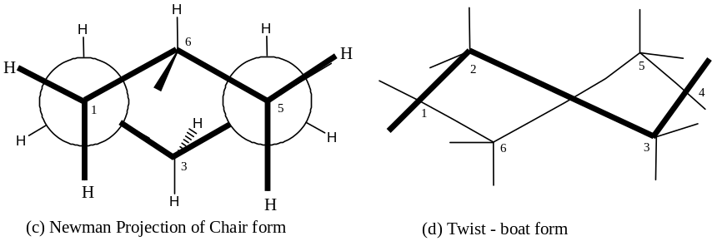
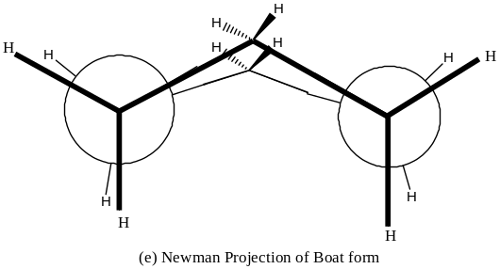
The energy profile diagrams of the stabilities of the two forms of cyclohexane are shown in the figure given below.
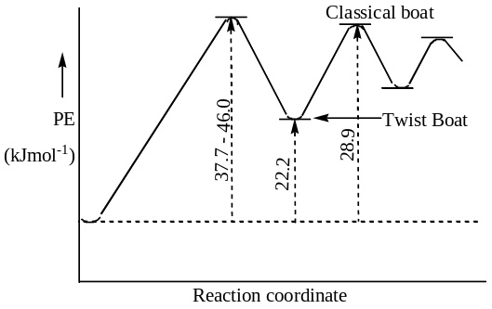

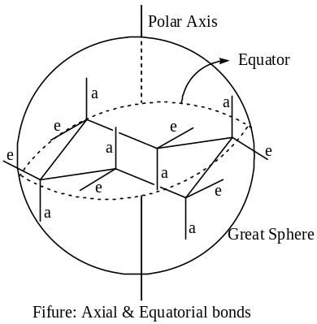Chair Conformation of Cyclohexane:
To avoid strain, rotation of several $C—C$ bonds of a cyclohexane molecule occurs at a time and thereby the molecule assumes a conformation in which alternative $C$- atoms occupy two separate planes to produce a rigid puckered structure, which is popularly called the chair conformation, because its shape resembles that of a chair. All the 12 – H – atoms in the chair conformation are not equivalent; there are two sets of six.
- Axial bonds — those pointing up & down, designated as “$a$”.
- 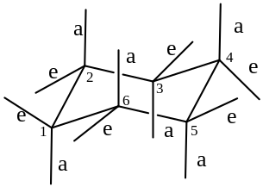 Equatorial bonds — those pointing sideways, designated as “$e$”.
If the chair conformation is supposed to be enclosed in an imaginary sphere (comparable to the earth), then one can conceive a middle belt of the sphere – the equator, and a polar axis which are mutually perpendicular to each other.
A set of six $C—H$ bonds and then found to be parallel to the polar axial bonds (a), three of these axial H’s are on the alternate $C$’s point up & other three H’s point down.
There are another set of six $C—H$ bonds each of which makes an angle $109.5^{°}$ with the axial bonds, i.e. these are almost parallel to the equator (they make $19.5^{°}$angle with it) and are called equatorial bonds ($e$).
Each of the $C$’s in the chair conformation has one “$e$” $C—H$ and one “$a$” $C—H$ bond. One of these two bonds points above the imaginary plane of the molecule and the other below it. Thus three axial $H$’s on three alternate $C$’s and three equatorial $H$’s on the other three $C$’s point above the plane while the remaining three alternate “$a$” $H$’s and three “$e$” $H$’s point below the plane.
The equatorial $H$- atoms on $C_{1}$ has four nearby $H$- atoms, these are $a \& e$ on the $C_{2}$ and$C_{6}$. Whereas there are also four nearby $H$’s to the axial $H$ on $C_{1}$ but these are axial on $C_{3}$ and $C_{5}$ and equatorial on and $C_{6}$ and $C_{2}$. These are further confirmed by the measurement of the distances between two hydrogen atoms in the chair conformation. For example,
$H$’s Involved | Distance ($nm$) | Distance ($Å$)
$$1e, 2e; 1e, 6e$$  $$1e, 2a; 1e, 6a$$ | $$0.249$$ | $$2.49$$
$$1a, 2a; 1a, 6a$$ | $$0.306$$ | $$3.06$$
$$1a, 3a; 1a, 5a$$ | $$0.251$$ | $$2.51$$

Sum of the van-der-Waal’s radii of two $H$’s is $2.240 nm$.
However, the rigid chair conformation of cyclohexane changes into other chair conformation and when these occurs all the six equatorial $C—H$ bonds of the previous chair form become axial and the axial $C—H$ bonds become equatorial. This interconversion requires $46.0 kJ{mol}^{-1}$ of energy though the two forms are identical. The half chair transition state is being involved in this interconversion.
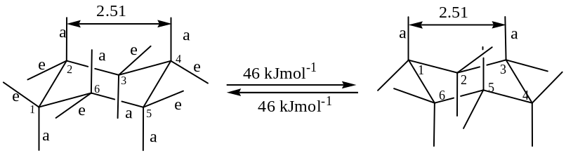
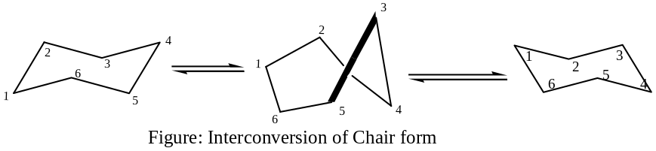
Conformational Analysis of Chair form of Cyclohexane:
Chair conformation is strain free and this can be explained by considering the chair model and its Newman projection formula as given below:
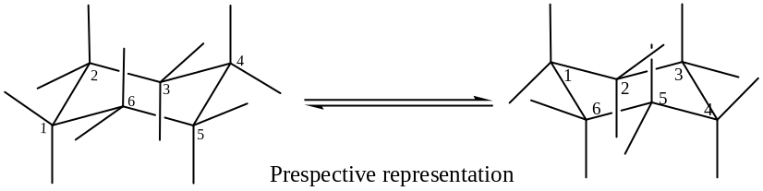
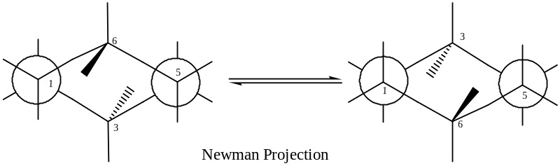
From the $NPF$, it is clear that all the $C—H$ bonds in the chair form of cyclohexane are staggered and hence is no bond opposition or torsional strain.
Again owing to the puckered shapes, each of the $C$’s exhibits ideal tetrahedral arrangements and therefore this conformation is also free of angle strain.
Furthermore, the distance between an $H$ on one $C$- that on another $C$ of chair form being greater than the sum of the van-der-Waals radii of two $H$’s ($0.24 nm$), the van-der-Waals strain is also absent in the chair conformation.
Being composed of $C \& H$ atoms, a cyclohexane molecule does not have any bond dipole practically. The question of intermolecular dipole – dipole interaction therefore does not arise. So the chair form is free of dipole – dipole interaction too.
All sorts of strain being absent in the chair form, it is strain less, which in its turn, makes the chair form very stable, it is as stable as an $n–alkane$.
Note: In general most of the six-membered rings, such as $pyran$, pyridine, etc. remain in the preferred chair form because of high stability. The atomic crystal of diamond is composed of chair cyclohexane rings, and that is why diamond possesses remarkable stability.
Boat Conformation of Cyclohexane: –
Owing to the rotation of several C — C bonds at a time, a cyclohexane molecule may assume a flexible puckered ring structure in which the two C’s of two opposite corners of the non-planar hexagon are bent up leaving the remaining four C’s in a plane to give a boat-like shape to the ring which is called boat conformation of cyclohexane.
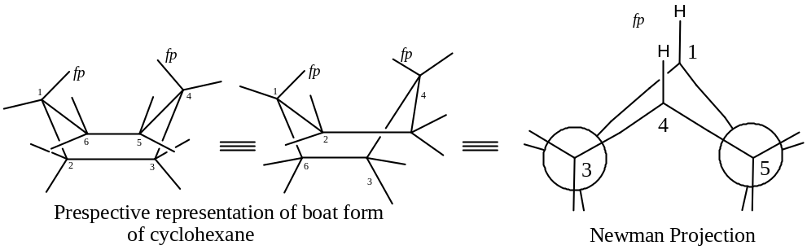
Newman projection of the boat form conformation indicates clearly that four pairs of eclipsed $H$’s on $C_{2}–C_{3}$, and $C_{5}–C_{6}$ parts. Two C — H bonds one on $C_{1}$ and the other on $C_{4}$ are very close to each other (0.183 nm) and are called flag – pole bonds, these $C—H$ bonds are so called because their orientations in space resembles those of a flag – pole.
Comparative stability of two forms of Cyclohexane: –
Boat form is free of angle strain because of its puckered ring structure, the $C—C—C$ and $H—C—H$ bond angles are $109.5^{°}$ (as usual for $sp^{3}–C$ - atom).
It is also free from dipole – dipole interactions, as there is no polar bond in the molecule.
On the other hand it has $4$- pairs of eclipsed $C—H$ bonds on $C_{2}–C_{3}$ and $C_{5}–C_{6}$parts. So there is appreciable amount of eclipsing or bond opposition strain. This brings instability to the boat form of cyclohexane ring.
Furthermore, flag-pole $H$- atoms being at a distance ($0.183 nm$) that is less than that the sum of their van-der-Waals radii ($0.240 nm$), indicating that there is a strong van-der-Waals strain in the boat conformation. This again brings instability to the boat form of the cyclohexane ring.
Taking all this above said points considering, we can say that boat form is sufficiently strained, while chair form is strain less. That is why the boat containing $28.46 kJ{mol}^{-1}$ of more energy than the chair.
%%%%%%%%%%%%%
Monosubstituted Cyclohexane:
Classical structure is —
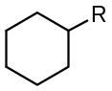
From conformational studies, there are two conformational isomers are possible in principle for a monosubstituted cyclohexane, such as methylcyclohexane. These are —
- $a$ – Methylcyclohexane — where the methyl group occupies the axial position, and
- $e$ – Methylcyclohexane — where the methyl group occupies the equatorial position.
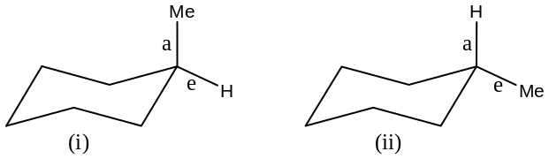
Interconversion and Stability:
$e$ – Substituted chair form of cyclohexane may be converted to less stable $a$ – substituted chair form through the flexible form, as the energy difference between this and chair form is very small, only $5–6 kcal{mol}^{-1}$.
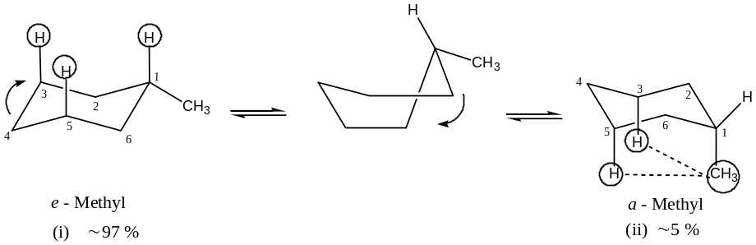
Figure: Interconversion of chair form of methylcyclohexane
The difference in potential energy between them can be estimated from an inspection of the models. The axial isomer (ii) has two interactions (of the type present in the gauche form of butane). These two are $1,3– and 1,5–$ popularly known as $1,3–diaxial$ (or 1a, 3a) interactions as shown in the figure. These are more clearly observed in the Newman projection formula as given below. No such interactions are present in the equatorial isomer (i).
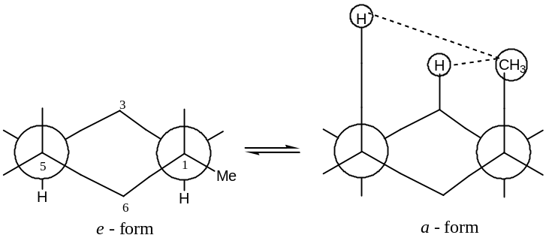
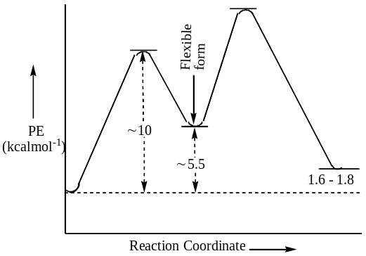Since the potential energy difference between the gauche and $anti$ - forms of butane is $0.8 to 0.9 kcal{mol}^{-1}$, the corresponding difference between the ‘$a$’– and ‘$e$’– forms of methylcyclohexane is twice as greater or $1.6 to 1.8 kcal{mol}^{-1}$. Thus the $e$ – methylcyclohexane is more stable than the forms $a$ – methylcyclohexane. The energy profile diagram is as shown in the figure given below. At room temperature, both isomers are present in a rapidly established equilibrium, with $95 \%$ of the molecule in the $e$ –, and rest $̴ 5 \%$in $a$ – form.
However, the energy difference and the amount of equilibrium mixture depend on the nature of the substituents. For example —
Sl No | Substituents | Energy difference  $$– ΔG kJ{mol}^{-1}$$ | $$\sim \% of e – form$$
1 | $$Me$$ | 6.97 | 95.0
2 | $$Et$$ | 7.38 | 95.5
3 | $$i – Pr$$ | 8.41 | 96.5
4 | $$t – Bu$$ | 22.55 | 99.9
5 | $$Ph$$ | 12.08 | 99.0
6 | $$Cl, Br, I$$ | 2.19 | 70.0
7 | $$OH, OR$$ | 2.87 | 77.0
&&&&&&&&&&&&&&
Disubstituted Cyclohexane:
In the case of disubstituted cyclohexane, we have to consider a number of factors such as —
- Positional isomerism,
- Stereoisomerism (both geometrical and optical),
- The relative size of the two substituents, and
- The nature of the substituents.
1, 1 – Disubstituted Cyclohexane:
Let the substituents are $R \& R$, $i.e.$ both the substituents are same.
In such a case there will be number of conformational isomers, i.e. on interconversion of chair form to another through flexible form we will get identical conformers, hence these may be called $topomers$ (the conformational isomers which are identical).
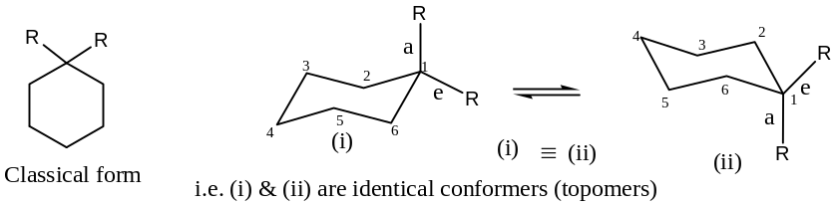
If the substituents are not same; i.e. when $R \& R$ are $R \& R^{'}$ and considering $R≫R^{'}$ then we will get two distinct conformers, on interconversion.
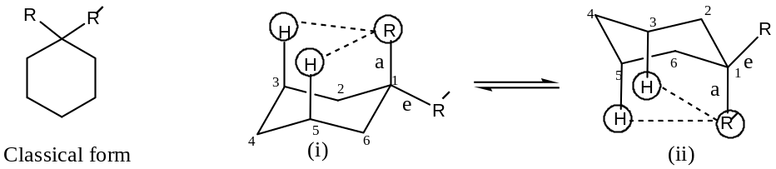
These two conformers are not identical, in —
- Bigger substituent ($R$) in the axial position and
- Bigger substituent ($R$) in the equatorial position.
In the equilibrium mixture, the conformer (ii) will be in excess, because of less $1,3–diaxial$ interaction between the $H$’s at $C_{3} \& C_{5}$ with the smaller substituent, which is, $i.e.$ $1,3–diaxial$ interaction is more when $R$, the bigger substituent in the axial position. Hence, the conformer ($i$) will be readily converted to the conformer ($ii$), in the equilibrium mixture.
For example, in $1–methylcyclohexanol$ (in DMSO); with ${CH}_{3}≫OH$
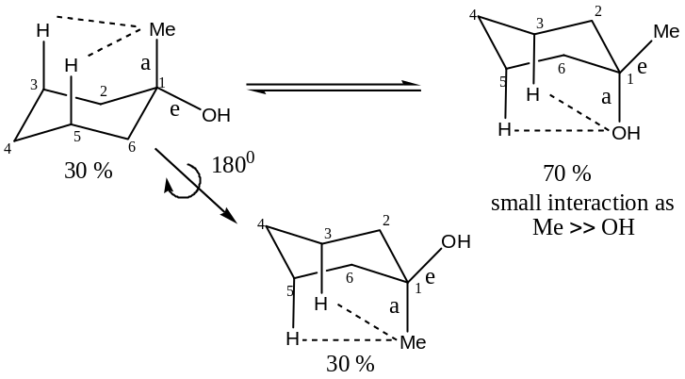
Exception: Now, let us consider the case of 1 – phenyl – 1 – methylcyclohexane, where$Ph≫{CH}_{3}$. The two conformers are —
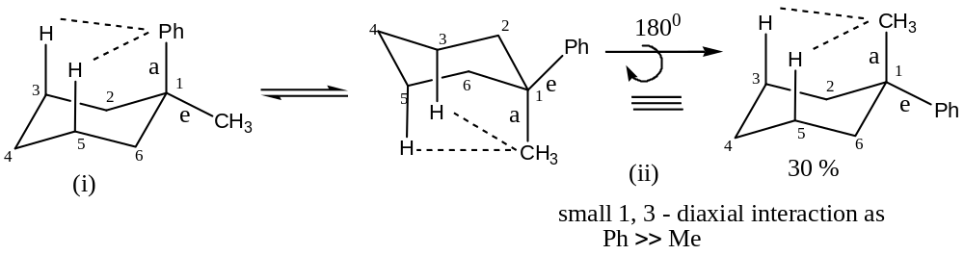
Theoretically, conformer (ii) should be in excess as the bigger group $Ph$- as compared to ${CH}_{3}$- group in the equatorial position, and hence should be less steric interaction ($1,3–diaxial$).
But practically, it has been found that actually conformer (i) is formed in excess over the conformation (ii). This can be explained as —
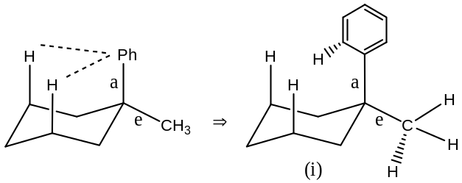
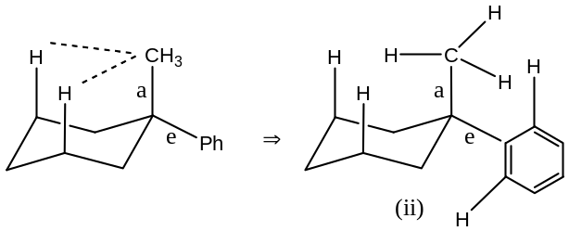
From the figure it is clear that the steric repulsion between H and 1, 3 – interaction is less in (i), which is more in (ii), i.e. the % of (i) > % of (ii).
%%%%%%%%%%%%%%%%%
1, 2 – Disubstituted Cyclohexane:
In disubstituted ($1,2– or 1,3– or 1,4–$) cyclohexanes there exists two diastereomeric forms, $cis$ – and $trans$ –.
Let us consider $1,2–disubstituted$ cyclohexanes and the substituents are $x \& y$. The 1, 2 – disubstituted cyclohexane shows diastereomerism even when $x=y$. The conformers are when —
(1) (2) (3) (4)
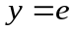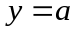
Here (1) & (2) are $cis$ – but (3) & (4) are $trans$ –.
If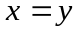, then (a, e) & (e, a) are identical, and thus there will be only one $cis$ – conformer, but the $trans$ – conformers are not same. Thus, if
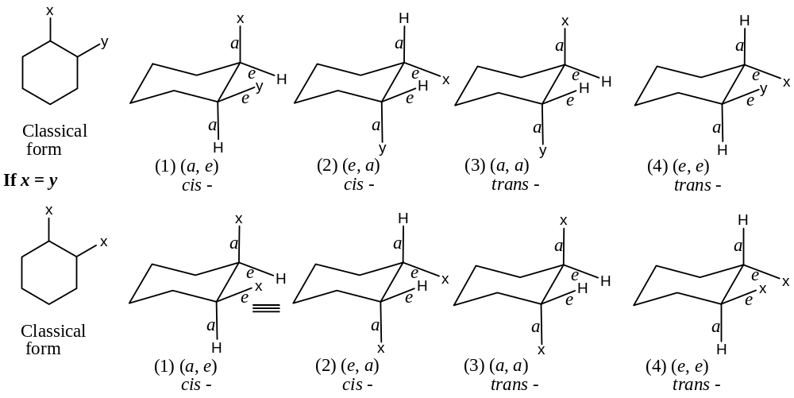
Thus, we get only 3 – diastereomers as (1) & (2) are identical for.
For $x≠y or x=y$, out of the conformations (3) is the least stable (practically non-existence), because here both the substituents suffer strong $1,3–diaxial$ steric repulsion.
If $x<y$, then the conformer (1) will be more stable than the conformer (2); because of the presence of strong $1,3–diaxial$ interaction of the bigger group in structure (2) [which is absent in structure (1)]. The conformer (1) is more stable [but not as (4)], here there is also 1, 3 – diaxial interactions with the smaller group (compared with $y$) then conformer (2). Conformer (4) is the most stable conformer out of all the four conformers, as here both the substituents are free from $1, 3 – diaxial$ steric hindrance.
Thus we can conclude that — in 1, 2 – disubstituted cyclohexane, in the $cis$ – compound one substituent must be axial and the other equatorial. If the substituents are differing in size, 1, 3 – interaction will be most powerful, when the larger group ($y$) is axial. Thus, the conformer with the lowest energy will be the one in which the larger group is equatorial (for $cis$ –).
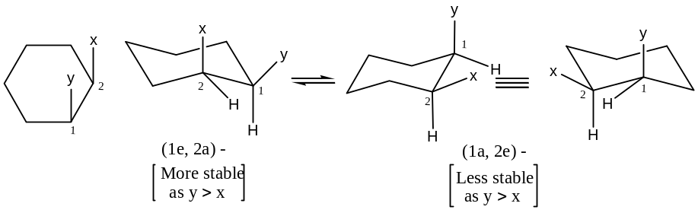
For example: (1) $cis$ – 2 – methylcyclohexanol:
Here ${CH}_{3}≫OH$
$⇒$ Expected preferred form is $1a$ – hydroxyl – $2e$–methylcyclohexane and this has been shown to so be in practice.
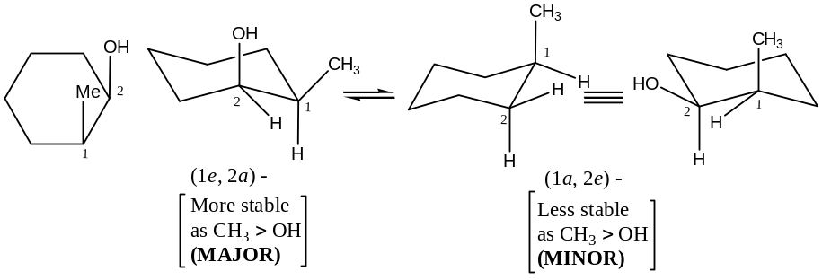
(2) $cis$ – Compounds with two identical substituents:
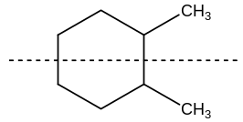For example: cis – 1, 2 – dimethylcyclohexane:
The classical structure is —
The classical structure shows the presence of plane of symmetry in the molecule, so optically inactive, i.e. not resolvable —
In the conformational isomer, one methyl group is axial and other is equatorial (to be cis –). Since the two forms are equally stable, so the equilibrium mixture contains equally (a, e) & (e, a) isomers.
At the first sight of the two conformers viz. (a, e) & (e, a), it may be seen that the molecule has no element of symmetry and thus, might be capable of optical activity (but which should not be). However, the two conformational isomers are also mirror images of each other. This can be seen by rotating the cis – isomer [marked as (a, e)] by an angle of 120⁰ around the vertical axis.
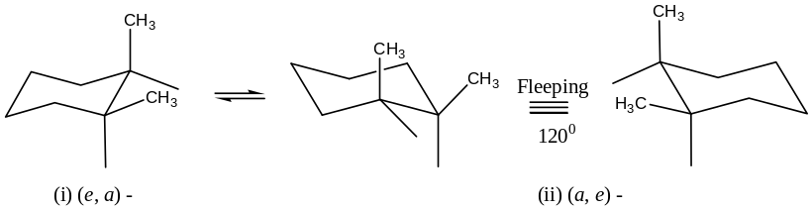
Since the two conformational isomers are present in equal amounts, cis – 1, 2 – dimethylcyclohexane exists as dl – pair, but the potential energy barrier between the isomers is too low to allow separation the dl – pair, i.e. non – separable. This is because of the fact that the two enantiomers undergo rapid auto-racemisation.
(3) 1, 2 – disubstituted $trans$ – cyclohexane:
In 1, 2 – disubstituted $trans$ – cyclohexane both the substituents are either (e, e) or (a, a).
Whether the substituents 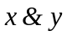 are identical or not, the two conformations are different, and because of the least 1, 3 – diaxial interactions, the preferred form is (e, e). Furthermore, (e, e) form will be more stable than the cis – [i.e. (a, e) or (e, a) form].
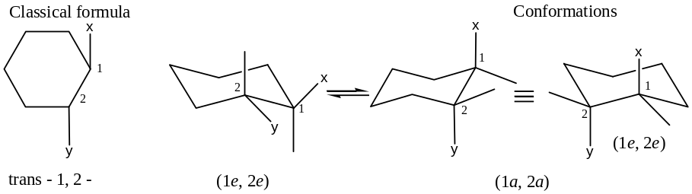
Both the classical formula and conformation of the trans – 1, 2 – compound (whether are identical or not) are not superimposable on their mirror images (so, optically active). Also, neither conformation can be converted into its mirror image by flipping. Hence, a trans – 1, 2 – disubstituted cyclohexane exists as a pair of enantiomers (whether are same or different).
For example (1): 1e, 2e – methylcyclohexanol,
Or 2e – methylcyclohexan – 1e –$ol$,
— This conformation is still stable than the cis – form, i.e. the most stable form is (e, e) [i.e. 1e – hydroxy – 2e –methylcyclohexane]. The cis – or 1a – hydroxy – 2e –methylcyclohexane is also stable (as less 1, 3 – diaxial interaction) but not as stable as (e, e) form.
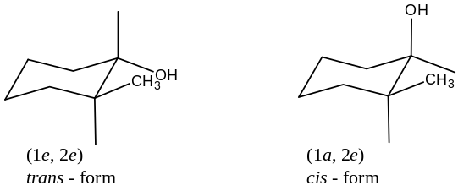
The $trans$ – form has been shown to be more stable than the cis – form. For example,
[1] The cis – form is readily converted into the $trans$ – form, when heated with sodium,
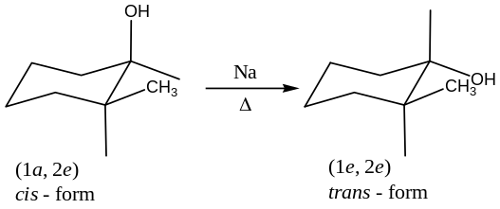
[2] Reduction of 2 – methylcyclohexanone (with Na in ethanol) produces $trans$ – alcohol,
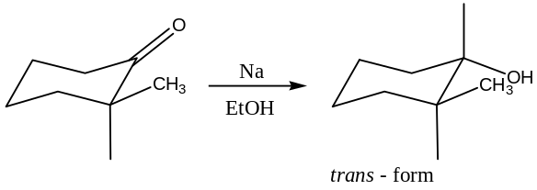
Thus, $trans$ – form is the most stable conformation of 1, 2 – disubstituted cyclohexane.
Example (2): Trans –1, 2 – dimethylcyclohexane:
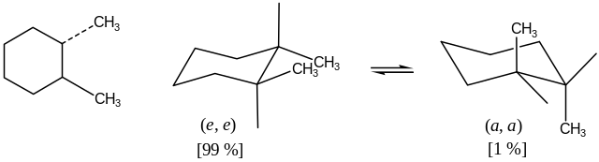There are two conformations of $trans$ – 1, 2 – dimethylcyclohexane, the diaxial and di-equatorial forms which are inter-convertible. The diaxial form has four gauche butane interactions (twice as many as the axial form of methyl cyclohexane) corresponding to an interaction energy of $4 0.9 or 3.6 kcal{mol}^{-1}$. The equatorial form has only one such interactions (between the methyl substituents) corresponding to an interaction energy of $0.9 kcal{mol}^{-1}$ only. Thus, the difference in energy between the conformational isomers is corresponding to an interaction energy of $3.6 – 0.9 = 2.7 kcal{mol}^{-1}$ i.e. the molecule is almost entirely (99 %) in the diequatorial form at room temperature. Both forms are shown below, which are dissymmetric and possess a non-identical mirror image which represents the enantiomers. Therefore, $trans$ – 1, 2 – dimethylcyclohexane forms a $d$l – pair, which are resolvable in agreement with the conclusion reached from planar models.
1, 3 – Disubstituted Cyclohexane:
1, 3 – Disubstituted cyclohexanes exists two diastereomeric forms, viz.
- cis – form, which is (e, e) or (a, a) and
Opposite for 1, 2 –
- trans –.form, which is (e, a) or (a, e)
Out of these (e, e) form is the most stable and (a, a) is the least stable form of 1, 3 – disubstituted cyclohexane. If both the substituents are same, then in either form both possess a plane of symmetry passing through C₂ and C₅ (so optically inactive).
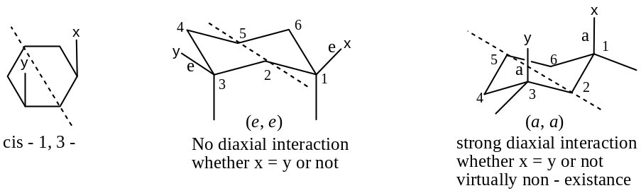
Stabilities of 1, 3 – Disubstituted Cyclohexane:
$Cis$ – 1, 3 – form is the most sable form, as it is fully free from diaxial interaction. In the case of cis – 1a, 3a – isomer of cyclohexane the substituents stick – out on the same side of the molecule and crowed each other badly. The resulting steric interaction has been found to give rise to an unfavourable energy term of $5.5 kcal{mol}^{-1}$, i.e. virtually nonexistence of the form.
In $trans$ – 1, 3 – disubstituted cyclohexane, one substituent is always equatorial and the other axial, i.e. either (e, a) or (a, e) form. These two forms are identical for the same substituents (say $R$). Here, one substituent always suffers $1,3–diaxial$ interactions. Thus, the stability order is —
Cis – 1e, 3e Trans – 1a, 3e Trans – 1e, 3a Cis – 1a, 3a (non-existence)
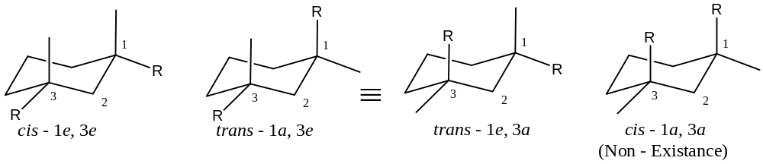
The stabilities of all the cis –, $trans$ – isomers of 1, 3 – disubstituted cyclohexane can also be considered in a different way. According to $Allinger’s$ rule — the isomers which has higher boiling point, refractive index, and density is the one which is less stable (conformation). Thus, according to this rule, the $trans$ – 1, 3 – disubstituted cyclohexane have the higher physical constants (as the $trans$ – form has the more axial substituents than the cis – form. Note that — cis – 1a, 3a – form is virtually nonexistence).
Optical activity of 1, 3 – disubstituted cyclohexane: —
For identical substituents (say for methyl group) cis – 1, 3 – dimethyl cyclohexane possesses a plane of symmetry passing through C₂ & C₅. Hence these are optically inactive.
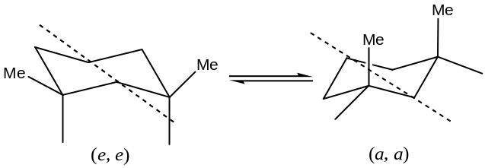
The $trans$ – 1, 3 – disubstituted cyclohexane molecule does not have a plane of symmetry (hence optically active) and, unlike in the case of cis – 1, 3 – compound, flipping the ring converts to the same molecule, not to its enantiomer, but to a species which is superimposable with the original molecule. Thus, in this case, the (+) – and (–) – forms are capable of discrete existence, hence are resolvable.
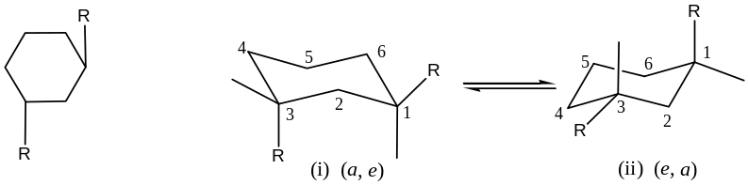
Since (i) and (ii) are identical (may not be if R = R) and has no any element of symmetry, hence are optically active, and so there should be a mirror image relationship, which are non – superimposable.
From the figure given below, it is obvious that (i) & (ii) are non-superimposable mirror images. Interconversion of (i) by an angle through $120^{°}$ gives (ii) which are not identical with (i), hence are not enantiomer.
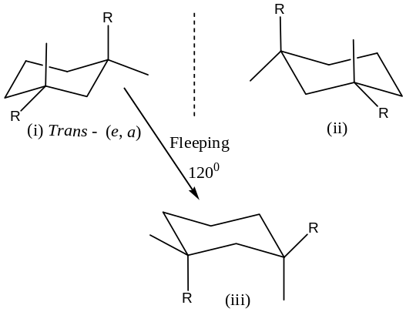
Problem: Write about the conformations of 1, 3 – dimethylcyclohexane. 5
1, 4 – disubstituted cyclohexane: —
It has two diastereomeric forms viz.
- cis – which is (e, a) or (a, e) and
- trans – which is (a, a) or (e, e)
Both the forms have a plane of symmetry passing through C₁ & C₄ and hence are optically inactive.
If the substituents are same, then the two cis – forms are identical, but the $trans$ – isomers are not the same. Again, if we consider the interactions then, $trans$ – diequatorial – 1, 4 – disubstituted cyclohexane will be the most stable form.
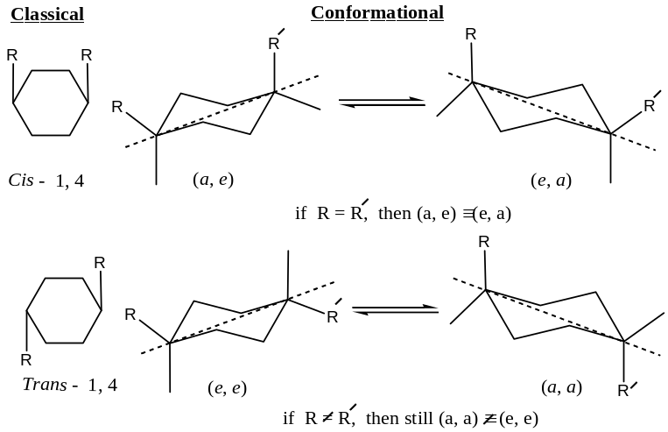
Energy order: If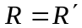, then
Trans – 1e, 4e Cis – 1a, 4e Cis – 1e, 4a Trans – 1a, 4a
If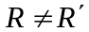and 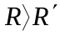, then
Trans – 1e, 4e Cis – 1e, 4a Cis – 1a, 4e Trans – 1a, 4a
Table: Conformations and Energies of Dimethylcyclohexane:
Isomer | Conformation | No of gauche interactions | Interaction energy in $kcal{mol}^{-1}$
Cis – 1, 2  Trans – 1, 2 | 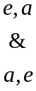  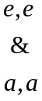 | 3  1  4 | 2.7  0.9  3.6
Cis – 1, 3  Trans – 1, 3 |  | 4  0  2 | 5.4  0  1.8
Cis – 1, 4  Trans – 1, 4 |  | 2  0  4 | 1.8  0  3.6

Question: In a stereoisomer of 2 – isopropyl – 5 – methyl cyclohexanol, the methyl group is cis to the hydroxyl group and the isopropyl is trans. Draw the two chair forms of the compound and explain which conformer would be the most stable.
Solution: The stereoisomers of 2 – isopropyl – 5 – methyl cyclohexanol, in which the methyl group is cis to the hydroxyl group and the isopropyl is $trans$ are drawn in the chair conformation as shown below:
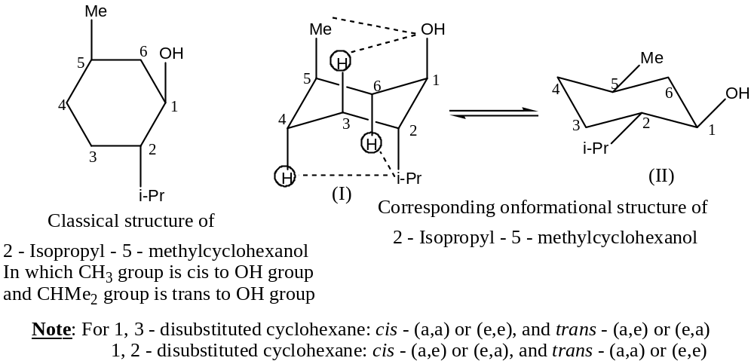
Out of these two conformations, conformer (II) is highly stable as it is fully free from 1, 3 – diaxial interactions compared to the conformer (I), which is unstable (practically non-existence) as in this conformation all the substituents suffering from strong1, 3 – diaxial interactions (shown by dotted lines). //
Decalin, $C_{10}H_{16}$: Stable conformations are —
