nitrogen containing functional Groups
Syllabus: Preparation and important reactions of nitro compounds, nitriles and isonitriles Amines: Effect of substituent and solvent on basicity; Preparation and properties: Gabriel phthalimide synthesis, Carbylamine reaction, Mannich reaction, Hoffmann’s exhaustive methylation, Hofmann-elimination reaction; Distinction between 1°, 2°and 3° amines with Hinsberg reagent and nitrous acid
NITRO COMPOUNDS (Aliphatic & Aromatic) —
Aliphatic Nitro Compounds —
(Organic Derivative of Inorganic Acids)
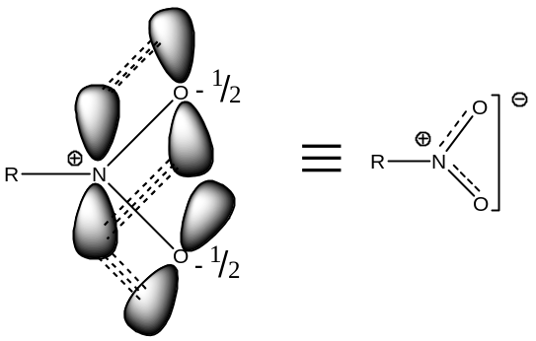
Alkyl Nitrates ($RONO_{2}$) —
Alkyl nitrates may be considered as esters of nitric acid —
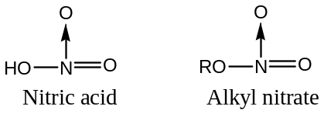
For example —
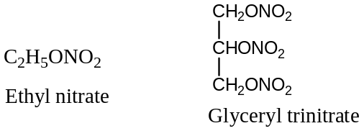
Glyceryl trinitrate, often misnomer “nitro-glycerine” is an important explosive used in the form of dynamite, blasting gelatine, cordite or smokeless gun-powder. It is also used as a medicine in the treatment of heart disease called angina pectoris.
Preparation of Alkyl Nitrates — Alkyl nitrates can be prepared by the following general methods —
[$1$] From Alcohol & Nitric acid: By the interaction of an alcohol and concentrated nitric acid or a mixture of nitric acid and sulphuric acid at low temperature yields an alkyl nitrate. Thus, —
$$ROH+HONO_{2} \left(HNO_{3}\right) \underset{→}{H_{2}SO_{4}, low temp} RONO_{2}+ H_{2}O$$
For example, —
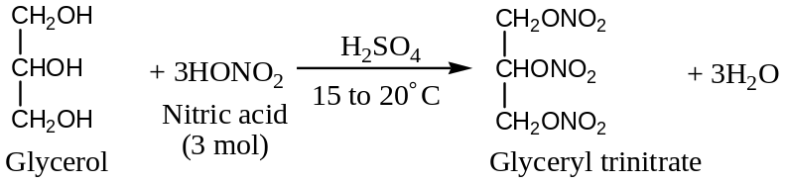
[$2$] From Alkyl Halides: Treatment of an alkyl halide with silver nitrate yields alkyl nitrate. Thus, —
$$R-X+AgONO_{2} \left(AgNO_{3}\right) ⟶ RONO_{2}+ AgX↓$$
This is an example of typical nucleophilic substitution reaction.
For example, —
$$C_{2}H_{5}-I+AgONO_{2} \left(AgNO_{3}\right) ⟶ C_{2}H_{5}ONO_{2}+ AgI↓$$
Ethyl iodide Ethyl nitrate
General Physical Properties of Alkyl Nitrate —
Alkyl nitrates are colourless low boiling point liquids.
General Chemical Properties (Reactions) of Alkyl Nitrate —
Important chemical reactions are —
[$1$] Hydrolysis of Alkyl Nitrates: Alkaline or acidic hydrolysis of alkyl nitrates results in the formation of an alcohol — [2019, 2020]
$$RONO_{2}+ HOH \underset{→}{{:OH^{-}}/{or H^{+}}} ROH+HNO_{3}$$
Alkyl nitrate Alcohol
For example, —
$$C_{2}H_{5}ONO_{2}+ HOH \underset{→}{{:OH^{-}}/{or H^{+}}} C_{2}H_{5}OH+HNO_{3}$$
Ethyl nitrate Ethyl alcohol
[$2$] Reduction of Alkyl Nitrates: Reduction of alkyl nitrates by $Sn+HCl$ yields an alcohol along with the formation of hydroxyl amine—
$$RONO_{2}+ 6\left[H\right]\underset{→}{Sn+HCl} ROH + :NH_{2}OH + H_{2}O$$
Alkyl nitrate Alcohol Hydroxyl amine
For example, —
$$CH_{3}CH_{2}ONO_{2}+ 6\left[H\right]\underset{→}{Sn+HCl} CH_{3}CH_{2}OH + :NH_{2}OH + H_{2}O$$
Ethyl nitrate Ethyl alcohol Hydroxyl amine
Alkyl Nitrites ($RONO$) —
Alkyl nitrates may be considered as esters of nitrous acid ($HNO_{2}$) —
For example —
$$HO-\ddot{N}=O, RO-\ddot{N}=O; For Example: C_{2}H_{5}O-\ddot{N}=O, {\left(CH_{3}\right)}_{2}CHCH_{2}CH_{2}ONO$$
Nitrous acid Alkyl nitrite Ethyl nitrite Isoamyl nitrate
Alkyl nitrites have been used in medicine. Ethyl nitrite, popularly known as sweet sprit of nitre, is used as a diuretic. Isoamyl nitrite is used as antispasmodic in angina pectoris and as a restorative in cardiac failure. Nitro alkanes ($RNO_{2}$) are isomeric with alkyl nitrites.
General methods Preparation of Alkyl Nitrites — Alkyl nitrites can be prepared by the following general methods —
[$1$] From Alcohol & Nitrous acid: Alkyl nitrites are generally prepared by the interaction of alcohols and nitrous acid (formed in situ by the action of $H_{2}{SO}_{4}$ on sodium nitrite). Thus, —
$$NaNO_{2}+ H_{2}{SO}_{4} ⟶NaHSO_{4}+ HNO_{2} or HONO$$
Nitrous acid
$$ROH + NaNO_{2}+ H_{2}{SO}_{4} ⟶RON=O + NaHSO_{4}+ H_{2}O$$
For example —
$$C_{2}H_{5}OH + HONO ⟶ C_{2}H_{5}ON=O + H_{2}O$$
Ethanol Nitrous acid Ethyl nitrite
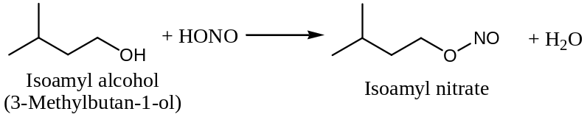
[$2$] From Alcohol & Nitrogen trioxide acid: Reaction of an alcohol with nitrogen trioxide results in the formation of an alkyl nitrite. Thus, —
$$2ROH + N_{2}O_{3} ⟶2RON=O + H_{2}O$$
For example —
$$2CH_{3}CH_{2}OH + N_{2}O_{3} ⟶ 2CH_{3}CH_{2}ON=O + H_{2}O$$
Ethanol Ethyl nitrite
General Chemical Properties (Reactions) of Alkyl Nitrite —
Following are the only two important chemical reactions of alkyl nitrite —
[$1$] Hydrolysis of Alkyl Nitrites: Alkaline or acidic hydrolysis of alkyl nitrites results in the formation of an alcohol —
$$RON=O+ HOH \underset{→}{{:OH^{-}}/{or H^{+}}} ROH+HNO_{2}$$
Alkyl nitrite Alcohol
For example, —
$$C_{2}H_{5}ON=O+ HOH \underset{→}{{:OH^{-}}/{or H^{+}}} C_{2}H_{5}OH+HNO_{2}$$
Ethyl nitrate Ethyl alcohol
[$2$] Reduction of Alkyl Nitrites: Reduction of alkyl nitrites by $Sn+HCl$ yields an alcohol along with the formation of ammonia—
$$RON=O+ 6\left[H\right]\underset{→}{Sn+HCl} ROH + NH_{3} + H_{2}O$$
Alkyl nitrite Alcohol Ammonia
For example, —
$$CH_{3}CH_{2}ON=O+ 6\left[H\right]\underset{→}{Sn+HCl} CH_{3}CH_{2}OH + NH_{3} + H_{2}O$$
Ethyl nitrite Ethyl alcohol
Nitroalkanes ($RNO_{2}$) —
Nitroalkanes (or nitro-paraffins) are derived from alkanes by the replacement of one or more $H$- atoms by the nitro group ($-NO_{2}$). For example, —
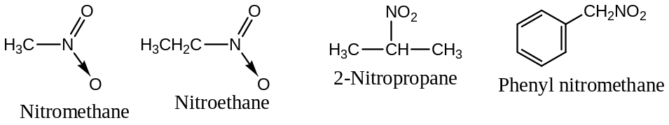
Nitroalkanes are classified as $1^{0}$-, $2^{0}$- or $3^{0}$- nitro compounds depending upon the nature of the $C$- atoms to which the $-NO_{2}$ group is directly attached. For example, —
$RCH_{2}NO_{2} ⟶$ Primary ($1^{0}$-) nitroalkane
$R_{2}CHNO_{2} ⟶$ Secondary ($2^{0}$-) nitroalkane
$R_{3}CNO_{2} ⟶$ Tertiary ($3^{0}$-) nitroalkane
Isomerism: Nitroalkanes exhibit chain and positional isomerism among themselves but functional group isomerism with alkyl nitrites. For example, —
Molecular formula, $C_{4}H_{9}NO_{2}$ can have the following isomers —
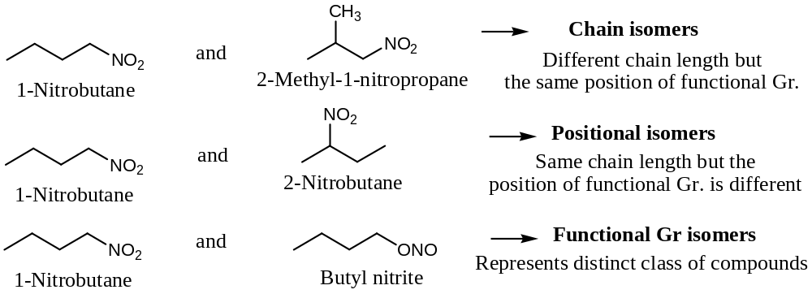
Important: $1^{0}$- and $2^{0}$- Nitroalkanes undergoes tautomerism, called $nitro$- $aci$ tautomerism as the two tautomeric forms are $nitro$- and $aci$- form.
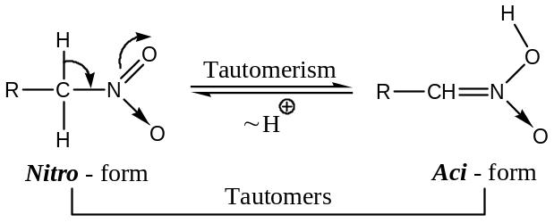
Structure: Nitroalkane may be regarded as the resonance hybrid of the following resonating structures —
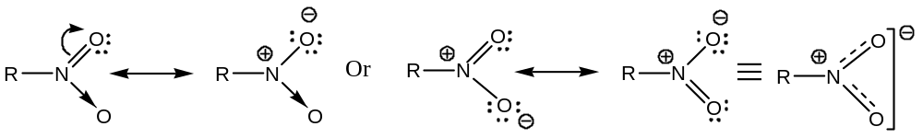
General methods of Preparation: Nitroalkanes can be prepared by the following general methods —
[$1$] By direct Nitration: Alkanes beyond hexane can be nitrated directly by prolonged treatment with fuming $HNO_{3}$ at high temperatures. For example, —
$$C_{6}H_{14}+ HONO_{3} \underset{→}{500℃ for 40 hrs} C_{6}H_{13}NO_{2} +H_{2}O$$
The reaction is believed to precede via free-radical substitution pathways.
[$2$] By the action of Metal nitrides and Alkyl Halides: Reaction of metal nitrites with alkyl halides results a mixture of alkyl nitrites and nitro-alkanes following nucleophilic substitution pathways. Thus, —
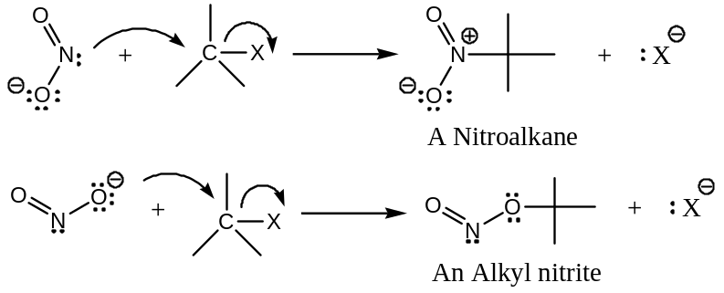
Out of the nitroalkane and nitrite, which one will predominant is determined by the structures of the reactants and the reaction conditions used.
[Note: Since both the $N$- with unshared electron pair and $O$- with $–ve$ charge act as nucleophile, hence such nucleophiles are called ambident nucleophiles]. For example —
($a$) With a given halide, $AgNO_{2}$ gives mainly nitro compound than alkali metal nitrite ($KNO_{2}$ as an example, say
($b$) With a given nitrite, the proportion of the nitro compound decreases from $1^{0}$- to $2^{0}$- to $3^{0}$- halides. For example —
$${CH}_{3}{CH}_{2}{CH}_{2}{CH}_{2}Br \underset{→}{{AgNO_{2}}/{ether}} {CH}_{3}{\left({CH}_{2}\right)}_{3}NO_{2} + {CH}_{3}{\left({CH}_{2}\right)}_{3}ONO$$
$n$- Butyl bromide $1$- Nitrobutane ($70\%$) $n$- Butyl nitrite ($15\%$)
$${\left({CH}_{3}\right)}_{2}CHBr \underset{→}{{AgNO_{2}}/{ether}} {\left({CH}_{3}\right)}_{2}CHNO_{2} + {\left({CH}_{3}\right)}_{2}CHONO$$
Isopropyl bromide $2$- Nitropropane ($20\%$) Isopropyl nitrite ($30\%$)
$${\left({CH}_{3}\right)}_{3}CBr \underset{→}{{AgNO_{2}}/{ether}} {\left({CH}_{3}\right)}_{3}C-NO_{2} + {\left({CH}_{3}\right)}_{3}CONO$$
$tert$- Butyl bromide $2$- Methyl-$2$-nitropropane $tert$- Butyl nitrite ($60\%$)
($traces$)
($c$) Alkali metal nitrites, normally give very low yields of nitro compounds, but the use of polar solvents like dimethyl formamide (DMFA) and dimethyl sulphoxide (DMSO) increases the yields.]
[$3$] By the action of Sodium nitride and $α$- Halogenated acids: The $α$- halogenated acids, on treatment with $aq NaNO_{2}$ yields $α$- nitro derivatives which on decarboxylation by heating results nitroalkanes. For example —
($i$) ${CH}_{3}CH\left(Cl\right)COOH +NaNO_{2} \underset{→}{ ∆ } {CH}_{3}CH\left(NO_{2}\right)COOH +NaCl$
$α$- Chloropropionic acid $α$- Nitropropionic acid
($ii$) ${CH}_{3}CH\left(NO_{2}\right)COOH +NaNO_{2} \underset{→}{ ∆ } {CH}_{3}CH_{2}NO_{2} +CO_{2}↑$
$α$- Nitropropionic acid Nitroethane
[$4$] By the Oxidation of $tert$- alkyl Nitration: Oxidation of $t$- alkyl $1^{0}$- amine by $KMnO_{4}$ yields the corresponding nitro alkane. Thus, —
$$R_{3}C-\ddot{N}H_{2} \underset{→}{{ [O]}/{KMnO_{4} }} R_{3}C-NO_{2} + H_{2}O$$
For example —
$${\left({CH}_{3}\right)}_{3}C-\ddot{N}H_{2} \underset{→}{{ [O]}/{KMnO_{4} }} {\left({CH}_{3}\right)}_{3}C-NO_{2} + H_{2}O$$
$tert$- Butyl amine $2$- Methyl-$2$-nitropropane ($80\%$)
General Physical Properties of Nitroalkanes —
Nitroalkanes are colourless, pleasant-smelling liquids, only sparingly soluble in water. They are much less volatile than the corresponding alkyl nitrites. For example — Nitroethane boils at $114℃$, as compared to ethyl nitrite boiling at $17℃$.
General Chemical Properties (Reactions) of Nitroalkanes —
Following are the important representative reactions of nitroalkanes —
[$1$] Reduction of Nitroalkane: Nitroalkanes yield different products under different conditions. For example —
($a$) In acid reducing medium (metal + acid) — $1^{0}$- amines are formed
$$RNO_{2} +6[H] \underset{→}{{ Zn }/{ HCl }} R\ddot{N}H_{2} + 2H_{2}O$$
($b$) Catalytic reduction — $1^{0}$- amines are formed
$$RNO_{2} +3H_{2} \underset{→}{Raney Ni} R\ddot{N}H_{2} + 2H_{2}O$$
($c$) In neutral reducing medium ($Zn$- dust$+ NH_{4}Cl$) — Hydroxyl amines are mainly formed
$$RNO_{2} +4[H] \underset{→}{{ Zn }/{ NH_{4}Cl }} R\ddot{N}HOH + 2H_{2}O$$
Alkyl hydroxyl amine
[In contrast, alkyl nitrites on reduction yields $1^{0}$- alcohols]
[$2$] Action of Nitrous acid on Nitroalkane: Different nitroalkanes react differently with nitrous acid ($HNO_{2}$). For example —
($a$) $1^{0}$- Nitroalkane yields nitrolic acid, which dissolve in alkalis to form red colourization
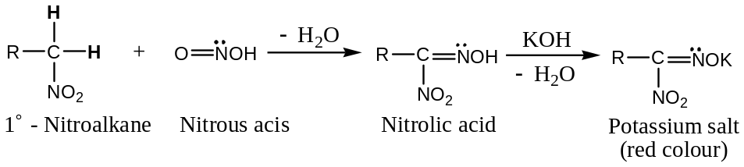
($b$) $2^{0}$- Nitroalkane yields pseudonitroles, which are blue or bluish green in the liquid state but do not dissolve in alkalis due to the absence of ionisable $H$- atom
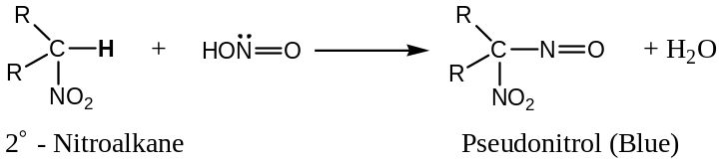
($c$) $3^{0}$- Nitroalkane compounds do not react with nitrous acid ($HNO_{2}$) and therefore remains colourless.
Thus, this reaction [reaction of nitroalkanes with nitrous acid ($HNO_{2}$)] can be used to distinguish all the $3$- classes of nitroalkanes ($1^{0}$-, $2^{0}$- & $3^{0}$-) or alkyl halides ($1^{0}$-, $2^{0}$- & $3^{0}$-) or alcohols ($1^{0}$-, $2^{0}$- & $3^{0}$-) from which these can be prepared.
[$3$] Halogenation of Nitroalkane: $1^{0}$- & $2^{0}$- Nitro compounds are easily attract by halogens (${Cl}_{2} \& {Br}_{2}$) in an alkaline solution resulting substitution at $α$- position only. For example —
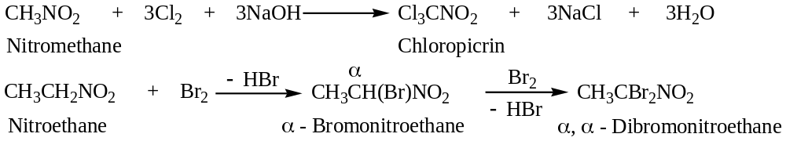
[$4$] Condensation of Nitroalkane with Aldehydes: $1^{0}$- & $2^{0}$- Nitro compounds having $α$- hydrogens easily condensed with aldehydes in the presence of a base to form hydroxy nitroalkane. Thus, —
$$RCHO + CH_{3}NO_{2} \underset{→}{ NaOEt } RCH(OH)CH_{2}NO_{2}$$
Aldehyde Nitromethane Hydroxy nitroalkane
Mechanism: Condensation of aldehyde with nitro alkane is similar to aldol condensation, involving nucleophilic addition of resonance stabilized carbanion ($H_{2}{\ddot{C}}^{-}NO_{2}$) to the carbonyl group of the aldehyde. The reaction completes in two steps —
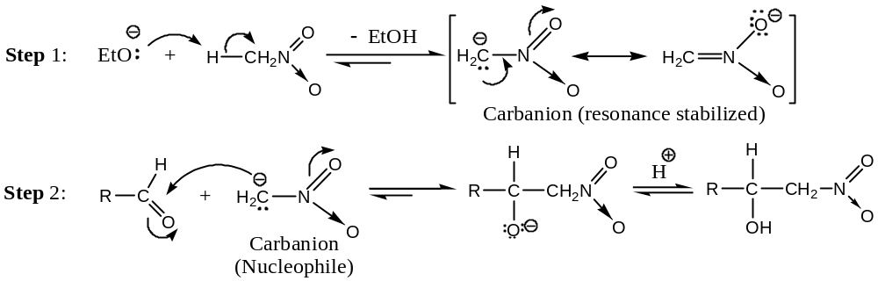
[Extra: ALDOL CONDENSATION: [Self-addition]
Dilute acid or base catalysed condensation reaction between two moles of carbonyl compounds, identical or different and at least one of them containing $α$-$H$- atoms (opposite to Cannizzaro’s reaction), which gives rise to a $β$- hydroxy carbonyl compound (a dimer, called aldol) or an $α,β$- unsaturated carbonyl compound is known as aldol condensation.
Usually dilute aqueous solution of $NaOH, KOH, Ba(OH)_{2}, K_{2}{CO}_{3}$ and that of $HCl$ are used as base & acid catalysts respectively.
Simple examples of aldol condensation reactions are:
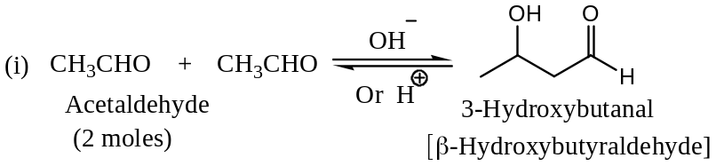
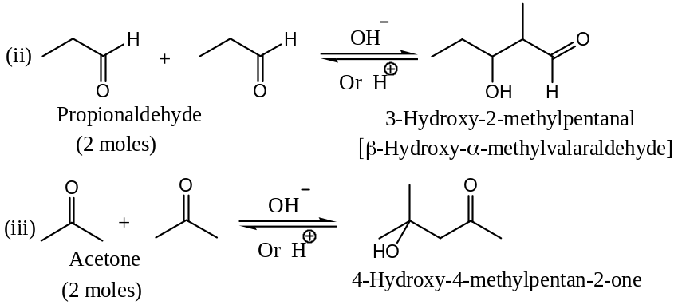
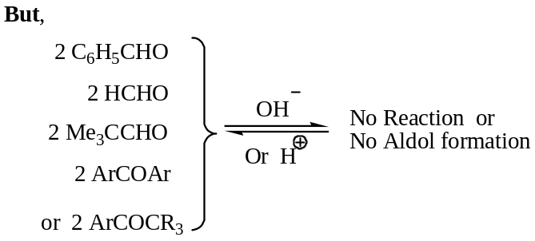
― as all these does not contain an $α$-$H$- atoms. [However, in presence of conc. base these undergo Cannizzaro’s reaction.]
Mechanism of aldol condensation:
- Generally accepted base catalysed aldol condensation reaction can be explained as:
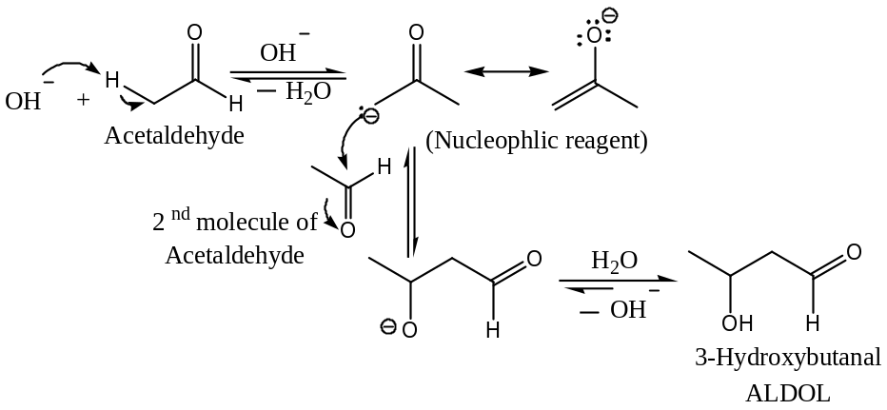
― Thus, the acidic $α$-$H$- atoms (proton) of one of the acetaldehyde is abstracted by the base to generate a resonance stabilised carbanion, which undergoes nucleophilic addition with another molecule of the carbonyl compound, hydrolysis of which yields the desired aldol.
- Acid catalysed aldol condensation for the formation of 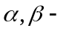unsaturated carbonyl compound can be explained as:
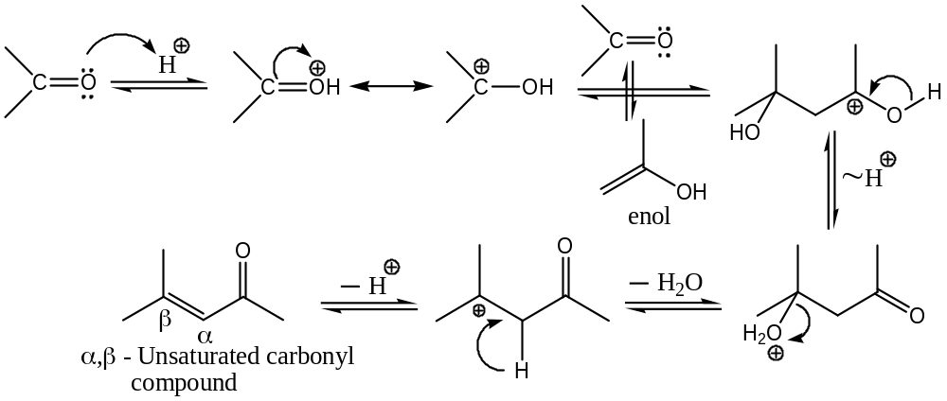
Important:
    - Dehydration of aldol products:
The$β$- hydroxy carbonyl compound obtained from aldol condensation can be easily hydrolysed to form mainly $α,β$- unsaturated carbonyl compound. For example,
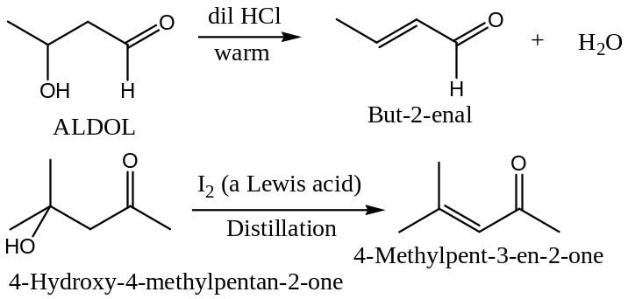
[Note: $C=C$ conjugated to $C=O$ of carbonyl group are more stable]
Similarly, with aromatic carbonyl compounds ―
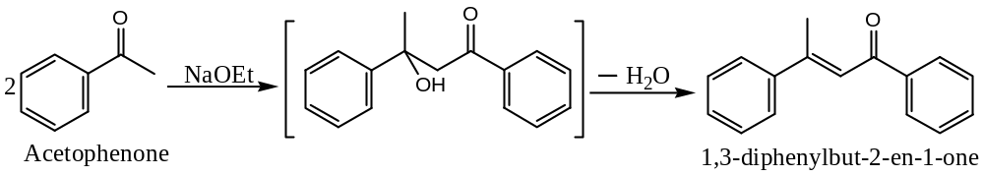
    - Use of Aldol Condensation in Synthesis:
Catalytic hydrogenation of $α,β$- unsaturated carbonyl compounds yields saturated alcohols, by the reduction of both $C=C$ and $C=O$ bonds. Thus, aldol condensation is ultimately used for the synthesis of saturated alcohols. For example,
Both of $n$-$Butyl alcohol$ and $2$-$Ethylhexan$-$2$-$ol$ are synthesised on industrial scale as:
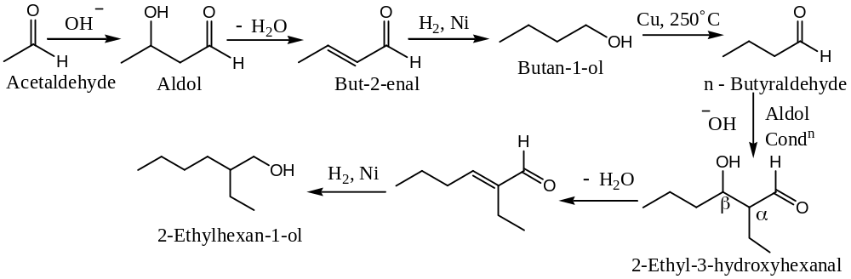
Question: Outline the synthesis of the following alcohols starting from alcohols of smaller carbon number:
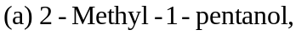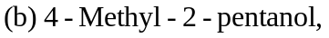
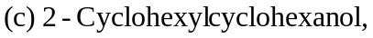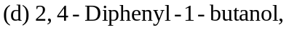
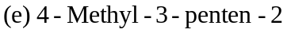.
    - Crossed Aldol Condensation:
An aldol condensation reaction involving two different carbonyl compounds is termed as Crossed Aldol Condensation. Under such conditions 4- possible products may result, however, under certain conditions; a good yield of a single product can be obtained from a crossed aldol condition:
        - One reactant without $α$-$H$- atoms (therefore, is in capable of condensing with itself, for example, benzaldehyde or formaldehyde)
        - This reactant is mixed with the catalyst, and
        - A carbonyl compound that contains $α$-$H$- atoms is added slowly to this mixture.
For example,
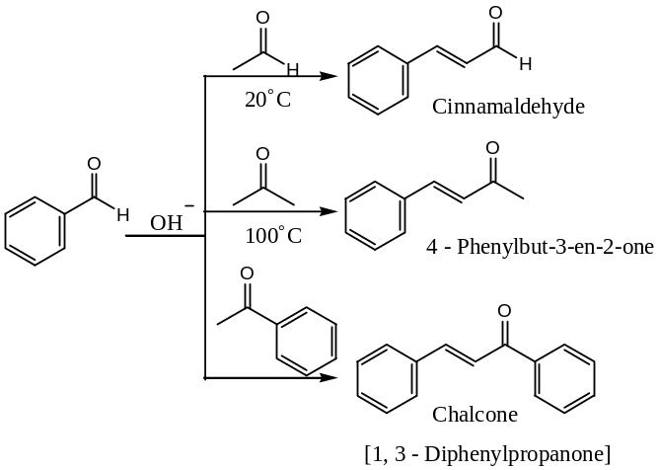
Question: Outline the synthesis of each of the following from benzene or toluene and any readily available alcohols:
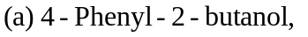
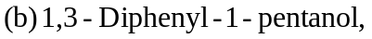
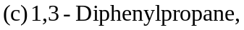
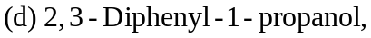
.]
[$5$] Action of Alkalies on Nitroalkane: $1^{0}$- & $2^{0}$- Nitro compounds are acidic and form salts with alkalis. The acidic character can be well explained form the resonance stabilized carbanion intermediate. These nitro compounds are capable of showing tautomerism as shown below —
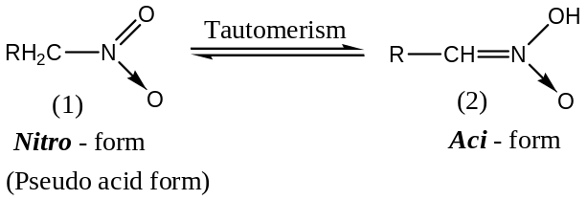
The $aci$- form readily reacts with alkalis forming salts —
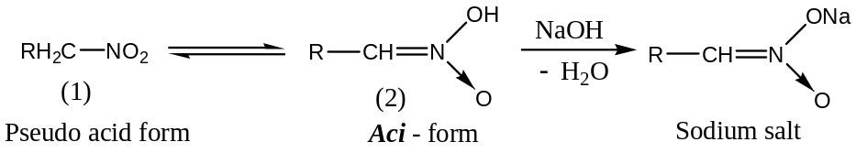
Application: Sodium salts of $1^{0}$- & $2^{0}$- nitro alkanes on hydrolysis by $50 \% H_{2}{SO}_{4}$ at room temperature yield aldehydes and ketones respectively. This reaction is known as the Nef- Carbonyl synthesis. Thus, —
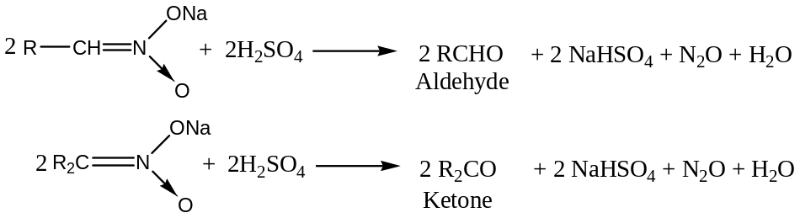
Mechanism of Nef- Reaction: Mechanism for Nef- carbonyl synthesis can be written as —
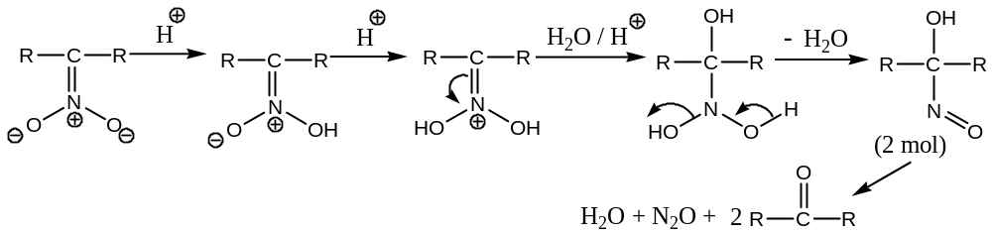
[$6$] Michael Addition with Nitroalkane: Addition of nitromethane to $α,β$- unsaturated ester is known as Michael addition. For example —
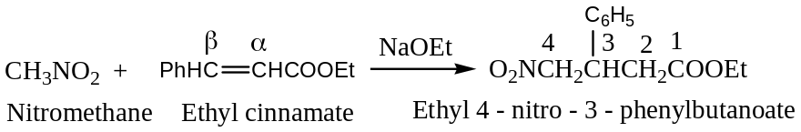
Mechanism: Michael addition involves three steps —
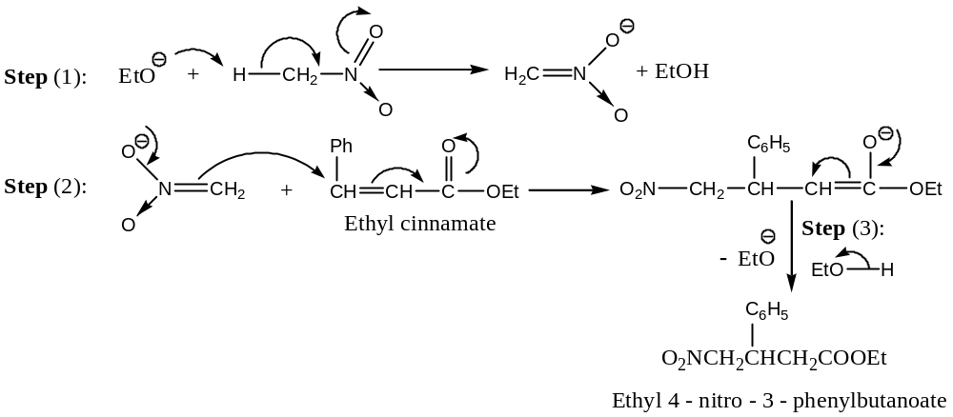
[Extra: Michael Condensation (Addition) —
The base catalyzed condensation ($\ddot{B}=NaOEt, or 2^{0}$-$amines$) reaction between an $α,β$- unsaturated keto compound or any activated unsaturated compounds (aldehyde-ketone, esters) and a compound with an active methylene group (malonic ester, Ethylaceto acetate, etc.) is known as Michael condensation. It is a reversible (hence, less important) nucleophilic $3,4$- addition reaction. Thus —
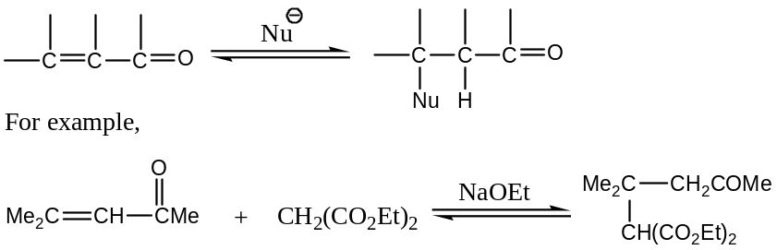
Mechanism: A resonance stabilized carbanion (nucleophile) is generated by the abstraction of the active $H$- by the base from the active methylene group compound. The nucleophilic addition of the carbanion (at position - $4$) to the active double bond to form a $C-C$ bond and generates another resonance stabilized carbanion, protonation (at position - $3$) completes the reaction.
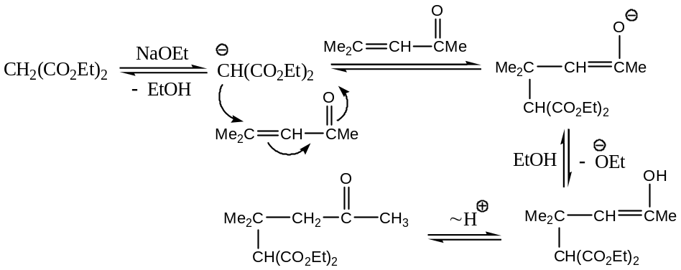
[In practice, actually $1,4$- addition product is formed first, which is then tautomerize to the $3,4$- addition product]
Important Note & Discussion:
$[1]$ Michael Retrogression (i.e. Reversal):
Michael condensation is a reversible reaction, thus a Michael retrogression i.e. reversal, may occur to produce compounds different from the starting compound. For example, —
Starting with $benzylidenemalonic ester$ and $ethyl acetoacetate, EAA$ in presence of large amount of $NaOEt$ results in a mixture containing the reactants, the Michael condensation product and $benzylidene acetoacetate$ and $malonic ester$ (produced by retrogression). If the reaction is carried out with the last two compounds as starting materials, the same mixture is obtained. Thus, —
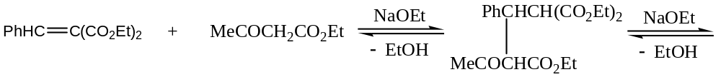
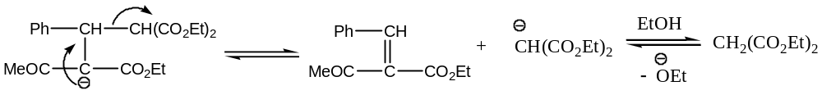
$[2]$ Michael Addition followed by Claisen Condensation:
After the Michael condensation has occurred, it is followed by an internal Claisen condensation and leads to the formation of $dimedone$.
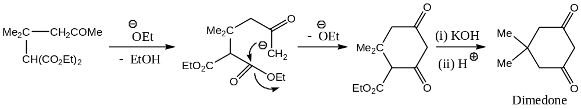]
[$7$] Mannich reaction with Nitroalkane: $1^{0}$- & $2^{0}$- Nitroalkanes (not tertiary) undergo Mannich reaction to form nitroamines. For example —
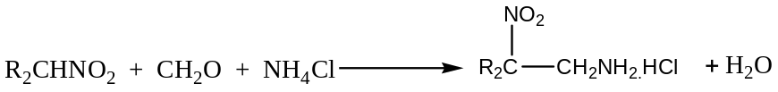
[Extra: Mannich Reaction —
Acid catalysed (base may also be used) condensation reaction involving formaldehyde (or any other aldehyde), ammonia, or $1^{0} or 2^{0}$- $amine$ (usually as their hydrochloride) and a compound containing active $H$- atom (for example, $aldehyde$, $ketone$, $β$-$keto ester$) is known as Mannich reaction. The product of Mannich reaction $i.e.$ amino- or substituted amino- derivatives of active $H$- atom containing compound is called the Mannich base. The Mannich base, so obtained is as the salt (or chloride), from where free Mannich base is obtained by hydrolysis. For example,
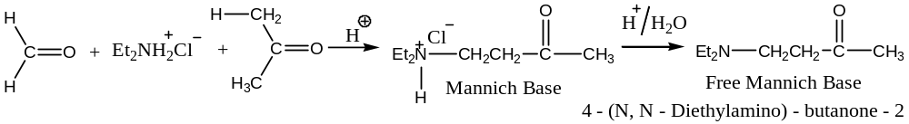
Mechanism:
First a resonance stabilized $iminium$ salt is formed in presence of acid by the nucleophilic addition of the amine to formaldehyde. Finally, nucleophilic addition of $iminium$ salt reacts with the enol form of the active $H$- atom containing compound completes the reaction.
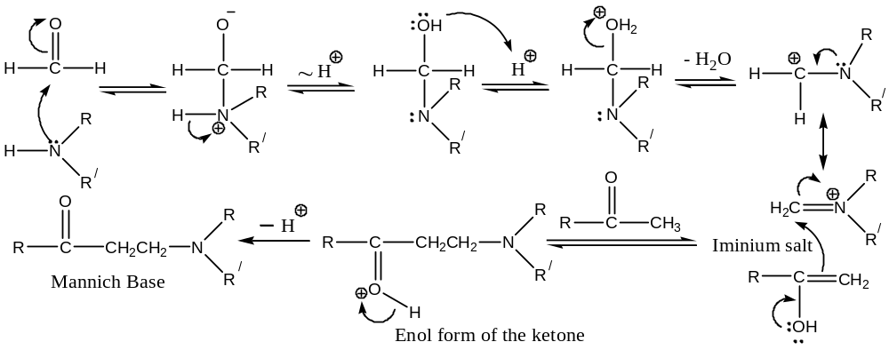
Scope & Application of Mannich Reaction:
Since the Mannich bases are useful as intermediate in synthesis, the Mannich reaction has wide range of applications. For example, When the Mannich base is an $β$- amino-carbonyl compound, an $α,β$- unsaturated carbonyl compound is obtained on heating it, which on catalytic hydrogenation gives the saturated ketone. Thus,
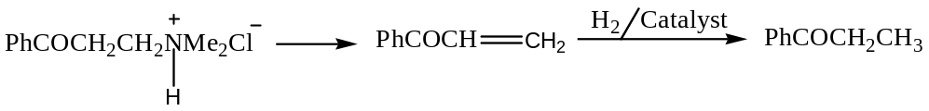]
Uses of Nitro Compounds: The nitro compounds, particularly the lower members (obtained by vapour phase nitration of paraffins), are finding extensive use as solvents for oils, resins, cellulose, esters, dyes, etc.
####################################
Aromatic Nitro Compounds —
Broadly speaking, aromatic nitro compounds are of $2$- types —
($A$) Nucleus Substituted (Nitroarenes): Here, the $-NO_{2}$groups are attached directly to the aromatic nucleus. These are generally known as the aryl nitro compounds. For example —
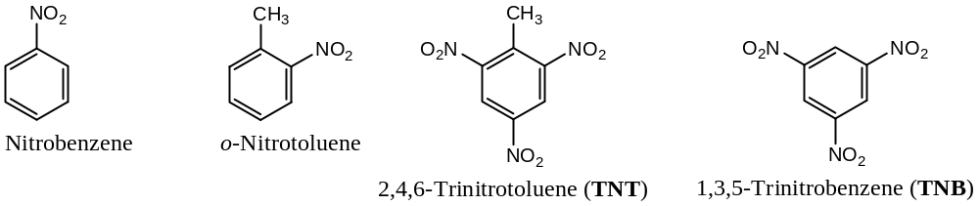
Nuclear substituted nitro compounds i.e. nitroarenes are valuable intermediate for the synthesis of drugs (e.g. chloramphenicol), dyes (e.g. picric acid), explosive (e.g. TNT) and some commonly used laboratory reagents like $2,4$- DNP (for carbonyl compounds), $3,5$- dinitrobenzoyl chloride ($3,5$- DNBC for alcohols & hydroxy compounds), $2,4$- dinitrofluorobenzene ($DNFB$), also known as Sanger’s reagent (for $N$- terminal amino acids).
($B$) Side-Chain Substituted (Nitroarenes): Here, the $-NO_{2}$group is attached in the side chain of the aromatic nucleus. For example —
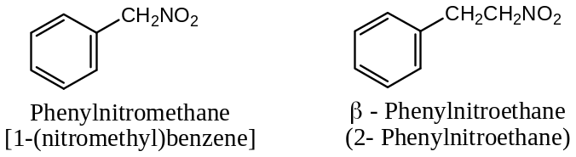
These are essentially aryl substituted nitroalkanes and are resembled to nitroalkanes.
Resonance: The nitro group is a resonance hybrid of two equivalent contributing structures —
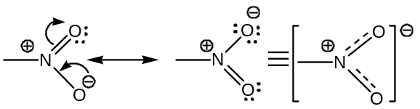
Thus, the nitro group appears to be iso-electronic.
General methods of Preparation: Aromatic nitro compounds (nuclear substituted) can be prepared by the following general methods —
[$1$] By direct Nitration: Nitration of benzene by Mixed acid:
Benzene on treatment with a mixture of conc. $HNO_{3}$ and $H_{2}{SO}_{4}$ (called nitrating mixture or mixed acid) gives nitrobenzene. The reaction is temperature dependent, for example, at temperature around $25-40℃$ yields $≈95\%$ nitrobenzene, but around $100℃$ temperature poly-nitration occurs (mainly $m$- dinitrobenzene). Thus, —
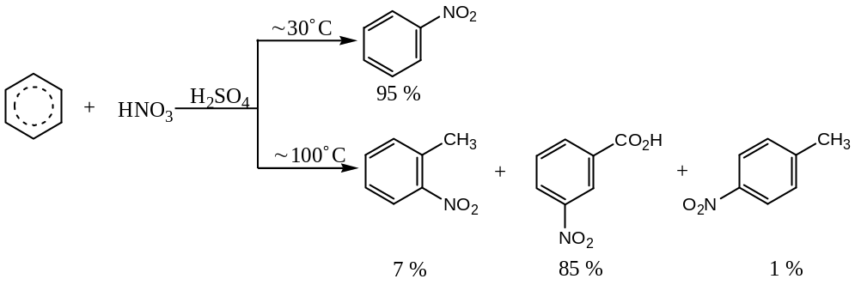
Mechanism: Rate of nitration depends on the conc. of the nitronium ion, $NO_{2}^{+}$, the attacking electrophile. The conc. of $NO_{2}^{+}$ in $HNO_{3}$ alone is too low to nitrate benzene at a convenient rate, but addition of $H_{2}{SO}_{4}$ to the $HNO_{3}$ increases the conc. of $NO_{2}^{+}$.
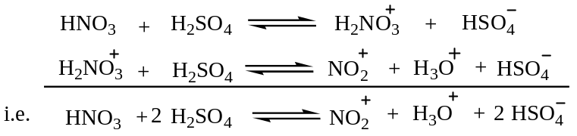
If only $HNO_{3}$ is used, conc. of $NO_{2}^{+}$ ion is low because, the position of the equilibrium is far to the left, —
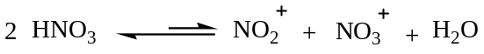
But, the addition of $H_{2}{SO}_{4}$ to the $HNO_{3}$ shifts the equilibrium far to the right, —
Now,
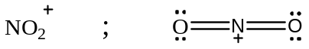
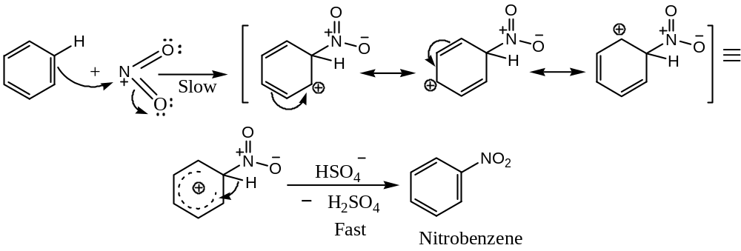
Thus, the attacking electrophile, $NO_{2}^{+}$, is generated by a simple acid-base equilibrium, in which $H_{2}{SO}_{4}$ serves as the acid, and the much weaker $HNO_{3}$ as a base. We may consider, that the very strong acid, $H_{2}{SO}_{4}$, cause $HNO_{3}$ to ionize in the sense $HO^{-}… NO_{2}^{+}$, rather than in the usual way, $HO^{-}… ONO^{+}$.
Important Note and Discussion on Nitration Reaction:
SET 1: The example given below illustrates the directing effect of a substituent already present on the aromatic ring during nitration:
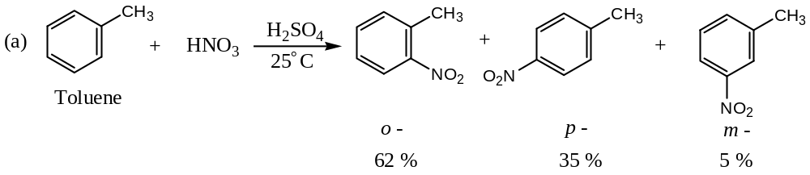
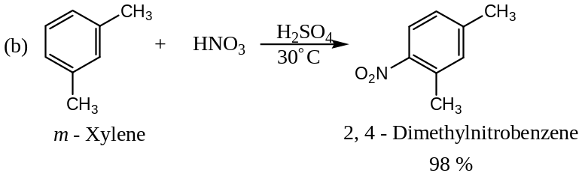
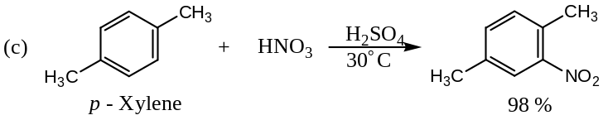
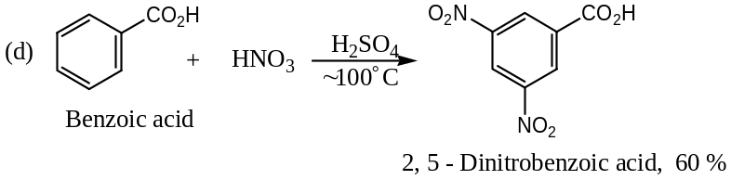
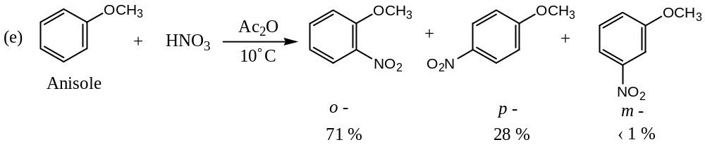
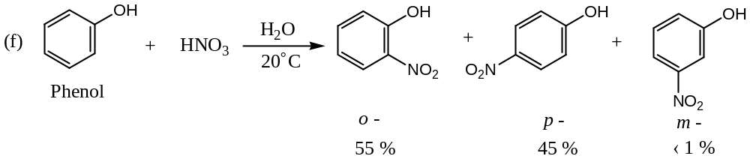
― Anisole & Phenol being activated aromatic compounds, so nitration requires mild conditions only, i.e. dilute $HNO_{3}$ ($HNO_{3} in$acetic anhydride, ${Ac}_{2}O$ is a mild nitrating agent, and used to introduce only one $-NO_{2}$ group, preferably at $o$- position as this position is facilitated by the presence of electron releasing groups like $–OH, -OCH_{3}$ in the benzene ring) is sufficient to carryout nitration. On the other hand, deactivated aromatic compounds (benzene ring containing electron withdrawing groups) like nitrobenzene requires vigorous (drastic) reaction condition for nitration
Let us now consider, reactions where poly-nitration occurs―
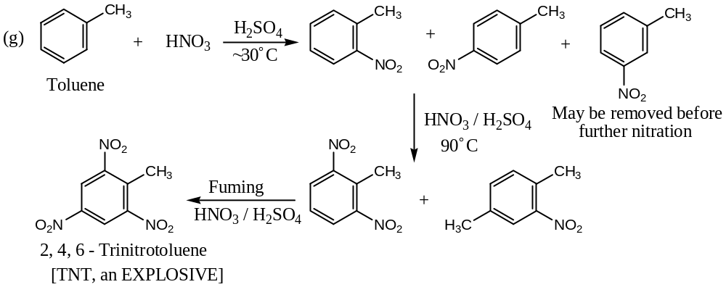
SET 2: Nitration of aromatic compound is one step process in the synthesis of large number of compounds, with high yield, so have synthetic value. The nitro group can be introduced as a $m$- directing group, and then can be reduced to the amino group, which is a $o$- and $p$- directing group.
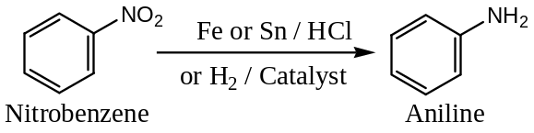
[$2$] By indirect Nitration: Indirect nitration has been basically utilized for the synthesis of $o$- and $p$- dinitrobenzene (as indirect nitration of nitrobenzene yields $m$- dinitrobenzene) and can be achieved by the following two methods —
($a$) Replacement of $-NH_{2}$ group: Here, nitration is carried out through a diazonium salt,
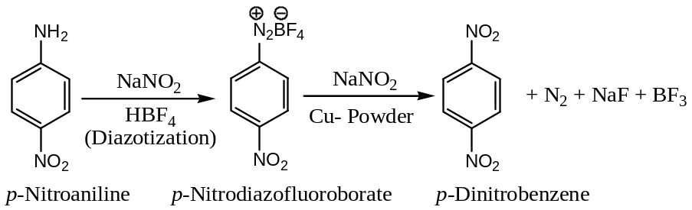
($b$) Oxidation of $-NH_{2}$ group: Here, amino acid group is oxidized by using the oxidizing agent Caro’s acid ($H_{2}{SO}_{5}$) or persulphuric acid ($H_{2}S_{2}O_{8}$) or peroxytrifluoro acetic acid ($F_{3}C{CO}_{3}H$),
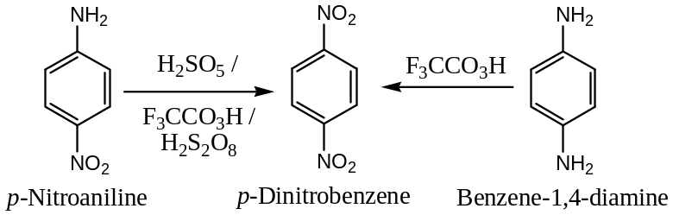
General Physical Properties of Nitroalkanes —
Aromatic nitro compounds are water insoluble yellow solids (except nitrobenzene, which is liquid), but soluble in organic solvents. These have high refractive index and boiling point. These are highly toxic in nature.
General Chemical Properties (Reactions) of Nitroalkanes —
The chemical properties of nitro arenes are systematically studied under the categories —
- Reduction of Nitrobenzene,
- Selective reduction of Polynitro compounds,
- Electrophilic substitution,
- Nucleophilic aromatic substitution,
- Effect of Nitro group on other Nuclear Substituents,
- Formation of Charge Transfer Complexes , and
- Acidic Character.
$1$) Reduction of Nitrobenzene —
Reduction of aromatic nitro compounds results a variety of products, depending on the $p^{H}$ of the reduction medium and the nature of the reducing agent. For example —
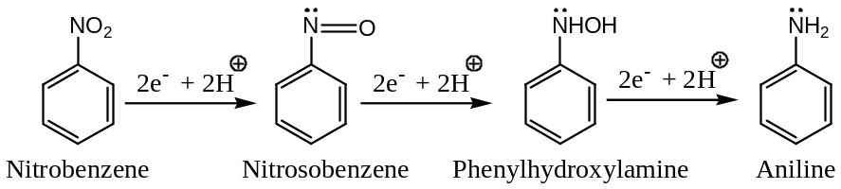
($a$) Reduction of nitrobenzene in Acidic medium: Common reducing agents used are —
$${Fe}/{HCl} or {Sn}/{HCl} or {Sn{Cl}_{2}}/{HCl}$$
And the final product formed is normally an $1^{0}$- aromatic amine (aniline or its derivative) —
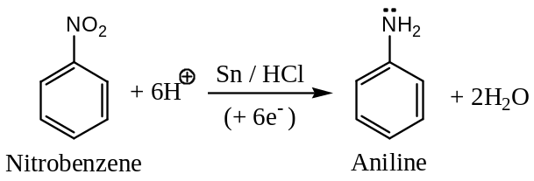
Mechanism: In acid solution, i.e. reduction by metal and acid, nitro compounds gets reduced to aniline via nitrobenzene and nitrosobenzene free-radical anion —
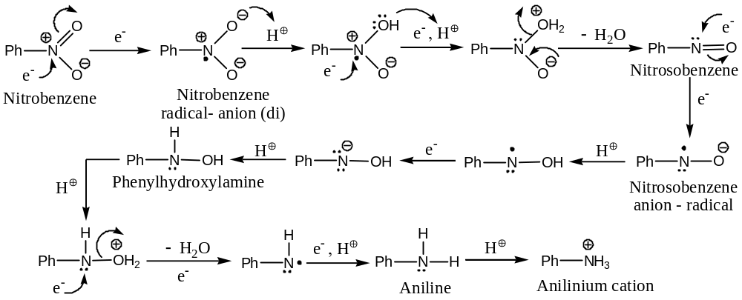
($b$) Reduction of nitrobenzene in Strongly Acidic medium: In strongly acidic solution, the product is $p$- aminophenol, formed by the rearrangement of phenyl hydroxyl amine.
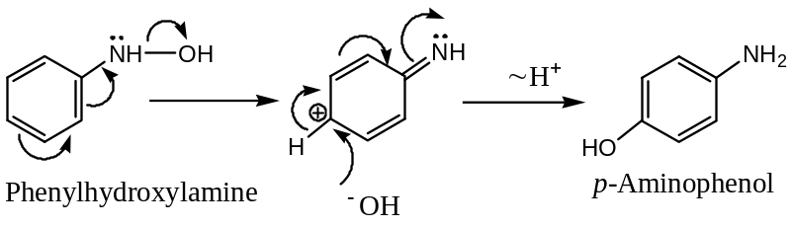
($c$) Reduction of nitrobenzene in Neutral medium: Nitrobenzene reduces to $N$- phenyl hydroxyl amine by $Zn$- dust and ${NH}_{4}Cl$ solution (a neutral medium) —
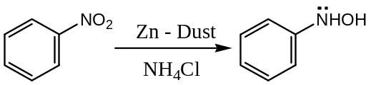
However, if the reduction is carried out under mild neutral medium, for example by $Fe$ and steam ($H_{2}O$), the product is the nitrosobenzene —
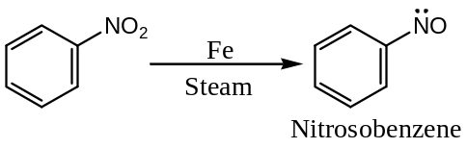
($d$) Reduction of nitrobenzene in Alkaline medium: The nature of the final product formed depends on the nature of the reducing agent used for the reduction of nitrobenzene. For example —
Stannous Chloride- Alkali mixture leads to the formation of azobenzene, by the self-condensation of nitrobenzene with aniline.
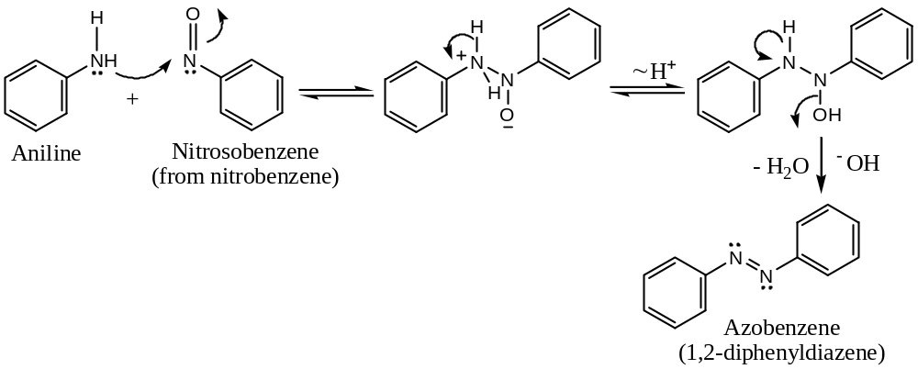
Zinc and Alkali generally leads to the formation of hydrazobenzene via azobenzene.
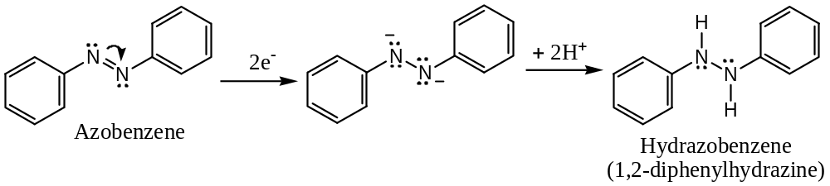
($e$) Electrolytic Reduction of nitrobenzene: Electrolytic reduction of nitrobenzene is $p^{H}$ dependent, in weakly acidic medium $1^{0}$- amines are formed, but in strongly acidic medium $p$- amino phenols are the main product. Thus, — Reactions are already discussed ($a \& b$)
($f$) Catalytic Reduction of nitrobenzene: Reduction of nitrobenzene by $H_{2}$ and a catalyst (like finely divided $Ni, Pt, etc.$) gives a $1^{0}$- amine (aniline) —
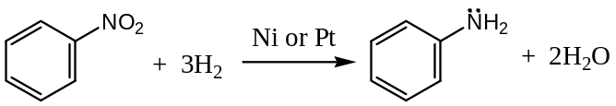
($g$) Reduction of nitrobenzene by Metal Hydrides: Nitro compounds are reduces to $1^{0}$- amine (aniline) by metal hydrides like $LiAlH_{4}$ —
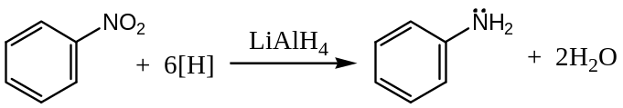
$2$) Selective Reduction of Polynitro Compounds: Sodium or ammonium polysulphide reduces only one nitro group of polynitro compounds into amino group, and the process is known as selective reduction. Thus, —
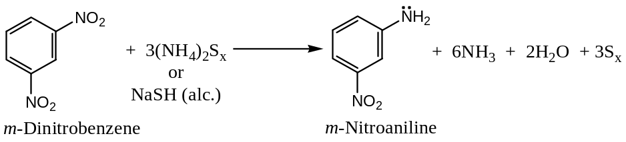
Actually, as soon as one of the $-NO_{2}$ group of $m$- dinitrobenzene is reduced to the $-NH_{2}$ group, which is strongly electron releasing ($+I effecting$), the reduction of the other $-NO_{2}$ group by a weak reducing agent such as sodium or ammonium polysulphide is difficult.
$3$) Electrophilic (AROMATIC) Substitution of Nitrobenzene:
Because of the electron withdrawing nature ($-I effecting and strongly deactivating$) of the $-NO_{2}$ group ($m$- directing), the rate of electrophilic substitution in nitrobenzene is very slow, and drastic reaction conditions are required. For example, —
$i)$ Nitration —
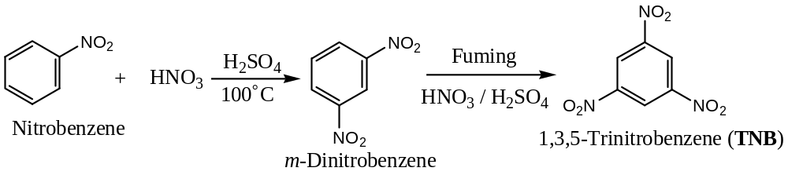
However, presence of an $+I$ effecting group in nitrobenzene facilitated the rate of electrophilic substitution, which is governed by the $+I$ effecting group. For example, —
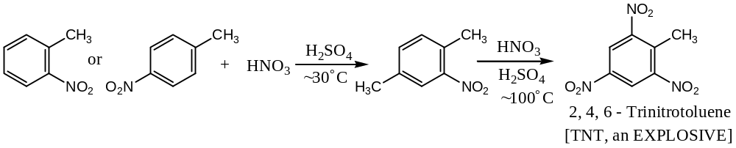
$ii)$ Halogenation — Bromination or chlorination of nitrobenzene is done by adding ${Br}_{2}$ or ${Cl}_{2}$ to the nitrobenzene in presence of metallic $Fe or Al{Cl}_{3}$ followed by heating. Thus, —
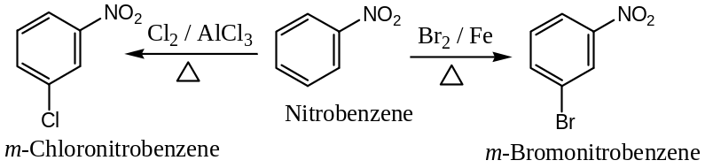
Actually ${Br}_{2}$ and ${Cl}_{2}$ is too weak electrophile to react at an appreciable rate with benzene, so a catalyst that increases the electrophilic properties of $X_{2}$ must be present. Actually, the active catalyst is not $Fe$- itself, but $FeX_{3}$, the Lewis acid, formed by the reaction of $Fe \& X_{2}$ is the active, which formed a complex compound with the $X_{2}$ and acts as the excellent electrophile. For example,
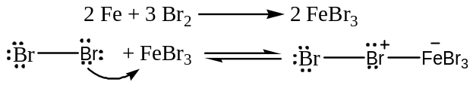
$4$) Nucleophilic Aromatic Substitution of Nitrobenzene:
Because of high $π$- electron density, benzene is inert for nucleophilic substitution, but presence of the $-NO_{2}$ group in the benzene ring (as in nitrobenzene) activates the ring towards nucleophiles, and the nucleophilic substitution occurs at $o$- and/ or $p$- position. For example, —
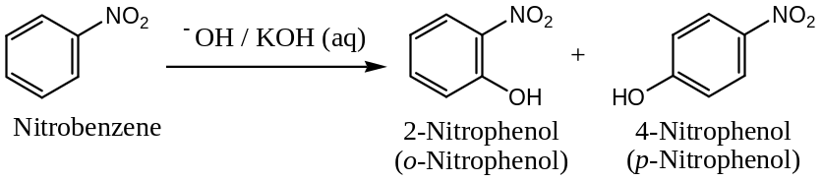
Mechanism: Formation of $o$- and $p$- substituted nucleophilic product of nitrobenzene can be explained as —
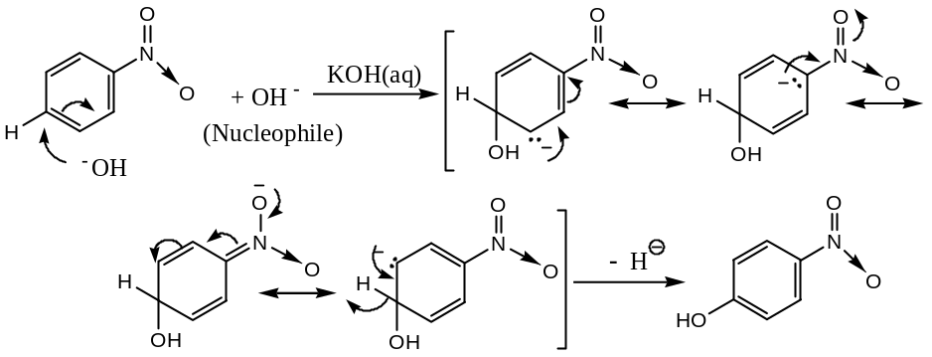
The intermediate resonance stabilized carbanion formed by the attack of the incoming nucleophile stabilized the product formed.
Exactly in the similar way, we can explain the formation of the $o$- substituted nucleophilic product of nitrobenzene.
Nucleophilic Aromatic substitution involving the Displacement of Nitro group by the Nucleophile — Because of high $π$- electron density in benzene ring and the $-NO_{2}$ groups are electron withdrawing ($-I$ effecting) in nature, hence the $-NO_{2}$ groups are firmly attached to the benzene nucleus to undergo displacement. However, in some polynitro compounds, by using certain basic reagents, one of the $-NO_{2}$ groups can be displaced by the new incoming nucleophile (derived from the base used). For example, —
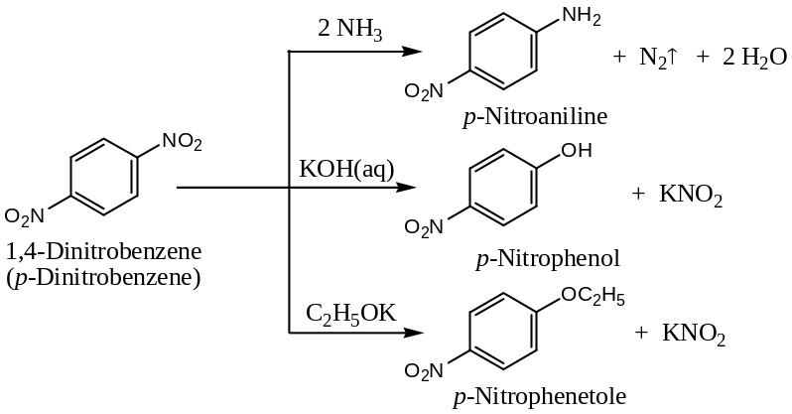
Mechanism: The mechanism of displacement of a $-NO_{2}$ group by a nucleophile i.e. nucleophilic substitution can be written as —
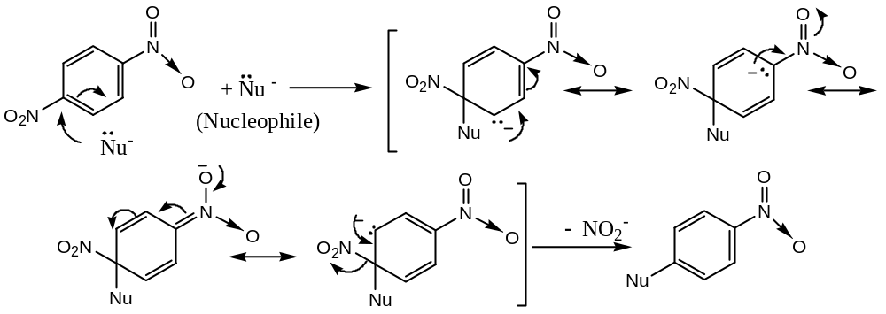
$5$) Effect of Nitro Group on other Nuclear Substitution:
The effect of $-NO_{2}$ group on the other nuclear substituents in substituted nitrobenzene can be explained under the following three sub-categories —
($a$) Effect on Nuclear Halogens: Nuclear halogen is ordinarily very unreactive, but in presence of one or more electron withdrawing $-NO_{2}$ groups at $o$- and $p$- positions, the halogen atoms becomes activated for nucleophilic substitution reactions. For example, —
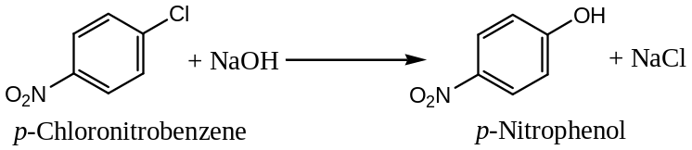
(Mechanism is same as above)
($b$) Effect on Nuclear Alkyl Groups: Alkyl groups are activated by the presence of f one or more electron withdrawing $-NO_{2}$ groups at $o$- and $p$- positions for nucleophilic substitution reactions. For example, —
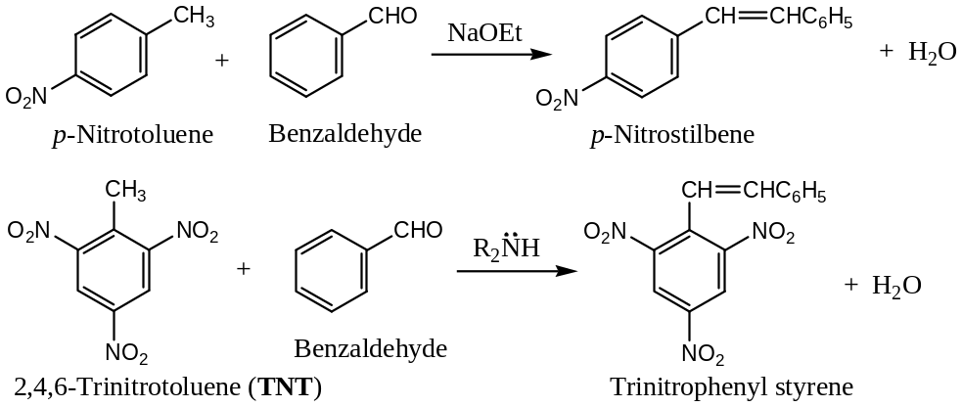
Mechanism: Due to the presence of one or more electron withdrawing $-NO_{2}$ groups at $o$- and $p$- positions with respect to the alkyl group, its hydrogens are activated (acidic) and released as proton, which is taken by the base to form a resonance stabilized carbanion. Nucleophilic addition reaction of the carbanion with benzaldehyde followed by protonation completes the reaction. Thus,
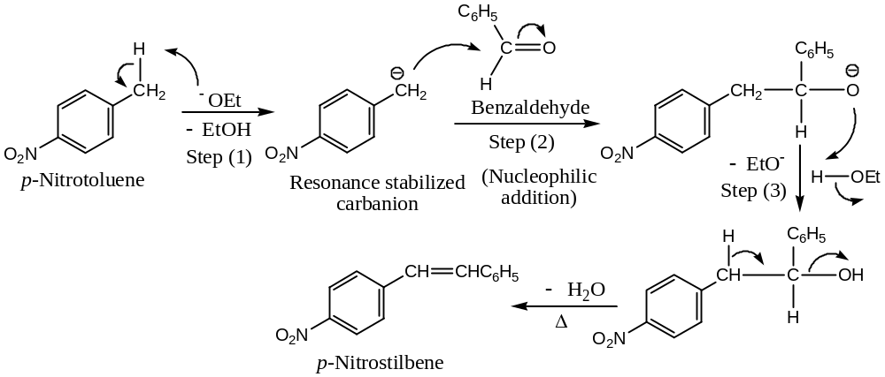
However, if the alkyl group is in $m$- position with respect to the $-NO_{2}$ group, the hydrogens are not as acidic as in the case of $o$- and $p$- positions, as in this case intermediate carbanion formed is not stabilized by resonance.
($c$) Effect on Phenolic $–OH$ Groups:
Due to the presence of one or more electron withdrawing $-NO_{2}$ groups at $o$- and $p$- positions with respect to the $–OH$ group in nitro phenols, the acidity of the phenolic $–OH$ group increased markedly. This can be explained from the observed fact that phenol feebly dissolved in $NaOH$ to form sodium phenoxide, but fails to evolve $CO_{2}$ gas with $Na_{2}CO_{3}$. But, $o$- and $p$- substituted nitro phenols evolve $CO_{2}$ gas with $Na_{2}CO_{3}$, indicating the high acidity of phenolic $–OH$ group in nitro phenols. Thus, —
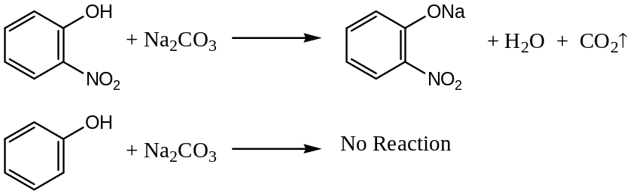
Similarly, $2,4$- dinitrophenol and $2,4,6$- trinitrophenol are still more acidic than $o$- and $p$- substituted nitro phenols (mono- nitrophenol). In fact, $2,4,6$- trinitrophenol is given the name picric acid, even though it has no $-CO_{2}H$ group.
Thus, it can be concluded that —
$$Decreasing order of-NO_{2} groups ⟶$$
$2,4,6$- Trinitrophenol $>$ $2,4$- Dinitrophenol $>$ $o$- and $p$- Nitrophenol $>$ Phenol
$$Decreasing order ofAcid Strength⟶$$
Derivative (Picrate) Nitrophenols: Acidity of nitro phenols compared with phenols can be quantitatively estimated from their picrate derivatives. Phenol gives poor yield of chlorobenzene with $P{Cl}_{5}$, while nitrophenols having $-NO_{2}$ groups at $o$- and $p$- positions with respect to the $–OH$ group give good yields of the corresponding chloro compounds (picrate derivative). This explained the unexpected acidity of $–OH$ protons in nitrophenols ($o$- and $p$- substituted). For example, —
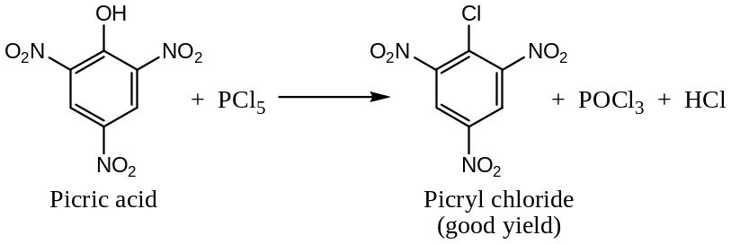
$6$) Formation of Charge Transfer Complexes by Aromatic Nitro Compounds:
Di- and polynitro compounds form highly coloured complexes with aromatic hydrocarbons, phenols, etc. in their molar proportions ($1:1$). In this addition product, hydrocarbon molecule acts as a donor and the nitro compound as an acceptor. These addition products have well-defined melting points, and therefore, are useful for the identification of aromatic compounds. Such products are known as charge transfer complexes having the following probable structure —
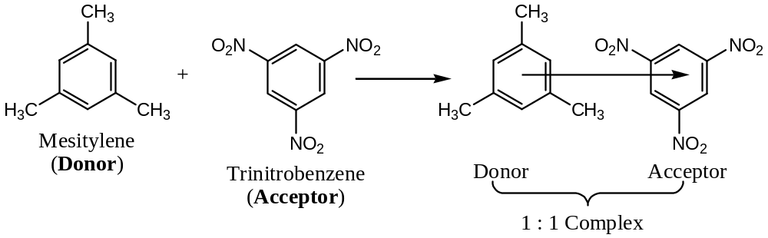
$7$) Acidic Character of Aromatic Nitro Compounds:
Since aryl nitro compounds like nitrobenzene ($C_{6}H_{5}NO_{2}$) do not have $α$- $H$- atoms attached to $α$- $C$- atom, and are resemble $3^{0}$- aliphatic nitroalkanes in being not acidic. On the other hand, when two or more $-NO_{2}$ groups are present on the aromatic ring, they render the adjacent ring hydrogens acidic due to the powerful $–I$ (electron withdrawing) effect of the $-NO_{2}$ groups. Thus, $1,3,5$- trinitrobenzene react with $NaOH$ to form an anion, which is highly coloured. Thus, —
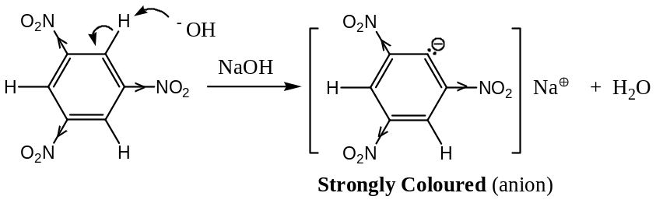

###################################

ORGANO NITRILES (Cyano or Cyanides: Aliphatic & Aromatic) —
Organo nitriles are the derivative of hydrocyanic acid ($HCN$), which exists in two tautomeric forms, viz. —
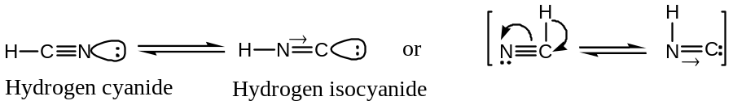
Thus, two alkyl derivatives (by the replacement of $H$- atom) are possible —
- Alkyl Cyanides or Nitriles ($R-C≡N$)
- Alkyl Isocyanides or Isonitriles ($R-N≡C$)
Alkyl Cyanides or Nitriles ($R-C≡N$) —
Nomenclature —
In common system, these are named in two ways —
$a$) These are named as alkyl cyanide (two word name), for example —
Methyl cyanide is ${CH}_{3}C≡N or {CH}_{3}CN$
Ethyl cyanide is ${CH}_{3}CH_{2}C≡N or {CH}_{3}CH_{2}CN$
$b$) Since, cyanides on hydrolysis yields an acid (carboxylic), hence these are also named by adding the suffix ‘nitrile’ for the ending “$-ic acid$” of the common name of the acid and putting the letter “$o$” between them, in a single word. Thus, —
$${CH}_{3}CN \underset{→}{ 2H_{2}O } {CH}_{3}COOH$$
Acetonitrile Acetic acid
$${CH}_{3}CH_{2}CN \underset{→}{ 2H_{2}O } {CH}_{3}CH_{2}COOH$$
Propionitrile Propionic acid
In IUPAC system, these are named by adding the suffix ‘nitrile’ to the parent name of the hydrocarbon (without dropping the final ’$e$’ of the hydrocarbon) —
${CH}_{3}C≡N:$ ${CH}_{3}CH_{2}C≡N:$ ${CH}_{3}CH_{2}CH_{2}C≡N:$ ${CH}_{3}{\left(CH_{2}\right)}_{4}C≡N:$
Ethanenitrile Propanenitrile Butanenitrile Hexanenitrile
General methods of Preparation: Alkyl cyanides can be prepared by the following general methods —
[$1$] From alkyl Halide: On heating an alkyl halide with alcoholic solution of potassium cyanide ($KCN$). The reaction involves the nucleophilic displacement of halide ion by the cyanide ion.
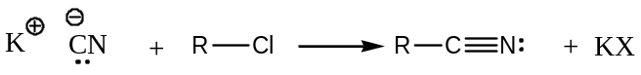
Notes & Discussion: ($a$) Since the reaction leads to the formation of a new $C-C$ bond, hence, it can be used for step-up of the series.
($b$) This method works most satisfactorily with $1^{0}$- alkyl halides.
($c$) With $3^{0}$- alkyl halides, instead of nucleophilic substitution, elimination takes place preferentially in presence of the base, the cyanide ion ($CN^{-}$) to form an alkene. For example, —
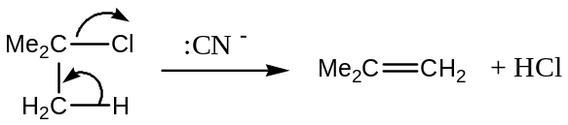
($d$) Aryl cyanides (say, benzonitrile) can’t be prepared by this method, these are prepared indirectly via diazonium salts.
[$2$] By the Dehydration of Amides and Aldoximes: Dehydration of amides and aldoximes by $P_{2}O_{5}$ yields their corresponding cyanides. For example, —
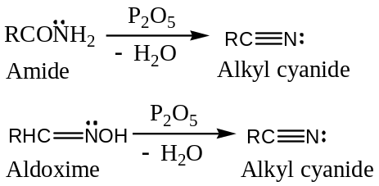
[$3$] From the Sodium salt of Sulphonic acids: Sodium salt of sulphonic acid (alkyl sodium sulphate) reacts with $KCN$ forming alkyl cyanide, by nucleophilic substitution pathway, —
[$4$] By the reaction of Cyanogen chloride and Grignard reagent: Cyanogen chloride reacts with appropriate Grignard reagent to form alkyl cyanide. This method is particularly suitable for the synthesis of cyanides from $tert$- alkyl halides. Thus, —
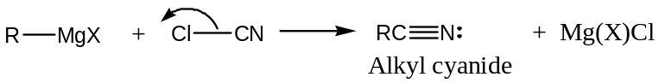
[$5$] From the Ammonium salts of Carboxylic acids: By heating of ammonium salts of suitable carboxylic acids (or a mixture of ammonia and a carboxylic acid) over alumina yields alkyl cyanide —
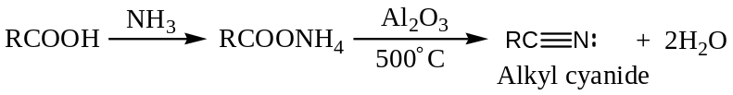
This method is used for the industrial synthesis of alkyl cyanides.
General Physical Properties of Alkyl cyanides —
Following are the characteristic physical properties of alkyl cyanides —
- Lower members (up to $C_{14}$) are colourless liquids with a strong characteristic sweet smell. The higher members are crystalline solids.
- Alkyl cyanides are moderately soluble in water, but feebly soluble in organic solvents.
- Alkyl cyanides are poisonous, but less than $HCN.$
- Alkyl cyanides have higher boiling points than the analogous acetylenes due to their high dipole moments due to the greater electronegativity of nitrogen. For example, propyne boils at $-23.2℃$ whereas propane nitrile boils at $82℃$.
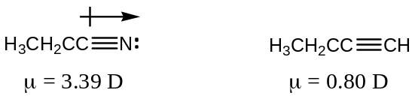
General Chemical Properties (Reactions) of Alkyl cyanides —
Following are the characteristic Chemical reactions of alkyl cyanides —
[$1$] Hydrolysis of Alkyl Cyanides: Alkyl cyanides are hydrolyzed to carboxylic acids on boiling with an alkali or dilute acid. However, the product is an amide (acid amide), if the hydrolysis is carried out at low temperature or in cold conditions. For example, —
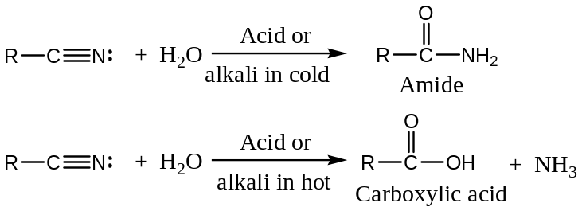
Amides can also be hydrolyzed to carboxylic acids by alkaline $H_{2}O_{2}$ or moderately concentrated $H_{2}{SO}_{4}$.
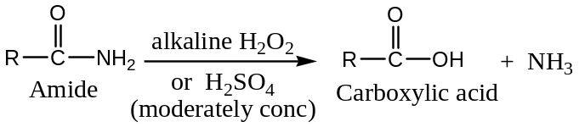
Mechanism of Hydrolysis of Cyanides: Acid hydrolysis of alkyl cyanides involves protonation, followed nucleophilic substitution and tautomerization first to form an amide, which is further hydrolyzed to the carboxylic acids. Thus, —
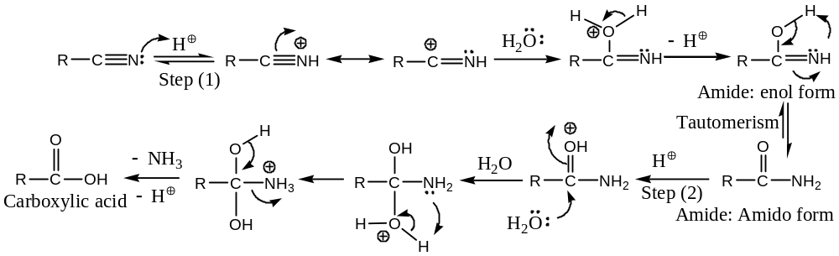
Similarly, alkaline hydrolysis of alkyl cyanides may be written as —
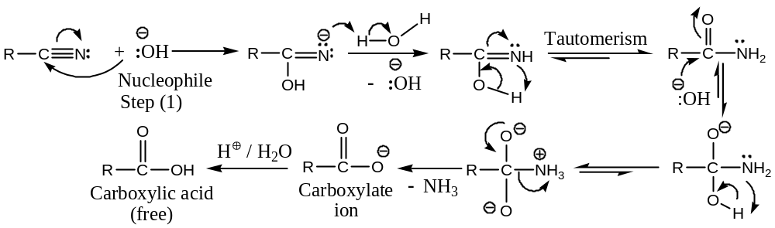
[$2$] Reduction of Alkyl Cyanides: Alkyl cyanide on reduction either by $LiAlH_{4}$ or by catalytic hydrogenation (${H_{2}}/{Ni}$), it is reduced yields $1^{0}$- amine. For example, —
$$R-C≡N: +2H_{2} \underset{→}{ Ni } R-CH_{2}\ddot{N}H_{2}$$
$1^{0}$- Amine
[$3$] Reaction of Alkyl Cyanides with Grignard Reagents: Alkyl cyanides react with Grignard reagent first to form an addition complex, which on hydrolysis yields a ketone. The ketone so formed may further reacts with the Grignard reagent, the subsequent hydrolysis of the tetrahedral complex results in the formation of a $3^{0}$- alcohol. Thus, —
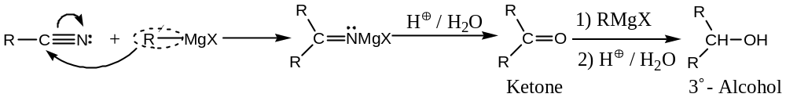
[$4$] Stephen’s Reaction: Alkyl cyanides when reduced with ${Sn}/{HCl}$ in ether or ethyl acetate solution, it is reduced to an aldimine, which on hydrolysis (steam distillation) aldehyde, and the reaction (conversion of an alkyl cyanide to an aldehyde) is known as the Stephen’s reaction (reduction). Thus, —
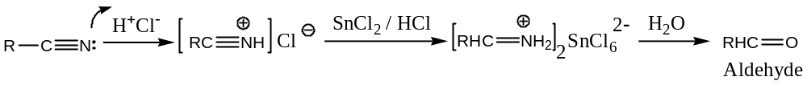
Cyanides can also be converted to aldehydes (reduction) using the complex metal hydride, lithium triethoxyaluminium hydride [$LiAlH{\left(OEt\right)}_{3}$].
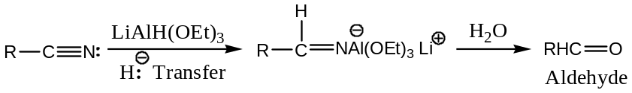
[$5$] Reaction of Alkyl Cyanides with Ammonia: Ammonia adds to alkyl cyanides to form amidines ($if R=NH_{2}, in RCN, amidine formed is guanidine$), which are strong bases by nature. Thus, —
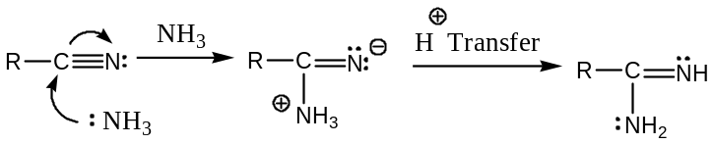
[$6$] Condensation reaction with Alkyl Cyanides: Following are the two important condensation reactions involving alkyl cyanide —
($a$) Thorpe Nitrile Condensation: The self condensation of two molecules of alkyl nitrile having $α$- $H$- atoms in presence of metallic $Na$ in ether to form iminonitrile is known as Thorpe nitrile condensation. Thus, —
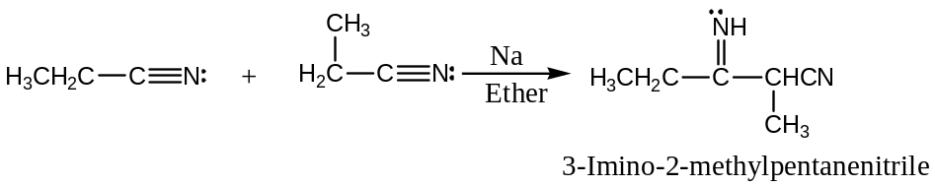
($a$) Levine and Hauser Condensation: The condensation of an alkyl nitrile having $α$- $H$- atoms with an ester in presence of sodamide ($NaNH_{2}$) in ether to form keto-nitrile is known as Levine and Hauser reaction or condensation. Thus, —
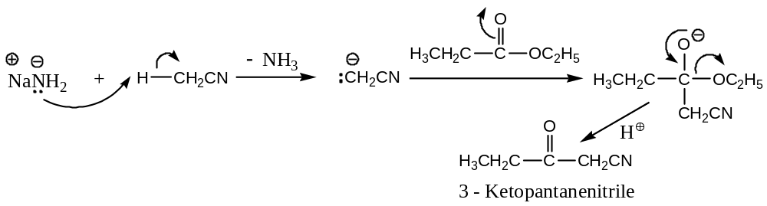
Since, the reaction involves the replacement of ethoxy ($OC_{2}H_{5}$) group of the ester by a cyanomethyl group ($-{CH}_{2}CN$), hence, the reaction is also known as cyano-methylation reaction.
ORGANO ISONITRILES: (Aliphatic & Aromatic) —
Alkyl Isocyanides or Isonitriles, $R-N≡C$ (Carbylamines) —
General methods of Preparation: Alkyl isocyanides or isonitriles can be prepared by the following two general methods —
[$1$] From $1^{0}$- Amines: On heating a $1^{0}$- amine with chloroform and alcoholic potash gives isocyanide and the reaction is known as the carbylamine reaction.
$$R\ddot{N}H_{2} + CH{Cl}_{3} + 3KOH\left(alc\right) ⟶ RN≡C + 3KCl + 3H_{2}O$$
$1^{0}$- Amine Chloroform Alkyl isocyanide
[$2$] From Alkyl Halides: Reaction of an alkyl halide with silver cyanide yields an alkyl isocyanide (along with small amount of alkyl cyanide), thus —
$$RX + AgCN ⟶ RN≡C + AgX$$
Alkyl halide Alkyl isocyanide
General Physical Properties of Isonitriles —
Following are the characteristic physical properties of isocyanides —
- Isonitriles are colourless, highly unpleasant smelling (bad odour) volatile liquids which are much more poisonous than the cyanides.
- Isonitriles are slightly water soluble, but fairly soluble in organic solvents.
- Isonitriles have lower boiling points than the corresponding isomeric alkyl cyanides. For example, $bp$ of methyl cyanide is $82℃$, but for methyl isocyanide it is $60℃$ only.
General Chemical Properties (Reactions) of Isocyanides —
Alkyl isocyanides are much more reactive compounds and differ from alkyl cyanides as shown below —
[$1$] Hydrolysis of Isocyanides: Alkyl isocyanides are not by alkalis, but they are hydrolyzed by dilute mineral acids to $1^{0}$- amines and formic acid.
$$RN≡C + 2H_{2}O \underset{→}{ acid \left(dilute\right) } R\ddot{N}H_{2} + HCOOH$$
Isocyanide $1^{0}$- Amine Formic acid
[$2$] Reduction of Isocyanides: Catalytic hydrogenation or hydrogenation by nascent hydrogens, alkyl isocyanides are reduced to $2^{0}$- amines —
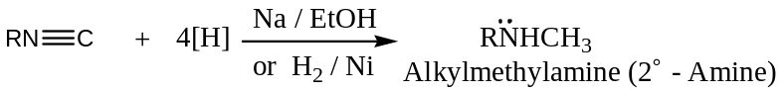
[$3$] Isomerisation in Isocyanides: Alkyl isocyanides on heating at $250℃$ isomerises to the more stable alkyl cyanides.
$$R-N≡C \underset{→}{ 250℃ } R-C≡N:$$
Isocyanide Cyanide
[$4$] Addition reactions involving Isocyanides: Alkyl isocyanides undergo addition reaction with halogen, sulphur and oxygen to form their corresponding addition products, thus —
$$\left(a\right) R-N≡C + X_{2} ⟶ R-\ddot{N}=X_{2}$$
Halogen
$$\left(b\right) R-N≡C + S ⟶ R-\ddot{N}=C=S$$
Alkyl isothiocyanate
$$\left(c\right) R-N≡C + O \underset{→}{HgO} R-\ddot{N}=C=O$$
Alkyl isocyanate
Distinction between Alkyl Cyanides and Isocyanides —
Compare both the physical and chemical properties to get the answer
############################################
AMINO COMPOUNDS: Amines (Aliphatic & Aromatic) —
Aliphatic Amines ($R{NH}_{2}, R_{2}NH or R_{3}N$): —
Amines are the organic derivative of ${NH}_{3}$ and are basic in nature. One, two or three alkyl groups may replace the $H$- atoms of ${NH}_{3}$ to give $1^{°}, 2^{°} or 3^{°}$- amines respectively.
Rules for Nomenclature:
[$1$] In IUPAC system for $1^{0}$ - amines, the final “$e$” of the parent hydrocarbons name is dropped, and the suffix “$-amine$” is added. The $N$- atom is neither counted to establish the parent name nor numbered.
The $R$- groups of $2^{°}\& 3^{°}$- amines are named as substituents on the parent chain and the letter “$N$” is used to show that the substituent is bonded to the $N$- atom.
[$2$] In common system, the suffix $-ylamine$ is added to the root name of the hydrocarbon.
For example, —
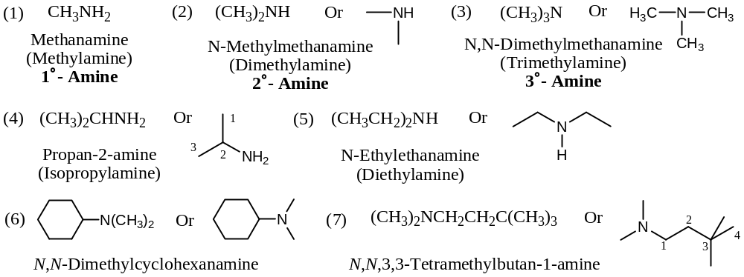
[$3$] When $-{NH}_{2}$ group is a substituent: The prefix $amino$ or $alkylamino$ is used when the amine group ($-{NH}_{2}$) is a substituent on a parent molecule. In some cases, in a parent chain, it is identified by adding the prefix $-aza-$ analouges to the use of $-oxa-$ for ethers. For example, —
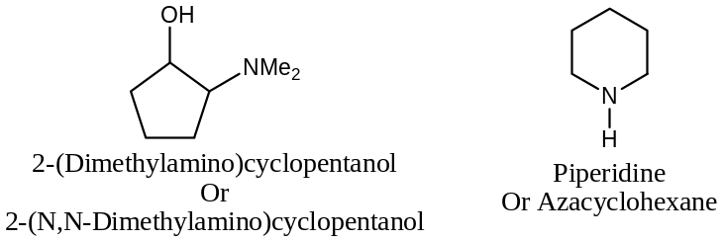
[$4$] Aromatic amines have their common names (accepted by IUPAC) and named as the derivative of aniline. Anilines are amines in which the $-{NH}_{2}$ group is directly attached to a $C-$ atom of the benzene ring. For example, —
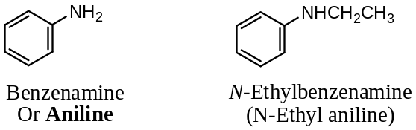
Thus, aromatic amines are of two types —
$a$) Nuclear Substituted: Theses are also called arylamines; here the $-NH_{2}$ group is directly attached to the aromatic nucleus. These are again of $3$- types —
($i$) Primary amines ($Ar\ddot{N}H_{2}$) —
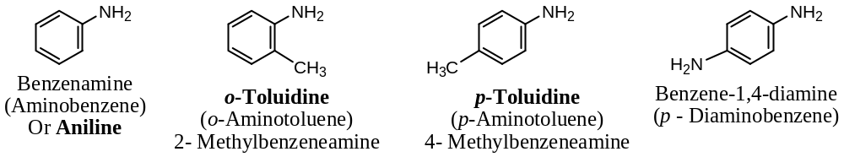
($ii$) Secondary amines ($Ar\ddot{N}HR or Ar\ddot{N}HAr$) —
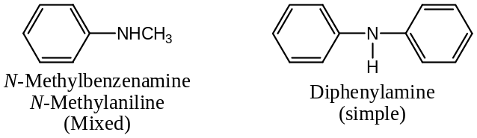
($iii$) Tertiary amines ($Ar\ddot{N}R_{2} or {Ar}_{3}\ddot{N}$) —
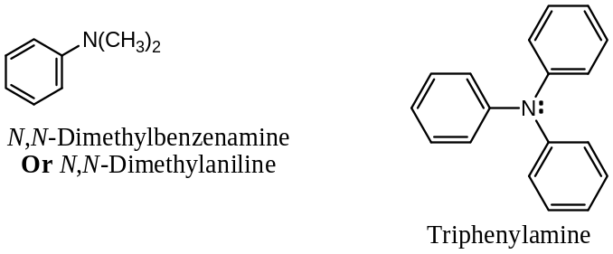
$b$) Side Chain Substituted: Theses are also called aralkylamines; here the $-NH_{2}$ group is attached in the aliphatic chain of the aromatic compound.
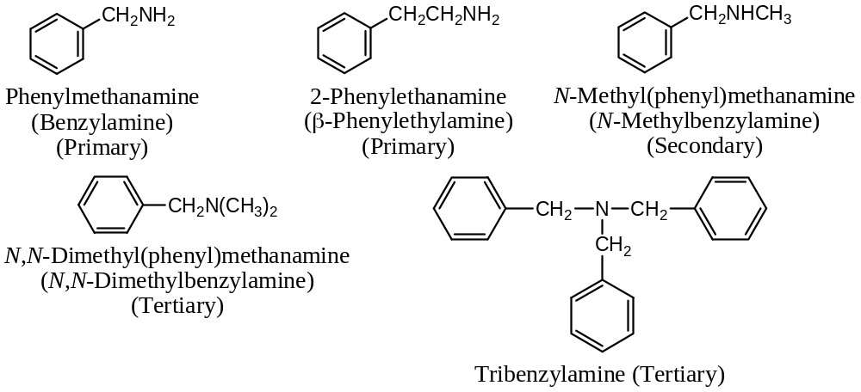
[$5$] When four alkyl groups are attached to the $N$- atom, the compound is no longer basic, the $tetra coordinated$ analogues $N$- atom possesses a formal $+ve$ charge and is the cationic portion of a type of compound known as a quaternary ammonium salt. For example, —
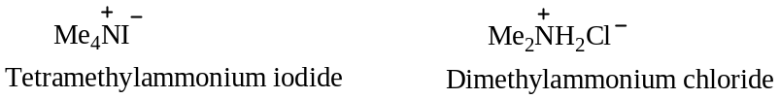
H/W: Provide IUPAC name for the following —
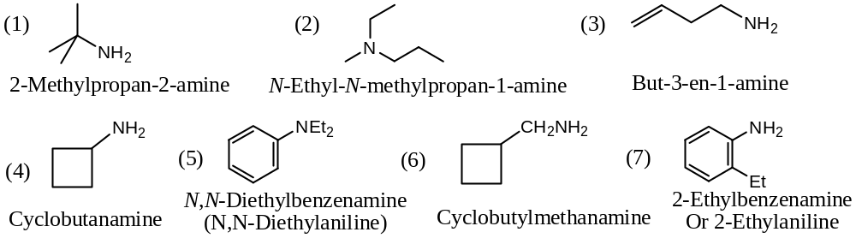
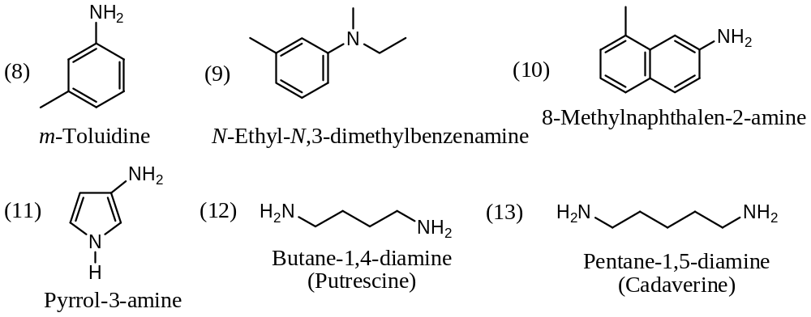
Important: $N$- containing compounds are most common in organic natural products. For example, alkaloids are the basic nitrogenous compounds distributed in plants and have physiological activity. Similarly, amino acids are the components of proteins.
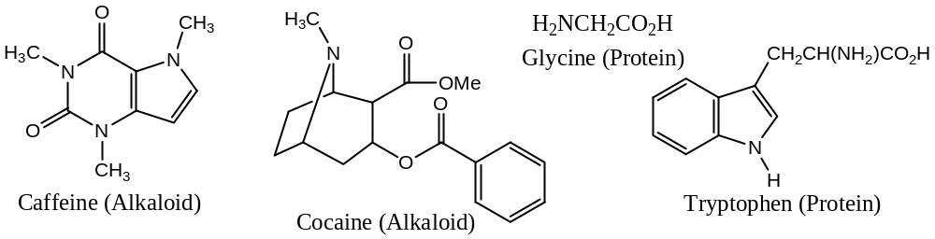
Isomerism in Amines:
Amines can exhibits the following $4$- types of isomerisms —
- Chain Isomerism,
- Positional Isomerism,
- Functional Group Isomerism, and
- Metamerism.
Chain Isomerism — due to different chain length, but the position of the functional group is the same. For example, —
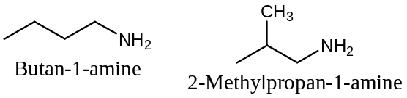
Positional Isomerism — due to same chain length, but the position of the functional group is the different. For example, —
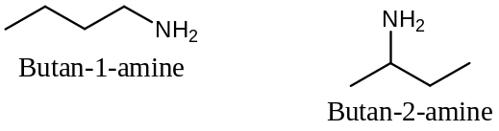
Similarly, with aromatic amines —
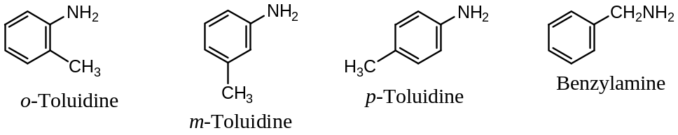
Functional Group Isomerism — due to a change in the nature of the functional group, in the case of amines it may be $1^{0}→2^{0}→3^{0}$ for the same molecular formula. For example, —
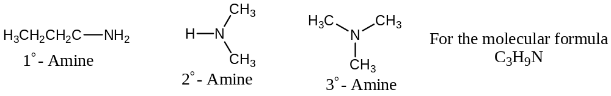
Metamerism — this type of isomerism is due to a change in the nature of the alkyl group directly attached to the $N$- atom in the amine. For example, — possible amines with the molecular formula $C_{4}H_{11}N$ are —
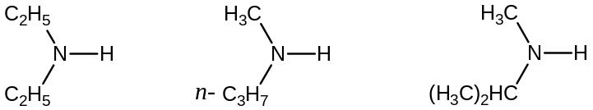
General methods of Preparation: Alkyl & Aryl, $R\ddot{N}H_{2}, Ar\ddot{N}H_{2}$
Primary Amines — Both the Aliphatic and Aromatic $1^{0}$- amines can be prepared by the following general methods —
[$1$] By the Reduction of Nitro Compounds: Reduction of nitro compounds by a variety of chemical methods leads to the formation of $1^{0}$- amines. For example —
$a$) By using Metal-Acid as reducing agent: Various metal-acid combinations usually used for the reduction of nitro compounds to amines are ${Sn}/{HCl}, {Fe}/{HCl} \& {Zn}/{AcOH}$. Thus, —
$$RNO_{2} +6H^{⊕}+ 6e^{-} \underset{→}{ Fe+HCl } R\ddot{N}H_{2} +2H_{2}O$$
$$2C_{6}H_{5}NO_{2} \underset{→}{ Fe+HCl } {\left(C_{6}H_{5}N^{+}H_{3}\right)}_{2}Sn{Cl}_{6}^{2-} \underset{→}{ :OH^{- } } 2C_{6}H_{5}\ddot{N}H_{2} +SnO_{2}^{2-}$$
Nitrobenzene Aniline
For example —
$$CH_{3}NO_{2} +6H^{⊕}+ 6e^{-} \underset{→}{ Fe+HCl } CH_{3}\ddot{N}H_{2} +2H_{2}O$$
Nitromethane Methylamine
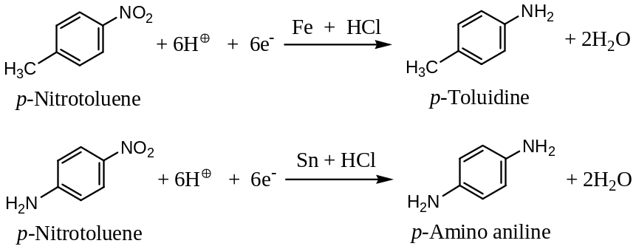
$b$) By using Ammonium Hydrogen Sulphide ($NH_{4}HS$) as reducing agent: This reagent is particularly useful for the selective reduction of polynitro aryl compounds to nitroanilines. This reduces only one $-NO_{2}$ group into $-NH_{2}$ group. For example, —
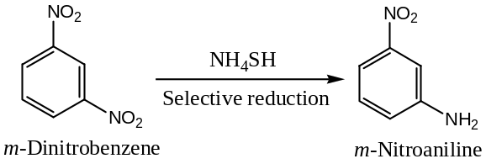
[$2$] By the Ritter Reaction: This reaction is particularly useful for the synthesis of $1^{0}$- amines with $tert$- alkyl group, and is performed by the treatment of an alkene or an alcohol with an alkyl cyanide or hydrogen cyanide in presence of an acid catalyst. For example, —
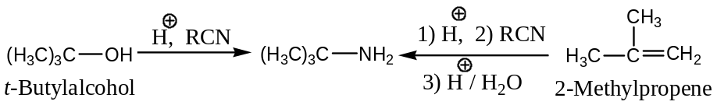
Mechanism of Ritter Reaction: The Ritter reaction proceeds through a carbocation intermediate involving four steps —
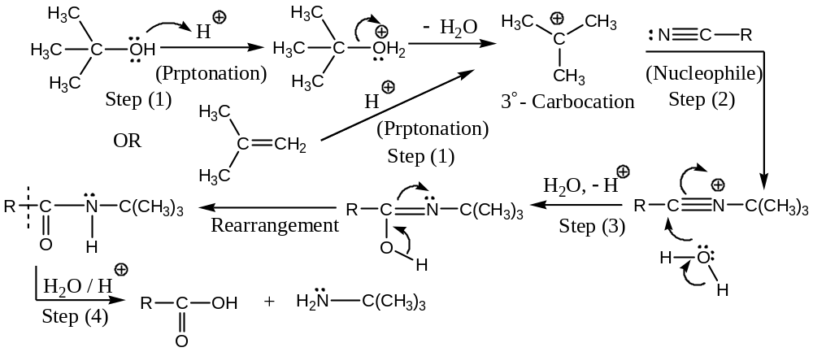
[$3$] By the Ammonolysis of Halides (Hofmann Ammonolysis): Since, the nuclear halogen cannot be replaced by amino group, except when the compound contains some electron-withdrawing substituents like $-NO_{2}, -CN, etc.$ at $o$- and $p$- positions, or the ammonolysis is done under drastic conditions. Thus, the reaction provides a route for the preparation of nitroanilines.
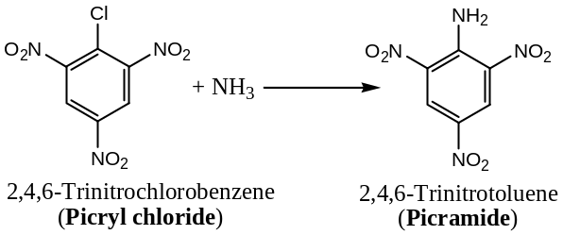
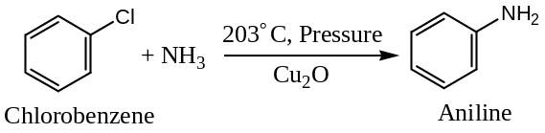
In this method, aliphatic $1^{0}$- amines are prepared by heating an $1^{0}$- $RX$ with alcoholic $NH_{3}$, however, the amine so formed react further wit $RX$ to form $2^{0} \& 3^{0}$- amines. Thus, —
$$RX+NH_{3} \left(ethanolic\right)⟶RNH_{2} \underset{→}{ RX } R_{2}NH \underset{→}{ RX } R_{3}N$$
$1^{0}$- Amine $2^{0}$- Amine $3^{0}$- Amine
[$4$] By the Hofmann Degradation of Amides: Hofmann degradation of amide consists of the reaction of an amide with potassium hypobromite ($or {Br}_{2}+KOH$), where by an $1^{0}$- amine having $1$- $C$ – atom less than the original amide is formed. Thus, —
$$RCO\ddot{N}H_{2}+{Br}_{2}+ 4KOH⟶R\ddot{N}H_{2}+ 2KBr+2H_{2}O+K_{2}CO_{3}$$
Amide $1^{0}$- Amine
For example, —
$$CH_{3}CO\ddot{N}H_{2}+{Br}_{2}+ 4KOH⟶CH_{3}\ddot{N}H_{2}+ 2KBr+2H_{2}O+K_{2}CO_{3}$$
Ethan amide Methyl amine
$$C_{6}H_{5}CO\ddot{N}H_{2}+{Br}_{2}+ 4KOH⟶C_{6}H_{5}\ddot{N}H_{2}+ 2KBr+2H_{2}O+K_{2}CO_{3}$$
Benzamide Aniline
Mechanism of Hofmann Degradation of Amide: The mechanism of the degradation of amide proceeds through a nitrene intermediate involving five steps —
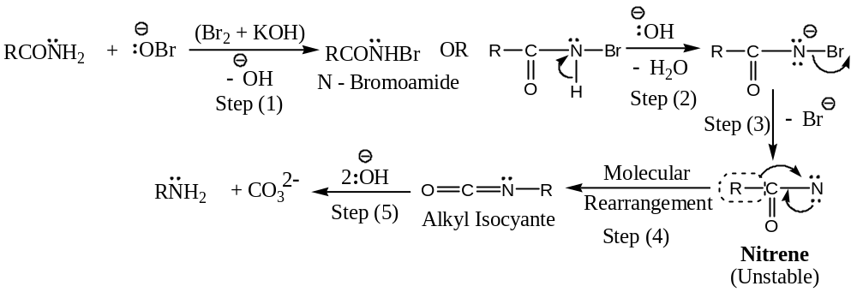
With benzamides, it has been observed that the $+I$ effecting group (i.e. electron donating or releasing groups like $-OCH_{3}, -CH_{3}, etc.$) enhances the rate of molecular rearrangement step forming the nitrene intermediate compared to $-I$ effecting group (i.e. electron withdrawing groups like $-Cl, -NO_{2}, etc.$). Thus, the decreasing order of the effect of the substituents in benzamide is —
$$-OCH_{3} >-CH_{3} >-Cl >-NO_{2}$$
[$5$] By Schmidt Reaction (From aromatic Carboxylic acids): Conversion of an acid into a $1^{0}$- amine with $1$-$C$- atom less by the action of $conc H_{2}{SO}_{4} \& N_{3}H$ (hydrazoic acid) is known as the Schmidt reaction. This reaction is specially used for the synthesis of sterically hindered $1^{0}$- amine, such as $2,4,6$- trimethyl aniline (from the corresponding acid). Thus, —
$$ArCOOH + N_{3}H \underset{→}{ H_{2}{SO}_{4} } Ar\ddot{N}H_{2} + CO_{2} + N_{2}↑$$
For example, —
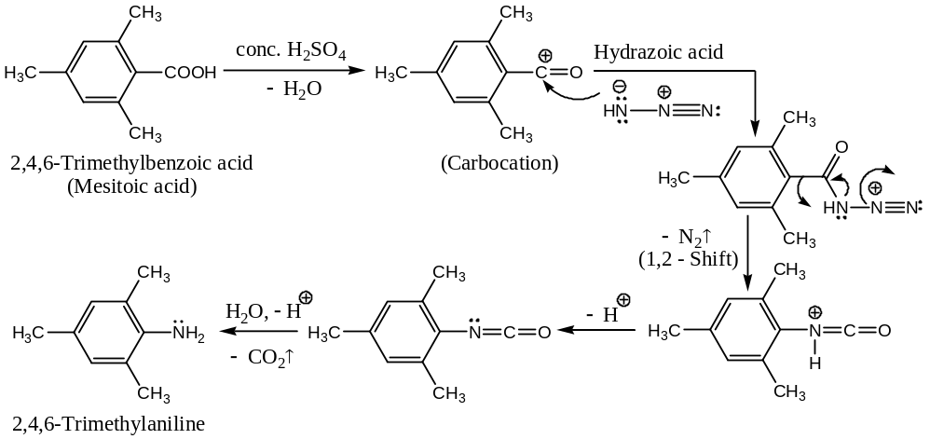
[$6$] By the Ammonolysis of Phenols & Alcohols: Phenols and alcohols when treated with ammonia at $300℃$, in presence of $Zn{Cl}_{2}$ give $1^{0}$- amine. For example, —
$$C_{6}H_{5}OH + NH_{3} \underset{→}{ 300℃, Zn{Cl}_{2} } C_{6}H_{5}\ddot{N}H_{2} + H_{2}O$$
Phenol Aniline
$$ROH + NH_{3} \underset{→}{ 300℃, Zn{Cl}_{2} } R\ddot{N}H_{2} + H_{2}O$$
Alcohol Primary Amine
[$7$] By the Reductive Amination of Carbonyl Compounds: Conversion of a carbonyl compound (aldehyde & ketone) into a $1^{0}$- amine by catalytic hydrogenation in presence of ${NH}_{3} at \sim 100℃ \& 150 atm$ is known as the reductive amination. Thus, —
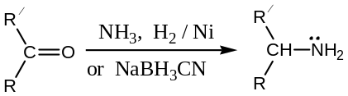
Mechanism of Reductive Amination: Transformation of carbonyl compound to a $1^{0}$- amine involves nucleophilic addition followed by elimination and addition at the double bond —
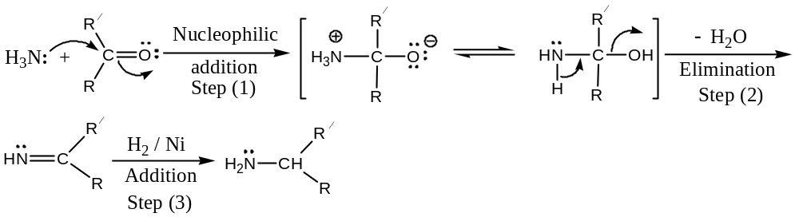
[$8$] By Gabriel’s Phthalimide Reaction: Gabriel phthalimide reaction involves the $S_{N}2$ reaction of an alkyl halide with potassium phthalimide, followed by acid hydrolysis of the resulting $N$- alkylphthalimide to yield the parent acid and an $1^{0}$- amine. This method offers a route for the synthesis of pure $1^{0}$- amines compared with ammonolysis of alkyl halides. Thus, —
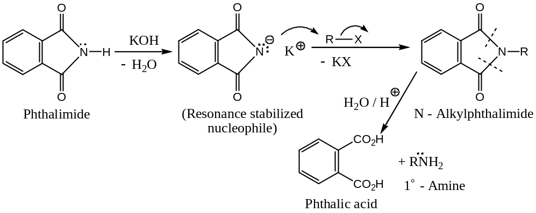
A major drawback of this method is that it is not applicable for the preparation of aromatic amines i.e. arylamines, because aryl halides are generally inert to undergo nucleophilic substitution with the anion of the phthalimide.
[$9$] By Curtius Rearrangement: The intramolecular rearrangement of an acyl azide (carboxylic acid azide) into isocyanate by the loss of molecular nitrogen just by heating (i.e. pyrolysis) is known as Curtius rearrangement. Hydrolysis of the isocyanate yields the amine. Thus, ―
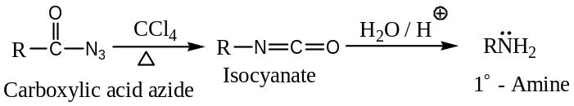
Mechanism: The reaction involves an intramolecular anionotropic $1,2$-shift of the migrating group with its bonding electron pair to the electron deficient $N$- atom from the $C$- atom, probably in a concerted step, and hence an example of $C$- to $N$- rearrangement.
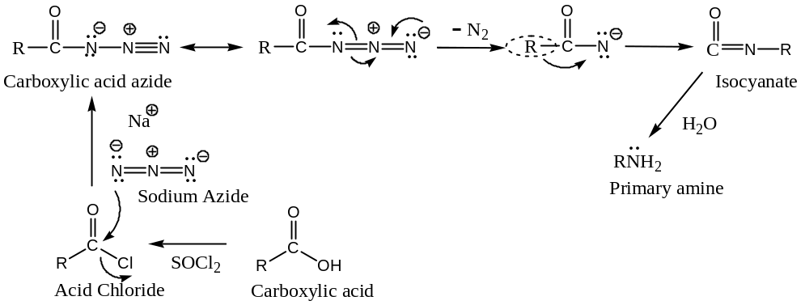
When Curtius rearrangement reaction is applied to $cycloalkylazides$, ring expansion takes place. For example,
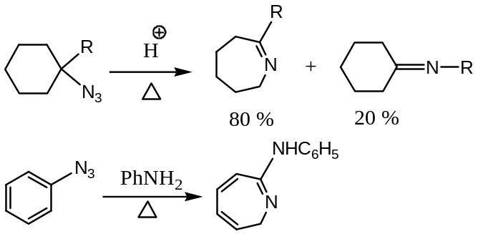
Application of Curtius Rearrangement: Curtius Rearrangement reaction may be used to step down a series. For example —
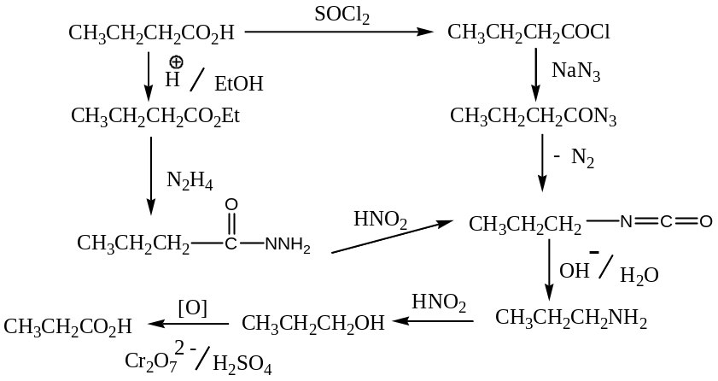
[$10$] By Leuckart Reaction: Conversion of an aldehyde or ketone by heating with ammonium formate and formamide, followed by acid hydrolysis to form the formyl derivative of amines to primary amine is known as Leuckart reaction. Thus, —
$R_{2}C=O+HCONH_{2}+HCOONH_{4}⟶ R_{2}CH\ddot{N}HCHO\underset{→}{{H^{+}}/{H_{2}O}} R_{2}CH\ddot{N}H_{2}+HCOOH$
Mechanism of Leuckart reaction: The reaction involves first a nucleophilic addition followed by elimination of water, hydride shift and hydrolysis to give the $1^{0}$- amine.
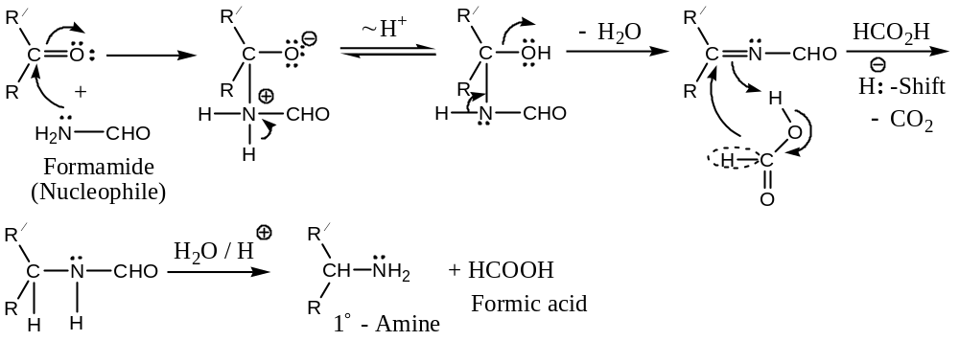
Preparation of Secondary & Tertiary Amines — Both the Aliphatic and Aromatic $2^{0} \& 3^{0}$- amines can be prepared by the following general methods —
[$1$] By the Ammonolysis of Alkyl Halides: Ammonolysis of alkyl halides using an $1^{0}$- or $2^{0}$- amine instead of ammonia results in the formation $2^{0}$- and $3^{0}$- amines respectively. Thus, —
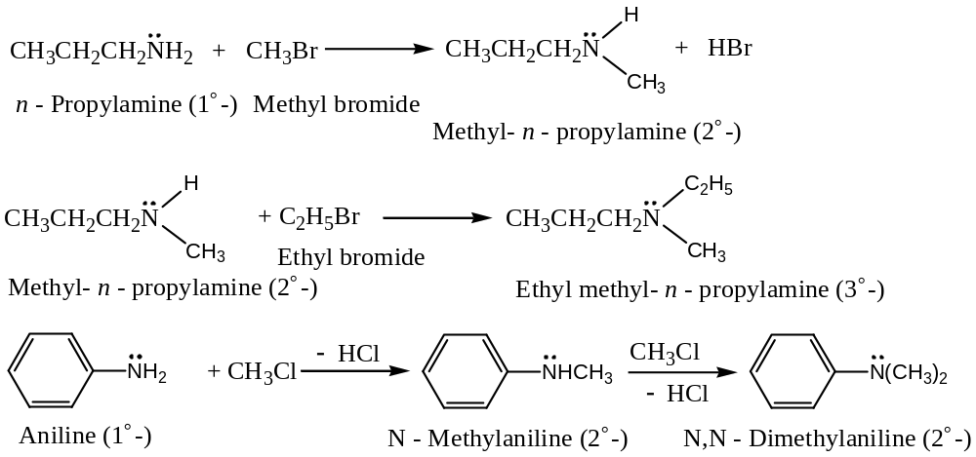
Limitation: Since, the aryl halides like chlorobenzene, compared to alkyl halides, are unreactive; therefore, diphenylamine and Triphenylamine cannot be prepared by this method.
[$2$] By the Reductive Amination of Carbonyl Compounds: Catalytic hydrogenation (or more better to use sodium cyanoborohydride, $NaBH_{3}CN$) of a carbonyl compound in presence of an amine, the carbonyl compounds are reduced to $2^{0}$- and $3^{0}$- amines, and the process is called the reductive amination of carbonyl compounds. For example, —
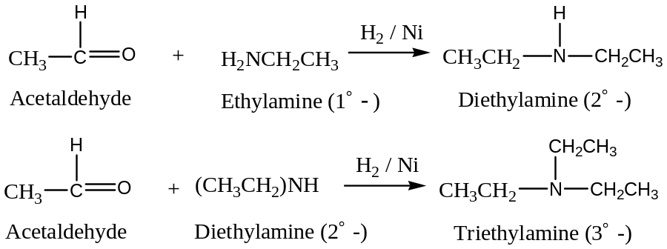
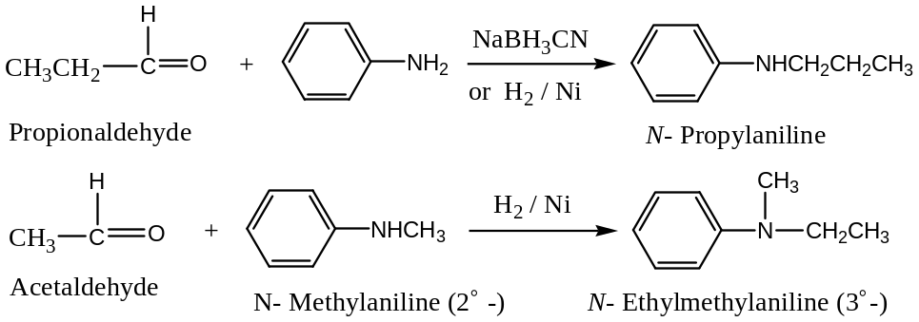
[$3$] From $p$- Nitrosodialkylaniline: $p$- Nitrosodialkylamines prepared from aniline, are treated with an alkali to for $p$- nitrosophenol and the dialkylamine ($2^{0}$- amine). Thus, —
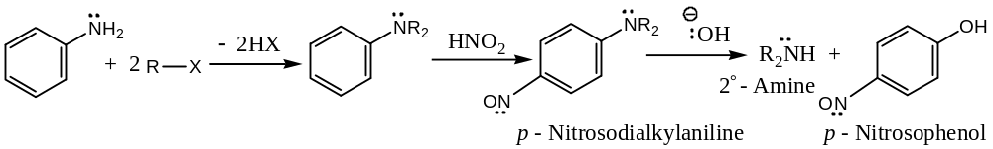
Application: This method provides an excellent route for the conversion of an aryl primary amine into aliphatic secondary amine.
[$4$] By the Reduction of $N$- Compounds: Nitrogen containing organic compounds such as isocyanides can be reduced to an $2^{0}$- amine by $Na \& EtOH$.
$$R-N≡C +4\left[H\right] \underset{→}{ {Na}/{C_{2}H_{5}OH }} RNHCH_{3}$$
Isocyanide $2^{0}$- Amine ($R=alkyl or aryl Gr.$)
Some Specific methods for the Synthesis of $2^{0} \& 3^{0}$- Aryl Amines —
Some specific methods especially Aromatic $2^{0} \& 3^{0}$- amines are —
[$1$] Diphenylamine — from Phenol & Aniline: $2^{0}$- Arylamine such as diphenylamine, can be prepared from phenol by heating it with aniline in presence of a dehydrating agent like anhydrous $Zn{Cl}_{2} at 260℃$. Thus, —
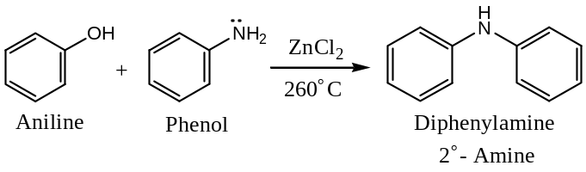
[$2$] Diphenylamine & Triphenylamine — by Ullamann Reaction: In Ullamann reaction, diphenylamine is prepared by refluxing a mixture of acetanilide, potassium carbonate bromo- benzene and small amount of $Cu$- powder in nitrobenzene solution. Thus, —
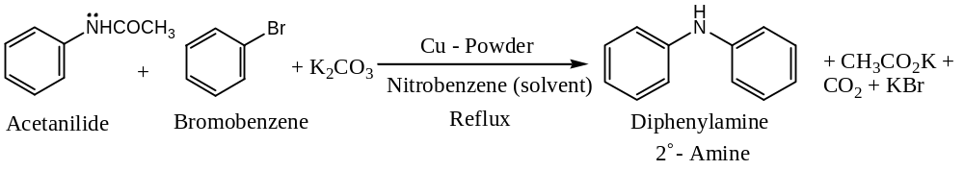
It has been observed that, Ullamann reaction is the most suitable method for the synthesis of substituted diphenylamines.
Triphenylamine ($3^{0}$- amine), can be prepared by Ullamann reaction using diphenylamine and iodobenzene —
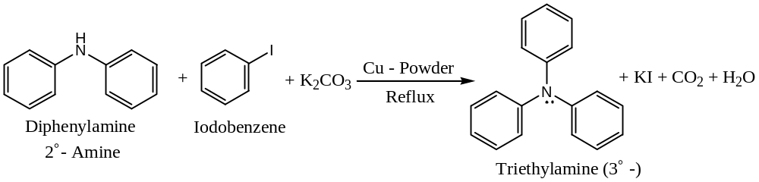
[$3$] Diphenylamine — a commercial synthesis: Commercially, diphenylamine is prepared by heating aniline with aniline hydrochloride at $140℃$ under pressure. Thus, —
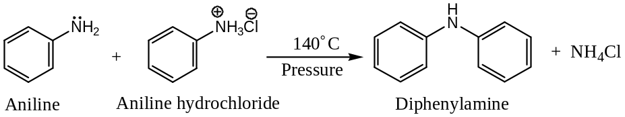
Separation of mixture of $1^{0}, 2^{0} \& 3^{0}$- Amines —
Usually adopted methods are — (1) Hofmann’s and (2) Hinsberg’s method
[$1$] Hofmann method of Separation of mixture of Amines: —
In Hofmann’s method, the mixture of amines is treated with diethyl oxalate, where three amines ($1^{0}, 2^{0} \& 3^{0}$-) react differently with the reagent, as shown below —
The $1^{0}$- amine ($RNH_{2}$), forms a substituted oxamide (crystalline solid) —
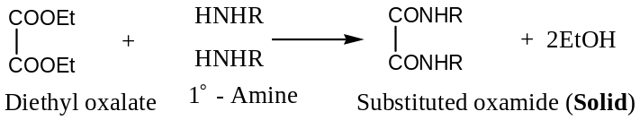
The $2^{0}$- amine ($R_{2}NH$), forms a dialkyl oxamic ester (Liquid) —
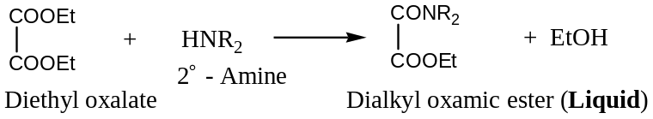
The $3^{0}$- amine ($R_{3}N$), fails to react with the reagent, as it has no replaceable $H$- atom.
Now, the mixture containing the substituted oxamide, oxamic ester and unreacted $3^{0}$- amine is distilled, when the $3^{0}$- amine distils over. The residual mixture contains substituted oxamide (solid) and oxamic ester (liquid) can be separated by simple filtration. Both the oxamide and oxamic ester when treated separately with strong alkali regenerate the corresponding amines.
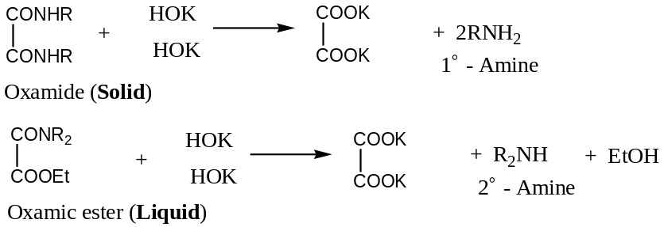
[$2$] Hinsberg’s method of Separation of mixture of Amines: —
The Hinsberg’s method is a better method compared with Hofmann’s method and based upon the fact that on reaction with benzenesulphonyl chloride, $C_{6}H_{5}{SO}_{2}Cl$, the Hinsberg’s reagent, whereby —
The $1^{0}$- amine ($RNH_{2}$), gives a monoalkyl sulphonamide which is soluble in alkali —
$$C_{6}H_{5}{SO}_{2}Cl + H\ddot{N}HR ⟶ C_{6}H_{5}{SO}_{2}\ddot{N}HR + HCl$$
Hinsberg reagent $1^{0}$- Amine Monoalkyl sulphonamide
$$C_{6}H_{5}{SO}_{2}\ddot{N}HR + KOH ⟶ C_{6}H_{5}{SO}_{2}{\ddot{N}}^{-}RK^{+} + HCl$$
Potassium salt (Soluble)
The $2^{0}$- amine ($R_{2}NH$), gives a dialkyl sulphonamide which is insoluble in alkali —
$$C_{6}H_{5}{SO}_{2}Cl + H\ddot{N}R_{2} ⟶ C_{6}H_{5}{SO}_{2}\ddot{N}R_{2} + HCl$$
Hinsberg reagent $2^{0}$- Amine Dialkyl sulphonamide
(Insoluble in alkali)
The $3^{0}$- amine ($R_{3}N$), fails to react with the reagent, as it has no replaceable $H$- atom.
In practice, the mixture of amines is treated with the Hinsberg’s reagent and the reaction mixture is basified with $5\% KOH$ solution and then shaken well with ether in a separating funnel. The $3^{0}$- amine and $2^{0}$- amine (as dialkyl sulphonamide) dissolve in ether layer. The aqueous layer containing potassium salt of benzene monoalkyl sulphonamide is separated and acidified to regenerate the $1^{0}$- amine which forms the salt $RNH_{2}.HCl$ , with excess acid.
($a$) Regeneration of $1^{0}$- amine from aqueous layer: It involves three steps —
$$\left(i\right) C_{6}H_{5}{SO}_{2}{\ddot{N}}^{-}RK^{+} + HCl ⟶ C_{6}H_{5}{SO}_{2}\ddot{N}HR + KCl$$
$$\left(ii\right) C_{6}H_{5}{SO}_{2}\ddot{N}HR + H_{2}O + HCl ⟶ C_{6}H_{5}{SO}_{3}OH + R\ddot{N}H_{2}.HCl$$
$\left(iii\right)$ The $1^{0}$- amine is recovered from its hydrochloride by distillation with $KOH$.
$$R\ddot{N}H_{2}.HCl + KOH ⟶ R\ddot{N}H_{2}.HCl + H_{2}O + KCl$$
($b$) Regeneration of $2^{0} \& 3^{0}$- amines from ether layer: The ether layer containing unreacted $3^{0}$- amine and $2^{0}$- amine (as dialkyl sulphonamide) is shaken with $HCl$, the amines in the form of their hydrochlorides go into the aqueous layer.
$$R_{3}\ddot{N} + HCl + KOH ⟶ R_{3}\ddot{N}.HCl$$
$3^{0}$- Amine hydrochloride
$$C_{6}H_{5}{SO}_{2}\ddot{N}R_{2} + H_{2}O + HCl ⟶ C_{6}H_{5}{SO}_{3}OH + R_{2}\ddot{N}H.HCl$$
Dialkyl sulphonamide (from $2^{0}$- Amine) $2^{0}$- Amine hydrochloride
The two types of hydrochlorides can be separated by fractional crystallization and two fractions are separately distilled with alkali to regenerate the corresponding amines.
$$R_{2}\ddot{N}H.HCl + KOH \underset{→}{ ∆ } R_{2}\ddot{N}H + H_{2}O + KCl$$
$$R_{3}\ddot{N}.HCl + KOH \underset{→}{ ∆ } R_{3}\ddot{N} + H_{2}O + KCl \#\#$$
General Physical Properties of Amines —
Boiling Point: Amines are polar compounds and capable of forming intermolecular $H$- bonding (except in the case of $3^{0}$- amines); and therefore, amines have higher boiling points than the non-polar hydrocarbons of the same molar mass. For example —
Compounds: $C_{6}H_{5}{NH}_{2} \& C_{6}H_{5}{CH}_{3} {CH}_{3}({CH}_{2})_{4}{NH}_{2} \& {CH}_{3}({CH}_{2})_{4}{CH}_{3}$
Aniline Toluene $n$- Pentylamine $n$- Hexane
Boiling Points: $134℃ 110℃ 130℃ 69℃$
Molar Mass: $93 92 87 86$
The boiling points of amines are lower than alcohols and carboxylic acids of comparable molecular weights due to weaker $H$- bonding ($O$- atom is more electronegative than $N$- atom). For example —
Compounds: ${CH}_{3}({CH}_{2})_{3}{\ddot{N}H}_{2} {CH}_{3}({CH}_{2})_{3}OH {CH}_{3}{CH}_{2}COOH$
$n$- Butyl amine $n$- Butyl alcohol Propanoic acid
Boiling Points: $77.8℃ 118℃ 141℃$
Molar Mass: $73 74 74$
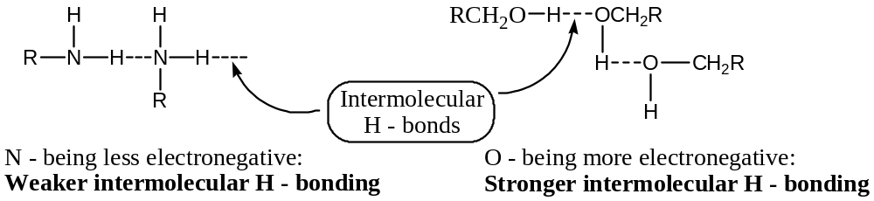
Finally, $1^{0}$- amines boil at higher temperature than isomeric $2^{0}$- amines, as molecular association by intermolecular $H$- bonding is more in $1^{0}$- amines than $2^{0}$- amines. By similar analogy, $3^{0}$- amines have still low $b.pts.$ due to lack of $H$- attached to $N$- atom (no intermolecular $H$- bonding).
Boiling Point: Lower members of aliphatic amines are quite soluble in water because they can form $H$-bonds with water. Amines containing $6$- or more $C$- carbons are almost insoluble in water, but are soluble in less polar organic solvents such as ether, alcohol, benzene, etc. Arylamines are insoluble or sparingly soluble in water.
General Chemical Properties (Reactions) of Amines —
[$1$] Basic Character of Amines: Because of the presence of the unshared electron pair over the $N$- atom, amines are basic in nature. However, arylamines are weak bases due to the less availability of lone pair ($-I effect of phenyl or aryl group$). Because, of the basic nature, amines can form salts with acids. For example, —
$$R{\ddot{N}H}_{2} + HCl ⇌ R{N^{+}H}_{3}{Cl}^{-}$$
For example, —
$$C_{6}H_{5}{\ddot{N}H}_{2} + HCl ⇌ C_{6}H_{5}{N^{+}H}_{3}{Cl}^{-}$$
Aniline Anilinium chloride
(Aniline hydrochloride)
[$K_{b} for Me{\ddot{N}H}_{2}=4.3×{10}^{-4}⇒p^{K_{b}}=3.37 \& p^{K_{a}}=14-3.37=10.63$]
[$2$] Influence of Structure on the Basic Character of Amines: Since, the basicity of amines is due the presence of the unshared electron pair over the $N$- atom, therefore, any factor that increases the availability of lone pair electron density will also increase the basicity of amines.
($a$) Alkyl amines versus Ammonia: Presence of $+I$ effecting group increases the basicity of the amines. For example, decreasing order of basicity of aliphatic amines is —
$$(CH_{3})_{2}\ddot{N}H > CH_{3}\ddot{N}H_{2} >(CH_{3})_{3}\ddot{N} >\ddot{N}H_{3}$$
$p^{K_{b}}$: $3.28 3.37 4.28 4.74$
The anomalous (irregular) basic strength of $3^{0}$- amine (though it has three $+I$ effecting methyl group) can be explained from the fact that its conjugate acid is less stabilized by solvation compared to primary and secondary amines.
($b$) Aromatic amines versus Ammonia and Alkyl amines: The $p^{K_{b}}$ values of some aromatic amines, showing the $I$- effect are represented below —
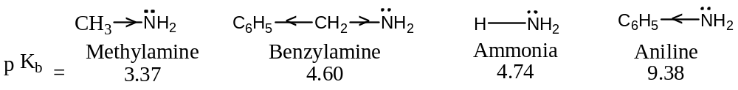
[Smaller the $p^{K_{b}}$ value, stronger the base]
In the case of arylamines, e.g. aniline, resonance effect reduces the availability of the line pair of electrons on $N$- atom. Aniline for example, is a resonance hybrid of the structures —
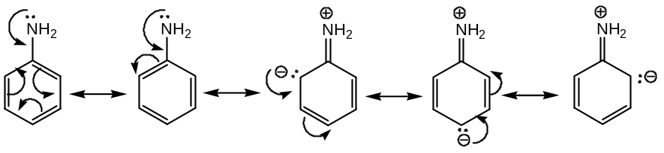
($c$) Basicity of $N$- Substituted Amines: $-I$ Effecting group such as phenyl group attached to the $N$- atom decreases the basicity of amines. For example Diphenyl amine and tri-phenyl amines are extremely weak bases having $p^{K_{b}}$ values $13.22$ and $>13.30$ respectively. Similarly, $+I$ effecting group such as methyl group attached to the $N$- atom increases the basicity of arylamines.
($d$) Basicity of $Nuclear$- Substituted Amines: Groups or atoms directly attached to the aromatic nucleus of aromatic amine (e.g. aniline) greatly influenced the basicity of the amines. It has been observes that —
- Electron releasing substituents ($+I$ effecting) tend to increase and Electron withdrawing substituents ($-I$ effecting) tend to decrease the strength of aniline except $o$- substituents.
- $o$- Substituted anilines tend to have $p^{K_{b}}$ higher than aniline, i.e. weaker bases than aniline irrespective of the nature of the substituents ($+I or-I$).
- The base weakening effecting of electron withdrawing substituents ($-I$ effecting) is most marked when they are present at $o$- position to the $-NH_{2}$ group (Ortho-effect).
($e$) Basicity of Amines having Special Structural arrangement:
($i$) Basicity of $N,N$- Dimethyl Aniline & $N,N,2,6$- Tetramethyl Aniline:
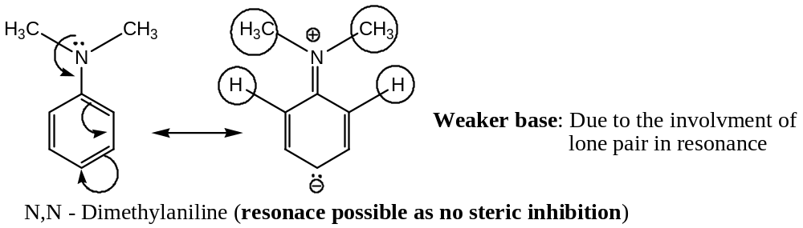
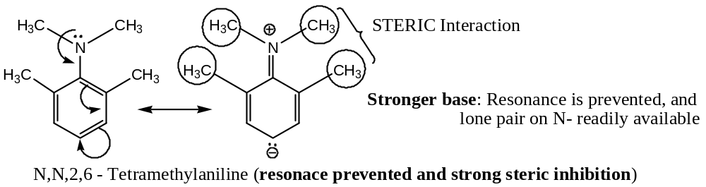
Now, one of the primary conditions of resonance is that all the atoms of a contributing structure in a resonating system must lie in the same plane. Therefore, in $N,N,2,6$- tetramethyl aniline, the methyl groups interfere in resonance stabilization. These steric factors, should, therefore, destabilize the whole system. In other words, there is steric inhibition of resonance and this should increase the base strength of $N,N,2,6$- tetramethyl aniline relative to $N,N$- tetramethyl aniline. This is actually so.
($ii$) Basicity of Picramide ($2,4,6$- Trinitro Aniline & $N,N$- Dimethyl Picramide:
On the basis of concept of resonance, as shown below, it is expected that $N,N$- dimethyl picramide should be a stronger base than picramide itself. This is actually so.
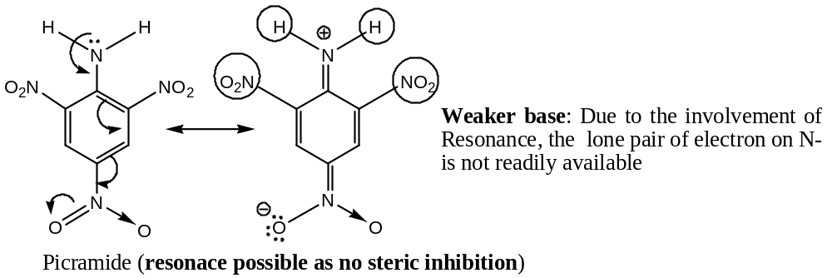
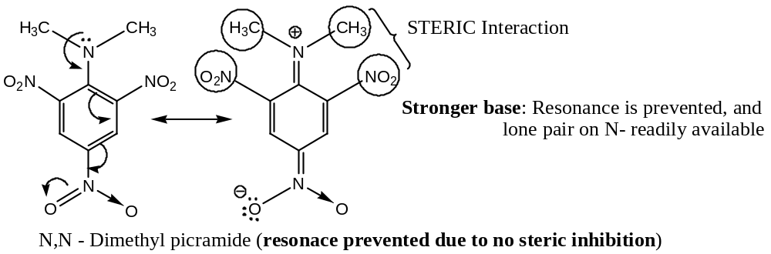
[$3$] Alkylation of Amines: Both the aliphatic and aromatic amines can be alkylated by a nucleophilic substitution reaction on treatment with alkyl halides, in presence of a base, to give successively $2^{0} \& 3^{0}$- amines and finally quaternary ammonium salts. Thus, — $1^{0}$- amines react with $3 moles$ of alkyl halides whereas $2^{0} \& 3^{0}$- amines react with $2 \& 1 mole$ of alkyl halides respectively to form quaternary salts. For example, —
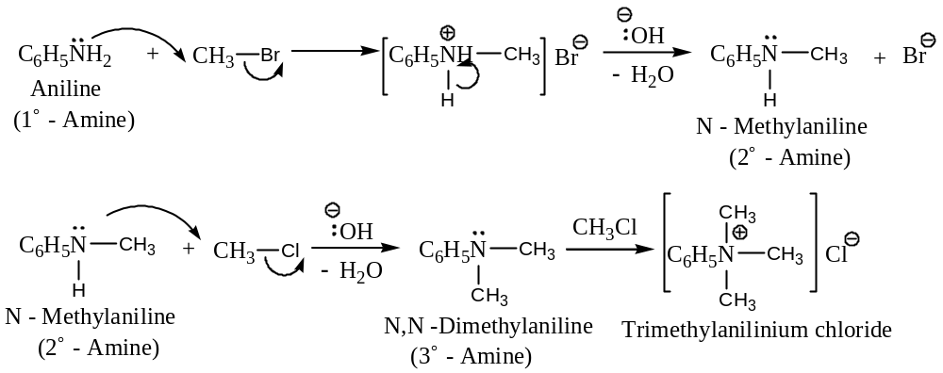
[$4$] Alkylation & Acylation of Amines (Schotten-Baumann Reaction):
Reaction of aniline (or any $1^{0}$- aromatic amine) with aromatic acid chloride or aromatic sulphonyl chloride (Hinsberg’s reagent) in presence of a base (usually aqueous $NaOH$ or pyridine) to form $N$- substituted amides or sulphonamides is the basis of Schotten-Baumann reaction. Thus, —
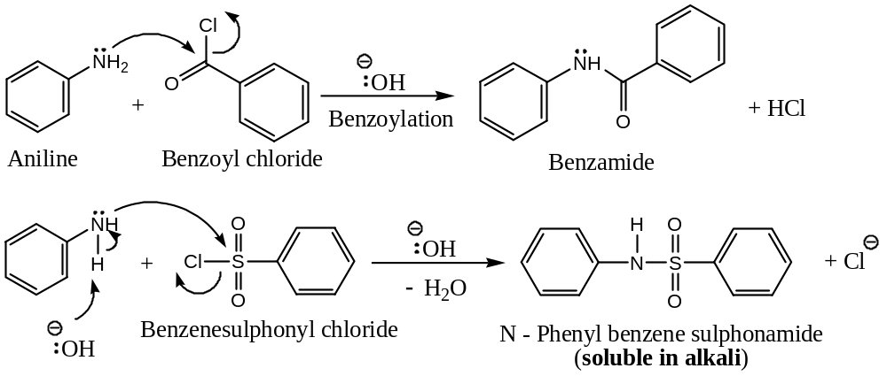
Since, $N$- substituted amides or sulphonamides are crystalline compounds with well-defined melting points, hence are useful for the identification of $1^{0}$- aromatic amine and the method is known as the Schotten-Baumann method.
Similarly, acylation of aniline or aliphatic amine can be done using acid chloride or anhydride as the acylating agent —
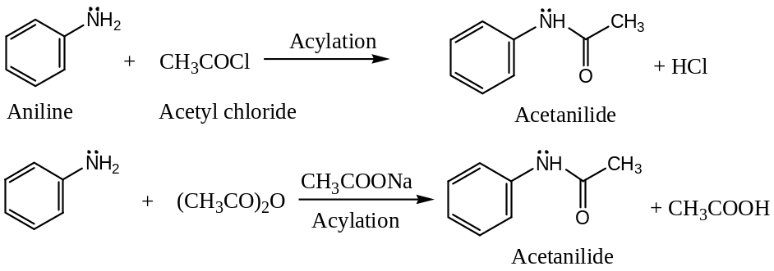
Application: ($a$) Ethanolic solution of acetanilide undergoes light induced Fries rearrangement to yield $o$- and $p$- amino acetophenones. Thus, the reaction provides a method for the conversion of arylamines into amino ketones.
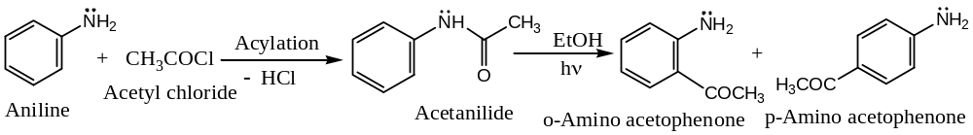
($b$) Acylation can also be used to protect amino group from oxidation —
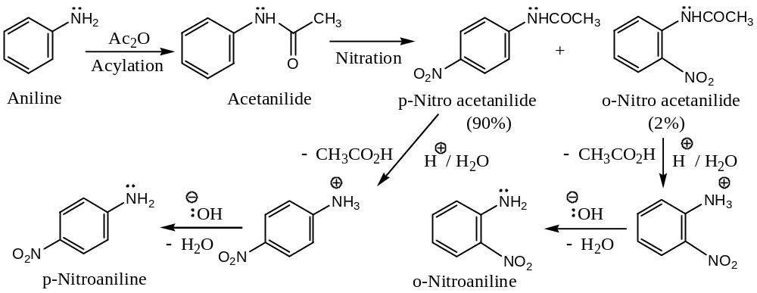
On direct nitration, aniline undergoes oxidation to quinone.
[$5$] Reaction of Amines with Nitrous acid (Diazotization reaction):
Only $1^{0}$- arylamines (e.g. aniline) react with nitrous acid at low temperature and in presence of a strong mineral acid, to form relatively stable, water soluble compounds known as diazonium salts, and the reaction is known as diazotization reaction.
$$Ar\ddot{N}H_{2}+ NaNO_{2}+2HX \underset{→}{Cold: 0-5℃} ArN_{2}^{+}X^{-}+ NaX+2H_{2}O$$
$1^{0}$- Amine Diazonium salt
On the other hand, the diazonium salts formed by aliphatic amines are highly unstable; hence have no any synthetic value.
Again $2^{0} \& 3^{0}$- arylamines react with nitrous acid in a different manner to give different products, instead of diazonium salts. For example, —
$$R_{2}\ddot{N}H +HNO_{2} ⟶ R_{2}N.NO + H_{2}O$$
$$R_{3}\ddot{N} +HNO_{2} ⟶ R_{3}N^{+}.HNO_{2}^{-}$$
$$C_{6}H_{5}\ddot{N}HCH_{3} +HNO_{2} ⟶ C_{6}H_{5}\ddot{N}\left(CH_{3}\right)NO + H_{2}O$$
$$C_{6}H_{5}\ddot{N}{\left(CH_{3}\right)}_{2} +HNO_{2} \underset{→}{ COLD } {\left(CH_{3}\right)}_{2}N-C_{6}H_{4}-\ddot{N}=O(p) + H_{2}O$$
$N,N$- Dimethylaniline ($3^{0}$-) $4$- Nitroso- $N,N$- dimethylaniline
[$6$] Reaction of Amines with Aldehydes: Both aliphatic and aromatic $1^{0}$- amines undergo condensation with aldehyde to give products known as aldimines or Schiff’s base (if the amine is aliphatic) or anils (if the amine is aromatic). This reaction is used to protect $-NH_{2}$ groups in certain reactions. Thus, —
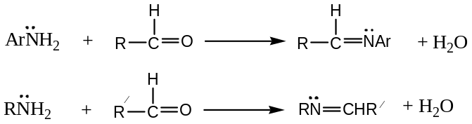
Aldimines can be converted back to amines on hydrolysis. This reaction is nor given by $2^{0}$- and $3^{0}$- amines.
Mechanism of formation of Aldimines, the Schiff’s Base: Formation of Schiff’s base is a nucleophilic addition reaction followed by the elimination of water.
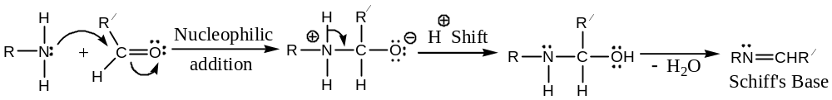
[$7$ Reaction of Amines with Chloroform (Carbylamine reaction):
$1^{0}$- Amines when heated with chloroform in presence of a base (usually alcoholic potash) produces obnoxious smelling compound called carbylamine or isocyanides. Thus, —
$$Ar\ddot{N}H_{2}+ CH{Cl}_{3} + 3KOH⟶ ArN≡C + 3KCl + 3H_{2}O$$
Arylamine Chloroform Aryl isocyanide
$$R\ddot{N}H_{2}+ CH{Cl}_{3} + 3KOH⟶ R-N≡C + 3KCl + 3H_{2}O$$
Alkylamine Chloroform Aryl carbylamine (foul smelling)
This reaction is used as a diagnostic test for aliphatic and aromatic $1^{0}$- amines.
Mechanism of Carbylamine reaction: The reaction proceeds through a dichloro carbene intermediate, initially formed from chloroform by the base —
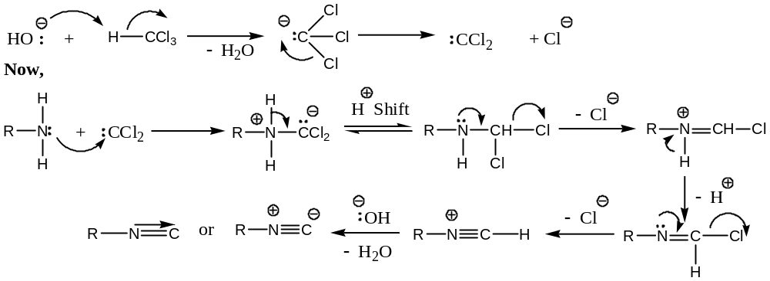
[$8$] Reaction of Amines with Phosgene ($CO{Cl}_{2}$):
Both aliphatic and aromatic $1^{0}$- amines react with phosgene to form deadly poisonous isocyanates. These reactions are not given by $2^{0} \& 3^{0}$- amine due to lack of two $H$- atoms (attached to $N$- atom) required in this reaction. Thus, —
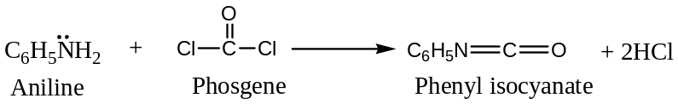
$${CH}_{3}{NH}_{2} +CO{Cl}_{2} ⟶ {CH}_{3}\ddot{N}=C=O + 2HCl$$
Methyl amine Methyl Isocyanate (MIC)
[$9$] Electrophilic Substitution Reactions of Arylamines:
Since, the $-NH_{2}$ group in arylamines is powerful activating substituent and $o$-, $p$- directing, therefore, arylamines undergo typical electrophilic substitution reactions vary readily. Because of the activating $-NH_{2}$ group, poly-substitution generally occurs and the reaction requires only mild reaction conditions.
If it is required to synthesise the monosubstituted product or required to stop the reaction at monosubstituted stage, the activating influence of the $-NH_{2}$ group has to be moderate. The acylamino group ($-\ddot{N}HCOCH_{3}$), is $o$-, $p$- directing but less activating substituent than the $-NH_{2}$ group, and can be easily hydrolyzed to regenerate $-NH_{2}$ group. Thus, acylation is a common technique generally employed to moderate the activating influence of the $-NH_{2}$ group. Some classic examples are —
[Important Note: That the acylamino group is less activating than the amino group in electrophilic substitution reactions can be explained from the fact that the electron pair on $N$- acetyl amino group is less available for sharing (compared with the amino group itself) with aromatic ring, due to the presence of electron withdrawing $–C=O$ group, as shown below —
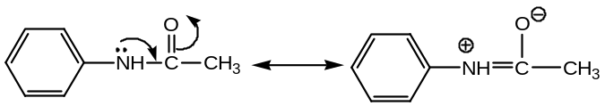
Thus, acylamino group is less activating than $-NH_{2}$ group]
($a$) Halogenation — (${Br}_{2}, I_{2} \& {Cl}_{2} only$) trihaloaniline is formed, i.e. every available $o$- and $p$- positions are halogenated. For example, —
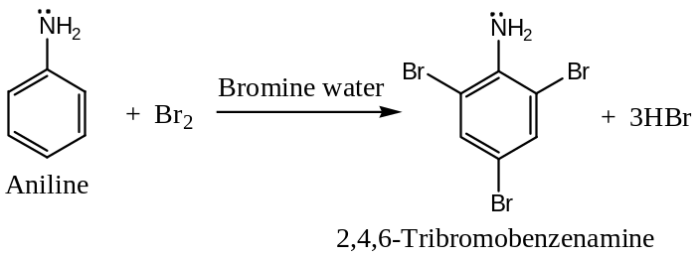
If only mono-halogenation is desired, the free amino group should be acetylated prior to halogenation to moderate the reaction. For example, —
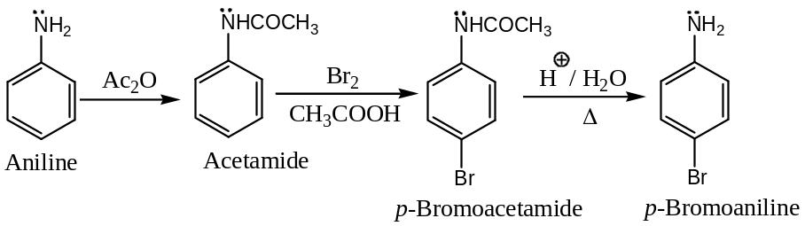
($b$) Nitration — direct nitration leads to the formation of tarry oxidation products (side product), in additional to nitrated products. Also in strongly acidic medium, the arylamine is protonated to anilinium ion, carrying a $+ve$ charge, unlike the $-NH_{2}$ group is $m$- directing. Consequently, significant amount of the $m$- product is formed in the reaction. For example, —
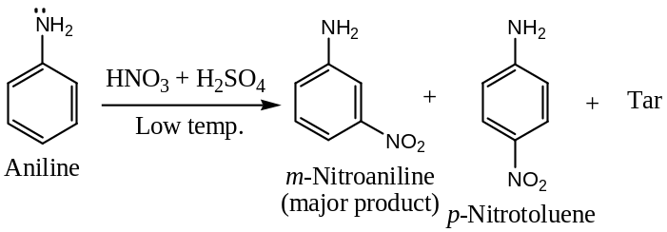
However, if the $-NH_{2}$ group is protected by acetylation, prior to nitration, the reaction proceeds in a controlled fashion according to the known principles of orientations and reactivity.
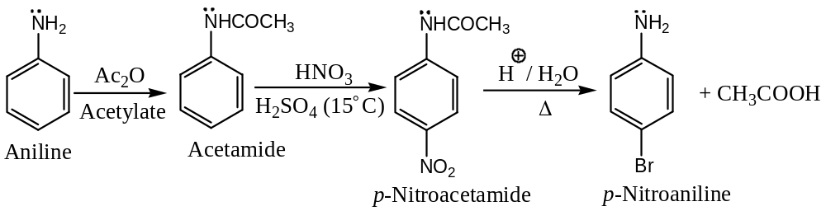
($c$) Sulphonation — when aniline is heated strongly with $H_{2}{SO}_{4}$, $p$- amino benzene-sulphonic acid ($also called PABA, sulpha drug or SULPHANILIC ACID$) is the major product, although $m$- isomer is expected.
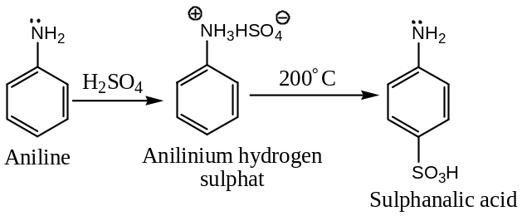
[$10$] Reaction of Amines with Carbon Disulphide ($CS_{2}$): —
Both aliphatic and aromatic $1^{0}$- amines directly add to $CS_{2}$ to form dithiocarbamic acids. Thus, —
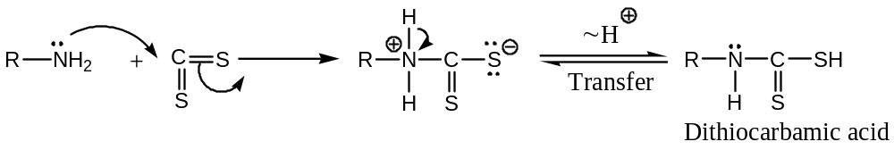
The dithiocarbamic acid so formed, on heating with $AgNO_{3} or Hg{Cl}_{2}$ converted to isothiocyanates, the smell of which is same as mustard oil, and hence known as Hofmann mustard oil reaction.
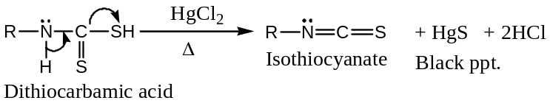
This reaction is not given by $2^{0} \& 3^{0}$- amines.
[$11$] Oxidation of Amines with: Arylamines are susceptible to oxidation by various oxidising agents having characteristic colour change. For example, —
If bleaching powder is the oxidising agent, final colour will be Violet,
Chromic acid ($K_{2}{Cr}_{2}O_{7}+ conc H_{2}{SO}_{4}$) is the oxidising agent; final colour will be Blue, and
$Cr(VI)$ Acid ($K_{2}{Cr}_{2}O_{7}+ CuSO_{4}+dil H_{2}{SO}_{4}$) is the oxidising agent; final colour is Black.
Considering the following reaction, specially for arylamines —
($a$) Oxidation by Chromic acid: Controlled oxidation of aniline with chromic acid yields yellow crystalline substance, $p$- benzoquinone —
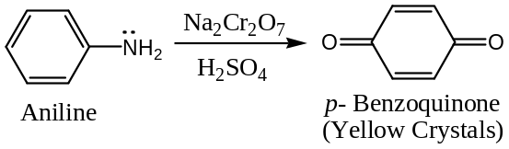
($b$) Oxidation by Alkaline Potassium Permanganate: Alkaline $KMnO_{4}$ oxidises aniline to azobenzene —
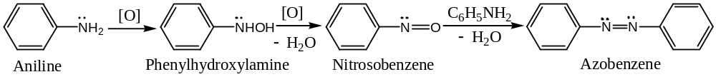
($c$) Oxidation by Caro’s acid ($H_{2}{SO}_{5}$): Caro’s acid oxidises aniline to nitrobenzene —
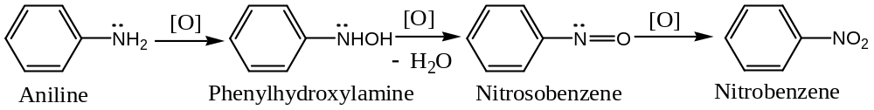
Incontrast aliphatic $1^{0}$- amines are oxidized to nitrosoalkane by Caro’s acid ($H_{2}{SO}_{5}$) or $H_{2}O_{2}$ in ${CH}_{3}{CO}_{2}H$, whereas aliphatic $2^{0}$- amines are gives hydroxylamine.
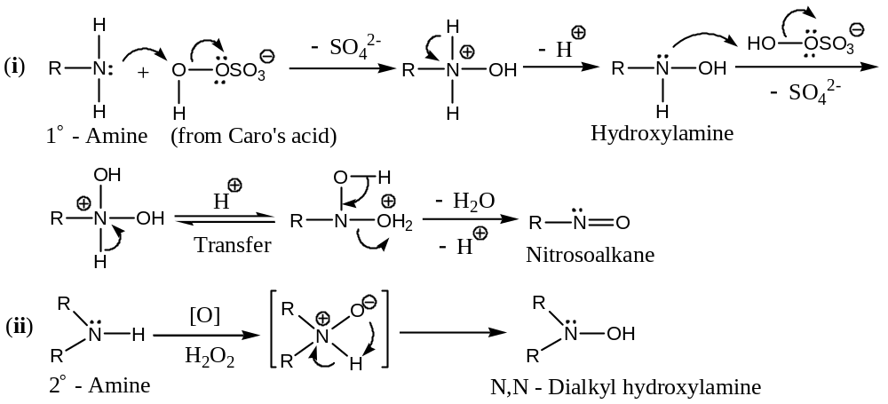
Aliphatic $1^{0}$- amines, in which the $-NH_{2}$ group is attached to a $tert$- $C$- atom are oxidized to nitro ($-NO_{2}$) compounds with $KMnO_{4}$. Thus, —
$$R_{3}C-\ddot{N}H_{2} \underset{→}{\left[O\right], KMnO_{4}} R_{3}C-NO_{2}$$
This is the usual method of preparing aliphatic nitro compounds.
Simple aliphatic $1^{0}$- amines, can be easily converted to the corresponding nitro ($-NO_{2}$) compounds with peracetic acid ($CH_{3}CO_{3}H$. Thus, —
$$CH_{3}(CH_{2})_{5}NH_{2} \underset{→}{CH_{3}CO_{3}H} CH_{3}(CH_{2})_{5}NO_{2} + H_{2}O$$
$n$- Hexylamine $1$- Nitrohexane
Quaternary Ammonium Hydroxide — Hofmann Elimination —
Hofmann Rule
This rule is applicable for those substrates in which the $α$- $C$- atom is attached to a $+vely$ charged atom (usually $N or S$). According to this rule, in the elimination reaction of $+vely$ charged species, the major product will be that alkene which is least substituted. Thus, —
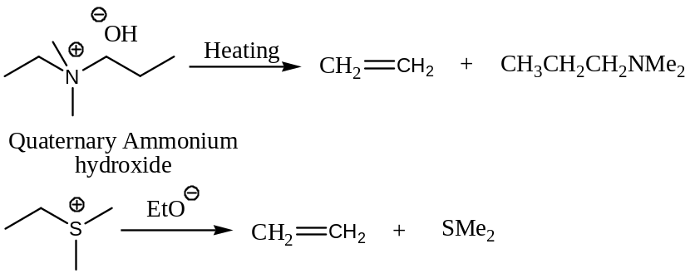
Hofmann rule can be understood by considering the mechanism of elimination reaction of quaternary ammonium hydroxide —
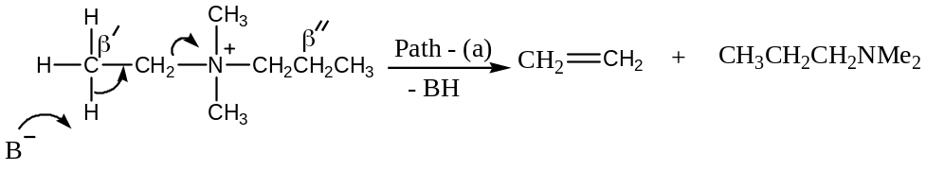
Another possibility is —
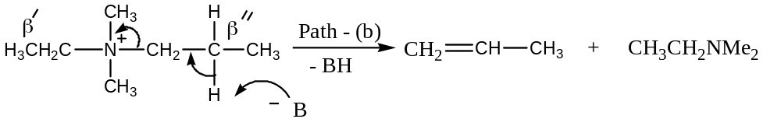
In the above reaction, the strong electron-withdrawing group makes the hydrogens of the $β$- carbons more acidic for facile abstraction by the base. In this compound, with alternate $β$- $H$- atoms (marked as $β^{'}\& β''$ ), the $β''$- $H$- atoms are less acidic due to $+I$ effect of the adjacent methyl group. Hence, $β^{'}$- hydrogen is relatively more acidic and is removed to give the alkene (ethene) by path (a).
Cope Elimination —
The conversion of a $tert$- amine to amine oxide by the reaction of $H_{2}O_{2}$ (i.e. oxidation) followed by an elimination reaction on heating (pyrolysis) to yield dialkyl hydroxyl amine and an alkene is known as the Cope elimination. Thus, —
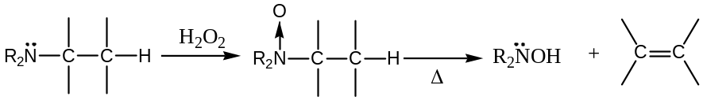
For example, —
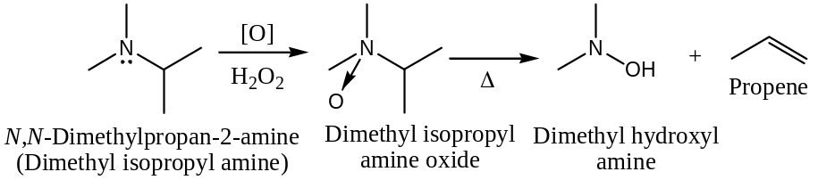
Mechanism: Cope elimination proceeds through a cyclic transition state, involving $cis$- elimination —
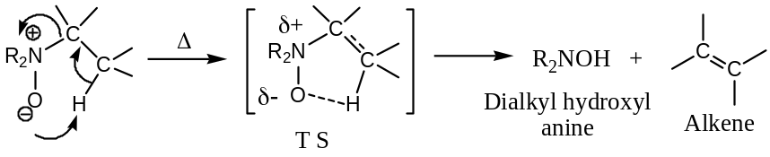
Important Results & Discussions: ($i$) Cope elimination is $cis$- elimination and requires lower temperature than the pyrolysis of quaternary ammonium hydroxides.
($ii$) If the resulting dialkyl hydroxylamine formed in Cope elimination contains $β$- $H$- atoms, it can undergo further elimination, when heated with ${CH}_{3}I \& Ag_{2}O$ to an alkene through amine oxide intermediate. Thus, —
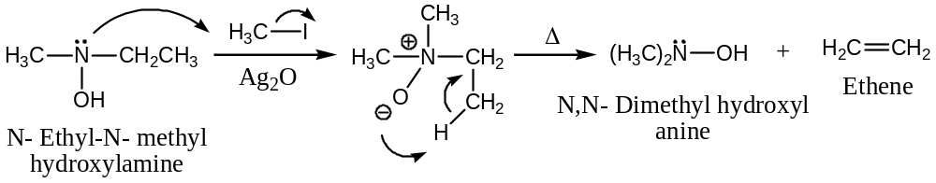
($iii$) Cope elimination is a general reaction useful in determining the structure of an unknown tertiary amine and also for the preparation of certain alkenes.
Demjanov Rearrangement —
Alicyclic $1^{0}$- amines when treated with $HNO_{2}$ undergo ring expansion or ring contraction and the overall sequence of reaction is known as Demjanov rearrangement. This is a characteristic reaction for alicyclic amines. Thus, —
($A$) Ring Expansion:
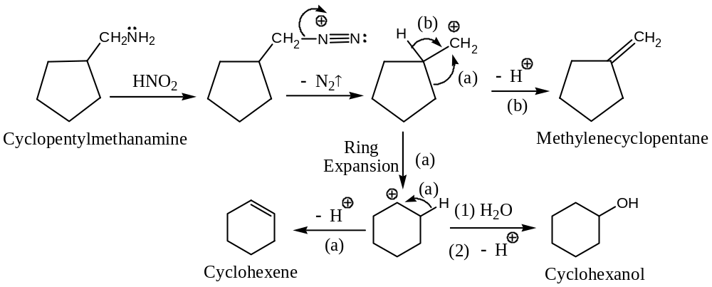
($B$) Ring Contraction:
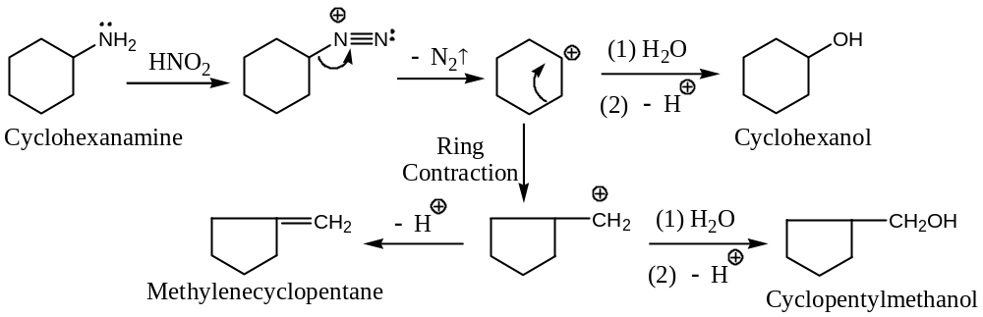
ENAMINES: $α,β$- Unsaturated Amines: Stork Synthesis —
Enamines are the compounds in which an amino group is directly attached to a $C-C$ double bond ($C=C$). These may be considered as $α,β$- unsaturated amines or the $N$- analogs of enols. Thus, —
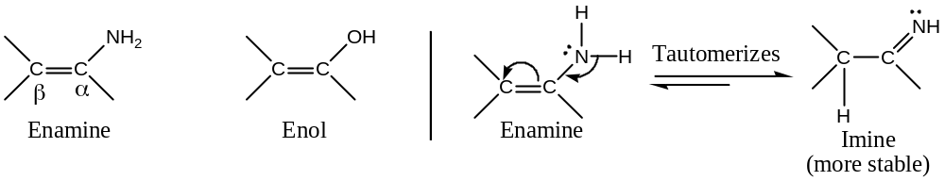
Like enols, enamines are generally unstable and undergo rapid interconversion to stable imine tautomer.
Preparation: Enamines are generally prepared by the condensation of a carbonyl compound having at least one $α$- $H$- atom with $2^{0}$- amine. For example, —
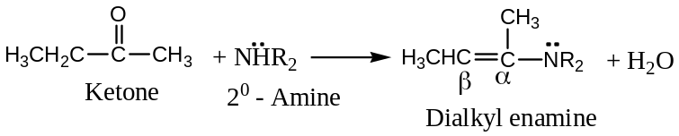
Important: —
($1$) Enamines obtained from ketones are more stable than those obtained from aldehydes.
($2$) Enamines obtained from cyclic $2^{0}$- amine like piperidine, pyrrolidine and morpholine are more stable than those obtained from acyclic $2^{0}$- amines.
For example, —
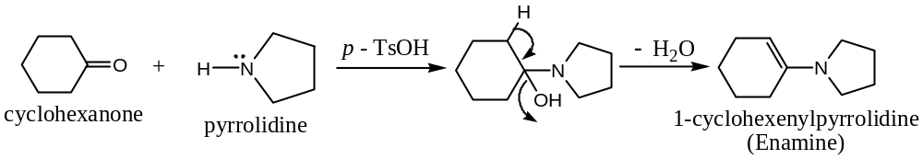
Properties of Enamines — Alkylation
Similar to amines, the amino group of enamine can be alkylated further to give dialkyl enamine. For example, —
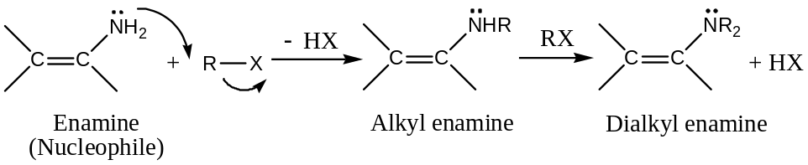
Dialkyl enamines are preferentially formed as are more stable. The stability of dialkyl enamines can be explained by considering the following resonance hybrid —
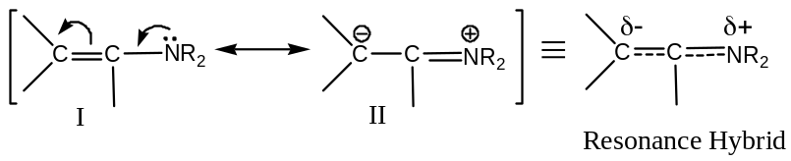
Hydrolysis of Alkylated Enamines —
$N$- Cyclohexeno pyrrolidine (enamine) reacts with alkyl halide to give $C$- alkylated iminium salt, which gives $α$- alkylated ketone on treatment with water. The $N$- alkylated product is also formed but, it is water soluble and unaffected by hydrolysis. For example, —
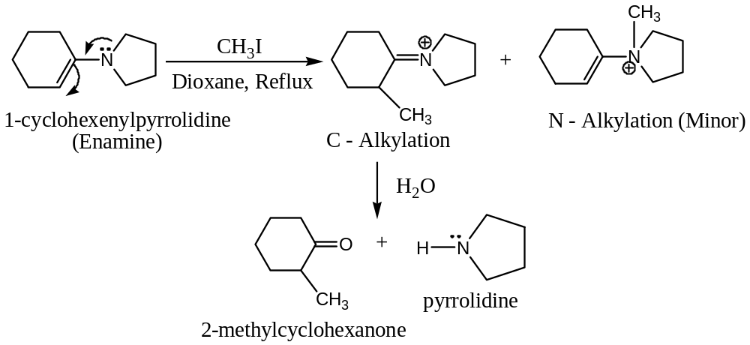
This method provides a very important synthetic route for the preparation of $α$- substituted ketones from ketones via enamines and this process is known as the Stork synthesis.
Some similar examples Stork syntheses are —
($a$) Conversion of cyclohexanone to $2$- allyl cyclohexanone — [Allylation]
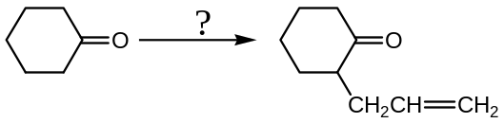
Solution:
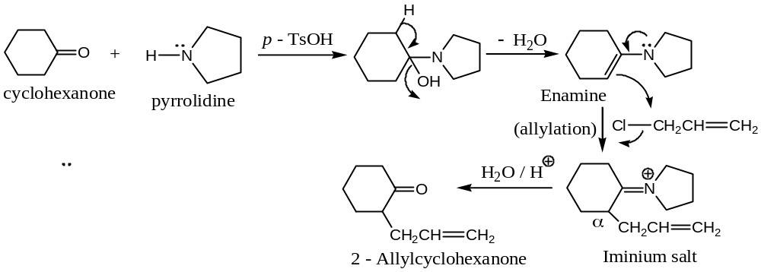
($b$) Conversion of cyclopentanone to $2$- acetonyl cyclopentanone — [Acetonylation]
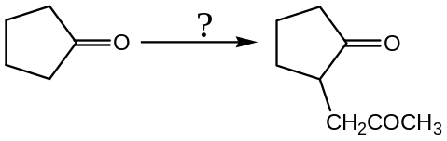
Solution:
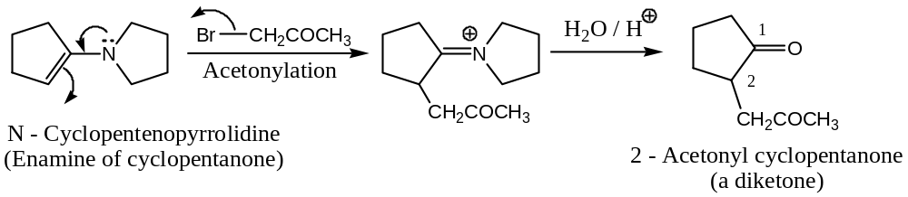
($c$) Conversion of acetone to $4$- phenyl butanone — [Alkylation]
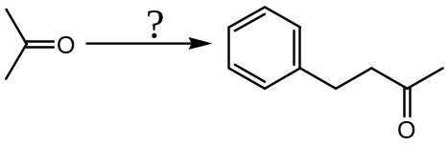
Solution:
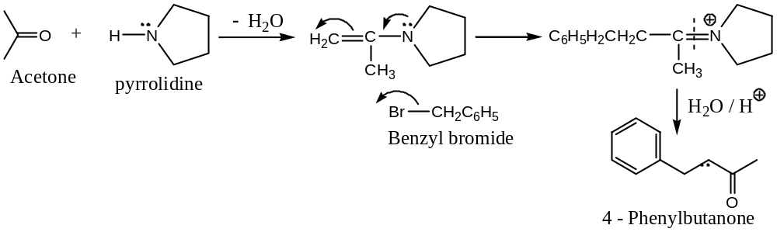
($d$) Conversion of Cyclohexanone to $2$- acetyl cyclohexanone — [Acetylation]
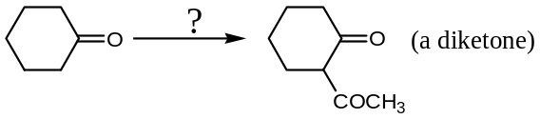
Solution:
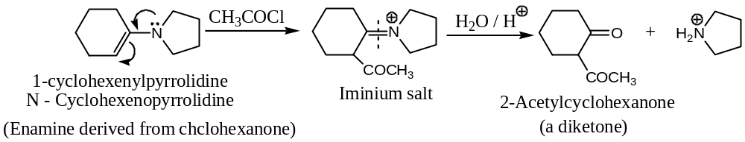
($e$) Conversion of Acetone to $2,4$- Pentanedione — [Acetylation]
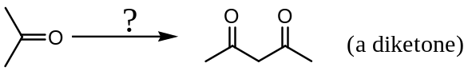
Solution:
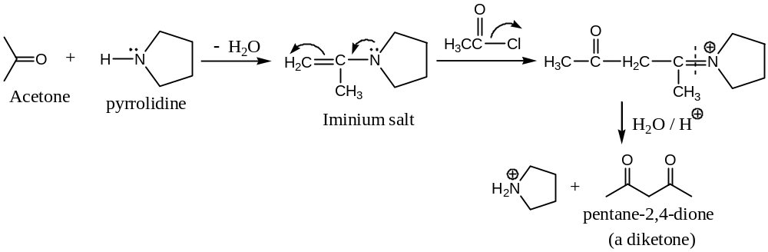
($f$) Conversion of Cyclohexanone to $2$- cyanomethyl cyclohexanone — [Cyanoethylation]
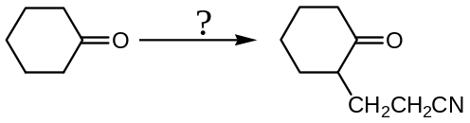
Solution:
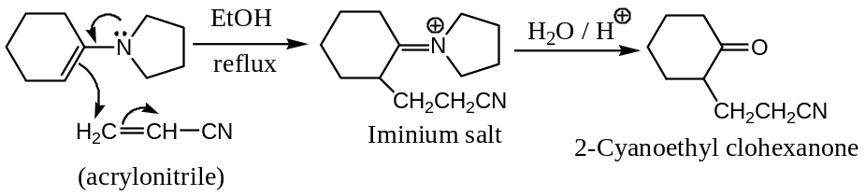
Conclusion: Enamines have wide application in organic synthesis

XXXXX#XXXXXX

