polynuclear hydrocarbons
Syllabus: Reactions of naphthalene, phenanthrene and anthracene; Structure, Preparation and structure elucidation and important derivatives of naphthalene and anthracene; Polynuclear hydrocarbons
Polynuclear Hydrocarbons:
Polynuclear aromatic hydrocarbons or polycyclic aromatic compounds are of $2$- types —
($1$) Isolated Systems — here the two rings are isolated. For example, —
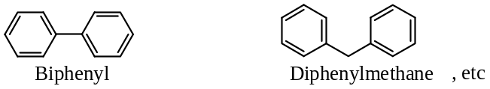
($2$) Condensed systems — here the two rings are fused at their $o$- positions. For example,
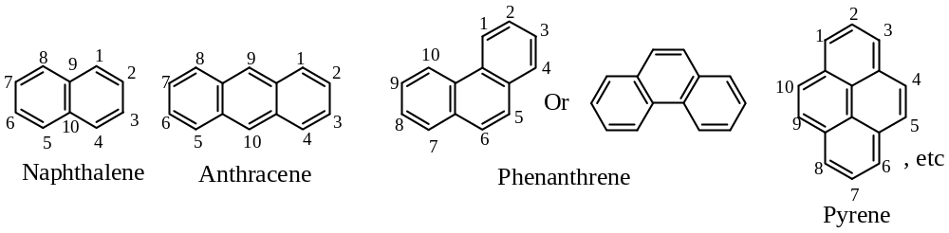
Naphthalene:
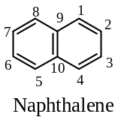
Molecular formula, $C_{10}H_{8}$ ; $mp=80℃$ ; highly volatile
Source: Naphthalene is the major constituent of coal tar ($9\%$)
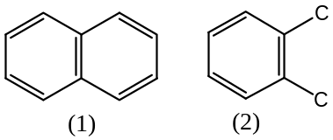Structure of Naphthalene:
Erlenmeyer proposed the symmetrical formula ($1$) for naphthalene, and Graebe proved that it did consist of two benzene rings fused together in the $o$- positions. He used several methods, but the line of approach was the same, for example, he found that on oxidation, naphthalene gave phthalic acid. Thus, naphthalene contains the group ($2$), i.e. a benzene ring with two side-chains in the $o$- positions.
Naphthalene on nitration gave nitronaphthalene which, on oxidation gave $o$- nitrophthalic acid. This indicates that the $-{NO}_{2}$ group is in the benzene ring, and that it is in the side-chains which are oxidized when nitronaphthalene was reduced and the corresponding aminonaphthalene is oxidized, phthalic acid was obtained. Since, the $-{NH}_{2}$ attached to the nucleus renders the latter extremely sensitive to oxidation; hence the inference is that the benzene ring in phthalic acid obtained by oxidation of aminonaphthalene is not the same ring as that originally containing the $-{NO}_{2}$ group in nitronaphthalene, i.e. naphthalene contains two benzene rings. The above facts fit the following scheme —
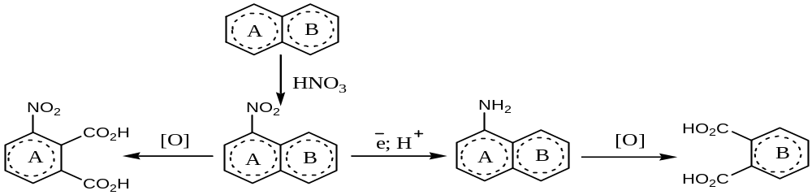
The structure i.e. ($1$) for naphthalene was confirmed by many syntheses. For example,
When $4$- $phenylbut$- $1$- $ene$ is passed over red-hot $CaO$, naphthalene is formed —
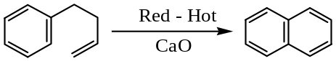
[Problem: How will you show that the naphthalene contains two benzene rings? 4 – 5]
Synthesis/ Preparation of Naphthalene: —
Naphthalene can be synthesised using the following starting materials —
($1$) From $4$- $phenylbut$- $1$- $ene$: See above
($2$) From $4$- $phenylbut$- $1$- $enoic acid$: When $4$- $phenylbut$- $1$- $enoic acid$ is heated with $H_{2}{SO}_{4}$ gives $1$- naphthol, which on $Zn$- dust distillation gives naphthalene. Thus, —
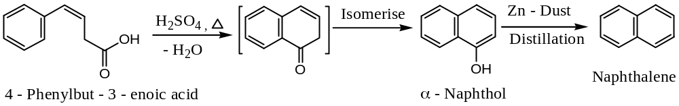
($3$) Haworth Synthesis — Naphthalene from Succinic acid anhydride:
In Haworth method naphthalene is prepared by treating succinic acid anhydride with benzene in presence of $Al{Cl}_{3}$, whereby a keto-acid is formed, which is reduced by $Zn/Hg$ & $conc HCl$ (i.e. Clemmensen reduction). The acid so formed, on heating with $conc H_{2}{SO}_{4}$ undergoes ring closure reaction to form $α$- tetralone, which is further reduced by Clemmensen method to tetrahydro-naphthalene. Dehydrogenation of tetrahydro naphthalene by $Se$ or Palladised charcoal ($Pd–C$) results the desired compound, naphthalene. Thus, —
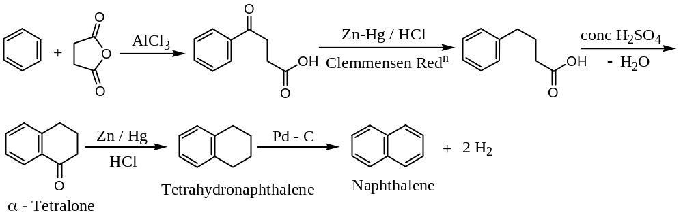
Important Note & Discussion:
[$1$] Ring closure may also be affected by means of a Friedel-Crafts reaction on the acid chloride —
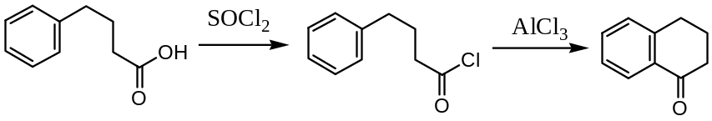
[$2$] For ring closure reaction — we use $H_{2}{SO}_{4}, H_{3}{PO}_{3}, HF$ or best $PPA$ as catalyst for acids but $Al{Cl}_{3}$ for acid chlorides.
[$3$] Tetralone may also be converted to naphthalene by heating with $1: 1$ mixture of $NaOH–KOH$ at $220℃$.
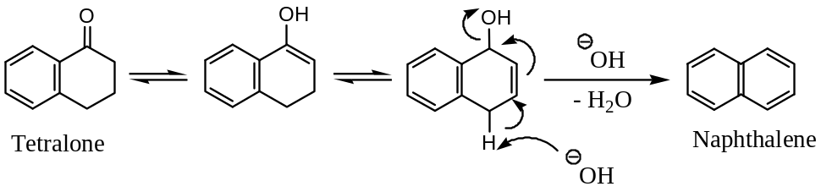
Preparation of Substituted Naphthalene:
Substituted naphthalene i.e. naphthalene derivatives are prepared by Haworth synthesis. With $o/p$- orienting groups present in benzene ring, the main product from the Friedel-Crafts reaction is the $p$- compound. For example, —
($1$) Preparation of $1$-methyl-$7$-chloronaphthalene —
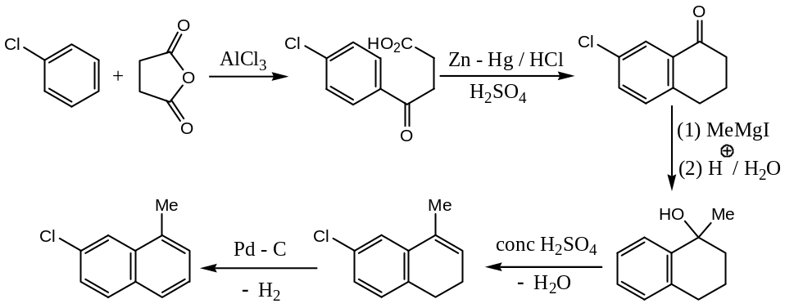
($2$) Preparation of $1$-ethyl-$6$-methylnaphthalene —
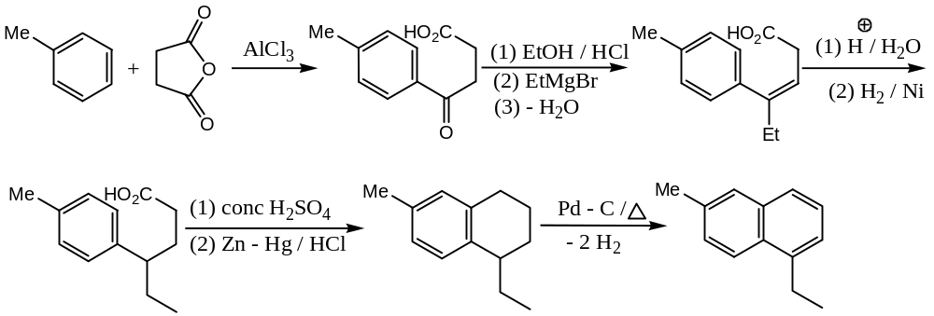
($3$) Synthesis of 1-isopropyl-6-methylnaphthalene —
Synthetic strategy — Retro synthetic approach
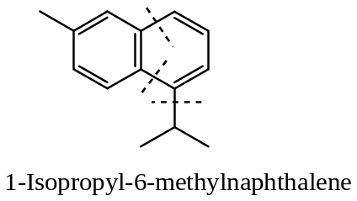
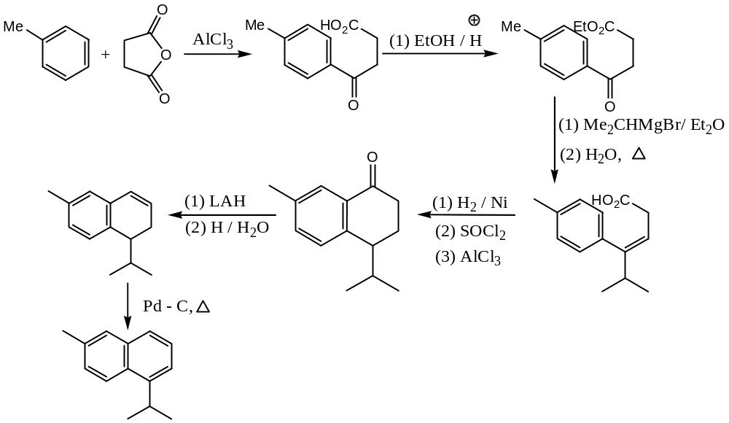
Problem: Complete the following reactions —
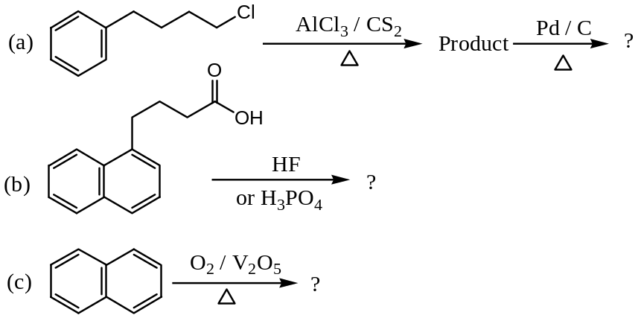
Solution: (a)
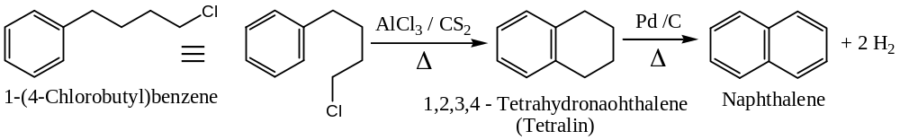
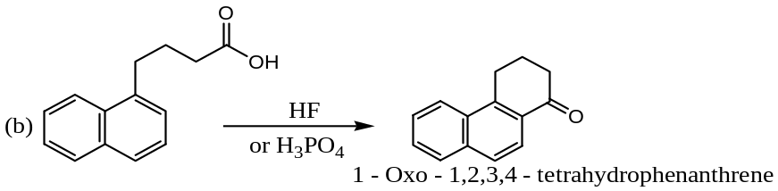
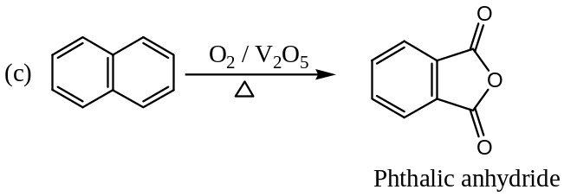
Position of Double Bonds in the Naphthalene & Anthracene:
Naphthalene is a resonance hybrid of the following three structures —
[Important Note: ‘$n$’ Benzene rings, $⇒(n+1)$ principal resonating structures]
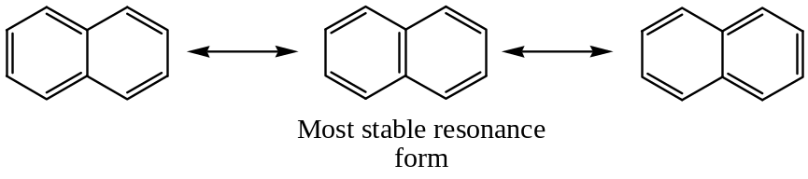
From the above three resonating structures, it is observed that —
In the 1st structure — only left ring corresponds to Keküle benzene
In the 2nd structure — both the rings corresponds to Keküle benzene
In the 3rd structure — only right ring corresponds to Keküle benzene
In general, the most stable structural formula for a polycyclic aromatic hydrocarbon (Fries Rule) is the resonance form which has the greatest number of rings that corresponds to Keküle formulations of benzene i.e. three double bonds in each individual rings. Thus, the most stable resonance form of naphthalene is the middle one.
Similarly for Anthracene:
Thus, anthracene is best represented regarded as a resonance hybrid of $4$- resonating structures, i.e. cannot be represented by any single Lewis structure in which all three rings corresponds to Keküle formulation of benzene.
The $C-C$ bond lengths in naphthalene:
In contrast to benzene, not all the $C-C$ bond lengths in naphthalene are the same. This can be explained as —
Resonating structures for naphthalene are —
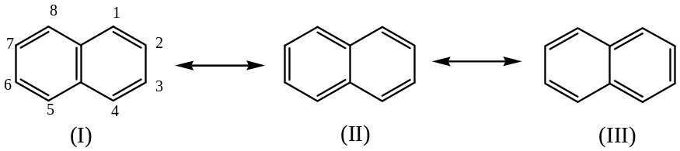
So, the double bond character of the various bonds in naphthalene would be as shown in the structure ($IV$), obtained by taking the average of the above three structures (assuming all contributing equally).
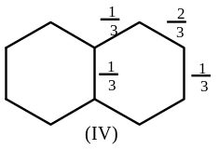
Thus, the $1,2$- bond would be expected to be shorter than the $2,3$- bond, and this has been shown to be case by $X$- ray analysis of naphthalene. This is shown in structure ($V$).
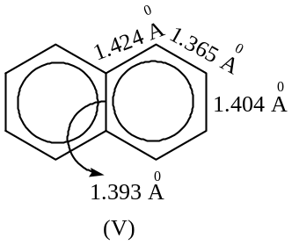
Isomerism & Nomenclature of Naphthalene Derivatives:
Positions — $1,4,5 \& 8$ are identical — these are also called $α$ – positions
Positions — $2,3,6 \& 7$ are identical — these are also called $β$ – positions
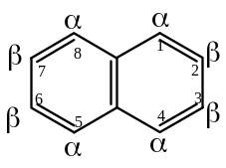
In old literature, the positions $1,2$ – were known as $o$- position; $1,3$ – were known as $m$- position; $1,4$ – were known as $p$- position; $1,5$ – were known as $ana$- position; $1,6$ – were known as $epi$- position; $1,7$ – were known as $kata$- position; $1,3$ – were known as $peri$- position; $2,6$ – were known as $amphi$- position and $2,7$ – were known as $pros$- position.
Some of these prefixes (for example $epi \& peri$) are still used, but it is better to use the numbers as it is recommended by the latest IUPAC systems.
Greek letters $α$- and $β$- are still frequently used to indicate the position of a single substituent. For example — $1$- naphthol as $α$- naphthol, and $2$- naphthol as $β$- naphthol —
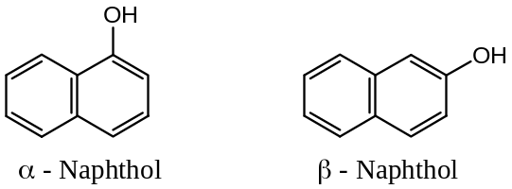
Number of Isomers: Number of possible isomers in substituted naphthalene is as described follows —
Mono-substituted products: $C_{10}H_{7}X$ $2$- isomers: $1$ – & $2$ –
Di-substituted products: $C_{10}H_{6}X_{2}$ $10$- isomers
Di-substituted products: $C_{10}H_{6}XY$ $14$- isomers
Tri-substituted products: $C_{10}H_{5}X_{3}$ $14$- isomers
Tetra-substituted products: $C_{10}H_{4}X_{4}$ $22$- isomers
Penta-substituted products: $C_{10}H_{3}X_{5}$ $14$- isomers
Hexa-substituted products: $C_{10}H_{2}X_{6}$ $10$- isomers
Hepta-substituted products: $C_{10}HX_{7}$ $2$- isomers
Octa-substituted products: $C_{10}X_{8}$ $No$- isomers
Physical properties of Naphthalene:
Problem: How will you account for the fact that the naphthalene is less aromatic than benzene? OR Why naphthalene is more reactive than benzene? 1
Solution: Since in naphthalene, we have two fused benzene rings, hence its expected resonance energy (RE) would be close to $=150.6×2=301.2 kJ{mol}^{-1}$
But its actual resonance energy is $255.2 kJ{mol}^{-1}$
This implies that naphthalene is less aromatic than benzene, as in benzene resonance energy for each ring is $127.6 kJ{mol}^{-1}$. Consequently, naphthalene will have less aromatic character than benzene and so will be more reactive.
Chemical Reactions of Naphthalene:
Naphthalene basically undergoes —
- Addition reactions (Reduction),
- Substitution reactions, and
- Oxidation reactions.
Addition Reactions of Naphthalene:
A number of reduction reactions products of naphthalene can be isolated; the nature of the product formed depends on the nature of the reducing agents used, for example —
($a$) Naphthalene to Dialin: Reduction of naphthalene by sodium and ethanol gives $1,4$- dihydro-naphthalene ($1,4$ - dialin) —
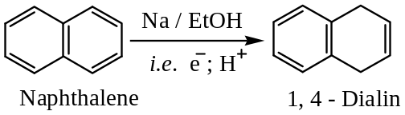
[Note: $1,4$- Dialin is unstable, readily isomerise to $1,2$- dialin, when heated with ethanolic sodium hydroxide —
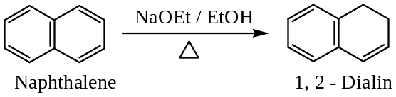
1, 2 – Dialin is also unstable, finally eliminating H₂ to form naphthalene —
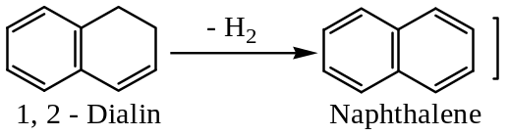
($b$) Naphthalene to Tetralin: Reduction of naphthalene by sodium and isopentanol, yields tetralin ($1,2,3,4$- tetrahydronaphthalene) —
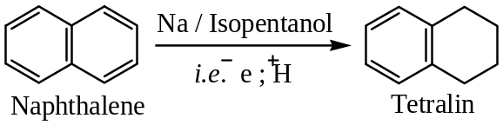
($c$) Naphthalene to $α$- Tetralone: Reduction of naphthalene by sodium and isopentanol, yields tetralin ($1,2,3,4$- tetrahydronaphthalene), which on heating in air forms the corresponding peroxide. The tetralin peroxide so formed on reaction with dilute base (usually $NaOH$) yields $α$- tetralone.
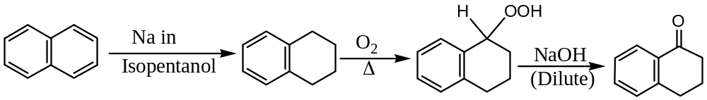
($d$) Naphthalene to α – Tetralone: By Haworth Process (Synthesis) —
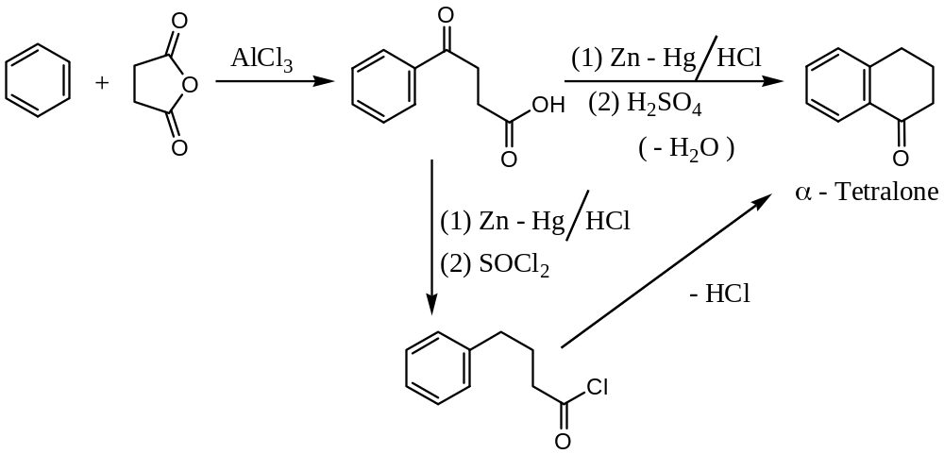
($e$) Naphthalene to Decalin: Catalytic reduction ($using$ $Ni or Pt$) of naphthalene yields firth tetralin, and then further reduced to decalin (decahydronaphthalene) —
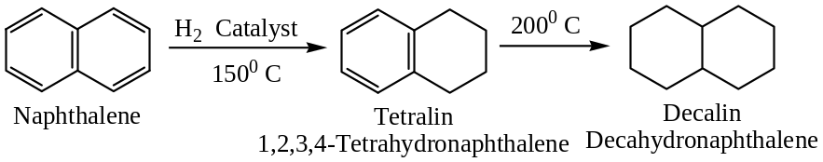
If $Ni$- is used as catalyst product is $trans$- decalin but if $Pt$- is used as catalyst product is $cis$- decalin. Conformations of these two forms are —
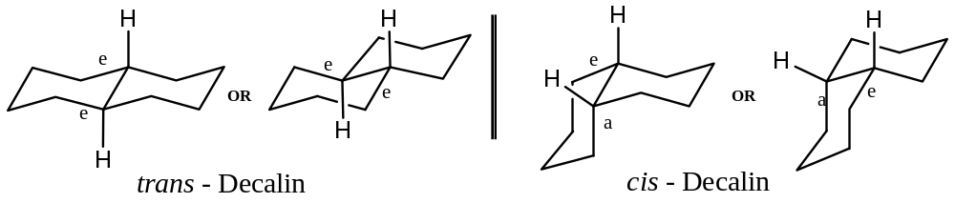
Oxidation Reactions of Naphthalene:
Naphthalene can be oxidized by using various oxidizing agents to yield variety of products. For example —
($a$) Naphthalene to Phthalic Anhydride: Oxidation of naphthalene by $conc. H_{2}SO_{4}$ and $Hg{SO}_{4}$ or oxidation by dry air ($O_{2}$) in presence of $V_{2}O_{5}$ yields phthalic anhydride —
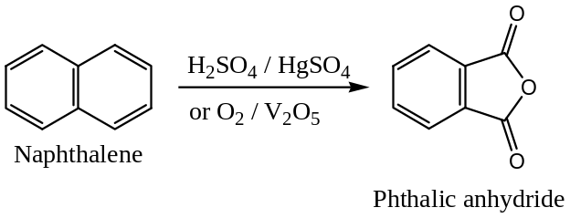
($b$) Naphthalene to Phthalic Acid: Oxidation of naphthalene by acidic permanganate yields phthalic acid —
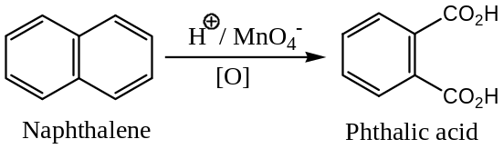
($c$) Naphthalene to Phthalonic Acid: Oxidation of naphthalene by alkaline permanganate yields phthalonic acid —
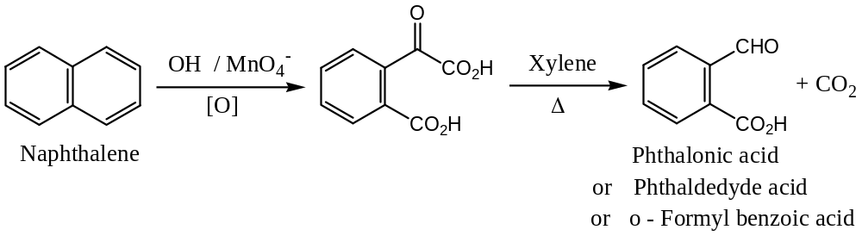
($d$) Naphthalene to Phthalaldehyde: Oxidation of naphthalene by ozone followed by hydrolysis i.e. ozonolysis yields phthalaldehyde —
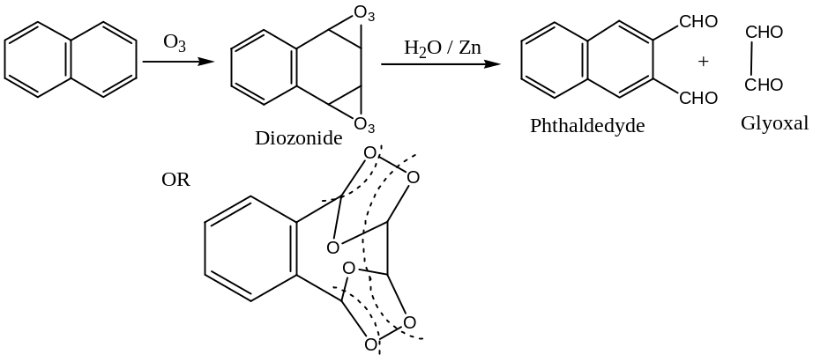
Substitution Reactions of Naphthalene:
Naphthalene always undergoes substitution at position – 1, except in two cases —
- Sulphonation at high temperature and
- In the Friedel-Crafts reaction
In these two cases $2$- derivative is the main product i.e. substitution at $α$- position is kinetically favoured relative to that at $β$- position. For example —
($a$) Nitration of naphthalene —
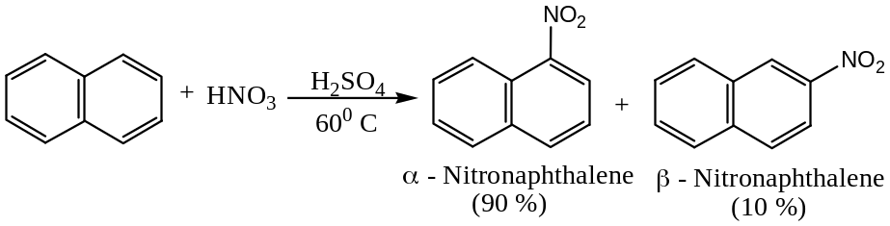
($b$) Bromination of naphthalene —
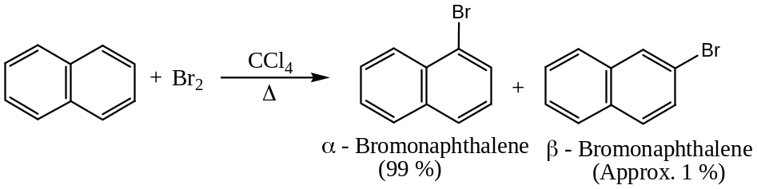
($c$) Benzoylation of naphthalene —
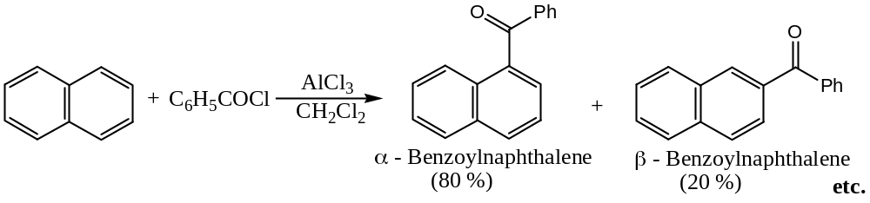
Explanation: Favourable formation of $1$- substituted (i.e. $α$-substituted) product can be well explained by considering the stability of the intermediate carbocation. As —
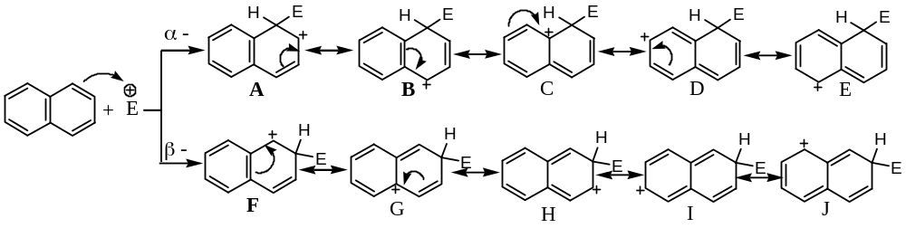
From the above resonating structures it is evident that in the case of $α$- substitution two structures ($A \& B$), but in $β$- substitution only one structure ($F$), retain an aromatic ring. Thus, substitution at $α$- position is favoured because it proceeds through the more stable carbocation intermediate.
Problem: Why naphthalene undergoes electrophilic substitution exclusively at $α$- position? 3
Solution: See as shown above
Sulphonation of Naphthalene:
Sulphonation of naphthalene produces either $α$- or $β$-naphthalene sulphonic acid depending on reaction temperature. At lower temperature ($80℃$) $α$- isomer (expected) forms exclusively, but at higher temperature ($160℃$) $β$- isomer becomes the major product. This is due to the fact that —
- $α$- Product converts to $β$- isomer at higher temperature, and
- Sulphonation of naphthalene is reversible.
Thus, $α$- naphthalene sulphonic acid is kinetically controlled product but its $β$- isomer is thermally or thermodynamically controlled product.
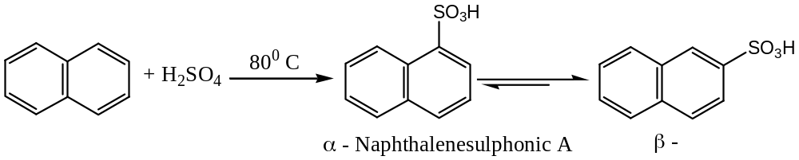
Friedel-Craft Reaction with Naphthalene:
Naphthalene undergoes Friedel-Craft reaction at low temperature (i.e. mild reaction condition) in presence of aluminium chloride (Lewis acid). However, under vigorous conditions $Al{Cl}_{3}$ attacks the naphthalene and one of the rings opens. Thus, mild reaction condition is essential for naphthalene to undergo Friedel-Craft reaction (for both alkylation & acylation). For example —
($a$) Reaction of Naphthalene with methyl iodide, ${CH}_{3}I$: $1$- and $2$- methylnaphthalene is formed —
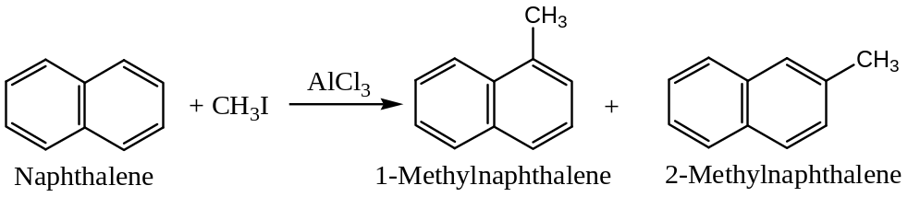
($b$) Reaction of Naphthalene with ethyl bromide: Only $2$- ethyl naphthalene is formed
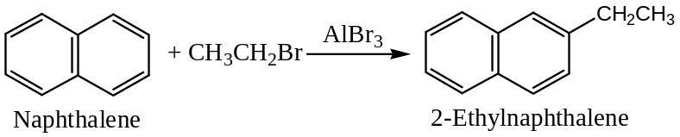
($c$) Reaction of Naphthalene with $n$- propyl bromide: Only $2$- isopropyl naphthalene is formed —
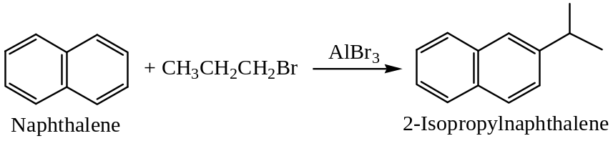
($d$) Reaction of Naphthalene with alcohols: Only $2,6$- dialkyl naphthalene is formed if $Al{Cl}_{3}$ is used as Lewis acid catalyst —
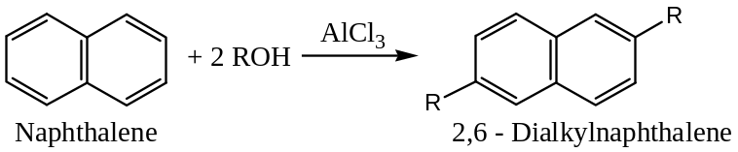
However, if the reaction is carried out in presence of $BF_{3}$, the Lewis acid the product is $1,4$- dialkyl naphthalene is formed.
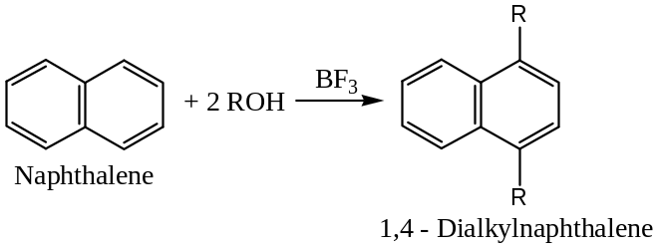
($e$) Acylation of Naphthalene: Acylation of naphthalene results $1$- and $2$- ketones, and the percentage yield of isomers formed depend on the solvent used. For example —
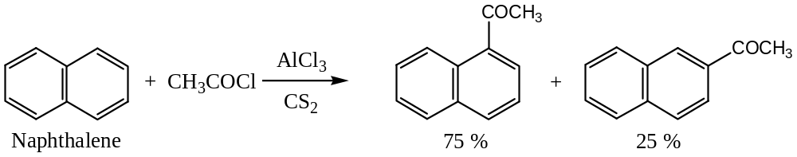
With acetyl chloride in $CS_{2}$ solvent, $1$- and $2$- naphthyl methyl ketones are formed in the ratio $1:3$. But, in nitrobenzene solvent these are formed in $1:9$ ratios —
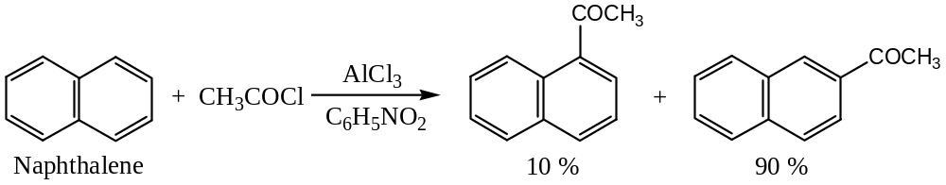
Derivatives of Naphthalene: Substituted Naphthalene
Halogen derivatives of naphthalene: Halogenation— Halonaphthalene
($1$) $1$- Halo naphthalene derivatives are conveniently prepared from naphthalene itself, for example, —
($a$) $1$- Bromonaphthalene is formed with ${Br}_{2}$ in boiling $C{Cl}_{4}$ solution, further bromination yields mainly $1,4$- dibromo derivative. Thus, —
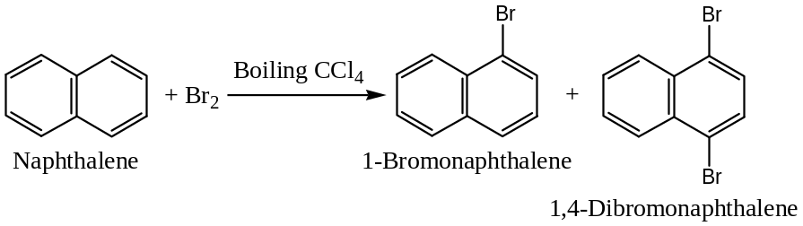
($b$) With $SO_{2}{Cl}_{2}$ (sulphuryl chloride) in presence of $Al{Cl}_{3}$ at $25℃$ naphthalene yields $1$- chloro derivative, but at $100-140℃$, $1,4$- dichloronaphthalene is formed. Thus, —
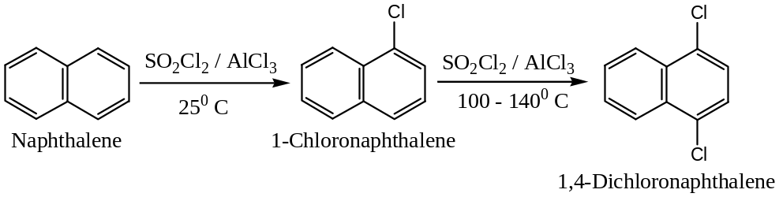
($2$) $2$- Halo-naphthalene derivatives are conveniently prepared from $2$- naphthylamine by diazotization —
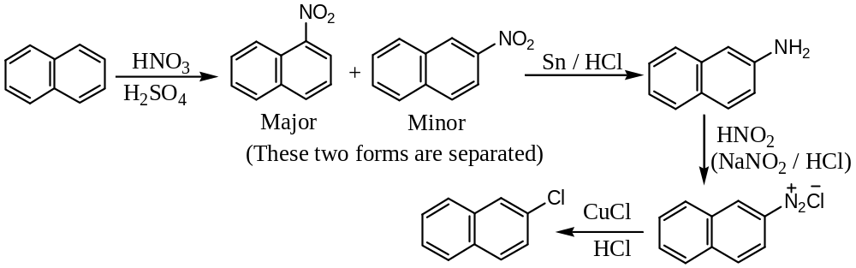
Nitro derivatives of naphthalene: Nitration — Nitronaphthalene
($1$) At room temperature nitration by $HNO_{3}$, naphthalene yields $1$-nitronaphthalene, (which behaves same as nitrobenzene) but at high temperature gives a mixture of $1,5$- and $1,8$- dinitronaphthalene. Thus, —
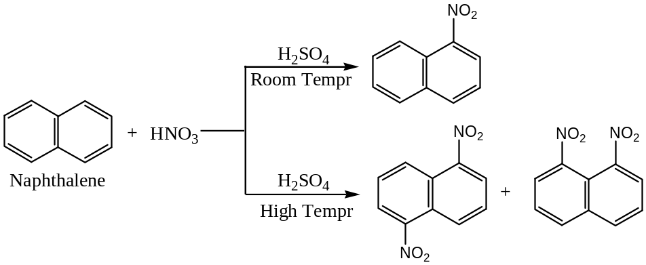
Question: How nitrobenzene differs from nitronaphthalene?
Solution: Hints —
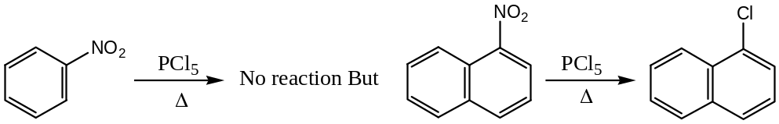
($2$) Formation of $2$- nitronaphthalene —conveniently prepared by diazotization reaction
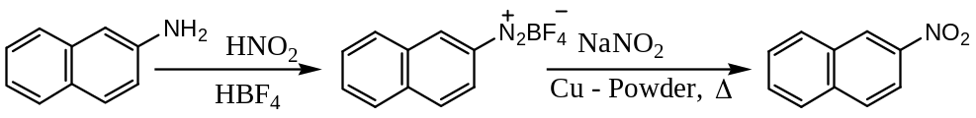
Amino derivatives of naphthalene: Amination — Naphthylamine
$α$- Naphthylamines are prepared by —
($1$) Reduction of $1$- nitronaphthalene with $Fe/HCl$,
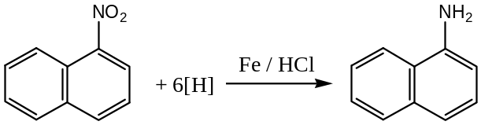
($2$) By heating $α$- naphthol with $NH_{3} \& Zn{Cl}_{2}$,
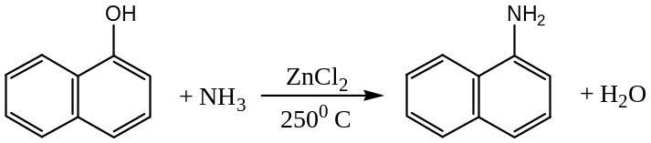
$β$- Naphthylamines are prepared by —
($1$) Bucherer reaction from $β$- Naphthols —
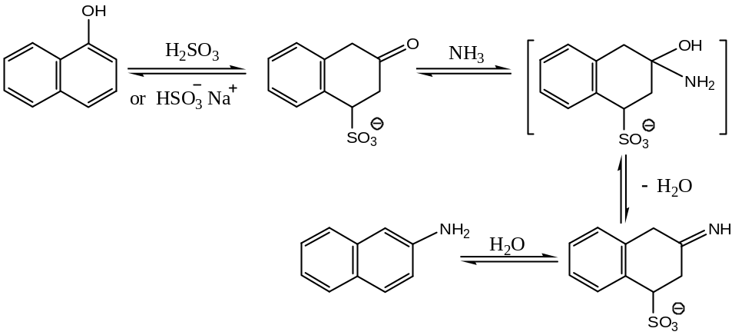
($2$) By heating $2$- naphthol with aqueous $NH_{4}HSO_{4} at150℃$ under pressure,
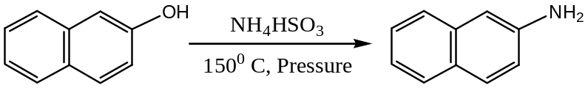
Hydroxyl derivatives of naphthalene: Hydroxylation — Naphthols
Both $1$- and $2$- Naphthols (hydroxy naphthalene) are industrially prepared by fusing the corresponding naphthalene sulphonic acid with $NaOH$. Thus, —
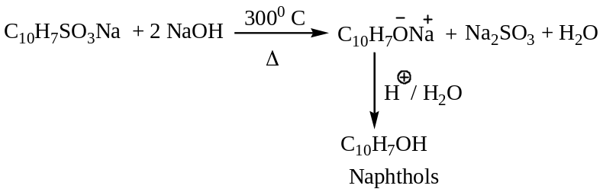
For example —
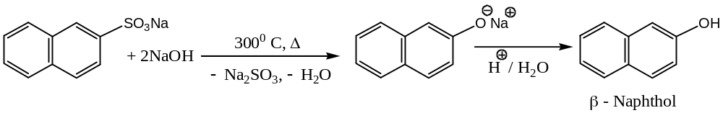
$α$- $or 1$- Naphthols may also be prepared as —
($a$) From $α$- naphthylamine —
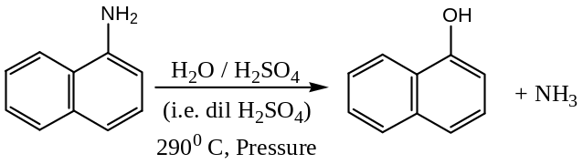
($b$) From o – bromofluorobenzene —
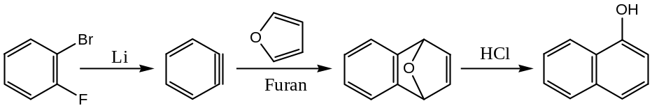
Alkyl substituted naphthalenes:
Alkyl substituted naphthalenes, like $2$- methylnaphthalene on oxidation with chromic acid (${CrO}_{3}-AcOH i.e. acetic acid$) gives $2$- methyl-$1,4$- naphthaquinone (menadione) which has vitamin- $K$ activity.
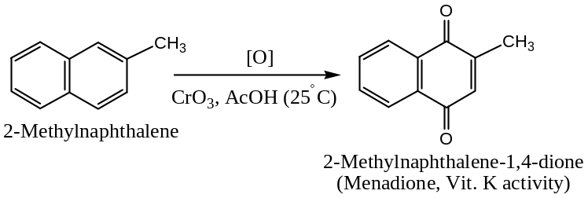
substituent effects in Naphthalene:
The partial rate factors (relative to benzene) for typical electrophilic substitution reactions at the $α$- position of naphthalene are in the range of ${10}^{2}-{10}^{5}$. The values indicate a significant activating influence of one ring on the other. For example, bromination of naphthalene proceeds without a Lewis acid catalyst but in benzene $Fe{Br}_{3}$ is required.
Further substitution in mono-substituted naphthalene can be explained with an orientation effect in the two rings of naphthalene as follows —
($A$) Activating Groups enhance the reactivity while directing the electrophile into the ring already containing the substituent. The process benefits from conjugation of the intermediate cation with the substituent (S) without sacrifice of aromaticity in the 2nd ring.
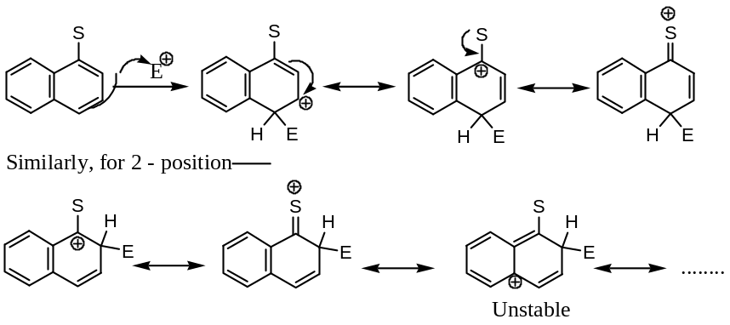
Thus, an $o$- $p$- directing group (i.e. electron donating group) on the $1$- position of naphthalene directs the new electrophile to the $2$- and $4$- positions.
On the other hand the same substituent (i.e. electron donating group) on the $2$- position directs substitution almost exclusively to the position –$1$.
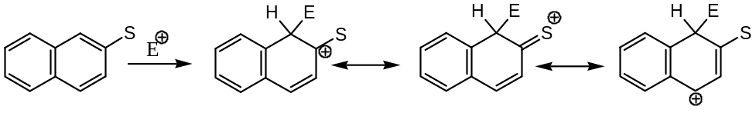
($B$) deactivating Substituent or Group (i.e. electron withdrawing) decreases reactivity in the ring to which it is attached and directs the electrophile to the other ring. Thus, —
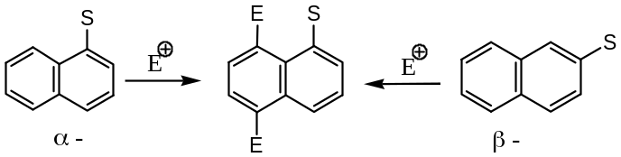
Important Notes & Discussions:
($1$) The table given below summarizes the orienting effects of substituents on naphthalene:
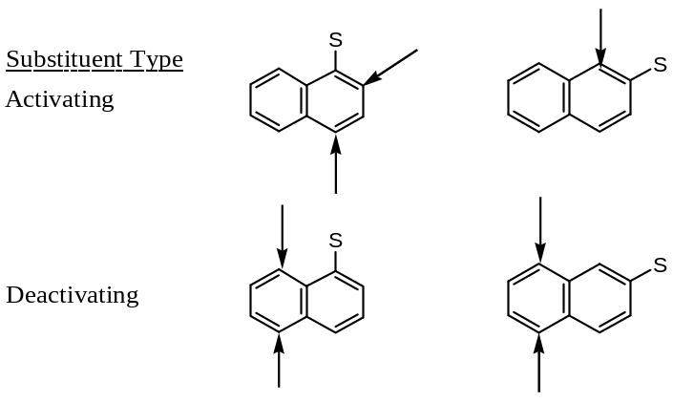
($2$) The following empirical generalizations are useful for predicting the position taken up by the new substituent in presence of the substituent ‘$S$’ already present in the naphthalene —
- When$Cl, Br, OH, CH_{3}, NHR or NHCOCH_{3}$in the $1$- position homonuclear substitution (i.e. within same ring) takes place mainly in position- $4$, and to a lesser extent in $2$- position.
- When $OH, CH_{3}, NHR or NHCOCH_{3}$ in the $2$- position, homonuclear substitution usually takes place in the $1$- position.
Thus, homonuclear substitution usually occurs when the group already present ($S$) in the naphthalene is $o$- $p$- directing.
- When $NO_{2} or SO_{3}H$ (electron withdrawing or $–I$ effecting groups) is present in $1$- or $2$- position, heteronuclear (i.e. in the $2nd$ ring) substitution occurs in position $5$- or $8$- ; if the halogen or $NH_{2}$ is in the $2nd$ position, heteronuclear substitution also occurs in position $5$- or $8$- position.
Question 1: Suggest a sequence for the conversions indicated below —
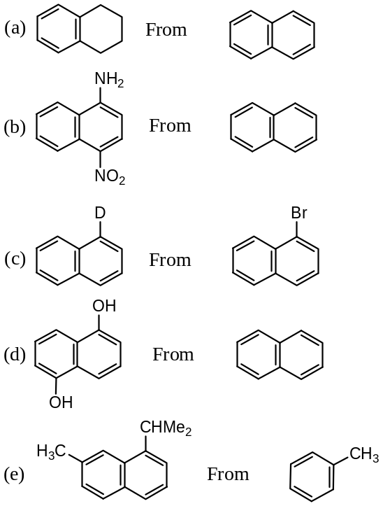
Question 2: Complete the following reactions —
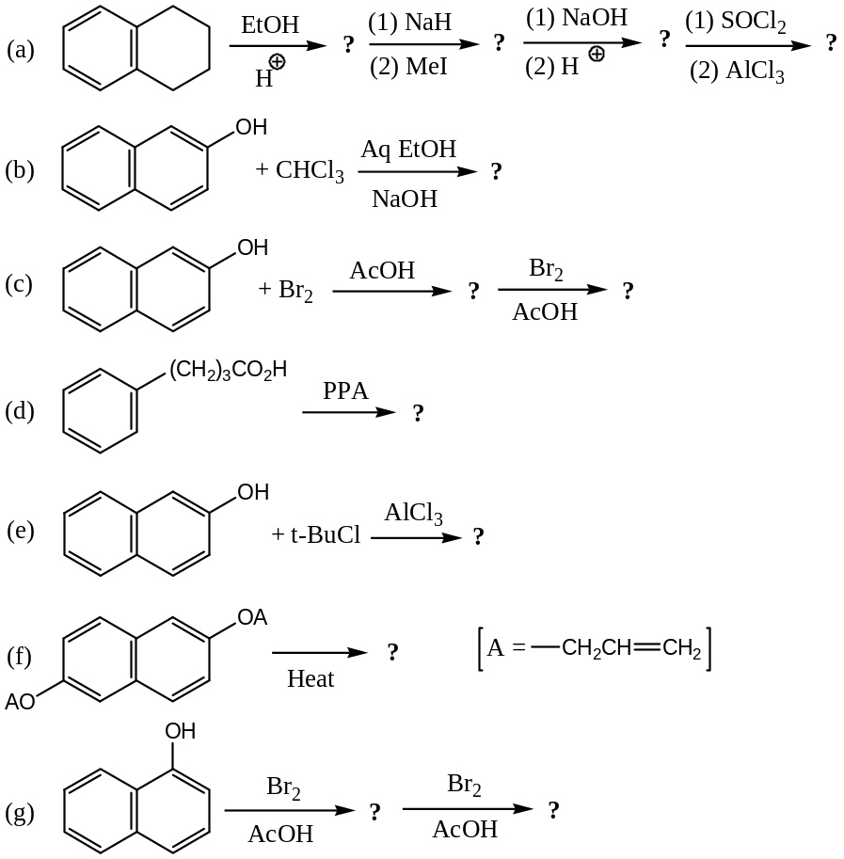

Anthracene $C_{14}H_{10}$
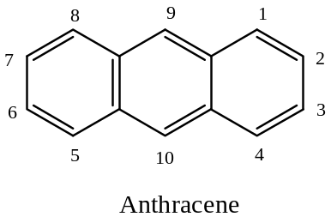

Synthesis of anthracene —
($1$) From Benzyl Chloride: By Friedel-Craft reaction —
In presence of $Al{Cl}_{3}$, benzyl chloride undergoes Friedel-Craft reaction to form $9,10$- dihydroanthracene, which readily eliminates two hydrogen atoms under experimental conditions to form anthracene.
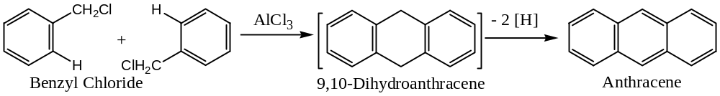
($2$) From Benzene: By Friedel-Craft reaction —
Benzene reacts with ${CH}_{2}{Br}_{2} or CH{Br}_{2}CH{Br}_{2}$ in presence of $Al{Cl}_{3}$ to form anthracene by a Friedel-Craft reaction.
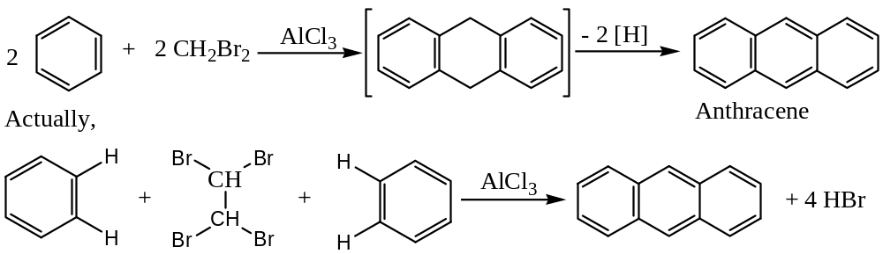
($3$) From Phthalic Anhydride:
Phthalic anhydride reacts with benzene in presence of $Al{Cl}_{3}$ to form $o$- benzoyl benzoic acid, which on heating with $conc H_{2}SO_{4} or PPA at 100℃$ gives anthraquinone. Anthraquinone so formed on $Zn$- dust distillation yields anthracene.
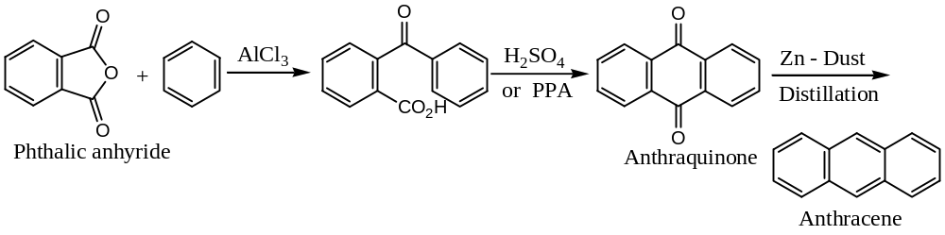
Note: Preparation of alkyl substituted (usually at position- $9$) anthracene —
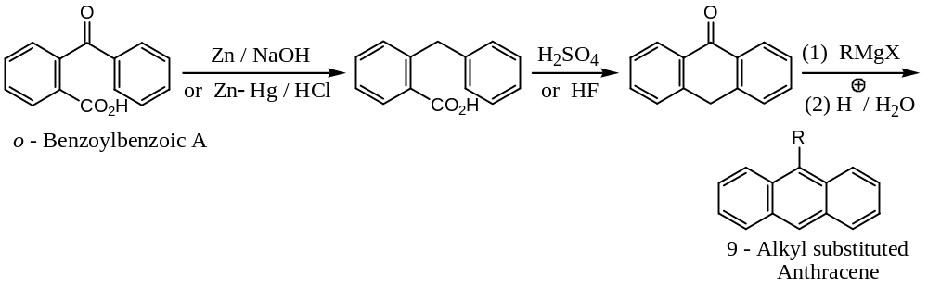
($4$) By the pyrolysis of Diaryl Ketone: $Elbs$ reaction —
Pyrolysis of diphenyl ketone containing a methyl or methylene group ortho to the carbonyl group, gives anthracene.
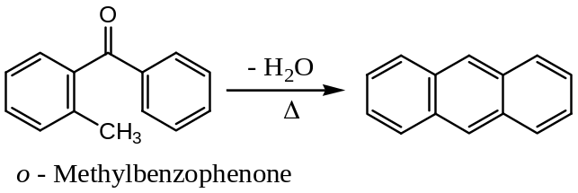
($5$) By Diels – Alder reaction:
Diels-Alder reaction involving $1,4$- naphthaquinone and butadiene, followed by oxidation of the product with $CrO_{3}$ in glacial acetic acid and then distillation with $Zn$- dust yields anthracene.
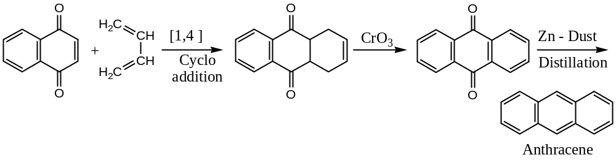
Resonance in Anthracene: Position of Double bonds in Anthracene —
Anthracene is best represented as a resonance hybrid of the following resonating structures:
Resonance energy of anthracene is $=351.5 kJ{mol}^{-1}$
The double bond character of the various bonds is shown in ($1$) and bond lengths (in Å) are shown in the structure ($2$) given below —
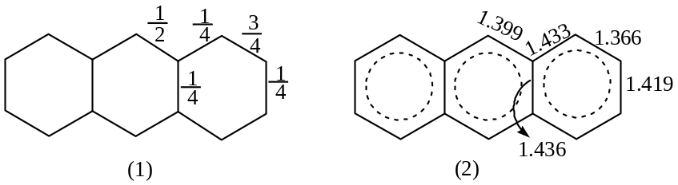
Isomerism in anthracene derivatives:
- Three possible mono-substituted products: $1$- or $α$-, $2$- or $β$- and $9$- or $γ$- ($meso$)
- For two identical substituents — $15$ possible isomers
- For two different substituents number of isomer is more than 15.
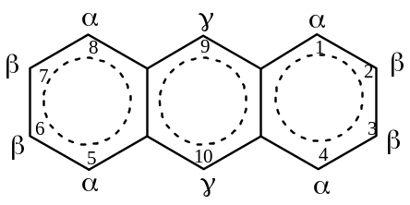
Chemical Reactions of Anthracene:
Anthracene undergoes typical aromatic substitution even more readily than does naphthalene. Substitution as well as addition reactions are usually takes place at the positions $9$- or $10$- of the central ring. The tendency toward product mixtures reduces the synthetic utility of the process. The resonance energy of anthracene is about $84 kcal{mol}^{-1} or 351 kJ{mol}^{-1}$, only slightly more than twice that of benzene. Any loss of resonance energy during reactions of anthracene is relatively small even when two isolated benzene rings remain. For example, —
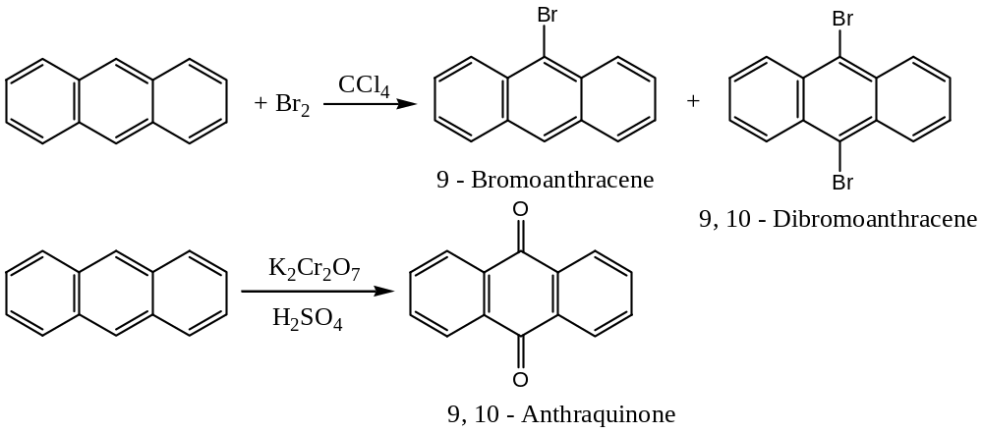
Question 1: Why do both substitution and addition take place at the $9,10$- position of anthracene?
Solution: Anthracene is very reactive in the $9,10$- positions. Electrophilic reactions to form $σ$- complexes at the $1$- or $2$- position leave a “naphthalene fragment” with the loss of $351.5-255.2=96.3 kJ{mol}^{-1}$, whereas the $σ$- complex at position $9$- leaves two benzene rings intact, and so the loss is $351.5-2×150.6=50.3 kJ{mol}^{-1}$. Hence, for Polynuclear aromatic hydrocarbons (with three or more rings), the $σ$- complex that contains the largest number of isolated rings will be the most stable. For example, —
Formylation of anthracene — (See reaction 4, given below)
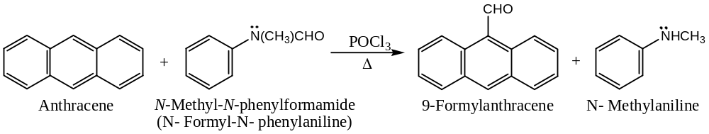
Chlorination of anthracene — (See reaction 5, given below)
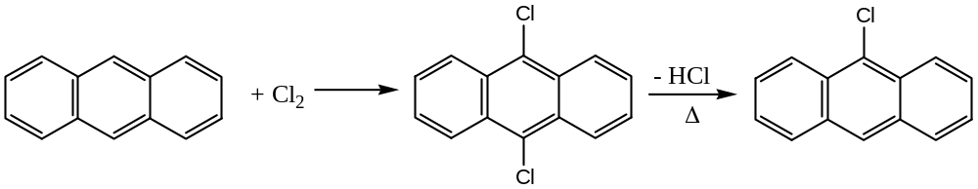
Diels-Alder reaction in anthracene: Anthracene undergoes Diels-Alder reaction in the position $9,10$- to form $endo$ - anthracene maleic anhydride, with maleic anhydride. (See reaction 8, given below)
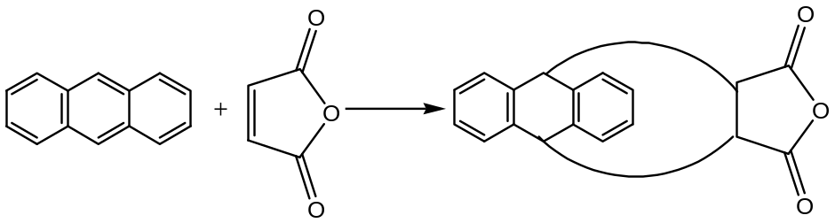
Some other important reactions of anthracene are, all leads to the formation of derivatives of anthracene, used in different fields —
[$1$] Reduction of Anthracene: Anthracene is readily reduced by $Na \& amyl alcohol$ into $9,10$- dihydroanthracene.
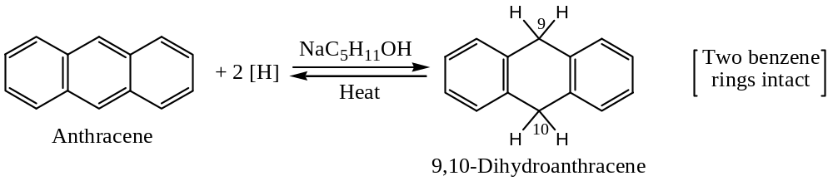
On the other hand, if the reduction is carried out by catalytic hydrogenation ($Ni/H_{2}$) than anthracene gives $tetra$-, $hexa$-, and $Octa$- hydroanthracenes, depending upon the amount of hydrogen used for the purpose. More vigorous hydrogenation at high temperatures and pressures gives completely hydrogenated anthracene, perhydroanthracene ($C_{14}H_{24}$).
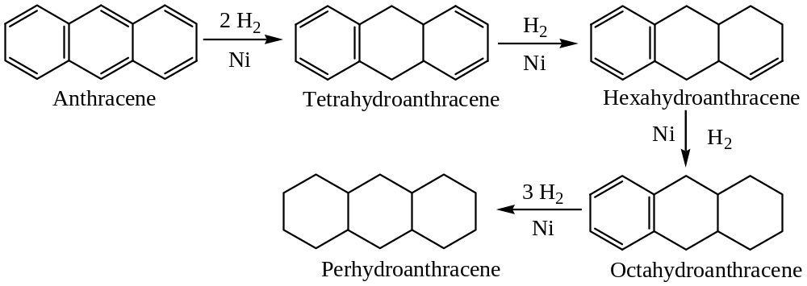
[$2$] Oxidation of Anthracene: Anthracene is readily oxidised by chromic acid ($K_{2}{Cr}_{2}O_{7}$ or ${Na}_{2}{Cr}_{2}O_{7} \& H_{2}{SO}_{4}$) to $9,10$- anthraquinone.
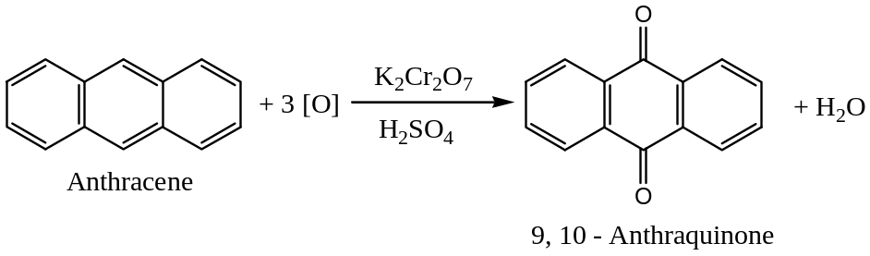
[$3$] Electrophilic Substitution Reactions in Anthracene:
Anthracene undergoes electrophilic aromatic substitution reactions like halogenation, nitration, acetoxylation, etc., preferably at position $9 \& 10$.
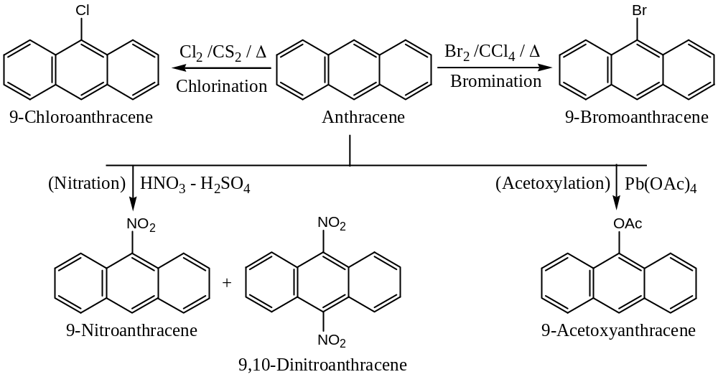
From all the above electrophilic aromatic substitution reactions of anthracene, it is apparent that the $9$- and $10$- positions of anthracene are the preferred positions of attack for the electrophile. (See mechanism below, after reaction 5)
Sulphonation of anthracene is, however, exceptional as in this case substitution mainly occurs at position- $1 \& 2$. (See mechanism below, after reaction 5)
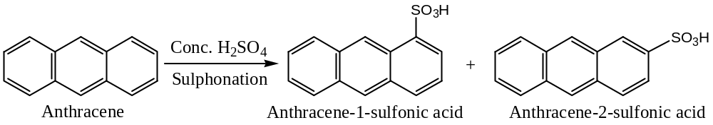
[$4$] Formylation of Anthracene: Anthracene can be formylated at position- $9$ to yield $9$- formylanthracene. Thus, anthracene when treated with $N$- formyl methyl aniline in the presence of phosphoryl chloride ($PO{Cl}_{3}$) yields $9$- formylanthracene.
[$5$] Electrophilic Addition Reactions in Anthracene:
Although anthracene is an aromatic compound (as it undergoes electrophilic substitution reactions), but it is relatively more unsaturated than benzene or naphthalene. For example, anthracene adds halogens at ordinary temperatures and the addition takes place preferably at $9$- and $10$- positions.
These addition products when heated lose hydrogen halide ($HBr or HCl$) to form $9$- halo anthracene.
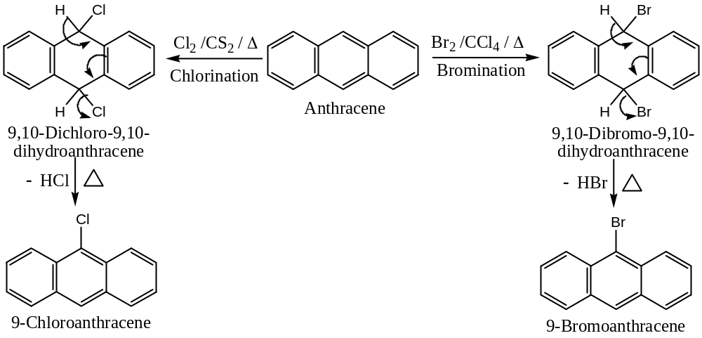
Mechanism of Electrophilic Substitution & Addition Reactions of Anthracene:
Thus, the attack of an electrophile ($E^{⨁}$) at position- $9$ leads to the formation of the most stable carbocation in which two benzene rings are retained (i.e. intact). Now, a nucleophile (${\ddot{Y}}^{⊖}$) can either donate its electron pair to the carbocation to form $9,10$- addition product or abstract a proton from position- $9$ to give substitution product with the retention of aromatization.
Let us consider the attack of a reagent, say $E-Y$ at $9$- and $10$- position of anthracene —
$$E-Y ⇌ E^{⨁}+ :Y^{⊖} [E^{⨁}={Cl}^{⨁},{Br}^{⨁}, NO_{2}^{⨁}, etc.]$$
Now, —
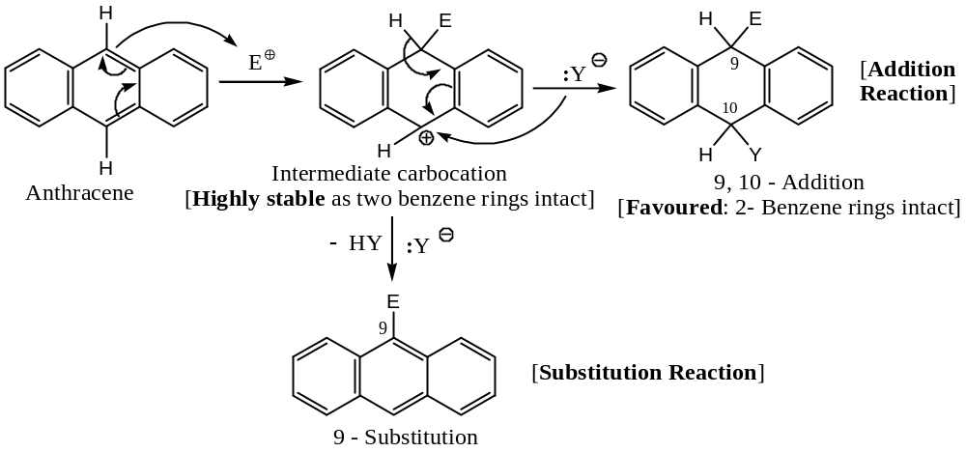
It is therefore, reasonable that electrophilic addition and substitution reactions occur at $9$- and $10$- position preferentially. Attack at any other position will destroy two benzene rings and therefore, will not form a stable intermediate carbocation in which two benzene rings are intact. For example, for the attack at position- $1$ —
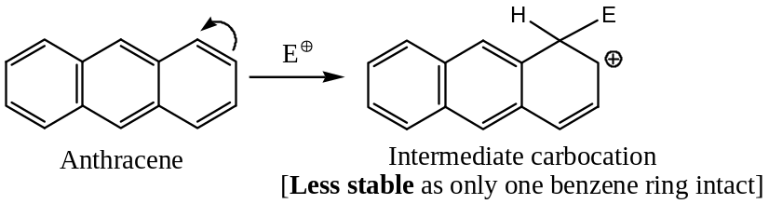
[$6$] Reactions of Anthracene with molecular Oxygen: Anthracene adds on molecular oxygen, in presence of light to form anthracene peroxide, having the following probable structure —
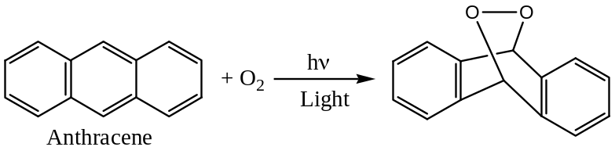
[$7$] Dimerization of Anthracene: When a xylene solution of anthracene is exposed to sunlight, it dimerised to $9,10$- dianthracene.
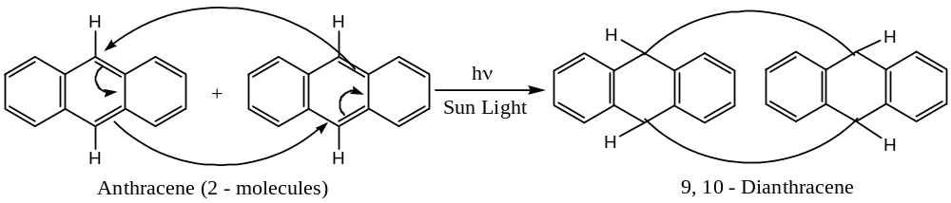
[$8$] Diels-Alder Reaction with Anthracene: The double bonds of anthracene at position $9$- and $10$- behave as a diene and therefore, it undergoes Diels-Alder addition reaction with a dienophile like maleic anhydride to form $endo$ - anthracene maleic anhydride.
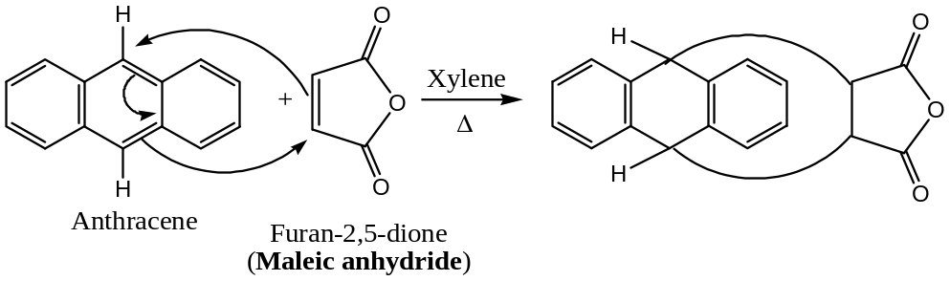
Problem: Give the structure of the adduct formed between anthracene and $1,4$- naphthaquinone.
[$9$] Reactions of Anthracene with Picric Acid: Anthracene forms a red picrate ($mp=138℃$) with picric acid, which is unstable and decomposes into its constituents when treated with excess of ethanol. Such compounds are called charge transfer complexes. Thus, —
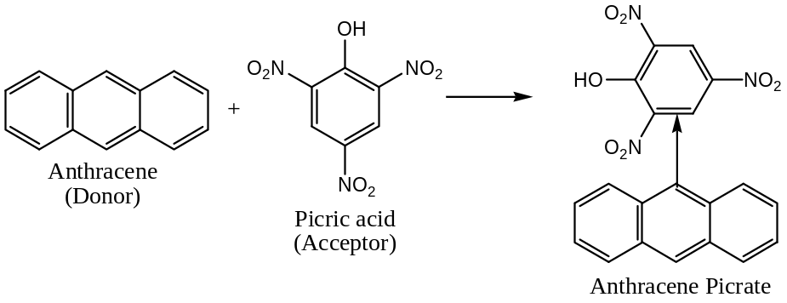
Derivatives of Anthracene:
Anthracene forms typical derivatives like hydroxyanthracenes ($anthrols$), anthracene carboxylic acids ($anthroic acids$), anthracene quinones ($anthraquinones$), etc. All these derivatives resemble to benzene and naphthalene series.
Out of the various derivatives of anthracene only anthraquinones are the most important derivatives. Nine possible isomers of anthraquinones are possible, but only three viz. $1,2$-, $1,4$- and $9,10$- anthraquinones are known. Of these, $9,10$- anthraquinone, commonly known as anthraquinone, is the most important.
Anthraquinone ($9,10$- anthraquinone), molecular formula, $C_{14}H_{8}O_{2}$:
Anthraquinone is a pale yellow, odourless solid with $mp=268℃$. It undergoes sublimation when heated above its $mp$. Anthraquinone is insoluble in water and alcohol, but soluble in benzene or glacial acetic acid.
Following are the methods usually adopted for the synthesis of anthraquinone —
[$1$] Synthesis of Anthraquinone from Benzene:
Phthalic anhydride reacts with benzene in presence of $Al{Cl}_{3}$ to form $o$- benzoyl benzoic acid, which on heating with $conc H_{2}SO_{4} or PPA at 100℃$ gives anthraquinone. Anthraquinone so formed on $Zn$- dust distillation yields anthracene.
[$2$] Synthesis of Anthraquinone from $1,4$- Naphthaquinone:
Diels-Alder reaction involving $1,4$- naphthaquinone and butadiene, followed by oxidation of the product with $CrO_{3}$ in glacial acetic acid and then distillation with $Zn$- dust yields anthracene.
[$3$] Synthesis of Anthraquinone from Anthracene by Oxidation:
The most common method of preparation of anthraquinone involves the oxidation of anthracene with chromic acid or by the air oxidation using vanadium pentoxide at high temperature ($300-500℃$). Thus, —
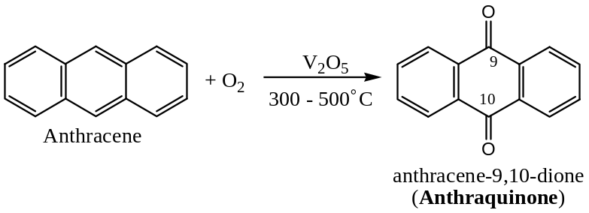
Following are the important chemical reactions of Anthraquinone —
[$1$] Reduction: Anthraquinone cannot be reduced by sulphurous acid (unlike $p$- benzo-quinone), but can be reduced by strong reducing agents, and the nature of the product formed depends on the nature of the reducing agent employed. For example, —
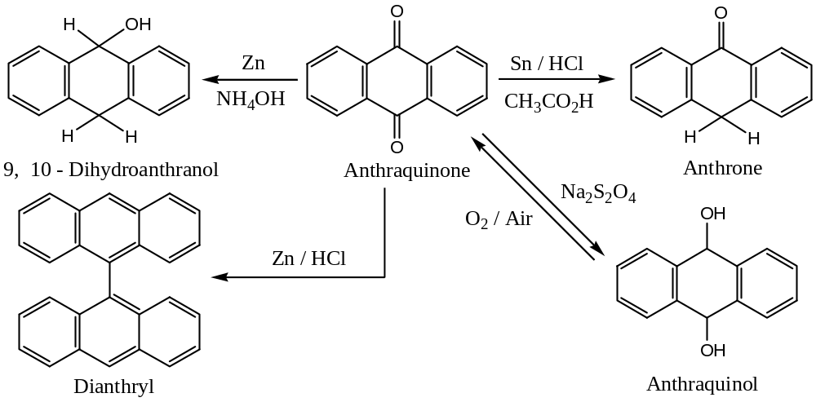
[$2$] Reduction: Anthraquinone on $Zn$- dust distillation or on heating with $HI$, it is reduced to anthracene. Thus, —
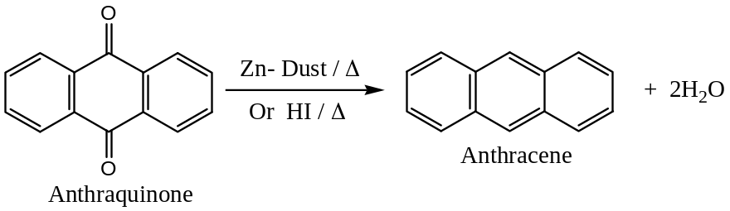
[$2$] Electrophilic Aromatic Substitution: Anthraquinone is somewhat resistant to electrophilic aromatic substitution reactions due to the presence of electron withdrawing deactivating carbonyl groups. For example, — halogenation of anthraquinone is difficult and does not undergo the Friedel-Craft reactions. However, anthraquinone can be —
($a$) Sulphonated by persulphuric acid ($H_{2}S_{2}O_{7}$) to give $1$- sulphonic acid at $120℃$, but $2$- sulphonic acid at $140℃$.
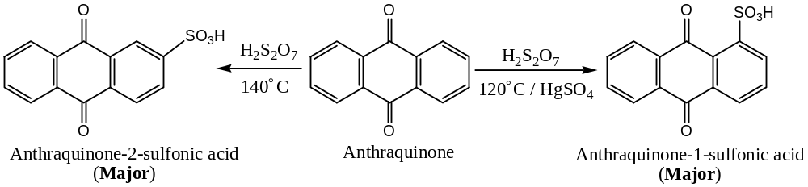
The sulphonic acid group at $1$- or $2$- position is very reactive and can be easily replaced (substitution) by other groups. For example, —
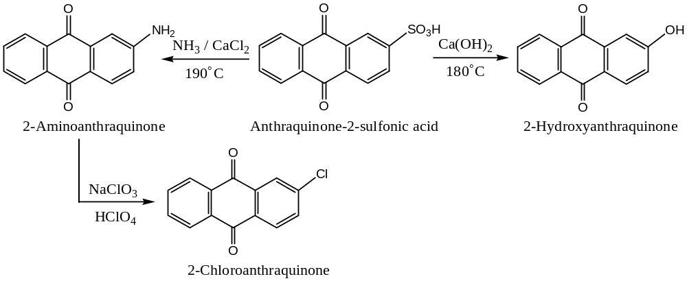
($b$) Nitrated by nitrating mixture ($conc, HNO_{3} \& H_{2}SO_{4}$) to give $1$- ($or α$-) nitro-anthraquinone under ordinary reaction conditions, but under vigorous conditions dinitro derivatives ($1,5$- and $1,8$-) of anthraquinones are formed. Thus, —
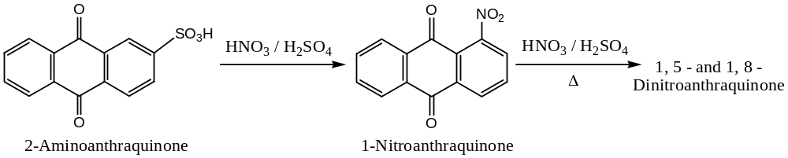
The $-NO_{2}$ group at $1$- ($or α$-) position is very reactive and can be easily replaced (substitution) by a $-NH_{2}$ group on heating with ${NH}_{3}$. Thus, —
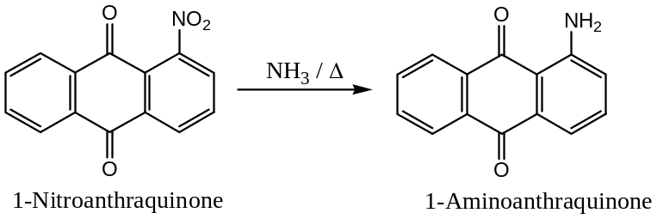
################################################
Phenanthrene $C_{14}H_{10}$
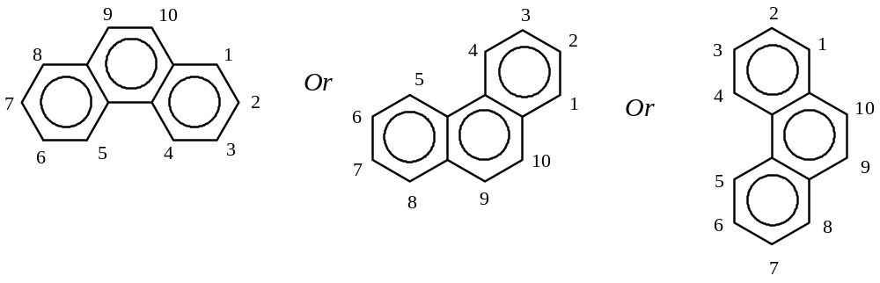
These three are the best way of representing the phenanthrene nucleus
The numbering of the ring system is as per IUPAC system
Further —
There are $5$ mono-substitution products possible: $1,2,3,4 \& 9$
If two substituents are identical, then $25$ substituted isomers are possible
Phenanthrene nucleus constitutes the basic structure of several natural products like Hormones, Cholesterol, Bile acids and Morphine (alkaloid)
Resonance in Phenanthrene —
Phenanthrene is an angular polynuclear hydrocarbon, isomeric with anthracene. It is a resonance hybrid of the following $5$- resonating structures with about $384 kJ{mol}^{-1}$ resonance energy. It has greater aromatic character than anthracene (resonance energy $301 kJ{mol}^{-1}$).
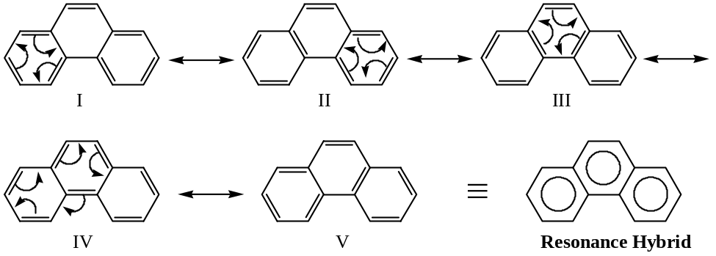
Synthesis of Phenanthrene and its Derivatives —
A synthetic scheme comparable to the Haworth’s synthesis of naphthalene derivatives is outlined below. This route is capable of wide extension. Use of various substituted naphthalenes and succinic anhydride can lead to the synthesis of phenanthrene derivatives.
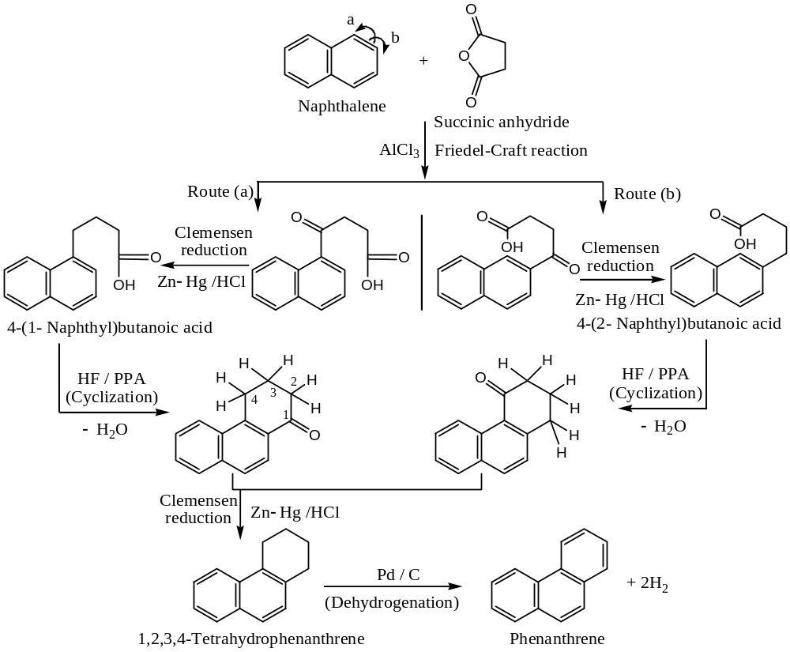

Chemical Reactions of Phenanthrene —
Phenanthrene resembles anthracene in many reactions. The positions $9 \& 10$ are particularly reactive because the attack of an electrophile at these positions will result a more stable intermediate carbocation in which two benzene rings are intact with sacrifice of $150.5 kJ$ resonance energy only. For example, —
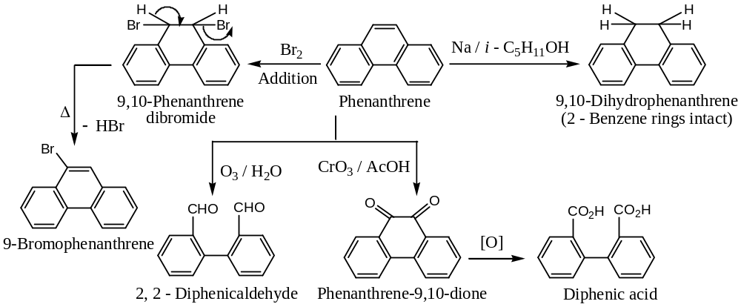
However, sulphonation takes place at $2$- and $3$- positions, which are less sterically hindered on sulphonation and resist desulphonation.
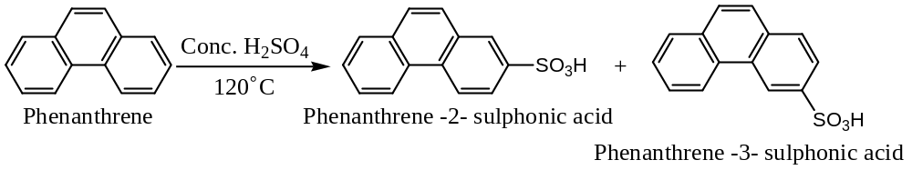
Similarly, nitration of phenanthrene by mixed acids (nitrating mixture) mainly forms $9$- nitro phenanthrene along with the formation of $1$-, $3$-, $2$- and $4$- nitro isomers of phenanthrene. Thus, —
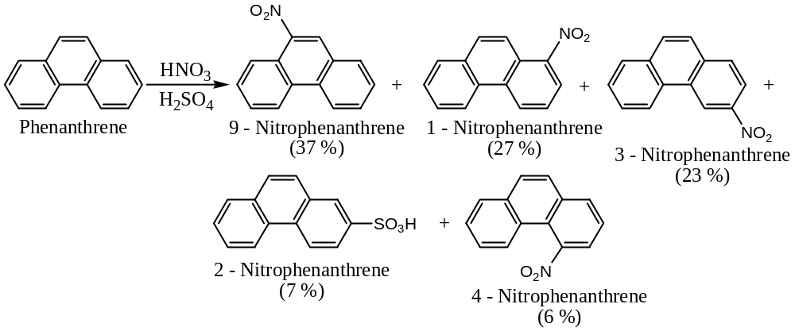
Mechanism: Stability of the intermediate carbocation with the intact of two benzene rings explains the formation of $9 \& 10$- substituted products in phenanthrene as shown below —
Step 1: $E-Y ⟶ E^{⊕} + Y:^{⊝}$
Reactant Electrophile Nucleophile
Step 2: Attack of the electrophile at position- $9$ —
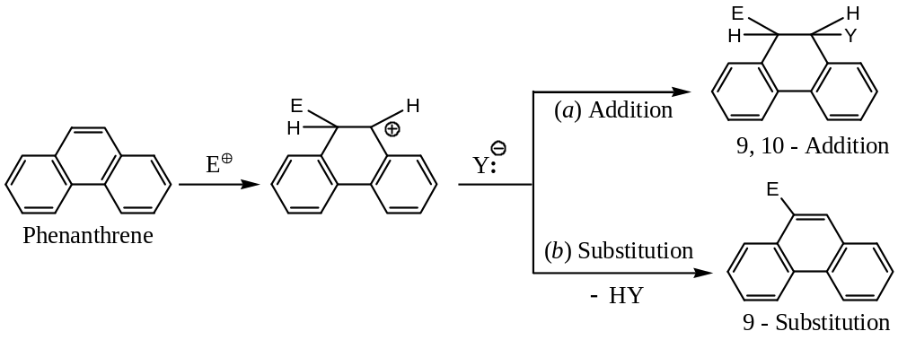
Some other widely available Polynuclear Aromatic Hydrocarbons —
Carcinogenesis —
Complex polynuclear hydrocarbons are carcinogenic (cancer causing). Some of the carcinogenic complex polynuclear hydrocarbons are —
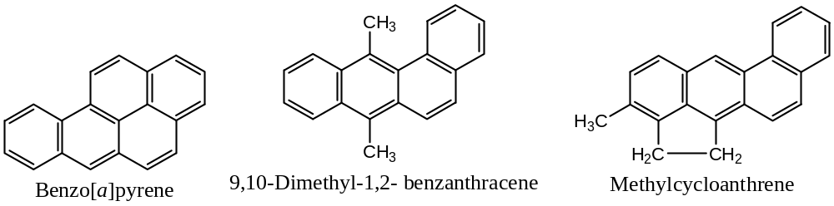
These polynuclear hydrocarbons are generated by the incomplete combustion of organic materials like tobacco, coal and petroleum. These are widely spread in the atmosphere and cause human cancer when inhaled.
Questions from previous examination —
2019 —
$Question$ $4\left(d\right) (i)$: What are polynuclear hydrocarbons? What are the different types? 1 + 2 = 3
$Question$ $4\left(d\right) (ii)$: Write the Haworth’s synthesis of naphthalene. 3
$Question$ $4\left(d\right) (iii)$: Give the product with name of the following: $1×4=4$
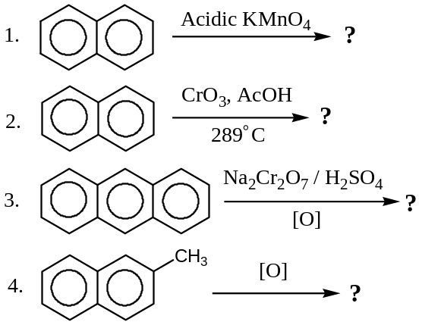
2018 —
$Question$ $4\left(b\right) (iv)$: Give the product in each of the following reactions with name — $1×2=2$
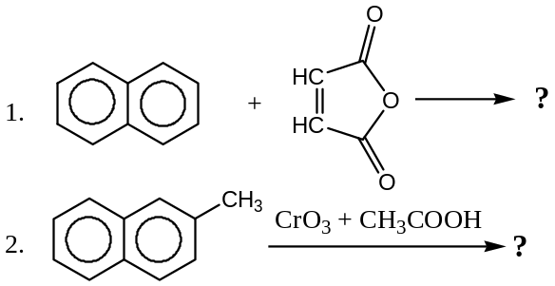
$Question$ $4\left(d\right) (i)$: How can tetralin and decalin be prepared from naphthalene? Give reaction. 2
$Question$ $4\left(d\right) (ii)$: “Anthracene gives both electrophilic substitution and addition reactions equally well.” Justify the statement with appropriate example. $1\frac{1}{2}+1\frac{1}{2}=3$
$Question$ $4\left(d\right) (iii)$: Write the Haworth’s synthesis for phenanthrene preparation. 3
$Question$ $4\left(d\right) (iv)$: Suggest the reagents for the following conversions: $\frac{1}{2}×2=1$
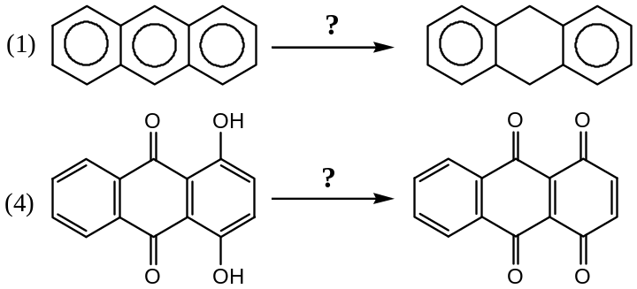
$Question$ $4\left(e\right) (i)$: Discuss about kinetically and thermodynamically controlled product of naphthalene, when it undergoes sulphonation reaction with $conc. H_{2}{SO}_{4}$ at $80℃ \& 160℃$. 3
2017 —
$Question$ $4\left(c\right) (ii)$: What is Fries rule on structure of polynuclear hydrocarbon? 1
$Question$ $4\left(d\right) (iii)$: What is peri-hydrogen interaction in sulphonation of naphthalene? 2
$Question$ $4\left(f\right) (iii)$: Write the product formed — 1
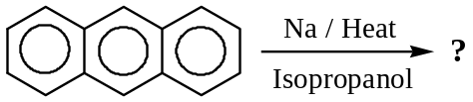
$Question$ $4\left(f\right) (v)$: What happens when anthracene reacts with ${Na}_{2}{Cr}_{2}O_{7}+ H_{2}{SO}_{4}$ ? Give product name and structure. 1
2016 —
$Question$ $1\left(e\right)$: Why is naphthalene less aromatic than benzene? 1
$Question$ $4\left(c\right) (i)$: Identify $A, B, C, D and E$ in the following reactions with name: $1×5=5$
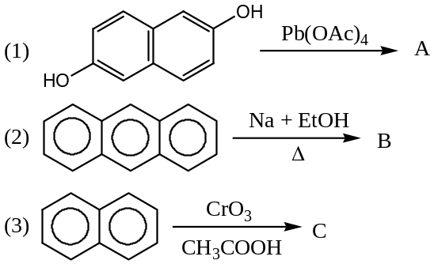
$Question$ $4\left(d\right) (iii)$: How can benzene be converted to anthracene with phthalic anhydride? Give reactions. 2
$Question$ $4\left(e\right) (ii)$: Write Haworth synthesis of naphthalene. 2
2015 —
$Question$ $1\left(d\right)$: Which bond of phenanthrene is readily attacked by reagents? 1
$Question$ $4\left(a\right) \left(ii\right)(1)$: Explain why reaction of naphthalene with conc. $H_{2}{SO}_{4}$ at $40℃$ yields naphthalene -1-sulphonic acid whereas at $160℃$naphthalene - 2 - sulphonic acid is the major product. 3
$Question$ $4\left(c\right) \left(ii\right)(4)$: Write the product formed — 1
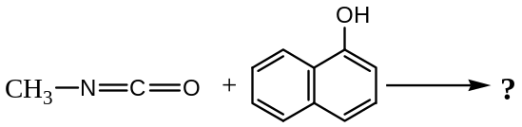
$Question$ $4\left(e\right) \left(i\right)$: How many monosubstituted derivatives of naphthalene are possible? Which position is preferentially attacked in electrophilic substitution reactions of naphthalene? How can the following naphthalene derivatives be prepared? 1 + 1 + 3 = 5
$1$) $2$- Naphthylamine
$2$) $1$- Naphthol
$3$) $1,4$- Naphthaquinone

XXXXX#XXXXXX

