Medicinal Chemistry
Drugs:
A drug is defined as any chemical substance which when applied on a patient kills the pathogenic microorganisms (these are i) Bacteria, ii) Fungus, and iii) Virus) without any adverse effect on the host. Thus, compounds which exert various physiological effects of therapeutic value are collectively known as drugs. Following are the ideal requirements of a chemical to be a good drug on administration to the host:
- It should prevent or destroy the growth of pathogenic microorganisms,
- It must be toxic to the pathogenic microorganisms,
- It should not be toxic to the host,
- It should not affect the tissues of the host,
- It should have localized action on the site of the disease,
- It should not remain on the body for ever, i.e. it should be eliminated through excretion.
Chemotherapy:
The process of destroying and/ or probability of growth of the pathogenic microorganisms by the use of chemical compounds is called chemotherapy. OR
The process of destroying and/ or probability of growth of the pathogenic microorganisms (for example bacteria, fungus, virus) without affecting to any material extent, the tissues (of the host) by the use of chemical compounds is called chemotherapy. Historically, the term chemotherapy was introduced by Ehrlich in 1909. The quality of chemotherapeutic agent is determined by its chemotherapeutic index (C.I.), defined as the ration of maximum tolerated doses by maximum curative doses. Thus,
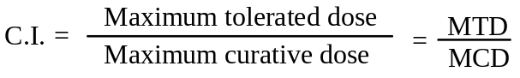
It is also defined as:
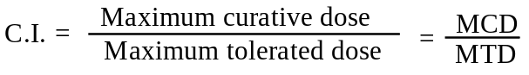
Higher the chemotherapeutic indexes (CI) better the drug.
Distinction between Chemotherapeutic Agents and Disinfectants:
Chemotherapeutic agents i.e. therapeutic agents may be used either externally or internally. The externally used compounds, for example formaldehyde, phenol, iodine, etc. are active in destroying the bacteria (pathogenic microorganism) and these compounds when applied externally also tend to destroy the tissues of the host, hence they are not included under the heading of therapeutic agents, but are known as disinfectant. Thus, the therapeutic agents are those which kill the pathogenic microorganisms without affecting the tissues of the host or any material extents.
Classification of Therapeutic Agents:
Based on the action of the therapeutic agents, these are further classified into two categories:
- Bactericidal and
- Bacteriostatic
Therapeutic agent which kills the pathogenic microorganisms causing disease are called Bactericidal therapeutic agents, on the other hands which just resist the growth of pathogenic microorganisms are called bacteriostatic therapeutic agents. In such case we define,
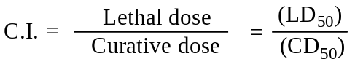
Living Organisms present in the body:
Living organisms are divided into two categories:
- Prokaryotes and
- Eukaryotes.
There are about 350 microorganisms are always present in our body in contact with different cell wall, and usually these are not harmful to us i.e. these cannot causes any diseases, and are called prokaryotes. These are also called normal flora and are usually some bacteria, fungi, blue – green alge, etc. These also help in different body functions, for example digestion.
On the other hand the pathogenic microorganism which causes diseases when come to contact to cell wall and enters into the cells, these are called eukaryotes and are usually some certain bacteria, fungus, virus, etc.
Physiological Properties of Drugs in relation to Biological action:
When a drug is administrate into a patient its action depends on the solubility, optical activity as well as the stereochemistry. Administration of drugs can be done by the following ways:
- Orally,
- Intravenous system,
- Muscular injection, and
- Subcutaneous.
After administration, the drugs undergo distribution into the site of biological action. The distribution of a drug is markedly influenced by many vital factors, such as tissue distribution and membrane penetration, which largely depends on the physico-chemical characteristics of the drug. After distribution, the drug undergo metabolism, also called biotransformation.
When a drug molecule gets converted into the body to an altogether different form, which may be either less or more active than the parent drug, this phenomenon is termed as biotransformation. Mostly the drug metabolism occurs in liver. In fact, a number of pathways are genuinely responsible for carrying out various metabolism reactions in the body. It has been observed that most of the metabolised products are usually more polar in character than the parent drug molecule. This increased polarity renders the metabolite less absorbable through the renal tubules and also makes it transient in the body.
After the drug action, it is finally eliminated from the sites of action by excretion. The excretion of drugs from the sites of reaction is most important and may be effectively with the help of a number of processes, namely: renal excretion, bilelary excretion, excretion through lungs and above all by drug metabolisms (biotransformation). Thus, the whole process can be schematically represented as:
Administration
↓
Distribution
↓
Metabolism (biotransformation)
↓
Excretion
Let us consider the oral administration of drugs:
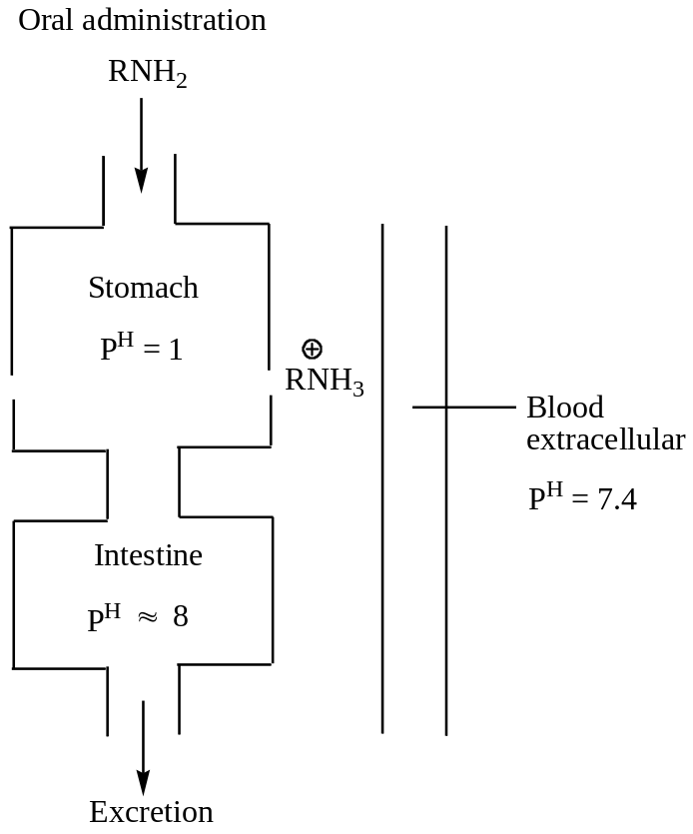
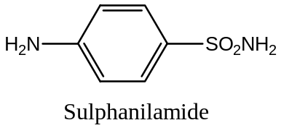Now, let us consider a specific example, sulphanilamide (p - aminobenzenesulphonamide), the basic unit of sulpha drugs, discovered in 1935 by Domagk.
Sulphanilamide itself is useful mainly for coccal infection. Its derivatives are used in the treatment of different diseases. For example, sulphathiazole is useful for stomach diseases as it is stable and is generally administrated orally.
On the other hand, acetyl derivative of sulphanilamide is inactive, having no drug activity. Thus, stereochemistry played an important role in the drug activity. This compound is required for the growth of coccal infection.
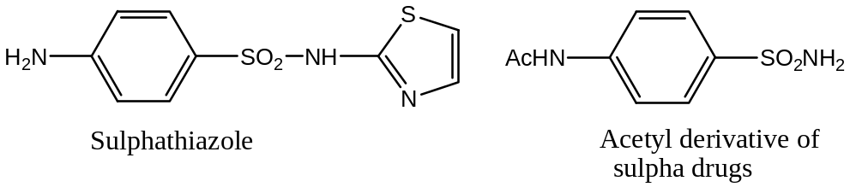
Sulpha drugs are bacteriostatic in nature as they prevent the growth of bacteria. The mechanistic action of sulpha drug is as follows:
Both the p – amino benzoic acid (PABA) and sulphanilamide are structurally almost similar having nearly same dimension (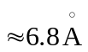). Experimentally it has been observed that pathogenic microorganisms which are effectively controlled by sulpha drugs need PABA for their metabolism.
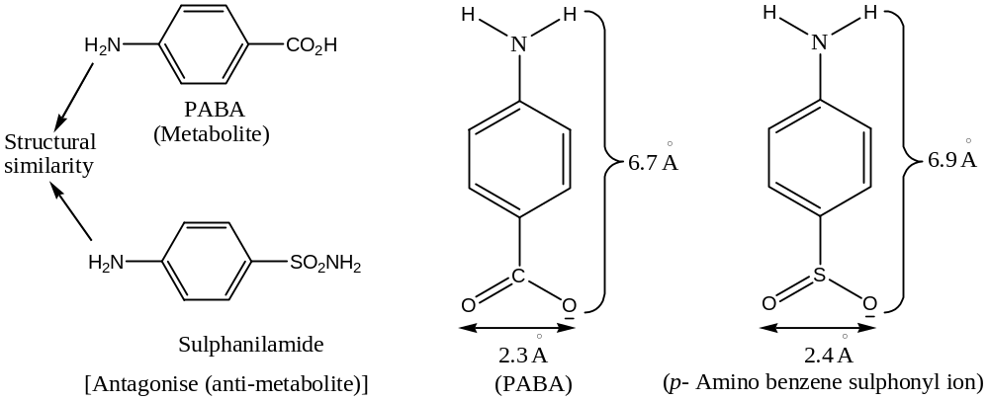
The microorganism (specially bacteria) cannot differentiate PABA and sulphanilamide ion and so misunderstoodly they take sulphanilamide instead of taking PABA and thus their metabolism stops as sulphanilamide is anti metabolite (antagonise).
Like sulphanilamide (sulpha drugs) most of the malaria drugs are bacteriostatic in nature.
Bactericidal drugs i.e. drugs which kills the bacteria essentially contains one or more toxophoric groups. The toxophoric groups present in the drug should be only toxic to the bacteria (chemoreceptor) but not to the host. The toxophoric group reacts with the active group present in the bacteria and thus killed it. Most of the toxophoric groups in Bactericidal drugs organic arsenicals, viz.
- R As = As. R (Arseno – benzene)
- RAsO (Arsenoxide)
- RAsO(OH)₂ (Arsenic acid)
The arsenobenzene or arsenic acid converted to the arsenoxide by metabolism (by oxidation and reduction) in the body and reacts with the bacteria and kills it.
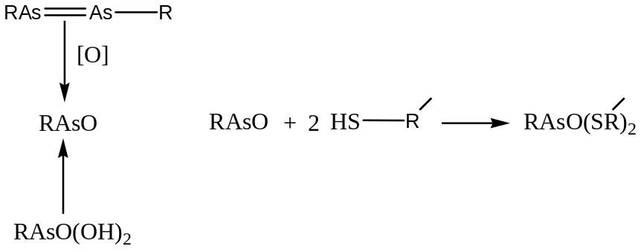
It has been found in invitro experiments of RAsO is not active but in invivo experiments it is active because of the above changes that takes place in the body.
However, in chemotherapeutic treatment it is essential to reduce the toxicity of the therapeutic agents and in increasing metabolic activities, which is studied under the heading of Drug – Receptor – Interaction Theory.
Invivo and Invitro Experiments:
In invitro experiments, the microorganisms are allowed to grow in a series of test tubes containing synthesis medium, i.e. which allows the growth of microorganisms. Then we add the drugs with serial dilutions (1 ppm, 10 ppm, 100 ppm, etc.) and observe, which dilution can stop the growth of microorganism (bacteriostatic) and kill microorganism (bactericidal).
In invivo experiments, the diluted drugs which is found to be effective in invitro experiments are injected to the experimental animals, for example, rats, albino rats, gunipigs, etc. and if it is found to be effective, than after studying its toxicity, it is applied to higher animals as well as marketed.
reduction of toxicity of drugs:
The chief criteria to be an ideal drug is that it should be non-toxic or less toxic to the host but highly toxic to the pathogenic microorganisms causing diseases. The toxicity of the drug can be reduced by introducing certain functional groups to the parent compound which acts as drugs. For example, —CO₂H group is less toxic, and thus introduction of this group reduces toxicity. That is why, HCO₂H, CH₃CO₂H, etc. are used as food preservatives.
The other functional groups, which reduce the toxicity of drugs, are:
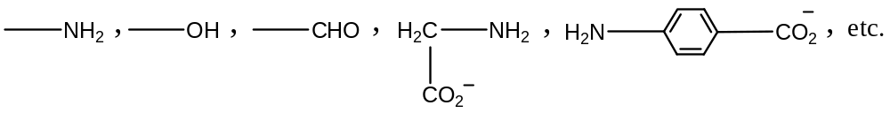
Again with the increase in side-chain toxicity of drugs increases, for example, for —OH group, in the following compounds, toxicity decreases from left to right,
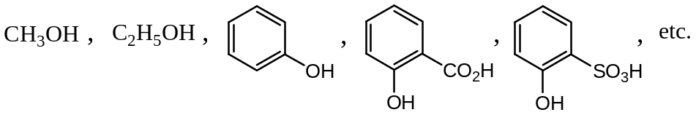
Similarly, toxicity of —CHO group is further decreased by the introduction of more —OH groups, as in glucose. Glucose: OHC—(CHOH)₄—CH₂OH
Metabolism and structural relationship of drugs:
The two most important aspects of drugs is that —
- The structural relationship and
- The mode of action of the drugs, i.e. the products obtained in the metabolism which are either bactericidal or bacteriostatic.
For example, prontosil is a drug, as it produces sulphanilamide, which is basically bacteriostatic during metabolic changes.
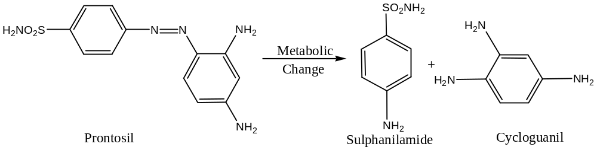Similarly, paludrine (proguanil) on metabolic changes produces triazine.
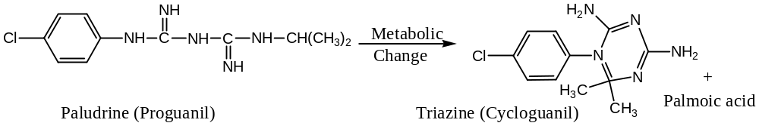
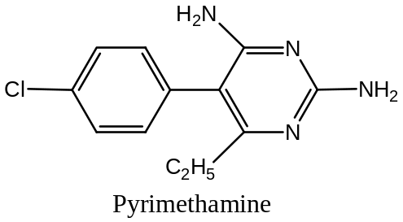 Cycloguanil palmolate is a repository drug.
Similarly, pyrimethamine is also a metabolic product and active against the pre – erythrocytic (liver) forms of malaria.

Structural similarity of drugs:
- Cats in contrast to other species are unable to form glucoxides in significant amounts.
- Drugs are unable to acetylate aromatic amines such as sulphonamides.
- 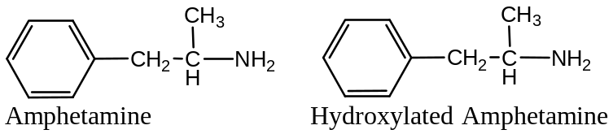In rabbits amphetamine is primarily dominated, whereas it is hydroxylated in aromatic ring in dogs.
- Acetanilide is hydroxylated in the p – position in dogs, whereas it is in the o – position in cats.
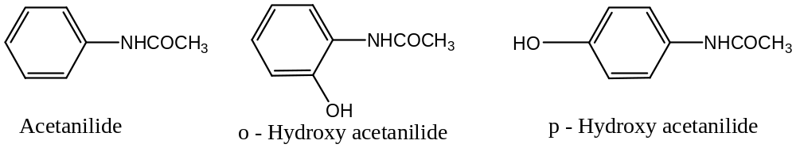

Classification of drugs:
Broadly speaking drugs are of two types —
- Bactericidal and
- Bacteriostatic.
The first type (Bactericidal) destroys or kills the pathogenic microorganisms, whereas the second type (Bacteriostatic) resists the growth of the pathogenic microorganisms responsible for causing diseases.
Since the drugs are the chemicals used in the treatment of diseases, which kills or resists the growth of pathogenic microorganisms without any adverse effect on the host, hence these are also called chemotherapeutic agents.
The chemotherapeutic agents can be used to the host either by internally or by externally. When some chemotherapeutic agents, such as formaldehyde, phenol, iodine, etc. used externally to the infected areas of the patient they no-doubt kills or resists the growth of pathogenic microorganisms, they also affects the tissues of the host, and are also called disinfectants.
Broadly, chemotherapeutic agents are classified as —
- Antimalarials
- Antibacterials
- Sulpha drugs
- Antibiotics and
- Anaesthetics
The chemotherapeutic agents contain toxophoric groups and these are basically organic arsenic compounds and are reacts with the chemoreceptor (pathogenic microorganisms).
Antibiotics
Originally the term “antibiotic” was designate to the —
- Active components (compounds) involved in the process of “antibiosis” or to the opposition of one living microorganism to another and
- Microbial metabolise which in relatively in high dilution may inhibit the growth of micro-organisms.
Waksman proposed the widely cited definition that — “an antibiotic or an antibiotic substance is a substance produced by the microorganisms, which has the capacity of inhibiting the growth and even of destroying other microorganisms”.
However, the restriction that an antibiotic must be a product of a microorganism is not keeping with common.
Later on Benedict and Langlykke coined a more general and acceptable definition of an antibiotic which states that — “a chemical compound derived from or produced by a living organism, which is capable, in small concentrations, of inhibiting the life processes of microorganisms”.
Therefore, a substance may be classified as an antibiotic provided it meets the following four cardinal requirements:
- That is a product of metabolism,
- That is a synthetic product produced as a structural analogue of a naturally occurring antibiotic,
- That is antagonizes (anti - metabolites) the growth and/ or the survival of one or more species of microorganisms,
- That is effective in low concentration.
Classification of Antibiotics:
Broadly, antibiotics are classified into eight different types depending upon their structures:
- Β – Lactum antibiotics: These are basically of two types —
  - 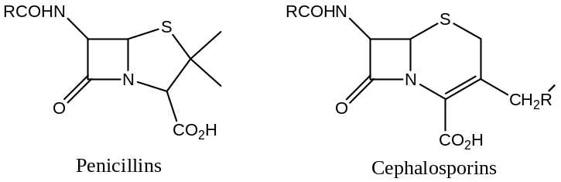 Penicillins and
  - Cephalosporins
- Amino glycosides: Common examples of amino glycoside antibiotics are: Streptomycin, Kanamycin, Neomycin, Gentamycin, etc.
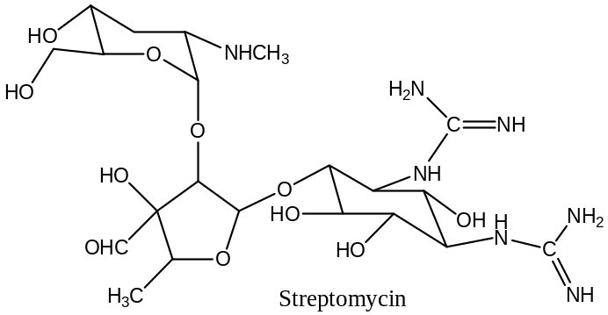

- Tetracyclines,
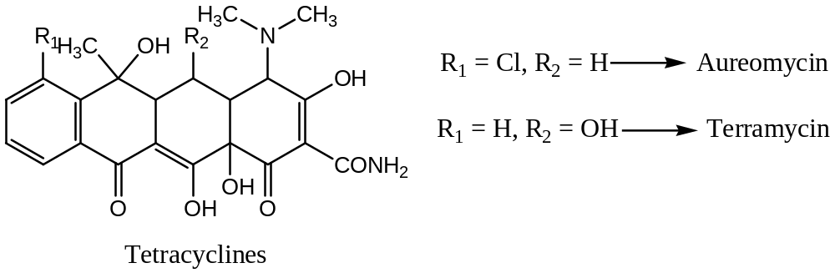
- Macrolides: These are the macro-cyclic lactones, for example, erythromycin group.
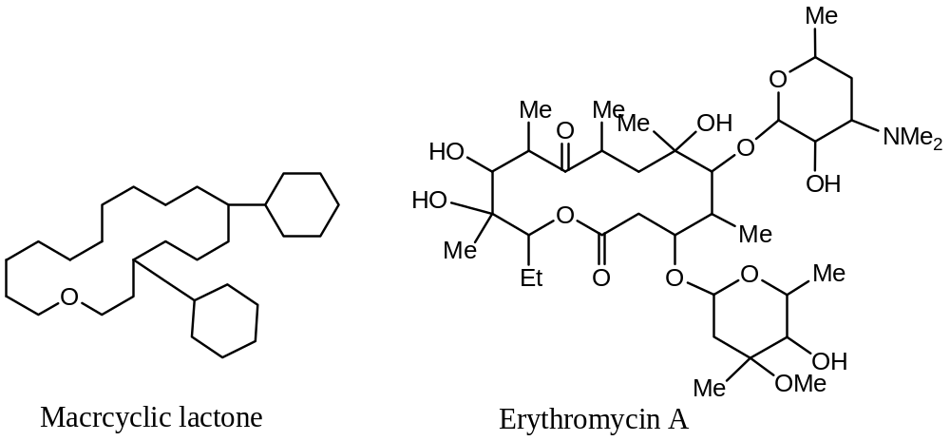
- Ansamycines (ansa → knife)
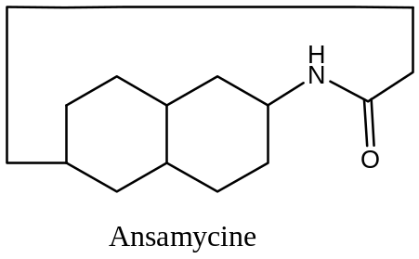
- Peptide antibiotics: For example,

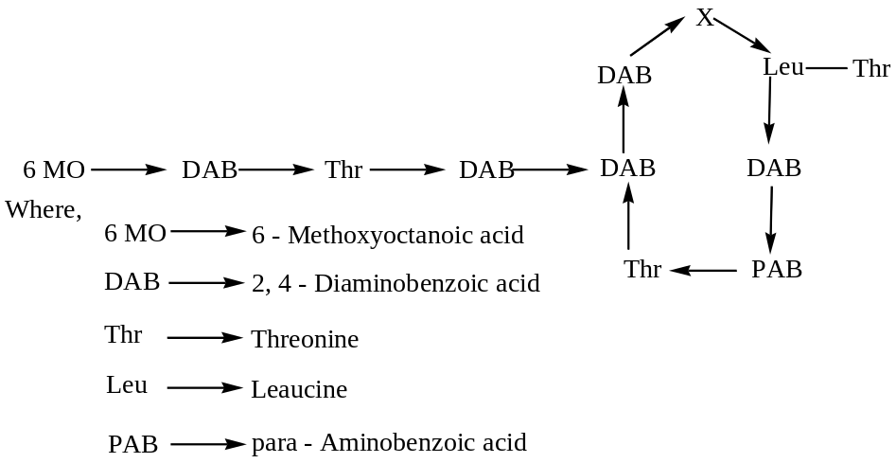
- Polyenes
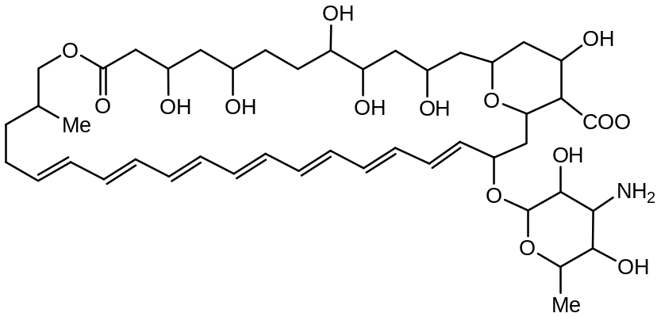
- Miscellaneous: For example, chloramphenicol.
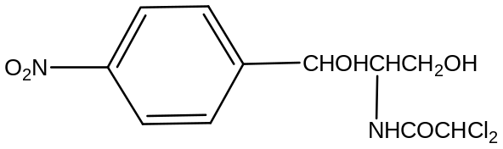
Production of Antibiotics:
Three different methods are usually applied for the production of antibiotics, these are:
- Surface culture,
- Submerged culture and
- Rice Bran culture.
The Penicillins:
In 1929, Fleming discovered a mould of Penicillium species which inhibit the growth of certain bacteria. Actually the name penicillin is assigned to the mixture of natural compounds having the molecular formula C₉H₁₁O₄N₂SR, and differing only in the nature of “R – Group”, and contains β – lactum ring in their structure.
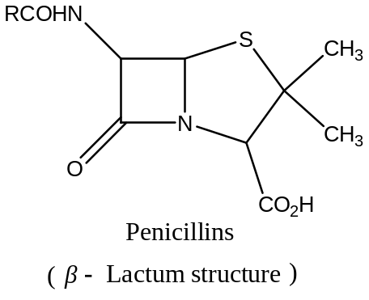
Penicillins are mainly produced from the following two strains/ species:
- Penicillium notatum and
- Penicillium chrysogenum
There are six naturally occurring penicillins, which contain the basic structure, and contain β – lactum ring in their structure and all differ only in the nature of “R – Group”. The chemical names, common names and the nature of “R – Group” are given in the following table:
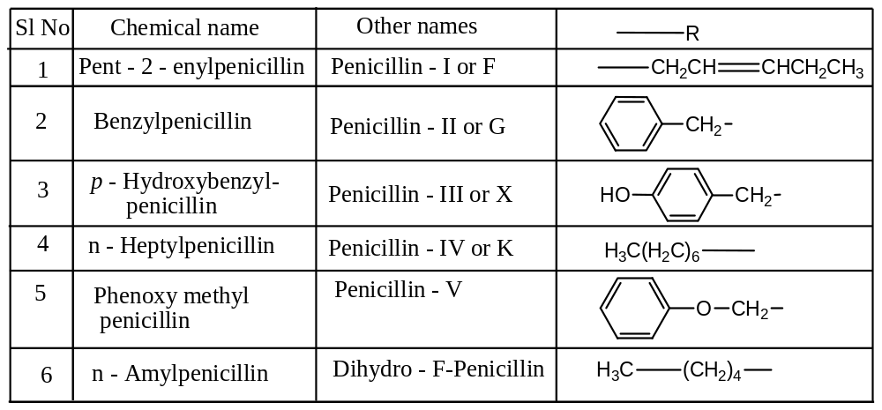
Structurally Modified Penicillins:
OR Chemical Modification of Natural Penicillins:
OR Semi synthetic Penicillins:
Structurally modified penicillins can be synthesised by finding out an appropriate acid chloride, which on condensation with 6 – aminopenicillinic acid will give semi-synthetic penicillin. For example,
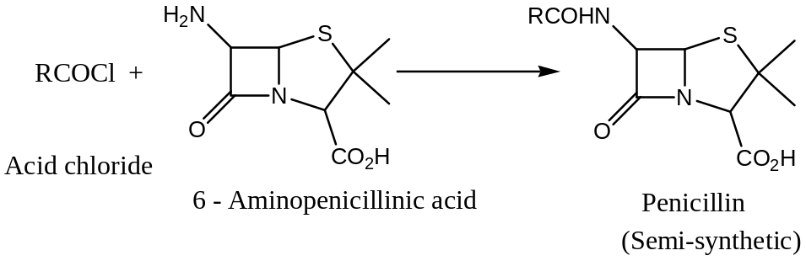
With this method a few acid resistant penicillin can be synthesised. Following are some of the examples of semi-synthetic penicillins:
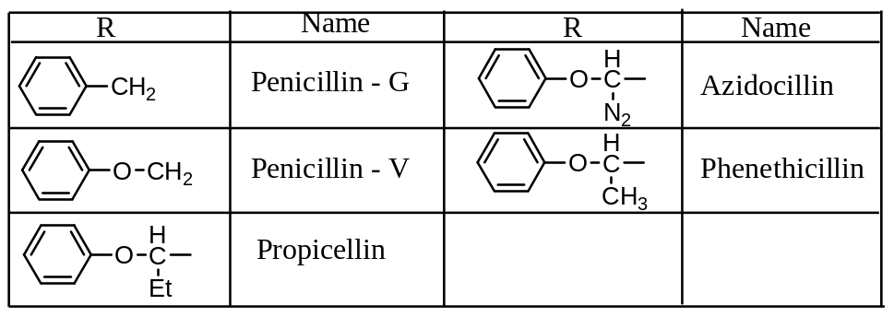
Among these, phenethicillin was the first semi-synthetic penicillin used in therapy, followed by its homolog penicillin shown above. The spectrum of antibacterial activity of these (antibiotics) compounds is generally similar to that of penicillin – G (active against Gram + ve bacteria, mainly against Chiphilist). They are, however, less active against Neisseria and are not recommended for the treatment of gonorrhoea.
The advantage in their use is a better absorption when given orally. Two structural aspects are important for oral absorption of penicillin:
- Stability in acid medium and
- Lipophilicity (lipid soluble) of their side chain.
Phenethicilline and propicillin — the two semi-synthetic penicillins are acid resistance and the azidocillin is well absorbed orally. The azidocillin is more active then penicillin – V, phenethicilline and propicillin and it is active against Homophilus influenza.
Β – Lactum Antibiotics:
The β – lactum antibiotics are chemically characterise by the presence of a β – lactum, a cyclic 4 – membered amide in the molecule. All β – lactum antibiotics have a common mechanism of action: inhibition of bacterial cell wall synthesis. However, differences have been shown in their capacity to inhibit different enzymes.
The β – lactum group includes two of the most important families of antibiotics, viz.
- The penicillins, in which the lactum ring is fused with a thiazolidine ring (5- membered ring) and
- The cephalosporins, in which there is a dihydro thiazine (a 6 – membered ring) fused with lactum ring.
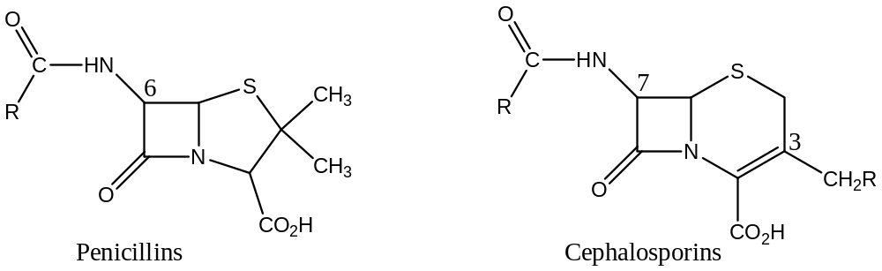
Most of the derivatives currently used in therapy have been obtained by modification at the lateral chain at position 6 of penicillins or position 7 of cephalosporins.
In addition to these “classic” β – lactum antibiotics, several new ones recently isolated from actinomycetes having good activities. These “non-classic” β – lactums include the cephamycins or 7 - methoxy cephalosporins and other derivatives in which the lactum is not fused with a sulphur – containing group.
Β – Lactum antibiotics are studied under the following headings: —
- Natural Penicillins,
- Penicillins absorbed after oral administration (semi-synthetic penicillins),
- Penicillins insensitive to staphylococcal Penicillinase,
- Penicillins with Enlarged Spectra of Activity,
- Anti – Pseudomonas and Anti – Proteus Penicillins,
- Amidino Penicillin, and
- Modification of Penicillin Nucleus,
Antimalarials
Antimalarials are the therapeutic agents which are used for the prevention and treatment of malaria.
Malaria is still one of the most dreadful infectious protozoal diseases affecting man. Though malaria is spreaded all over the world, the disease occurs now mainly in tropical countries of the world. More than one million people die of malaria each year and most of these people belong to the third – world countries. Malaria has been eradicated from the developed countries, as a result of the Malaria Eradication Programme of WHO. It was achieved through improved living conditions, use of insecticides, destruction of breeding places of mosquitoes and use of Antimalarials as prophylactic agents.
The causal organisms responsible for malaria belong to the genus plasmodium, which is one of the classes of protozoa known as sporozoa. There are four different species which are accepted as being responsible for human malaria, these are —
- Plasmodium vivax,
- Plasmodium falciparum,
- Plasmodium malariae and
- Plasmodium ovale.
The parasite, Plasmodium vivax causes tertian malaria, Plasmodium falciparum, the parasite of malignant or sub-tertian malaria; Plasmodium malariae, the parasite of quartan malaria; and Plasmodium ovale, the parasite that causes a mild type of tertian malaria. Out of these, plasmodium falciparum is the most dangerous. The carrier of the parasite plasmodium is the female anopheles mosquito.
Life Cycle of Malaria Parasite:
Life cycle of malaria parasite is complex involving two stages viz. —
- In female anopheles mosquito, the carrier and
- In the human body, the host.
In human body the parasite can be increased its number by asexual reproduction in two phases viz. —
- In blood phase — Erythrocyte and
- In liver phase — Tissue phase.
Hence, an ideal antimalarial must be able to exert an effect on two fronts simultaneously, namely: to eradicate the microzoan from the blood and also from the tissues, in order to produce an effective “radical cure”.
Life Cycle in Female Anopheles:
When a female anopheles mosquito bites a malaria patient, it takes up some malaria parasite along with blood, these are called Gamete. The gametes are of two types: male gametes and female gametes, these undergo sexual reproduction to generate Ookerite in the stomach of the mosquito. Ookerite then converted to Oocyst and finally to Sporozoites and these conversion needs only seven days. The sporozoites so formed go to the saliva of the mosquito.
Life Cycle in Human:
When such an infected mosquito bites a healthy man, some of the sporozoites enter to the human body (the host). In the body of the host the sporozoites can stay in two phases viz. in the blood phase or in the tissue phase. In the blood phase these undergoes asexual reproduction to generate Schizonts, which converted to Trophozoites and finally to the Merozoites. The merozoites so formed feeds on blood RBC, and thus cause anaemia, and these are the responsible for malaria diseases and increases body temperature abnormally.
When antimalarial drugs are administered into the host (malaria patient), the merozoites gets converted into the Schizonts stage and stated in the liver (tissue phase) and as result temperature decreases. However, when the drug action is diminished, these again converted to the merozoites through Trophozoites and again body temperature increases and thus cause malaria again. Thus, once malaria parasite enters into the host body it is very difficult to cure.
The Plasmodium falciparum variety of malaria parasite is very dangerous in the sense that, these can be directly converted into the merozoites from Schizonts, and thus can feed most of the RBC of blood with in very short term. Hence, without emergency treatment, the patient can die.
Antimalarial Drugs (Chemotherapy of Malaria):
Broadly speaking, antimalarial drugs are of four types — depending upon the mode of action
- Sporozoitocides — which kills the Sporozoits. These are the prophylactic agents.
- Erythrocytic Schizontocides — these kill the parasite in the blood phase and are only suppressive in nature.
- Exo – erythrocytic Schizontocides — which kills the parasites in the tissue form and are curative.
- Gametocytocides — these are the insecticides which destroys the mosquitoes.
Chemical Classification of Antimalarials:
Following are the antimalarials popularly used in the treatment of disease malaria:
- Cinchona alkaloids,
- 8 – Amino quinolines,
- 4 – Amino quinolines,
- 9 – Amino acridines,
- Biguanides,
- Pyrimidines,
- Sulphonates,
Now, a new drug recently been introduced called
- Artemisinin: — obtained from the plant Artemisinia annua.
Cinchona Alkaloids:
There are about 25 alkaloids have been synthesised from the cinchona (dates) bark. Out of these only a few are useful clinically for the treatment of malaria and these are: Quinine, Quinidine, Cinchonine and Cinchonidine. These are also been synthesised by chemical means. These have the following basic structural unit:
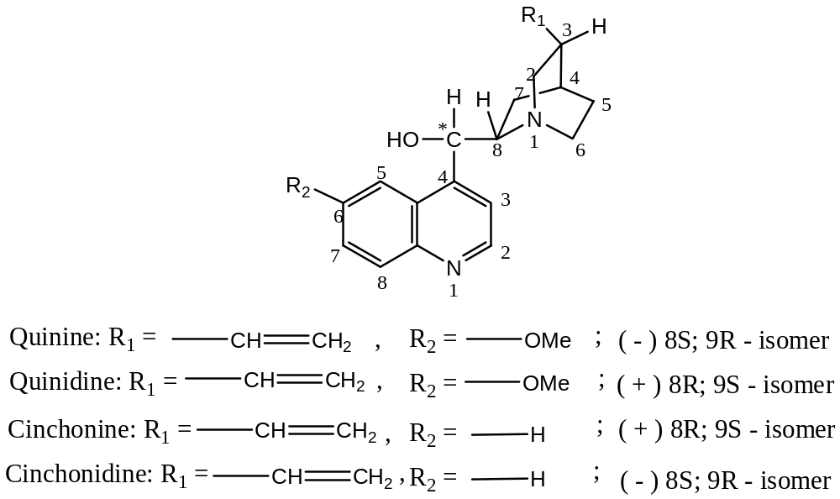
In general, the cinchona alkaloids have been found to act only as suppressive agent (Erythrocytic Schizontocides) on the asexual form of the malaria parasite.
Quinine possesses many toxic and side effects. When it is used for a long time, its side effects are ringing in the ear, headache, nausea, and disturbance of vision. It should be avoided during pregnancy because it has been found to be toxic to both mother and to foetus.
4 - Aminoquinolines:
The general structure of 4 – aminoquinolines is
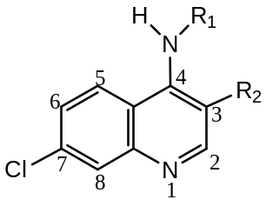

Following are the important antimalarials of this class:
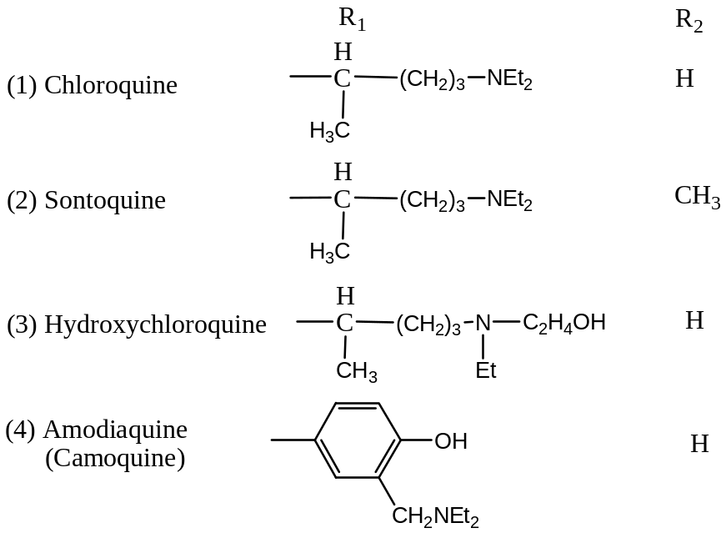
Chloroquine hydrochloride is used for injections, whereas its sulphate (nivaquine) and phosphate are used as tablets. It is very active against Plasmodium vivax and Plasmodium falciparam and its activity is 3 to 4 times that of quinine. Chloroquine has many side effects. Sonoquine is less reactive than Chloroquine.
Camoquine has been found to be 3 to 4 times more active than quinine, especially against the malaria caused by Plasmodium vivax and Plasmodium falciparam. It has been shown that the phenolic group is essential for its antimalarial activity, since its removal depresses while its methylation completely destroys the antimalarial activity.
The action and uses of hydroxy chloroquine are similar to those of chloroquine. Owing to its specific action on the erythrocytic phase of malaria parasite it fails to serve as a ‘radical cure’ of Plasmodium vivax infections.
8 - Aminoquinolines:
The general structure of 4 – aminoquinolines is
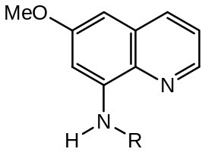
Following are the important antimalarials analogues of this class:
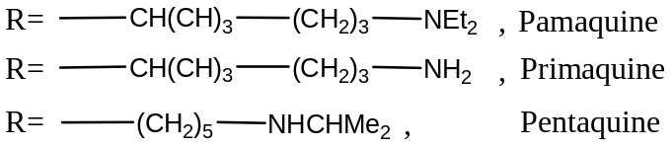
8 – Aminoquinolines are active against pre – or exoerythrocytic form of the malaria parasite, but less active against the erythrocytic forms. The 8 – aminoquinolines possess gametocidal activity. They are used mainly for the radical cure of relapsing malaria like vivax malaria. All analogues of this class are mainly used as phosphate base.
9 – Amino acridines:
Mapacrine is the most important analogue of this class. Mapacrine hydrochloride inhibits the erythrocytic stage of development of the malaria parasite. It is found to be toxic and less effective than chloroquine, but however a superior drug to both quinine and chloroquine. It has also side effect (such as producing a yellow colour in skin, nausea, etc.).
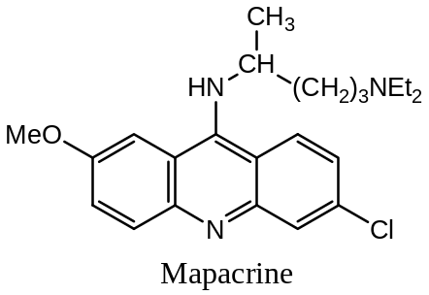
Biguanides:
The general structure of biguanides analogue of antimalarial is —
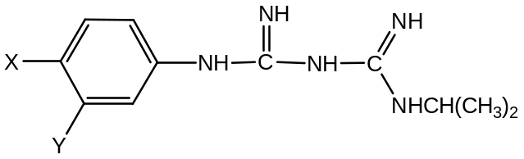
With,
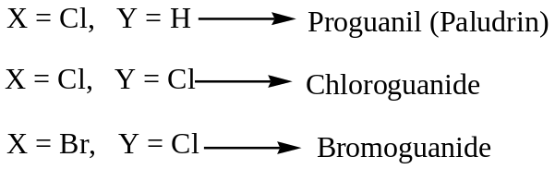
Biguanides are the best antimalarials. Proguanil is superior to Mapacrine and Chloroquine, and appears to be the best antimalarial known at present time.
Pyrimidine Analogues (Diaminopyrimidines):
Pyrimidine antimalarials are active to both exoerythrocytic and erythrocytic forms of Plasmodium Falciparam, together with the exoerythrocytic of Plasmodium Vivax. Following are the most important drugs of this class:
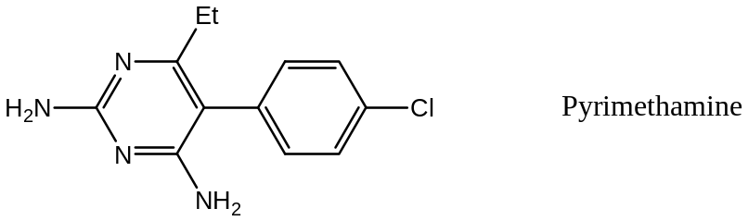
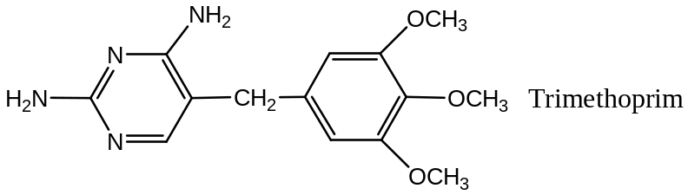
Artemisinin:
The antimalarial Artemisinin, obtained from the plant Artemisinia and Arether is the only important analogue of this class.
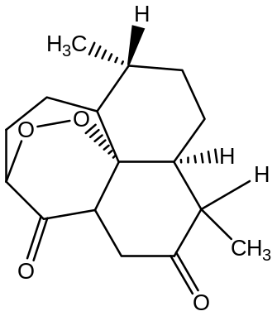
Synthesis of Antimalarials:
- Synthesis of 4 – Aminoquinoline Analogues:
Synthesis of Chloroquine:
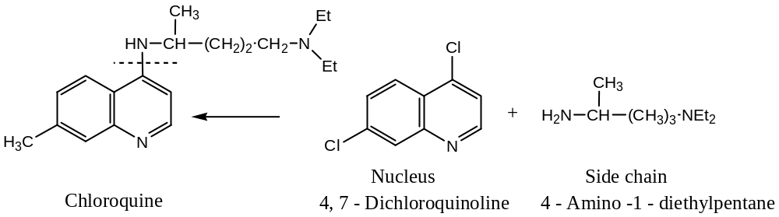
Now, synthesis of Quinoline Nucleus:
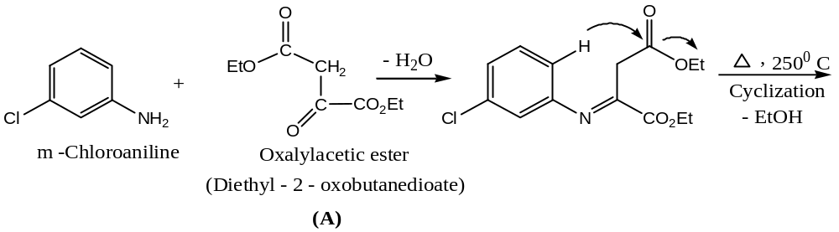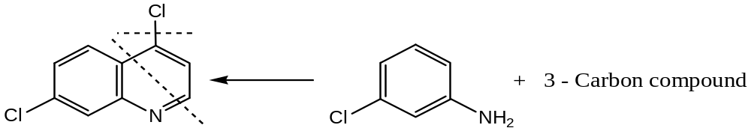

- Synt
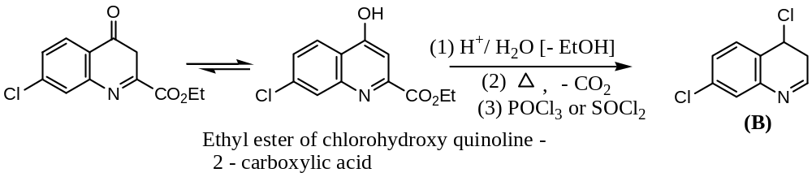
Synthesis of side chain:
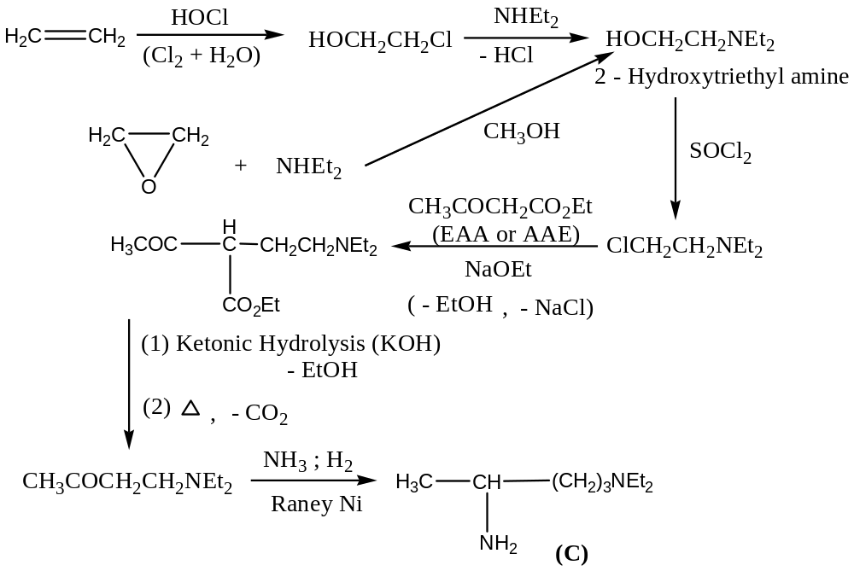
Synthesis of (A):
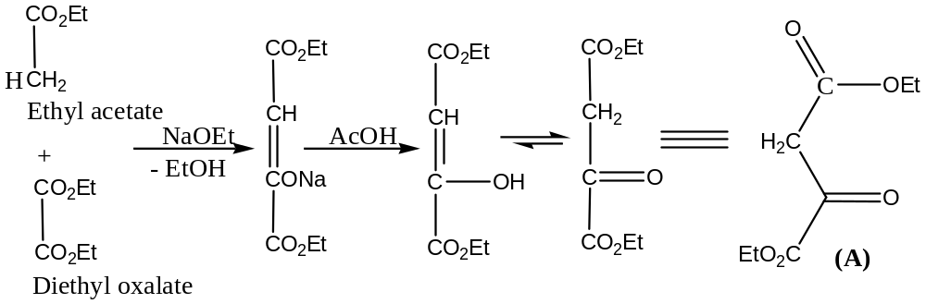
Condensation of (B) & (C):
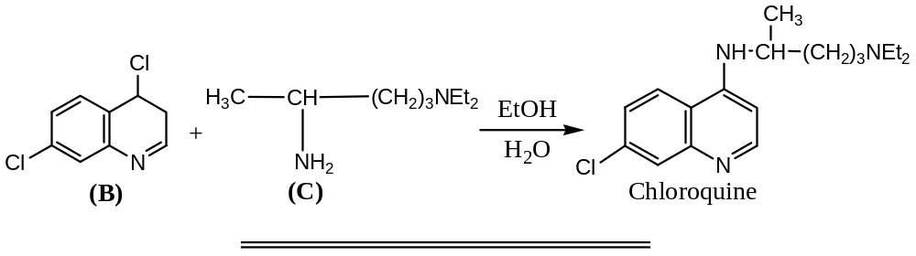
- Synthesis of 8 – Aminoquinoline: Primaquine
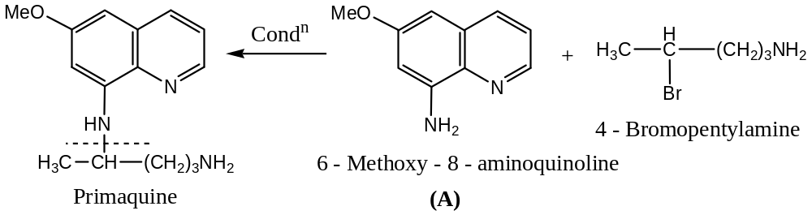
Now, the synthesis of 6 – methoxy – 8 – aminoquinoline nucleus:
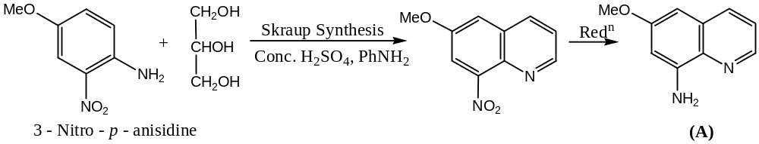
Synthesis of side chain:
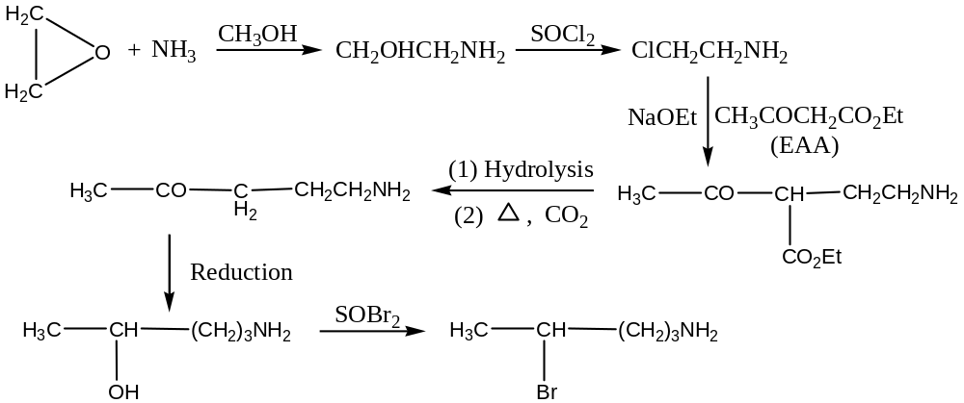
Finally, the condensation of this side chain with the nucleus (A) yields the antimalarial Primaquine:
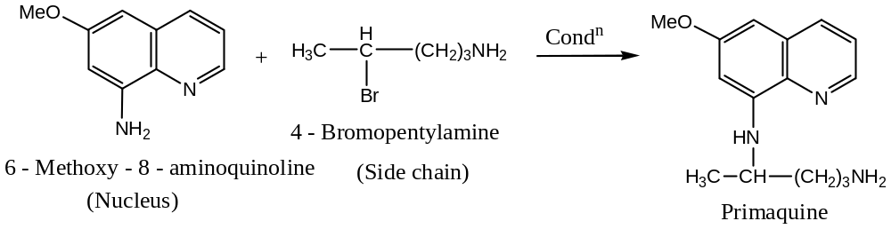
Question (1): Write short notes on antibiotics and sulpha-drugs. What is the difference between antibiotics and sulpha-drugs?
Solution: Antibiotics:
The chemical compounds produced by some microorganisms that can be used to destroy or inhibit the growth of pathogenic microorganisms i.e. the metabolic activities of other microorganisms responsible for disease are called antibiotics. Antibiotics are classified as —
- Gram Positive — the antibiotics which are effective against gram +ve bacteria are called Gram Positive antibiotics. For example: Penicillin — an effective drug for pneumonia, sore throat, syphilis, abscesses, etc.
- Gram Negative — the antibiotics which are effective against gram –ve microorganisms are called Gram Positive antibiotics. For example: Gramicidine, Bacitracin, etc.
- Broad Spectrum Antibiotics — the antibiotics that are effective both for Gram Positive and Gram Negative as well as for other pathogenic microorganisms are called Broad – Spectrum Antibiotics. For example: Tetracyclines (this family has 3 – members viz. Oxytetracycline or Terramycine, Tetracycline or Aureomycin and Chlorotetracycline) — this is used for whooping coughs, respiratory tract, bacterial infections.
- Chloramphenicol (obtained from Streptomcyces Venezuelae) — this is used for the treatment of typhoid bacillary dysentery, bacterial pneumonia. It is a drug of choice in typhoid.
- Streptomycin (obtained from Streptomyces Griseus) — this drug is effective against Tuberculosis (TB) and pneumonia.
Sources of Antibiotics: 3 – main sources are — Bacteria, Fungi and Actinomycetis.
Sulpha drugs:
Sulpha drugs are the derivatives of sulphanilamide. These drugs are used against the diseases caused by bacteria and other microorganisms. These are synthetic chemicals i.e. not obtained from microorganisms like bacteria, fungi, etc. like antibiotics. The parent compound for all sulpha drugs is the sulphanilamide: For different sulpha drugs, there will be variation only in “R” group.
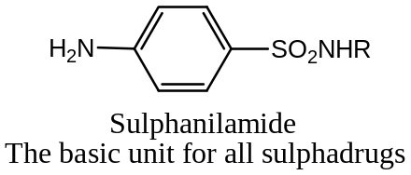
For example:
Sulphapyridine — used against pneumonia
Sulphathiazole — used against stomach disease and also as antiseptic
Sulphagunidine — active against Cholera and bacillary dysentery
The basic difference between Antibiotics & Sulpha drugs:
Antibiotics are the chemical compounds produced by microorganisms i.e. microbial but sulpha drugs are the synthetic chemicals, the derivatives of sulphanilamide.
Antipyretics: The synthetic chemical compounds (drugs) that are used to reduce our body temperature during fever are called antipyretics. Some commonly used antipyretics are paracetamol, phenacetin, antipyrine, aminopyrine, etc.
Anaesthetics:
Anaesthetics are the chemical medicines that are used to block a part or complete nervous system of our body during surgical operation to relief from pain.
Anaesthetics are of 2 – types:
- Local anaesthetics, and
- General anaesthetics.
Local anaesthetics: Local anaesthetics are the chemicals which produce loss of sensation in a small area where the drug is applied. Common local anaesthetics are: Xylocaine, Procaine, Orthocaine, Penzocaine, etc. Local anaesthetics are used to perform minor operations such as removing teeths, etc.
General anaesthetics: General anaesthetics are the chemicals or medicines which causes unconsciousness by blocking whole nervous system. These are usually volatile and used to perform major operations. Common general anaesthetics are: Chloroform, Nitrous oxide, Diethyl ether, Divinyl ether, Morphine, Cocaine, Pathedine, Cyclopropane, ether, etc. Sodium pentothal is the most commonly used general anaesthetics.
Question (1): What are general and local anaesthetics? Select one general and one local anaesthetic from the followings:
Pathedine, Cocaine, Ethyl chloride, Nitrous oxide

