terpenes
Syllabus: Occurrence, classification, isoprene rule; Elucidation of structure and synthesis of Citral, Neral and $α$-terpineol
Terpenes or Terpenoids: —
The name —
Though the suffix “$ene$” is appeared in the term terpene, but these are not alkenes/ olefins. That is why instead of terpene it is better to use the term terpenoids to cover the compounds containing other functionalities as well.
Introduction:
Terpenes or more generally terpenoids are naturally occurring substances that are present in flowers, leaves, stems or roots in some plants. Steam distillation or solvent extraction of these plants or their parts gives sweet smelling oils, called essential oils which are used as perfumes or food flavouring agents. Terpenes are volatile organic compounds which are odoriferous constituents of the essential oils. They contain carbon, hydrogen and/ or oxygen and are not aromatic in character.
Basic Unit: Structural features: Isoprene Rule —
A common feature of terpenes is that the carbon skeletons of their molecules are build up of by isoprene ($C_{5}$) unit.
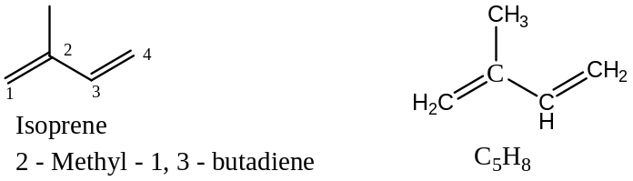
The terpene skeletons can be divided into isoprene units, which are generally jointed to a head-to-tail fashion. This head-to-tail arrangement of isoprene units in terpenes was first suggested by Ingold and this rule is generally known as the isoprene rule. Here, the $C_{1}$ position of the isoprene unit is linked to the $C_{4}$ position of another isoprene unit and that is why this leads to the special name isoprene rule and hence terpenes are also known as the isoprenoids.
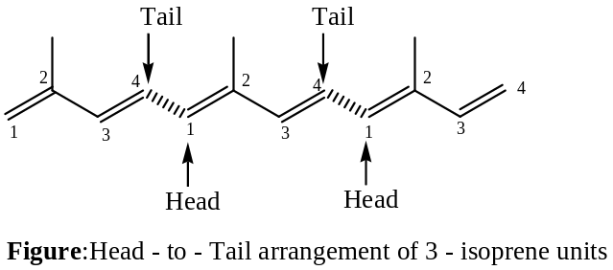
The isoprene rule has received from the observation that isoprene can be dimerised in the laboratory to give the widely occurring terpene, dipentene [$(±)$ $Limonene$].
$$2C_{5}H_{8} ⟶ C_{10}H_{16}, dipentene$$
Structure of some terpenes are given below showing (by broken lines) the head-to-tail union of two or more isoprene units, $C_{5}H_{8}$ with or without concomitant cyclization.
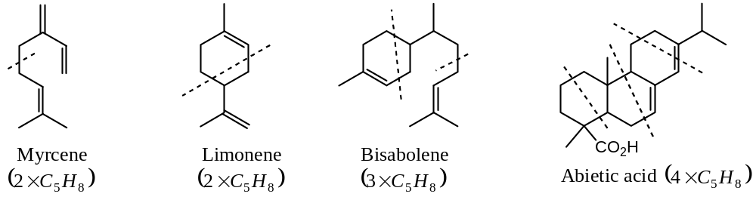
On the other hand, there are some other examples of terpenoids, whose carbon skeleton are divisible into isoprene units but they are not linked by head-to-tail arrangement. Lavandulol and Artemisia alcohol provided good examples. The relationship of such compounds with isoprene forms the basis of the general isoprene rule, which embraces all structures that are divisible into isoprene units irrespective of the position of their linkage (numbering).
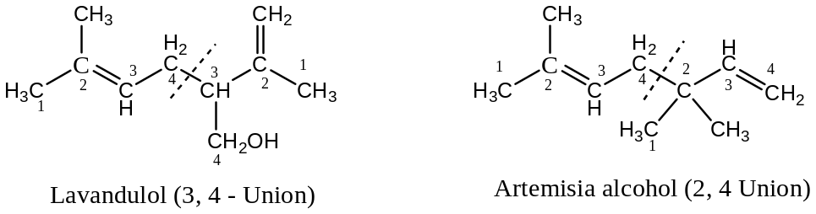
The isoprene rule is valid in most of the cases, but there are only few examples which violet the rule. For example, eremophilone and totarol structures cannot be divided into isoprene units though these are well known terpenes.
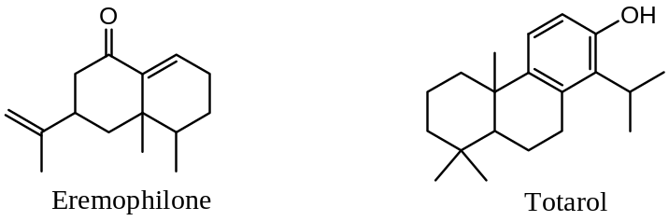
Methods of writing structures of terpenes:
Monocyclic terpenoids contain a six-membered ring, and in this connection Ingold point out that a gem-dialkyl group tends to render the cyclohexane ring unstable. Hence, in closing the open chain to a cyclohexane ring, use of this gem-dialkyl rule limits the number of possible structures. Thus, the mono-terpenoid open chain gives rise to only one possibility for a monocyclic mono-terpenoid, viz. the $p$- cymene structure. This is shown in the following structures, the alicyclic structures being written in the conventional ring shape.
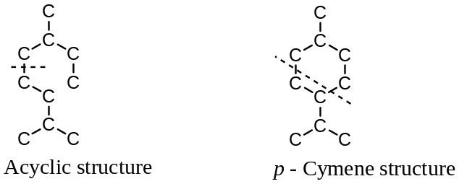
Most naturally occurring monocyclic mono-terpenoids are the derivatives of $p$ – cymene.
Bicyclic mono-terpenoids contain a six-membered ring and a three, four or five membered ring. Ingold also point out that cyclopropane and cyclobutane rings require the introduction of a gem -dimethyl group to render them sufficiently stable to be capable of occurrence in nature. Thus, closer of the $10C$- open chain gives three possible bicyclic structures, all three types are known.
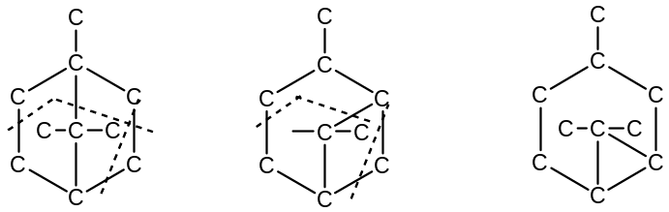
The $di$- and $tri$- terpenoids are not steam volatile, and are obtained from plant and tree gums and resins. The $tetra$-$terpenoids$ forms a group of compounds known as the carotenoids and it is usually treated in a separate branch. For example, $vitamin$ $A_{1}$,
Rubber is the most important poly-terpenoids, $(C_{5}H_{8})_{n}$.
Classification of Terpenoids:
Since the basic unit of terpenes is isopropene ($C_{5}$) and majority of terpenes are the polymers of isopropene units. Hence, depending upon the number of isoprene unit present, terpenes are classified as —
Sl. No | Class of Terpenoids | No of Isoprene units | No of $C$- atoms
1 | Monoterpenes | 2 | 10
2 | Sesquiterpenes | 3 | 15
3 | Diterpenes | 4 | 20
4 | Triterpenes | 6 | 30
5 | Tetraterpenes | 8 | 40
6 | Polyterpenes, $(C_{5}H_{8})_{n}$. | $n$ | $>$ 40

($1$) Monoterpenes: These are the terpenes with two isoprene units, and hence $10C$- atoms. Depending upon the nature of carbon skeleton, they are further subdivided into ($a$) acyclic, ($b$) monocyclic and ($c$) bicyclic monoterpenes. Examples of each class are shown below —
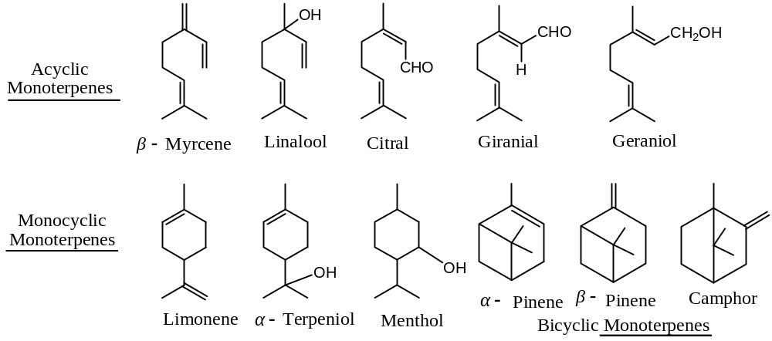
($2$) Sesquiterpenes: These are the terpenes with three isoprene units, and hence contain 15 carbon atoms. They form higher boiling fractions of essential oils and like monoterpenes; they are also divided into various subgroups.
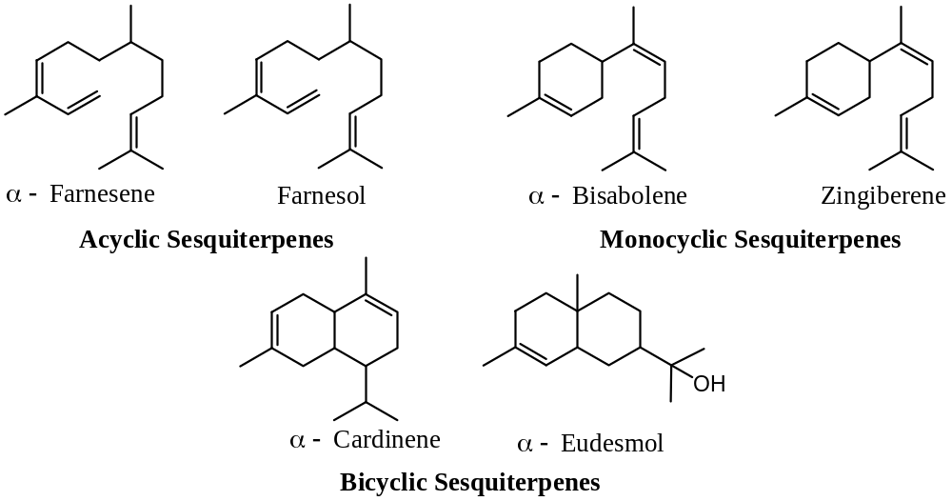
($3$) Diterpenes: These are the terpenes containing four isoprene units, and hence $20C$- atoms. These are also classified into four subgroups and these are —
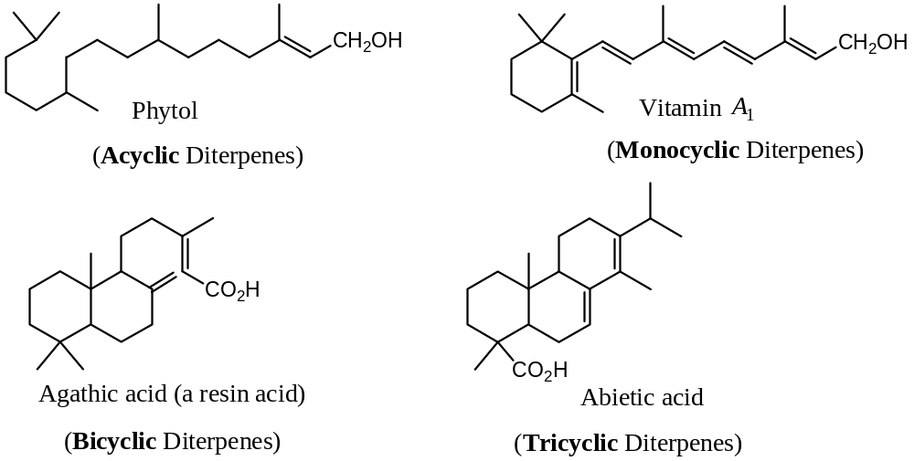
($4$) Triterpenes: These are the terpenes with six isoprene units, and hence $30C$- atoms. These may be cyclic or acyclic. The most important triterpene is squalene, the constituent of shark liver oil and also present in yeast.
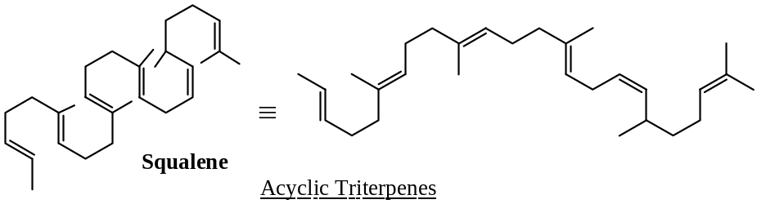
($5$) Tetraterpenes: These types of terpenes are compost of eight isoprene units, and hence $40C$- atoms. Carotenes i.e. carotenoids, the colouring pigment of carrots; lycopene the colouring pigment of tomatoes etc. are belong to this class.
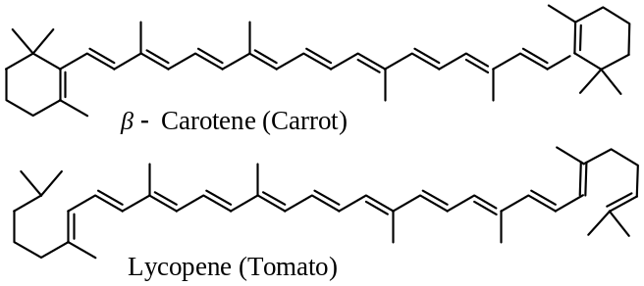
($6$) Polyterpenes: This class of has more than $40C$- atoms i.e. contains more than eight isoprene units. Rubber [$(C_{5}H_{8})_{n}$] is an example of this class.
Role of Terpenes/ Essential Oils:
Plants elaborate thousands of terpenoids many of which do not yet have identifiable physiological, biochemical, or even ecological roles. So, in the past, these were classified as “waste products” or “secondary metabolites” having no direct metabolic role in the organisms. However, now it has been established that their production is regulated in plants. For example —
- The volatile monoterpenes are synthesized and accumulated in complex secretary structures such as resin ducts or resin cavities. These specialized organs are found only in certain parts of the plant at particular stages of the development of the plant, and their formation is greatly influenced by the environment. For this reason, synthesis of monoterpenes by plants is restricted to certain timed and places in the life of the plant. Therefore, these compounds cannot be the waste products of the metabolism of the plants as was earlier believed.
- It is now believed the volatile class of terpenes may act as chemical signalling agents between plants and other living organisms. They act as an attractant to pollinators and $allelopathic$ agents, or as defence chemicals against predators and pathogens.
- Some of the terpenes may act as substance for enzymatic processes. For example, camphor acts as a substrate for $cytochrome P450 monooxygenase enzyme$ system.
- Yet some other terpenes may be secondary metabolites obtained from other natural products. For example, Sesquiterpenes may be obtained from the juvenile hormones of plants.
- Some of the terpenes may have been formed during the synthesis of primary metabolites, called steroids, by plants.
Methods of Isolation of Terpenes/ Essential Oils:
[Mainly used for mono & Sesquiterpenes, however may be used for any terpenes]
Plants containing essential oils usually have the greatest concentration at some particular time, for example, Jasmine at sunset. In general there are four methods of isolation/ extraction of terpenoids —
- Expression method,
- Steam distillation,
- Solvent extraction, and
- Adsorption method.
The extracted terpenoids are subsequently separated into individual components by employing physical or chemical methods.
Expression Method: The plant material is crushed and filtered to remove the unwanted solid particles. The filtrate is subjected to high-speed centrifuge and the clear essential oil is obtained at the top.
Steam Distillation: This is the most widely used method. Here the powdered plant material is steam-distilled, when the constituents of the essential oils go into the distillate, from which they are extracted by low-boiling point solvents such as ether or light petroleum. If the component is decomposed under these conditions, it may be extracted with light petrol at $50℃$, and the solvent is then removed by distillation under reduced pressure.
Solvent Extraction: The essential oils which are sensitive to heat are extracted from the plant material with low – boiling point solvents, such as light petroleum or ether at room temperature. Distillation of the solvent from the filtered extract under reduced pressure leaves the essential oil.
Adsorption Method: The petals (leaves) of flowers are left in contact with a fat preparation [a mixture of lard (melted fat of swine (pig)) and tallow (the melted animal fat)] for several days at about $50℃$ , until the fat is saturated with essential oil. The saturated fat is then extracted with ethanol and the solvent (ethanol) is removed under reduced pressure at $0℃$. Recently, activated charcoal has been used instead of fat.
After extraction of the essential oils, which are really mixtures of a number of compounds/ components, the constituents are separated by a variety of methods depending upon their physical or chemical properties.
($A$) Physical Methods: The most commonly used physical methods are fractional distillation and chromatography. Of these two methods, chromatography is now more in use. The essential oil is adsorbed on a column of suitable adsorbent such as alumina or silica gel and subsequently eluted using solvents of increasing polarity. Each elute representing a class of terpenes is then further subjected to column chromatography to separate its constituents i.e. individual terpenes.
($B$) Chemical Methods: The actual method to be adopted depends upon the chemical nature of the constituents. For example, an unsaturated terpene hydrocarbon such as myrcene may be separated through its crystalline adducts with hydrogen halides or nitrosyl chloride ($NOCl$). An alcohol, for example, geraniol may be separated through its ester with phthalic anhydride or through phenyl urethane obtained by treatment with phenyl isocyanate. The aldehydic or ketonic terpenes may be separated by reaction with carbonyl reagents such as sodium bisulphate, semicarbazine, $2,4$ - $DNP$, etc. the terpene is then regenerated by hydrolysis of the products.
General Methods of Determining Structure:
Monocyclic Monoterpenoids:
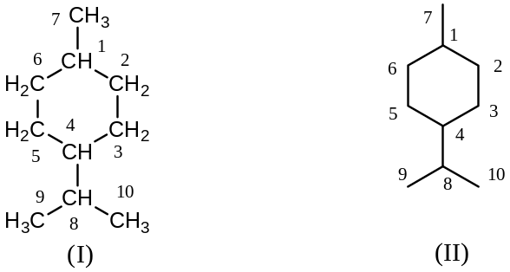For the nomenclature of monocyclic monoterpenoids, the fully saturated compound $p$ – $methylisopropylcyclohexane$, hexahydro- $p$-cymene or $p$- $menthane$, $C_{10}H_{20}$, is used as the parent structure, it is a synthetic compound with boiling point $170℃$. $p$- Menthane is ($I$), and ($II$) is a conventional method of drawing formula of ($I$). The positions of substituents and double bonds are indicated by numbers, the method of numbering being shown in (I) & (II). When a derived from $p$ – menthane contains one or more double bonds, ambiguity may arise as to the position of a double bond, when this is indicated in the usual way by a number which locates the first carbon atom joining by a double bond. To prevent ambiguity, the second carbon atom joined to the double bond is also shown, but it placed in parentheses. The examples illustrates the method of nomenclature in the first example, all the types of methods of nomenclature have been given in the second and third examples, only the nomenclature that is used more commonly.
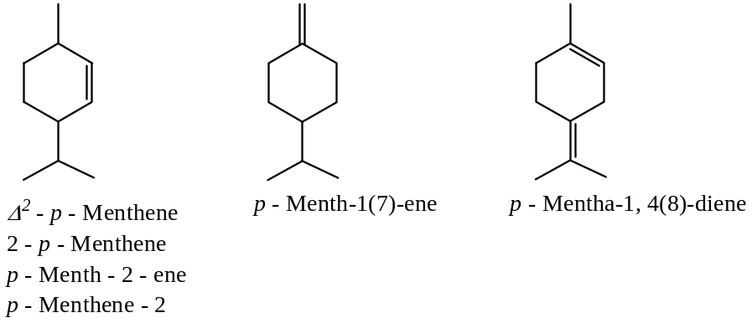

Bicyclic Monoterpenoids:
Introduction: There are seven types of bicyclic monoterpenes are known and these are divided into three classes according to the size of the second ring, the first ring is being a $6$- membered ring in each class.
Class I: [$6$- $+3$- Membered Ring] — Here, only two groups are known viz. thujane & carane
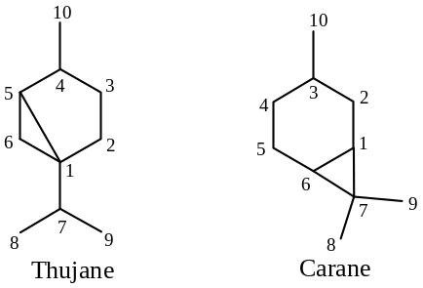
Class II: [$6$- $+4$- Membered Ring] — Here, only one group is known viz. pinane
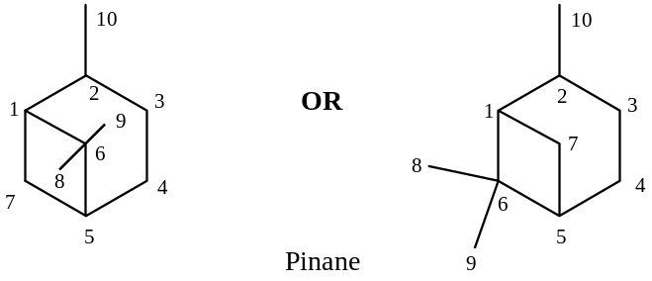
Class III: [$6$- $+5$- Membered Ring] — Here, only four groups are known viz. camphane (bornane), isocamphane (norbornane derivt.), fenchane (norbornane derivt.) and isobornylane (norbornane derivt.)
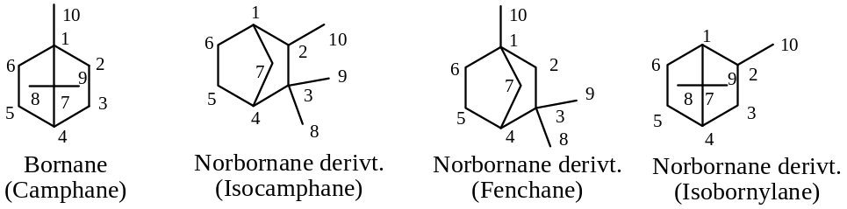
In bicyclic monoterpenes, the two rings are not in one plane, but are almost perpendicular to each other.
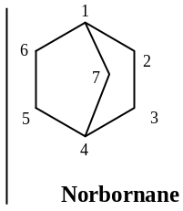The names, including those given in parentheses are still commonly used, but according to the IUPAC system of nomenclature, the name thujane, carane and pinane are retained, but the following changes are made —
Bornane for camphane and the other shown as above are to be named as the derivatives of norbornane. Thus, $isocamphane$ is $2,3,3$-$trimethylnorbornane$; $fenchane$ is $1,3,3$-$trimethylnorbornan$; $isobornylane$ is $2,7,7$- $trimethylnorbornane$.
General methods of establishing the structure of terpenes:
The important steps that are involved in determining the structure of an unknown terpene are as follows —
- The molecular formula of the compound is found out by elemental analysis and molecular mass determination. In modern day practice, it is done by mass spectrometry from which the signal due to molecular ion ($M^{+}$) is identified.
- In the next step, the nature of the functional group is established. The molecular formula of the compound as is obtained under Step ($1$) provides some hints about the nature of the functional groups and the degrees of unsaturation in the molecule.
The tests of unsaturation are done by performing addition reaction with $H_{2},X_{2}, NOCl$, and so on.
Infrared ($IR$) spectroscopic methods are also used to detect the presence of $C-C$ double bond in the molecule. Presence of conjugated double bonds is established by $UV$-$Vis$ spectroscopy and optical exaltation measurement. Common oxygen containing functional groups such as alcoholic $-OH$ group, aldehyde group, keto group, and rarely as carboxylic acid group, ester, or lactone are conveniently detected by $IR$ spectroscopy.
- After establishing the nature of the functional groups, the nature of the carbon framework is established by oxidative degradation at the $C-C$ double bond or secondary alcoholic or carbonyl group of the molecule to obtain simpler and easily identifiable smaller molecules. Presence of acetyl group ($-COCH_{3}$) is established by the haloform reaction and that of tertiary methyl group by Kuhn-Roth’s oxidation method.
The cyclic compounds are subjected to Vesterberg’s dehydrogenation reaction with $S, Se, or Pd/C$ at a high temperature to give known aromatic compounds.
The oxidation degradation reactions also establish the relative locations of the functional groups in the carbon framework.
- In the next step, an unambiguous synthesis of the compound is done to confirm the proposed structure based on the above – mentioned analytical evidences.
Synthesis & determination of structure of citral:
Elemental analysis, molecular mass determination and also from the molecular ion peak ($M^{+}$) of mass spectroscopy of citral, it has been found that the molecular formula is $C_{10}H_{16}O$.
The molecular formula indicates the presence of unsaturation in the molecule. Citral adds 2 moles of bromine to give a tetrabromo derivative. This shows the presence of two $C-C$ double bonds in the molecule. It forms a hydrazone and also reduces Fehling’s solution, which shows that the oxygen atom is present as an aldehydic $–CHO$ group.
Citral absorbs in the $UV$-$Vis$ regions above $200 nm$ showing the presence of conjugation in it. The aldehydic group in citral is reduced to geraniol with sodium ethanol.
$$C_{10}H_{16}O \underset{→}{ Na+ C_{2}H_{5}OH } C_{10}H_{18}O$$
Citral Geraniol
Geraniol does not absorb in the $UV$-$Vis$ regions above $200 nm$. This shows that the citral contains a conjugated $enal$ system, $C=C-CHO$. This is supported by the fact that the citral undergoes a retro - aldol reaction of conjugated unsaturated $enal$ system with aqueous $K_{2}{CO}_{3}$ at the boiling point of water to give acetaldehyde and an unsaturated $C_{8}$- ketone, methyl heptanone.
$$C_{7}-C=C-CHO \underset{→}{ aq K_{2}{CO}_{3}, Boil } C_{8}-Ketone+CH_{3}CHO$$
Since citral contains two $C-C$ double bonds and one $-CHO$ group, the saturated hydrocarbon corresponding to citral should have the molecular formula $C_{10}H_{22}$. This corresponds to a $C_{10}$- alkane. This implies that citral is an acyclic compound. Methyl heptanone, the $C_{8}$- ketone, obtained from citral by retro - aldol reaction, on oxidation gives acetone and a known compound, laevulinic acid.
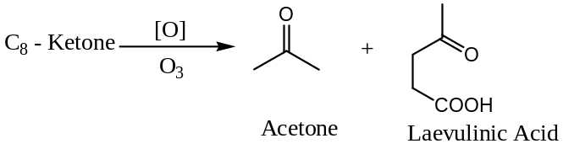
Therefore, $C_{8}$- ketone has the structure shown below that, in turn establishes the structure of citral.
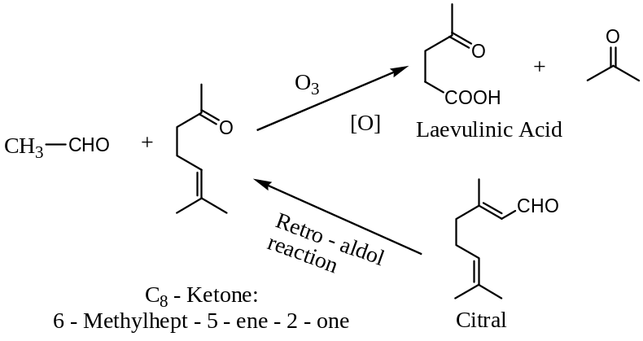
The structure of the citral proposed on the basis of the analytical evidences is supported by a synthesis (by Barbier and Bouveault and Arens and Van Drop).
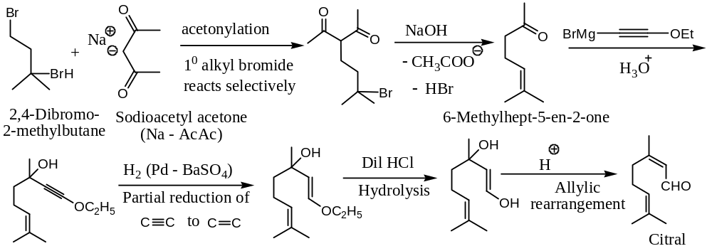
The structure of the citral, as written above, shows that it can exist as a pair of geometrical isomers at the, $β$- unsaturated aldehyde unit. This means that citral may occur as a mixture of two stereoisomers, namely ‘citral- $a$’ and ‘citral- $b$’.
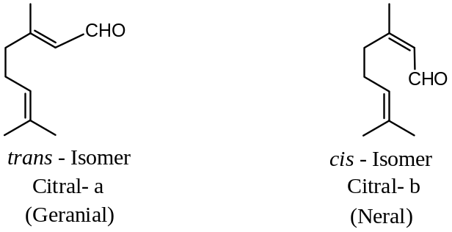
Both the isomers on reduction with sodium & ethanol give the corresponding alcohols, namely geraniol and nerol. Under the influence of an acid catalyst, these alcohols are cyclised by intramolecular addition of alcoholic $–OH$ group to the isolated double bond. Due to the proximity of the $–OH$ group and the isolated $C-C$ double bond in nerol, this alcohol is cyclised about nine times faster than the $trans$ – isomer to form $α$- terpineol.
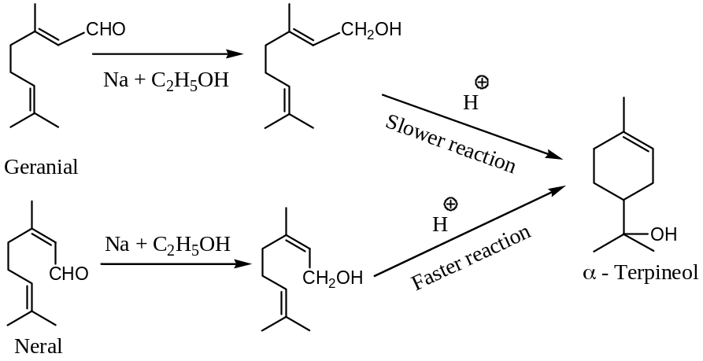

XXXXX#XXXXXX

