Marchantia
- Systematic Position:
• Kingdom-Plantae
• Division-Bryophyta
• Class-Hepaticopsida
• Order-Marchantiales
• Family-Marchantiaceae
• Genus-Marchantia

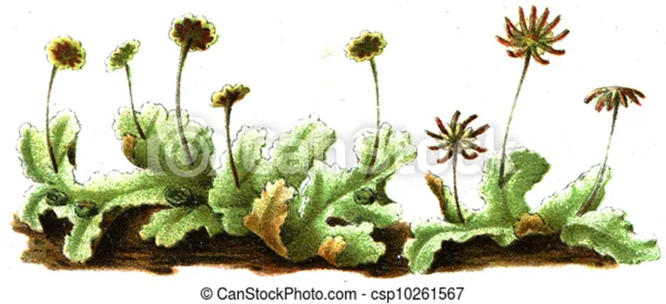

- Habitat and Distribution: • Genus has about 65 species • Grows best in cool, moist and shady places • Marchantia polymorpha grows as a pioneer in burnt forest soil Distribution in India: • 11 species occur in India mainly in western Himalayas • M.polymorpha occurs at high altitudes in Himalayas on moist river banks and rocks • M.palmate occurs in Kashmir, Kumaon, South India, Bengal and Assam • M.simlana occurs in Himachal Pradesh • M.nepalensis in Punjab and in Garhwal & Kumaon hills.

- Gametophyte Morphology:
• Plant body is prostrate, dorsiventral and dichotomously branched

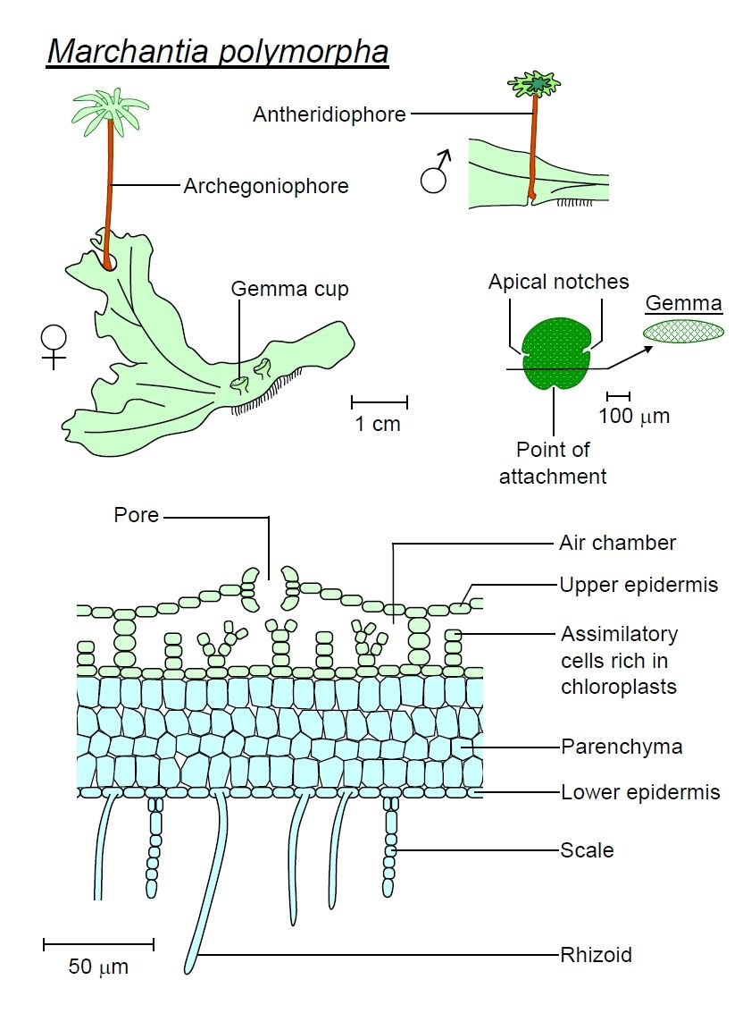
- Dorsal Surface: • A shallow groove marked by the presence of a distinct midrib in each branch • Many polygonal areas which demarcate the outline of underlying air chambers • Each polygonal area has a pore in its centre called air pore • Gemma cups are present along the midrib • Each branch has a growing point situated at the apex in a groove called apical notch

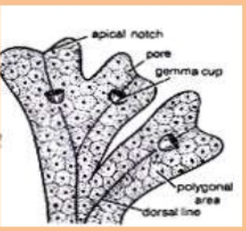

- Ventral Surface: Bears rhizoids and scales along midrib

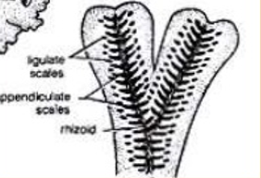
- Rhizoids: • Unicellular and colourless • Two types i. Smooth walled- Inner walls are smooth ii. Tuberculate- Inner walls show papilla like outgrowths • Function– Anchorage and absorption of water and minerals Optical Section
- Scales: • Multicellular (one cell in thickness) and violet coloured due to presence of anthocyanin pigments • Arranged in 2 rows on either side of mid-rib • Two types i. Appendiculate– these have an apical sub-rotund appendage and from inner row of scales ii. Ligulate– these are small, without appendage and form outer row of scales • Function—Protection of growing point and retention of water by capillary action Appendage Appendiculate Scale Ligulate scale.

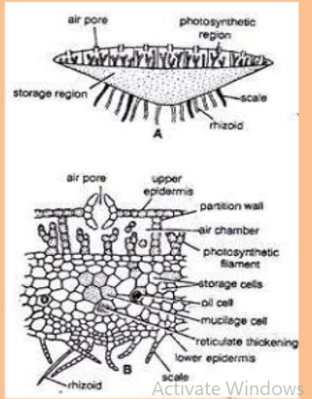
- Anatomy: A cross-section of thallus shows shows 3 distinct regions: (i) Epidermal region (ii) Photosynthetic region (iii) Storage region.
Barrel shaped ¬ Each pore has 4-8 superimposed tiers of cells in the Epidermal Region • Includes upper and lower epidermis • Upper epidermis forms protective covering over photosynthetic region • Has many air pores that open internally into air chambers • Lower epidermis forms lowermost layer of thallus • Cells of lower epidermis give rise to rhizoids ¬ Each tier consist of a ring of 4-5 cells ¬ The cells of lowermost tier project inward giving the pore a star-shaped appearance ¬ Half of tiers project outward and half project inward ¬ The pores have comparatively wide pore passage in the middle than on margins ¬ These are analogous to stomata but they cannot control the pore size like stomata
- Anatomy: Photosynthetic region • Lies below upper epidermis • It consists of large air chambers separated by single layered partition wall • Uniform in shape and are arranged in a horizontal row • Many photosynthetic filaments arise from foot of each chamber • The filaments are made of chloroplast containing cells
- Storage region: • Lies below photosynthetic region • Compact zone of several layers of polygonal parenchymatous cells • Cells devoid of chloroplast and no intercellular spaces in between • Cells contain starch and protein granules • Mucilage and oil containing cells are also present • Storage region thick in the centre and tapers towards the margins • Cells of midrib region are elongated and with reticulate thickenings Anatomy.
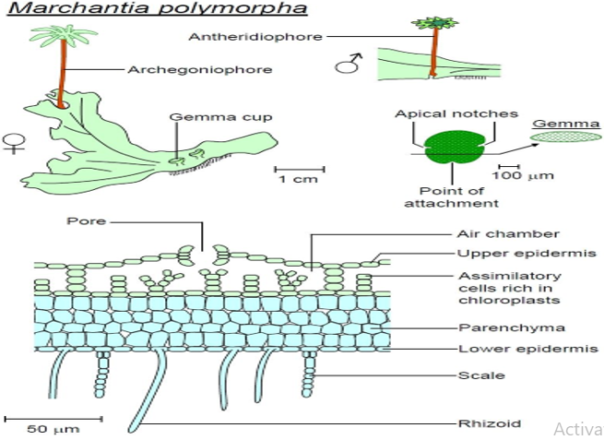
- Reproduction:
Vegetative reproduction:
By progressive death and decay: • Mature cells are present at posterior end and are short-lived • New cells are regularly formed by apical cell • Death and decay therefore naturally starts from the posterior end • As the process of decay reaches the point of dichotomy, two apical parts of thallus separate • Each grows into a new plant.

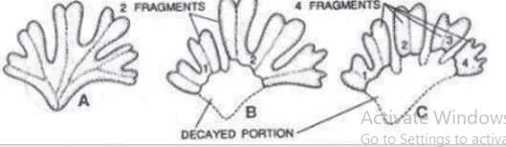
- By adventitious branches: • Some species possess adventitious branches on ventral surface • On separation these grow into new thalli.

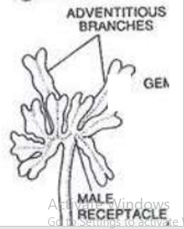

- By Gemma: • Gemma cups (2mm X 3mm) are cupules present on dorsal surface along midrib region • Margins are hyaline, lobed, spiny or entire • From floor of gemma cup many small, stalked, discoid & biconvex gemma arise • Gemma is constricted in middle and 2 notches possess a row of apical cells • Gemma contains chloroplast containing cells and rhizoidal cells • Some mucilage hairs also arise from gemma cup’s floor which imbibe water and help in deispersal of gemmae • Gemmae on coming in contact with ground start germinating immediately
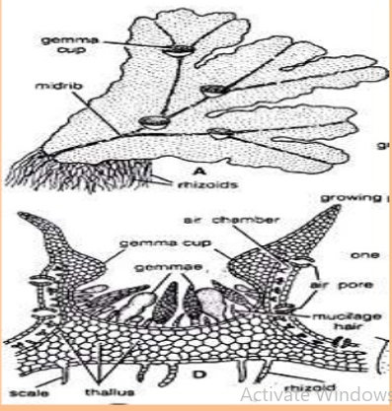
- Sexual Reproduction
• Marchantia is a heterothallic or dioecious plant • Male thallus bears antheridiophores and female thallus bears archegoniophores • They arise from distal end of thallus from growing point and after their formation growth of thallus ceases
- Antheridiophore:
• It has 1-3cm long stalk that bears 8 lobed peltate disc • Inner structure similar to that of thallus with upper epidermis (having air pores), air chambers(having photosynthetic filaments) • Antheridial chambers alternate with air chambers • Each antheridial chamber contains a single antheridium and opens externally by a pore called ostiole. • On each lobe antheridia arise acropetally • Antheridiophore has 2 longitudinal grooves which contain rhizoids and scales.
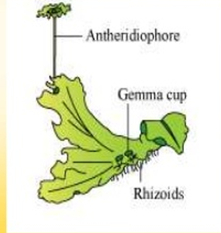
- Antheridium: • A mature antheridium is globular or oval with multicellular stalk • Body of antheridium has a single layered sterile jacket enclosing androcytes which eventually metamorphose into antherozoids • The antherozoid is a minute biflagellate structure Dehiscence of antheridium: • Water enters the antheridial chamber through ostiole • Some cells at the distal end disintegrate when they come in contact with water and hence antheridium ruptures • Antherozoids come out of ostiole like smoke column and spread on surface of antheridial disc.
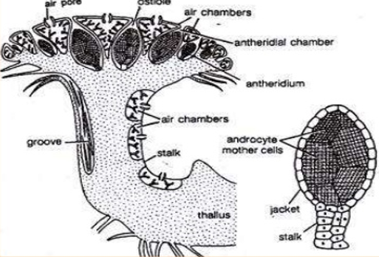
- Archegoniophore:
• It has slightly longer stalk(2-5cm) and a terminal disc which is 8 lobed • Archegonia are borne on dorsal surface in acropetal succession • Internal structure is similar to thallus with upper epidermis having air pores and underlying air chambers.
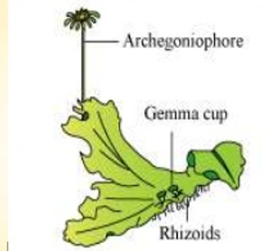
- Archegonium: • The archegonium is a stalked flask shaped structure with a basal swollen venter and an elongated neck • Venter is surrounded by 1 celled thick sterile jacket and contains a large egg cell and relatively small venter canal cell • The neck consists of 6 vertical rows of cells called neck cells which enclose 4-8 neck canal cells • Tip of neck has a rosette of 4 cover cells.

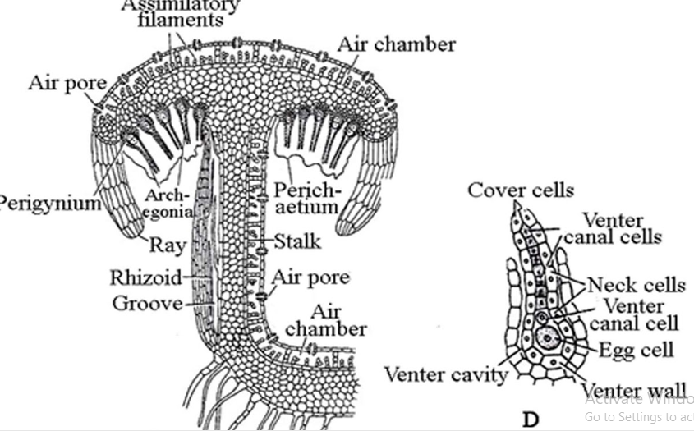

- Fertilization:
• Water is essential for fertilization • Archegonia are placed upright on archegonial disc • Venter canal and neck canal cells degenerate to form a mucilaginous substance which imbibes water and results in sparation of cover cells by pressure • Antherozoid present on surface of antheridial disc are splashed by rain drops on to the surface of archegonial disc • They are attracted chemotactically towards the neck of archegonium • Antherozoids enter archegonium and only one fuses with egg leading to formation of zygote
- Post fertilization events (Inversion of Archegonia):
• After fertilization, archegoniophore elongates accompanied by rapid growth of central part of archegonial disc that leads to inversion of archegonia • The arrangement of archegonia is also reversed from acropetal to basipetal • This process of inversion is accompanied by development of one cell thick tissue called perichaetium or involucre on both sides of each archegonial row • Also long, green, finger-like projections arise from margins of disc known as Rays
- Sporophyte:
• Zygote develops to form sporophyte • It is differentiated into foot, seta and capsule • Foot-It is basal bulbous part which anchors and provides nutrition to sporophyte • Seta-It is short stalk that connects foot to capsule • Capsule-It is yellow coloured oval structure and has a single layered jacket • In young sporophyte, capsule encloses sporogenous mass which differentiate into spore mother cells and elater mother cells.

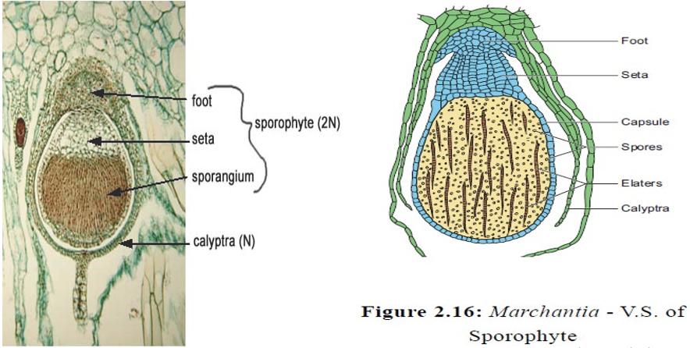

- Sporophyte: • Spore mother cells give rise to spore tetrad by meiosis and elater mother cells give rise to elaters which are diploid and sterile • During the development of sporophyte from zygote, the venter wall cells give rise to 2-3 layered protective covering of sporophyte called calyptra • The basal cells of archegonium give rise to one celled thick collar like outgrowth outside the calyptra called Perigynium or Pseudoperianth • Towards maturity of sporophyte, the seta elongates and pushes the mature capsule out through calyptra, perigynium and perichaetium
- Dehiscence of sporophyte: • Single layered capsule wall splits into a no. of longitudinal valves which extend from apex towards the middle of capsule • The valves are rolled back due to annular thickenings in jacket cells • Jerky movement of elaters due to their hygroscopic nature leads to loosening up of spore mass and scattering of spores in air.
- Germination of Spores: • Spores are viable for about a year • Under favourable conditions they absorb moisture from substratum and increase in size • Chloroplasts reappear at this stage • Spore undergoes repeated divisions to form 6-8 celled filamentous structure with a rhizoid at one end • The apical cell cuts off derivatives on lateral sides and finally give rise to gametophyte.

