alkaloids
Syllabus: Natural occurrence, General structural features, Isolation and their physiological action Hoffmann’s exhaustive methylation, Emde’s modification, Structure elucidation and synthesis of Nicotine. Medicinal importance of Nicotine, Hygrine, Quinine, Morphine, Cocaine, and Reserpine
Alkaloids: —
Contents
- Definition 01
- Theories of Alkaloids 02
- Function of Alkaloids 03
- Nomenclature of Alkaloids 03
- Double Bond Equivalent 03
- General properties of Alkaloids 03
- Extraction of Alkaloids 03
- Classification of Alkaloids 03
- General methods for Determination of Structure of Alkaloids 10
- Determination of Number of $OH$- in Alkaloids 15
- Determination of Number of Carbonyl groups in Alkaloids 15
- Determination of Number of Oxo groups in Alkaloids 15
- Determination of Ester, Amide, Lactone and Lactam ring in Alkaloids 15
- Determination of Number of $–OMe$ Group in Alkaloids (Zeisel Method) 15
- Determination of Methylene $Dioxyl$ Group in Alkaloids 15
- Functional Nature of $N$- in Alkaloids 30
- Herzig-Meyer Method to determine the Functional Nature of $N$- in Alkaloids 30
- Degradation of Alkaloids 35
- Hofmann degradation / Exhaustive Methylation in Alkaloids 36
- Emede Degradation in Alkaloids 36
- $Zn$- Dust Distillation in Alkaloids 36
- Alkali-Fusion, Oxidation in Alkaloids 36
- Emetine 45
- Morphine (Heroine) 50
- Reserpine 55
- Strychnine 60
- Lysergic acid 65
- Colchicines 70
- Solved Questions 80

Alkaloids
Definition of Alkaloids:
Originally the name alkaloid (alkali – like) was given to —
[$1$] All organic bases isolated from plants —
This definition covers an extraordinary wide variety of compounds, and as the study of alkaloids progressed, so the definition changed. Konigs (1880) suggested that an alkaloid should be defined as —
[$2$] Naturally occurring organic bases which contain at least one Pyridine Ring —
This definition however, can be applied to only a limited number of alkaloids, hence was again modified by Ladenburg, who defined alkaloids as —
[$3$] Alkaloids are natural plant (particularly higher plants) compounds having a basic character, and containing at least one $N$- atom in the hetero cyclic ring.
Ladenburg’s definition excludes any synthetic compounds and any compounds obtained from animal sources. Thus even today, it is still difficult to define an alkaloid.
The term “alkaloid” generally limited to organic bases formed in plants. Some chemists specify alkaloids those obtained from plants as Plant Alkaloids or Vegetable Alkaloids. On the whole, alkaloids are very poisonous, but are used medicinally in very small quantities. Thus we find that —
[$4$] The basic properties, usually complex structures, having physiological action and plant origin are the main characteristics which define plant alkaloids.
Even so, the class of compounds known as purines, which possess the above characteristics, are not usually included under the headings of alkaloids, as some purines are also obtained from animal sources.
Shortly, the definition of alkaloids may be proposed as —
The alkaloids may defined as (also the characteristics of alkaloids) —
- Nitrogenous heterocyclic base,
- Have physiological activities,
- They occur in plant kingdom, particularly in higher plants (dicotyl ledouons) and
- Are not widely occurring in nature
Out of the above definitions only (1) & (3) are highly acceptable, though still today, there is not any clear definition of alkaloids. Purines and Pyrimidines are not alkaloids due to above number (4) reason.
Theories of Alkaloids:
- They are the store materials for amino acids ($10-15 \%$),
- They are the growth factor for living species,
- They are the metabolic wastes of plants and
- They are the defence chemicals of many plants.
Alkaloids chemistry was started from 1809, after the synthesis of Morphine (from opium by Serturner). Then by 1810 Gomes synthesised Quinine and Cinchonine. Now-a-days about 200 alkaloids are well known.
Functions of Alkaloids:
The function of alkaloids within the plants is not clearly understood, but it is clear that they are not produced in plants for a single function but for many functions that are summarised as follows —
- They may act as reverse substance to supply nitrogen,
- They may be the end-products of detoxification mechanisms, otherwise their accumulation in plants may cause damage to the plants,
- They may act as poisonous substance which afford plant safety from herbivorous and insects,
- They may function as plants stimulants or regulators similar to the hormones in the activities like growth, metabolism and reproduction, and
- They may act as reservoirs for protein synthesis.
It is interesting to note that $85 –95\%$ plants carry out all their normal activities without involving alkaloids, thus indicating that the function of alkaloids within the plants, if any, is still not understood clearly.
Nomenclature of Alkaloids:
Because of the complex molecular structure and some historical reasons, there is no systematic nomenclature for alkaloids. These are named according to various methods, which are as follows —
- A large number of alkaloids have been named according to the plants from which they are obtained, for example —
Papaverine from Papaver Somenifenum and
Berberine from Berberis Vulgaris
- A few alkaloids are named according to their physiological action. For example —
Morphine (German – morphin – God of dreams)
Narcotine (Greek – narkoo – to benumb) and
Emetine (Greek – emetikos – to vomit)
- Some alkaloids have been named after the name of their discoverer. For example —
Pelletierine group has been named from its discoverer P J Pelletier
- Name of the minor group of alkaloids has been derived by adding one prefix or suffix to the name of principal alkaloids; as for example, cinchona series
- Sometimes, related bases have been named by transpositions as narcotine, cotarnine and tarconine
- Prefixes such as $epi$ - , $iso$ - , $neo$ - , $pseudo$ - , $etc$. or Greek letters have been used to designate isomeric or slightly modified structures. The prefix $nor$- denoted the structure which does not have a methyl group to the $N$- atom.
Double Bond Equivalent, D. B. E.: [Deficiency of Hydrogen Index]
Frequently used in Alkaloid Chemistry in Structure Elucidation:
When the molecular formula of a compound is known, then the probable structure of the compound may be ascertained by the application of DBE, i.e. the number of double bonds or / and rings in the compound to be ascertained. The concept of double bond is widely used in the determination of structure of complex molecules in the elucidation of structure. This method however, gives an idea about the probable structure of the compound as well as the total number of double bond or ring present in the compound. If the general formula of the compound is $C_{a}H_{b}N_{c}O_{d}$, then —
$$DBE=\left(a+1\right)-\frac{b-c}{2}$$
For example —
[$1$] Benzene, $C_{6}H_{6}$
$$DBE=\left(6+1\right)-\frac{6-0}{2}=4$$
$→$ This corresponds to $1$- ring and $3$- double bond in the benzene molecule
[$2$] Allylamine, $C_{3}H_{7}N$
$$DBE=\left(3+1\right)-\frac{7-1}{2}=1$$
$→$ This corresponds to only $1$- double bond in the molecule
In the concept of $DBE$, univalent elements such as halogens may be replaced by $H$- atom and bivalent elements may be ignored (as in above for oxygen).
General properties of Alkaloids:
Some of the general properties of alkaloids are listed below —
- The alkaloids are usually colourless, crystalline, non-volatile, water insoluble solids; but are soluble in organic solvents like ether, ethanol, carbon tetrachloride, etc. Some alkaloids are liquids and water soluble, for example, coniine and nicotine. A few alkaloids are also coloured, for example, berberine is yellow.
- Most of the alkaloids have a bitter test, and are optically active (laevo-rotatory). The optically active alkaloids are very useful for resolving racemic acids.
- Alkaloids are generally tertiary nitrogen compounds and contain one or two $N$- atoms usually in the tertiary state in the ring system. Most of the alkaloids also contain $O$- atom as another hetero atom.
- Alkaloids also yield insoluble precipitation when treated with the solution of phospho-tungestic acid, phospho-molybdic acid, picric acid, potassium mercuric iodide etc. Many of these precipitates have definite crystalline shapes and so may be used to help in the identification of an alkaloid. Some of these reagents also used as a means of detecting in paper and $TLC$.

Extraction or Isolation of Alkaloids:
Alkaloids are usually found in the seeds, roots, leaves or bark of the plants, and generally occur as salt of various plant acids, for example, acetic, oxalic, citric, malic, tartaric acid, etc. A common method of isolation of alkaloids is as follows —
The plant is dried, then finely powdered and extracted with boiling methanol. The solvent is distilled off and the residue is treated with inorganic acids, where upon the bases are extracted as their soluble salts. The free bases are liberated by the addition of sodium carbonate and extracted with various solvents like ether, chloroform, etc. The mixtures of bases thus obtained are separated by various methods into the individual compounds. More recent methods of separation involve the use of chromatography. Lee (1960) has converted plant alkaloids into their reineckates (Reinecke’s solution is $H[Cr(NH_{3})_{2}(SCN)_{4}]$, dissolved these into acetone, and passed these solution through an ion-exchange column, and thereby obtained the alkaloids in a high state of purity. Most of the alkaloids are obtained from natural sources, but a few are also synthesised commercially, for example, ephedrine and papaverine.
Classification of Alkaloids:
There are several methods of classification of Alkaloids, some of these are as follows —
- Taxonomic: This is done according to family. Thus alkaloids may be described as solanceous or papilinaceous without reference to the chemical type of alkaloid present. Since both families contains alkaloids of several types. The disadvantages of the systems are obvious. It is usual to describe alkaloids to the genus in which they occur, e.g. Ephedra, Cinchona, etc.
- Pharmacological: Pharmacological classification lists alkaloids according to their use or pharmacological activities. For example, Analgesic alkaloids, Cardio-active alkaloids, etc. Whereas alkaloids within a group frequently have chemical similarities, this is by no means the rule.
- Biosynthetic: This is more fundamental method than the chemical classification, depending as it does on the types of precursors or building block compounds used by plants to synthesise complex structures. For example, Morphine, Papaverine, Narcotine, Tubo-Curarine and Colchicine may be listed as phenyl-alanine-tyrosine derived bases. This classification also has many disadvantages.
- Chemical: The chemical classification of alkaloids is universally adopted and depends on the fundamental ring structure (frequently hetero-cyclic) present. Thus, Quinine is regarded as a quinoline type, Papaverine as iso-quinoline and Ergometrine and Indole. On the other hand, morphine, which is normally regarded as a Phenanthrene derivative could easily be included in the quinolines; thus to some extent chemical classification depends on the convention adopted.
On the basis of chemical classification, a number of classes of alkaloids are possible, but following are of important —
- Phenyl ethylamine Group: For example, $β$- Phenyl ethylamine, Ephedrine
- Pyrrolidine Group: For example, $β$- Hygrine
- Pyridine and Piperidine Group: For example, Ricinine, Piperine
- Pyridine – Pyrrolidine Group: For example, Nicotine, Atropine
- Quinoline Group: For example, Quinine, Cinchonine
- Iso-Quinoline Group: For example, Papaverine, Berberine, Emetine, Morphine, etc.
- Phenanthrene Group: For example, Morphine, Codeine, Thebaine, etc.
- Indole Group: For example, Ergotamine, Reserpine, etc.
- Tropane Group: For example, Atropine, Cocaine, etc.
- Troplone Group: For example, Colchicines
General methods for Determining Structure of Alkaloids:
Following are the general approach applied sequentially in the elucidation of structures of an Alkaloid —
[1] Molecular formula Determination: After a pure specimen has been obtained, it is subjected to qualitative analysis (invariably the alkaloids contain $C, H \& N$; most alkaloids also contain $O$- as element). This is then followed by quantitative analysis and thus the empirical formula is obtained, determination of the molecular weight finally leads to the molecular formula. If the alkaloid is optically active, its specific rotation is also measured. For the simpler alkaloids of known molecular formula, we can also apply the principle of double bond equivalent, i.e. the number of double bond or/ and ring present in the structure. For the compound of molecular formula, $C_{a}H_{b}N_{c}O_{d}$, then —
$$DBE=\left(a+1\right)-\frac{b-c}{2}$$
[2] Functional Group Analysis: When an alkaloid contains oxygen, the functional nature of this element is determined: it may be present as $–OH(PhOH or ROH$,$-OCH_{3}$, $-OCOCH_{3}$ (acetoxy), $-OCOPh$ (bezoxyl), $-COOH$ or carbonyl group (ketone or aldehyde). Occasionally, lactone ring systems have also been detected / encountered, e.g. in narcotine hydrastine.
($i$) Hydroxyl Group: The presence of $–OH$ group may be ascertained by the action of acetic anhydride, acetyl chloride or benzoyl chloride on the alkaloid to give acetate, or benzoate respectively. These tests are applied carefully as $1^{0}$- amines also respond to the above reagents and yields acetyl and benzoate derivatives.
$$ROH+(CH_{3}CO)_{2}O ⟶ROOCCH_{3}+CH_{3}COOH$$
$$ROH+CH_{3}COCl ⟶ROOCCH_{3}+HCl$$
$$ROH+C_{6}H_{5}COCl ⟶ROOCC_{6}H_{5}+HCl [IL Finar Vil 1, Page 256]$$
[Mechanism:
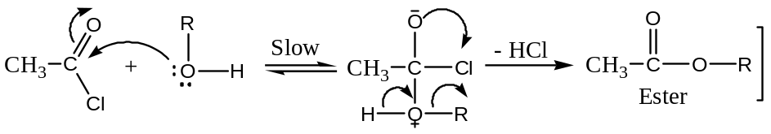
When it has been ascertained that hydroxyl groups are present, then their number is also estimated either by Acetylation or by Zerewitinoff’s active hydrogen determination method (active hydrogen atoms are those which is directly attached to $O, N or S$ - atom)
In Acetylation method, the number of $–OH$ groups is determined by acetylating the alkaloid and hydrolysing the acetyl derivative with a known volume of $1N NaOH$ solution.
$$R-OH\underset{→}{ CH_{3}COCl } R-OCOCH_{3} \underset{→}{ 1N NaOH } ROH+CH_{3}COONa$$
The excess of alkali is estimated by titration with a standard solution of HCl acid. The number of acetyl groups or hydroxyl groups can be calculated from the volume of alkali used for hydrolysis.
Zerewitinoff’s method is the determination of active hydrogen atom (or reactive H – atom) by the double decomposition of the compound with $CH_{3}MgI$, whereby the alkyl group of $CH_{3}MgI$ is converted to hydrocarbon (Methane). Since, the compound containing active hydrogen result in the quantitative yield of methane so can be used to determine the number of active hydrogen in the compound. The methane which is liberated is measured (by volume), one mole of methane being equivalent to one active hydrogen atom. For example —
$$CH_{3}MgI+ROH ⟶CH_{4}+ROMgI$$
$$CH_{3}MgI+RNH_{2} ⟶CH_{4}+RNHMgI\underset{→}{CH_{3}MgI} CH_{4}+RN(MgI)_{2}$$
$$R^{1}R^{2}NH+CH_{3}MgI ⟶CH_{4}+R^{1}R^{2}NHMgI$$
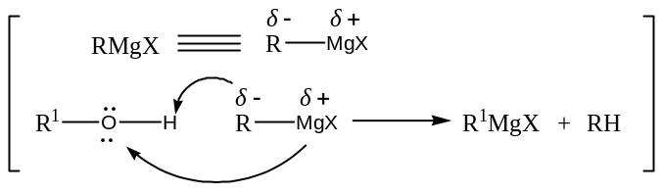
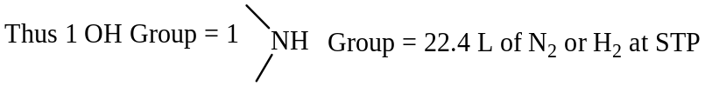
The next problem is to decide whether the hydroxyl group is alcoholic or phenolic. The hydroxyl group is said to be phenolic if the alkaloid is —
- Soluble in $NaOH$,
- Re-precipitated by $CO_{2}$ and
- Gives a colourization with neutral $Fe{Cl}_{3}$ solution.
$$PhOH+NaOH \underset{→}{-H_{2}O }PhO^{-}{Na}^{+}\underset{→}{CO_{2} }PhO^{-}{Na}^{+}+H_{2}{CO}_{3}⟶PhOH+NaH{CO}_{3}$$
Insoluble Soluble Soluble Insoluble
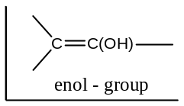Phenol gives coloured water soluble precipitates (Complexes) with neutral $Fe{Cl}_{3}$ solution. This test is also given by the compounds containing “$enol$” group, and distinguishes between a phenol and alcohol.
$$C_{6}H_{5}OH+Fe{Cl}_{3} ⟶[Fe(OC_{6}H_{5})_{3}]^{3-}+3{Cl}^{-}+6H^{+}$$
Violet colour
If the compound does not behave as phenol, the hydroxyl group may be assumed to be alcoholic and this assumption may be verified by the action of dehydrating agents (like $conc H_{2}{SO}_{4}$, $P_{2}O_{5}, etc.$)
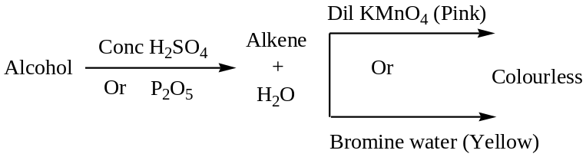
$$CH_{3}-CH_{2}-OH \underset{→}{H_{2}SO_{4} }CH_{2}=CH_{2}+ H_{2}O$$
Mechanism:
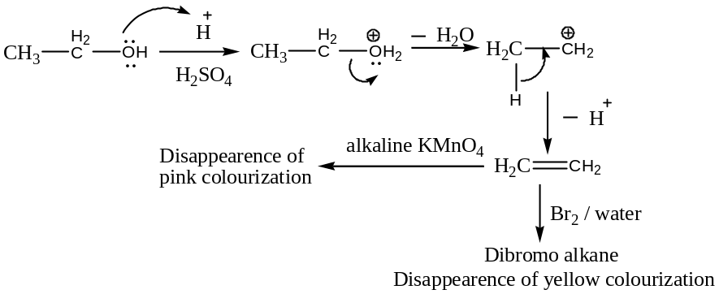
However, to know the exact nature of the alcohol i.e. whether the alcoholic group is primary, secondary or tertiary is determined by the use of an oxidizing agent or by Victor Mayer tests as follows:
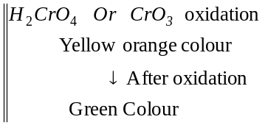Methods of Distinguishing between the $3$- classes of Alcohols:
By Means of Oxidation: The nature of the oxidation products of an alcohol depends on whether alcohol is primary, secondary or tertiary.
Primary alcohol, on oxidation, 1st gives an aldehyde, and this on further oxidation gives an acid. Both the aldehyde and acid contains the same number of $C$- atoms as the original alcohol. For example —
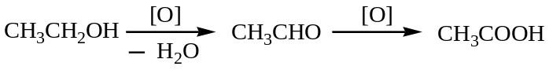
Mechanism with chromic acid:
$$H_{2}CrO_{4} ⇋CrO_{4}^{2-}+2H^{+}$$
$$CrO_{3}+H_{2}O ⇋2H^{+}+CrO_{4}^{2-}$$
Now,
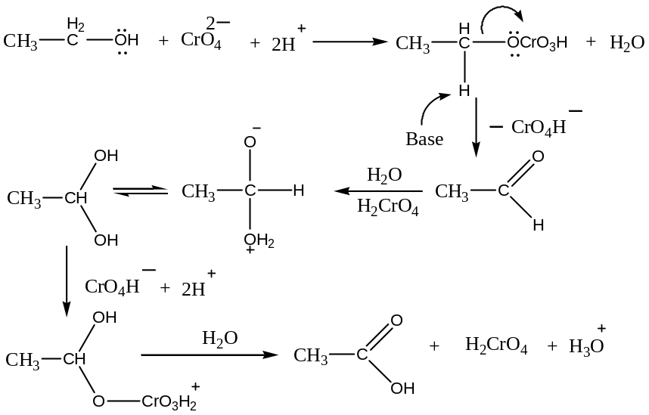
Secondary alcohol, on oxidation, 1st gives a ketone with the same number of $C$- atoms as the original alcohol. Ketones are fairly difficult to oxidise, but on prolonged action of the oxidizing agents produces a mixture of acids, each containing fewer carbon atoms than the original alcohol. For example —
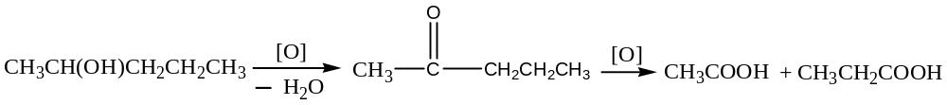Mechanism:
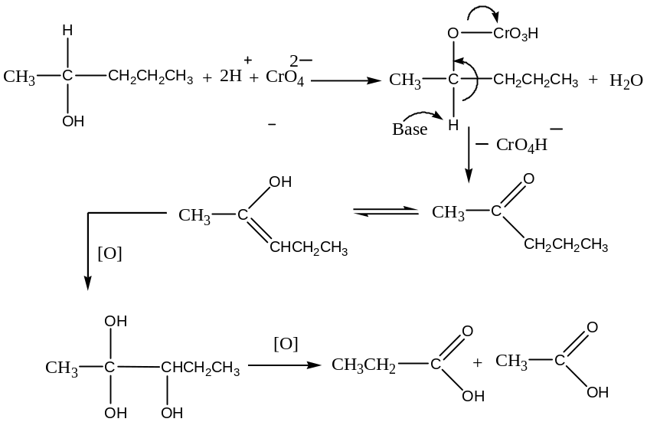
Tertiary alcohols are resistant to oxidation in neutral or alkaline solution, but are readily oxidised by acidic oxidizing agents to a mixture of acids, each containing fewer carbon atoms than the original alcohol. For example —
$$({CH}_{3})_{2}C\left(OH\right)CH_{2}{CH}_{3}\underset{→}{ \left[O\right] } ({CH}_{3})_{2}COH+{CH}_{3}COOH$$
Similarly,
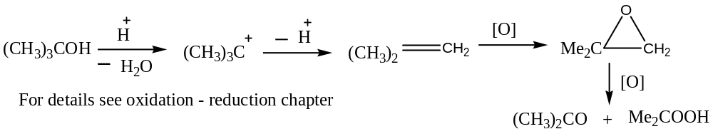 ($ii$) Carboxyl Group: The solubility of the alkaloid in $aq {Na}_{2}CO_{3}$or $NH_{3}$ indicates the presence of carboxylic group. The formation of ester on treatment with an alcohol also indicates the presence of $–COOH$ group.
The number of carboxylic acid group may be determined volumetrically by titration against a standard solution of $Ba(OH)_{2}$, using phenolphthalein as an indicator or gravimetrically by $Ag$- salt method.
$$RCOOH\underset{→}{ aq } RCO_{2}^{-}+H^{+}; {Na}_{2}{CO}_{3} \underset{→}{ aq } NaH{CO}_{3}$$
$$RCOOH+NaH{CO}_{3} ⟶ RCO_{2}^{-}{Na}^{+}+H_{2}O+CO_{2}$$
$$RCOOH+NH_{3} ⟶ RCO_{2}^{-}NH_{4}^{+}$$
For the determination of number of $–COOH$ group, we actually determine the equivalent weight of the compound. Thus, we can determine the basicity of the acid i.e. the number of $–COOH$ group.
$$Basicity=\frac{Molecular weight of the acid}{Equivalent weight of the acid}$$
($iii$) Oxo Group: The presence of an oxo group is readily ascertained by the formation of an oxime, semicarbazone and phenylhydrazone.
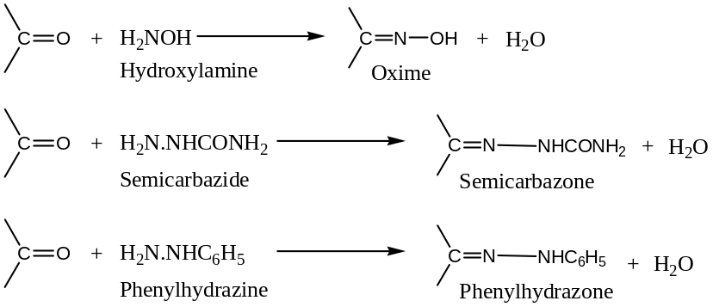
Distinction between Aldehyde & Ketone can be made on the basis of oxidation and reductions —
Aldehydes are very easily oxidized, and hence are powerful reducing agents. Aldehydes reduces Fehling solution (an alkaline solution containing a complex $Cu-tartrate$) to red cuprous oxide, and Tollen’s reagent ($ammoniacal AgNO_{3}$ solution) to $metallic Ag$, etc.
$$RCHO+2Ag(NH_{3})OH ⟶ RCO_{2}NH_{4}+2Ag+3NH_{3}$$
Tollen’s reagent Silver mirror
Aldehydes are readily oxidised by acid dichromate, permanganate, etc. The oxidation with dichromate is believed to proceed by a mechanism similar to that of primary & secondary alcohol. 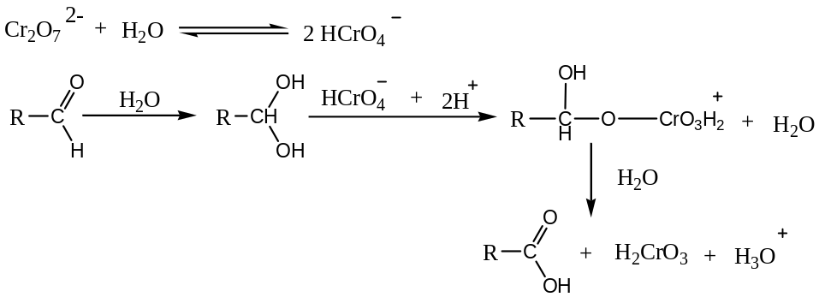
Ketones are not easily oxidised, they do not reduce Fehling solution or Tollen’s reagent.
The presence of an oxo group and distinction between an aldehyde and a ketone may be further confirmed by several physical methods such as $IR$, $UV$- $Vis$ and $NMR$ techniques.
($iv$) Esters, Amide, Lactone and Lactam Groups: These groups can be detected and estimated by observing the products formed by the hydrolysis (acidic or alkaline) of the alkaloid,
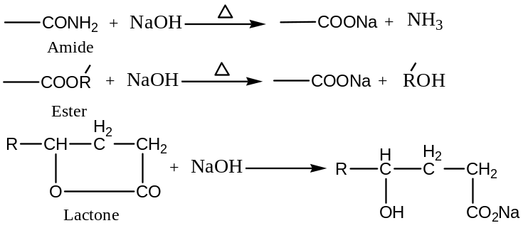
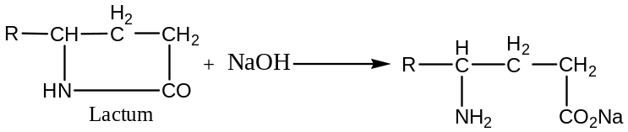
($iv$) Methoxy Group ($-OCH_{3}$): Zeisel Method
The presence of methoxy group and their number may be determined by Zeisel method. The alkaloid is heated with concentrated $HI$ acid at its boiling point ($126℃$), the $-OCH_{3}$ groups are thereby converted to $CH_{3}I$, which is then absorbed by ethanolic $AgNO_{3}$and $AgI$ s weighted. From the weight of $AgI$, the number of $-OCH_{3}$ groups can be calculated.
$$-O-Me+HI ⟶ -OH+MeI\underset{→}{ AgNO_{3} } AgI (ppt)$$
Estimated Gravimetrically
For example, papaverine, ($C_{20}H_{21}NO_{4}$), when treated with $HI$, consumes $4$- moles of $HI$, producing $4$- moles of $AgI$, and thus confirming the presence of $4-OCH_{3}$ groups.
$C_{16}H_{9}N(OCH_{3})_{4}+4HI \underset{→}{ } C_{16}H_{9}N(OH)_{4}+-4CH_{3}I\underset{→}{ 4AgNO_{3} } 4AgI (ppt)$
($vi$) Methylene-dioxyl Group ($-OCH_{2}-O-$): The presence of this group is indicated by the formation of formaldehyde when the alkaloid is heated with HCl or H₂SO₄ acid. Formaldehyde obtained in this reaction is converted into $dimedone$ derivative which can be estimated gravimetrically, thus giving the information about the number of the $-OCH_{2}-O-$ group.
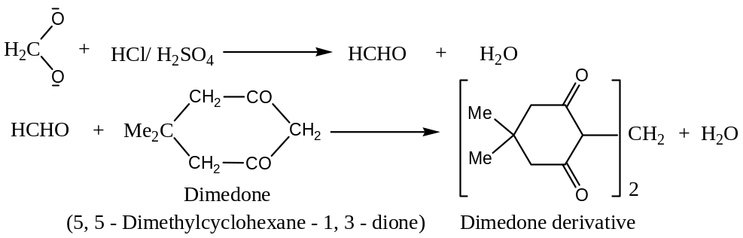
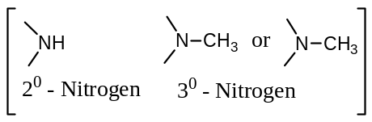[3] The Functional Nature of Nitrogen: All alkaloids contain nitrogen as an element. But in the majority of the alkaloids, it is present as a part of a heterocyclic system. Therefore, it must be either secondary or tertiary. However, there are phenyl alkyl amine types of alkaloids (adrenaline, ephedrine, etc.) which do not contain $N$- as a part of heterocyclic ring, but in the form of a primary amine ($-NH_{2}$) group.
$(i$) The general reactions of the alkaloid with acetic anhydride, methyl iodide and nitrous acid often show the nature of the N – atom. For example, if all reactions are negative, then the $N$- atom is most probably tertiary. The difficulty here is that some alkaloids may undergo ring fission, the product being an $N$- acylated derivative.
If the alkaloid reacts with one molecule of $CH_{3}I$ to form $N$- methyl derivative, it means that a secondary $N$- atom is present. For example, coniine, $C_{8}H_{17}N$ reacts with $1 mol$ of $CH_{3}I$ to form a $–N-{CH}_{3}$ derivative, indicating that coniine must contain a secondary $N$- atom.
$$C_{8}H_{16}NH+CH_{3}I \underset{→}{ } C_{8}H_{16}N-CH_{3}+HI$$
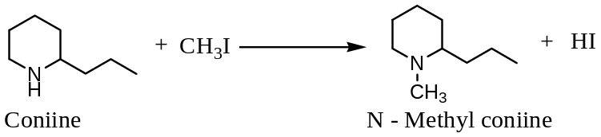
If the alkaloid reacts additively with two molecule of $CH_{3}I$ to form a crystalline quaternary salt, this indicates that $N$- atom present in this alkaloid is tertiary. For example, nicotine reacts additively with two molecules of $CH_{3}I$, indicating that it contains both $N$- atoms as tertiary.
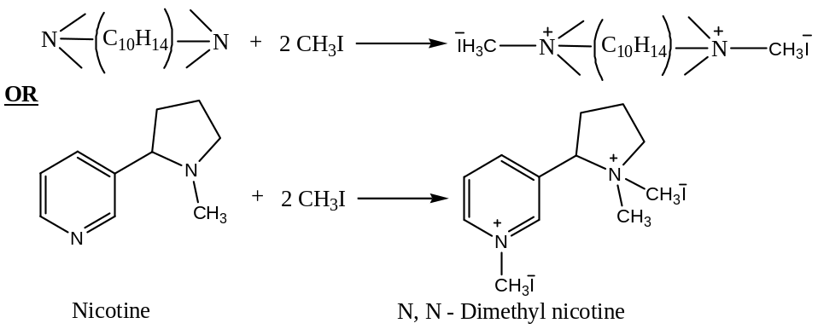
The presence of tertiary $N$- atom in an alkaloid can be detected by treating it with $30\%$ $H_{2}O_{2}$, where by the tertiary $N$- atom is oxidized to amine oxide.
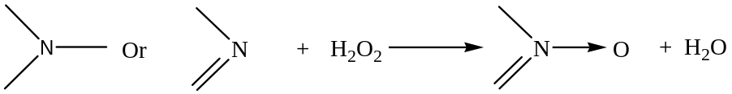
$(ii$) Distillation of an alkaloid with aqueous $KOH$ usually leads to information regarding the nature and number of alkyl groups attached to $N$- atom. The formation of methyl amine, dimethyl amine or trimethyl amine indicates respectively the attachment of one, two or three methyl groups to an $N$- atom, the formation of ammonia shows the presence of an amine group in the alkaloid molecule.
$(iii$) Herzig – Meyer Method: The presence of $N$- methyl group and their number may be determined by means of Herzig-Meyer method — when the alkaloid is heated with $HI$ acid at $150-300℃$ under pressure, $N-CH_{3}$ groups are converted into methyl iodide, which is then absorbed by ethanolic $AgI$ and it is estimated gravimetrically.
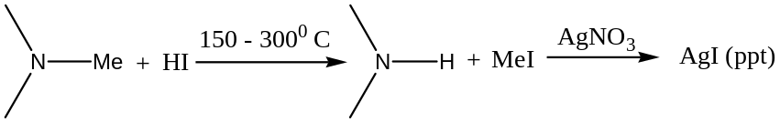
Note: By the same method, $-OCH_{3}$ groups are estimated but the only difference is in the temperature, for $N-CH_{3}$ temperature is $150-300℃$, but for $-OCH_{3}$groups it is $126℃$ .
$(iv$) The result of hydrolysis (by $KOH$) will show the presence of an amide, Lactum or betaine (Betaine → these are trialkyl derivatives of glycine, which exists as dipolar ions of formula $R_{3}N^{+}{CH}_{2}{CO}_{2}^{-}$. Betaine itself is a trimethyl derivative, and may be prepared by heating glycine with $MeI$ in methanolic solution —
$H_{3}N^{+}{CH}_{2}{CO}_{2}^{-}+3MeI ⟶ {Me}_{3}N^{+}{CH}_{2}{CO}_{2}^{-}+ 3HI$
It is more conveniently prepared by warming an aqueous solution of chloroacetic acid with trimethyl amine —
$${\left({CH}_{3}\right)}_{3}N+Cl{CH}_{2}COOH ⟶ {Me}_{3}N^{+}{CH}_{2}{CO}_{2}^{-}+ 3HCl$$
For example, the amide linkage if present shall be indicated by hydrolysis followed by the characterization of acid and amine moieties. For example, alkaline hydrolysis of piperine ($C_{17}H_{19}O_{3}N$), yields piperidine and piperic acid; since, piperidine is a base and piperic acid is a monobasic acid, therefore, piperine is a piperidine amide of piperic acid.
$$C_{17}H_{19}O_{3}N+H_{2}O \underset{→}{ KOH } C_{5}H_{11}N+ C_{12}H_{10}O_{4}$$
Or
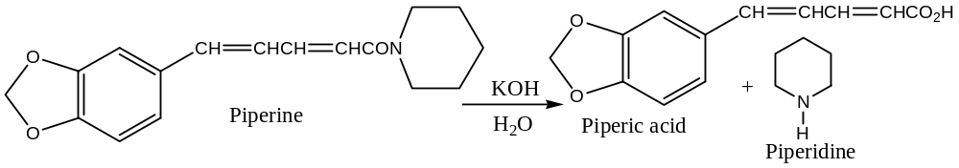
$(v$) The presence of $N$-methyl group is often detected by distillation of alkaloid with soda lime whereby methyl amine is obtained. For example, nicotine on heating with soda lime yields methyl amine, indicating that it must contain an $N$-methyl group.
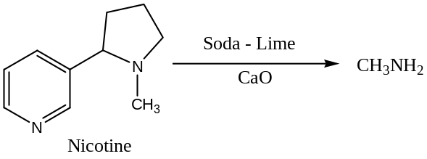
[4] Degradation of Alkaloids: After knowing functional groups or elements present, to know their exact position of these groups we have to degradation of the alkaloid and identification of each fragment. Thus degradation is the most important part in the alkaloid chemistry to know the actual structure of the alkaloid. Most of the reactions used in such work are as follows —
- Hofmann’s Exhaustive Methylation Method,
- Emde’s Degradation,
- Von Braun’s Method,
- Reductive Degradation and 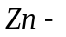 Dust Distillation,
- Alkali Fusion,
- Oxidation, and
- Dehydrogenation
Hofmann’s Exhaustive Methylation Method (1883):
This is the most important process in the alkaloid chemistry. In this process heterocyclic rings are opened with the elimination of nitrogen, and thereby the nature of the $C$- skeleton is thereby confirmed. The general procedure is to hydrogenate (by catalytic hydrogenation: $H_{2}/Ni,∆$) the heterocyclic ring (if this is unsaturated), convert this compound to the quaternary methyl ammonium hydroxide (reaction with 1) $MeI$, 2$) AgOH$) which is then heated ($200℃$). In this last step (heating step) a molecule of water is eliminated, an $H$- atom in the $β$- position w.r.t. to the $N$- atom combining with the hydroxyl group, and the ring is opened at the $N$- atom on the same side as the $β$-$H$- atom eliminated. The process is repeated on the product produced; this results in the complete removal of the $N$- atom from the molecule, leaving an unsaturated hydrocarbon, which, in general, isomerise to a conjugated diene. For example, pyridine gives piperylene [the principle of this method is that compound which contains the structural unit —
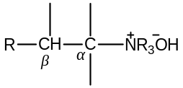
This eliminates a trialkyl amine on pyrolysis at $200℃$ or above to yield an olefin.
$$R-CH_{2}-CH_{2}-N^{+}R_{3}{OH}^{-} \underset{→}{ } R-CH=CH_{2}+ NR_{3}+H_{2}O]$$
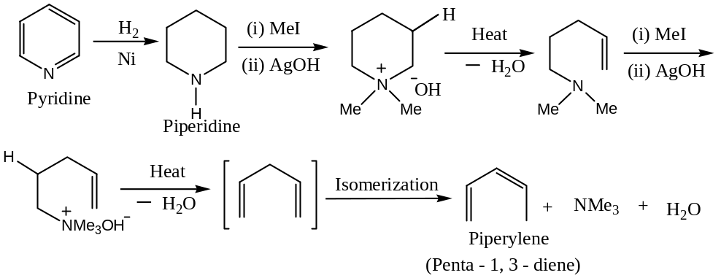
This reaction is generally proceeds by an $E_{2}$- mechanism in which the requisite $β$- hydrogen and quaternary $N$- group are present in the $trans$- $anti$-parallel configuration.
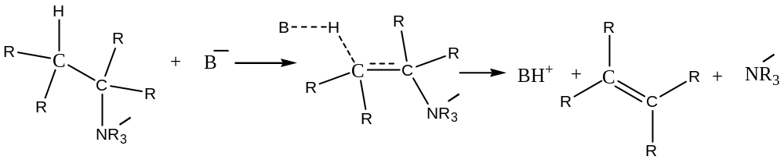
Although the general procedure for exhaustive Methylation is to heat the quaternary hydroxide at about $200℃$, in a number of cases the reaction may be carried out by refluxing an aqueous or ethanolic solution of $KOH$ containing the methyl iodide or methyl sulphate as the base. This procedure is usually satisfactory for the bases which contain benzene ring in the $β$- position to the $N$- atom. This is explained on the basis that benzilic hydrogen has an increased acidity (and so is more readily removed) because of stabilization of the transition state by conjugation (with the benzene ring).
For example, hordenine methyl ether yields $p$- methoxy styrene
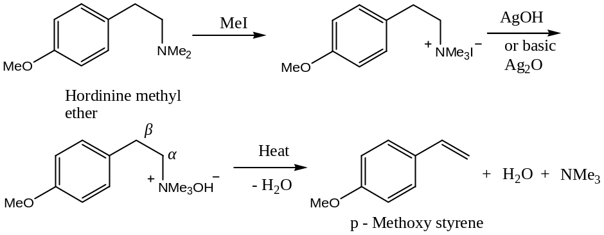
If the ring incorporates the 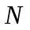 – atom, two complete sequences are to be carried out to eliminate it from the molecule. For example, laudanosine is converted into a styrene derivative (or stilbine derivative) as follows —
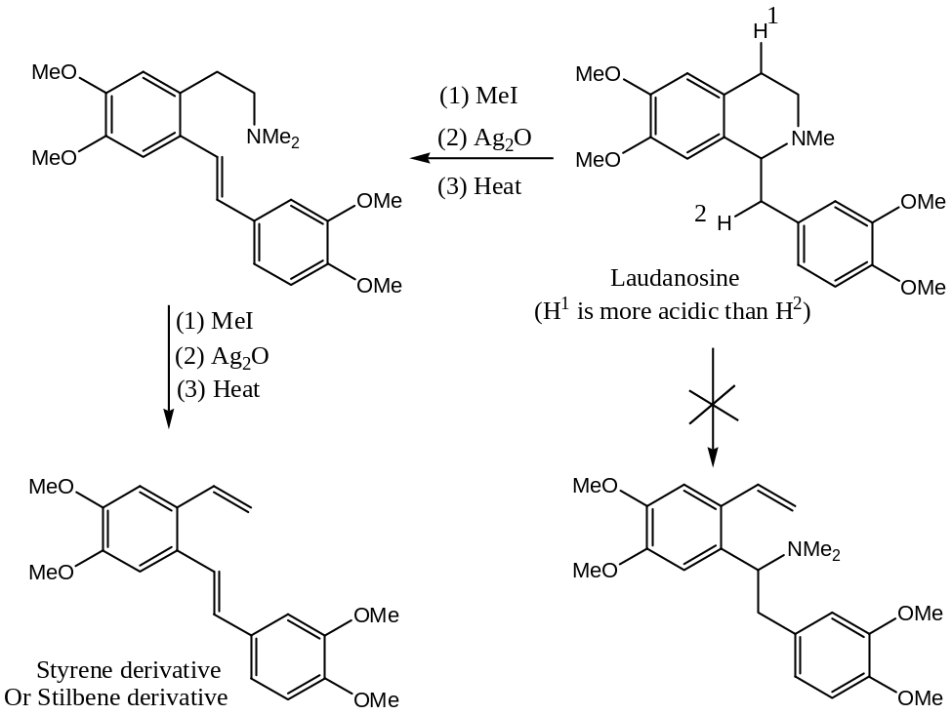
Hofmann’s Exhaustive Methylation fails —
- With unsaturated heterocyclic rings
- When there is no $β$-$H$- atom and
- With tetrahydroquinoline.
For example, with quinoline (unsaturated heterocyclic ring) —
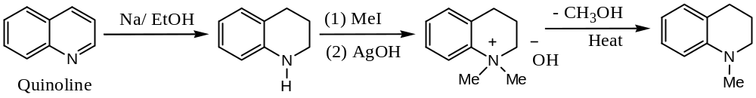
Even though compound containing a $β$-$H$- atom, the exhaustive methylation method may fail, for example, with tetrahydroquinoline —
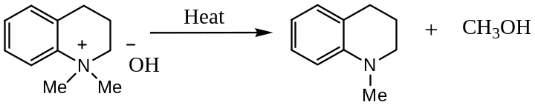
When more than one sequence is required for eliminating the nitrogen atom, the overall process is sometimes known as the exhaustive methylation and it is generally convenient in practice to hydrogenate the olefin formed after each elimination step, thus removing the possibility of double bond isomerism under the basic reaction condition.
Emde’s Degradation:
When the base (alkaloid) does not contain a $β$-$H$- atom, Hofmann’s exhaustive methylation is failed and we use Emde degradation method. In this method the final step involves the reductive cleavage of the quaternary ammonium salt (generally halide), by $Na—Hg$ in aqueous ethanol or with $Na$ with liquid ammonia, or is catalytically hydrogenated.
$$R-CH_{2}-N^{+}R_{3}X^{-} \underset{→}{ } R-CH_{3}+ R_{3}N^{+}HX^{-}$$
Emde method can be explained by considering the case of isoquinoline,
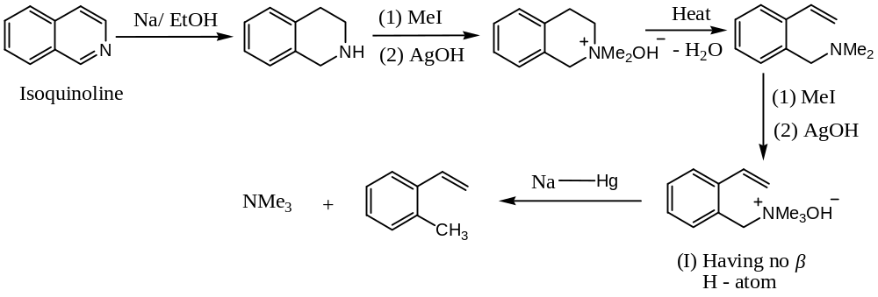
Hofmann’s exhaustive methylation cannot be applied to the above compound (I), because it does not contain $β$-$H$- atom.
It has been seen earlier that exhaustive methylation fails with tetrahydroquinoline; however, the heterocyclic ring in this compound (tetrahydroquinoline) is opened by Emde degradation.
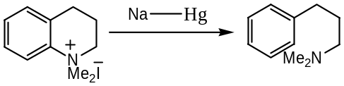
The Emde degradation on tetrahydroquinoline is also interesting —
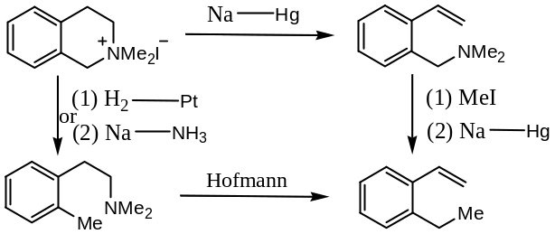
Occasionally, successive Emde degradation have been employed as a means of eliminating a $N$- atom from an alkaloid but where possible the preferred sequence is Hofmann followed by Emde reaction.
Von Braun’s Method: This method is of two types —
Type I: In the first method, the tertiary amine, which contains at least one alkyl substituent, is treated with $BrCN$ (cyanogens bromide). This results in cleavage of an alkyl-nitrogen bond to give an alkyl halide and a substituted cyanamide.
$$R_{3}N+CN-Br \underset{→}{ } R-Br+ R_{2}N-CN$$
Fission of unsymmetrical substituted amines generally takes place to yield the alkyl halide derived from the smallest alkyl substituent.
$${Et}_{2}NMe+CN-Br \underset{→}{ } Me-Br+ {Et}_{2}N-CN$$
Now we will apply Von Braun’s method to $3^{0}$ - cyclic amines —
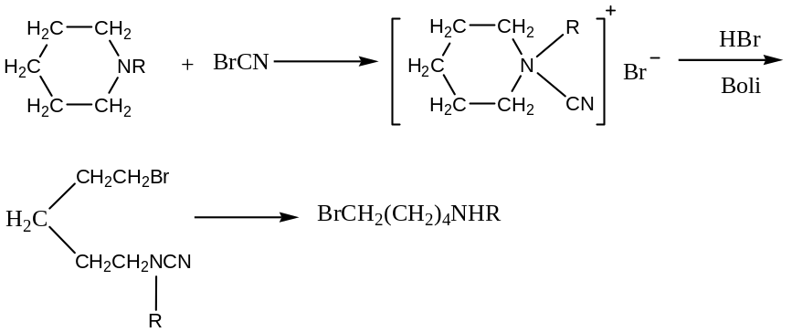
Von Braun’s cyanogen method is often applicable to such compounds which do not responds to Hofmann’s method. Furthermore, where both methods are applicable ring opening occurs at different points of the ring. For example —
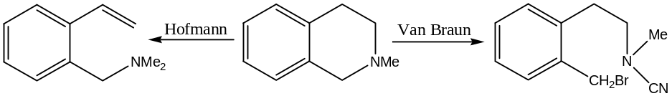
In the above examples, ring is opened, however, in either cases de-alkylation takes place with the formation of the cyclic $N$- cyano derivative. For example, with cocaine —
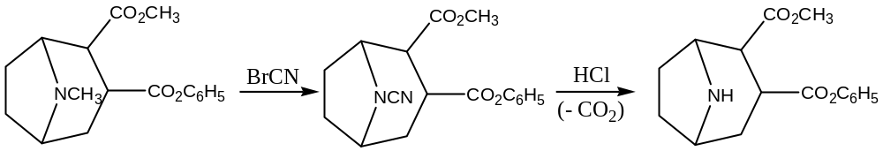
Hydrolysis of the cyano compound with hydrochloric acid brings about the following change:
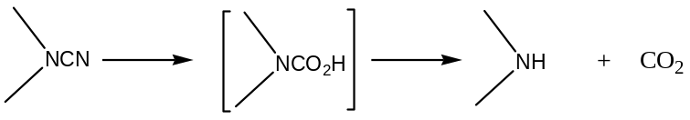
Thus, the final result is the removal of the $N$- methyl group without opening the ring.
Type II: Von Braun’s method for 2⁰ – cyclic amines: In this method cyclic amines are treated with benzoyl chloride in presence of $NaOH$ to yield benzoyl derivative, which on treatment with $P{Br}_{5}$ followed by distillation under reduced pressure yields an $α, ω$- dihalo compound with the elimination of benzonitrile. For example, with piperidine —
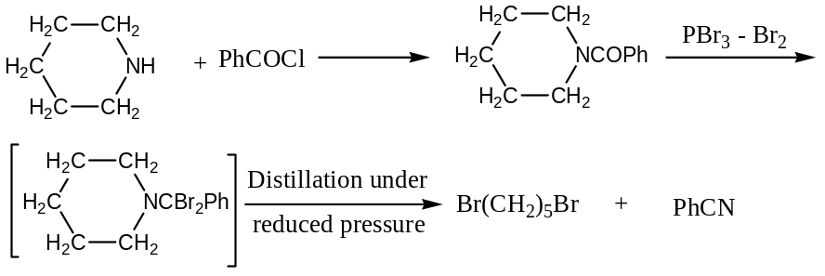
In a number of cases ring may be opened by heating with HI at $300℃$, for example —
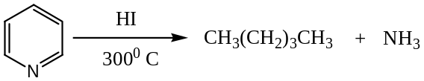
Reductive Degradation and $Zn$- Dust Distillation:
This usually gives the same compound or relatively smaller fragments, except that when the alkaloid contains oxygen. This is removed or dehydrogenated, for example —
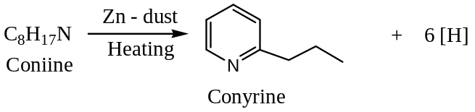
As conyrine is formed by the loss of six –H – atoms, it means that coniine must contain a piperidine ring.
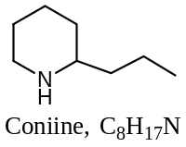
Alkali Fusion: This is a very drastic method which is often employed to break down the complex alkaloid molecule into simpler fragments, the nature of which gives information on the type of nuclei present in the alkaloid molecule. For example, adrenaline when fused with solid $KOH$ yields protocatechuic acid, indicating that adrenaline is a catechol derivative.
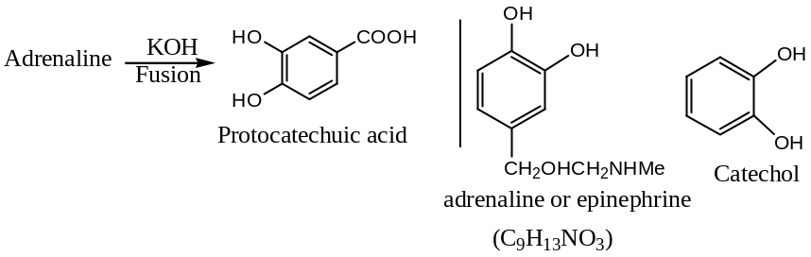
Similarly, papaverine on fusion with alkali yields an isoquinoline, indicating that papaverine must contain an isoquinoline unit. Also cinchonine when fused with alkali yields quinoline, showing the presence of quinoline nucleus in cinchonine.
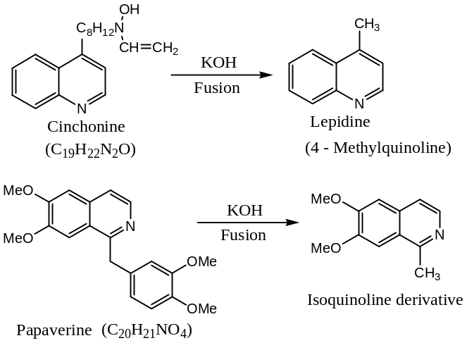
Oxidation: Oxidation is one of the most valuable means of determining the structure of alkaloids. By varying the “strength” of the oxidising agent, it is possible to obtain a variety of products —
- For mild oxidation, usually $H_{2}O_{2}, O_{3}, I_{2}/ EtOH$, or alkaline potassium ferricyanide, $K_{3}[Fe(CN)_{6}]$ are used.
- Moderate oxidation may be carried out by means of acidic or alkaline $KMnO_{4} or CrO_{3}$ in ethanol.
- Vigorous oxidation is usually carried out by $K_{2}{Cr}_{2}O_{7} in H_{2}SO_{4}$.
These reagents usually brake up an alkaloid into smaller fragments whose structures are either known or can be readily ascertained. For example, considering nicotine —
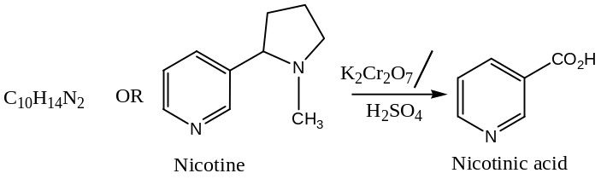
From the above reaction it can be concluded that nicotine contains a pyridine nucleus having a side chain at $β$- position.
The above classification of oxidizing agents is not rigid because the “strength” of an oxidizing agent depends to some extent on the nature of the alkaloid which is being oxidized.
In some cases where it can be done, better results are sometimes achieved by first dehydrating the compound and then oxidizing the unsaturated compound, thus obtained, oxidation is readily affected on a double bond. More recently, mercury acetate has been used to dehydrogenate certain alkaloids, thereby introducing olefinic bonds.
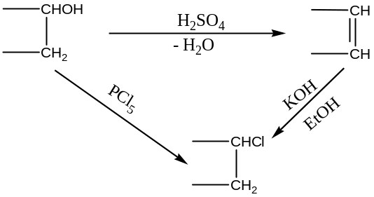
Dehydrogenation: When an alkaloid is distilled with a catalyst such as $S, Se, or Pd$, dehydrogenation takes place to form relatively simple and easily recognizable products which provide a clue to the gross fragments obtained during degradation, there occurs the elimination of peripheral groups such as hydroxyl or $C$- methyl.
[$1$] Unsaturation: The presence of unsaturation in an alkaloid may be ascertained by the addition of Br₂ or HX – acids or by the ability of hydroxylation with dilute alkaline $KMnO_{4}$. Reduction by means of $Na-Hg, Na-EtOH, Sn-HCl, HI$ acid etc. also may be used to show the presence of unsaturation. In some cases reduction may decompose the molecule. This often happens, when the catalytic reduction is employed (ring cleavage also occurs), and hence milder methods of reduction are desirable. Two particularly mild reducing agents are $LiAlH_{4} \& NaBH_{4}$. $Na$ in liquid ammonia gives the Emde type of degradations.
[$2$] Physical Methods: Physical methods are now being used, in conjugation with chemical methods, to elucidate structure more easily. In alkaloid chemistry, the most important instrumental methods widely used are —
- UV – Visible Spectroscopy,
- IR Spectroscopy,
- NMR Spectroscopy,
- Mass Spectroscopy,
- Optical Rotatory Dispersion (ORD),
- Conformational Analysis, and
- X – Ray Diffraction
[$3$] Synthesis: The structure of the alkaloid arrived at by the exclusive analytical evidence based on the foregoing methods is only tentative. The final confirmation of the structure must be done by the unambiguous synthesis.
Briefly: General methods for Determining Structure of Alkaloids: Outline of the general methods employed for the determination of the Structure of Alkaloids:
Following are the methods employed for the determination of the structure of alkaloids:
Step I: The molecular formula is determined by the usual methods viz. elemental analysis and knowing molecular ion peak from mass spectroscopy.
Step II: Nature of the functional groups is also established by common chemical tests and analytical methods.
Alkaloids contain basic nitrogen (only with few exceptions) and almost always oxygen as the other heteroatom. Oxygen atom(s) may be present as alcoholic $OH$, phenolic $OH$, carboxylic acid, amidic, lactone, ketones and only in few cases as aldehydic ethers, cyclic ethers and so on. Common routine tests are performed to detect the presence of these functionalities in alkaloid molecules. $N$- atom is almost always basic — as a $2^{0} or 3^{0}$- base. $1^{0}$- Amino groups do not occur because of its easy methylation in plants. Often tertiary $N-CH_{3}$ group is present, which can be detected and estimated by Herzig-Mayer’s method by heating the compound with $HI$ and then and then trapping the evolved $CH_{3}I$ in alcoholic $AgNO_{3}$to get quantitative precipitation of $AgI$. Occasionally, methylene-dioxy group of cyclic ethers is detected by the formation of $CH_{2}{Cl}_{2}$ on heating the compound with $conc HCl$.
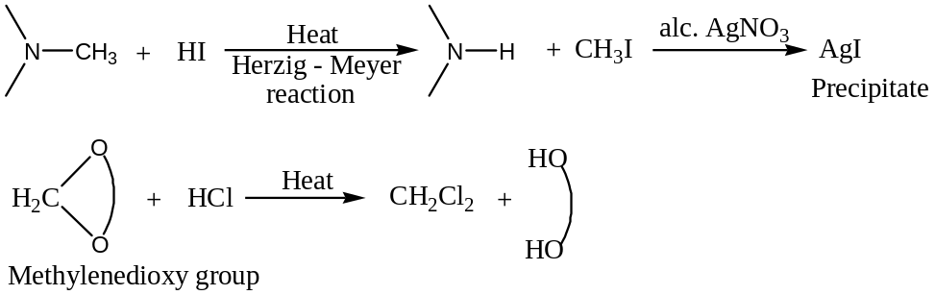
Many alkaloids contain a methoxy group that is detected and estimated by Zeisel’s method in heating the compound with $HI$ and then trapping the evolved $CH_{3}I$ in alcoholic $AgNO_{3}$ to obtain the precipitate of $AgI$ quantitatively.
$$R-CH_{3}+HI ⟶ ROH+ CH_{3}I \underset{→}{ alc. AgNO_{3}}AgI (ppt)$$
Presence of $C-C$ double bond can be established by the addition reaction with $H_{2},{Br}_{2},{Cl}_{2}$ and so on. Ester and amide functions are detected by hydrolytic reactions.
Modern day analytical techniques can establish the presence of functional groups of alkaloids by various spectroscopic methods. These analytical methods, unlike chemical methods, are non-destructive in nature (except mass spectrometry) where the valuable materials are not lost in the tests. Today chemist can establish the structure of a compound from a few milligrams of the pure sample by judicious application of the spectroscopic methods, which could not even be thought of $50 years$.
Step III: After establishing the nature and the number of the functional groups, the location of these groups in the carbon framework is determined. The nature of the carbon framework and the hetero ring(s) is generally established by the degradation of the $N$-containing ring(s) into simpler compounds, and identification of these degradation products helps to establish the nature of the hetero ring and the carbon framework of the alkaloid molecule. Hofmann’s elimination reaction is widely used in such degradation reactions. Each Hofmann’s elimination in a molecule breaks one $C-N$ bond and introduces a $C-C$ double bond on the same side of the $C-N$ bond, which is broken in the hetero ring. For example —
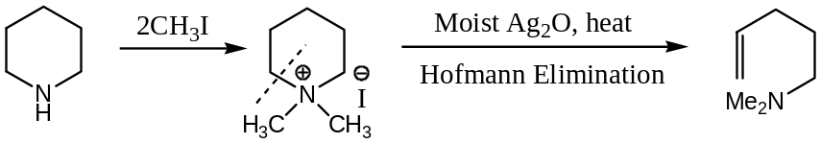
So, if two successive Hofmann eliminations expel the ring $–N$, then the $N$- atom is present in one ring. If three successive Hofmann eliminations are necessary to expel the $N$- atom, then the $N$- atom is common to the two rings. For example —
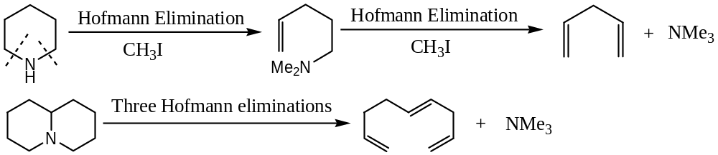
The $C-C$ double bond introduced by Hofmann elimination can further be degraded by oxidative methods to simpler products.
Presence of $C-C$ double bond, $2^{0}$- alcoholic $OH$ group or carbonyl group in the molecule is encouraging to perform the oxidative degradations at theses functional groups (like terpenes). Often $Zn$- dust distillation method is employed to obtain a stable simple known compound.
Step IV: The structure proposed from the above analytical evidences is usually confirmed by an unambiguous synthesis of the compound. In modern day structure elucidation methods, $X$- ray analysis is very convenient to establish the final structure of the molecule as this technique literally lakes the ‘image’ of the molecule showing the relative positions of all the atoms constituting the molecule.
Structure of Nicotine:
Nicotine is the tobacco alkaloid and does not occur in free-state in the tobacco leaves. It is isolated by liberating the base from its malic or citric acid salt with lime followed by the steam distillation of the resulting mass. It is an optically active, levorotatory liquid having a very high boiling point ($bp=246-47℃$) and one of the rare water-soluble alkaloids.
Structure —
- Molecular formula $C_{10}H_{14}N_{2}$
- Nature of the functional groups —
It absorbs three moles of $CH_{3}I$ to form a diquaternary salt, which shows that of the two $N$- atoms one is a $2^{0}$- amine and the other is a $3^{0}$- amine. It does not contain any $C-C$ double bond to undergo ready electrophilic addition with ${Br}_{2} or {Cl}_{2}$.
- 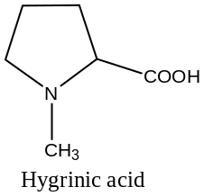The $C$- framework and ring systems —
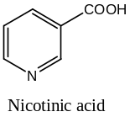 Nicotine on treatment with one mole of $HI$ forms a hydroiodide that is quaternized with one mole of $CH_{3}I$. This salt on oxidation with a mild oxidant like potassium ferricyanide, $K_{3}[Fe(CN)_{6}]$ followed by an oxidation with a strong oxidant like chromic acid, $CrO_{3}$ fives a known compound hygrinic acid.
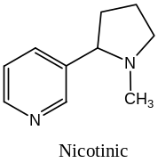 This shows the presence of a pyrrolidine ring in the molecule. Nicotine itself on drastic oxidation forms $pyridine$-$3$-$carboxylic acid$ (nicotinic acid). This shows that nicotine contains a $β$- substituted pyridine ring.
On the basis of above analytical evidences, the nicotine can be proposed to have the structure as shown below:
- An unambiguous synthesis of nicotine supports the proposed structure. Craig’s synthesis of nicotine consists of the following steps —
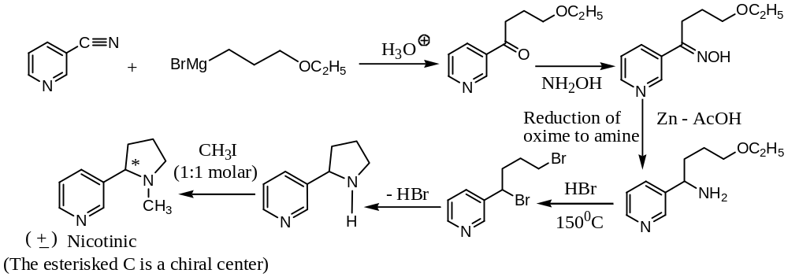

XXXXX#XXXXXX

