heterocyclic compounds
Definition of Heterocyclic Compounds —
Any cyclic organic compounds in which there is at least one atom other than $C$- atom, is called hetero atom, among others which constitute the ring is called heterocyclic compound. According to this definition of heterocyclic compound ethylene oxide, succinic oxide, phthalic anhydride, etc. may be classified under the name of heterocyclic compound; but their most of the properties are so similar to either aliphatic or aromatic compounds.
Following are the heterocyclic compounds which we have to study in details —
[1] Three $5$- membered rings containing one hetero atom —
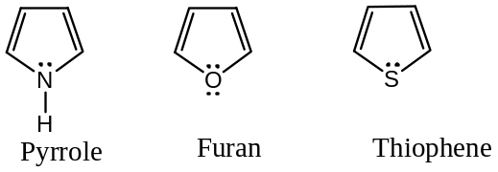
[2] One $6$- membered ring containing one hetero atom —
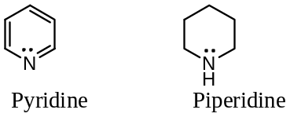
[3] Two fused ring systems —
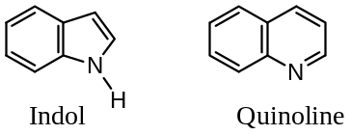
Aromatic Character of $5$- membered Heterocyclic Compounds:
The aromatic character of furan, pyrrole and thiophene arises from the delocalization of four carbon $π$- electrons and two paired electrons donated by the hetero atom ($O, N or S$), thus forming a sextet of electrons which is the characteristic of the aromatic systems. In terms of molecular orbitals, these heterocycles are planar with $sp^{2}$- hybridized $C$- atoms. This arrangement leaves each of the four $C$- atoms with a $p$- orbital which overlaps with a doubly filled $p$- orbitals of the hetero atom resulting in the formation of $π$- cloud above and below the plane of the ring. Since there are six electrons ($4q+2$) in these systems, they are aromatic in character. The above discussion may be illustrated by having a look at the orbital picture of one of these molecules. For example, with pyrrole —
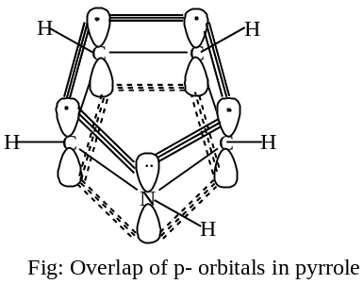
The structure of these heterocycles can also be visualised in terms of valence bond description where these molecules are considered as resonance hybrid of the following contributing structures —
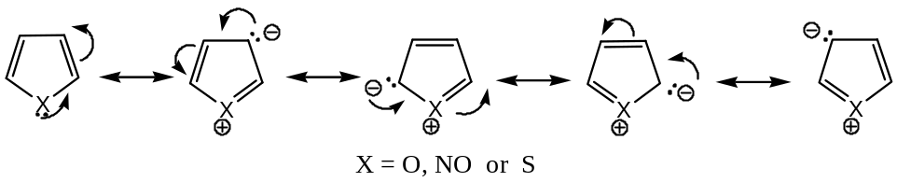
Note: The above explanation can be also proposed as follows —
In all $5$- membered heterocyclic compounds there are two $C-C$ double bonds, which accounts for the $4π$- electrons to complete the aromatic sextet, the other two electrons are donated by the hetero atoms, because $N, S or O$ contain a lone pair of electrons. Thus, the aromatic sextet is completed. Moreover, a number of resonating structures can be drawn by such a heterocyclic compound. This accounts for their unusual stability. In many reactions, they show complete aromatic character.
Importance of Heterocyclic Compounds in Chemistry:
IUPAC/ Systematic Nomenclature of Heterocyclic Compounds:
[$A$] Saturated Heterocyclic Compounds: For saturated heterocyclic compounds, three-part names are recommended —
($a$) The hetero atom — $az=Nitrogen, ox=Oxygen and thi=Sulphur$
($b$) The ring size — $ir=3, from tri, et=4, from tetra, ole=5, nothing for 6 (ine)$
$$ep=7, from hepta, oc=8, from octa,$$
($c$) The degree of Saturation—$ene or ine$ for unsaturated and $idine or ane$ for saturated
For example —
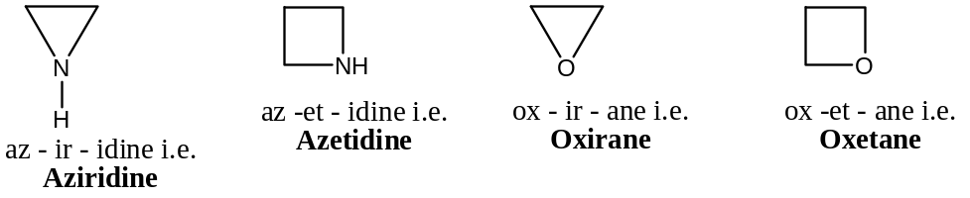
Some popularly used common names —
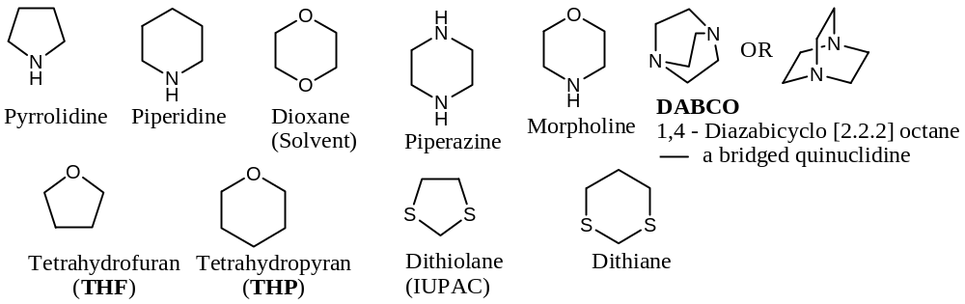
[$B$] Aromatic Heterocyclic Compounds: For aromatic heterocyclic compounds, the ending is — “$ole$” in systematic system and refers to a $5$- membered heterocyclic ring. All the $5$-membered aromatic heterocycles with nitrogen in the ring are sometimes called “the azoles”. Strictly speaking, pyrrole is “azole”, pyrazole is $1,2$- diazole, and imidazole is $1,3$- diazole.
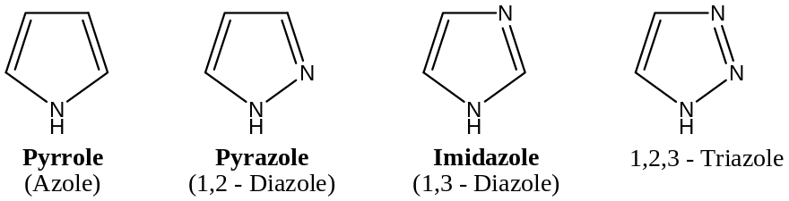
These $IUPAC$ names are not used, except oxazole and thiazole are used for $O \& S$- analogues of imidazole.
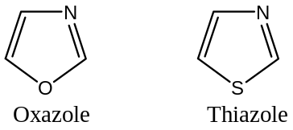
[$C$] Numbering the Ring: For numbering mono heterocyclic compounds, numbering is given in such a way that the heteroatom gets the lowest number and proceeds in anticlockwise round the ring. When hetero atoms different, we follow priority rule ($aza →N, oxa →O, and thia→S$).
However, in common systems, Greek letters ($α, β, γ$) denote the position of the substituents. For example, —
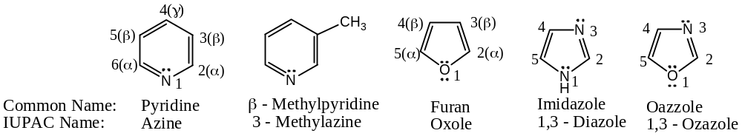
The radicals derived from pyrrole, furan and thiophene by the replacement of one $H$- atom are named as pyrryl-, furyl- and thienyl- respectively. The position of $H$- replaced is indicated by the number assigned to that carbon. For example, —
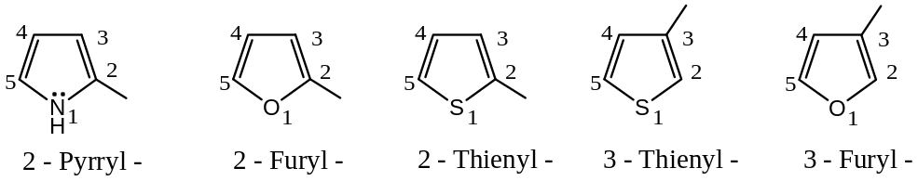
Exception: ‘$N$’ does not get the lowest number in isoquinoline, here the numbering is followed in accordance with quinoline structure, as shown below —
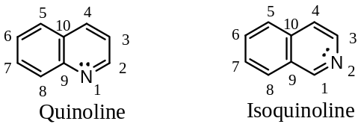
%%%%%%%%%%%%%%%%%%%

Five-Membered Heterocycles — Containing Single Hetero Atom
Examples are — Pyrrole, Furan and Thiophene
These three are the simplest $5$- membered heterocycles
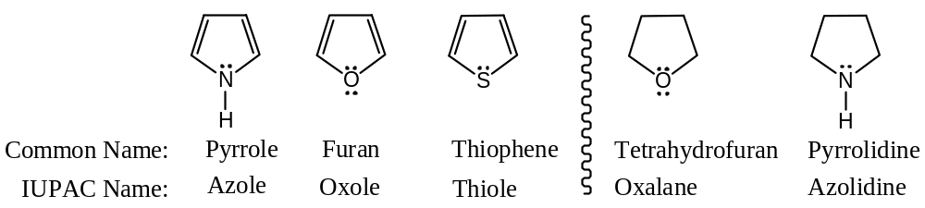
Pyrrole occurs in coal-tar, whereas furan is present in pine wood. Thiophene occurs in coal-tar and shale oil. Naturally, occurring compounds, like chlorophyll, haemin, cyanocobalamine (vitamin $B$- 12), auxins, alkaloids, etc. contain pyrrole ring system.
General method of Synthesis of Pyrrole, Furan and Thiophene —
Paal-Knorr Synthesis —
A general synthesis for pyrrole, furan and thiophene derivatives can be achieved from $1,4$- dicarbonyl compounds, as outlined below and the procedure id called Paal-Knorr synthesis.
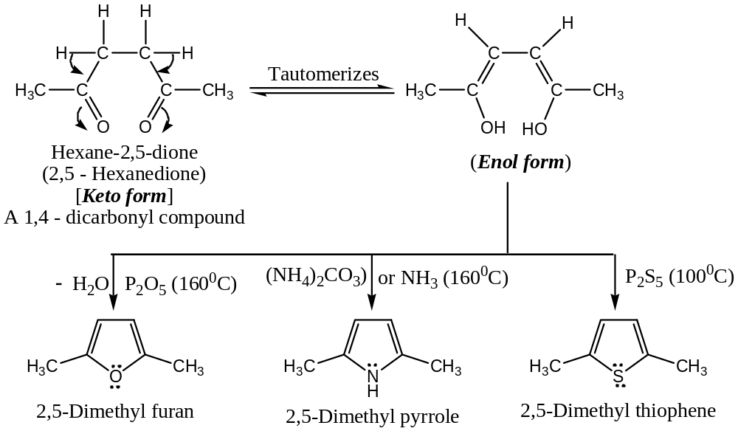
In this method, unsubstituted $5$- membered heterocycles like furan, pyrrole and thiophene can be prepared by heating succinaldehyde with the reagents $P_{2}O_{5}, {NH}_{3} \& P_{2}S_{5}$ respectively.
Study of individual members —
PYRROLE $C_{4}H_{5}N$
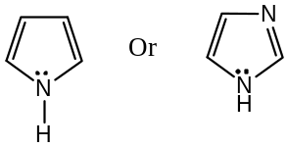
General Methods of Preparation of Pyrrole —
Following are the general methods usually adopted for the preparation of pyrrole —
[$1$] From Acetylene: When a mixture of acetylene and formaldehyde react together in presence of ${Cu}_{2}C_{2} \& NH_{3}$ at high pressure yields pyrrole —
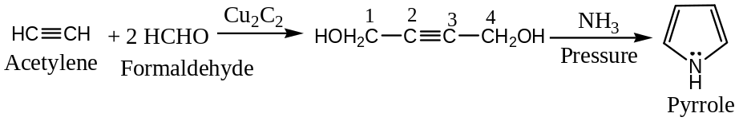
[$2$] From Ammonium Mucate: Pyrolysis of ammonium mucate at elevated temperature yields pyrrole —
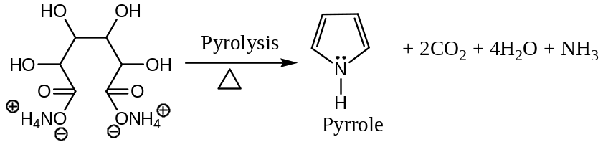
Ammonium Mucate
[$3$] From Furan: Commercially pyrrole is prepared from furan — here a mixture of furan, ammonia and steam is passed over heated alumina at high temperature ($400-450℃$) to yields furan. Thus, —
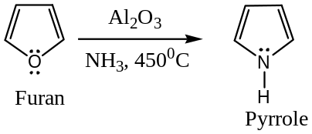
[$4$] From $1,4$- Diketone — [Paal-Knorr synthesis] reaction of $1,4$- diketone (unsaturated) with $NH_{3}$ or am amine ($RNH_{2}$) yields pyrrole $N$- alkyl pyrrole (i.e. derivative of pyrrole). Thus, —
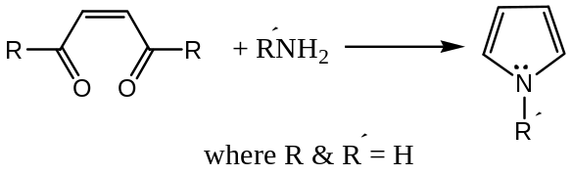
[$5$] From $EAA$- Ethylaceto acetate — [Knorr Pyrrole Synthesis]
In Knorr synthesis of pyrrole, EAA (active methylene group containing compound) is used as a reactant or starting material. Here, EAA is first oxidised by $HNO_{2}$ acid to the hydroxyl amine, which on $Zn-CH_{3}COOH$ reduction yields an $α$- amino- $β$- keto ester. The $α$- amino- $β$- keto ester so formed on condensation with another molecule of EAA yields pyrrole or its derivatives. Thus, —
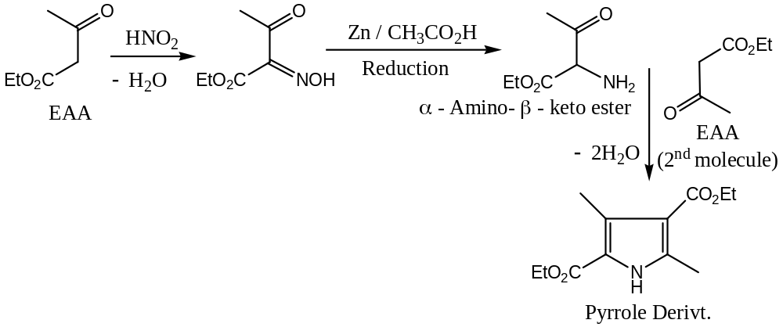
[$6$] Hantzsch Pyrrole Synthesis —
It deals with the synthesis of pyrrole derivatives by the reaction of $β$- keto ester with $α$- chloro ketones in presence of $NH_{3}$ or $1^{0}$- amine. Thus, —
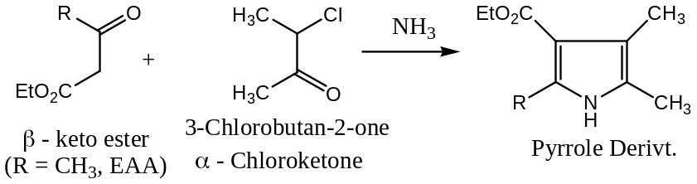
Mechanism: The reaction involves the formation of intermediate $β$- amino- $α,β$- unsaturated ester ($1$) [from $β$- keto ester and $NH_{3}$], which on reaction with $α$- chloro ketones, followed by cyclization and dehydration gives the pyrrole derivative.
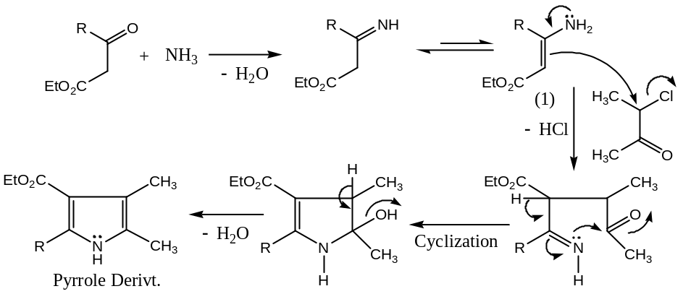
Properties of Pyrrole —
[$1$] Acidic Character — Pyrrole is slightly acidic instead of basic. The acidic nature of pyrrole is attributed from —
($a$) Heating with sodamide or solid $KOH or NaOEt$ etc. pyrrole forms salts —
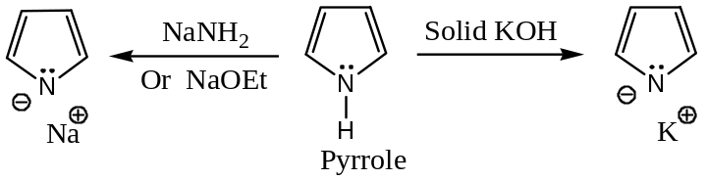
($b$) When pyrrole is treated with methyl magnesium iodide ($MeMgI$, a Grignard reagent), $CH_{4}$ gas evolves and a salt of $MgI$ forms; this on further treatment with $RX or RCOCl$ forms $N$- alkyl or $N$- acyl derivatives respectively, which on heating gives $2$- alkyl and $2$- acyl derivatives respectively. Thus, —
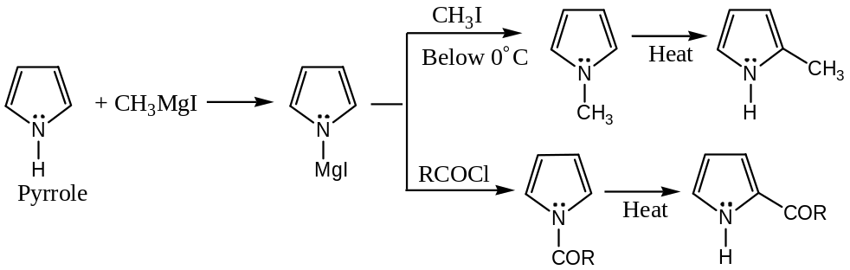
Mechanism: Mechanism of the reaction can be written as —
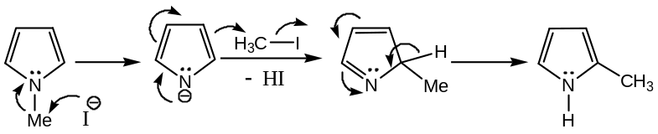
[$2$] Diene Character — in dilute acid medium, pyrrole trimerises, which indicates the diene character in it —
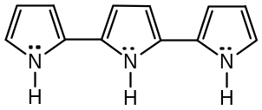
[$3$] Basic Character — Pyrrole dissolves in acids forming salts, so it behaves as a base —
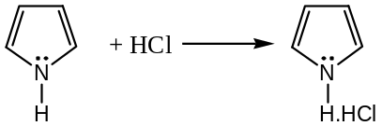
[$4$] Electrophilic Substitution: It is found that in the electrophilic substitution, pyrrole (as well as furan & thiophene) mainly gives $2$- substituted (or $5$- substituted) products. This can be explained on the basis of the following facts —
($a$) More resonance stabilized structure for $2$- or $5$- substituted products —
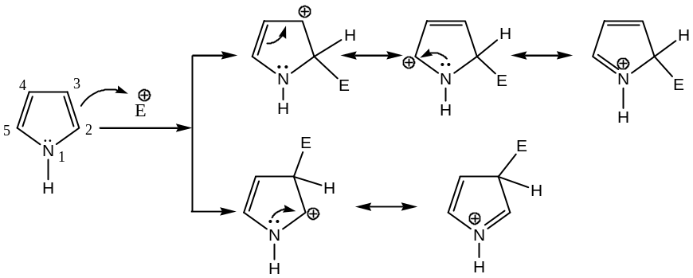
From the above resonating structures, it is clear that when the electrophile attacks the position $2$ ($or$ $5$), three resonating structures are possible; whereas in the case of $3$- substitution only two such structures are possible.
($b$) From the energy profile diagram, it is also clear that the activation energy ($E$) of $2$- substitution is less than that of $3$- substitution —

($c$) The charge density calculation of different positions of pyrrole shows that the charge density has its maximum value at $2$- and $5$- position. So these positions will be first attracted by an electrophile.
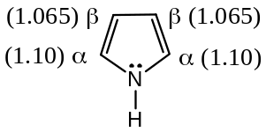
[$5$] Reduction of Pyrrole: Following are the important reduction reactions of pyrrole —
($a$) Reduction of pyrrole by nascent hydrogen i.e. by zinc in acetic acid yields dihydropyrrole ($2,5$ - dihydropyrrole) —
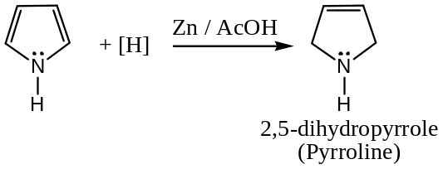
($b$) Catalytic reduction of pyrrole results pyrrolidine (tetrahydropyrrole) —
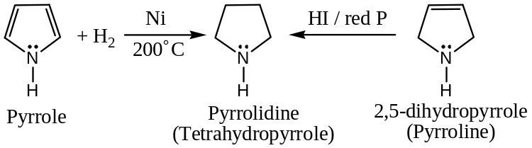

Some Selected Problems encountered with Pyrrole —
Problem 1: “Pyrrole shows resemblances to phenol”. Explain the statement with suitable examples. Give also some example against each point.
Solution: The resemblances of pyrrole with phenol are —
($a$) Both are acidic; for example, they form salts with bases.
($b$) Salts of both the compounds are strong nucleophiles and undergo reactions even with weak electrophiles.
($c$) Both undergoes —
($i$) The Reimer -Tiemann reaction —
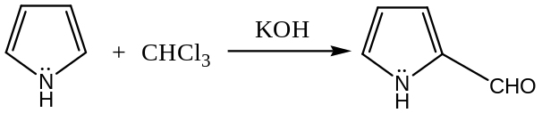
($ii$) The Kolb- Schmidt reaction —
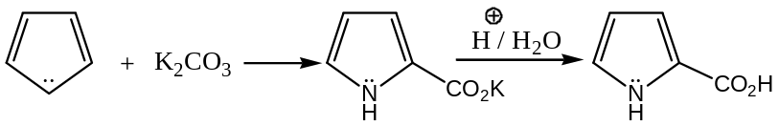
($iii$) The Mannich reaction —
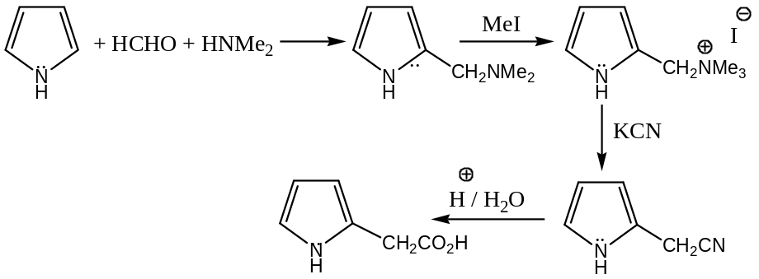
($iv$) The diazonium coupling reaction —
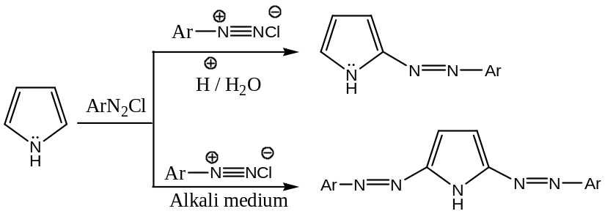
Problem 2: Pyrrole is much more acidic than $N$- alkyl amines. Suggest a reason.
Solution:
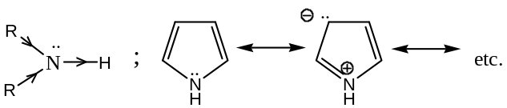
Because of $+I$- effect of an alkyl group, proton release in $sec$- alkyl amines is retarded. On the other hand, pyrrole can be represented as a resonance hybrid, where the $N$- atom carries a positive charge in it, which facilitates the release of the proton. Hence, pyrrole is much more acidic than the $sec$- alkyl amines.
Problem 3: “Pyrrole is much more acidic than pyrrolidine”. Explain the statement with suitable justification. 2
Solution: The structures of pyrrole and pyrrolidine is ―
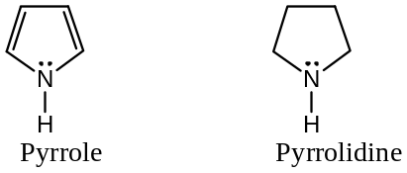
Since, the anion obtained from pyrrole is stabilized by resonance, i.e. by the delocalization of $π$- electrons ―
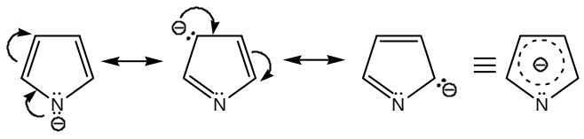
But, such resonance stabilization is not possible with the anion obtained from pyrrolidine,
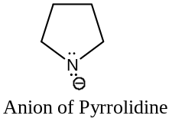
Hence, pyrrole is much more acidic (${10}^{23}$- times, in fact) than pyrrolidine.
Problem 4: “Pyrrole, Furan and Thiophene are more reactive than benzene towards Electrophilic Substitution”. Explain the statement with suitable justification. 2
Solution: The structures of pyrrole, furan and thiophene is ―
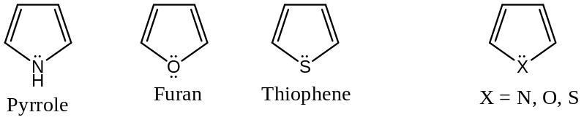
These three aromatic $5$- membered heterocyclic compounds may be represented as a resonance hybrid of the following structures ―
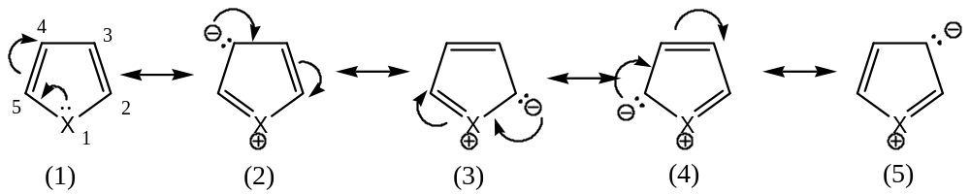
Because of the large charge separation in structures (2) & (5) contributes less to the resonance hybrid. Thus, on the basis of charge distribution, position – 2 (or position – 5) is activated towards an incoming electrophile. Such an activated position is not possible with benzene, and hence, these heterocycles are more reactive than benzene towards Electrophilic Substitution.
%%%%%%%%%%%%%%%%%%%

FURAN & THIOPHENE
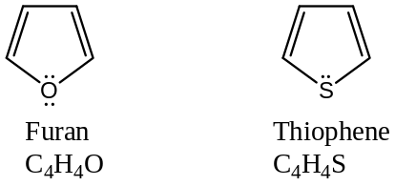
Preparation of furan:
($1$) From Mucic acid: Dry distillation of mucic acid (tetrahydroxy dicarboxylic acid) yield furoic acid, which on decarboxylation (by heating in presence of quinoline and $Cu$- powder) gives furan ―
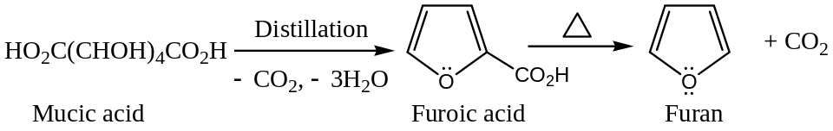
($2$) From $1,4$- Diketones or Dialdehydes [Paal-Knorr Synthesis]: $1,4$- Diketones or dialdehydes on heating with a dehydrating agent like $P_{2}O_{5}$ or conc. $H_{2}SO_{4}$, etc. yields derivatives of furan ―
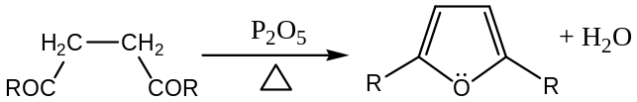
($3$) From $Pentosan$ [Commercial Synthesis]: Furan is readily prepared by the decarbonylation ($-CO$) of furfural (furfuraldehyde), which in turn made by the treatment of oat hulls, corncobs, or rice hulls (all are agricultural waste) with hot $HCl$. The pentosans (poly-pentosides, an aldopentose) so formed from the agricultural waste are hydrolyzed to pentose, which then undergo dehydration and cyclization to form furfural. Thus ―
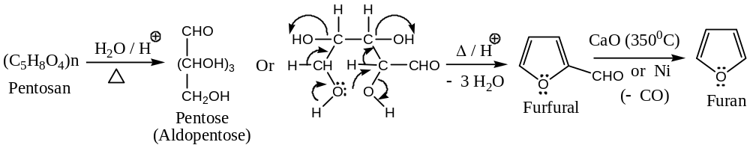
General Properties of Furan:
Following are the general chemical properties of furan ―
[$1$] Electrophilic substitution in Furan: Furan can be represented as a resonance hybrid of contributing structures as shown ―
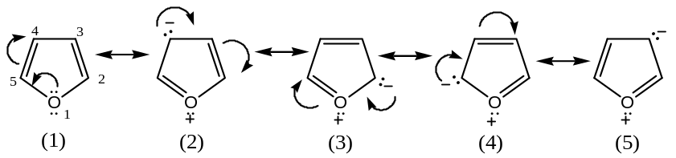
Now, we know that ―
- Canonical structures carrying charges are less stable than the uncharged one, and
- Larger the charge separation less is the stability, i.e. will contribute less to the resonance hybrid.
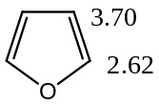So, structure ($2$) and ($5$) will contribute less compared to structures ($3$) & ($4$) to the resonance hybrid, and consequently the resonance hybrid has a larger electron density at position - $2$ (or position -$5$), than at $3$ (or $4$). Thus, on the basis of charge distribution, electrophilic substitution would be expected to occur at position - $2$ (or position - 5).
Also, because of the donation of the oxygen lone-pair, the ring becomes activated, hence the substitution occurring at faster rate than in benzene.
Alternatively, if we consider the contributing resonating structures of the intermediate carbocations ($σ$- complex), then we will get there are $3$- resonating structures for $2$- substitution and $3$- substitution. These are depicted below ―
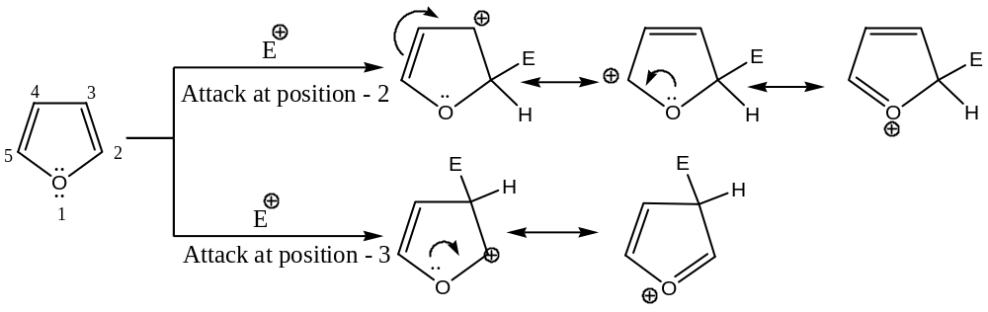
Hence, $2$- substitution will be favoured, since for this we have more number of contributing structures i.e. for $2$- substitution, there is greater spreading of charge in the resonance hybrid.
[$2$] Furan undergoes Diels-Alder reaction:
Though furan is an aromatic compound, yet it shows a few properties of conjugated dienes ($1,3$- diene). So, it is less aromatic than thiophene and pyrrole, the two other $5$-membered heterocyclic rings, and this is due to the strong electronegative character of the $O$- atom, which attacks $π$- electron cloud towards itself, and thus makes furan less aromatic. Of course, the resonance energy of furan is much higher than that of a conjugated diene. It undergoes Diels-Alder reaction because of its less aromatic character and behaves slightly as diene. For example, ―
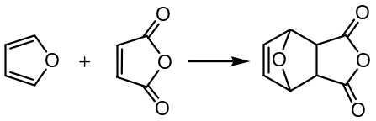
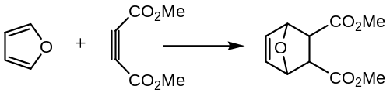
Thus, in the above two examples, furan behaves as a conjugated diene, i.e. $1,3$- diene.
General Reactions of Furan:
Following are the general characteristic chemical properties of furan ―
[$1$] Reduction of Furan: Catalytic reduction of furan yields tetrahydrofuran ($THF$), an extensively used non-polar organic solvent ―
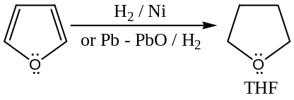
[$2$] Sulphonation of Furan: Since, furan polymerises in presence of mineral acids; hence it cannot be sulphonated by $H_{2}SO_{4}$. Sulphonation of furan is done by ${SO}_{3}$in pyridine to yield $2$- furansulphonic acid (Furan-$2$- sulphonic acid).
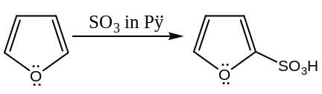
But, furan-$2$- carboxylic acid may be sulphonated by $H_{2}SO_{4}$ ―
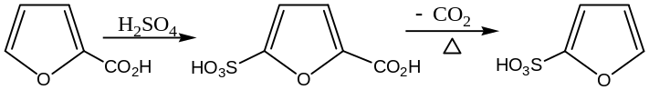
This is due to electron-withdrawing effect of the carboxylic group which makes furoic acid less susceptible to oxidation than furan.
[$3$] Nitration of Furan: For the same fact furan cannot be nitrated by $HNO_{3}$ or by acid mixture ($H_{2}{SO}_{4} \& HNO_{3}$) but can be nitrated by acetyl nitrate ―
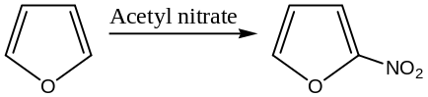
[$4$] Halogenation of Furan: Furan reacts readily with halogens, but the liberated halogen acid causes polymerization. Because of this, halogenated furans are usually prepared by indirect methods. For example, brominated furoic acid undergoes decarboxylation by heating in quinoline in presence of $Cu$- powder to form $2$- bromofuran from $5$- bromofuran. Thus, ―
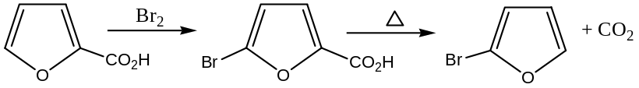
However, chlorination of furan at about $-40℃$ gives $2$- chloro and $2,5$- dichlorofuran as the main products ―
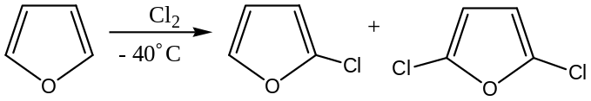
[$5$] Mercuration of Furan: Furan is very readily mercurated in the $2$- position. For example, when heating with $Hg{Cl}_{2}$ in aqueous sodium acetate, $2$- chloromercuric furan is obtained. Since, the mercury group is readily replaced by bromine or iodine, or by an acyl group, these mercury compounds are useful intermediates. Thus, ―
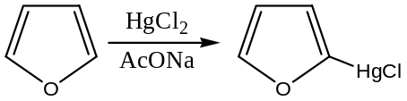
thiophene $C_{4}H_{4}S$
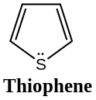
General methods of preparation of thiophene:
($1$) From the disodium salt of succinic acid [Paal-Knorr Synthesis]: Thiophene is generally (common) prepared from the disodium salt of succinic acid just by heating with $P_{2}S_{3}$. Thus, ―
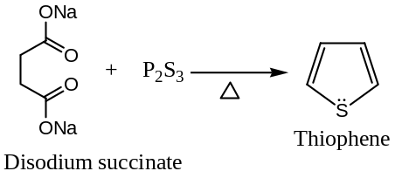
However, commercially thiophene is prepared by the following two methods ―
($2$) From Acetylene: When a mixture of acetylene and $H_{2}S$ passed over heated alumina yields thiophene. Thus, ―
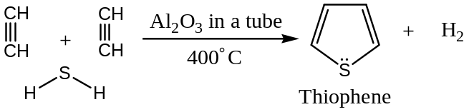
($3$) From $n$- butane: Interaction of $n$- butane with sulphur in vapour phase at $600℃$ yields thiophene. Thus, ―
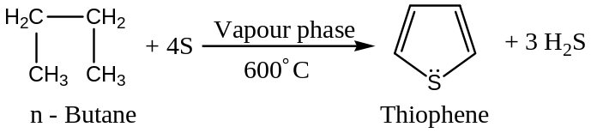
General Properties & Reactions of Thiophene ―
Electrophilic Substitution in Thiophene: Thiophene undergoes electrophilic substitution reactions mainly to give $2$- ($or 5$-) substituted products. This can be explained as ―
Thiophene is a resonance hybrid of the following resonating structures ―
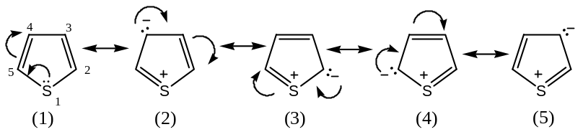
From the canonical structures it is evident that the structure (3) & (4) in thiophene has least charge separation between $2$- ($or 5$-) with $1$- position than at position $3$- ($or 4$-), hence, these two positions $2$- ($or 5$-) are more stable, so electrophilic substitution mainly occurs at this positions. On the basis of charge distribution, it has been also seen that thiophene has greater $-ve$ charge density at position $2$- ($or 5$-), than $3$- ($or 4$-). Hence, electrophile will attack these positions first.
Again, if we consider the contributing resonating structures of the intermediate carbocations ($σ$- complex), then we will get three resonating structures for $2$- substitution and only two for $3$-substitution.
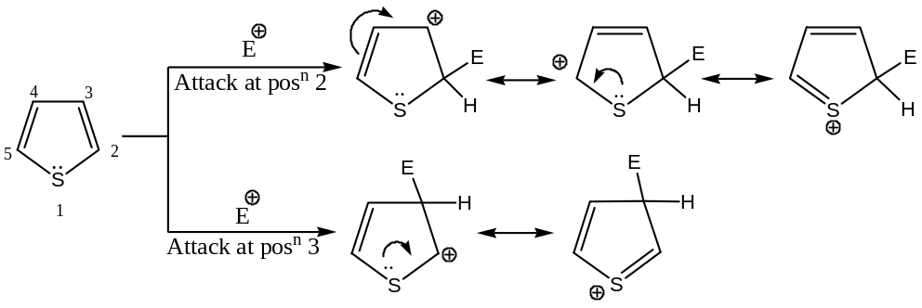
Hence, $2$- substitution will be favoured, since there is also greater spreading of charge in this case.
Problem: Furan is less reactive than thiophene so far as electrophilic substitution is concerned ― explain the statement with suitable example.
Solution: Since, oxygen is more electronegative than sulphur; the $O$- atom of furan draws the charge cloud of the ring more towards itself than the $S$- atom of thiophene draws the charge cloud of the thiophene ring. Thus, furan ring is slightly deactivating than the thiophene ring, so the aromatic electrophilic substitution (${Ar}_{S}E$) reactions take place more readily on thiophene than on furan. For example, thiophene undergoes Mannich reaction but furan itself doesn’t ― $2$- methyl-furan undergoes the reaction.
General Reactions of Thiophene:
Following are characteristic reactions of thiophene ―
($a$) Reduction of Thiophene: Thiophene reduced to $2,3$- dihydro thiophene and $2,5$- dihydro thiophene by metallic $Na$ in liquid ${NH}_{3}$.
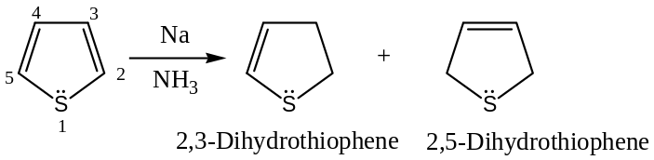
($b$) Sulphonation of Thiophene: Thiophene can be readily sulphonated by cold and concentrated $H_{2}{SO}_{4}$ in $2$- position.
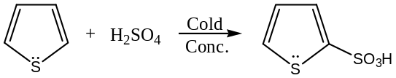
($c$) Nitration of Thiophene: Thiophene can be readily nitrated by fuming $HNO_{3}$ in acetic anhydride to give mainly $2$- nitro thiophene.
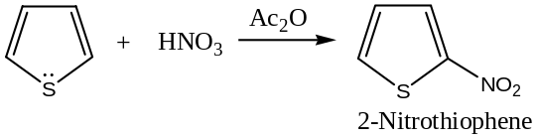
($d$) Halogenation of Thiophene: Treatment of thiophene with ${Cl}_{2} at-30℃$ , $2$- chloro and $2,5$- dichloro thiophenes are formed as the main products. However, thiophene can be brominated at $2$- position by $N$- bromosuccinimide ($NBS$) whereas $2$- iodo derivatives are prepared by treating it with iodine in presence of yellow mercuric oxide.
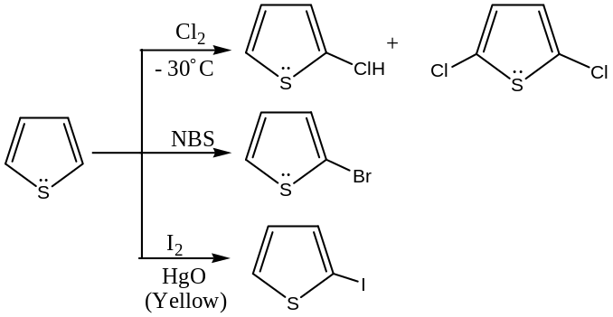
($e$) Mannich Reaction with Thiophene: Thiophene undergoes Mannich reaction with formaldehyde and secondary amine.
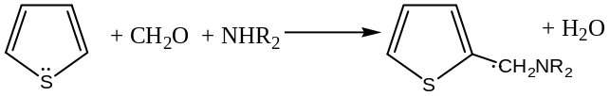
($f$) Friedel-Craft Reaction with Thiophene: Thiophene can be acylated at $2$- position by Friedel-Craft reaction using $Sn{Cl}_{4}$ as catalyst. But, when thiophene is alkylated with $iso$- butylenes, a mixture of $2$- and $3$- $tert$- butyl thiophene is obtained.
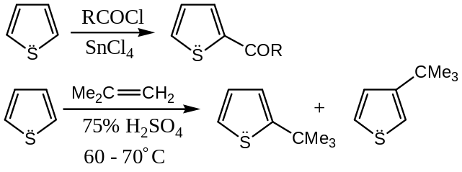
($g$) Grignard Reaction with Thiophene: When $2$- bromo thiophene (prepared by the reaction of thiophene with NBS) is treated with metallic magnesium in ether, corresponding Grignard reagent $2$- thionyl magnesium bromide is formed, which can be converted to $2$- thiophene carboxylic acid. Thus ―
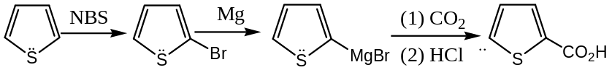
$$$$$$$$$$$$$$$$$$$
six – membered heterocyclic compound
Pyridine ― azine
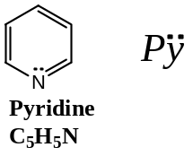
The pyridine ring system is present in a number of natural products, viz. Vitamins, nicotinic acid (Niacin), nicotinamide (Niacinamide), pyridoxine (Vitamin $B_{6}$); alkaloids, nicotine (from tobacco), piperine (from black pepper), etc., Nucleotides, diphosphopyridine nucleotide ($DPN$) and tri-phosphopyridine nucleotide ($TPN$), etc.; Isoniazide (the anti-tubercular drug), Coramine (the respiratory stimulant), $α$- and $β$- Eucane (the local anaesthetic), Demerol (the analgesic), $2,2$- bipyridyl (the analytical reagent), etc. are synthetic pyridine compounds.
Nomenclature:
The nuclear positions in pyridine are numbered as shown below ―
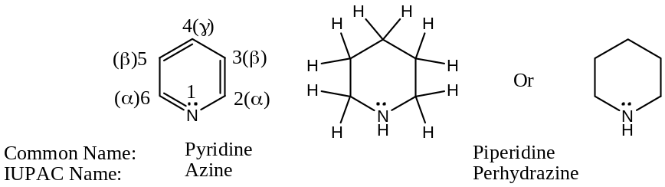
The completely reduced, i.e., hexahydro derivative of pyridine is called piperidine, a much more stronger base than pyridine, due to greater availability of a lone pair of electron (as attached to $sp^{3}$- hybridized $N$- atom).
Mono-, di-, and tri- methyl substituted pyridines are named as picolines, lutidines and collidines respectively, as shown below ―
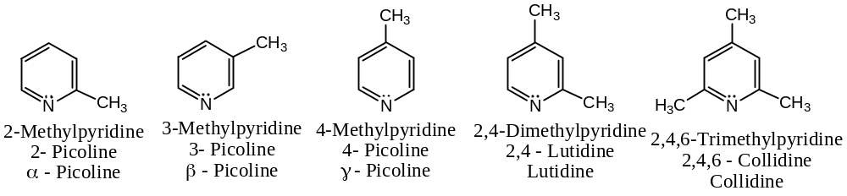
$2$-, $3$- & $4$- Pyridine carboxylic acids are named by their common named as picolinic, nicotinic and isonicotinic acids respectively. The corresponding IUPAC names are representative only.
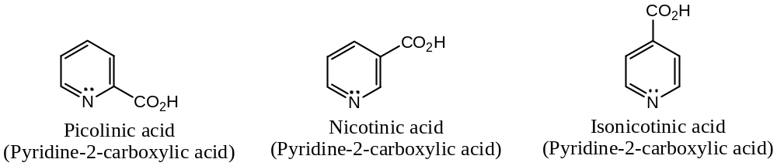
General methods of preparation of PYRIDIne:
Pyridine can be prepared by the following general methods ―
[$1$] From Furfural:
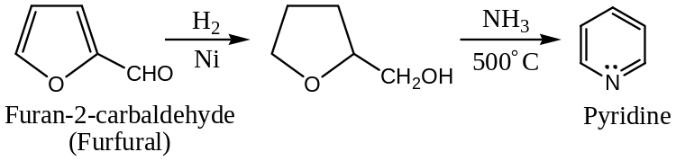
[$2$] From Pyrrole:
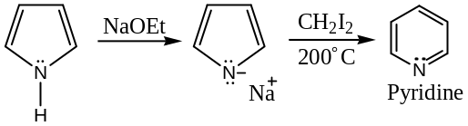
[$3$] From Acetylene and Hydrogen Cyanide:
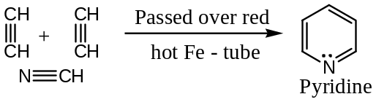
[$4$] From Hemi-methylal of Formaldehyde:
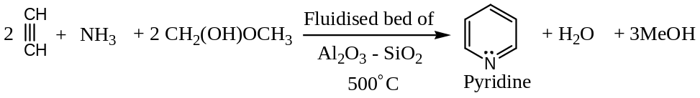
[$5$] From Nicotinic acid: Laboratory preparation of pyridine includes the distillation of nicotinic acid with soda lime ($NaOH+CaO$).
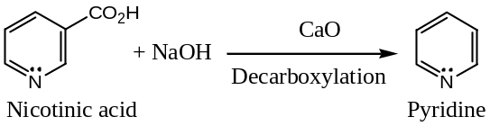
[$6$] From the salt of penta methylene diamine: On heating penta methylene diamine hydrochloride in presence of an oxidising agent yields pyridine.
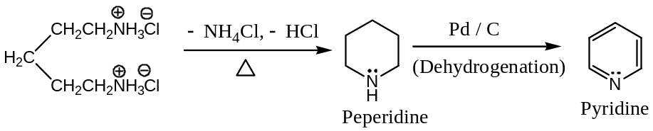
[$7$] Hantzsch Synthesis of Pyridine and its Derivatives:
[Planning of Synthesis ― Retrosynthetic Approach:
The idea of coupling of two keto-esters together with a $N$- atom also works for pyridine except that an extra $C$- atom is needed. This is provided as an aldehyde and another important difference is that the $N$- atom is added as a nucleophile rather than an electrophile. These are features of the Hantzsch pyridine synthesis. This is a four-component reaction that goes like this ―
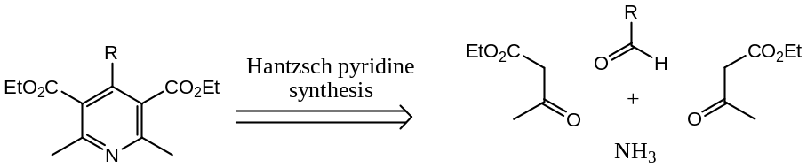
To explore the reaction ―
The product of the reaction is actually the dihydro-pyridine, which has to be oxidised to the pyridine by a reagent such as $HNO_{3}, Ce(IV)$, or a quinine.
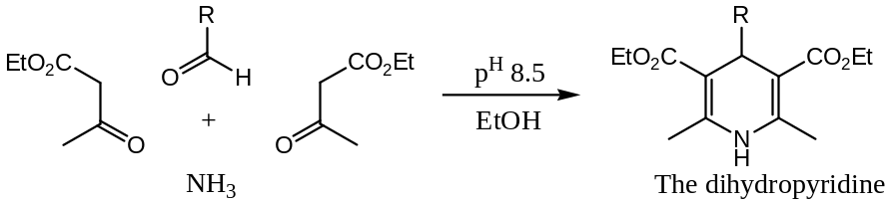 ]
The condensation of an aldehyde, a $β$- ketoester (or a $β$- diketone) with $NH_{3}$ gives dihydro-pyridine, which on oxidation (say, with nitric acid) gives the corresponding pyridine derivative. The whole sequence of the reaction is known as Hantzsch pyridine synthesis, and the reaction completes in three steps.
Step 1 ― Reaction of one of the $β$- ketoester (enol-form) with $NH_{3}$ to form an enamine
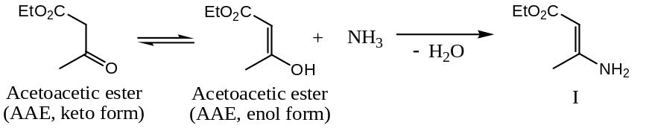
Step 2 ― Reaction of another molecule of the $β$- ketoester (keto-form) with the aldehyde, $RCHO$ to form an addition product ―
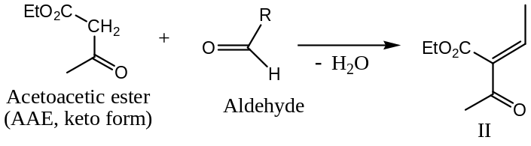
Step 3 ― Condensation of $I \& II$ to form dihydro-pyridine, which on $HNO_{3}$ oxidation yields the pyridine derivative ―
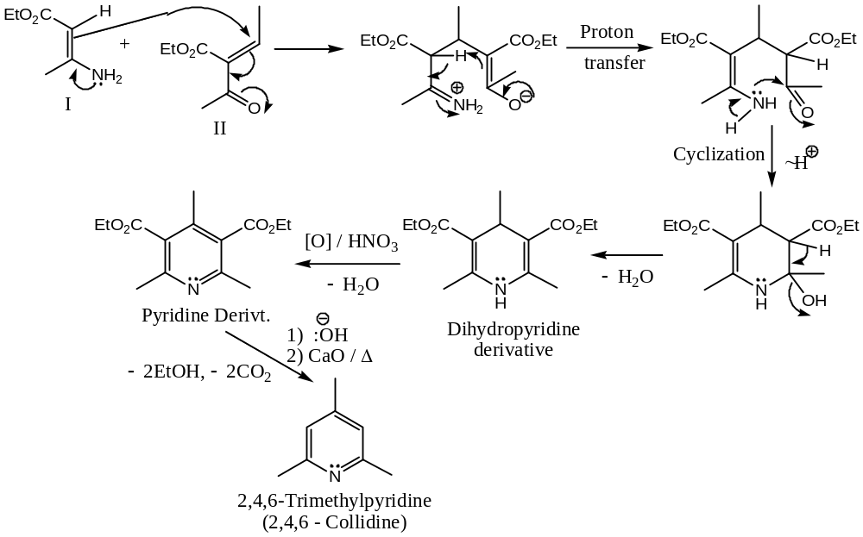
Out of these four methods only ($1$) & ($4$) are used commercially for the preparation of pyridine.
Scope of Pyridine Derivatives ― Pyridine is found in coal tar. Along with it are found a number of methyl pyridines, the most important of which are the mono-methyl compounds, known as picolines.
Oxidation of picolines yields pyridine carboxylic acids ―
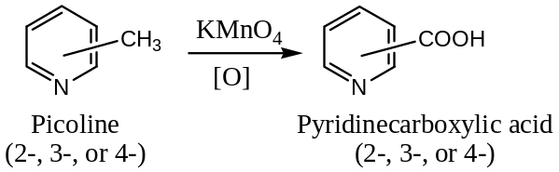
The $3$- isomer of pyridine carboxylic acids is a vitamin called nicotinic acid or niacin. The $4$- isomer of isonicotinic acid has been used, in the form of its hydrazide, in the treatment of tuberculosis.
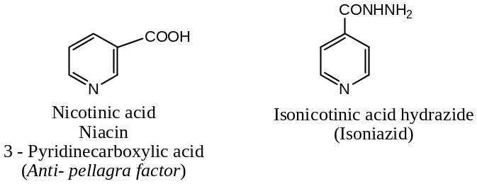
General Properties & Reactions of Pyridine ―
Basic Properties of Pyridine:
Question 1: “Pyridine is more basic than Pyrrole.” Explain with proper justification.
Answer: Structure of pyridine and pyrrole is ―
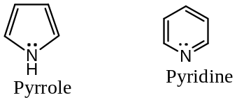
Because of the contribution of the lone-pair of electrons of the $N$- atom for the formation of $(4n+2)π$- electrons i.e. aromatic sextet, the availability of the lone-pair of electrons on $N$- atom of pyrrole for protonation is much decreased and consequently pyrrole is weak base. But, in pyridine the lone-pair of electrons on$N$- atom do not take part in preserving aromatic character of the compound and hence, these lone-pair of electrons are available for donation (i.e. protonation). Hence, pyridine is more basic than pyrrole.
Question 2: “Pyridine is more basic than Alkyl-amine.” Explain with proper justification.
Answer: That the pyridine is less basic relative to aliphatic amines can be explained as follows ―
The pairs of electrons responsible for the base strength of pyridine is held in a $sp^{2}$- hybridized $N$- atom, but the electron pairs of$N$- atom in alkyl-amines are in $sp^{3}$- hybridized state. But, we know that the base strength of a particular substance depends upon the availability of this unshared pair for sharing with acids. Further, an electron in an $s$- orbital is held more tightly, due to its proximity to the nucleus relative to an electron in an $p$- orbital. Since, the proportion of $s$- character is more in $sp^{2}(≈33\%)$ than in $sp^{3}(25\%)$ orbital, the pair of electrons in $N$- atom of pyridine ($sp^{2}$- hybridization) is somewhat less available for sharing with acids than the pairs of electrons in an aliphatic amine ($sp^{3}$- hybridization). Thus, pyridine is less basic than alkyl-amines.
Question 3: “Pyridine undergoes Electrophilic Substitution at position- $3$ ($or$ $5$).” Explain with proper justification.
Answer: Pyridine is regarded as a resonance hybrid of the following resonating structures ―
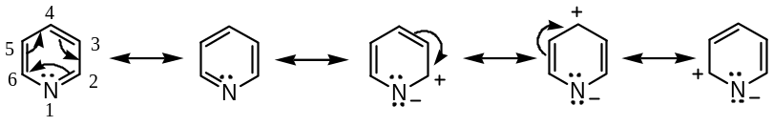
Examination of the contributing structures of pyridine shows, from the point of view of charge distribution in the molecule that positions- $3 \& 5$ will be sites for electrophilic attack (because in these two positions electron density is the maximum) and positions- $2,4 \& 6$ will be the sites for nucleophilic attack.
The position of substitution may also be considered from the stabilities of the intermediate carbocations formed ($σ$- complex). For example, there are $3$- resonating structures each for $2,3 \& 4$-substitutions (electrophilic), but in the $2$- and $4$- cations, only one contributing structure has a $+vely$ charged $N$- atom, which would increase the energy (so less stable) of the transition state. Hence, electrophilic substitution in pyridine occurs preferentially at position- $3 (or 5)$. Thus, ―
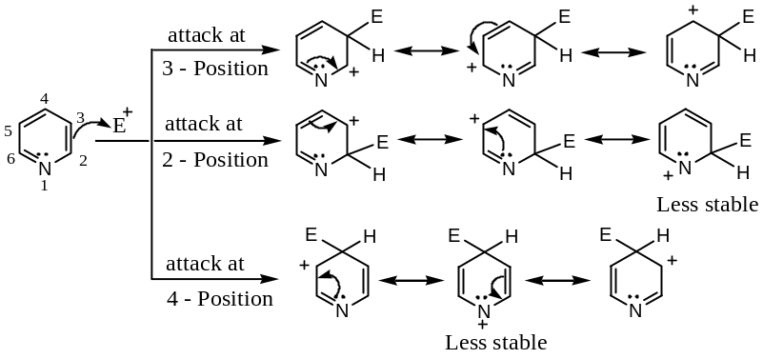
Question 4:“Pyridine undergoes Nucleophilic Substitution at position- $2(or 6)$ and $4$.” Explain with proper justification.
Answer: There are three resonating structures in the resonance hybrid of pyridine in which $+ve$ charge appears at $2$-, $4$- and $6$- positions. This means that the pyridine ring as a whole bear a partial $+ve$ charge and hence nucleophilic substitution reactions are possible at $2$-, $4$- and $6$- positions.
The position of substitution may also be considered from the relative stabilities of the intermediate carbanion ($σ$- complex). For example, three resonating structures are possible for the nucleophilic substitution each for $2$-, $4$- and $6$- positions, but the anion of the nucleophilic substitution shows that the $2$-, and $4$- anions have a structure, in which $N$- atom carries a $–ve$ charge, and so, these ions will be more stable than the $3$- anion. Thus, pyridine undergoes nucleophilic substitution preferentially at $2$- ($or 6$-) and $4$- positions. Thus, ―
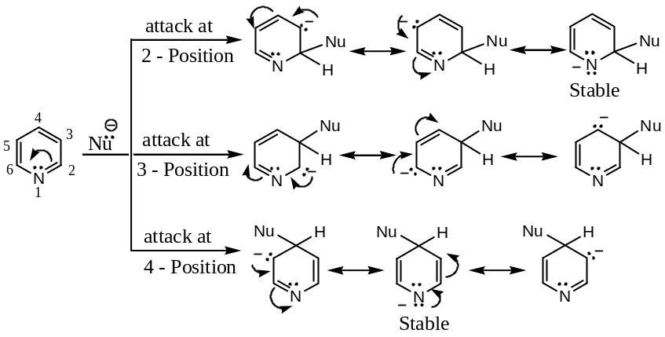
Question 5: “Pyridine is considerably less reactive compared to benzene towards Electrophilic Substitution.” Explain with proper justification.
Answer: Pyridine is considerably less reactive than benzene towards electrophilic substitution reaction. This can be explained on the basis of electrical charge on the constituent atoms in the two compounds in their resonance hybrid.
All the $C$- atoms of benzene are equivalent and no extra charge develops on any one of the six carbons.
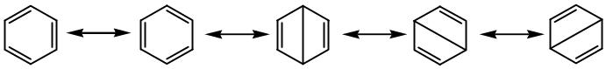
On the other hand, resonating structures of pyridine are ―
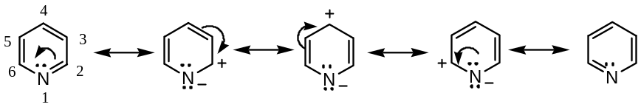
The charge distribution in pyridine ring shows that the $2,4 \& 6$- positions are electron deficient and hence, $ArS_{E}$ reactions occur only at positions $3$- and $5$-. But in benzene an electrophile can attack at any one of the $C$- atom, because in benzene all the $π$- electrons are equally spreads in all the $C$- atoms. Hence, benzene is more reactive than pyridine towards electrophilic substitution.
Again, the electronegativity of $N$- atom is greater than that of $C$- atom, so $N$- atom withdraws the electrons from the ring $C$- atoms towards itself, so the pyridine ring will be partially $+vely$ charged, i.e. ring is deactivated towards electrophilic substitution or reagents, thereby pyridine resembles the benzene ring in nitrobenzene (which is also deactivated towards electrophilic reagents). So, due to the presence of $N$- atom in pyridine it deactivated the ring hence, substitution occurs only at drastic or strong conditions, which is not generally necessary in benzene. Thus, pyridine is less reactive towards electrophilic substitution or reagent than benzene.
Question 6: “Pyridine fails to undergo Friedel-Craft reaction.” Explain with proper justification.
Answer: Pyridine does not undergo Friedel-Craft reaction because ―
The $N$- atom of pyridine donates its electron pair to the electron deficient $Al$- in $Al{Cl}_{3}$, the Lewis acid, and hence, a complex is formed which inhibits the Friedel- Craft reaction with pyridine.
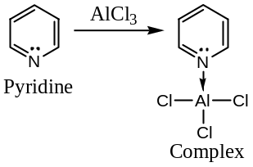
Some other characteristic Electrophilic substitution reactions of pyridine are ―
Substitution occurs chiefly at the $3$- (or $β$-) position ―
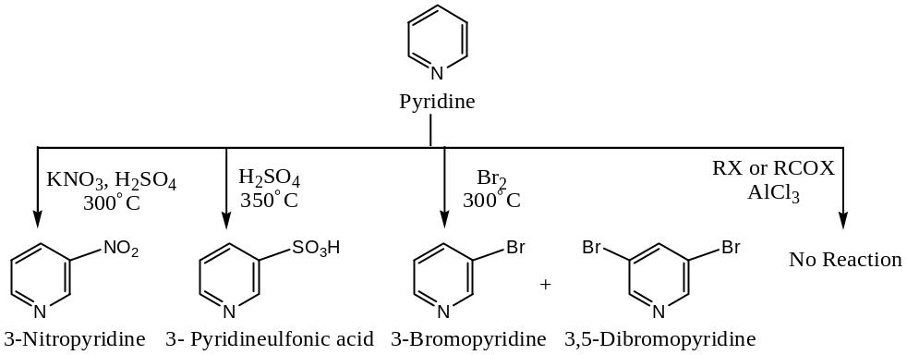
Question 7: “Pyridine undergoes $α,γ$- Nucleophilic substitution, but benzene does not.” Explain with proper justification.
Answer: In the resonance hybrid of benzene, there is not any charge distribution, which occurs in the resonance hybrid of pyridine as shown below ―
On the other hand, resonating structures of pyridine are ―
Because of the greater electronegativity of $N$- atom than that of $C$- atom, the $N$- atom draws electrons towards itself without disturbing aromaticity in pyridine. The $N$- atom has one electron in its $P_{z}$- orbital, so it accommodates another electron from neighbouring atom, and thus $N$- atom becomes $–vely$ charged and $C_{2}, C_{4} \& C_{6}$- atoms become $+vely$ charged. Therefore, these $C$- atoms are less electron dense than $C_{3} \& C_{5}$- atoms. Since, nucleophilic substitution occurs at less electron dense site, it will occur most readily at $C_{2}, C_{4} \& C_{6}$- atoms (i.e. $α \& γ$- positions). Since, in benzene, there is no such electron deficient site, hence, a nucleophile cannot attack readily in benzene.
Question 8: What are the important reactions (name reactions) of Pyridine? Write short notes.
Answer: Following are some important reactions exhibited by pyridine ―
[$1$] Tischibabin (Chichibabin) Reaction (Nucleophilic Substitution in Pyridine): When pyridine is heated with sodium amide (i.e. sodamide) in toluene, sodio-salt of $2$- amino-pyridine is formed, which on hydrolysis yield amine. When excess of sodamide is used $2,4$- diamino-pyridine is formed, and the reaction is called Chichibabin reaction.
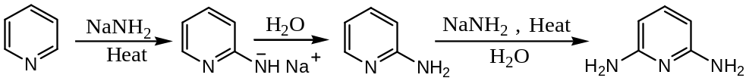
[$2$] Hydroxylation (Nucleophilic Substitution in Pyridine): When pyridine is heated with solid $KOH at 400℃, 2$- hydro pyridine is formed.
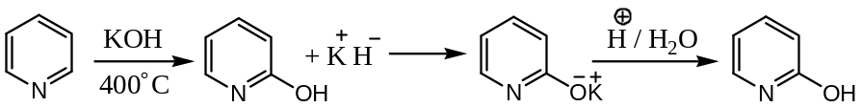
[$3$] Reduction of Pyridine: Catalytic reduction of pyridine yields the aliphatic heterocyclic compound piperidine, $C_{5}H_{11}N$.
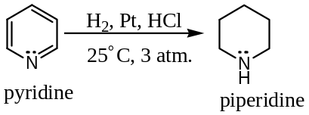
Some other characteristic Nucleophilic substitution reactions of pyridine are ―
Substitution occurs chiefly at the $2$- & $4$- (or $α$- & $γ$-) position ―
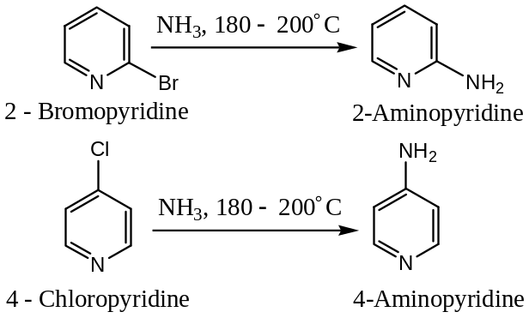
Important: Pyridine $N$- oxide, in contrast to pyridine, undergoes electrophilic substitution at $4$- position under milder conditions. This provides a route to prepare $4$- substituted pyridines. For example, ―
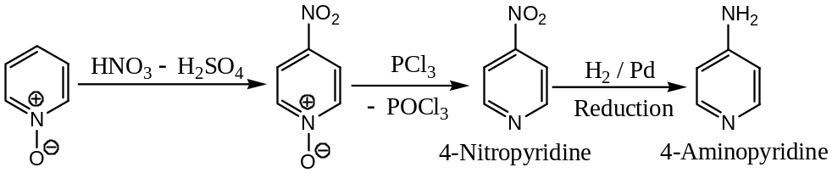
Mechanism: It is the mesomeric electron release from oxygen that stabilizes the cation intermediate formed during $4$- substitution as shown below ―
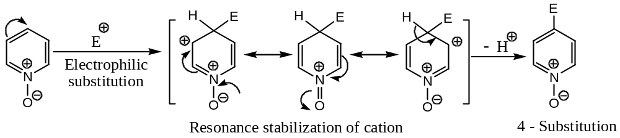
Uses of Pyridine: Pyridine is widely used (1) as a mild base in organic reactions (for example, acylation, dehydrogenation, etc.) (2) as a solvent (3) as a catalyst in number of organic reactions (for example, Knoevenagel reaction) (4) as a denaturant for ethanol and (5) as raw material in the preparation of sulphapyridine, a sulpha drug. ///
heterocyclEs conaining more than one hetero atom
purines & pyrimidines ―
The biological macromolecules that are involved in the transfer of genetic information and the control of protein biosynthesis are called nucleic acids. Nucleic acids, as their name implies, they are acidic substances present in the nuclei of cells. There are two major kinds of nucleic acids ―
Ribonucleic acid ($RNA$) and Deoxyribonucleic acid ($DNA$)
In order to understand the complex structure of nucleic acids, we need to know some simpler substances, $N$- containing aromatic heterocycles called pyrimidines and purines. The parent substance of each class and the numbering system used are as shown below ―
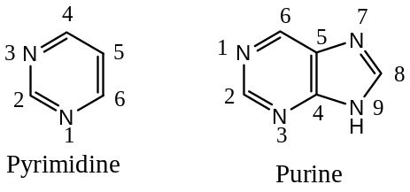
The pyrimidines that occur in DNA are cytosine and thymine. Cytosine is also a structural unit in RNA, which, however, contains uracil instead of thymine. Other pyrimidine derivatives are sometimes present but in small amounts.
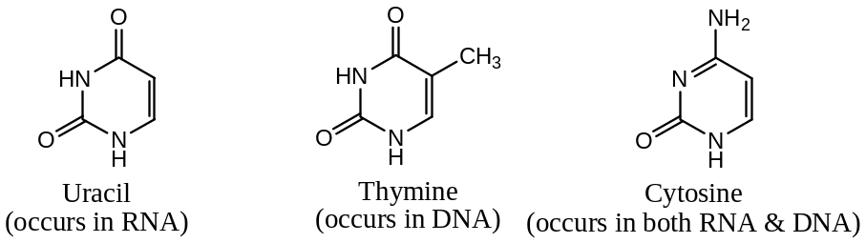
Adenine and guanine are the principal purines of both DNA & RNA ―
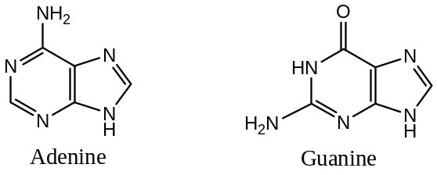
The rings of purines and pyrimidines are aromatic and planar. This flat shape plays important role in considering the structure of nucleic acids, the complex Biomolecules.
Pyrimidines and purines occur naturally in substances other than nucleic acids. For example, caffeine present in coffee contains the purine ring system. Similarly, tea contains both caffeine and theobromine.
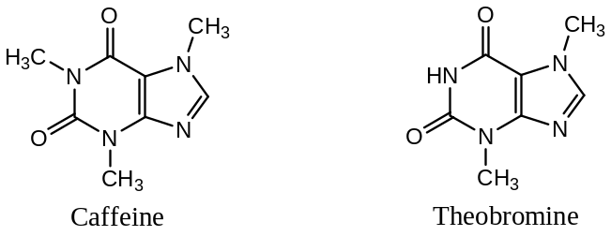 ///
Pyrimidine ―
Pyrimidine is the most important $6$- membered heterocyclic compound containing two $N$- atoms. This ring system is present in many natural products (e.g. nucleic acid) and synthetic drugs (e.g. barbiturates).
Pyrimidine is isomeric with pyridazine and pyrazine ―
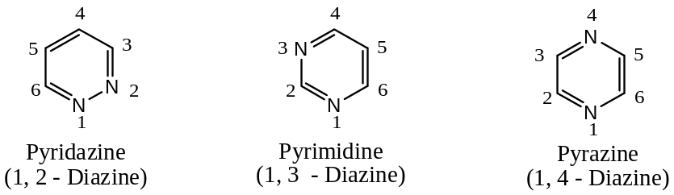
Synthesis of Pyrimidine ―
A typical synthesis of pyrimidine by the condensation of malonic ester and urea is outlined below through the intermediate barbituric acid ―
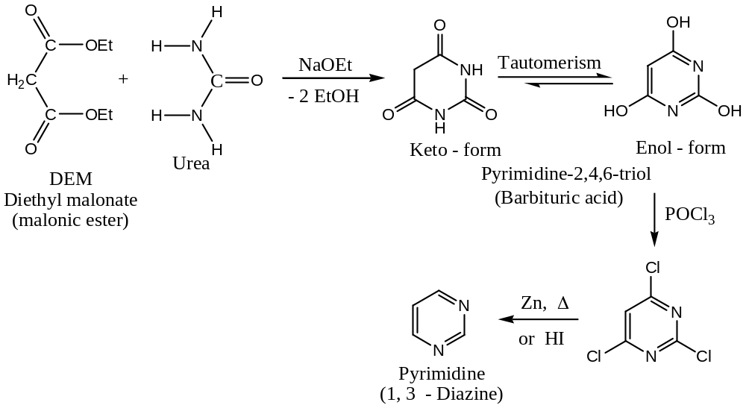
Physical Properties of Pyrimidine ―
Pyrimidine is a colourless compound with $mp=23℃$. As it follows $Huckel’s (4n+2)π$- electron rule and hence exhibit aromatic character. It has resonance energy $=109 kJ{mol}^{-1}$.
Chemical Properties of Pyrimidine ―
[$1$] Basic Character: Pyrimidine is a weaker base ($K_{b}≈{10}^{-11}$) than pyridine ($K_{b}=1.4×{10}^{-9}$). Under normal conditions only one $N$- of pyrimidine can be protonated. However, under very strong acidic conditions, both the nitrogens can be protonated to form diprotonated pyrimidine.
[$2$] Alkylation: Alkyl iodide can alkylate only one nitrogen atom of pyrimidine but strong alkylating agents like triethyloxonium fluoroborate can alkylate both the $N$- atoms to form a dialkyl derivative of pyrimidine.
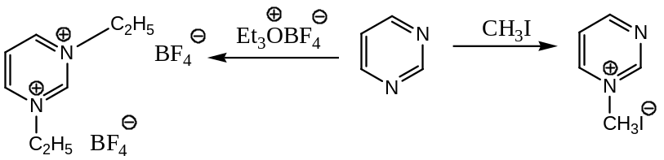
[$3$] Electrophilic Substitution: Pyrimidine resembles pyridine in electrophilic substitution reactions. The presence of one additional $N$- atom in pyrimidine ring deactivates it further to electrophilic aromatic substitution reactions. However, its mono-protonated pyrimidine undergoes bromination at position $5$-.
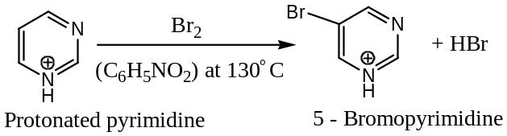
Further, electrophilic substitution is facilitated by the presence of electron releasing groups like, $-OH, -NH_{2}$ at $2$-, $4$- or $6$- positions.
Explanation: Electrophilic attack at position- $5$ can be explained by considering the following resonating structures of pyrimidine ―
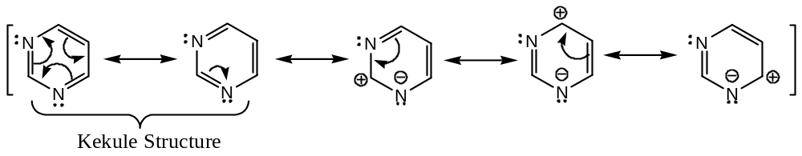
From the above resonating structures, it is evident that position- $5$ of the pyrimidine ring is comparatively rich in electron density and therefore, electrophilic substitution occurs preferentially at position- $5$, which is further facilitated by electron releasing groups at $2$-, $4$- or $6$- positions by increasing electron density.
[$4$] Nucleophilic Substitution: From the above resonating structures, it is evident that in Pyrimidine, nucleophilic attack will be facilitated at $2$-, $4$- or $6$- positions, as these positions are electron deficient. Some representative examples are ―
($a$) Nucleophilic Substitution of Halogenated Pyrimidines: Chlorine atom at $2$-, $4$- or $6$- positions can readily be replaced by $–OH or-NH_{2}$ groups. For example, ―
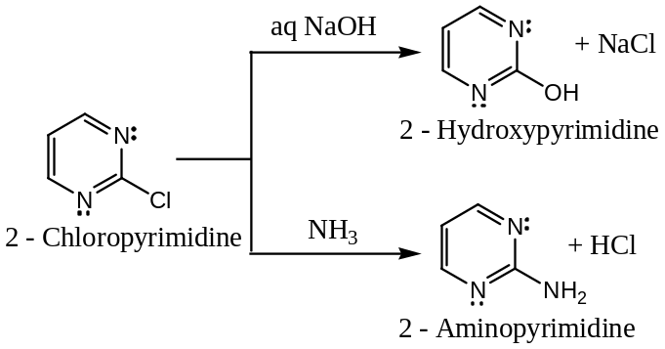
Similarly, an amino group at position $2$- or $4$- is replaced readily on boiling with water ―
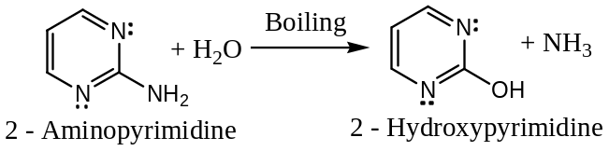
Mechanism: Displacement of $–Cl$ by a nucleophile involves two steps ―
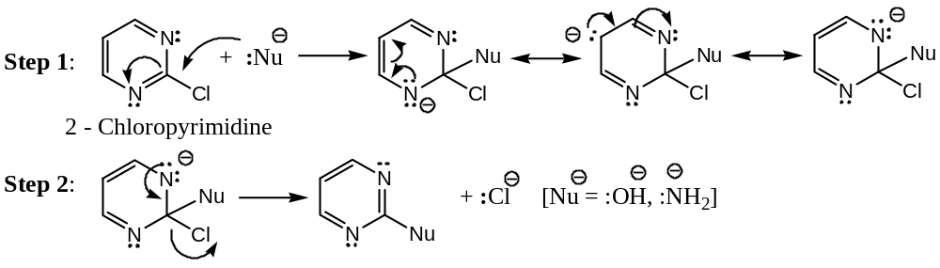
($b$) Reaction with Alkyl or Aryl Lithium: This reaction can be represented as ―
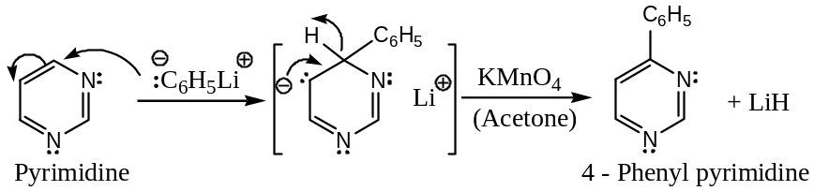
($c$) Reaction with Hydrazine: It reacts with aqueous solution of hydrazine at $130℃$ to form nucleophilic adduct as an intermediate, which undergoes ring contraction to form pyrazole. Thus, the method provides a step-down a series in heterocyclic compounds ―
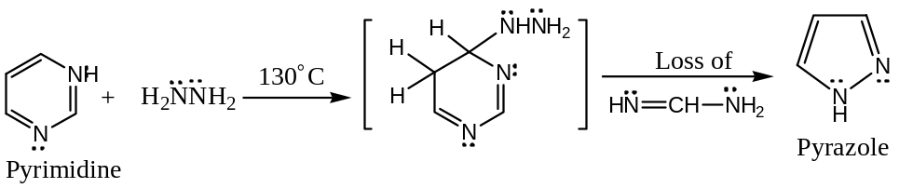
[$5$] Free Radical Substitution: Pyrimidine undergoes free radical substitution at $2$- and $4$- position with $p$- nitrobenzene diazonium chloride.
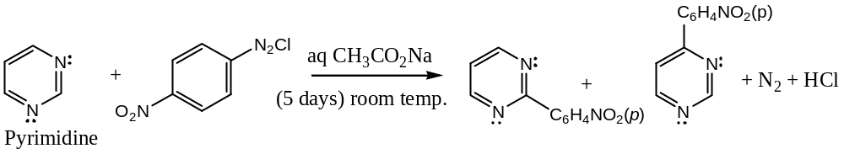
Uses of Pyrimidine: Pyrimidine bases like uracil, thymine and cytosine are important constituents of nucleic acids (DNA and RNA).
&&&&&&&&&&&&&&&&&&&&
fused ring system heterocyclic compound
quinoline & indol ―
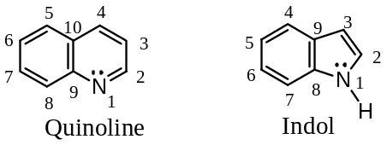
Quinoline: ―
Quinoline is an aromatic $N$- containing heterocyclic compound containing two six- membered rings; one benzene ring fused with a pyridine ring fused at position $9 \& 10$, with molecular formula $C_{9}H_{7}N$. By principle, quinoline is a tertiary base; however, it is less basic than pyridine. The structures and numbering system of two isomeric benzopyridines viz. quinoline and isoquinoline are as shown below ―
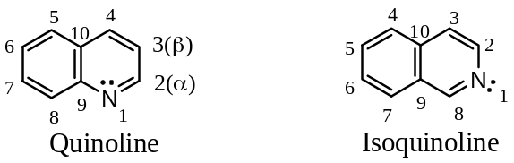
Quinoline is the benzo[b]pyridine and isoquinoline is the benzo[c]pyridine isomer. These two are very important heterocyclic units because their derivatives widely occur in nature as alkaloids. For example, the anti-malarial quinine (chloroquine & pamaquine), the analgesic drug cinchopen, the analytical reagent oxine (8- hydroxy quinoline) and the pain reliever morphine are the compounds containing the quinoline ring structure.
Preparation of Benzo pyridines ―
Synthesis of Quinoline:
[$1$] The Skraup Quinoline Synthesis―Laboratory method:
In the Skraup synthesis, quinoline is prepared by heating a mixture of aniline, nitrobenzene, glycerol, concentrated $H_{2}SO_{4}$ and $FeSO_{4}$. The reaction takes place violently but the addition of $FeSO_{4}$ to the reaction mixture, decreases the violent nature i.e. decreases the rate of the reaction. Thus, ―
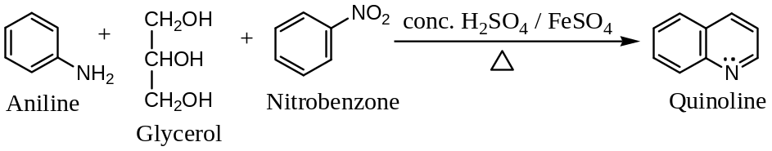
When substituted aniline is used ($say o$- aminophenol) then quinoline derivative is formed ($β$- hydroxy quinoline). For example ―
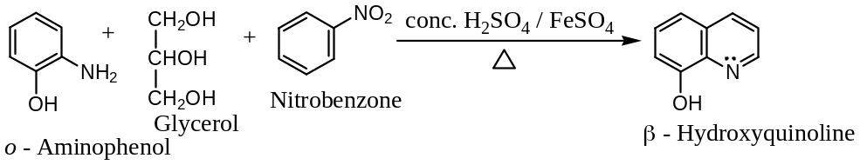
Mechanism: Mechanistically, Skraup synthesis may be divided into 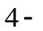distinct steps ―
Step I: Dehydration of glycerol to acrolein (acrylaldehyde) ―
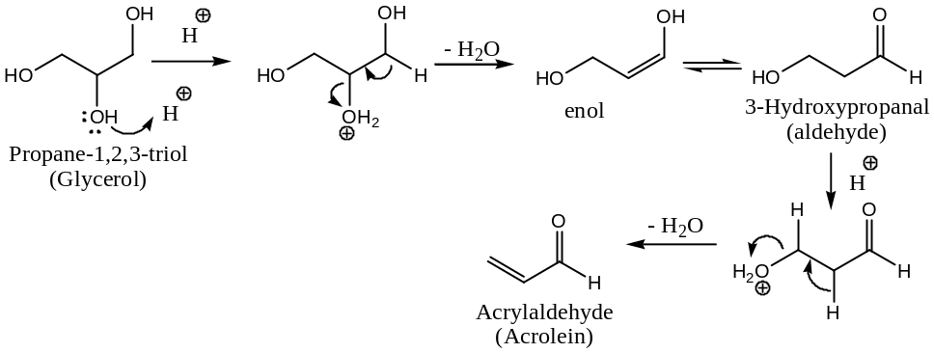
Step II: Michael type addition of aniline to the acrolein ($α,β$- unsaturated aldehyde) ―
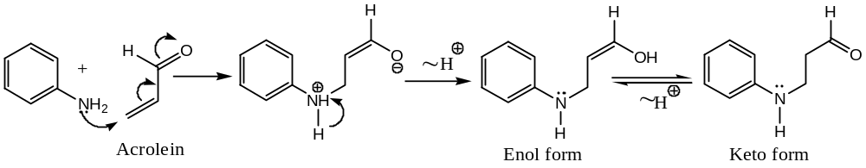
Step III: Intermolecular electrophilic substitution upon the aromatic ring by protonated aldehyde followed by dehydration ― a Friedel-Craft ring closure reaction,
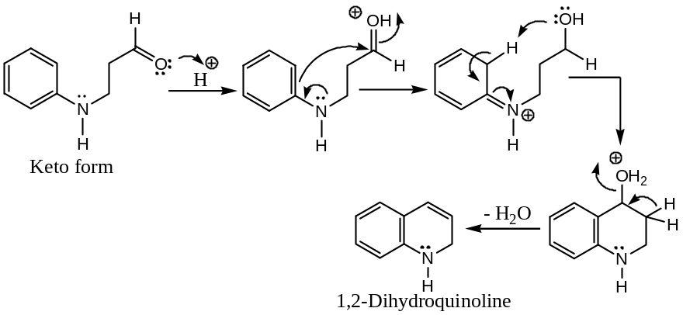
Step IV: Finally, dehydrogenation of $3,4$- dihydroquinoline by nitrobenzene to give the product quinoline i.e. an oxidative aromatization by $PhNO_{2}$, the oxidizing agent.
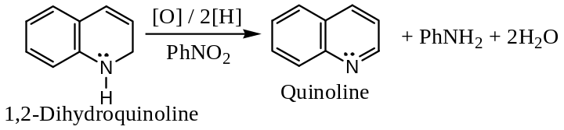
[2] Doebner-Miller Synthesis of Quinoline ―
Doebner-Miller synthesis is a modification of Skraup synthesis of quinolines and consists in heating $1^{0}$- aromatic amine and aldehyde with $H_{2}SO_{4}$. In this synthesis glycerol is replaced by two molecules of aldehydes. For example, aniline on heating with acetaldehyde (paraldehyde) and $HCl$ gives $2$- methylquinoline ―
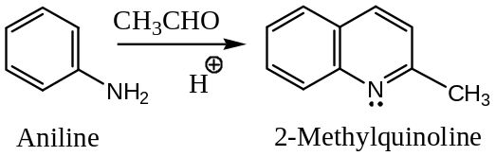
The reaction of aromatic amines with aromatic aldehydes and pyruvic acid to give cinchoninic acids is known as Doebner synthesis of quinoline-$4$- carboxylic acids (cinchoninic acids). For example, synthesis of $2$- phenylquinoline-$4$- carboxylic acid by heating aniline with benzaldehyde and pyruvic acid in alcohol ―
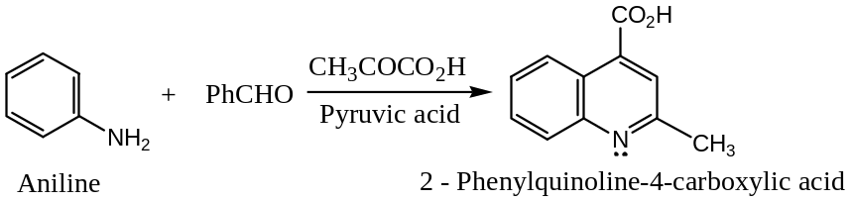
Mechanism: The $α,β$- unsaturated aldehyde ($1$), initially formed from two molecules of aldehydes by acid-catalyzed aldol condensation, reacts with aniline to give ($2$). Its cyclization in presence of strong acid and dehydrogenation yields quinoline homologue. It is believed that the oxidative step is brought about by the action of Schiff base ($3$) produced in situ (from aniline & aldehyde).
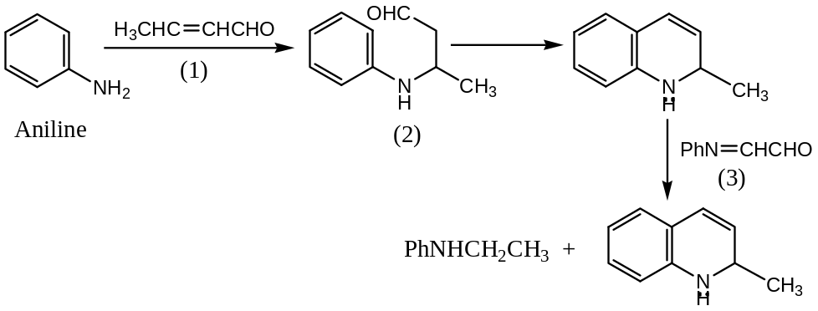
[$3$] Friedlander’s Quinoline Synthesis ―
Friedlander’s method is used for the synthesis of quinoline and its derivatives. For example, quinoline is produced when $o$- aminobenzaldehyde is condensed with acetaldehyde in presence of $aq NaOH$. Thus, ―
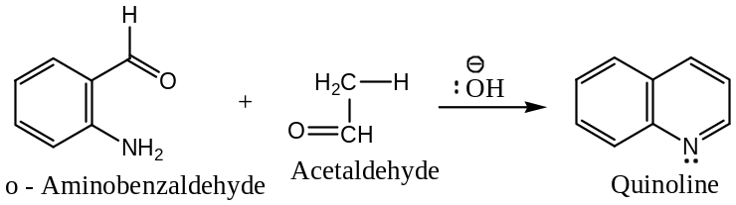
Mechanism: The reaction is believed to proceed by the nucleophilic addition of amino benzaldehyde to acetaldehyde followed by cyclization and elimination ―
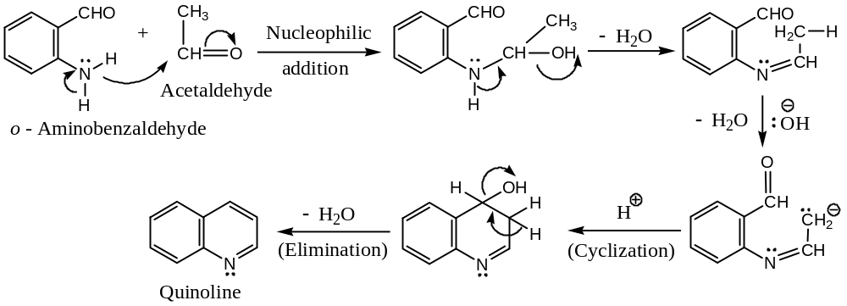
[$4$] Knorr Quinoline Synthesis ―
Knorr quinoline synthesis is carried out by the condensation of $β$- keto-esters and aryl amines at $110℃$. The resulting anilides on cyclization with conc. $H_{2}SO_{4}$ give $α$- hydroxy quinolines.
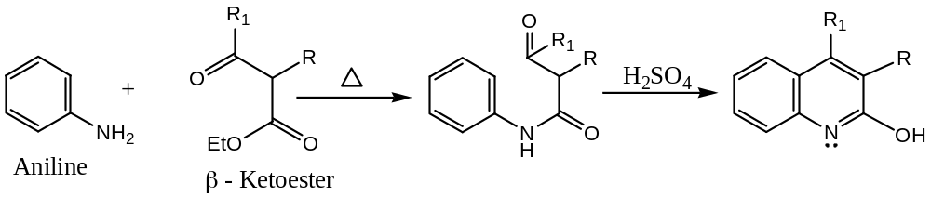
The mechanism involves the nucleophilic attack by aniline at the carbonyl group of the ester, followed by cyclization of the intermediate anilide.
However, at low temperature, the attack takes place at carbonyl group of ketone and final product, after cyclization is $4$- quinoline (Conrad-Limpach synthesis).
Application: $2$- Hydroxy-$4$- methylquinoline is obtained by the condensation of aniline and ethyl acetoacetate ($EAA$).
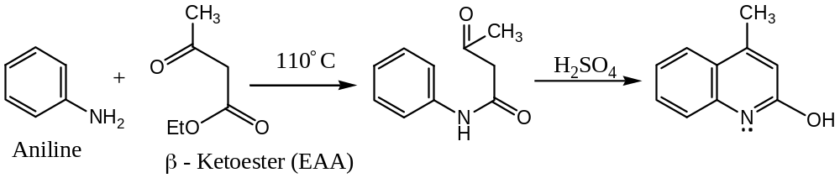
[$5$] The Bischler-Napieralski Synthesis of Isoquinoline ―Common method
In this reaction $1$- alkyl isoquinoline can be synthesised and involves the following steps ―
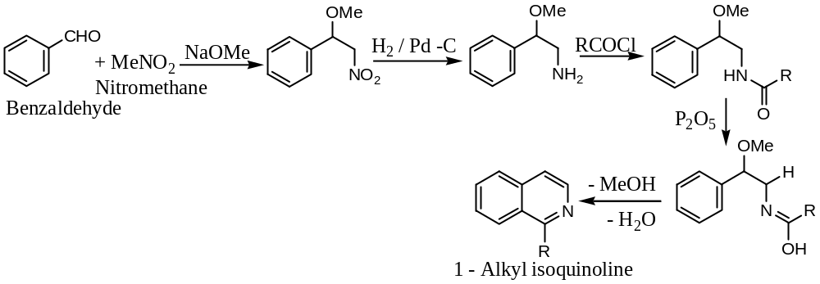
[6] The Pomeranz-Fritsch Synthesis of Isoquinoline ―Laboratory method
In the reaction the parent compound, isoquinoline can be synthesised as follows ―
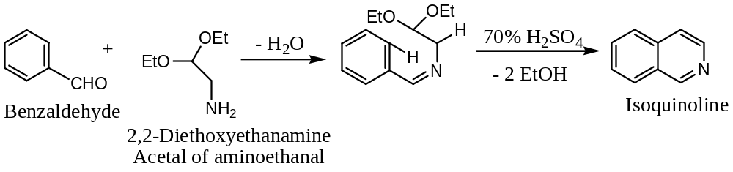
[7] Pictet-Spengler Synthesis of Isoquinoline ―
In this synthesis a $β$- aryl ethylamine is treated with an aldehyde in presence of dilute acid; ring closure occurs by a reaction of Mannich type and the tetrahydroquinoline is dehydrogenated on palladium. Thus, ―
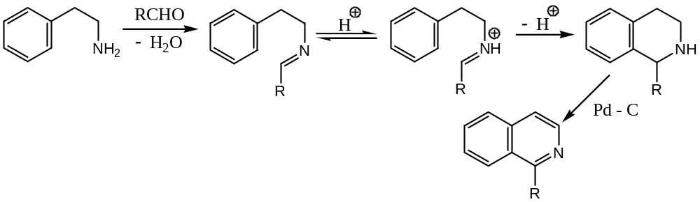
Properties & Reactions of Quinoline
[$1$] Basic character of Quinoline ―
Quinoline is a basic compound (tertiary base), but it is less basic than pyridine. It reacts with inorganic acids and alkyl halides to form quinolium salts (quaternary base). For example, with ${CH}_{3}I$, it forms quinoline methiodide ($1$- methylquinolinium iodide); similarly, with $(CH_{3})_{2}SO_{4}$, it forms quinoline methyl thiosulphate ($1$- methylquinolinium), etc. Thus, ―
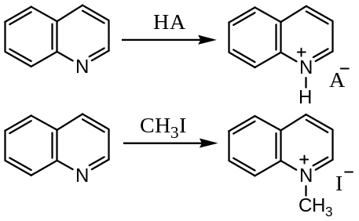
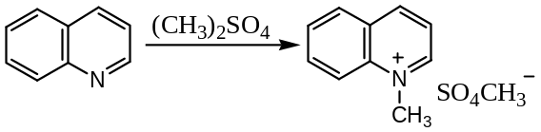
[$2$] Electrophilic Substitution Reactions in Quinoline
Quinoline gives $5$- and $8$- $S_{E}$ Products ―
Quinoline is considered to be the hybrid of the following canonical forms―
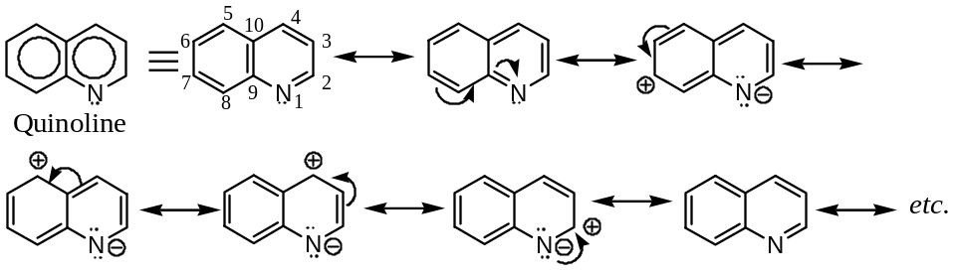
From the above canonical forms, it is seen that at position $3 \& 8$- there is not any $+ve$ charge, i.e. these two positions are preferentially attracted by an electrophile. Since, the pyridine ring in quinoline is a deactivated ring towards electrophilic attack (due to larger electronegativity of $N$- atom); hence, the position $3$- is not attracted easily by an electrophile. Hence, electrophilic substitution mainly occurred at $8$- position. However, under vigorous reaction condition position $5$- is also attracted by the electrophiles. For example ―
Quinoline (also isoquinoline) undergoes nitration with fuming $HNO_{3}$in presence of fuming $H_{2}SO_{4}$ to give a mixture of $8$- and $5$- nitroquinoline.
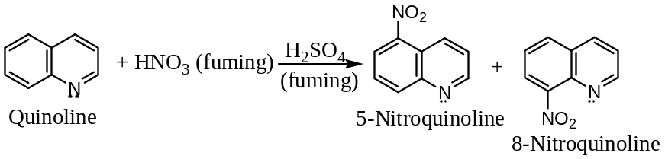
Similarly, quinoline (also isoquinoline) may be sulphonated by fuming $H_{2}SO_{4} at 220℃$ to yield a mixture of $8 \& 5$- sulphonic acid derivatives of quinoline. And so on, ―
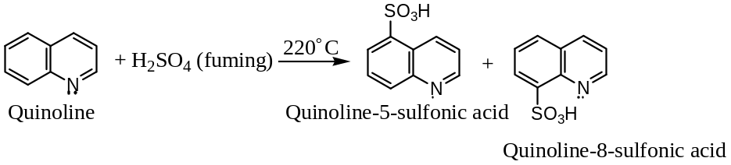
[$3$] Nucleophilic Substitution Reactions in Quinoline
Quinoline undergoes nucleophilic substitution (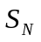) reactions at $C$- $2$ positions only ―
Quinoline is considered to be the hybrid of the following canonical forms ―
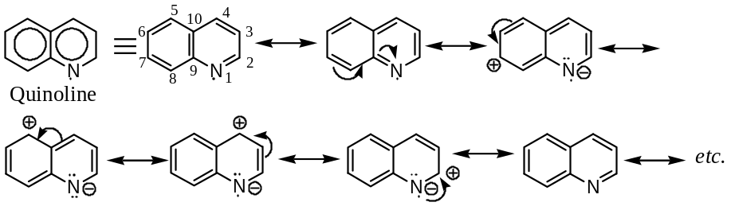
In quinoline, the benzene ring is deactivated towards nucleophilic reagents; hence nucleophiles are attracted at the pyridine ring of the quinoline. From the resonance hybrid of pyridine, it is seen that the pyridine ring contains $+ve$ charge at $C$- $2$ and $C$- $4$. Since, the charge separation ($N$- atom have $-ve$ charge) at $C$- $2$ with $N$- atom is less hence, the nucleophiles attacks at $C$- $2$ preferentially, if this position is blocked, then only nucleophiles attacks at $C$- $4$. For example,
($a$) Amination: Quinoline reacts with 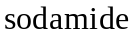in liquid ${NH}_{3}$ at about $100℃$ to form $2$- aminoquinoline (Chichibabin reaction) ―
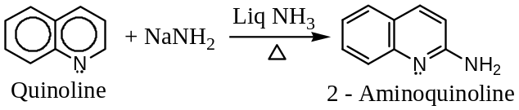
However, under similar condition isoquinoline gives $1$- aminoquinoline ―
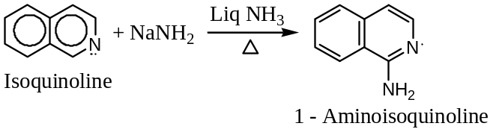
($b$) Hydroxylation: Quinoline as well as isoquinoline reacts with $KOH$ at about $220℃$ to form $2$- hydroxyquinoline and $2$- hydroxy isoquinoline respectively ―
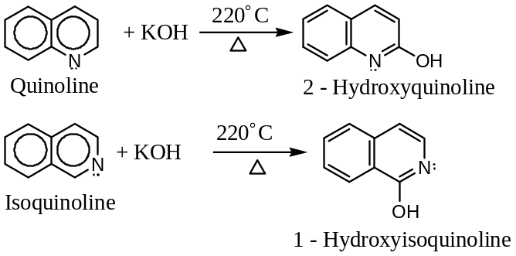
($c$) Alkylation and Arylation:
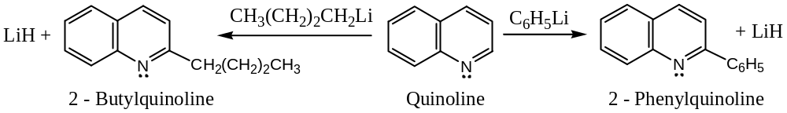
($d$) Nucleophilic Substitution of Halogens in Haloquinones: Halogen atoms at $2$- and $4$- positions are fairly mobile and undergo typical nucleophilic replacements. For example, ―
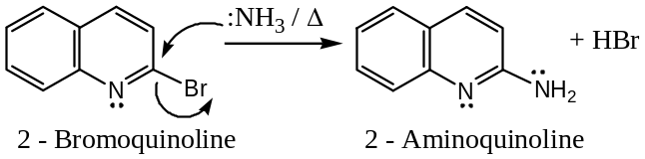
Addition-Substitution Reactions of Quinoline ― Quinoline to Nitroquinoline ―
Quinoline react acetyl nitrate at $20℃$ to yield $3$- nitroquinoline following addition- substitution mechanism. However, isoquinoline undergoes no such reaction in the pyridine ring. Thus, ―
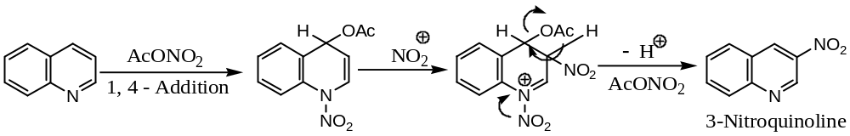
Question: “Isoquinoline undergoes nucleophilic substitution at $C$- $1$.” Explain the statement with proper justification.
Oxidation-Reduction:
($a$) Reduction of Quinoline: Nature of the product depends on the nature of the reducing agent used, for example ―
Quinoline can be reduced to $1,2,3,4$- tetrahydroquinoline by ${Ni}/{H_{2}}$. Complete reduction to decahydro quinoline is difficult as benzene ring is comparatively resistant to reduction. However, quinoline can be reduced to decahydro quinoline by $Pt-AcOH$ catalyst. Both of these two reduction products are more basic than pyridine due to decahydro quinoline $N$- atom carrying an unshared electron pair, which is readily available for accepting a proton from an acid. Finally, reduction of quinoline by $LiAlH_{4}$ yields $1,2$- dihydro quinoline.
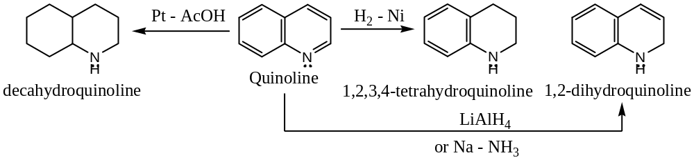
($a$) Oxidation of Quinoline: On vigorous oxidation with acidic $KMnO_{4}$, quinoline oxidized to quinolinic acid. The benzene ring being less stable than pyridine undergoes oxidation.
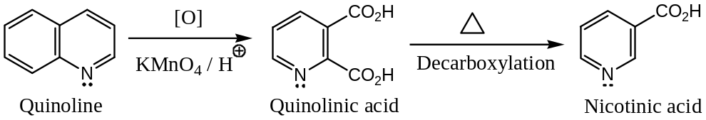
($a$) Oxidation of Isoquinoline: Oxidation of isoquinoline with acidic $KMnO_{4}$, yields a mixture of phthalic and cinchomeronic acid (different from quinoline oxidation) ―
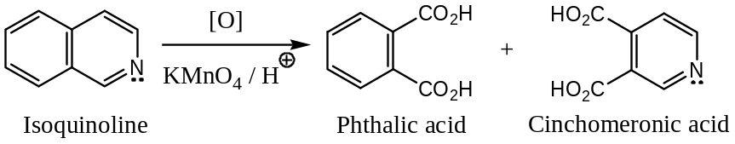
&&&&&&&&&&&&&&&&&&&&
Indole: Benzo[b]pyrrole
Indole is assumed to be formed by the fusion of benzene and pyrrole ring through a common pair of $C$- atoms.
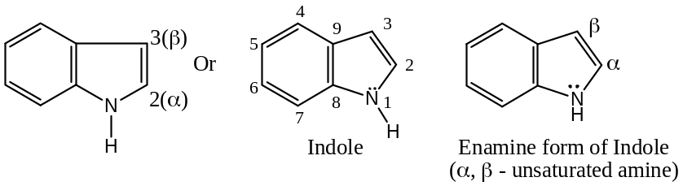
Occurrence ―
It occurs in coal-tar, jasmine flowers and orange blossoms. It is a parent compound of indigotin (a vat dye, obtained from indigofera tinctoria).
Indole ring occurs in nature widely as alkaloids $–N-$ containing base and hence, have medicinal values. In these compounds, a benzene ring fused with a pyrrole ring and hence behaves as an aromatic heterocyclic compound with molecular formula $C_{8}H_{7}N$. Because of the aromatic stability of the benzene ring, the most important contributing structure of indole to its resonance hybrid is its enamine form.
Nomenclature― the various atoms in the ring system are numbered as shown in the above structure and its derivatives are named accordingly. For example, ―
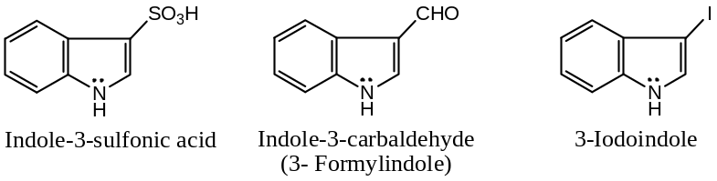
Synthesis of Indole ―
[$1$] The Fischer Indole Synthesis― Synthesis of Indole starting from Pyruvic acid ―
In the synthesis of indole from pyruvic acid, pyruvic acid is first treated with phenyl- hydrazine to form the corresponding hydrazone. The hydrazone so formed is treated with anhydrous $Zn{Cl}_{2}$ or poly-phosphoric acid ($H_{3}{PO}_{4}+ P_{2}O_{5}$) to yield indole-$2$-carboxylic acid, which on decarboxylation gives indole. Thus, ―
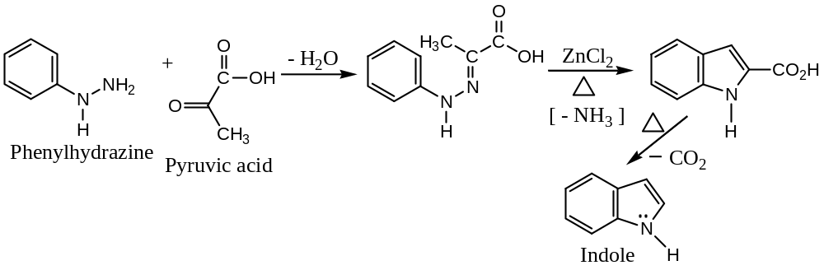
Fischer indole synthesis may also be written as ― (for substituted indole)
Fischer indole synthesis consists in heating phenyl hydrazone of an aldehyde or a ketone or a keto acid (like pyruvic acid) in presence of catalyst zinc chloride, boron trifluoride, etc. For example,
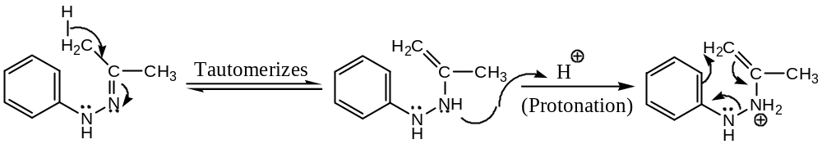
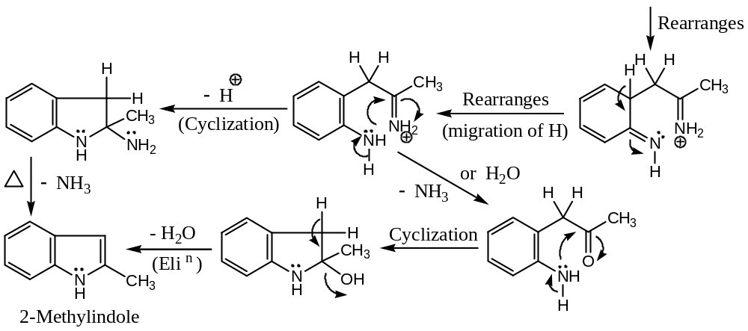
[$2$] The Madelung Indole Synthesis―
Madelung indole synthesis involves cyclization of an $o$- acylamidotoluene by a strong base, such as sodamide ($NaNH_{2}$) and sodium $tert$- butoxide ($t$-$BuO^{-}$). This method can be used for the synthesis of $α$- substituted indoles. Thus, ―
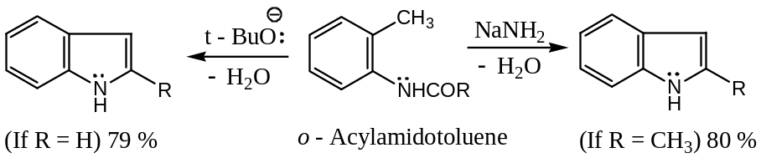
Mechanism: The reaction involves three steps ― ($i$) formation of intermediate carbanion (nucleophile) by the base followed by ($ii$) Cyclization with protonation and ($iii$) elimination of water.
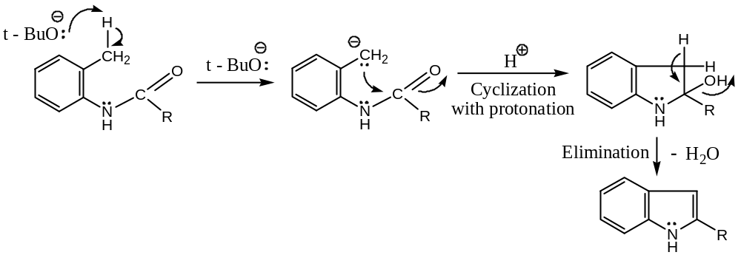
General properties of Indole ―
Indole is a crystalline pleasant smelling solid with $mp=52℃$
It resembles pyrrole in its chemical behaviour. It undergoes usual electrophilic substitution at position $3$, because the carbanion intermediate in this case is more stable than $2$- substitution, as discussed below ―
Electrophilic Substitution Reactions in Indole ― Indole gives $3$- substituted products during $S_{E}$- reactions
Indole is a resonance hybrid of the following contributing forms ―
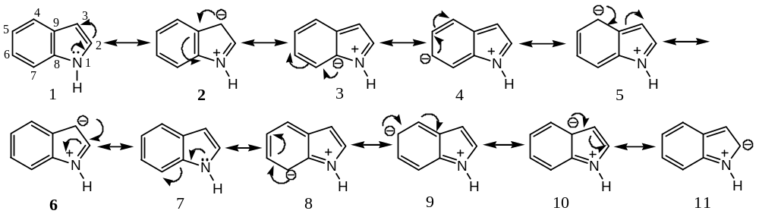
From the above resonating structures of indole, it is evident that only structures $2 \& 6$ are stable, as these two carriages a $–ve$ charge at position - $3$. Further, these two structures ($2 \& 6$) are more stable than others simply because each of them contain a benzene ring (i.e. aromatic, implies extra stability). So, electrophilic substitution on indole will take place at position - $3$. However, if position - $3$ is blocked, the substitution occurs at position - $2$. When both positions $2 \& 3$- are occupied by groups other than hydrogen, the substitution takes place at position - $6$.
For example, when indole is treated with $NaOEt \& EtNO_{2}$, $3$- nitro indole is formed ―
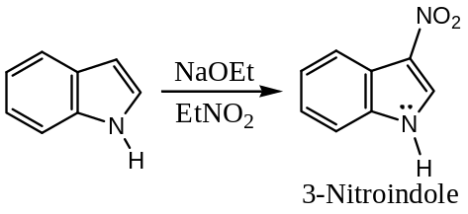
Similarly, Indole undergoes Mannich reaction with formaldehyde and dimethyl amine to form $3$- dimethyl amino methyl indole ―
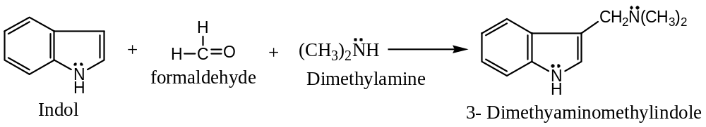
Acidic Property of Indole
Synthesis of Indole $N$- Carboxylic acid ―
The $N-H$ proton of indole is sufficiently acidic to be abstracted by reagents such as $n$- butyllithium. This provides a facial method for the synthesis of indole $N$-carboxylic acid. Thus, ―
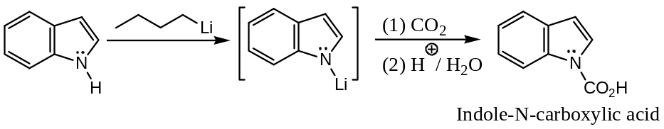
Following two reactions of indole also confirms its acidic property ―
- Reaction with Grignard confirms the presence of active 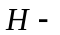atom in indole, and
- Formation of $N$- metal polar bond confirms the presence of acidic $H$- atom in indole.
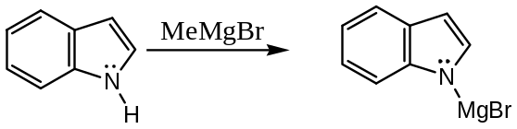
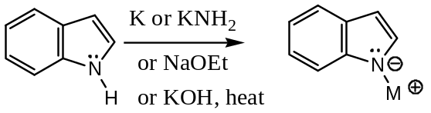
Some other important reactions of indole are ―
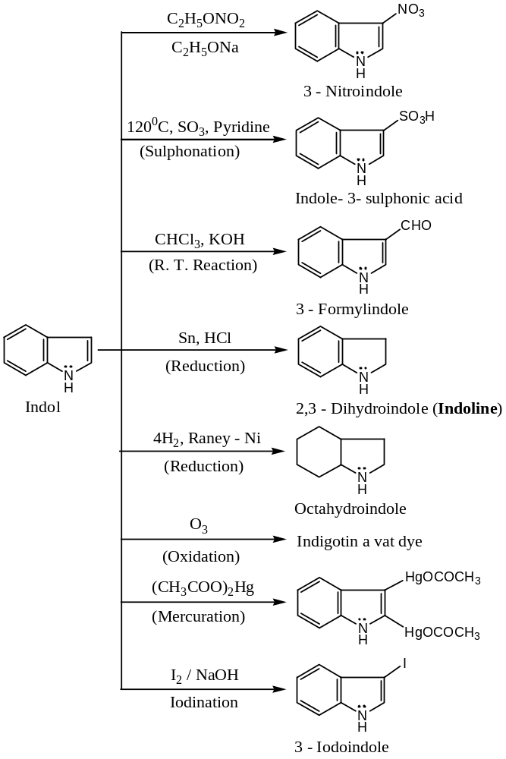
Tautomerism in Indole ―
Indole behaves as a tautomeric substance, the tautomer is known as indolenine. The indolenine itself has never been isolated, but its derivatives are known. These derivatives may be prepared by the condensation between indoles and aldehydes. For example, ―
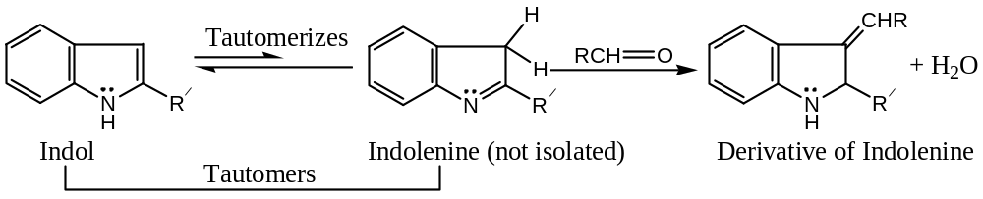
Important Derivatives of Indole ―
Following are the two important derivatives of indole ―
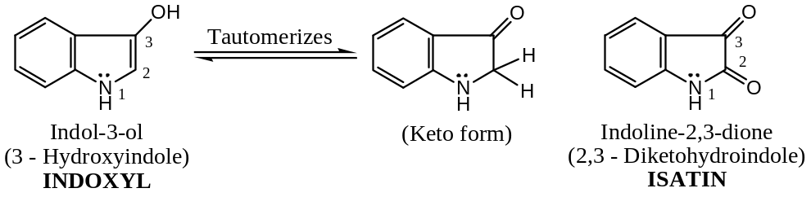
&&&&&&&&&&&&&&&&&&&&

― The End ―
Dr Nuruddin Ahmed
Associate Prof & HOD
Dept of Chemistry
JN College, Boko
Date: 19.05.2021

XXXXX#XXXXXX

