Organic Reaction Intermediates:
Direct conversion of reactants into products is not merely possible in most of the organic conversions, but takes place through some intermediate stages in the transition state. These intermediate species are called organic reaction intermediates, which are ―
- Highly reactive,
- Unstable,
- Non-isolable, and
- Very short lived.
Types of organic reaction intermediates:
- Carbocation and Carbanions,
- Free Radicals,
- Carbenes and Nitrenes (also called Imidogens),
- Benzynes (general name Arynes), and
- Ion Radicals.
Carbocation and Carbanions:
― When a $C―C σ$- bond heterolyzes, two charged species are formed. The $+vely$ charged species formed is called the carbocation, and the $–vely$ charged species is the carbanion.
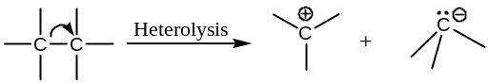
Free Radicals:
― Homolysis of C ― C $σ$- bond gives rise to two $C$- centred odd-electron species called the free radicals.
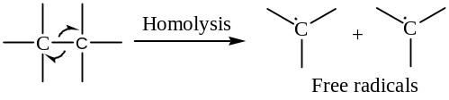
Carbenes and Nitrenes (also called Imidogens):
― When two $σ$- bond bonds on the same $C$- atom cleaved, a charge less $C$- species is formed having only $6$- electrons in the valence shell. These are called carbene intermediates. For example,
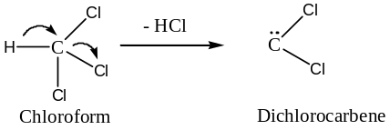
― In a similar reaction, nitrene intermediates (nitrenes are popularly known as imidogens) are also formed. For example,
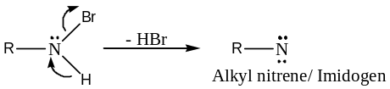
Benzynes (general name Arynes):
― Elimination of two atoms or groups from the vicinal positions of substituted benzenes results highly reactive intermediate species called benzynes (whose general name is arynes), that have a formal $C≡C$ bond in the benzene ring. For example,
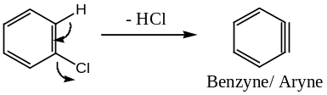
Similarly, elimination of molecular nitrogen from benzene diazonium ion yields benzyne,
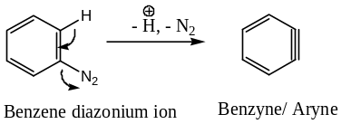
Ion Radicals:
― These are the reaction intermediate that, in addition to having one or more unpaired electrons have either a net 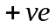 charge (called cation radical) or a net charge (called anion radical). For example,
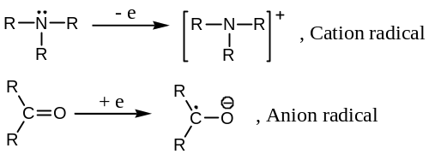
CARBOCATIONS or CARBONIUM ION:
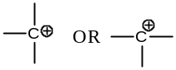Definition: Carbocations are the highly reactive, short lived tricoordinated $+vely$ charged carbon species obtained from organic molecules which possesses only six bonded electrons in its valence shell and a $+ve$ charge on the central $C$- atom. Hence, a carbocation may be represented as ―
The $+ve$ charge of the carbocation may be localized or delocalized due to electron displacement effect (resonance, inductive, etc.). For example,
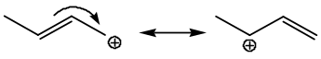
Hybridization and Geometry: Carbocations has three filled AO’s and a vacant AO with a formal charge. Theoretical calculation shows that the hybridized state should be ${sp}^{2}$. The percentage of $s$-character is given by
$0.2×J_{G-C}=\% s-Character$
$where:J=Coupling constant, and$
$G=A group attached with the+vely charged C-centre$
For example, in the compounds ―
${\left({CH}_{3}\right)}_{3}CF$ ${\left({CH}_{3}\right)}_{2}C^{+}F$
$0.2×J_{F-C}=0.2×134$ $0.2×J_{F-C}=0.2×162$
$=26.8 \% s$- Character $=32.8 \% s$- Character
$={sp}^{3}$- Hybridization $={sp}^{2}$- Hybridization
Thus, carbocations are in 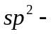hybridized state for which the ions have planar geometry and the $p_{z}$- AO remains empty.
For, example, the parent carbocation, the methyl cation, ${CH}_{3}^{+}$ is —
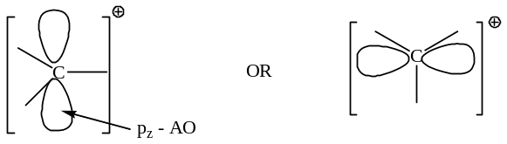
Nomenclature:
Carbocations are named by the word cation, or they may be by the derived system of nomenclature as a derivative of methane. For example,
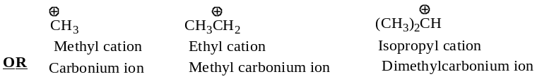
Olah’s Method of nomenclature: In this method only tricoordinated carbocations are called carbonium ion.
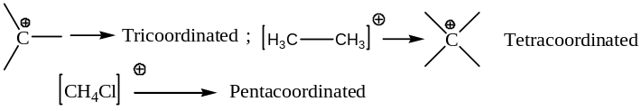
Classification of Carbocations:
Depending upon the number of groups directly attached to the 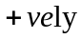 charged carbon centre carbocations are classified into three classes:
- Primary ($1^{∘}$) carbocations,
- Secondary ($2^{∘}$) carbocations, and
- Tertiary ($3^{∘}$) carbocations.
For example,
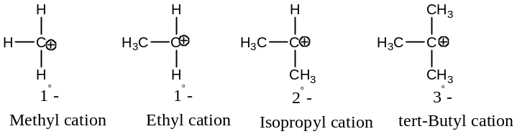
Generation of Carbocations:
Carbocations are generated by the following general methods:
- By the removal of an electron from a neutral molecule or free radicals:
For example: Following two methods are usually adopted ―
- From alkane:
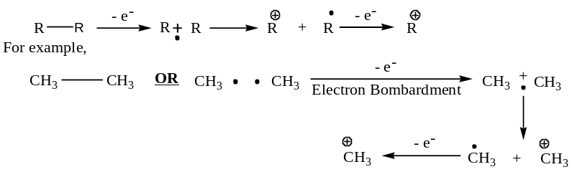
- By the Kolbe oxidation of carboxylate ion at the anode:
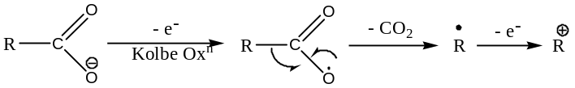
- By the heterolytic fission of $C$- heteroatom covalent bond:
For example: Following five methods are usually adopted ―
- Solvolysis of $R―X$ covalent bond,
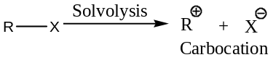
Where:
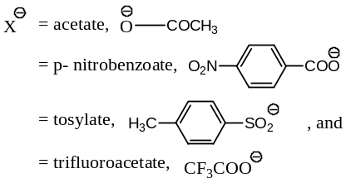
- Heterolytic fission of alkyl halides induced by ${Ag}^{+}$, the Lewis acid catalyst,
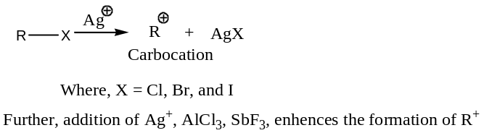
- From onium salts in acid medium,
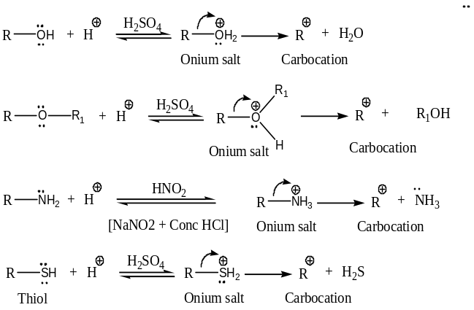
- By the heterolysis of alkyl diazonium salts,
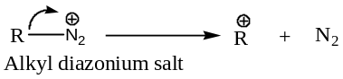
- By the heterolysis of pyrophosphates,
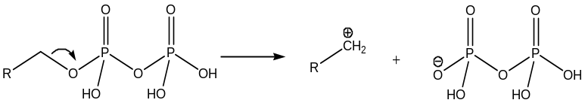
- By the heterolysis of mercuric acetates,
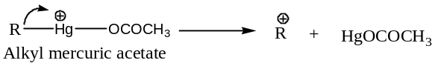
- By the addition of cations to the double bond:
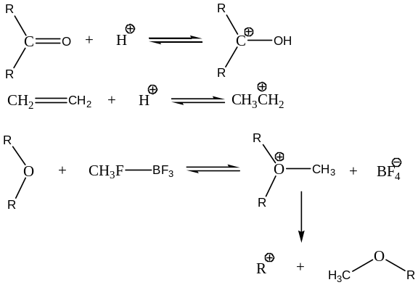
- Generation of carbocations by Olah’s Method:
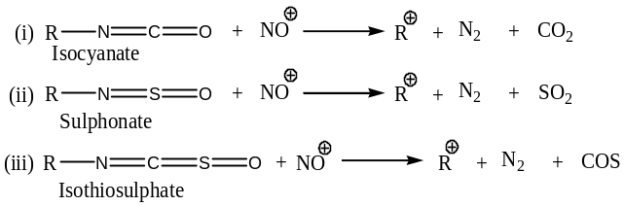
Stability of Carbocations:
Both alkyl and aryl carbocations follows the following stability order (in non-polar solvents like $C_{6}H_{6}, {CCl}_{4}, {CS}_{2})$:
${Me}_{3}C^{+}> {Me}_{2}{CH}^{+}> MeH_{2}C^{+}> H_{3}C^{+}$
$i.e. 3^{°}>2^{°}>1^{°}>H_{3}C^{+}$
But, in polar solvents the above stability order is reversed.
The above stability order of carbocations can be well explained on the basis of the following six factors/ effects ―
- Medium effect or Solvation effect:
Smaller cations are more stable in more polar solvents due to extensive solvation effect. For example, ${Me}_{2}{CH}^{+}$ is more stable in water than ${Me}_{3}C^{+}$ but less stable in benzene.
- Inductive effect:
The more $+I$ effect on the $C$- atom bearing the $+ve$ charge, the more stable is the carbocation. On the other hand, the more is the $-I$ effect on the $C$- atom possessing the $+ve$ charge, the less stable is the carbocation.
Methyl group has $+I$ effect, i.e. electron donating/ releasing group. Thus, due to $+I$ effect of three methyl groups attached to the $+vely$ charged $C$- atom, the $+ve$ charge of the tertiary butyl cation, ${Me}_{3}C^{+}$ is almost neutralized, i.e. neutralized to a greater extent in comparison to that of the isopropyl cation, ${Me}_{2}{CH}^{+}$ which possesses only two methyl groups for such an effect. Since, we know that the neutral or less charged species are more stable than the charged one, hence, ${Me}_{3}C^{+}$ is more stable than the isopropyl cation, due to the $+I$ effect of three methyl groups. This charge neutralization effect is still less in the case of ethyl cation, ${CH}_{3}{CH}_{2}^{+}$ as it contains only one methyl group and it is least in methyl cation, ${CH}_{3}^{+}$ because it does not have any electron releasing group attached to the$+vely$ charged $C$- atom, to diminish the extent of the $+ve$ charge of the cation. Thus, the stability order of the various carbocations can be pictorially represented as follows:
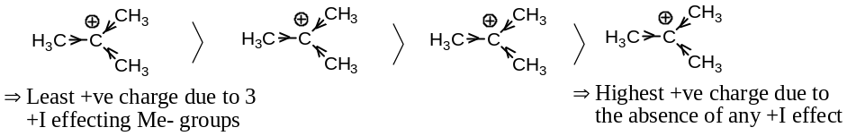
[This stability order is in non-polar medium/ solvent]
- Hyper-conjugative effect:
The stability order of carbocations can be well explained by hyper-conjugative eject, i.e. delocalization of charge through conjugation without involving bonds i.e. no bond resonance. Tertiary butyl cation, ${Me}_{3}C^{+}$ has nine resonating forms without odd electron in its resonance hybrid; ${Me}_{2}{CH}^{+}$has six such structures; ${CH}_{3}{CH}_{2}^{+}$ possesses only three hyper-conjugative structures without odd electrons and finally methyl cation has none. As we know that higher the number of hyper-conjugative structures, greater is the stability order, hence, the stability order among the carbocations follows the order ―
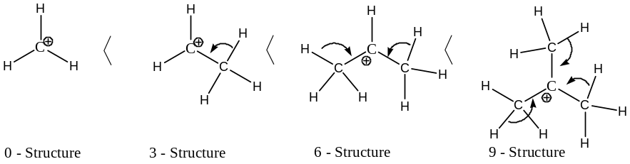
- Aromatization effect:
Cyclic carbocations are stabilized by aromatization. For example,
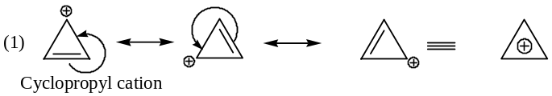
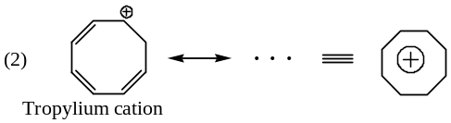
- Resonating effect:
Resonance effect involves the delocalization of π – electrons. It depends upon the overlap of certain orbitals, and therefore, can only operate, when the substituent is located in certain special ways relative to the charge centre. For example,
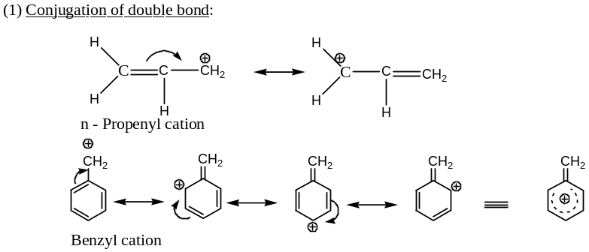
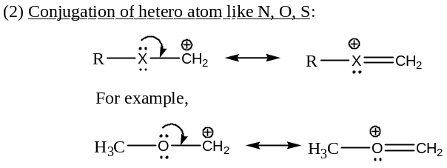
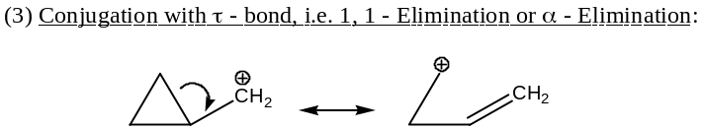
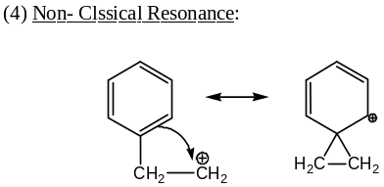
- Steric effect or Baeyer Effect:
Intermolecular crowding producing intermolecular pull, which is called Baeyer strain. As the bulkiness of the groups attached with the central 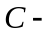atom increases, Baeyer strain increases and hence, the cation becomes increasingly less active to the nucleophiles (${Nu}^{..} or {Nu}^{-}$), because of the increase in Baeyer’s strain in the ${sp}^{3}$- state. For example,
Tertiary butyl cation, ${Me}_{3}C^{+}$is less active towards${Nu}^{..} or {Nu}^{-}$, than ethyl cation, ${CH}_{3}{CH}_{2}^{+}$. Hence, tertiary butyl cation undergoes electrophilic reactions rather than substitution reactions.
reactions of Carbocations: Carbocations undergo following types of reactions —
- Carbocations as electrophile: Carbocations ($R^{+}$) acts as an electrophile to react with nucleophiles (${Nu}^{-}$).
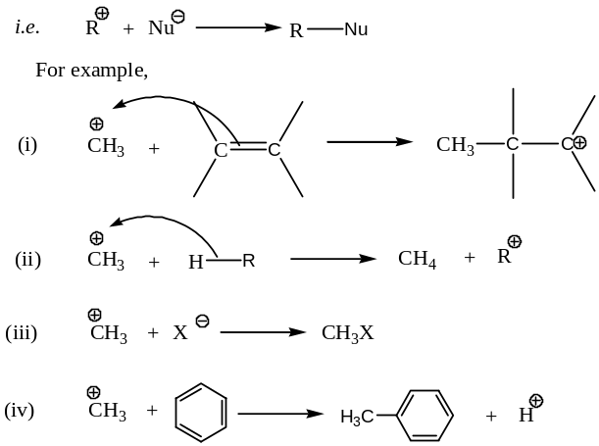
- Carbocations as Bronsted acid: Some carbocations act as Bronsted acid to lose a proton. For example,
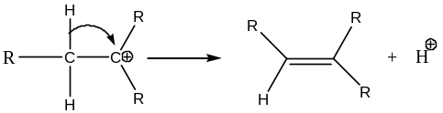
- Carbocations undergo Elimination reactions: Methyl cation, ${CH}_{3}^{+}$ the simplest carbocation undergoes $α$- elimination reaction to generate carbene intermediate.
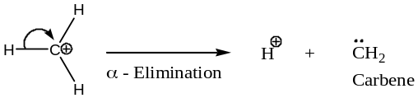
As the structure of $R^{+}$ becomes complex, the nature of the reactions is also varied. For example, ${CH}_{3}{CH}_{2}^{+}$ will undergo all the reactions of ${CH}_{3}^{+}$ and in addition also undergo $β$- elimination. More complex cations may also undergo $γ$- elimination, fragmentation and may undergo Wagner – Meerwein rearrangement by an anionotropic 1, 2- shift of a hydride or alkyl anion.
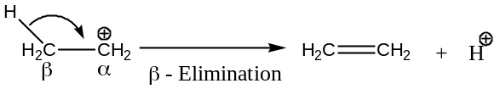
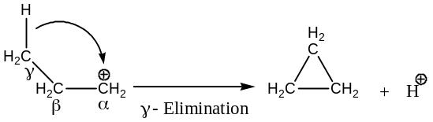
- Carbocations undergo 1, 2 – anionotropic shift: $1^{°} or 2^{°}$- carbocations often undergo Wagner-Meerwein rearrangement by an anionotropic 1, 2- shift of a hydride or an alkyl anion. For example,
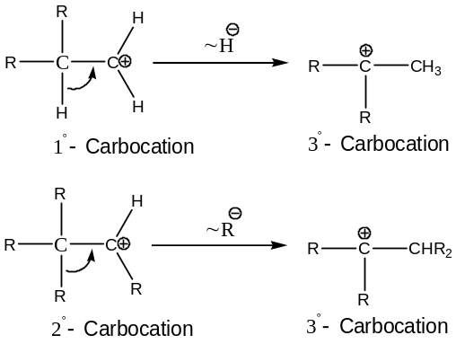
- Carbocations undergo cathodic reduction: Carbocations can be reduced to a free radical or carbanions by cathodic reduction. Thus,
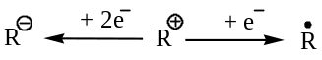
- Carbocations undergo fragmentation reaction: Bulky or long chain $1^{°}$- carbocations can undergo fragmentation of $C$- chain to form smaller or more stable carbocation with the liberation of a smaller neutral molecule, usually ethylene. Thus,
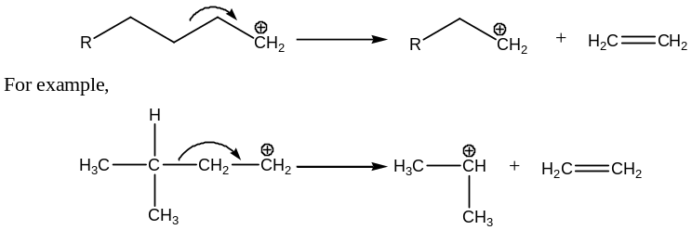
- Carbocations undergo intermolecular cyclization: Internal alkylation of a $C-C$ double bond sometimes may take place with a carbocation, i.e. carbocations undergo intermolecular cyclization. For example,
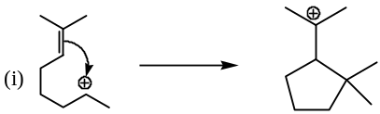
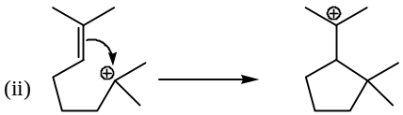
Detection of Carbocations:
Since, carbocations are highly reactive, short lived organic reaction intermediates i.e. cannot be isolated hence, are detected either from the analysis of the products formed by them or best from spectroscopic techniques.
- Detection of Carbocations from Product Analysis:
Let, us consider the example,
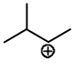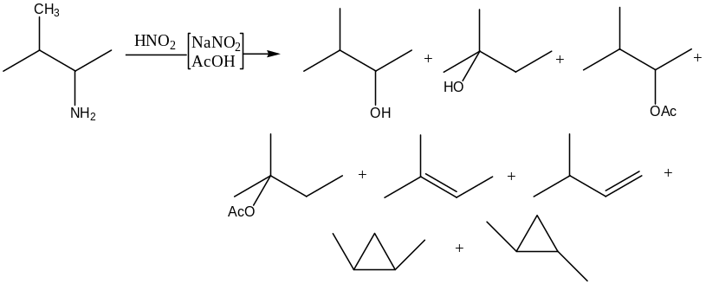
Formation of all the above products can be explained, only if we consider the following carbocation as the reactive intermediate:
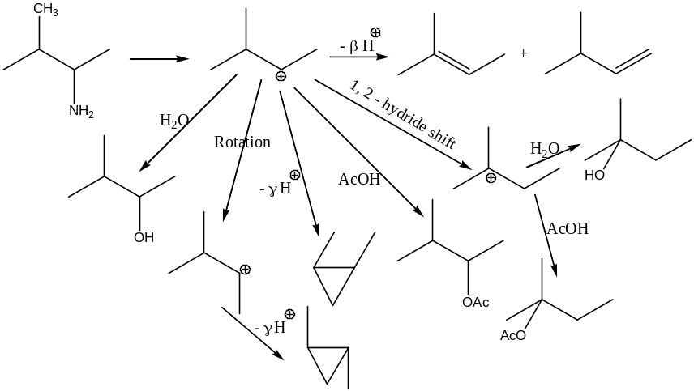
- Detection of Carbocations by the Spectroscopic Methods:
During the course of reaction, the existence of the intermediate carbocations are detected by most of the spectroscopic methods, such as ―
- NMR – spectroscopy: Depending upon the $δ$- values in NMR analysis we can detect the carbonium ions. Larger $δ$- value means deshielded, whereas smaller $δ$- value means shielded. For example,
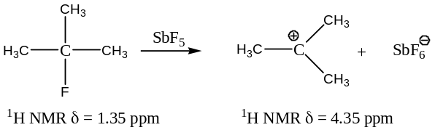
- IR – Spectra: Both classical and non-classical carbocations shows a strong absorption band at $1250-1550 {cm}^{-1}$
- UV-Vis Spectra: From the transition energy value for a particular transition, we can detect the existence of a carbonium ion. For example,
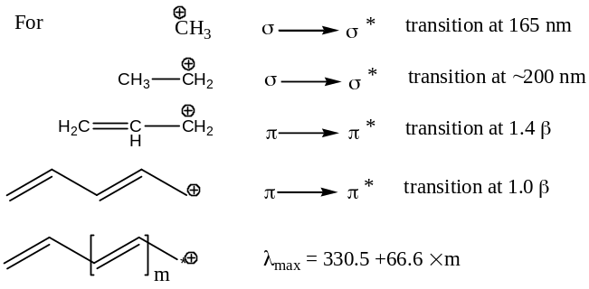
Non - Classical Carbocations or bridged carbonium ions
The carbonium ion in which the $+ve$ charge does not remain on a single $C$- atom, but spreads over at least three atoms and these three atoms forms a cyclic cation are thus called bridged carbonium ions or non-classical carbonium ions. For example, $β$- phenyl ethyl cation is a non-classical carbonium ion.
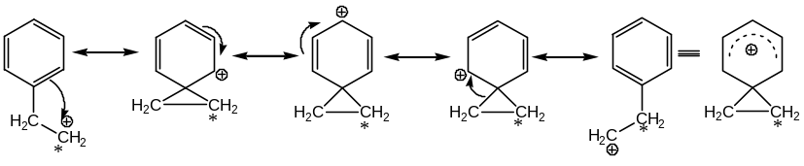
Following are some important observations, which are well explained by the formation of non-classical carbocations:
[1] Considering the reaction ―
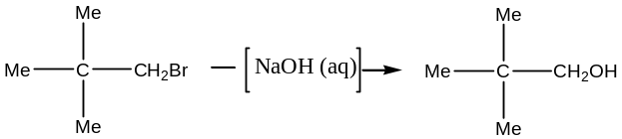
― This reaction is very slow and this can be explained by the steric effect
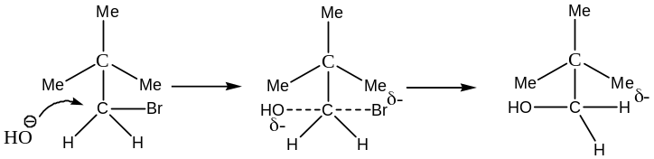
Due to the presence of three bulky methyl groups, the attack of the nucleophile viz. ${OH}^{-}$ is sterically hindered. Thus, the reaction takes place slowly.
Again, considering the reaction ―
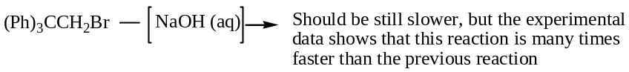
Hence, steric effect cannot explain the above observation. The fastness of the later reaction can be explained by the formation of non-classical carbocation as an intermediate.
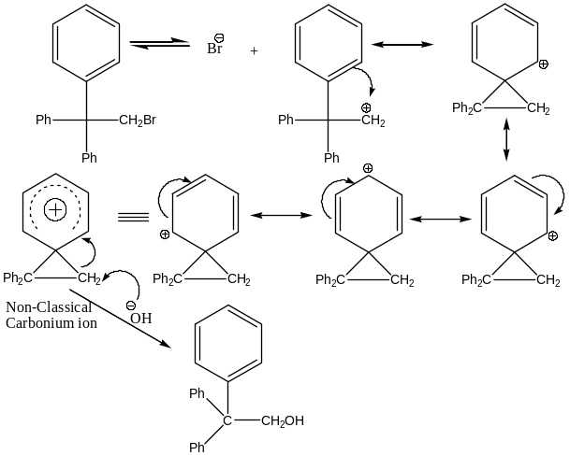
Explanation: Experimentally it has been observed that nucleophilic displacement of ${Ph}_{3}C{CH}_{2}Br$ is about $60, 000$ times faster than that of ${Me}_{3}C{CH}_{2}Br$― but the steric effect predicts the opposite rates. In order to explain such anomalous observation Robert and Lee invoked the idea of “non-classical carbocation” which was defined by Bartlett as “those organic cations in which the non-conjugated $π$- bonds (or $σ$- bonds) gets delocalized in the ground state of the cation.” These types of carbocations are called the aryl bridged non-classical cation.
Another type of non-classical carbocation is homo allyl type non-classical carbocation ―
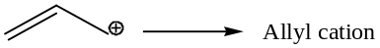
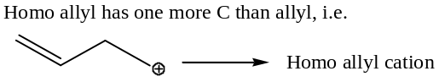
Formation of non-classical cation by homo allyl cation ―
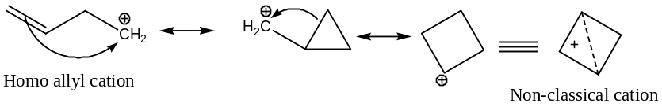
In order to explain the participation of non-classical carbocations to the reaction rate let us consider another experiment:
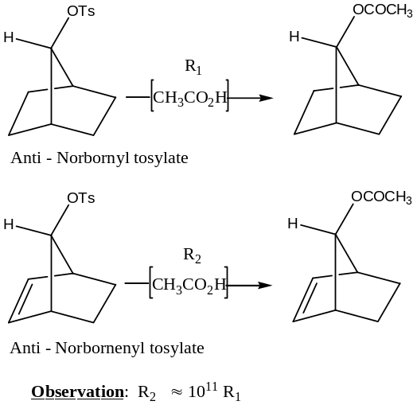
Explanation:
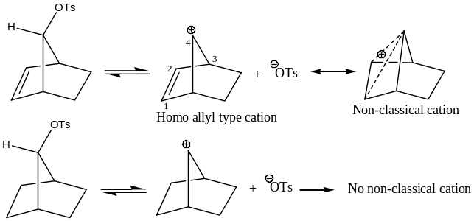
[Important: Aryl bridged and Homo allyl non-classical cations are called electron-rich non-classical cations.
Formation of such cations always assists the reaction ― the effect is known as Anchimeric Assistance or Neighbouring group participation or Synartetic effect.]
Experiments with $exo$- and $endo$- Brosylates of $Non$-$bornene$:
Experiment with $exo$- and $endo$- brosylates of $non$-$bornene$ shows that the $exo$- substituted isomer is much faster ($100R$) than that of $endo$- isomer ($R, rate$). This is explained by invoking the idea of $anchimeric assistance$ in the formation of non-classical cation by the $1,6$ - $σ$- bond in the $exo$- isomer, much in the same way as that of $S_{N}2$ attack.
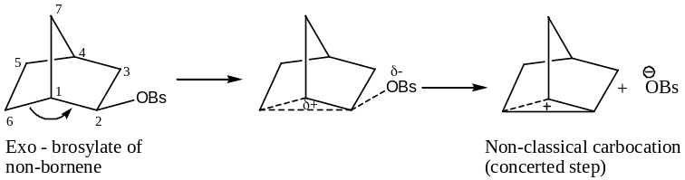

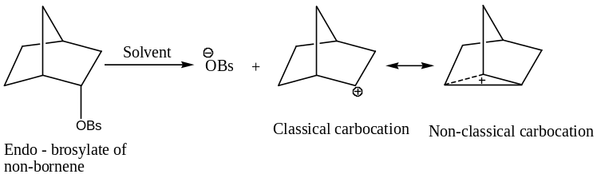
In the $endo$- isomer such $S_{N}2$ type assistance is not possible. In this case the solvent assistance, classical cation is formed first and then it is stablished by non-classical resonance. Hence, substitution in $exo$- isomer is much faster than the $endo$-$brosylate$ of $non$-$bornene$.
Non-Classical Resonance ― Stabilizes by $τ$ – Bond:
Let us consider the reaction ―
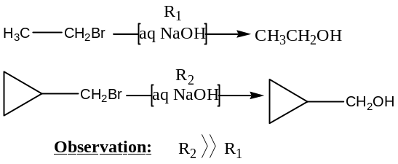
Explanation: $τ$ – Bond helps in stabilization of the classical cation formed in the case of cyclopropyl methyl bromide by non-classical carbocation, which is not occurs in ethyl bromide. Hence, the rate of hydroxylation, in the first case is much faster than the later.
[Note: Non-classical carbocations formed by the participation of non-adjacent σ – bonds are classified as electron deficient non-classical carbocations.]
Carbanions: Carb - anions
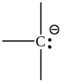Carbanions are the $–vely$ charged, highly reactive, short lived $C$- species, in which the octet of the $C$- atom is completed. Thus, the $C$- atom in carbanions carries three $σ$- bonds, a lone pair i.e. unshared electron pair and a $-ve$ charge. Therefore, carbanions are the anions of carbon generated by the removal of a mono-valent group or atom attached to the $C$- atom without removing the bonding electrons, and the simplest member is ${CH}_{3}^{-}$. So, a carbanion may be represented as ―
Geometry, Hybridization and Optical activity: In carbanions, the central $C$- atom is ${sp}^{3}$- hybridised, and the shape is pyramidal due to the presence of non-bonded electron pair ― bonded pair repulsion i.e. not ideal tetrahedral in shape (i.e. distorted tetrahedral, called pyramidal). Two enantiomeric forms that may be possible for asymmetric carbanions of the type $R_{1}R_{2}R_{3}C^{-}$ are in rapid equilibrium for which no optical activity is shown by such anions (due to tunnel effect).
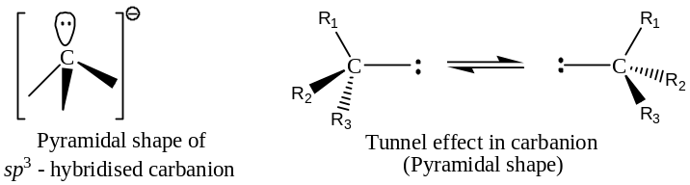
However, carbanions stabilized by conjugation are planar due to a $C―C$ double bond formation and are thus, ${sp}^{2}$-hybridised. For example,
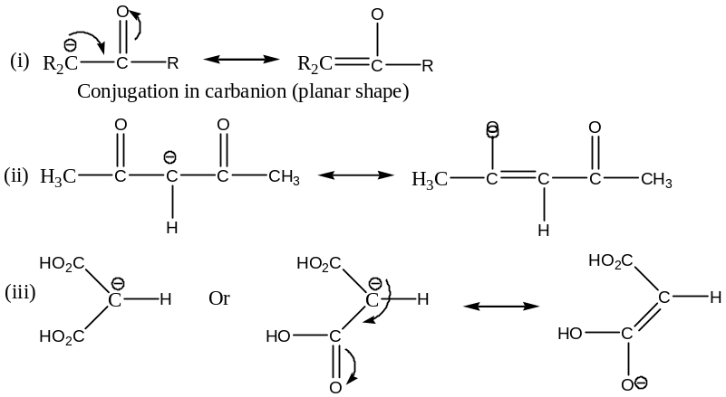
[Note: Simple carbanions like methyl carbanion are isoelectronic with ammonia]
Generation of Carbocations:
Carbocations are generated by the following general methods:
- By the hetero – type nature of C ―H bonds:
- The $C_{sp}-H$ of alkynes are acidic in nature, hence, can be replaced by strong base to generate carbanions. For example,
(b) If a strong base is used (which is stronger base than the carbanion) aromatic substrate forms carbanions. For example,
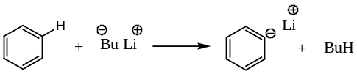
- By the Metal – Halogen Exchange:
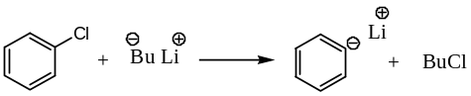
- By the Electron transfer reaction: Strongly reducing metals like Na, or Li, or Mg can convert alkyl halides (both aliphatic and aromatic) to alkyl sodium or alkyl lithium or Grignard reagent. Thus,
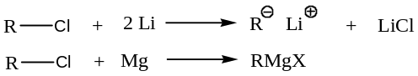
For example,
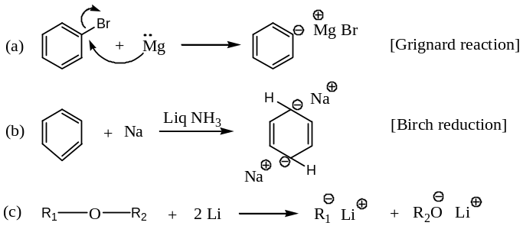
- From the active methyl, methylene and methine compounds using metal alkoxide: Acidic hydrogens of active methyl, methylene or methine group containing compounds on treatment with strong bases like sodium alkoxides, or lithium diisopropylamide (LDA) forms carbanions that are stabilized by the 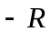 effect of electron-withdrawing groups like $―CHO, ―COOR, ―CN, ―{NO}_{2}$, carbonyl moiety, and so on. For example, with ―
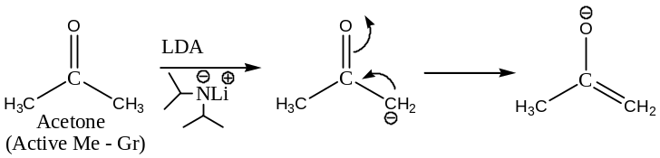
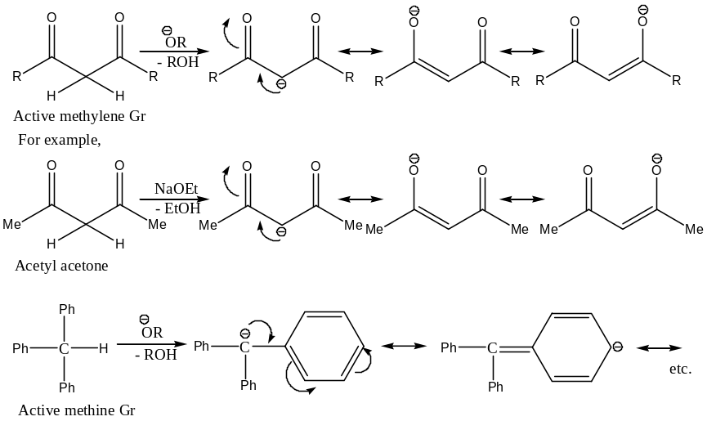

Stability order of Carbocations:
For alkyl carbanions, the stability order is:
$H_{3}C^{-}>H_{3}CH_{2}C^{-}>(H_{3}C)_{2}HC^{-}>(H_{3}C)_{3}C^{-}$
$i.e. H_{3}C^{-}>1^{°}>2^{°}>3^{°}$
The above stability order of carbanions is because of the $+I$ effect of alkyl groups, which further increases the $-ve$ charge density (as electron donating group) on the $-vely$ charged $C$-atom and thus, making increasingly less stable. Schematically,
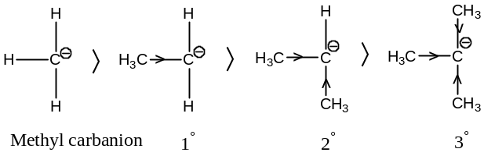
Stabilization of Carbocations:
- By Resonance effect: For example,
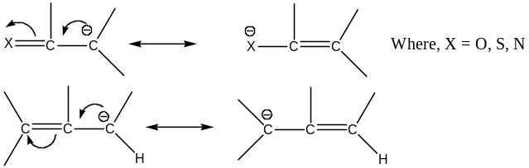
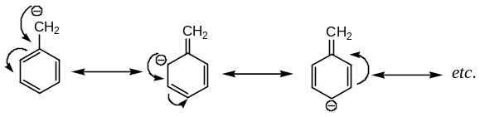
- By Inductive effect: Following examples given below explains how carbanions are stabilized by inductive effect ―
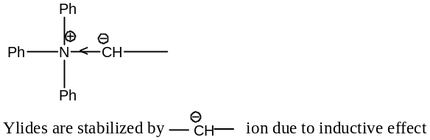
- By Aromatization: Following examples given below explains how carbanions are stabilized by aromatization ―
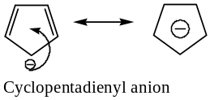
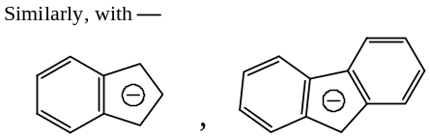
- By the increase in $s$ – character of the Hybrid state of C – atom:
With the increase in $s$- character of the hybrid state, stability of the carbanions increases. For example,
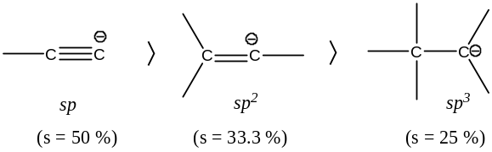
- By Non – Classical Resonance:
Following example given below explains how carbanions are stabilized by aromatization ―
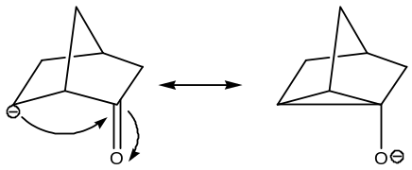
reactions of Carbocations:
Following are the important types of reactions exhibited by Carbanions:
- Carbanions acts as a Nucleophile: Following are the reactions, in which carbanions acts as a nucleophile (${Nu}^{-}$) to react with electrophilic species:
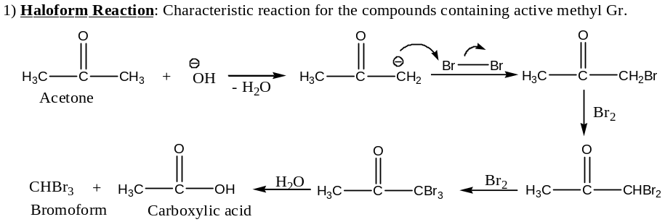
2) Reaction with alkyl halides: Carbanions undergoes acyl substitution reaction —
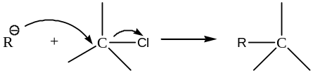
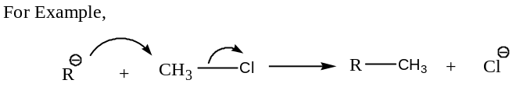
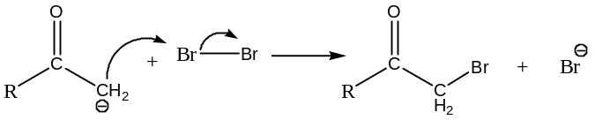
3) Substitution at ${sp}^{2}$-$C$: Reaction with the derivative of carboxylic acid —
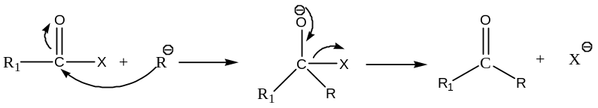
[This is the tetrahedral mechanism of nucleophilic substitution reaction]
For example,
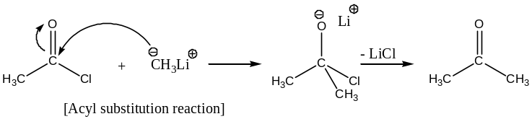
4) Nucleophilic addition: If $X$ in the above reaction with $RCOX$ is not a good leaving group, then instead of nucleophilic substitution, addition occurs —
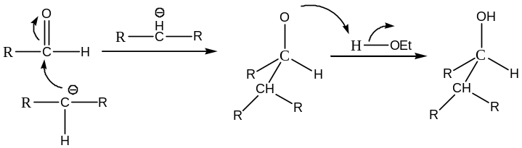
[This is the tetrahedral mechanism of nucleophilic addition reaction]
Important examples belong to this class includes: Aldol condensation, Perkin’s reaction, Grignard reaction, Thorpe reaction, Claisen reaction, Reformatsky reaction and Dieckman reaction.

Both the nucleophilic substitution and addition reactions of carbanions are widely used for making $C ― C$ bonds in organic synthesis. Almost all base-catalysed reactions of carbonyl compounds belong to this category. For example,
Aldol Condensation:
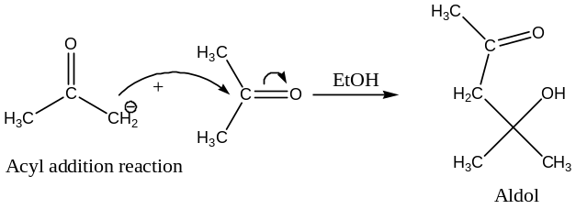
Conjugate addition of active methylene group (diethyl malonate) to the carbonyl compound:
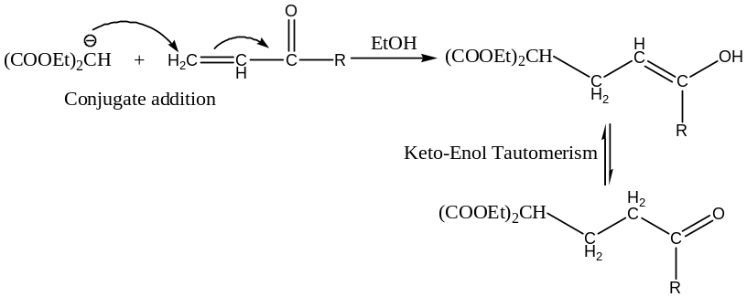
5) Michael Addition:
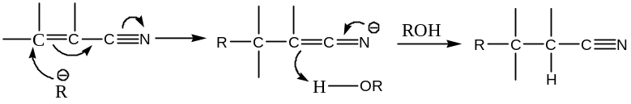
- Skeletal Rearrangement: Steven’s rearrangement,
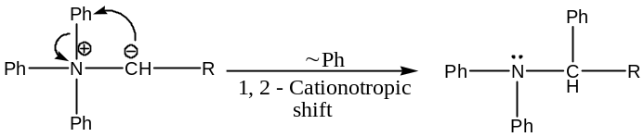
- Oxidation:
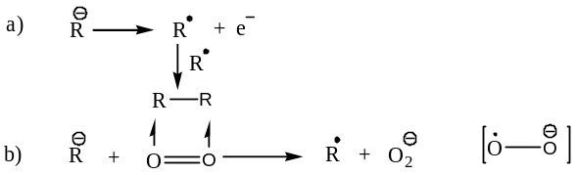
Detection of Carbocations:
Carbanions of the type ${CH}_{3}^{-}$, where the $-ve$ charge is not delocalized, and carbanions of the type,
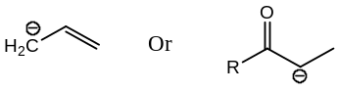
where the $-ve$ charge is appreciably delocalized due to conjugation, can be distinguished from their $proton$-$NMR$ spectra.
Formation of carbanions can be detected by the $UV-Vis$ spectra of the species that are significantly different from the starting compounds.
Trapping of carbanions with an electrophile may also show their formation in a reaction.
%%%%%%%%%%%%%%%%%%%%%%%

Carbenes:
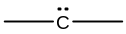Definition and Classification: Carbenes are electrically neutral, highly reactive, short lived, electron deficient, bivalent $C$- species. Thus, in carbene, $C$- atom is covalently bonded ($i.e.$ $σ$- bonds) to two monovalent atoms or groups and has two other non-bonding valence electrons. Thus, a carbene can be represented as ―
Based on the distribution of the two non-bonding electrons in one or two orbitals, carbene are classified as ―
- Singlet carbene, and
- Triplet carbene.
Geometry and Hybridization:
Singlet Carbene: If two non-bonding electrons are accommodated in one orbital the singlet carbene is formed. Singlet carbenes are ${sp}^{2}$- hybridised, and planar in shape. In singlet carbene, the two non-bonding electrons occupy one of the ${sp}^{2}$- hybridised orbital in the spin paired state (i.e. opposite electron spin). Thus,
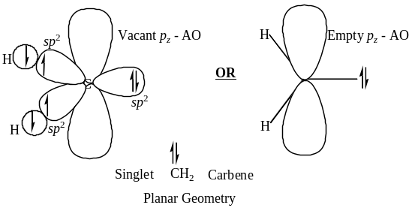
Triplet Carbene: If the accommodation of the two non-bonding electrons in two orbitals, having parallel spins, gives rise to the triplet carbene. The$C$- atom in many triplet carbenes is $sp$-hybridised with one electron each with parallel spins in the remaining two unhybridized $p$-$AO$’s. These carbenes have a linear shape.
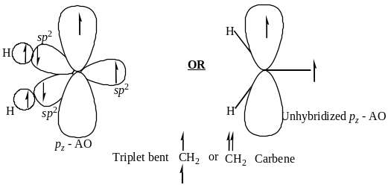However, bent triplet carbenes are also known, where the atom is 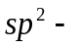hybridised, and the two non-bonding electrons occupy an orbital and an unhybridized 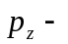AO with parallel spin. Thus,
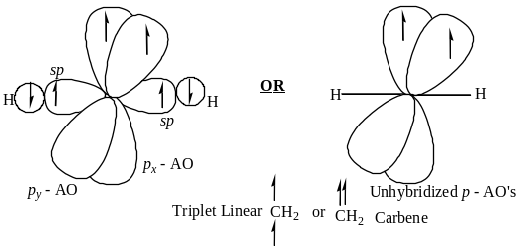

Important ― Stability of Singlet & Triplet Carbene: Singlet carbene is slightly less stable than the triplet carbene because of lower spin multiplicity.
Examples of Carbene: The simplest member of carbene is methylene, $\ddot{C}H_{2} or ∶{CH}_{2}$ a non-isolable species. Besides this, the most common carbene is dicloromethylene, $\ddot{C}{Cl}_{2}$. Some other carbenes are ―
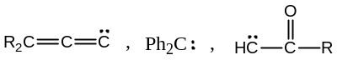
Nomenclature of Carbenes: Usually, carbenes are named as a derivative of methylene, the simplest carbene. Thus,
$\ddot{C}{Cl}_{2} is the dichloro carbene$
${Ph}_{2}\ddot{C} is the diphenyl carbene$
${CH}_{3}CO\ddot{C}H is the aceto carbene, etc.$
Generation of Carbenes: Carbenes are endothermic species. So, for their generation energy is supplied in the form of heat or light. Mostly these are prepared by thermal or photolytic $α$- elimination reactions.
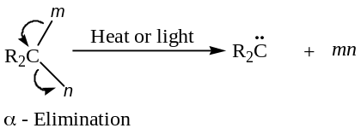
[General approach to Elimination: When two groups are lost from one and the same atom of a substrate in an elimination reaction, then it is said to be $1,1$- or an $α$- elimination reaction. Similarly, $1,2$- or $β$- elimination reactions are those in which two atoms or groups are lost from two adjacent atoms. On the other hand, $1,3$- or $γ$- elimination reactions are those in which two atoms or groups are lost from two different atoms which are separated by another atom in the chain.]
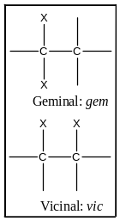Following are the some $α$- elimination reactions involving different substrate induced by heat or light used to generate carbene intermediate:
- From polyhalo alkanes with concentrated alkali: For example,
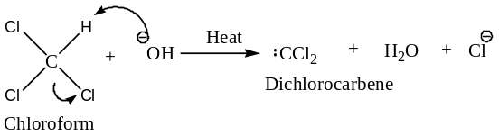
- By the reduction of gem – dihalo alkanes using active alkali metals: For example,
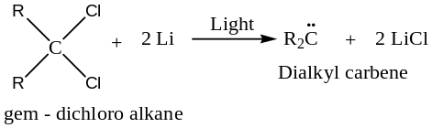
Mechanism:
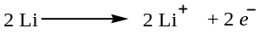
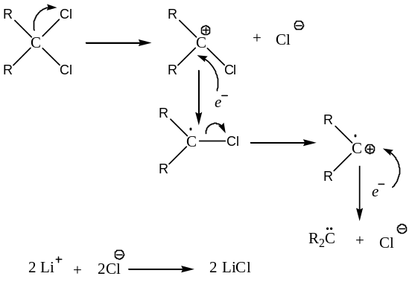
- By the thermolysis of azo-alkanes: For example,
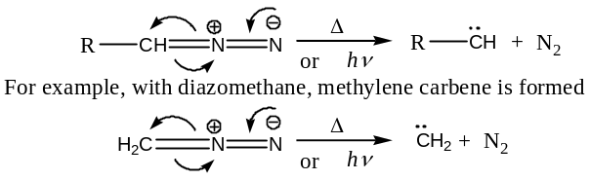
- By the photolysis of cyclopropanes ($cyclo$ elimination): For example,
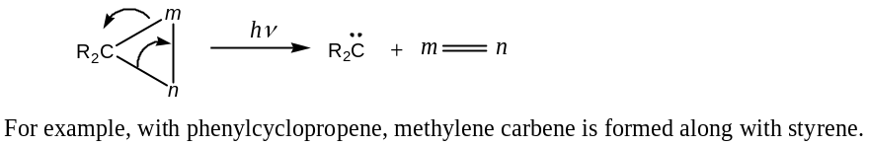
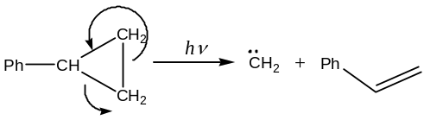
(5) By the thermolysis of ketenes ($keto$-alkenes): For example,
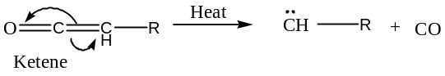
Reactions of Carbene:
Since, singlet carbenes are slightly less stable than the triplet carbenes and therefore, singlet carbenes are slightly more reactive than the triplet species. This may be due to the electron repulsion energy that must be overcome to pair two electrons in an orbital. So, the ground state of a carbene is the triplet state. Both the singlet and triplet carbenes are highly reactive species. However, their reactivity can be moderated by using copper powder in their reactions.
Carbenes undergo a variety of reactions. Following are the five synthetically important reactions of carbenes ―
- $σ$- insertion reaction,
- $π$- insertion reaction,
- Insertion into aromatic rings,
- Skeletal rearrangement, and
- Reaction with nucleophile.
$σ$- Insertion reaction:
[Insertion reactions are those in which one species is inserted between two bonded atoms in another species. It is important to note that insertion occurs mainly in the $C―H$ bond, it also occurs in $C―O$ and $C―Cl$ bonds, but does not at all occur in $C―C$ bond.]
In $σ$- insertion reactions of carbene, the carbene is inserted between two atoms which are bonded by a $σ$- bond of a substrate. However, these reactions have a little synthetic utility, as these take place indiscriminately. Thus,
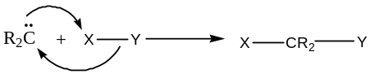
Based on mechanism, there are three types of $σ$- insertion reactions of carbene. These are:
- Via triangular transition state: For example,
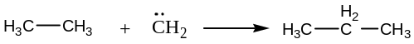
Mechanism:
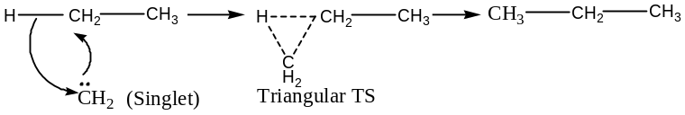
- Abstraction, recombination mechanism: Carbenes takes part in abstraction reactions to generate free radicals, which on recombination produces the next higher homologs. For example,
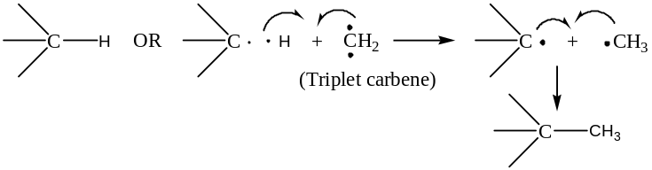
- Ion pair formation mechanism: Carbenes react with the hetero atom ($X$), containing at least one lone pair of electrons of a substrate to form an ion pair.
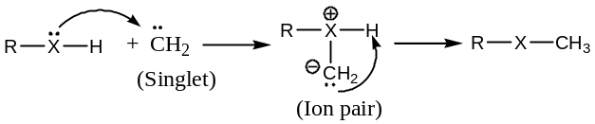
$π$- Insertion reaction:
A singlet carbene, which is a strong electrophile, undergoes insertion reaction to give cyclopropane or its derivatives, and this is possible because of the spin-paired nature of the non-bonding electrons of the singlet carbene. In the $π$- insertion reactions of carbene, both the $σ$- bonds of the cyclopropane ring are formed in a concerted step. Moreover, the insertion of the singlet carbene takes place from the less hindered side of the alkene i.e. from the less hindered side of $C―C$ double bond. Such insertion process has the following characteristics ―
- The reactions are completely $cis$- stereospecific,
- Thermodynamically less stable cyclopropanes are formed, and
- Electron releasing groups attached to $C―C$ double bond enhances the reaction rate.
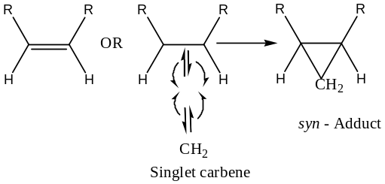
When a triplet carbene is inserted in a $π$- bond, a $diradical$ intermediate is formed. Formation of 2nd $σ$-bond needs a spin-inversion of an electron of the $diradi$―during which it undergoes a rotation around $C―C$ single bond, $i.e. σ$- bond. Hence, mixtures of geometrical isomers are obtained, of which the thermodynamically more stable (here $anti$-adduct) one predominates.
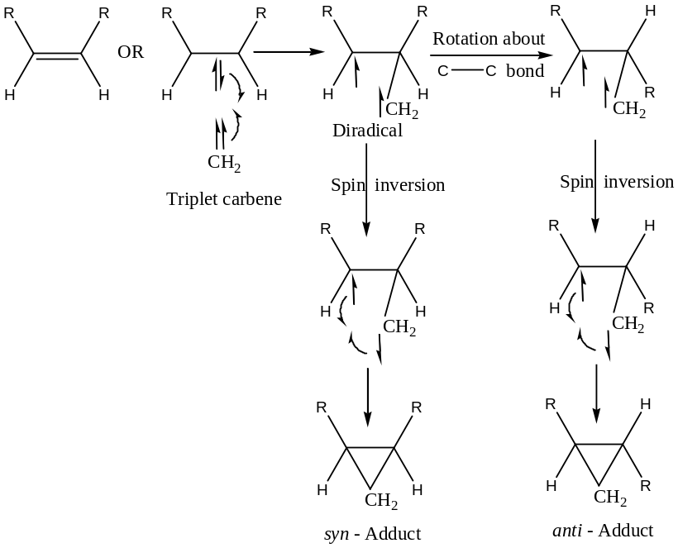
Insertion into aromatic rings: In such cases generally, ring expansions take place. For example, synthesis of $quinoline$ and its derivative from indole ―
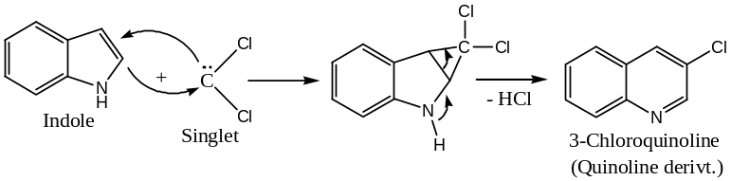
Similarly,
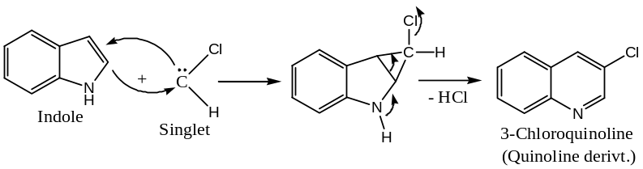
[Important Note: If the carbene is $\ddot{C}H_{2}$, the reaction does not occur, because, in the intermediate step, there must be an electron withdrawing group, to produce a $+ve$ charge on the $C$- atom, which is neutralized by the ring expansion.]
Skeletal Rearrangement: In these reactions migration of an alkyl group and 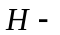atom generally takes place. For example,
- Alkyl carbenes readily undergo rearrangement to give alkenes, i.e. to a stable molecule. For example,
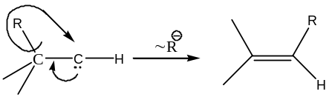
- Cyclopropyl and cyclobutyl carbenes undergo rearrangement to give cyclobutene and cyclopentene respectively i.e. ring enlargement takes place.
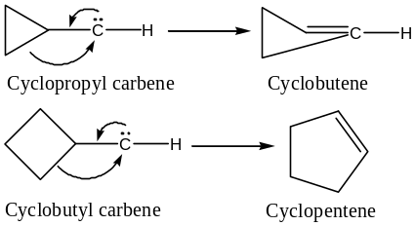
- Acyl carbenes undergo rearrangement involving anionotropic 1, 2 – shift to form ketene in Wolff rearrangement.
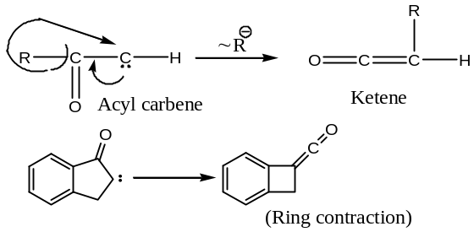
Reaction with nucleophile:
Carbenes react with nucleophiles to form different classes of compounds. For example,
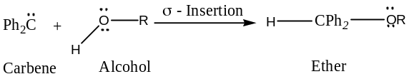
Again, carbenes being the electron deficient species may take part in electrophilic aromatic substitution reactions. For example, in Reimer – Tiemann reaction—
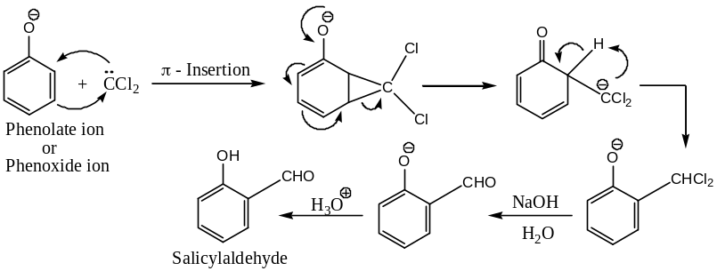
Detection of Carbenes:
Electron paramagnetic resonance spectroscopy ($EPRS$) can be used to detect the formation of the triplet carbenes. These carbenes are paramagnetic in nature due to the presence of two unpaired electrons in them.
Rotational fine structure of the $UV–Vis$ spectra can detect the formation of the singlet (bent form) or triplet (linear form) carbenes.
$π$- Insertion reactions can also detect and distinguish the formation of singlet and triplet carbenes.
$$$$$$$$$$$$$$
Free Radicals
Definition: An atom or a group of atoms, which are short lived, neutral species, with a magnetically non-compensated unpaired electron (i.e. odd electron) are called free radicals. These are formed by the homolytic cleavage (i.e. rupture) of a covalent bond. Thus,
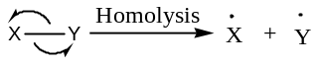
Free radicals are highly reactive intermediates and are often involved in reactions carried out at high temperature or under the influence of light.
Hybridization & Geometry: A carbon-based free radical is a trivalent $C$- species having a single 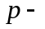electron in the valence shell. $C$- Centred free radicals like $\dot{C}H_{3}$ which are not stabilized, $i.e.$ reactive free radicals, have tetrahedral geometry where the central $C$- atom is ${sp}^{3}$hybridized. On the other hand, stabilized free radicals, that is, less reactive free radicals may be planar (hence, ${sp}^{2}$- hybridized) or may have in between structures. Thus,
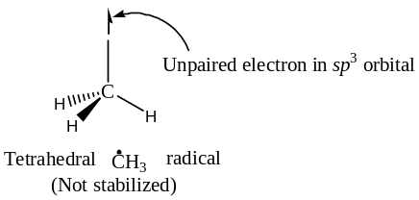
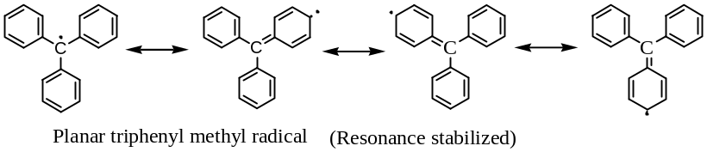
Classification: Free radicals are of two types ― on the basis of their life period,
- Short – lived free radicals ― these are extremely reactive species and are difficult to isolate. These are the most common free radicals.
- Stable free radicals ― these are not so reactive and exist in equilibrium with the normal compounds.
Short – lived free radicals: Generation // Production:
Short lived free radicals are generated when a molecule is supplied with sufficient energy ― thermal ($Δ$) or photochemical ($hν$) - to cause homolytic cleavage of the covalent bond, generally, in the presence of a free radical generator like azo isobutyl nitrile ($AIBN$). Similarly, in oxidation-reduction (redox) reactions resulting in the gain or loss of a single electron can also be used for the generation of free radicals.
Following are some examples used to generate free radicals involving ―
- Only thermal reactions,
- Only photochemical reactions,
- Either thermal or photochemical, and
- Redox reactions.
Thermolysis or photolysis of organic peroxides and azo compounds generates free radicals:
For example,
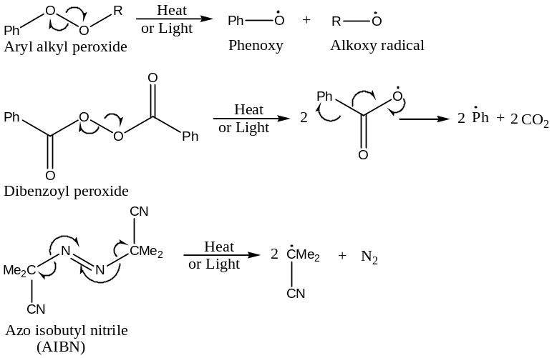
In fact, peroxides and AIBN are generally used as free radical generators from other molecules, and often this triggers free radical chain reactions. For example,
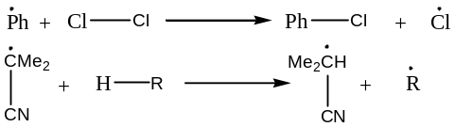
Some other commonly used Thermal reactions to generate free radicals are:
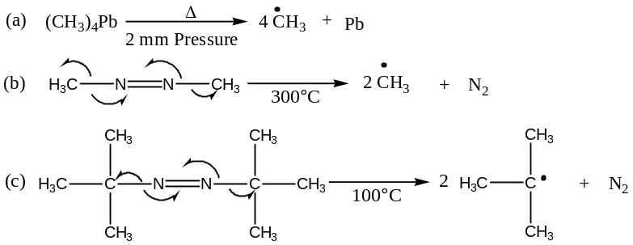
Photochemical reactions to generate free radicals:
${CH}_{3}CO{CH}_{3}\underset{→}{hν}\dot{C}H_{3}+\dot{C}OCH_{3}$
$2\dot{C}H_{3}→{CH}_{3}-{CH}_{3}$
$\dot{C}OCH_{3}→\dot{C}H_{3}+CO$
$2\dot{C}OCH_{3}→CH_{3}COCOCH_{3}$
Redox reactions to generate free radicals: One electron oxidation – reduction reactions are very often employed to generate free radicals. For example ―
- Kolbe electrolysis of salts of organic acids:
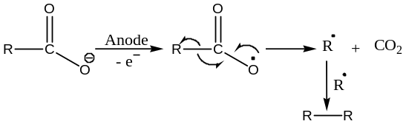
- Production of Fenton’s reagent by ${{Fe}^{2+}}/{H_{2}O_{2}}$:
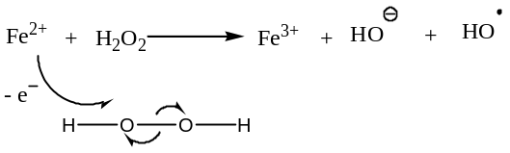
Hydroxyl radicals (Fenton’s reagent, ${{Fe}^{3+}}/{OH^{.}}$) is oxidised organic substances:
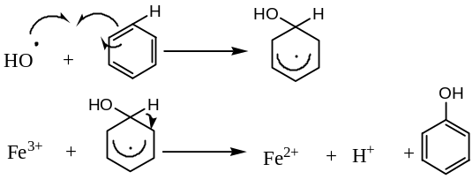
- Bimolecular redox reaction involving $Cu(I)$ and dibenzoyl peroxide also generate free radicals. For example,
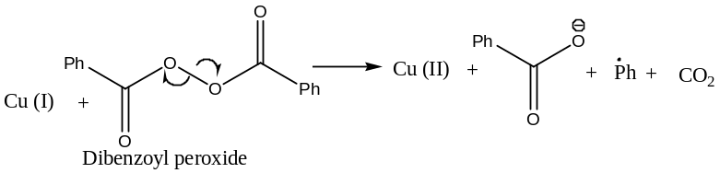
Stability of Free Radicals:
Stability of a free radical depends upon its bond dissociation energy which may be defined as the energy required for the homolytic rupture of the covalent bond in the molecule to form two radicals. Generally, the smaller of energy required for the bond rupture the more stable is the radical.
For example, $({CH}_{3})_{3}\dot{C}$ is more stable than $\dot{C}H_{3}$ radical as the bond dissociation energy of $({CH}_{3})_{3}C-H$ and $CH_{3}-H$ bonds are $86 and 102 kcal{mol}^{-1}$ respectively.
The relative stabilities of different radicals depend on the different environment around the covalent bonds that are being broken. Normally, stability order is ―
$1^{°}<2^{°}<3^{°}$
For example, for alkyl free radicals, the relative stability order is ―
$\dot{C}H_{3}<({CH}_{3})_{2}\dot{C}H<({CH}_{3})_{3}\dot{C}$
This stability order can be explained by ―
- Hyper-conjugative effect,
- Steric repulsion,
- Resonance effect,
- Inductive effect, and
- Non-classical resonance.
Hyper-conjugative effect: More the number of hyper-conjugative structures, higher the stability of the free radical. For example, for tertiary butyl radical, $({CH}_{3})_{3}\dot{C}$ there are nine possible hyper-conjugative structures ―
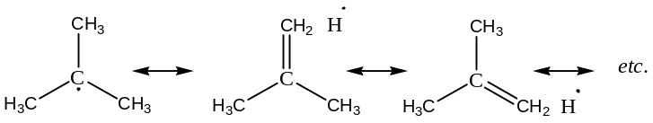
Similarly, for $2^{°}$- free radicals we have six such structures, whereas for $1^{°}$- free radicals we have only three such structures; and hence the stability order is $1^{°}<2^{°}<3^{°}$.
Steric repulsion: Formation of $t-Bu$ free radical by the removal of an $H$- atom from $isobutane$ is favoured as the steric repulsion between the methyl groups is relieved to a certain extent by an increase in bond angles from about ${109}^{°}$ to about ${120}^{°}$. Clearly, this steric relief should be the greatest in the formation of a tertiary radical.
Similarly, steric crowding sometimes prevents free radicals from acquiring an octet configuration, that is, it stabilizes the free radical. For example, the $di-ortho$ substituted benzylic free radical is unusually stable.
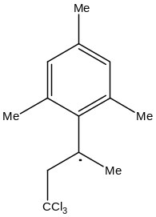
Resonance Effect: Resonance effect due to conjugation stabilizes the free radicals. For example,
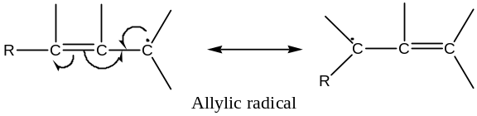
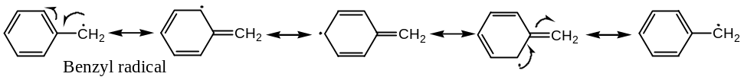
Inductive Effect: Electron releasing groups generally stabilize free radicals by 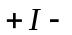effect. Thus,
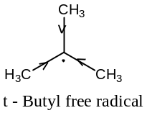
By Non-Classical Resonance Effect: Some cyclohexyl free radicals are stabilized by non-classical resonance forming bridged free radicals. For example,
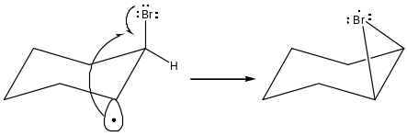
Configuration of Radicals: Geometry of Free Radicals:
Experiment: Chlorination of $(+)$-1-$chloro$-2-$methylbutane$ (I) yields racemic $1,2$-$dichloro$-2- $methylbutane$ (II).
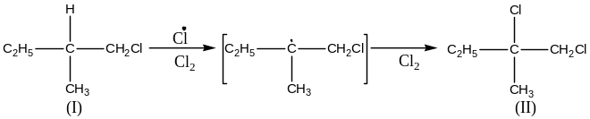
This reaction is found to be proceeds via free radical mechanism. This observed result can be explained if the radical has a planar structure, in which the carbon atom bearing the odd electron is 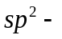hybridized (as in the carbonium ion) and the odd electron remains in the unhybridized 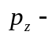AO. Existence of such a planar radical, in which attachment of 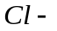atom to the either face is equally probable, explains the equal formation of the two optical isomers of 1, 2 – dichloro – 2 – methyl butane, leading to racemization.
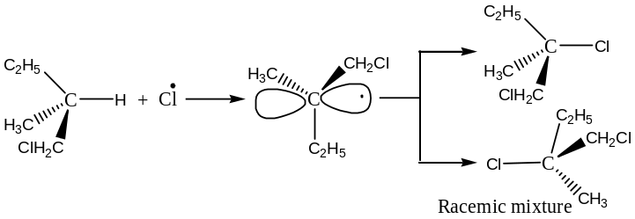
Reactions of Free Radicals:
Initiation of Radical Reactions:
Most of the free radical reactions are initiated by another molecule, called radical initiators. These are generally ―
- Organic peroxides such as benzoyl peroxide, $PhCO.OO.COPh$ in presence of benzene.
- Azo compounds such as azo methane, $Me-N=N-Me$.
Benzoyl Peroxide, $PhCO.OO.COPh$ as free radical reaction initiators:
― It breaks to form two free radicals
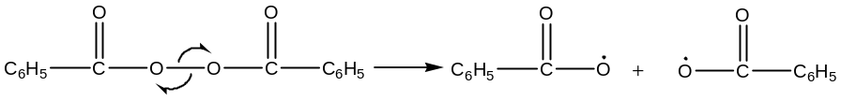
These radicals are stabilized by resonance. The benzoyloxy radicals may liberate ${CO}_{2}$ to produce phenyl radicals, which finally combines to form biphenyl.
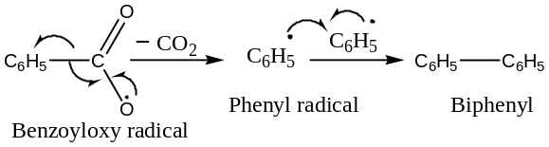
Presence of these free radicals are established from the fact that in presence of benzene, the decomposition of benzoyl peroxide, results in the formation of substitution products along with ${CO}_{2}, C_{6}H_{5}-C_{6}H_{5}, and C_{6}H_{5}COOH$.
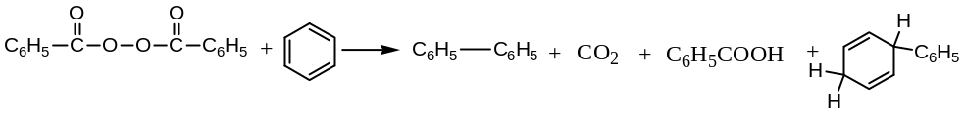
Thus, the decomposition of benzoyl peroxide in a chain reaction proceeds through the intermediate free radical viz. benzoyloxy or phenyl radicals.
$Azomethane$, $Me-N=N-Me$ as free radical reaction initiator:
This compound decomposes to ethane, which proceeds via the formation of methyl free radical,
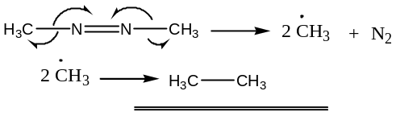
Mechanism of Free Radical Reactions:
Most of the free radical reactions proceed via chain mechanism ― which involves 3 – steps:
- Chain Initiation: This step consists of the reaction between the reactant molecule with the radicals of the initiator (usually benzoyl peroxide ― which generates benzoyloxy or phenyl radicals) to form another radical.
- Chain Propagation: This step is very rapid, here the radicals generated in the initiation step, combines with the reactant molecule, to form another radical.
- Chain Termination: In this step two radicals interact either by combination or by disproportionation.
Examples of Free Radical Reactions:
Following are the some widely studied free radical reactions:
Polymerization of Olefins:
These reactions are proceeds via the free radical chain mechanism process. For example, polymerization of styrene, initiated by benzoyl peroxide takes place in the following steps ―
Chain Initiation: Here, benzoyl peroxide decomposed to yield benzoyloxy (and phenyl) radicals, and these subsequently attack on the double bond of styrene.
Now,
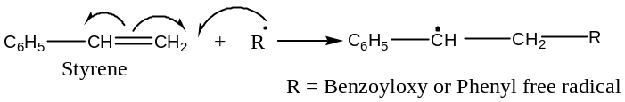
Chain Propagation: Here, the new radical so formed in the initiation step combines rapidly with styrene double bond, to generate another radical, and the process continues.
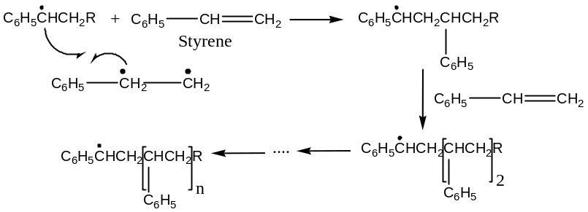
Chain Initiation: Here, two chains interact either by combination or by disproportionation. And the process may be represented as ―
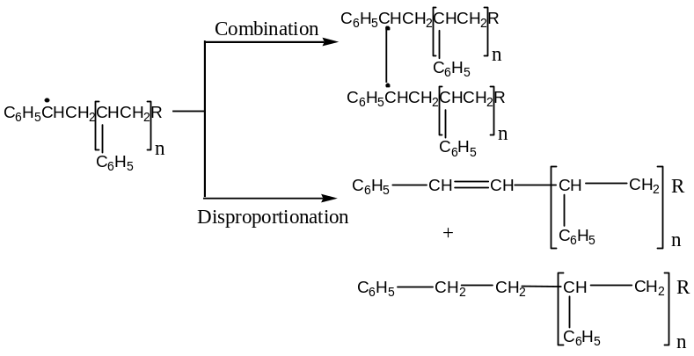
When we need to control the molecular weight of the polymer, chain – terminators are added to the reaction mixture. These compounds are capable of donating a hydrogen radical to the chain radical and thus terminating the chain. For example,
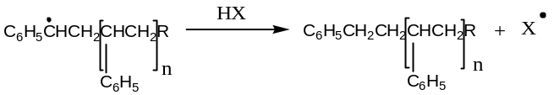
Here, $X$ is usually a radical of low reactivity which is not capable of further initiating ant radical reaction.
Halogenation of Alkanes:
Halogenation alkane is a free radical chain reaction consisting of chain initiation, propagation and termination steps. For example,
Chlorination:
Chlorination of alkane takes place either thermally $∆=250℃$ or photochemically (by the irradiation at, $hν=457.8 nm$. In either case, the reaction follows free radical chain mechanism and takes place in the following steps ―
Initiation: Initiation is the first step of chlorination of alkane, and involves the breaking of ${Cl}_{2}$- molecule into $Cl$- free radicals, which is an endothermic process and thus,
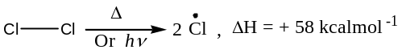
Chain propagation: Here, $Cl$- free radical formed in the initiation step attacked the alkane molecule to abstract an atom to generate an alkyl radical, which can collide with ${Cl}_{2}$- molecule to form alkyl chloride and a $Cl$- free radical again. This is a rapid step as exothermic.
$\ddot{Cl}+H-{CH}_{3} →HCl+\dot{C}H_{3}, ∆H=-1 kcal{mol}^{-1}$
$\dot{C}H_{3}+Cl-Cl →CH_{3}-Cl+\dot{C}l, ∆H=-23 kcal{mol}^{-1}$
Chain termination: Here, the chain is finally terminated by the union of two radicals.
$\dot{Cl}+ \dot{Cl} → {Cl}_{2}$
$\dot{C}H_{3}+ \dot{C}H_{3} → {CH}_{3}-{CH}_{3}$
$\dot{C}H_{3}+ \dot{Cl} → {CH}_{3}-Cl$
As expected, the $H$- atoms in an alkane are substituted in the general order:$1^{°}<2^{°}<3^{°}$ which is also the stability order of free radicals. For example,
Chlorination of propane yields $n$- propyl and $isopropyl$ in the ratio$1:3$.
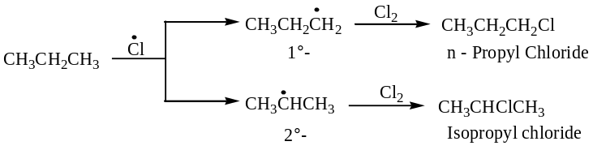
Bromination:
Unlike chlorination, bromination of alkane is relatively slow. So, more ${Br}_{2}$- molecules are to be dissociated to produce the same yield. The slowness of the reaction is due to fact that in the bromination both the initiation and propagation steps are endothermic ($∆H=+ve$). Thus,
$Initiation: Br-Br\underset{→}{∆ or hν} 2\dot{Br}, ΔH=+46 kcal{mol}^{-1}$
$Propagation: \dot{Br}+H-CH_{3} →HBr+\dot{C}H_{3}, ΔH=+15 kcal{mol}^{-1}$
$\dot{C}H_{3}+Br_{2} →CH_{3}Br+\dot{Br}, ΔH=-21 kcal{mol}^{-1}$
$Termination: \dot{Br}+\dot{Br} →Br-Br$
$\dot{C}H_{3}+\dot{C}H_{3} →CH_{3}-CH_{3}$
$\dot{C}H_{3}+\dot{Br} →CH_{3}-Br$
An important consequence of the low reactivity of $Br$- atom with alkane is its high selectivity for $3^{°} \& 2^{°}$ positions in comparison to the $Cl$- atom. For example,
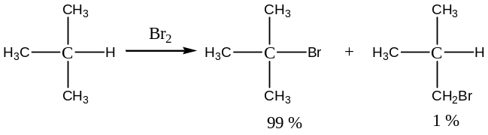
Bromination by NBS (N – Bromosuccinimide):
NBS, N - bromosuccinimide is a very specific reagent for allylic and benzylic bromination. For example,
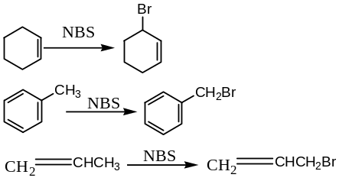
Mechanism:
The function of NBS is merely to act as a bromine reservoir maintaining a low concentration of molecular bromine by reacting with $HBr$ that is initially formed in a side reaction.
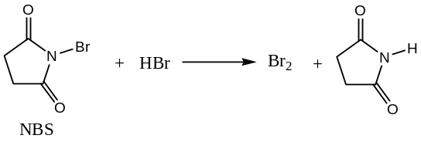
The ${Br}_{2}$- molecule dissociates into $Br$- atom in presence of light or radical initiators. This explains why bromination by NBS initiated by organic peroxide or $UV$- light. Hydrogen abstraction by $Br$- atom generates an allylic radical, which then reacts with the molecular ${Br}_{2}$ to yield the product.
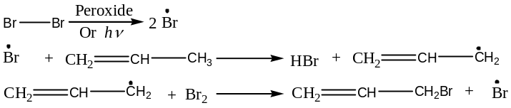
The chain then continues with the production of $HBr \& Br$. At low concentration of ${Br}_{2}$ favours allylic bromination over addition to the double bond, and this is a reversible process.
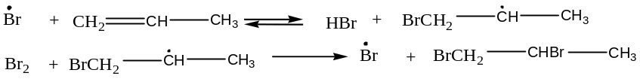
In the other words, the radical formed as a result of addition of ${Br}_{2}$ will revert to the alkene if the concentration of ${Br}_{2}$ is low, whereas an allylic radical is capable of waiting till it gets a ${Br}_{2}$ molecule. Thus, a low ${Br}_{2}$ concentration (by $NBS$) favours allylic bromination.
Question: Write the general mechanism of allylic bromination. What are the evidences that prove the mechanism? What will be the products of allylic bromination of?
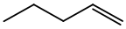
Solution: Substitution of a $H$- atom by a $Br$- atom in an olefin at its allylic position by using NBS (N – Bromosuccinimide) in $C{Cl}_{4}$ (a $non-polar$ solvent) in presence of organic peroxide or light is known as allylic bromination. Thus,
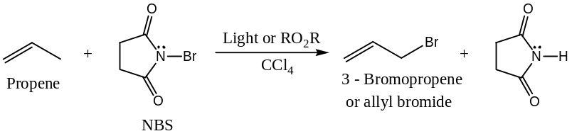
Similarly,
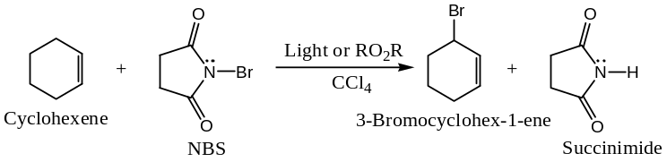
Generally,
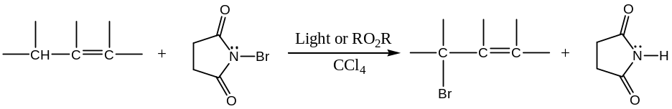
Mechanism:
Allylic bromination is a free-radical type reaction. The reaction is initiated by the formation of a small amount of $\dot{Br}$ (possibly formed by the dissociation of $N―Br$ bond of the $NBS$). The main propagation steps for this reaction are as follows:
Chain – Initiation:
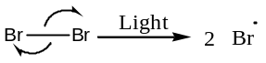
Chain – Propagation: This involves the following two steps ―
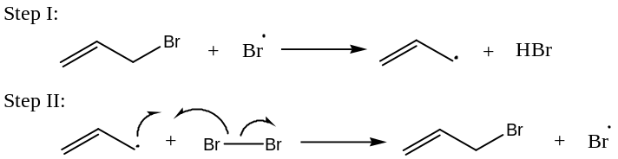
The source of the Br₂ in the first ionic reaction between NBS and the HBr liberated in step I.
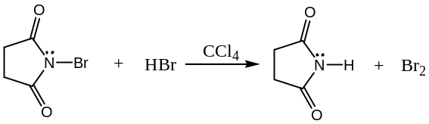
Since, NBS is nearly insoluble in $C{Cl}_{4}$ (non-polar solvent), hence provides a constant, but very low conc. of ${Br}_{2}$ in the reaction mixture. The very little Br₂ instead of adding to double bond reacts by substitution and replaces an allylic $H$- atom i.e. yields allylic bromination.
Evidences in support of allylic bromination:
The function of $NBS$ in allylic bromination is to provide a low and constant source of Br₂ conc. The main evidence for this mechanism is that NBS and ${Br}_{2}$ show similar reactivity and that the various $N$- bromoamides also show similar reactivity, which is consistent with the hypothesis that the same species is abstracting in each case.
If Br₂ is the reacting species, it may add to the double bond either by an ionic or a free-radical mechanism to give dibromo-alkane.
3rd Part:
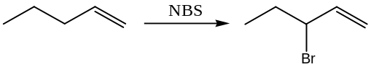
Free Radical Addition Reaction: Let us consider the specific example,
Addition of $HBr$ to Olefins:
Free radical addition is the ‘abnormal’ addition of $HBr$ to olefins. It has been seen that (by Kharasch and Mayo) the reaction is proceeds by either an ionic or a radical mechanism. In the dark and in the absence of radical initiators, the reaction proceeds in an ionic fashion, however, in presence of light, or a peroxide, a much faster radical addition occurs. For example,
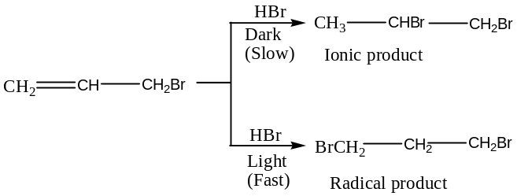
The difference in the nature of the products can be explained on the basis of the relative stabilities of the free radicals and carbonium ions, which follow the order $1^{°}<2^{°}<3^{°}$.
Initial addition of a proton produces a relatively stable carbonium ion in the ionic reaction, while an $Br$- atom adds first to generate the more stable $2^{°}$- free radical. Thus,
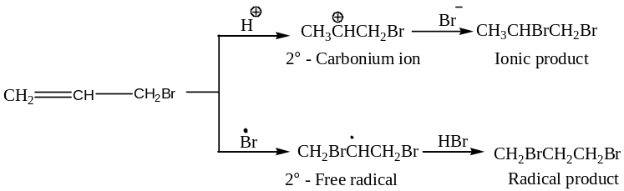
In presence of $O_{2}$, light or peroxides, $HBr$ dissociates to generate $\dot{Br}$,
$HBr+ O_{2} →H{\dot{O}}_{2}+ \dot{Br}$
$HBr \underset{→}{hν} \dot{H}+ \dot{Br}$
$RCOOH →R\dot{O}+ \dot{O}H+CO$
$R\dot{O}+HBr →ROH+ \dot{Br}$
Stereochemistry of free radical addition of HBr to Olefins:
Free Radical Aromatic Substitution Reaction: Free radical addition is usually a stereospecific process, yielding a trans – product. Addition of deuterium bromide ($DBr$) to $cis$- (I) and $trans$-2- butene (II), for example, yields $threo$- (III) and $erythro$- 3 – deutero-2-bromobutanes (IV).
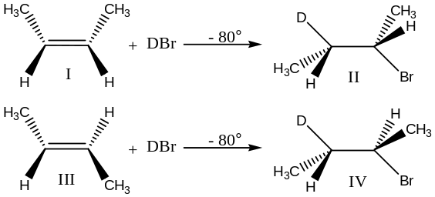
Note: Radical addition of $HI and HCl$ to olefins normally does not take place ― as here the 2nd step is endothermic.
Free Radical Aromatic Substitution Reaction:
It has been observed that the thermal decomposition of diazonium salts in aromatic solvents leads to the arylation of the aromatic rings. It was explained by the homolysis of the ionized salts to provide aryl radicals, which directly displaced a hydrogen atom in the aromatic solvent molecule.
$Ar-N=NX → \dot{Ar}+ N_{2}+ \dot{X}$
$\dot{Ar}+ C_{6}H_{5}-H → Ar-C_{6}H_{5}+ \dot{H}, X=Cl, OCOMe, OH$
The phenyl radicals generated from the other sources such as decomposition of benzoyl peroxide in aromatic solvents also lead to similar results.
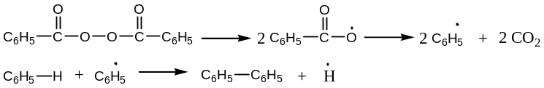
Rearrangement Reactions Free Radicals:
Rearrangement of free radical takes place by the migration of a neighbouring group to form a more stable free radical. For example, the rearrangement accompanying decarbonylation (removal of $CO$) of $β$-phenyl isovaler -aldehyde. This reaction is induced by butyl peroxide, yields a product mixture consisting of almost equal amounts of isobutyl benzene and butylbenzene.
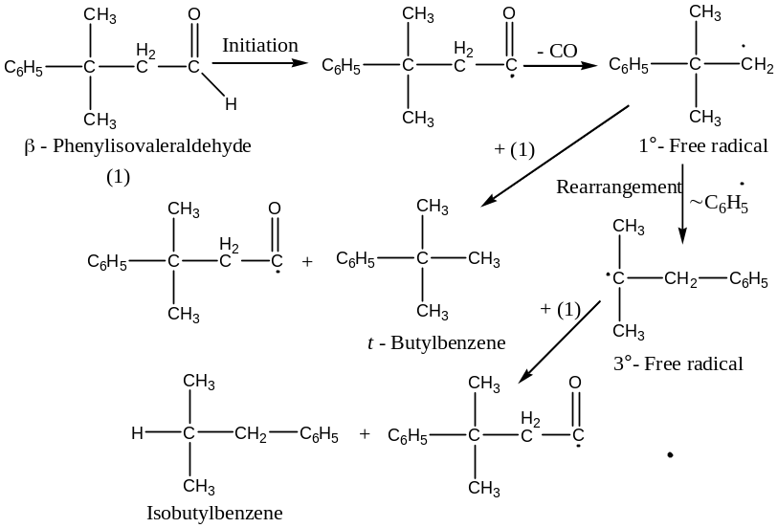
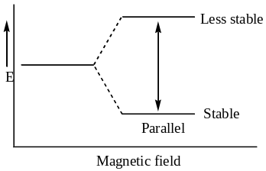Detection of Free Radicals:
Classically, free radicals are detected from the kinetic study in presence of a small quantity of a radical initiator such as hydroquinone, and in the absence of the initiator (high rate).
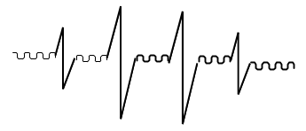 As the free radical contains an odd electron, so the presence of this odd electron, can be directly detected from $ESR$- (Electron Spin Resonance) or $EPR$- (Electron Paramagnetic Electron Paramagnetic) spectroscopy. When a free radical is placed in a magnetic field, followed by electromagnetic radiation, then the magnetic field generated by the spinning of the odd electron can be lined up or parallel (or aligned) or opposed with the external magnetic field ― in two different energy levels.
Transition of the odd electron between stable and less stable levels produce a line in the ESR spectrum. In practice, we get several lines ― this splitting of single line is due to the coupling of the odd electrons with the protons situated on the same atom that carry the odd electron.
If there are ‘$n$’coupling protons, then there will be ‘($n+1$)’ lines in the $ESR$ spectrum.
For example, methyl radical $\dot{C}H_{3}$ has 3 – protons with the $C$ carrying odd electron, so there will be $\left(3+1\right)=4$ resonance lines.
Similarly, cyclopentatrienyl $({\dot{C}}_{7}H_{7})$ radical generates by $X$- ray irradiation, shows $8$- equally spaced lines ―including that the odd electron couples with $7$- equivalent protons. This confirms that the electron is equally distributed around the ring.



